**Laravel Installation and Folder Structure Assignment**

**Laravel Installation Process**

**Steps:**

1. composer create-project laravel/laravel my-first-laravel-project
2. cd my-first-laravel-project
3. php artisan serve

**Now Server is live port: http://127.0.0.1:8000**

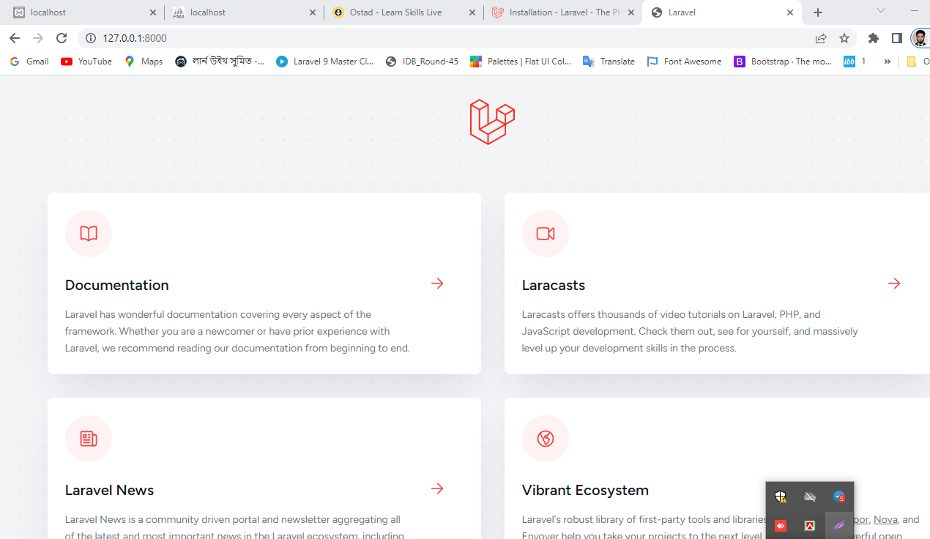

**Fig:** **Screenshot of the running server**

**Laravel Folder Structure**

**In a Laravel project, each folder serves a specific purpose and plays a vital role in the overall structure and functionality of the application. Here is a brief description of each folder:**

**App:** This folder contains the core code of your Laravel application. It typically includes models, controllers, middleware, jobs, and other classes that define the business logic and functionality of your application.

**Bootstrap:** The bootstrap folder contains the application's entry point and various configuration files. It includes the app.php file, which initializes the Laravel framework, and the cache folder, which stores framework-generated files to improve performance.

**Config:** The config folder contains configuration files for different aspects of your Laravel application. It includes files for database connections, application settings, service providers, logging, and more. You can modify these files to customize the behavior of your application.

**Database:** This folder is used for database-related files. It typically includes migration files that define the structure of your database tables, as well as seed files that allow you to populate the database with initial data. It may also contain database factories for generating test data.

**Public:** The public folder is the document root for your web server. It contains the entry point for your Laravel application, the index.php file, as well as publicly accessible assets such as images, JavaScript files, and CSS stylesheets.

**Resources:** The resources folder holds various assets and views used by your application. It typically includes Blade templates for generating HTML views, along with assets like JavaScript, CSS, and image files. This folder is organized into subdirectories for views, language files, and assets.

**Routes:** The routes folder contains the route definitions for your application. It includes the web.php file for handling HTTP routes, the api.php file for API routes, and possibly other route files for organizing your application's routes.

**Storage:** The storage folder is used for storing files generated by your application. It includes subfolders for storing logs, cached views, uploaded files, and other temporary or persistent storage needs. It's important to ensure that the web server has write permissions for this folder.

**Tests:** The tests folder contains automated tests for your Laravel application. It includes test cases that help ensure the correctness of your code and the application's behavior. Laravel provides a testing framework and utilities to facilitate writing and running tests.

**Vendor:** The vendor folder holds the dependencies required by your Laravel application. It includes the third-party libraries and packages installed via Composer, Laravel's dependency management tool. This folder should not be manually modified, as Composer manages it automatically.

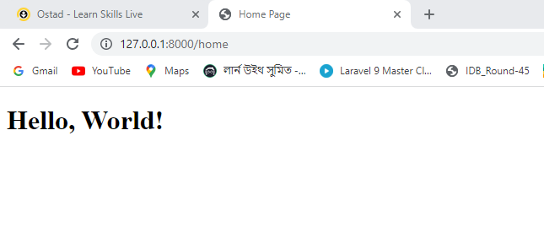

**Fig: Screenshot of the running route.**