TCGer
  - Mobile & Desktop Interface Review
  - Visual walkthrough • Responsive layouts • Android emulator follow-up
8 October 2026

What this document covers
This document shows the current TCGer web interface at desktop and phone sizes. It explains how the main screens work, highlights differences between the layouts, and records the checks completed during the local review. All web screenshots use demo data and the dark theme.
Mobile web and the native Android app are separate interfaces. A narrow browser screenshot is labelled “mobile web”; it is not presented as an Android screenshot. The Android section records the result of the emulator attempt.

Review at a glance
Surface | Evidence
Desktop and mobile web | 42 automated Chromium workflow checks passed. Fresh screenshots captured at 1440 × 1000 and 390 × 844.
Narrow phone settings | 320 × 800 regression passed; dialog content and game switches fit.
Backend and API | 270 backend tests plus 130 JavaScript/Convex API assertions passed.
Native Android | Debug APK built. Full JVM suite: 250 passed, 1 skipped. Emulator follow-up recorded below.
Production and hardware | Production build downloads were blocked by upstream errors. Physical camera, biometrics, Safari and iOS are not verified.

How to read the screenshots
The comparison pages show the first viewport of each screen. Longer mobile pages continue below the captured area. Screenshot figures contain the actual local interface; image zoom in Word preserves detail. Developer controls visible in the lower corners belong to the local development build.
The initial audit identified six issues and applied fixes for request-log credentials, frontend container packaging, Scryfall headers, mobile settings overflow, optional catalog filters and incomplete search results. The screenshot follow-up also exposed overlapping actions in mobile search results. A responsive card grid now keeps those controls readable; the updated result screenshots show the fix.

01 Dashboard
The home screen summarizes owned cards, estimated value, active games and recent additions. Distribution and set-completion sections appear below the summary.
Desktop web · 1440 × 1000 | Mobile web · 390 × 844
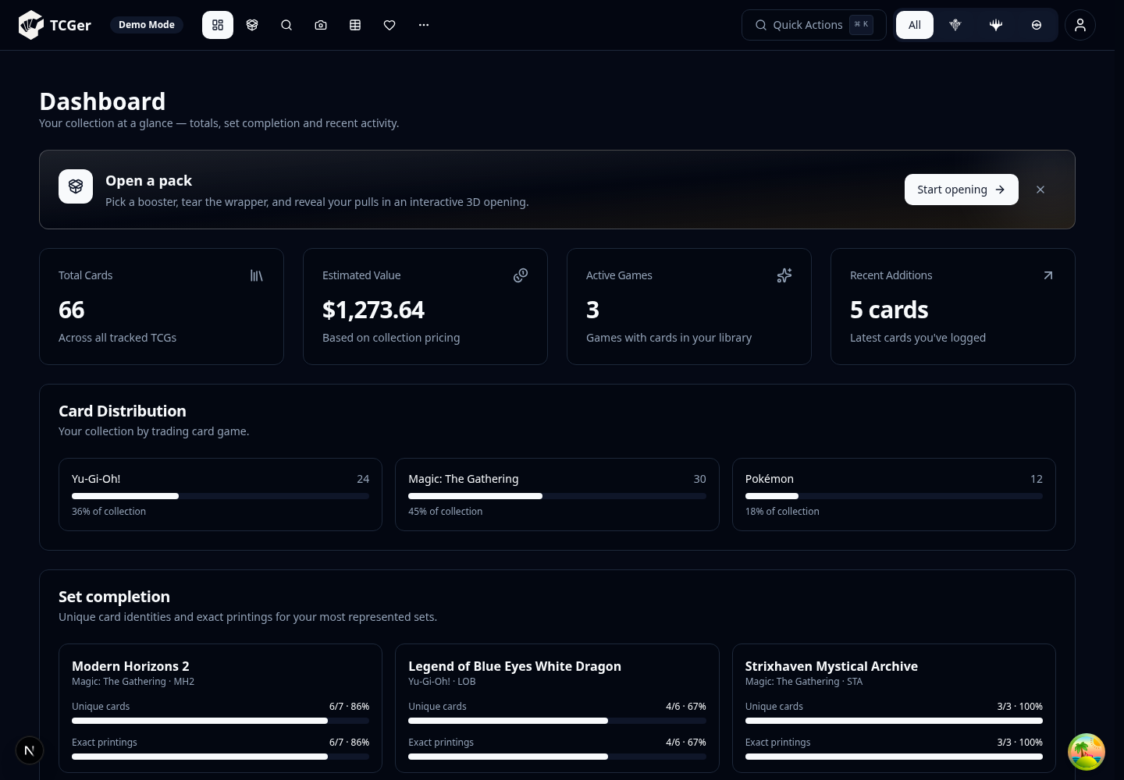 | 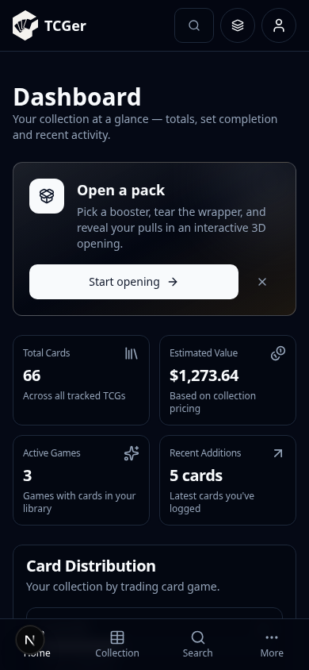
Desktop places four summary tiles in one row. Mobile uses a two-column grid and vertical scrolling. Values shown are sample demo values, not a live account valuation.

02 Collections and binders
Collections groups owned cards by binder and preserves individual-copy details. The page exposes import/export, history, binder scope, smart folders and row filters.
Desktop web · 1440 × 1000 | Mobile web · 390 × 844
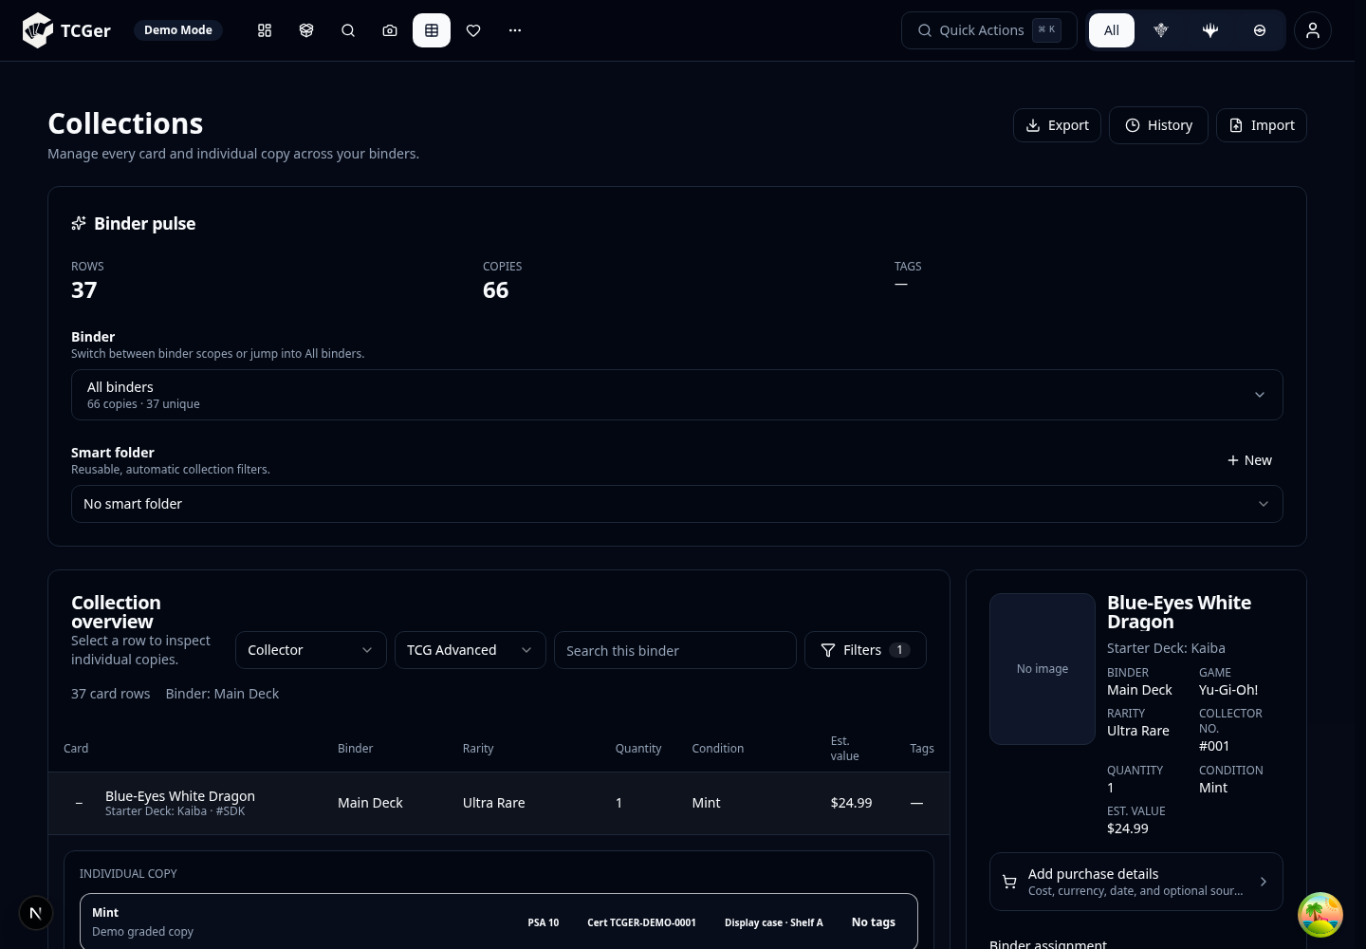 | 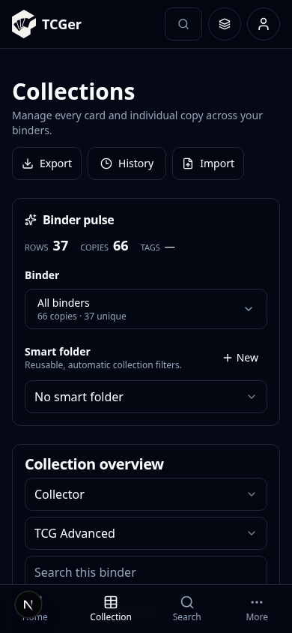
Desktop uses a dense table with rarity, quantity, condition and estimated value columns. Mobile stacks controls and renders compact card rows further down the page. Copy details include grading, certificate and storage information.

03 Card Explorer
Search by keyword and game, then refine by set, rarity or collector number. Discover offers a random-card starting point. These figures show the initial state before a query.
Desktop web · 1440 × 1000 | Mobile web · 390 × 844
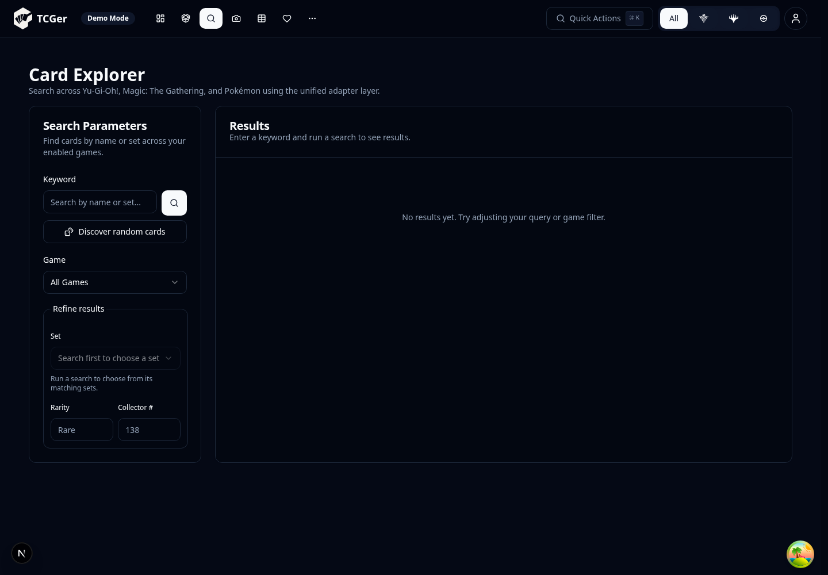 | 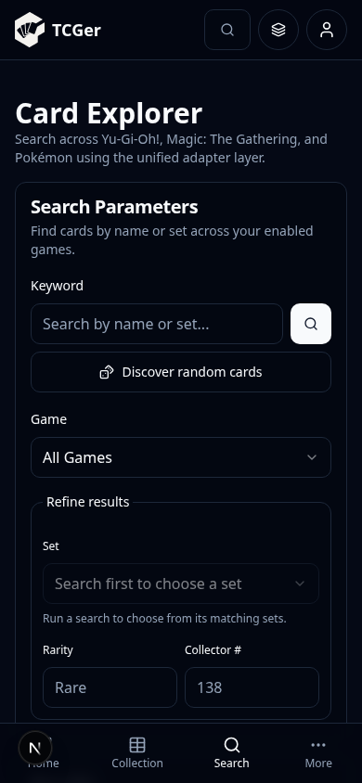
Desktop keeps parameters beside the result area. Mobile stacks the panels, so results require scrolling. New error handling distinguishes a provider failure from a genuine empty search; partial web results display a warning.

04 Wishlists
Create named wishlists, select one, and compare wanted quantities with cards already owned. Completion percentages summarize progress toward each list.
Desktop web · 1440 × 1000 | Mobile web · 390 × 844
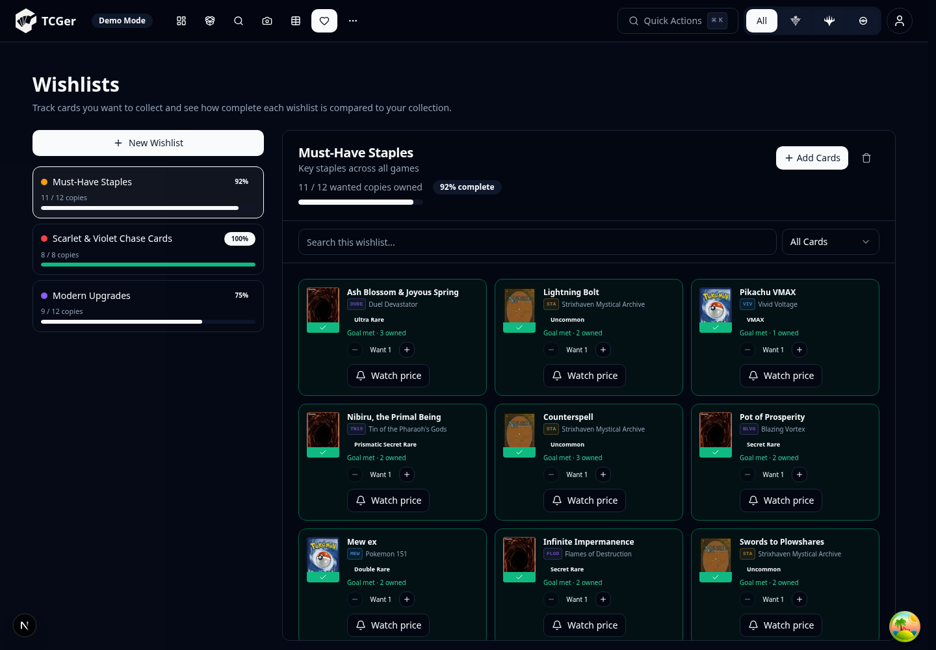 | 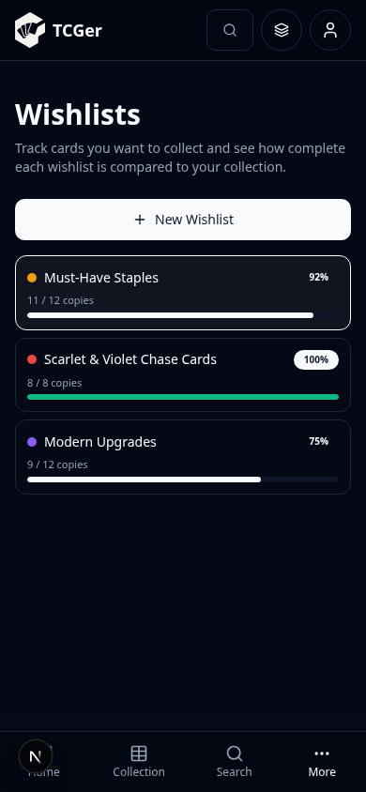
Desktop shows the list selector and selected wishlist together. Mobile first shows the selectors; opening a list reveals its detail view. The mobile navigation and detail-views page includes a screenshot of the open list.

05 Browser scanner
Choose a game and recognition mode, start the camera or upload a card/page image, and review captured copies before saving to a destination binder.
Desktop web · 1440 × 1000 | Mobile web · 390 × 844
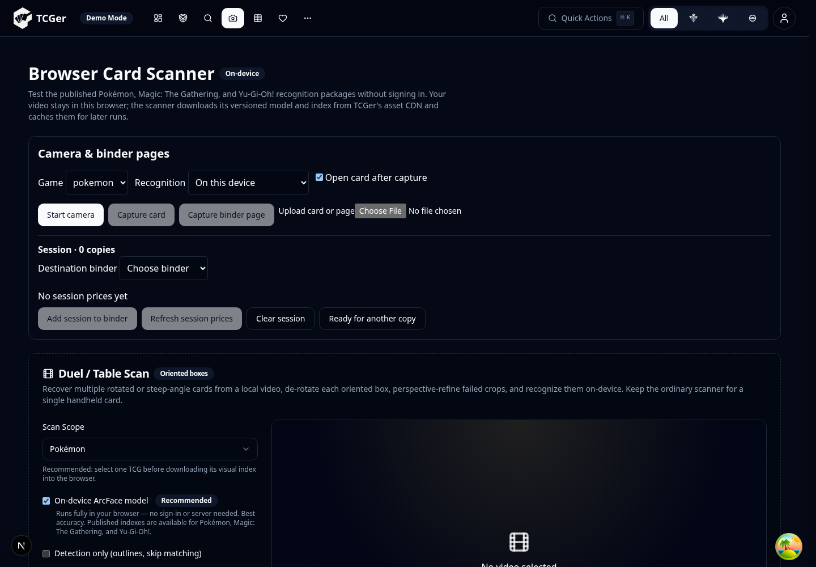 | 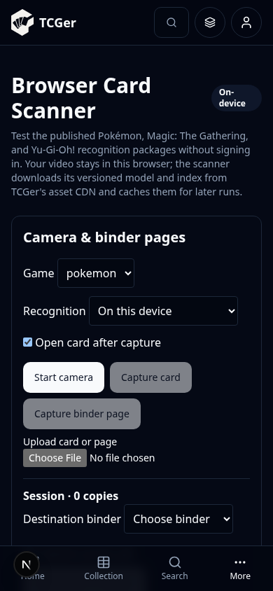
This is the browser scanner, not the Android camera screen. Buttons and destination controls were inspected; real camera hardware and recognition accuracy are not established by these screenshots. The page also offers a multi-card video/table workflow below the initial viewport.

06 Grading planner
Compare selling raw with potential graded outcomes. Inputs include language, grader, currency, raw value, costs, grade values and scenario weights. Manual estimates can be used without live market data.
Desktop web · 1440 × 1000 | Mobile web · 390 × 844
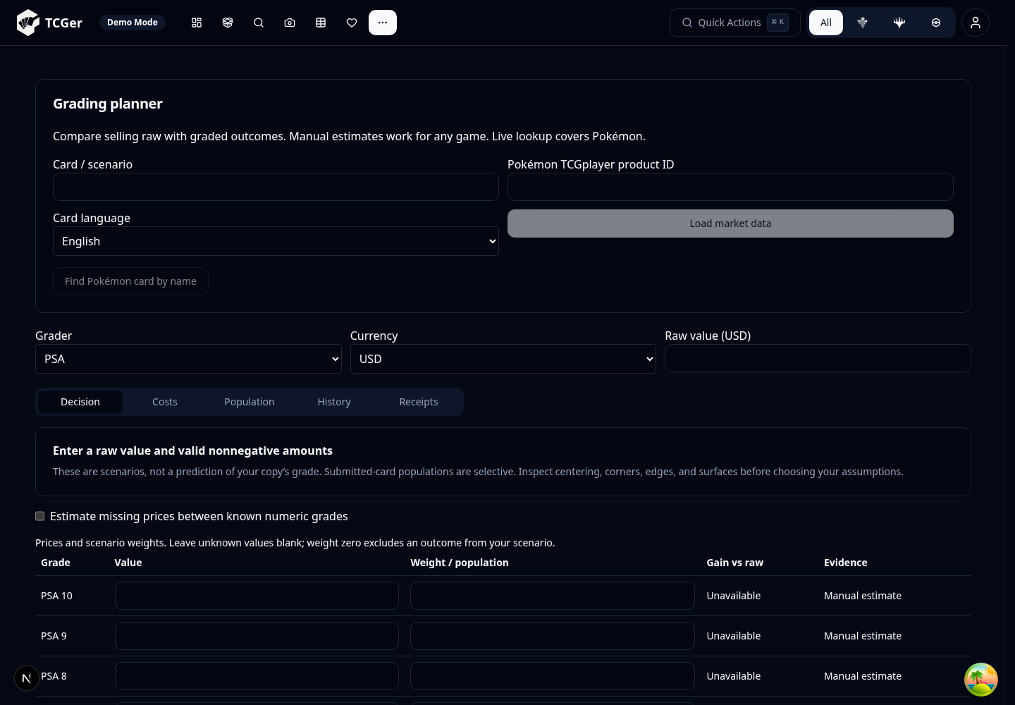 | 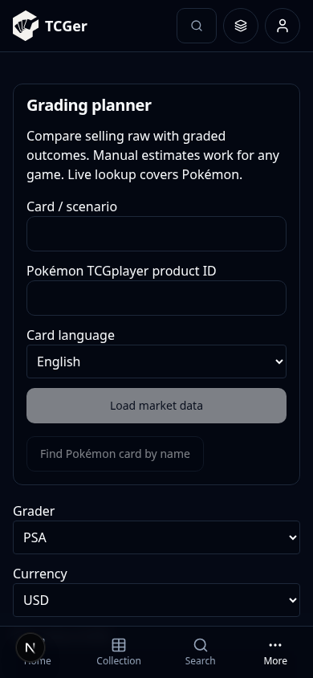
Desktop exposes more of the planning table at once; mobile requires scrolling. Decision, Costs, Population, History and Receipts views are available. Outputs are scenarios, not predictions of a card’s grade.

07 Account and preferences
The user menu opens account details, theme selection, game-module toggles, game-library management, scanner options, pricing preferences and backup/recovery controls.
Desktop web · 1440 × 1000 | Mobile web · 390 × 844
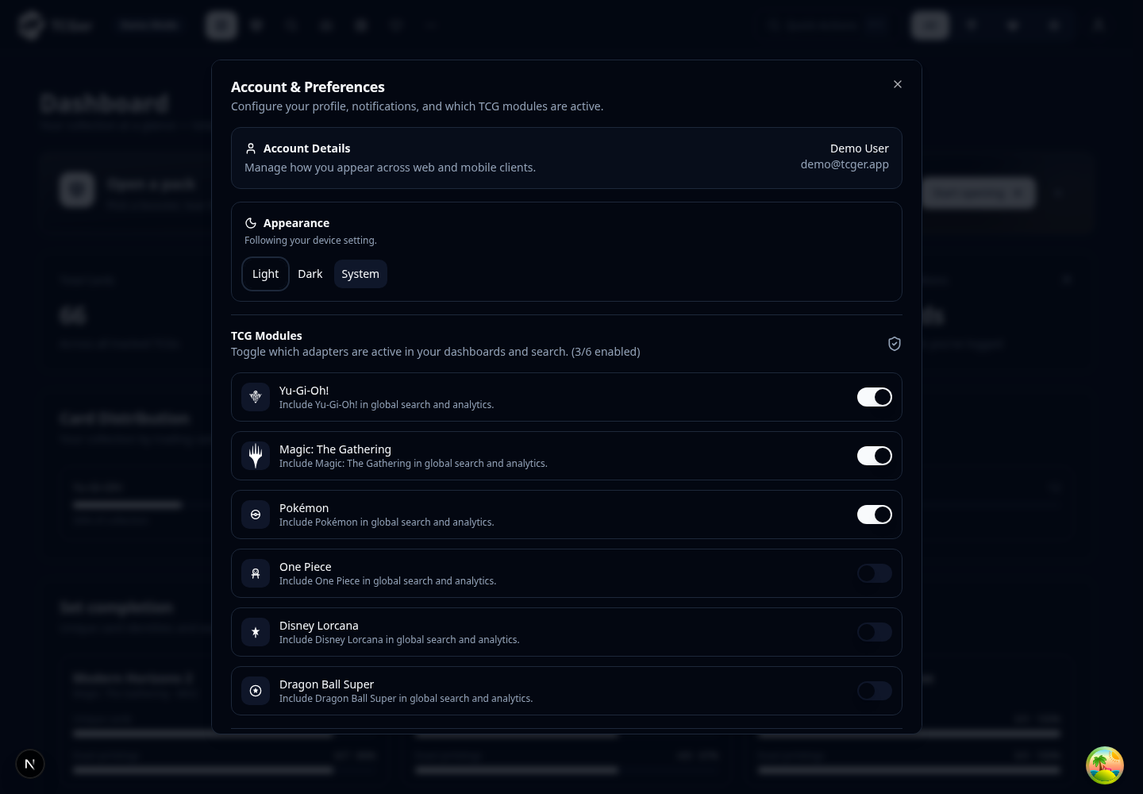 | 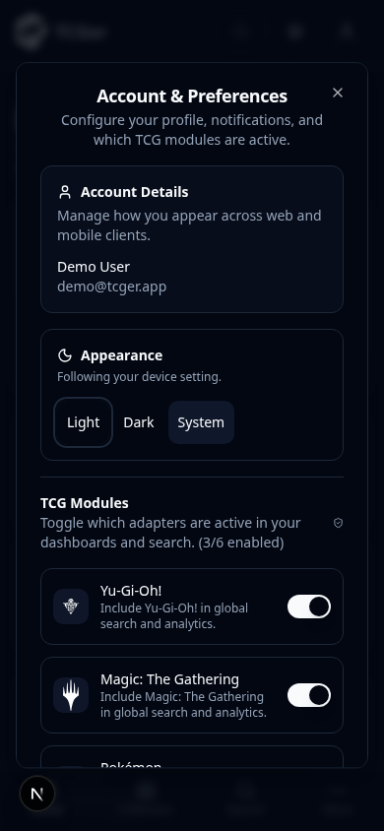
The earlier phone overflow has been fixed with a shrinkable dialog grid, wrapping account/module rows and a constrained file picker. A separate 320px test confirms Pokémon’s switch stays inside the dialog and can be changed.

08 Search results in use
A demo search for Pikachu shows the card results after submitting a keyword. Select a card to inspect its printing and available actions.
Desktop web · 1440 × 1000 | Mobile web · 390 × 844
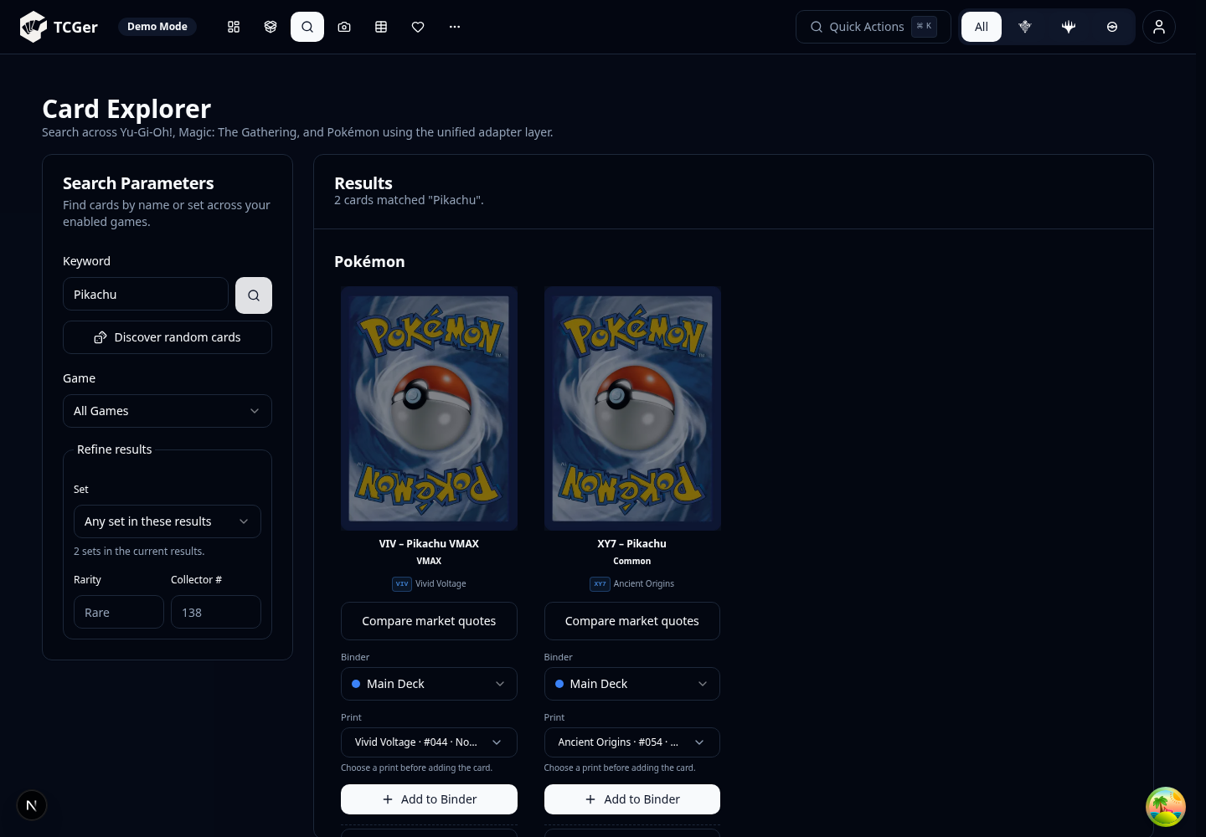 | 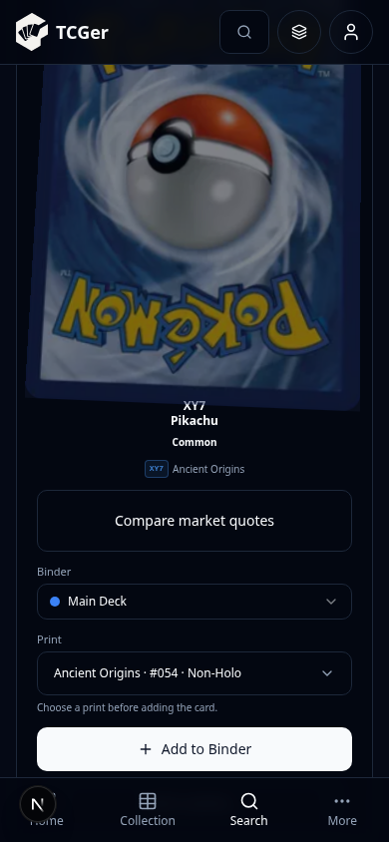
Desktop keeps the search controls and card grid side by side. Mobile now gives a card the available width, avoiding the earlier overlapping actions. This figure is scrolled to a result; the search form is above it. Demo results are examples, not live market quotes.

09 Mobile navigation and detail views
The mobile web header keeps search, game selection and the user menu. The fixed bottom bar provides Home, Collection, Search and More. More opens the secondary sections, including Scan, Wishlists, Sets, Prices and Analytics.
More menu | Collection copy details | Wishlist details
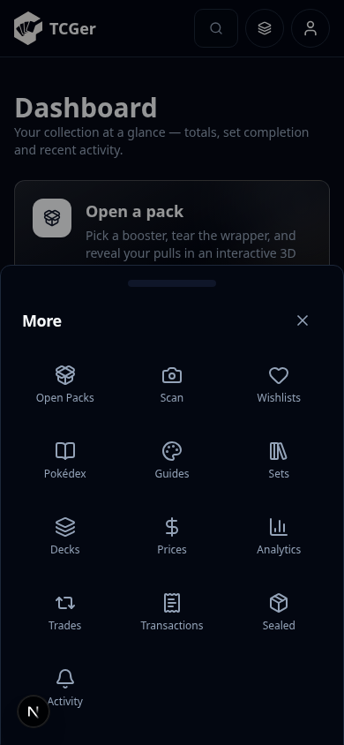 | 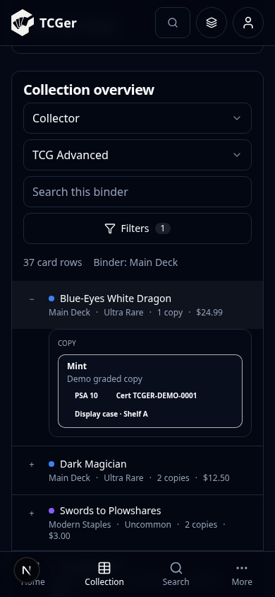 | 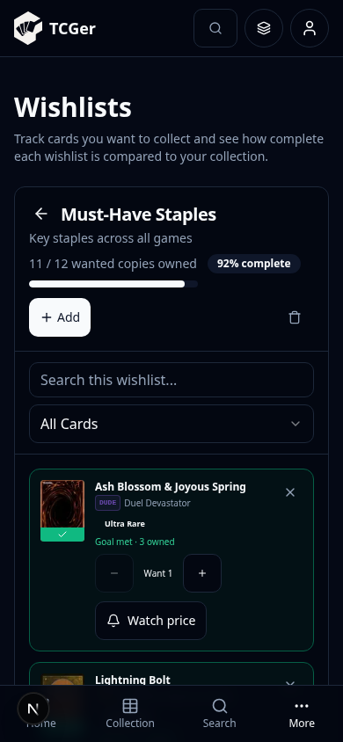
Mobile detail screens are shown after opening or scrolling to their content. The bottom bar remains available while navigating. These screenshots use demo records.

Suggested interface improvements
- Add persistent labels or a clear help affordance to compact desktop navigation icons; touch and first-time users cannot rely on hover labels.
- Reduce the distance between the mobile search button and results, for example with collapsible advanced filters or a result jump after search.
- Review the scanner’s long form for a shorter mobile sequence: input, recognition, review and save. Keep advanced video options out of the primary task path.
- Test larger system text, keyboard navigation, screen-reader announcements and light-theme contrast before release. These are follow-up recommendations, not confirmed accessibility failures.

10 Android emulator follow-up
An Android emulator was installed and run here. Android booted, TCGer was installed, and MainActivity received a launch command. Native UI verification remains incomplete: the first run was killed by the host memory limit during test-driver setup; after freeing memory and restarting, Maestro stalled while installing its driver. No native UI test pass or usable native app screenshot is claimed.
Check | Result
Emulator / device | Android Emulator 37.2.12; Android 11 / API 30; Pixel 2 profile.
Acceleration | No KVM or vmx/svm CPU support. Software emulation was used.
Boot and app installation | Boot completed; the installed package was confirmed and MainActivity appeared in the resumed activity record.
Stability | The OS displayed a System UI “not responding” dialog. One host out-of-memory kill was recorded.
Resource retry | Stopped idle Gradle/Kotlin services, moved the SDK out of RAM-backed /tmp, reduced display size and capped Maestro memory. The retry stayed within the memory limit.
UI automation | Maestro driver setup stalled on installation; the bounded retry did not complete a flow. Fresh native UI evidence is missing.

What an emulator can verify
A working emulator can exercise launch, navigation, forms, local persistence and screen layout. It can also run the repository’s Maestro flows. Camera quality, physical biometric behavior and release installation still require real devices.

Run the Android UI suite on an accelerated emulator
In Android Studio, boot a virtual Pixel device, preferably on API 35, with hardware acceleration enabled. In a shell with JDK 17, Android SDK platform-tools and Maestro available, run the following from the repository root. Replace the device ID with the value returned by adb devices.
adb devices
npm run parity:check
MAESTRO_DEVICE_ID=emulator-5554 npm run parity:android

Checks to finish before release
- Run native Android flows on a booted emulator or device, then inspect representative screens at different display and font sizes.
- Run iOS verification locally on a Mac with Xcode. Android results do not substitute for iOS execution.
- Retry the production Docker build when registry/font downloads are available, then verify login and persistence through the production-style gateway.
- Keep live-server results separate from demo UI evidence and from API contract tests.
Reference: the detailed audit is saved as review.txt in the tcger-audit folder. Source fixes remain uncommitted; no production deployment was performed.

