COFE-FORMEC-IUFRO 2022 – One Big Family: Shaping Our Future Together Corvallis, Oregon, U.S.A. – October 4-7, 2022

The Virtual Wood Supply Arena

– next generation on-line training tool for forest logistics

Dag Fjeld
Swedish university of agricultural sciences, Sweden
Dag.Fjeld@slu.se

Philippe Marier
FORAC, Université Laval, Québec, Canada
Philippe.Marier@forac.ulaval.ca

Björn Edlund
Swedish university of agricultural sciences, Sweden
Bjorn.Edlund@slu.se

Lars.Eliasson
Skogforsk, Sweden
Lars.Eliasson@skogforsk.se

Mikael Frisk
Creative Optimization Sweden AB
Frisk@creativeoptimization.se

Mikael Rönnqvist
Université Laval, Québec, Canada
Mikael.Ronnqvist@gmc.ulaval.ca

Keywords: wood supply chain, coordinating operations, weather, trafficability

EXTENDED ABSTRACT

The Virtual Wood Supply Arena (VWSA) is an on-line training tool for managing roundwood purchase, production and transport in CTL supply systems. The training environment simulates 12-week periods with monthly mill delivery goals while handling weekly weather and site trafficability for harvesting and hauling.

Earlier logistics training tools developed by the same group include the Wood Supply Game (D’Amours et al. 2017) and Transport Game (Abasian et al. 2019). The VWSA is designed to come as close to reality as possible in an on-line environment. It includes three roles per company (purchase-, production- and transport managers) managing 10 harvesting teams and 10 trucks over 4 supply regions and 2 climate zones (highlands, lowlands). Deliveries of 5 assortments are managed to 5 mills (2 pulp mills and 3 saw mills). Team KPIs include monthly delivery precision per mill assortment, capacity utilization, relocation- and hauling distances. The user interfaces are presented below.

Each 12-week training scenario may be selected from 4 annual weather cycles (52 weeks). The annual cycles include 1) 10-year average, 2) cold winter, 3) dry summer and 4) warm-wet summer. The training includes both development of monthly goals as well as weekly decisions for each of the three functions.
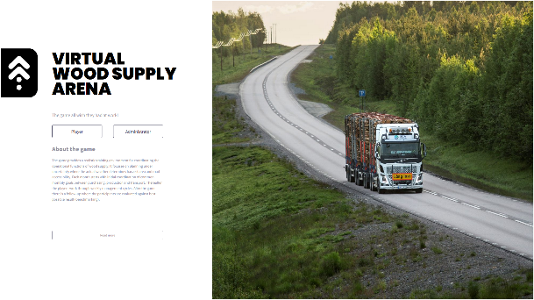
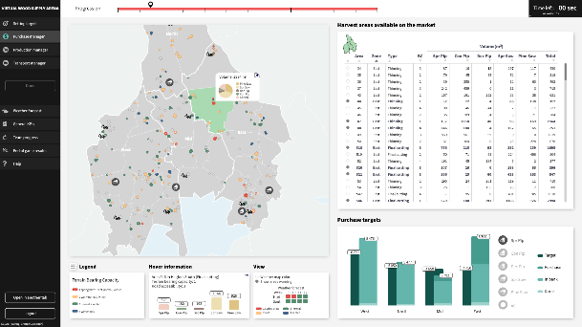

Figure 1. User log-in (left) and purchase manager interface (right)
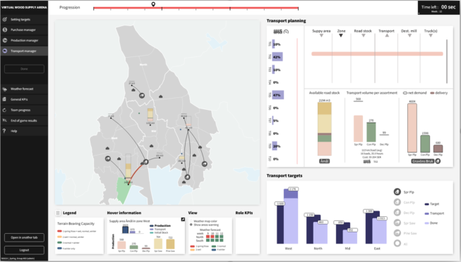
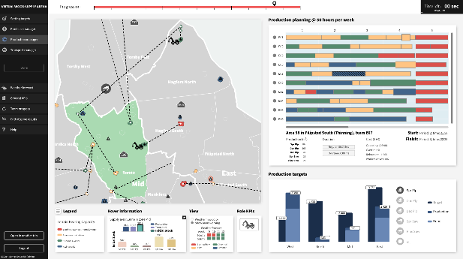

Figure 2. Production manager interface (left) and transport manager interface (right).

In the context of university training, the VWSA provides a high level of realism and accelerated experience-based learning. Participants respond to both typical and atypical weekly variation in the operating environment and learn effective geographical allocation of resources, as well as the adaptive management of road-side stocks to ensure secure deliveries, regardless of trafficability challenges.

The exercise is suitable for participants who have a basic understanding of production and transport management in CTL supply systems. A single training run requires 4-6 hours and is followed by a post-session analysis of team performance. The first prototypes were implemented in forestry training at SLU and Université Laval in 2022. A benchmarking function is under development so that competing teams can compare their performance to an optimal solution. The development of the VWSA was financed the Ljungbergs Foundation of Sweden. The development team includes SLU, FORAC/Université Laval, Skogforsk and Creative Optimization Sweden.

References

Abasian, F, Rönnqvist, M, Marier P, Fjeld D (2019). The Transportation Game. IRE Transactions on Education. 21. 10.1287/ited.2019.0223.
D’Amours, S, Marier, P, Rönnqvist, M, Azouzi, R, Fjeld, D (2017). The Online Wood Supply Game. INFORMS Transactions on Education. 18. 10.1287/ited.2017.0174.

