 |  |  |  | Vehicle Modification Assessment
Worker’s last name |  |  | First name |  |  |  |  |  | Middle initial | WorkSafeBC claim number
Mailing address |  |  |  |  |  |  | City/town |  |  |  | Province |  | Postal code
Telephone number (include area code) |  | Date of injury (yyyy-mm-dd) |  |  |  | Date of birth (yyyy-mm-dd) |  | Height (in./cm) |  |  |  | Weight (lb./kg)
Contact’s name |  |  |  |  |  |  |  |  | Telephone number (include area code)
Date of service (Date of assessment yyyy-mm-dd) |  |  |  |  | Assessment conducted by |  |  |  | Assessment conducted at
Nature of disability
Paraplegic | Level Complete Incomplete
Quadriplegic | Level Complete
Hemiplegic | Left Right
Amputee (describe)
Brain injury (describe)
Other (describe)
Comments

Current transportation
Client owns a vehicle  Yes No | Make |  | Model |  | Year
Client drives adapted vehicle  Yes No | Make |  | Model |  | Year
Client uses accessible public transportation service
Yes No
Type of adaptations on the current vehicle (check all equipment used)
Hand controls  Type  Steering modifications  Parking brake | Steering device  Type  Six-way seat base  Power ramp  Type (in-floor or foldout) | Left foot gas  Type  Remote starter  Wheelchair securement  Type  Manual ramp |  | Secondary Controls Type  Power/remote doors  Brake modification  Lowered floor
Wheelchair lift Type Age
Electronic assistive driving system Type
Other specialized adaptive equipment

Functional use of modified vehicle (How will the client use the vehicle?)
Who will be the principal driver(s)? (specify)

Is the vehicle modified to transport the client only (i.e., the passenger)?
Yes No
Is the client a driver or potential driver?  Yes No | If yes, specify
Has the client had an adapted driving assessment?  Yes No N/A | If yes, please confirm date.
Does the client have a valid driver’s license with appropriate restrictions for required adaptive equipment?  (re-licensing is required for adaptive equipment)  Yes No N/A | If yes, what licensing restrictions apply?  Specified vehicle modifications required (restriction 26)  Automatic transmission only (restriction 28)  Other
Additional comments:

Which location(s) in the vehicle needs to be modified to accommodate a wheelchair?
Driver Front passenger Main compartments Rear
Comments

Other considerations
Where will the vehicle be parked?
At home | Outside In garage Carport Parkade
At work | Outside In garage Carport Parkade
What is the height clearance of the garage or parkade doors?
At home |  | At work
What is the area available on the passenger side and rear of the vehicle for the worker to load or unload wheelchair?
At home | Passenger side Rear | At work | Passenger side Rear
What type of road and weather conditions does the client normally travel? (ground clearance is important for adapted vehicles)
Paved Gravel Combination Average kms driven per week:
Comments

Vehicle recommendations
Vehicle Type:
Minivan Full-size Van Truck SUV Other
Vehicle make | Model | Conversion | Year | Package/model
Vehicle specifications/options: requirements (check required items)
Automatic transmission | Rationale
Power driver’s seat (OEM) | Rationale
Power lift tailgate | Rationale
Remote start | Rationale
Block heater | Rationale
Leather seating | Rationale
Additional hands-free controls  (e.g., rain sensing wipers, auto-sensing head lamps) | Rationale
Electric park brake | Rationale
Power doors | Rationale
Push button start | Rationale
Tilt steering wheel | Rationale
Power door locks | Rationale
Power mirrors | Rationale
Other | Rationale
Comments

Vehicle modification requirements (check required items)
Conversion
Wheelchair lift | Specify type  Location  Driver Side Passenger Side Rear
Lift controls | Specify type  Wireless remote Dashboard Pendent
Lowered floor | Specify type
Wheelchair ramp | Location Side Rear  Type Fold-out In-Floor
Wheelchair securement | Specify location  Docking system Manual Retractable  Additional comments:
Interchangeable seat | Specify
Other | Specify
Comments

Vehicle/modification assessment (check required items)
Driver will be driving from | Seat Wheelchair Not applicable (passenger only)
Vehicle specification or option requirements (check required items)
Hand controls | Specify type  Location  Right Left Vertical
Steering device | Specify type and location
Torso support | Specify
Six-way power seat base | Specify
Parking brake | Specify  Manual adapter or Electric
Reduced effort steering | Percentage
Reduced effort braking | Percentage
Electronic assistive driving devices | Specify (list on separate sheet if necessary)
Secondary functions  (e.g., horn, wipers, etc.)  (list on separate sheet if necessary) | Functions required
Push button start
Gear shift extension
Left foot gas pedal
Gas guard
Brake guard
Battery maintainer
Seasonal considerations
Other
Comments
Summary and recommendations

Options requested by client (may not be covered by WorkSafeBC)
Vehicle None
Modifications None
WorkSafeBC wheelchair assessment
Wheelchair make | Model | Recliner/other | Foot rest (split/solid) | Assessment date (yyyy-mm-dd)
Measurements
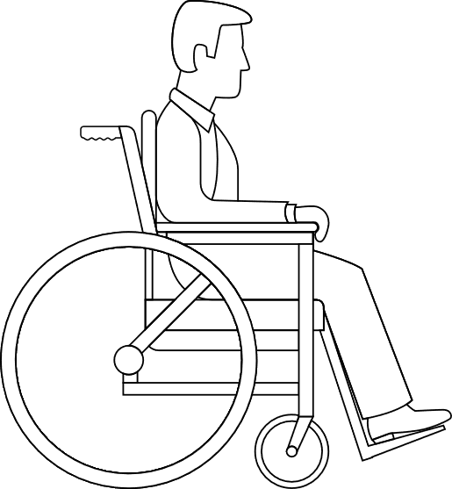 |  |  | Top of head to floor | Floor to top of push canes
 |  |  | Seat cushion to top of head | Back rest to front of knee
 |  |  | Eyes to floor
 |  |  | Top of arm rest to floor
 |  |  | Top of knees to floor
 |  |  | Top of cushion to floor
 |  |  | Top of toes to floor |  | Lowest point of heels to floor
 |  |  |  |  | 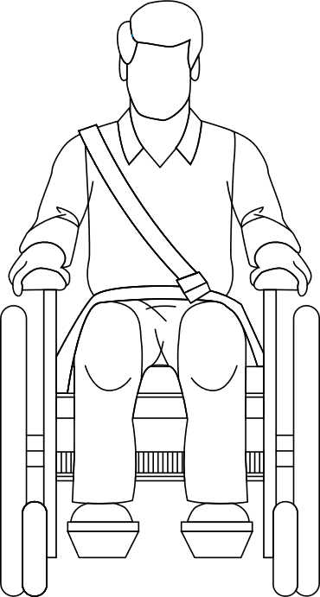
Back of rear wheel to end of toe | Centre of castor to toes
Wheelchair frame tubing diameter |  |  | Widest point at arm rest
 |  |  | Widest point at foot rest
 |  |  | Widest point at rear wheels
WorkSafeBC power wheelchair assessment
Wheelchair make |  |  |  |  | Model |  |  |  |  | Assessment date (yyyy-mm-dd)
Tilt | Recline |  |  |  |  | Foot rest (split/solid) |  |  |  | Year
Measurements
Caution: If wheelchair has tilt/recline, please ensure that wheelchair is in its fullest upright position when taking measurements.
Eyes to floor |  | 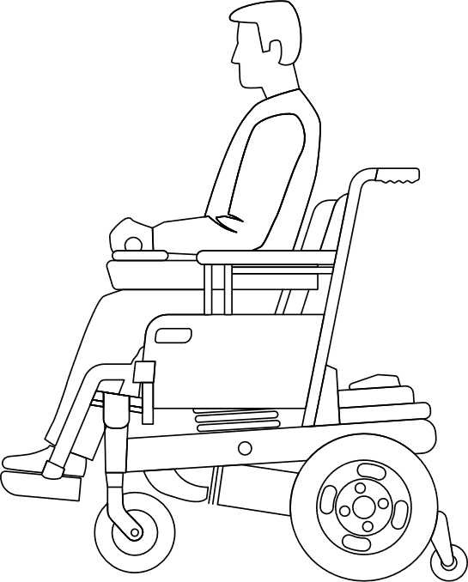 |  |  |  |  |  |  | Top of head to floor
 |  |  |  |  |  |  |  |  | Chest to end of joystick or steering wheel
Top of joystick to floor |  |  |  |  |  |  |  |  | Top of arm rest to floor
Top of knees to floor |  |  |  |  |  |  |  |  | Top of cushion to floor
 |  |  |  |  |  |  |  |  | Top of seat to floor
Top of foot

Lowest point of foot rest |  |  |  |  |  |  |  |  | Anti-tip clearance
 |  | Wheel diameter |  |  |  |  | Wheel diameter
 |  |  | Tip of toes to back of anti-tippers

Width of rear wheels at widest point | Width of front wheels at widest point
Widest point at arm rest | Widest point at foot rest
Turning radius | Length in fully tilted position
Length in fully reclined position | Length with legs and back slightly reclined or tilted
Wheelchair concerns
Is this the worker’s permanent wheelchair and cushion that will be used to access the vehicle? (explain)
Yes No
Provider information
Provider’s or business name | Provider’s phone number (include area code)
Name of community occupational therapist | Provider’s fax number (include area code)
Or
WorkSafeBC Occupational Therapy Clinical Advisor (for internal use only)
Name of occupational therapist | Occupational therapist’s phone number (include area code)

I declare that the above information is true and correct to the best of my knowledge.
Signature | Date (yyyy-mm-dd)

Claims Call Centre  Phone 604.231.8888  Toll-free 1.888.967.5377  M–F, 8 a.m. to 6 p.m. | Fax  604.233.9777  Toll-free 1.888.922.8807 | Mail  WorkSafeBC  PO Box 4700 Stn Terminal  Vancouver BC V6B 1J1
WorkSafeBC collects information on this form for the purposes of administering and enforcing the Workers Compensation Act. That Act, along with the Freedom of Information and Protection of Privacy Act, constitutes the authority to collect such information. To learn more about the collection of personal information, contact WorkSafeBC’s FIPP Office, at PO Box 2310 Stn Terminal, Vancouver BC, V6B 3W5, or email FIPP@worksafebc.com, or call 604.279.8171.

