Conversion Fidelity Test: All Formatting Features
Test Dataset | 2026-04-03 | Formatting Verification
Test Author | 2026-04-03
Analysis Confidence: B+ (85/100)
Treat as directional — test data only.

Context
This document tests every formatting feature used by gdoc_builder.build_readout(). Upload it to Google Drive with convert_to_google_doc=True and check each feature against the manual test checklist in the script header.

Summary

Primary Learnings
- Bold labels are auto-detected — The builder detects known label prefixes and applies bold styling automatically. >> See Finding 1
- Bookmark links connect Summary to Analysis — The >> links in Primary Learnings should jump to the corresponding Finding heading. >> See Finding 2
- Missing chart shows placeholder — When a chart path doesn't exist, a placeholder message appears. >> See Finding 3

Recommendations
- Verify heading hierarchy in doc outline — H1-H4 should appear in the Google Doc outline sidebar. Confidence: High.
- Check bookmark link navigation — >> links should jump to the correct finding. Confidence: Medium.
- Verify SQL formatting survives — Gray background and monospace font should persist. Confidence: Low.

Analysis

Finding 1: Bold labels are auto-detected
[1.2M rows | Jan-Mar 2026 | CHECKOUT_EVENTS | Confidence: B+ (85/100)]
The builder detects known label prefixes and applies bold styling automatically.

Sub-finding with chart
The Insight: This paragraph starts with a known bold label prefix. The label should be bold, the rest regular weight.
Why this matters for product: Another bold label test. If this renders with just the label bold, the detection works.
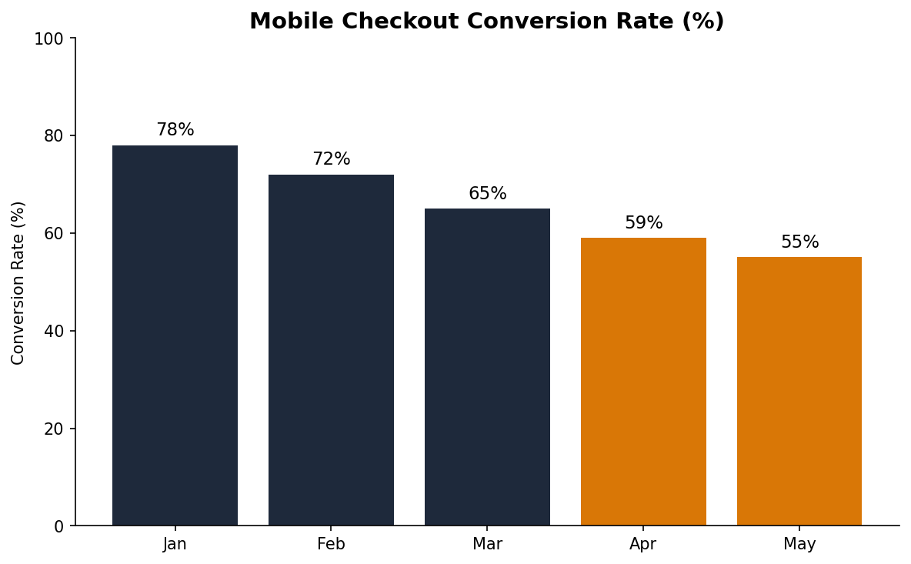
Figure 1: Mobile Checkout Conversion Rate by Month.

Sub-finding without chart
Bottom line: This tests a third bold label. The text after the colon should be regular weight.
This paragraph has no bold label — it should render entirely in regular weight body text.

Methodology & SQL
Approach: segmented comparison of mobile vs desktop checkout funnels. Aggregation: COUNT DISTINCT user_id by step and device. Filters: date >= '2026-01-01', status IN ('completed', 'abandoned'). Date handling: monthly granularity, UTC.
SELECT
device_type,
step_name,
COUNT(DISTINCT user_id) AS users
FROM checkout_events
WHERE event_date >= '2026-01-01'
AND status IN ('completed', 'abandoned')
GROUP BY device_type, step_name
ORDER BY device_type, step_name
Cross-verification: Type B: Parts-to-whole — PASS (Within 0.30% tolerance)

Finding 2: Bookmark links connect Summary to Analysis
[340K rows | Jan-Mar 2026 | FUNNEL_EVENTS | Confidence: B+ (85/100)]
The >> links in Primary Learnings should jump to the corresponding Finding heading.

Link target verification
If you clicked '>> See Finding 2' in the Summary section, you should have landed here. This tests internal bookmark navigation.

Methodology & SQL
Approach: bookmark navigation verification. No SQL required.
Cross-verification: Type A: Boundary check — PASS (3 checks passed)

Finding 3: Missing chart shows placeholder
When a chart path doesn't exist, a placeholder message appears.

Missing chart test
This sub-finding references a chart that does not exist.
[Chart: missing_chart.png — file not found]

Synthesis
All formatting features should render correctly in the converted Google Doc. Any feature that does not survive conversion should be documented in the test results.
This analysis carries B+ confidence (85/100). Treat as directional — test data only.

Implications
Features that do not survive .docx-to-Google-Docs conversion will need alternative approaches (text references instead of hyperlinks, plain code blocks instead of shaded cells, etc.).

Next Steps

Recommended Actions
1. Upload this .docx to Google Drive
2. Open as Google Doc
3. Check each item in the manual test checklist

Success Tracking
Metric: Formatting features surviving conversion
Baseline: Unknown
Target: All 14 features pass
Check-in: After first upload test

Open Questions
Do python-docx bookmarks survive .docx → Google Docs conversion?
Does gray table cell shading survive conversion?
Do page breaks become section breaks or just spacing?

Resources

Additional Queries

Query 1: Sample Funnel Query
Used in: Finding 1
Database: novamart.funnel_events
SELECT
step_name,
COUNT(DISTINCT user_id) AS users,
ROUND(
COUNT(DISTINCT user_id) * 100.0
/ FIRST_VALUE(COUNT(DISTINCT user_id))
OVER (ORDER BY step_order),
1
) AS pct_of_start
FROM funnel_events
WHERE event_date >= '2026-01-01'
GROUP BY step_name, step_order
ORDER BY step_order;

Companion Analyses
- Previous checkout analysis (Dec 2025)
- Mobile UX audit report

Data Sources
NovaMart production database. Tables: checkout_events, funnel_events. Date range: Jan 1 - Mar 31, 2026. 1.2M sessions, 340K unique users.

