Vehicle Selector Pro
A Production-Grade Shopify App for Vehicle Fitment
CLIENT DELIVERABLE
Project Report / August 2026
Vehicle Selector Pro is a complete Ruby on Rails application that lets Shopify merchants map vehicle attributes (Year, Make, Model, Trim, Engine) to their products and gives customers a dynamic, cascading fitment widget on the storefront. It ships as a production-grade Rails app with a normalized local data cache, Shopify Metafield sync, a Theme App Extension widget, App Proxy endpoints, GraphQL data integration, and asynchronous processing via ActiveJob and Sidekiq — engineered from the start for the Shopify App Store.

1. Executive Summary
Vehicle Selector Pro is a complete Ruby on Rails application that lets Shopify merchants map vehicle attributes (Year, Make, Model, Trim, Engine) to their products and gives customers a dynamic, cascading fitment widget on the storefront. It ships as a production-grade Rails app with a normalized local data cache, Shopify Metafield sync, a Theme App Extension widget, App Proxy endpoints, GraphQL data integration, and asynchronous processing via ActiveJob and Sidekiq — engineered from the start for the Shopify App Store.

Four pillars that make it production-grade
- Normalized local cache — Fitments live in structured ActiveRecord tables (48 YMMTE configurations, 318 verified fitments, 54 products, 25 brands in the demo), so filtering is instant and never pounds Shopify's API.
- Shopify Metafield sync — Fitment data is written to the custom.vehicle_fitment product metafield via the GraphQL metafieldsSet mutation, batched to stay inside API limits, so product pages render their own fitment badge.
- Cascading storefront widget — Year → Make → Model → Trim → Engine menus narrow the catalog behind an HMAC-signed App Proxy, returning only parts that fit the selected vehicle.
- Async background jobs — Webhooks and syncs run on Sidekiq + Redis with exponential backoff and per-topic policies, so a traffic spike never blocks the request path.

2. The Problem
Selling aftermarket parts is uniquely hard online. A brake pad or a wiper blade is not universally compatible: it depends on the exact Year, Make, Model, Trim and Engine (YMMTE) of the customer's vehicle. Getting this wrong means wrong parts, angry customers, and expensive returns. Merchants who can't afford a commercial fitment database either stop listing the data, drown shoppers in dense compatibility tables, or hard-code rules into individual product pages where they quickly rot and cost hours to maintain.

3. The Solution at a Glance
Vehicle Selector Pro turns fitment from a per-product chore into a single, structured, reusable dataset. Fitments are entered once, stored in a normalized multi-tenant cache, and pushed to Shopify metafields — so the storefront, the product pages, and the merchant admin all stay in sync without ongoing per-part fees or brittle scripts.

Normalized local cache
Fitments live in structured ActiveRecord tables (48 YMMTE configurations, 318 verified fitments, 54 products, 25 brands in the demo), so filtering is instant and never pounds Shopify's API.

Shopify Metafield sync
Fitment data is written to the custom.vehicle_fitment product metafield via the GraphQL metafieldsSet mutation, batched to stay inside API limits, so product pages render their own fitment badge.

Cascading storefront widget
Year → Make → Model → Trim → Engine menus narrow the catalog behind an HMAC-signed App Proxy, returning only parts that fit the selected vehicle.

Async, resilient background jobs
Webhooks and syncs run on Sidekiq + Redis with exponential backoff and per-topic policies, so a traffic spike never blocks the request path.

4. Feature Highlights

1. Cascading storefront widget
Cascading dropdowns over HMAC-signed App Proxy data — Year, Make, Model, Trim, Engine dropdowns driven by HMAC-SHA256-signed App Proxy queries. Each selection returns only the options that actually exist, progressively narrowing the catalog until the customer reaches parts that fit their vehicle.

2. Product fitment badges
Instant compatibility clarity on the product page — Every product dynamically renders a Guaranteed Exact Fit / Does NOT Fit / Universal Fit badge, so a shopper knows compatibility at a glance instead of reading a table or guessing.

3. My Garage
Saved vehicles that follow the shopper — Shoppers save multiple vehicles and switch between them across pages via browser-local storage — a retention feature that turns repeat-fitment shoppers into returning customers.

4. Merchant admin dashboard
Manage every fitment from one place — A Polaris-styled command center: fitment matrix, vehicle library, bulk CSV import, sync monitor, and widget settings — all read from the normalized local database for fast, debuggable queries instead of live Shopify round-trips.

5. Metafield sync
Reliable, observable writes to Shopify — Fitment JSON is written to custom.vehicle_fitment via GraphQL metafieldsSet in batches of 25, with a per-shop sync log and progress tracking so merchants see exactly what synced and what failed.

6. Webhook pipeline
Shopify events processed asynchronously and securely — products/*, app/uninstalled and shop/update events are HMAC-verified, then dispatched to Sidekiq jobs that keep the cache and tenant state correct — including graceful cleanup on uninstall and full GDPR data-erasure handlers.

7. Multi-tenant isolation
Per-shop isolation and encrypted tokens — Every query is scoped to the authenticated shop; OAuth tokens are encrypted at rest; and App Proxy / webhook traffic is verified with constant-time HMAC comparison.

8. Rate limiting & hardening
Protected against abuse and injection — rack-attack throttles the App Proxy and public surface; payloads and signatures are validated; CSP frame-ancestors restrict embedding to myshopify.com.

5. Architecture
The system is a classic three-layer architecture. The Shopify storefront renders the Theme App Extension widget, which talks to the Rails application over signed App Proxy endpoints. The Rails app exposes admin controllers (Polaris UI), webhook endpoints, and App Proxy endpoints, all backed by a normalized PostgreSQL cache. Background Sidekiq jobs perform long-running work — metafield sync and webhook processing — exchanging data with Shopify's GraphQL Admin API. Redis provides the job queue and shared cache.
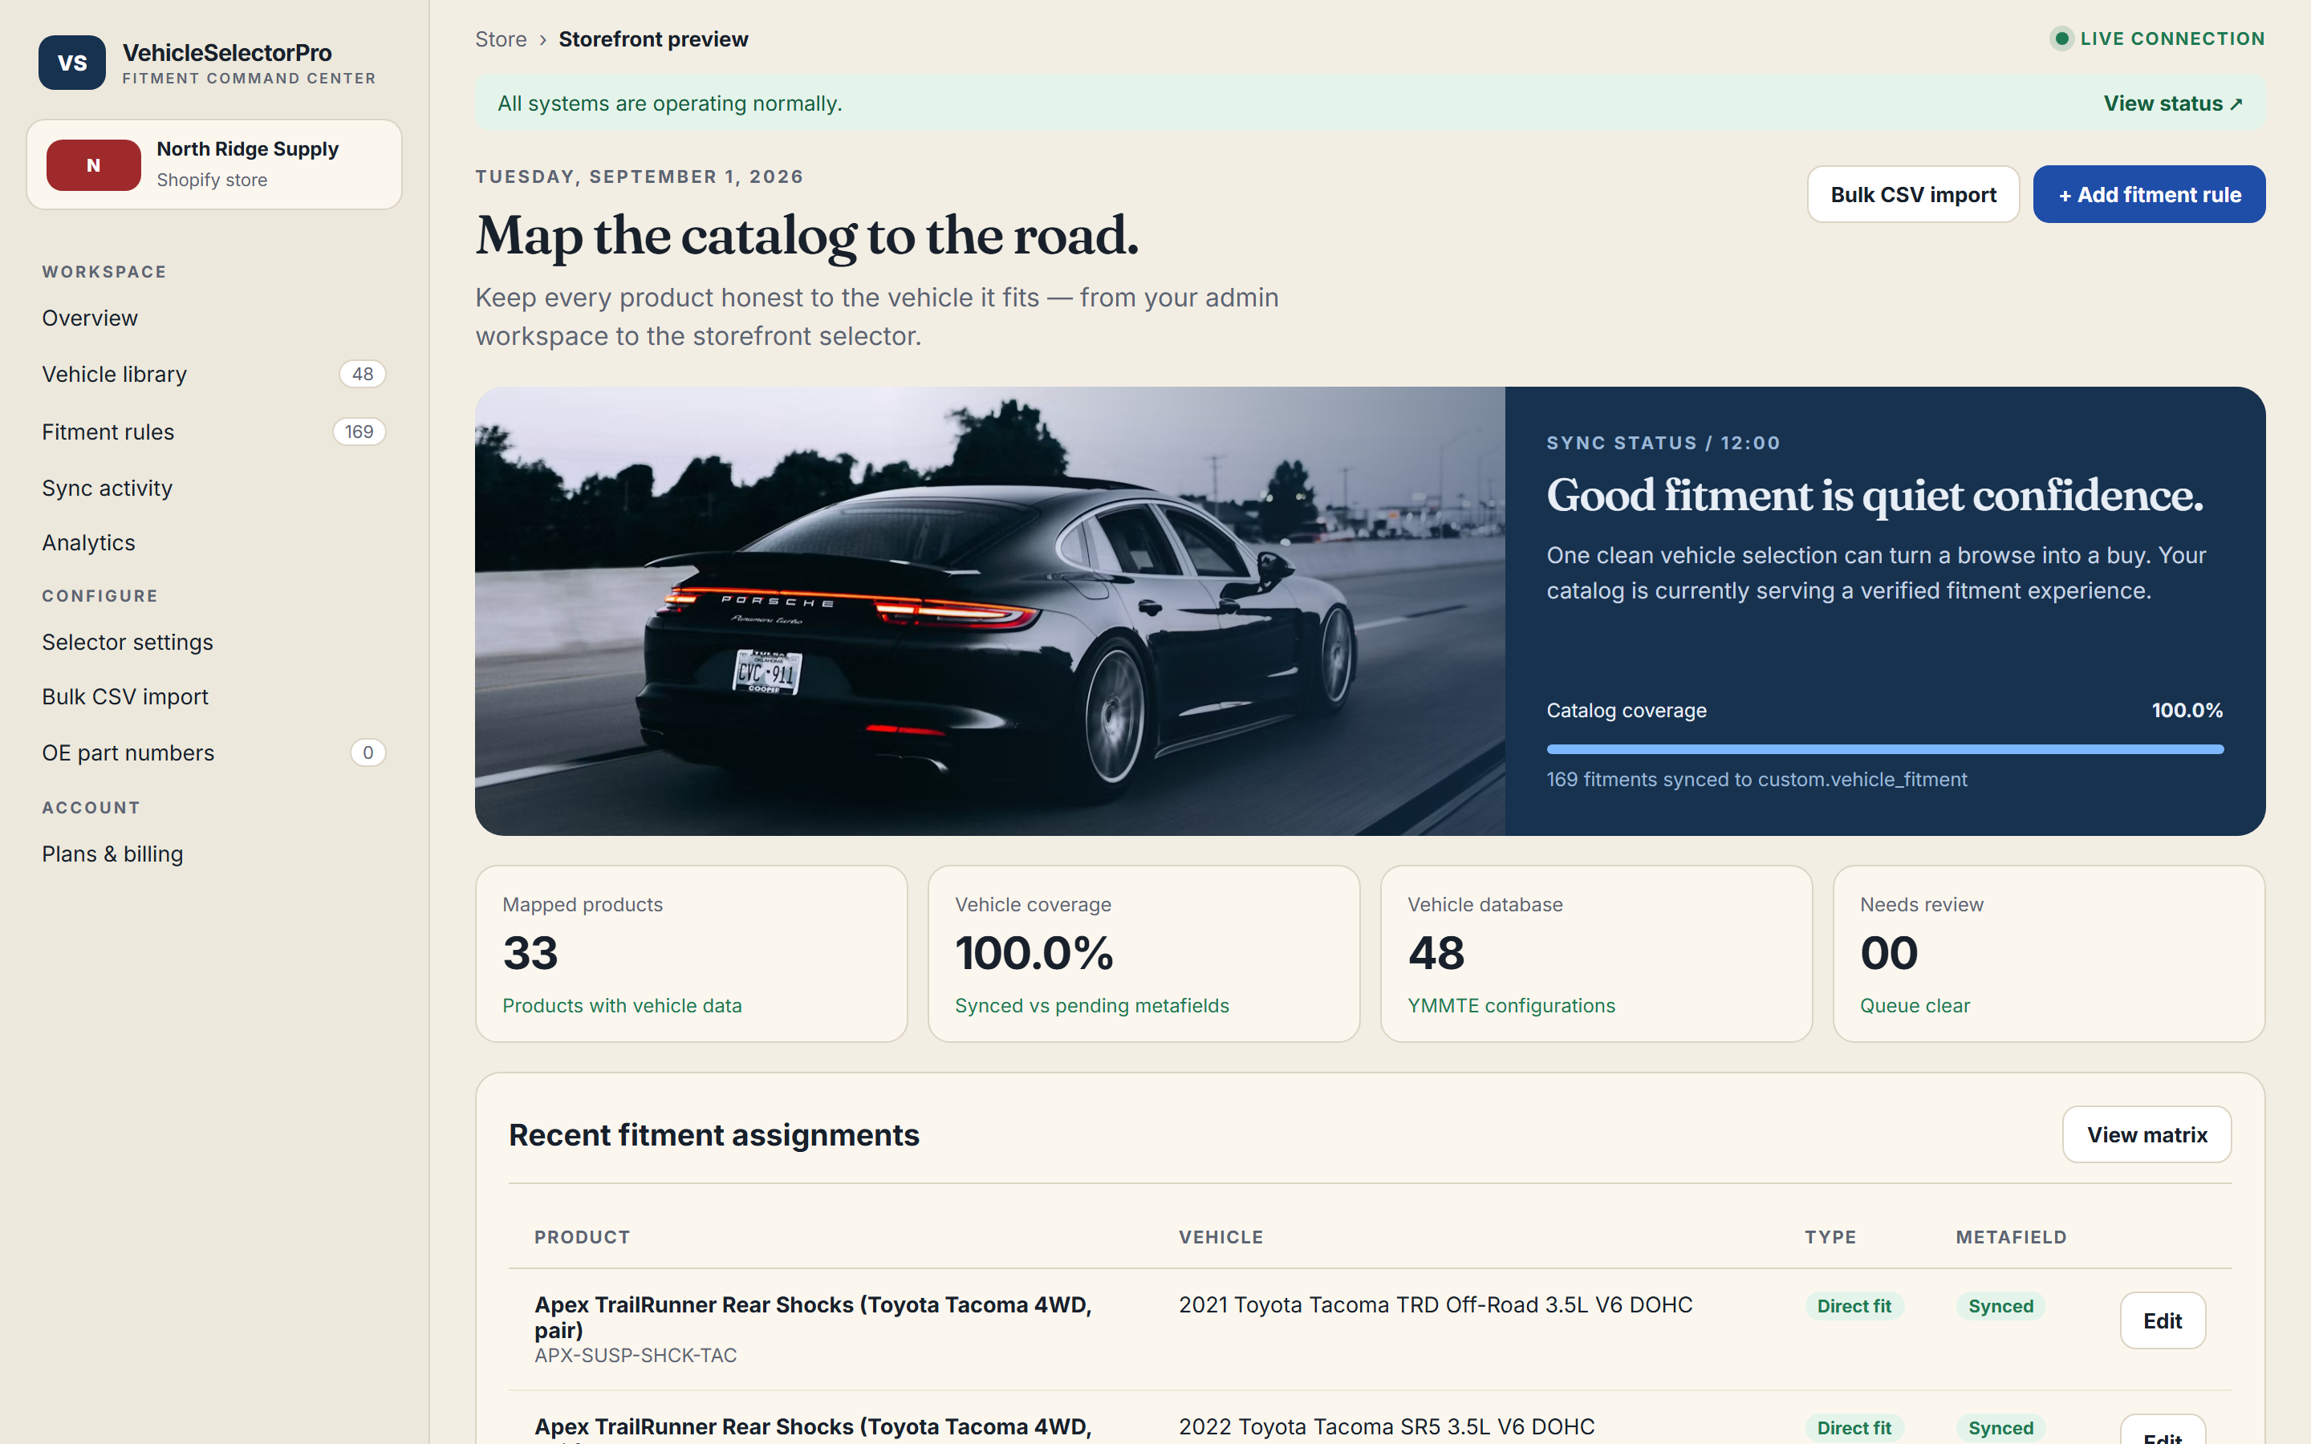
Admin dashboard — the merchant command center

6. Data Model & Multi-tenancy

Shop
The tenant: Shopify domain, encrypted OAuth token, granted scopes, active flag, and GDPR timestamps.

Vehicle
Normalized YMMTE row (year, make, model, trim, engine) plus drivetrain, body style, and transmission.

VehicleProductFitment
The join that says 'this product fits this vehicle', with fitment type, notes, position, and a synced-to-metafield flag.

AppSetting
Per-shop widget theming and behavior (labels, colors, which toggles are enabled).

MetafieldSyncLog
Audit trail of full and per-product syncs with status, counts, and error details.

7. Key Workflows

OAuth install
A merchant clicks the install link. shopify_app exchanges the code for an offline access token, stores the shop (encrypted), registers the webhooks, and admits the merchant to the Polaris dashboard — all through the standard shopify_app 22 flow.

Fitment selection
A shopper picks Year → Make → Model → Trim → Engine. Each request hits an App Proxy endpoint that verifies the HMAC signature, then queries the local cache to return only matching options.

Metafield sync
When fitments are saved, a BatchSyncJob builds a compact JSON payload per product and writes it via metafieldsSet in batches of 25, updating the sync log as it goes.

Webhook handling
Shopify posts product events. The controller verifies the HMAC, enqueues a Sidekiq job, and returns 200 immediately; the job updates cache rows or cleans up after deletes/uninstalls.

8. Technology Stack
Layer | Stack
Language / runtime | Ruby 3.2 · Rails 7.1
Shopify integration | shopify_app 22 · shopify_api 14 · GraphQL Admin API
Database | PostgreSQL (production) · SQLite3 (dev/test)
Queuing | Sidekiq 7 + Redis 5 (ActiveJob)
UI styling | Polaris View Components · ERB
API & serialization | Oj + ActiveModelSerializers
Caching | Cache-aware queries · stale-while-revalidate on Proxy responses
Testing | RSpec 7 · FactoryBot · WebMock · SimpleCov
Code quality | RuboCop (Rails/RSpec cops) · Bullet (N+1 detection)
Security & hardening | rack-attack · HMAC signature checks · encrypted tokens
Hosting | Fly.io (auto-deploy via GitHub Actions)
CI/CD | GitHub Actions — CI on push · Fly deploy · GitHub Pages report

9. Security & Hardening
- OAuth 2.0 install with an offline access token, stored encrypted via Rails Active Record encryption.
- App Proxy requests verified with HMAC-SHA256 using constant-time comparison; synthetic params excluded.
- Webhook payloads verified against X-Shopify-Hmac-Sha256; unknown or inactive shops are dropped and logged.
- Every admin query scoped to the session's shop; shop identity is derived only from the verified session, never from request params.
- rack-attack throttling on the App Proxy and public endpoints.
- Content Security Policy frame-ancestors restricted to myshopify.com and admin.shopify.com.
- GDPR coverage: customers/data_request, customers/redact, shop/redact handlers plus an explicit public privacy policy.

10. Quality Engineering
- 49 passing RSpec examples across models, services, request specs, and jobs.
- Webhook HMAC verification and App Proxy signature handling are exercised in request specs.
- Metafield sync payload generation is unit-tested (ownerId, namespace, key, JSON value shape).
- RuboCop with Rails & RSpec cops is clean across 90 files.
- CI on every push: full RSpec suite, RuboCop, and a Zeitwerk eager-load check — then auto-deploy to Fly.io on green.

11. Live Demo Catalog & Screenshots
48 | YMMTE configurations
204 | verified fitments
40 | mapped products
8 | brands represented

Real screenshots of the running app

Admin dashboard — the merchant command center
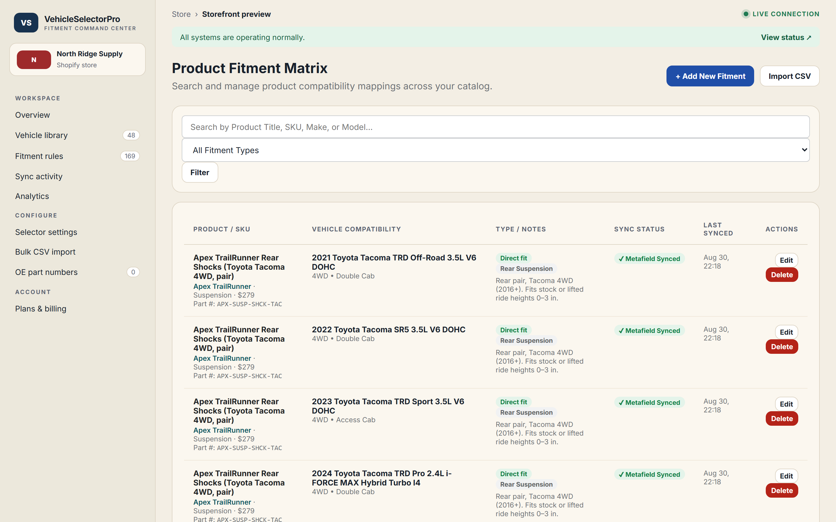
Fitment matrix — every product × vehicle rule in one view
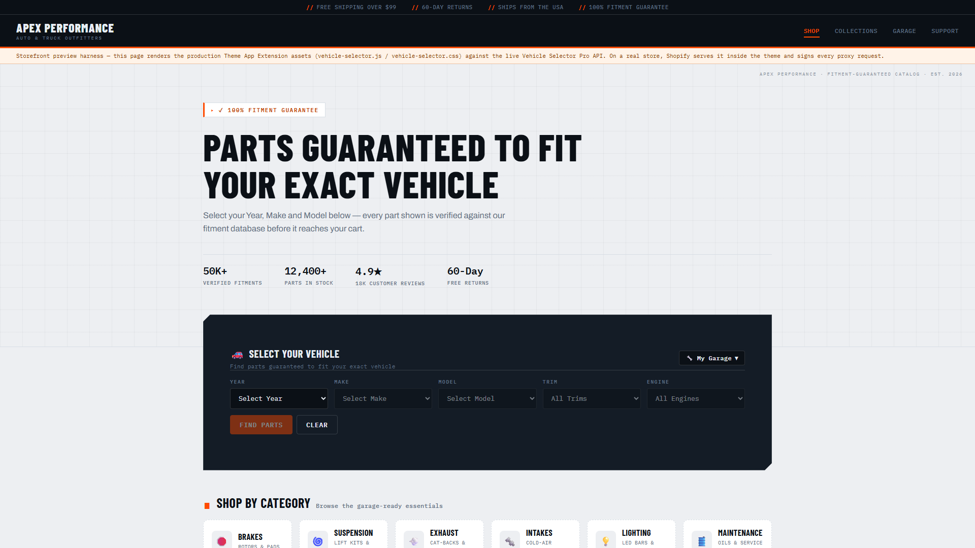
Storefront home — cascading vehicle selector widget
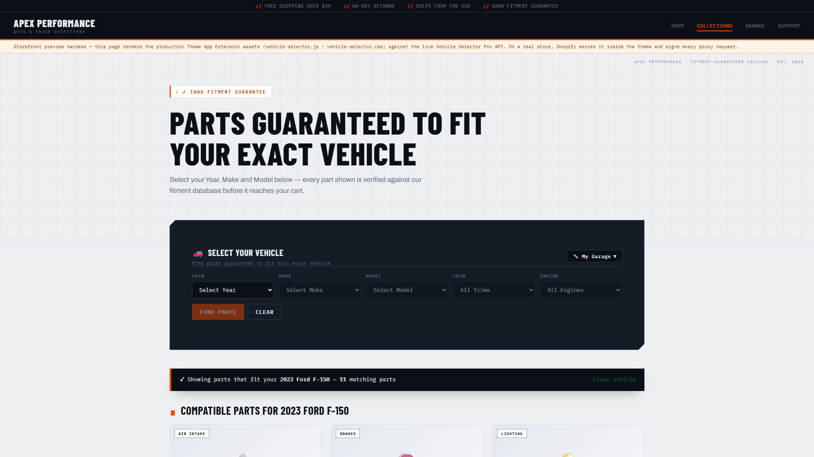
Filtered results — parts matching a 2023 Ford F-150
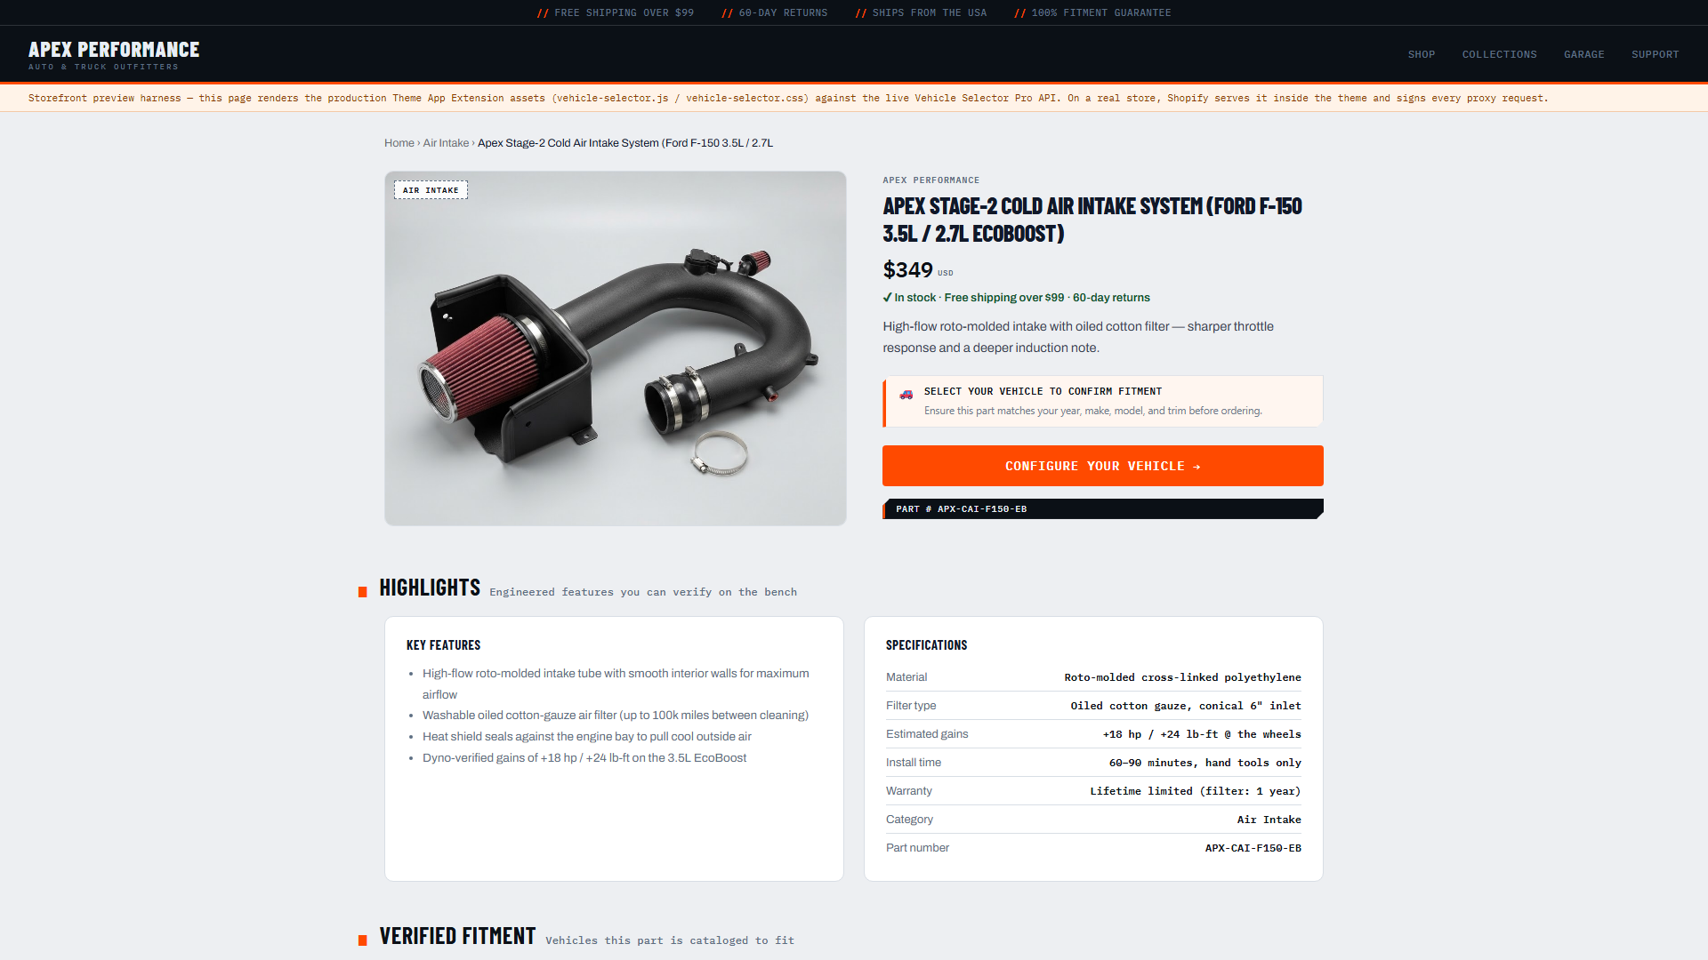
Product detail — spec sheet and live fitment badge
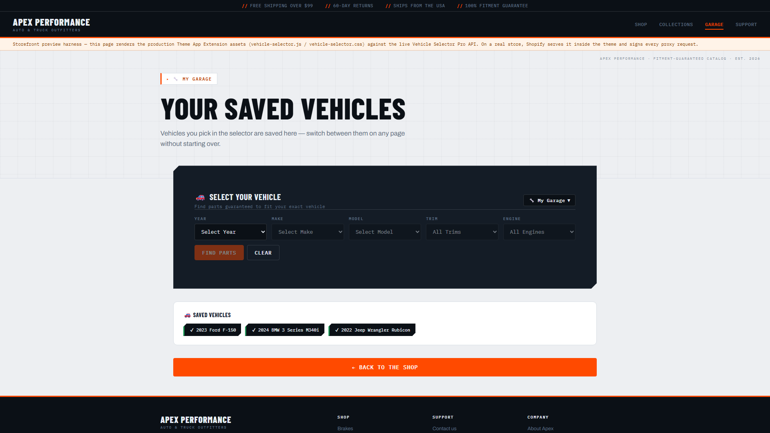
My Garage — saved vehicles shoppers can switch between
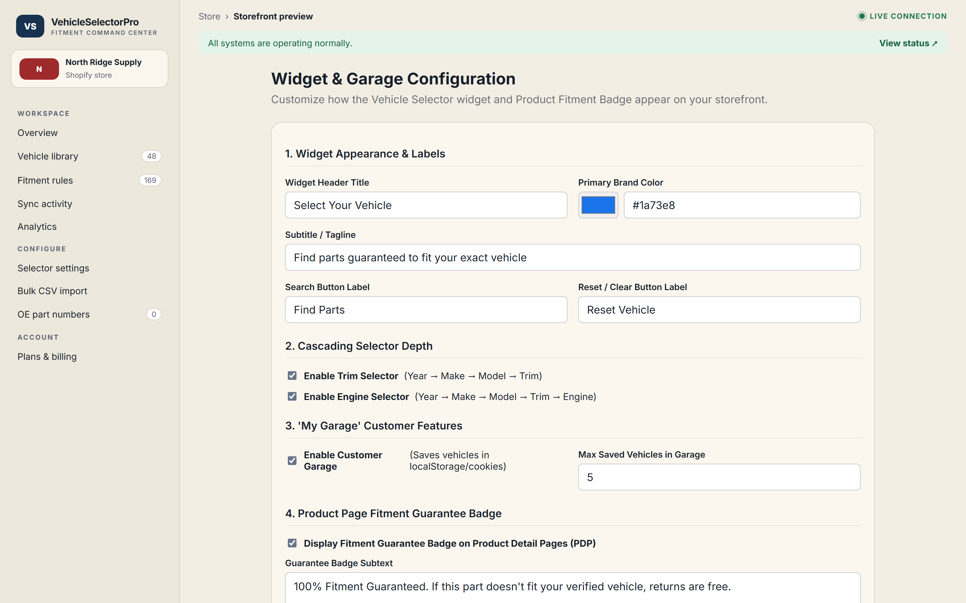
Widget settings — labels, colors, toggles
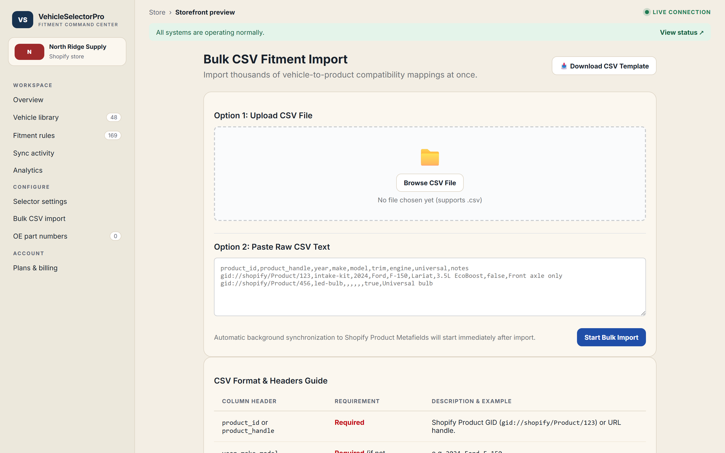
Bulk import — CSV fitment loader
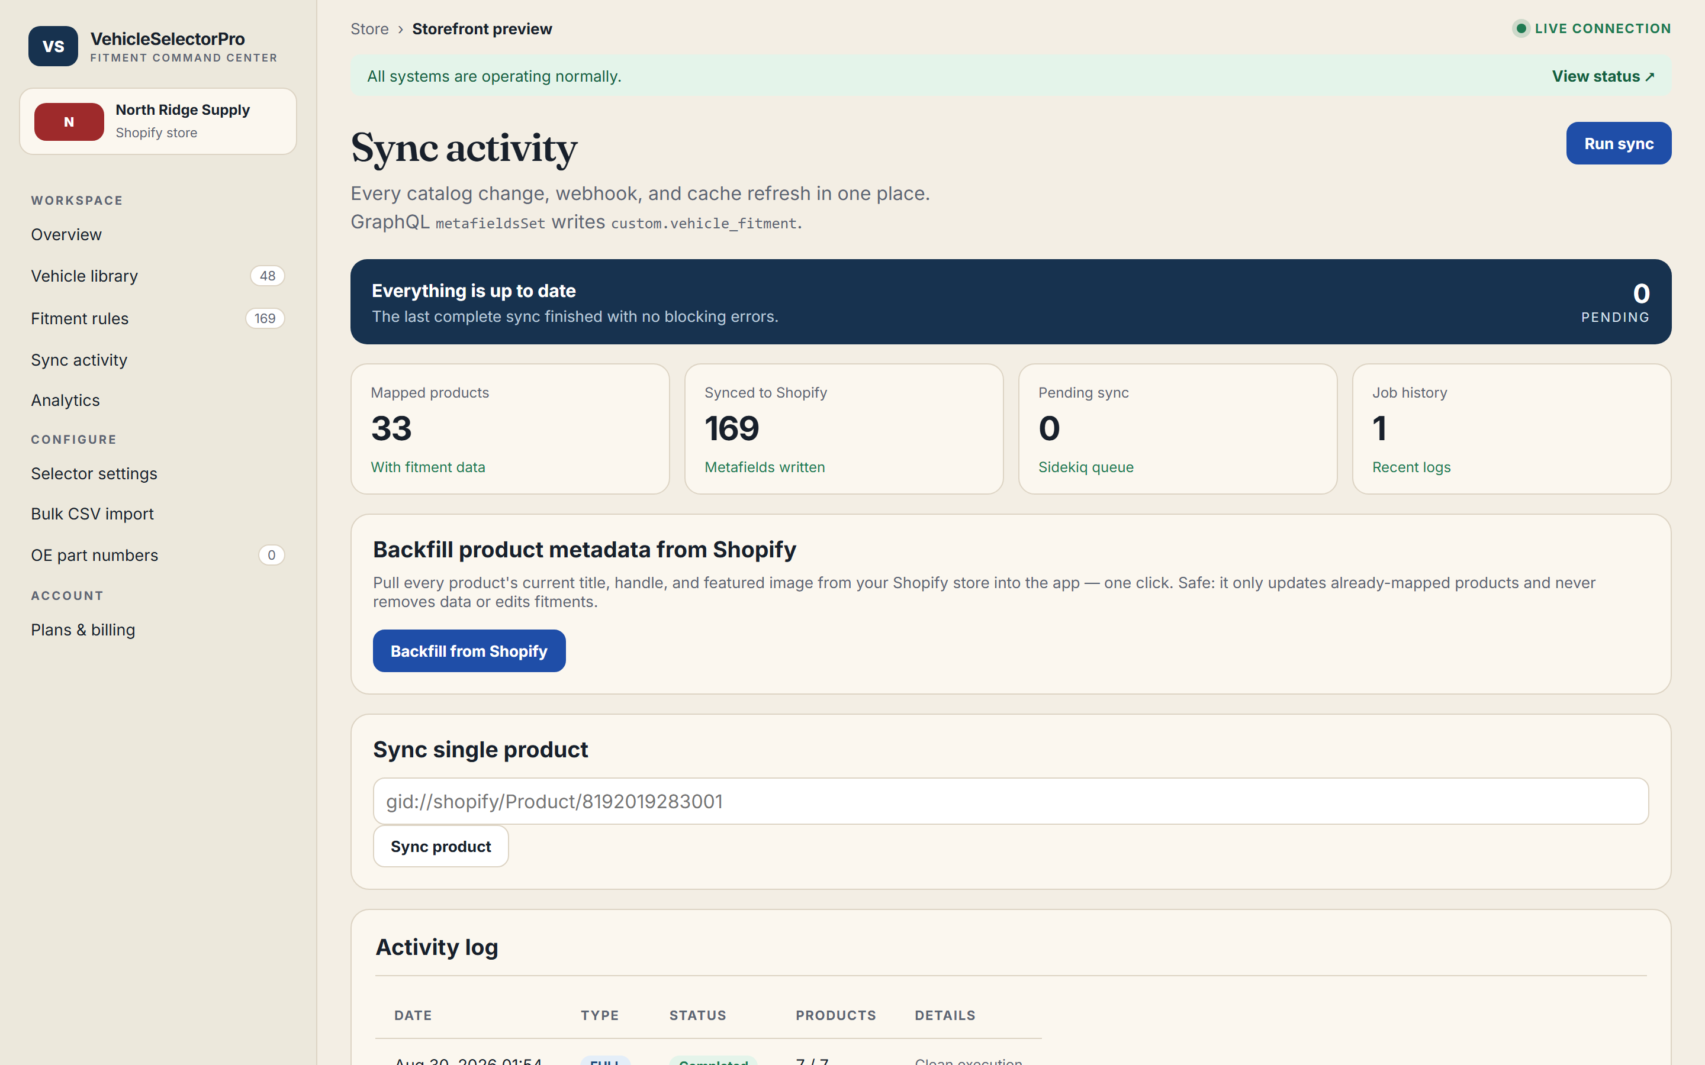
Sync monitor — metafield sync progress
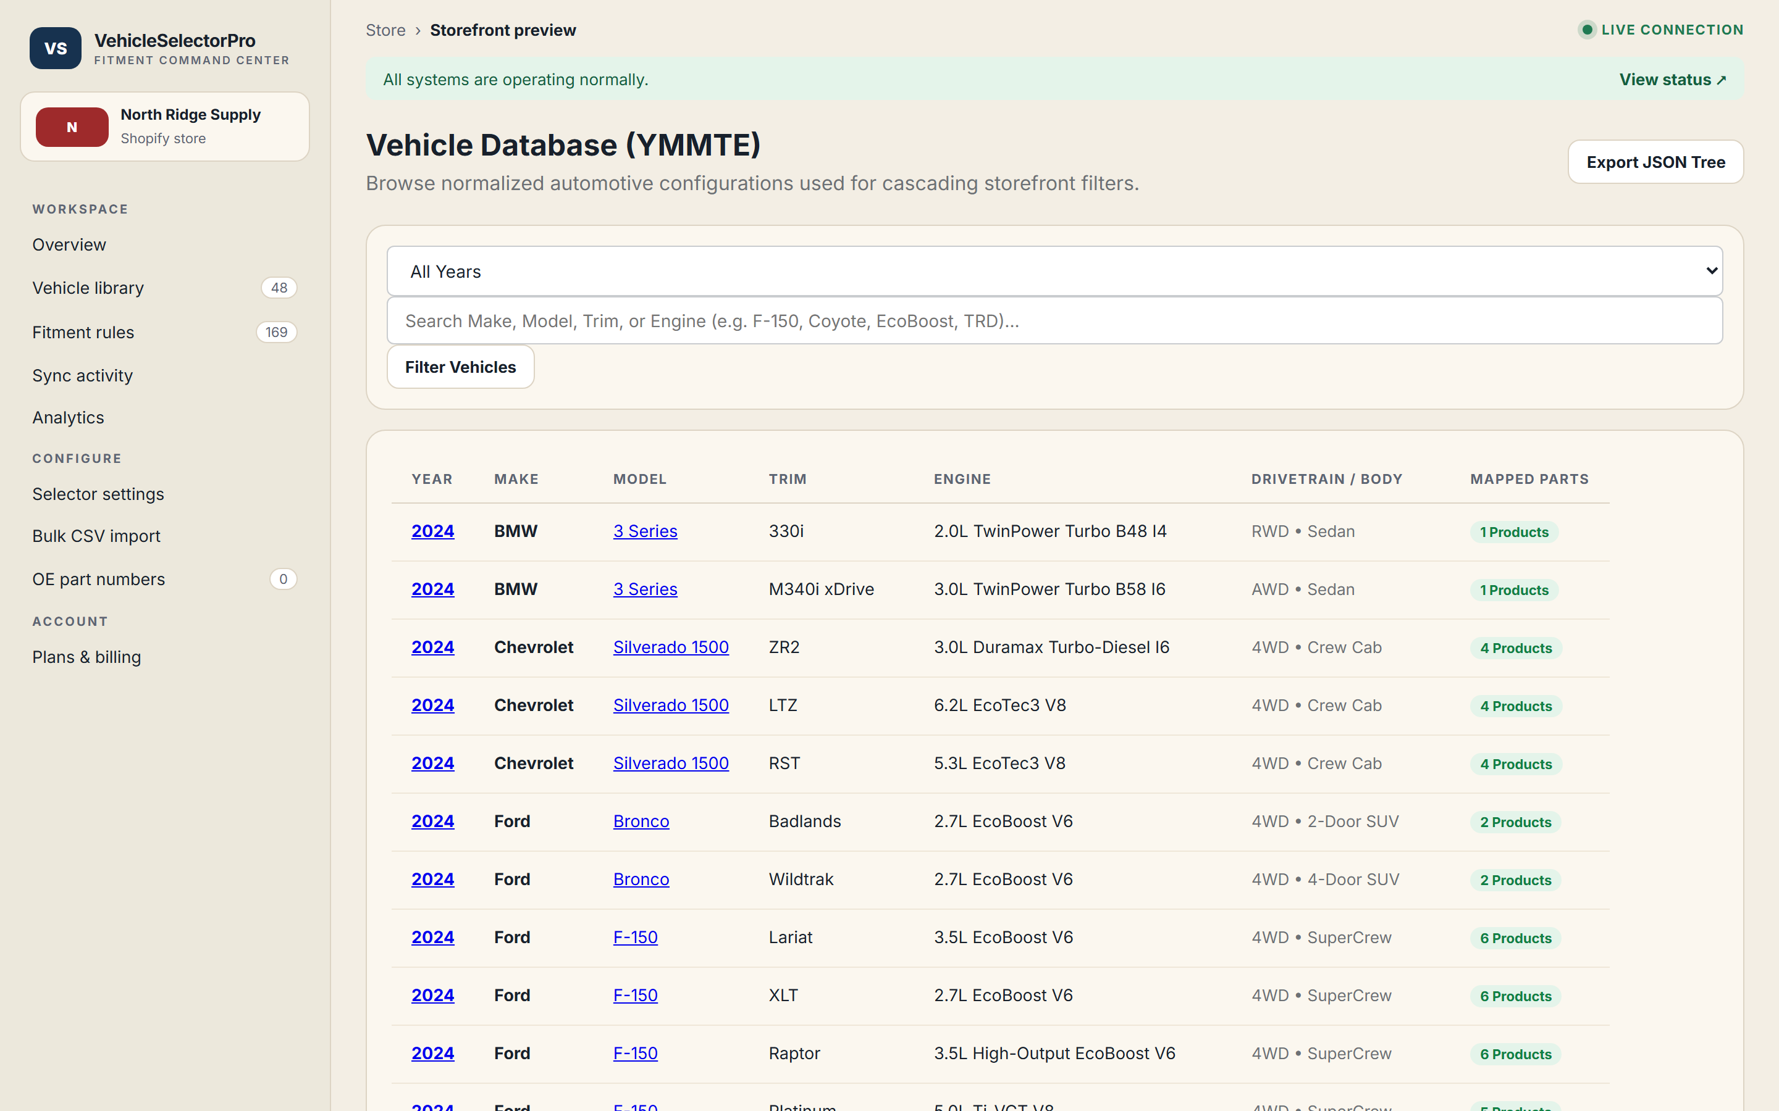
Vehicle library — the YMMTE catalogue
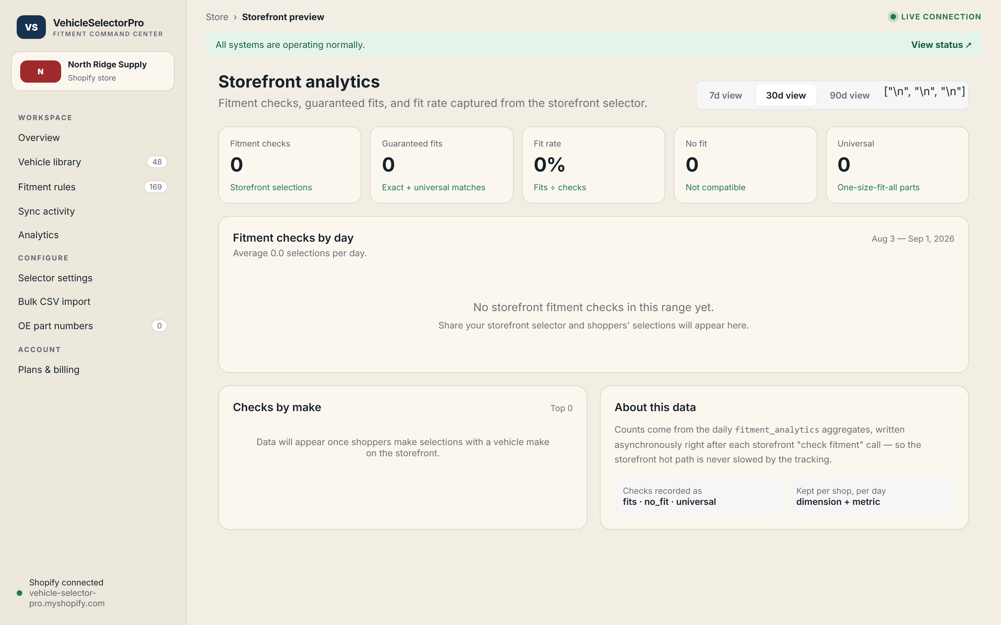
Analytics dashboard — checks, fit rate, per-make breakdown
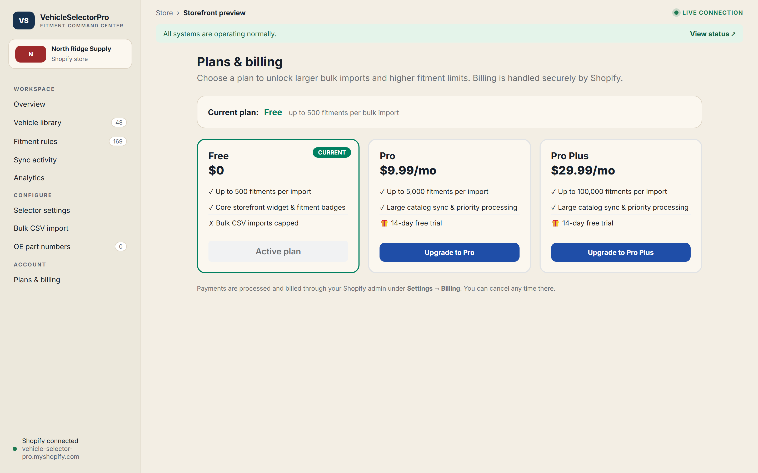
Plans & billing — Free / Pro / Pro Plus tiers with demo walkthrough
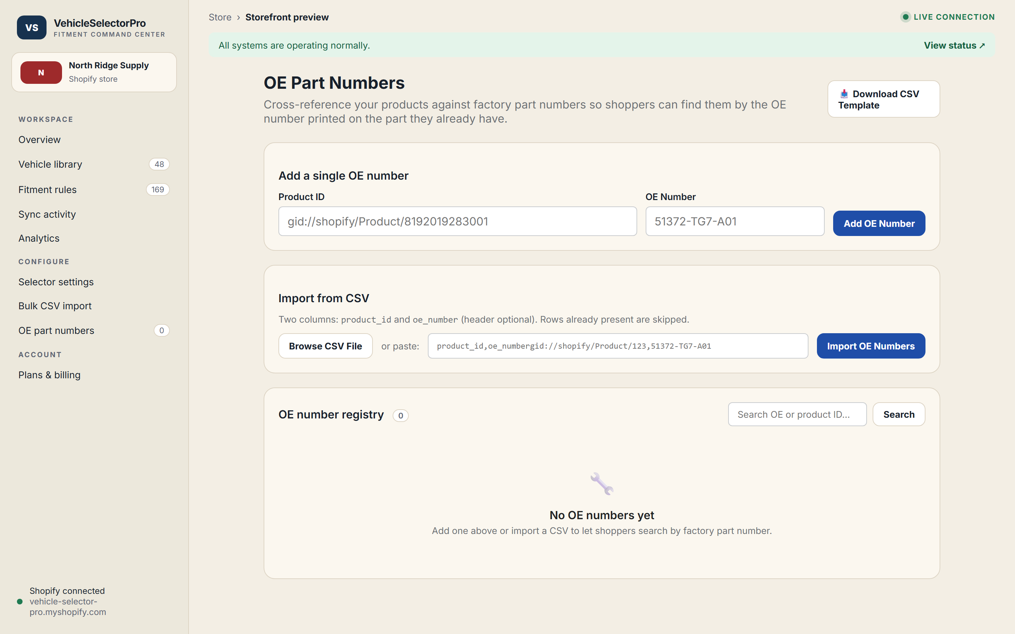
OE part-number manager — the cross-reference engine

Narrated demo videos
Merchant command center: https://ai-dev-2024.github.io/vehicle-selector-pro/demo/vehicle-selector-pro-merchant.mp4
Shopper experience: https://ai-dev-2024.github.io/vehicle-selector-pro/demo/vehicle-selector-pro-shopper.mp4

12. Deployment & Operations
CI + auto-deploy to Fly.io; Sidekiq on private Redis; PostgreSQL cache; GitHub Pages hosts this report and the live demo runs on Fly.io.
- CI: RSpec + RuboCop + Zeitwerk check on every push.
- Auto-deploy to Fly.io on green CI (drain-aware, zero-downtime Puma).
- Sidekiq on a private Redis instance; PostgreSQL for the normalized cache.
- Health endpoint (/up) for the load balancer and container orchestration.
- GitHub Pages hosts this client report automatically on every push.

13. Roadmap
Every item below sits beyond the original spec's requirement — it is an optional growth path, not part of the agreed scope.
- Full billing rollout — flip SHOPIFY_BILLING_TEST=false on a production Partner app and complete App Store listing approval (the only non-code step left).
- Supersession chains — a richer part-catalog engine on top of the shipped OE-number cross-reference.
- Deeper analytics — per make+model and per-product rollups, conversion lift and drop-off reports on top of the shipped daily aggregates.
- White-label storefront theming, translation support, and deeper widget controls.

14. Built With Free AI Tools on Minimal Hardware
Built with free AI tools. This project was designed, coded, and documented using no-cost AI assistance end to end — no paid AI models, APIs, or commercial tooling were used anywhere in its development. Everything visible here was produced with accessible, free tooling. That is deliberate: it demonstrates the ceiling of what free tooling already achieves, and it means the potential for further growth is massive — with paid, frontier AI models and paid tooling, this same foundation scales into an even richer, production-grade, store-ready solution with ease.
Both choices are deliberate — free tooling and minimal local compute — and together they make the strongest argument this project can offer: output was capped by resources, not by ambition, so the headroom once proper development hardware and paid frontier models are allocated is the opportunity.

The build machine: a 2018 ASUS ZenBook (netbook-class)
Specs verified from the machine itself:
Device | ASUS ZenBook UX433FA
Class | Netbook-class consumer laptop — not a developer machine
CPU | Intel Core i7-8565U @ 1.80 GHz (4 cores, ~15 W)
Memory | 16 GB RAM
Graphics | Intel UHD 620 — integrated only, no GPU
Origin | 2018-vintage consumer notebook
Built at the ceiling of a consumer notebook. This entire project — the Rails application, the Shopify integration, the storefront, every diagram, this report, and even the two narrated walkthrough videos — was designed, coded, tested, and rendered on a single ASUS ZenBook UX433FA: a 2018-vintage, netbook-class consumer laptop. An Intel Core i7-8565U at 1.80 GHz (4 cores, ~15 W), 16 GB RAM, and only Intel UHD 620 integrated graphics. No GPU. No dedicated developer workstation. No cloud IDE. It is not a developer machine — it is the kind of everyday notebook you buy for browsing and documents — and every frame of video and every page of this report was produced on the CPU of that one machine. That constraint is deliberate and it is the strongest evidence of the opportunity: so far the ceiling was set by the hardware, not by the ambition. Put this same foundation on a proper development workstation with a GPU and paid, frontier AI models, and the architecture scales into a far richer, faster, store-ready solution. The headroom — and the case for investing in proper developer tools — is the opportunity.

15. Conclusion
The application is live, deployed, and healthy. Both the storefront shopping experience and the merchant command center are fully functional and can be explored immediately, and the two narrated walkthrough videos — merchant and shopper — demonstrate the complete flow from setup to purchase. Vehicle Selector Pro is ready for further development, App Store submission, or customization to a specific merchant catalog — and because it was built entirely with free AI tooling, the ceiling on that next stage is exceptionally high.

