SENTINEL Protocol — System Architecture
Multi-Agent Sepsis Detection System | Team Architecture Document
Date: July 2026 | Demo: Erasmus Toulouse | Status: Production-Ready Demo

Architecture Overview
The diagram below shows the full SENTINEL stack, from simulated device input through the multi-agent deliberation council to the live dashboard and audit trail.
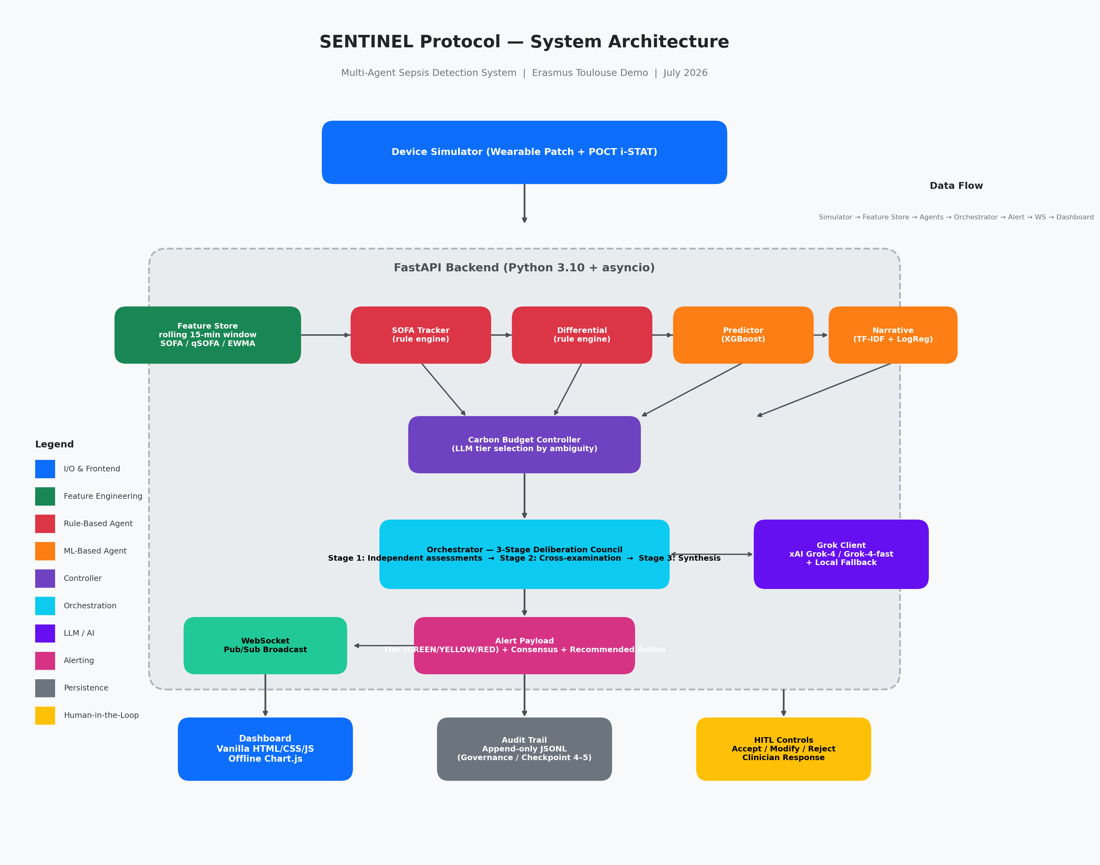

Component Breakdown

1. Device Simulator
Simulates a wearable patch + POCT i-STAT device. Streams realistic vitals for 6 scripted patient test cases (Karen, Anya, Maria, Robert, James, Frank) with deterministic noise (seed=42). Reproducible demo every run.

2. Feature Store (feature_store.py)
Rolling 15-minute window with slopes, deltas, EWMA smoothing, SOFA/qSOFA scoring (Sepsis-3 proxies), and shock index. Deque-based, zero-allocation updates.

3. Four Specialist Agents (agents.py)
• SOFA Tracker — Sepsis-3 organ-dysfunction rule engine (deterministic).
• Differential — Mimic rule-out for pancreatitis and post-op stress (deterministic).
• Predictor — XGBoost classifier for P(sepsis), trained on 7,200 synthetic samples (AUC 1.00, recall 0.99).
• Narrative Analyst — TF-IDF + LogisticRegression for P(note indicates concern).

4. Carbon Budget Controller (agents.py)
Selects LLM tier by case ambiguity: <0.30 → ml_only (~0.01g CO₂), 0.30–0.70 → grok-4-fast (~0.15g CO₂), ≥0.70 → grok-4 (~1.20g CO₂).

5. Orchestrator (orchestrator.py)
3-stage deliberation council: Stage 1 (independent deterministic assessments), Stage 2 (cross-examination via Grok), Stage 3 (synthesis → weighted consensus + tier + recommended action). Hallucination-grounding: consensus and tier are always deterministic.

6. Grok Client (grok_client.py)
Async OpenAI-compatible client pointing to xAI endpoint (https://api.x.ai/v1). Supports grok-4 and grok-4-fast. Deterministic local-reasoning fallback if no key / auth failure / timeout.

7. FastAPI Backend (main.py)
Async-native ASGI server. REST endpoints for device control, HITL response, speed/pause, audit, and metrics. Native WebSocket (/ws) with per-subscriber asyncio.Queue for pub/sub broadcast.

8. Dashboard (static/)
Self-contained vanilla HTML/CSS/JS. Offline charting (Chart.js vendored). Live vitals grid, per-patient drawer with agent reasoning cards, sparklines, SOFA breakdown, and HITL controls.

9. Audit Trail (audit.py)
Append-only JSONL log. Every tier change, clinician response, and model invocation recorded. Supports governance requirements (Checkpoint 4–5).

10. ML Training Pipeline (ml/)
Synthetic cohort generator + XGBoost + TF-IDF trainer. Deterministic, ~10s runtime. Models persisted with joblib. Automatic rule fallback if model files are missing.

Data Flow (End-to-End)
Device Simulator → Feature Store → 4 Agents (Stage 1, zero-LLM) → Carbon Budget Controller → Orchestrator (Stage 2 cross-exam + Stage 3 synthesis via Grok) → Alert Payload → WebSocket Broadcast → Dashboard
Clinician Response (Accept / Modify / Reject) → Audit Trail + Outcome Tracker
The 80% zero-LLM path means most inferences never call an LLM — only ambiguous cases trigger Grok deliberation, keeping latency low and cost minimal.

Tech Stack Summary
Layer | Technology | Purpose
Language | Python 3.10 | Type hints, dataclasses, asyncio
Backend | FastAPI + Uvicorn | REST + WebSocket, async-native ASGI
LLM | xAI Grok (grok-4 / grok-4-fast) | 3-stage deliberation + synthesis
LLM SDK | openai >=1.30 | OpenAI-compatible async client
ML | XGBoost + scikit-learn | Risk classifier + note concern classifier
Serialization | joblib | Model persistence + lazy load
Validation | Pydantic v2 | HTTP API request/response models
Config | python-dotenv | Env-driven dataclass Settings
Frontend | Vanilla HTML/CSS/JS | No build step, fully offline
Charts | Chart.js (vendored) | Offline sparklines + vitals charts
Persistence | JSONL (append-only) | Audit trail, no DB dependency
Simulation | Deterministic script + noise | Reproducible patient cases

Patient Test Cases
Six scripted cases stream simultaneously to demonstrate full system behaviour:
Patient | Ward | Case | Expected Behaviour
Karen Whitfield | ER | Sepsis (headline) | GREEN → YELLOW (~t=30) → RED (~t=44). Caught before collapse.
Anya Petrova | ICU | Septic shock | RED early, de-escalates to YELLOW on recovery.
Maria Sanchez | ER | Pancreatitis mimic | Stays GREEN — Differential rules out sepsis.
Robert Hayes | Surgical | Post-op stress mimic | Stays GREEN — distinguished from sepsis.
James Okafor | General | Healthy control | Stays GREEN — silent monitoring.
Frank Doyle | Palliative | Sepsis + Comfort Care directive | Consensus ~88 (sepsis physiology) but tier capped at YELLOW. Goals-of-care pathway, not aggressive bundle. Ethics safeguard demo.

Key Design Principles
- Deterministic Safety Layer — Consensus and alert tier are always rule-derived; the LLM only explains. Alerts fire correctly even if Grok is offline.
- Carbon-Aware AI — The Carbon Budget Controller selects model size by ambiguity. 80% of cases take the zero-LLM path (~0.01g CO₂).
- Graceful Degradation — Local-reasoning fallback stubs produce clinician-style explanations when xAI is unavailable. Demo never breaks.
- Human-in-the-Loop — Every RED/YELLOW alert requires clinician response (Accept/Modify/Reject) with counterfactual outcome tracking.
- Ethics Safeguard — Advance directives (e.g., Comfort Care) cap alert tier and suppress aggressive bundles, preserving patient dignity.
- Reproducibility — Deterministic simulator with fixed noise seed means every demo run is identical and predictable.

— Generated by SENTINEL build tooling | For internal team use only

