

**Solution Name**

Expense Management - Receipt Submission Solution

**Solution Design Document Lite**

**Ashling Partners Edition**

**Document History**

|  |  |  |  |  |
| --- | --- | --- | --- | --- |
| Date | Version | Role | Name | Comments |
| MM/DD/YYYY | 1.0 | Solution Architect |  | Initial Draft |
|  |  |  |  |  |
|  |  |  |  |  |
|  |  |  |  |  |

**Document Approval Flow**

|  |  |  |  |  |
| --- | --- | --- | --- | --- |
| Version | Flow | Role | Name | Signature and Date: |
| **1.0** | **Prepared by:** | Solution Architect |  |  |
|  | **Approved by:** |  |  |  |
|  | **Approved by:** |  |  |  |
|  | **Approved by:** |  |  |  |

**Change Log**

|  |  |  |
| --- | --- | --- |
| Date | Section | Change Requested By |
|  |  |  |
|  |  |  |
|  |  |  |

Table of Contents

1. Document Objective 4

2. Solution Overview 5

2.1 Solution Overview 5

2.2 High Level Solution Diagram 5

2.3 Solution Steps 5

2.4 Performance Considerations 5

2.5 Process Diagram 6

2.6 Target Applications 6

2.7 Composable Assets 6

3. Components 6

4. Assumptions & Risks 7

5. Security and Data Policies 8

5.1 Data Inputs 8

5.2 Data Outputs 8

5.3 Logging/Archiving 8

5.4 Regulatory Requirements 8

5.5 Risks 8

5.6 Access/Control 8

5.7 Credentials 8

# Document Objective

The purpose of this document is to explain in detail, all architectural aspects of the automated solution design.

The document is targeted at those developing and supporting the solution. It should be composed using non-technical to mildly technical terms, which are understandable by administrators of the solution, who may be required to provide support post implementation.

This document will evolve if the solution receives investment and advances through the delivery life cycle, and all solution amendments/updates must be captured accurately within.

All changes to this document must also be recorded in the ‘Version Control’ section.

# Solution Overview

**Solution Overview**

The Expense Management - Receipt Submission Solution enables employees to submit receipts via a mobile app, extract information using UiPath's document understanding workflow, and update PeopleSoft software. This solution streamlines the receipt submission process, enhances data accuracy, and improves efficiency.

## High Level Solution Diagram

*Input = <enter input here (email inbox, shared drive folder, SQL table, etc)>*

*Output = <enter output here (email summary, Excel output, log to SQL table, Reporter process, etc)>*

*1*

**System Architecture**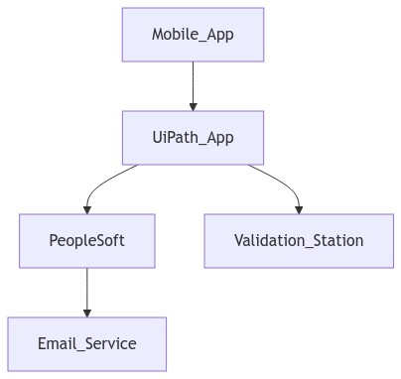

**ERDiagram**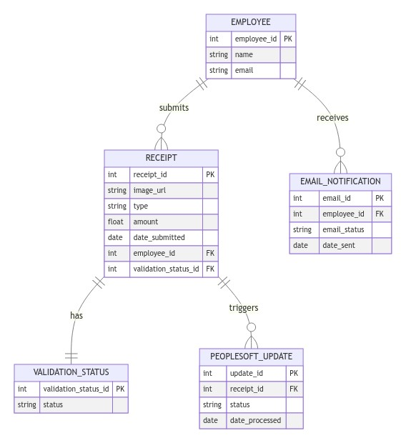

## Solution Steps

|  |  |  |  |  |
| --- | --- | --- | --- | --- |
| **Step** | **Input** | **Details** | **Exception Handling** | **Screenshots** |
| 1 |  |  |  |  |
| 2 |  |  |  |  |
| 3 |  |  |  |  |
| 4 |  |  |  |  |
| 5 |  |  |  |  |

## Performance Considerations

**Performance Consideration**

- Detail performance requirements and constraints

- Describe scaling considerations

- Outline response time expectations

# Components

**Components**

- Mobile App: Allows employees to submit receipts

- UiPath App: Utilizes document understanding workflow for information extraction

- PeopleSoft Integration: Updates PeopleSoft software with extracted data

- Email Service: Sends confirmation emails

- Validation Station: Ensures data accuracy

|  |  |  |
| --- | --- | --- |
| **API Name** | **API Location (URL)** | **API Key (Unique)** |
| Ex. OpenAI |  |  |
| 2 |  |  |
| 3 |  |  |

# Assumptions & Risks

**Assumptions Risks**

- Assumptions: Employees have access to mobile phones, UiPath document understanding workflow is accurate

- Dependencies: Integration with PeopleSoft software, availability of mobile network

# Security and Data Policies

## Data Inputs

**Data Inputs**

- Data Input Sources: Receipt images from employees

- Input Data Formats: Image files

- Data Validation Requirements: Accuracy of extracted information

## Data Outputs

**Data Outputs**

- Output Types: Updated information in PeopleSoft

- Reporting Requirements: Confirmation emails

- Data Export Capabilities: N/A

## 

## Logging/Archiving

**Logging**

- Logging Strategy: Log all submission and extraction activities

- Audit Requirements: Track changes made in PeopleSoft

- Monitoring Approach: Regularly review logs for errors

## Regulatory Requirements

**Regulatory**

- Applicable Regulations: Data privacy laws

- Compliance Requirements: Secure handling of sensitive data

- Security Standards: Encryption of data in transit and at rest

## Risks

**Risks**

- Risks: Inaccurate data extraction, system downtime

- Mitigation Strategies: Implement validation station, regular system backups

- Contingency Plans: Manual data entry as backup option in case of system failure