Helmet and No Helmet Detection with Adaptive-Threshold Contour Extraction and YOLOv8
S Fatima | Artificial Intelligence Internship, Progree

Abstract
This paper presents a real-time computer vision pipeline that detects and counts objects in video streams. Two complementary approaches are combined in one web application: (1) a classical OpenCV pipeline that applies Gaussian filtering and adaptive thresholding to extract shapes from pixel bounds, and (2) a YOLOv8 detector fine-tuned on a 2-class traffic dataset (helmet, no_helmet). Dynamic per-class count vectors are overlaid on every frame. On the held-out test split the fine-tuned model reaches mAP@0.5 of 0.734, precision 0.668, recall 0.717 and F1 0.692, with a mean inference time of 51.9 ms per image (19.3 FPS) on the evaluation hardware.

1. Introduction
Detecting riders, helmets and no helmets in traffic footage supports road-safety monitoring, for example flagging riders without helmets. Real-time operation matters: a system that cannot keep up with the video stream cannot be used for live monitoring. This project therefore evaluates not only accuracy but also frame-by-frame latency.
The objectives were: build a pipeline that extracts and tracks target contours in real time; apply adaptive threshold matrices and Gaussian filters to video frames; overlay dynamic text counts per target class; and evaluate frame-by-frame inference metrics.

2. System Architecture
The system has three layers. A Web based front end captures frames from an uploaded video or the webcam, downsizes them to 640 px width and sends each frame as a JPEG to the back end. A Flask back end runs either the YOLO detector or the contour pipeline and returns bounding boxes, class labels, confidences, per-class counts and the server-side latency. The front end draws the boxes, renders the count-vector overlay and records per-frame metrics that can be exported to CSV.

2.1 Classical contour pipeline
Each frame is converted to grayscale and smoothed with a Gaussian filter to suppress sensor noise. An adaptive Gaussian threshold then computes a local threshold for every pixel neighbourhood, which makes the segmentation robust to uneven lighting. External contours are extracted, filtered by a minimum area, and classified by polygon approximation (triangle, square, rectangle, circle or n-gon). The Gaussian kernel size, adaptive block size and minimum area are adjustable at run time in the interface.

2.2 YOLOv8 detector
The deep-learning branch uses yolov8n.pt (Ultralytics), a single-stage anchor-free detector. The model was initialised from COCO pre-trained weights and fine-tuned for 5 epochs at 416 px with batch size 8. The best checkpoint by validation fitness is loaded by the back end.

3. Dataset
The Helmet v9 dataset (Roboflow Universe, CC BY 4.0) contains traffic-camera frames annotated with bounding boxes. After removing the ambiguous 'noise' class, 3746 images remain across the provided train, validation and test splits, which were kept unchanged to avoid leaking near-duplicate frames between splits.
Class | Train boxes | Valid boxes | Test boxes
Helmet | 6206 | 185 | 124
no_helmet | 3134 | 115 | 63
Images | 3555 | 127 | 64

Table 1. Dataset composition (annotated boxes per class and image counts per split).
The class distribution is imbalanced: 'helmet' has 6206 training boxes while 'no_helmet' has 3134. Many frames come from a small number of fixed cameras, so scene diversity is limited.

4. Experimental Results

4.1 Overall accuracy
Split | Precision | Recall | F1 | mAP@0.5 | mAP@0.5:0.95
Validation | 0.728 | 0.637 | 0.680 | 0.694 | 0.360
Test | 0.668 | 0.717 | 0.692 | 0.734 | 0.393

Table 2. Detection metrics of the fine-tuned model (F1 = 2PR/(P+R) computed from mean precision and recall).

4.2 Per-class performance
Class | Precision | Recall | F1 | mAP@0.5 | mAP@0.5:0.95
Helmet | 0.834 | 0.798 | 0.816 | 0.889 | 0.511
no_helmet | 0.502 | 0.635 | 0.561 | 0.580 | 0.276

Table 3. Per-class metrics on the test split.
'helmet' is detected best (mAP@0.5 0.889), while 'no_helmet' is the weakest (mAP@0.5 0.580). The lowest recall belongs to 'no_helmet' (0.635), meaning the model misses a larger share of those objects than of any other class.
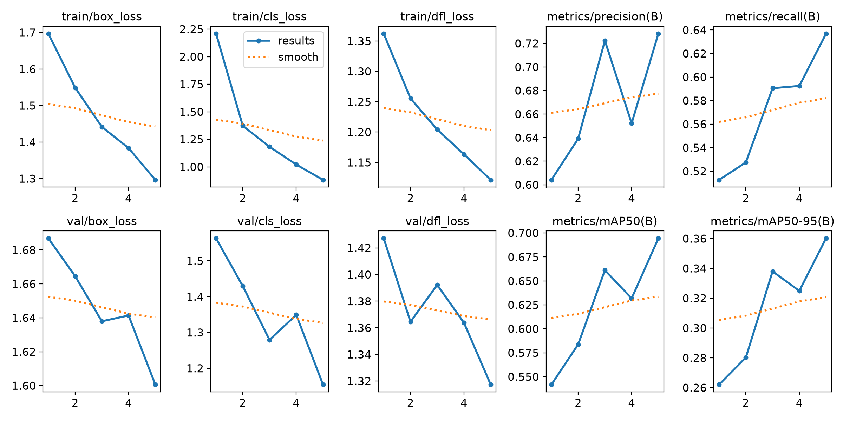
Figure 1. Training and validation loss and metric curves per epoch.
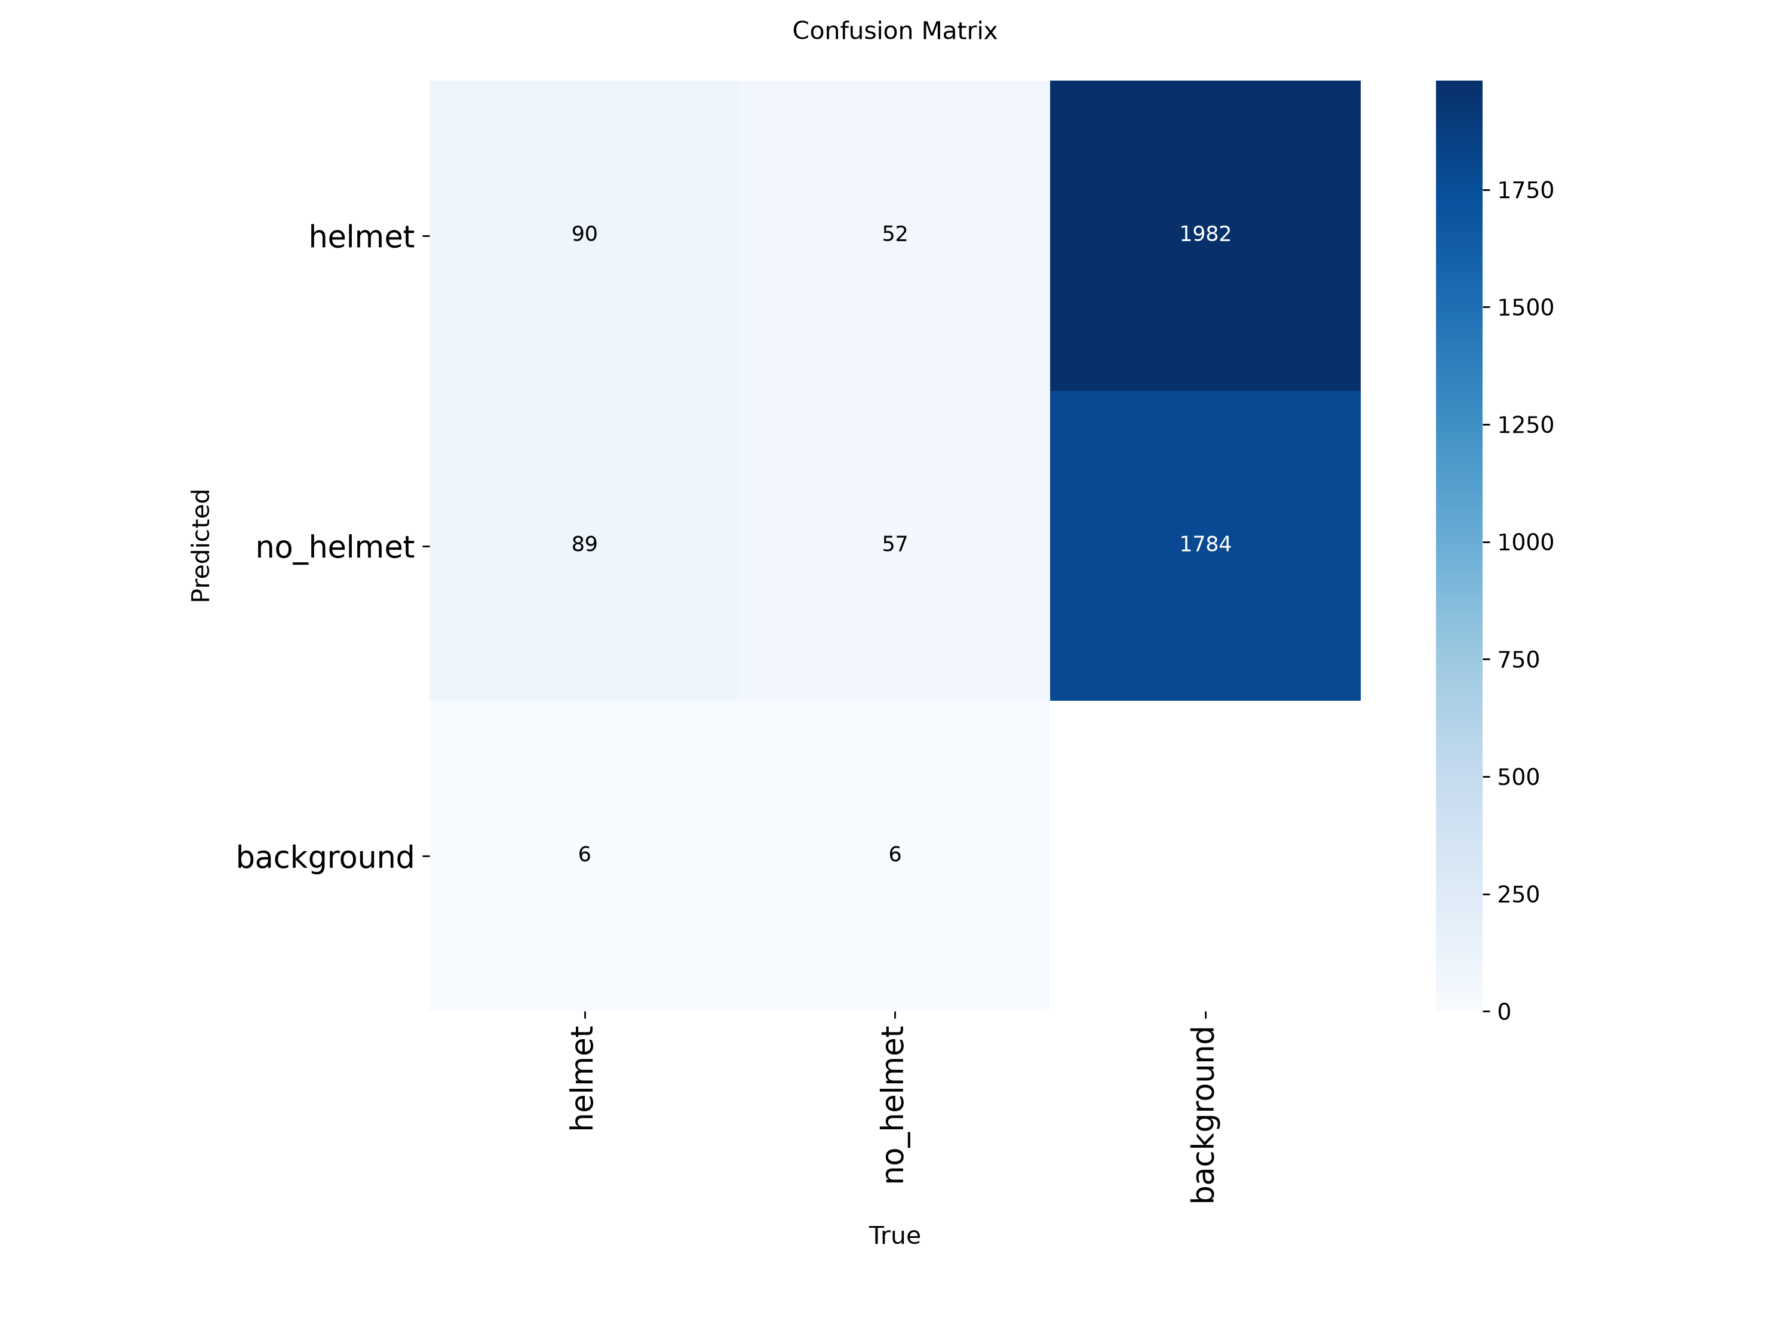
Figure 2. Confusion matrix (raw counts) on the validation split

5. Frame-by-Frame Real-Time Performance
Offline benchmark: over 64 test images the model needed 51.9 ms on average (19.3 FPS) for inference through the Python API.
Mode | Frames | Server ms | Round-trip ms | Median ms | P95 ms | Mean FPS | Objects/frame
Yolo | 1176 | 141.5 | 154.6 | 143.1 | 192.7 | 6.0 | 1.3

Table 4. Live metrics logged by the web application (frame_metrics.csv), one row per processed frame.
The gap between server time and round-trip time is the cost of JPEG encoding, HTTP transfer and canvas rendering. For live use, the round-trip figure and the 95th-percentile latency are the relevant numbers, because they determine whether the overlay keeps up with the video.

6. Discussion and Limitations
Validation mAP@0.5 (0.694) and test mAP@0.5 (0.734) differ by 0.040. Because the frames originate from a few fixed cameras, both numbers probably overestimate performance on unseen camera angles and lighting; validation on footage from new locations is needed before deployment.
Counts are per-frame detections, not unique objects: without a tracker, the same rider is counted again in every frame. Adding a tracker such as ByteTrack would give true cumulative counts. The contour pipeline needs no training and is fast, but it responds to any edge structure and cannot tell a helmet from other round shapes, so it is best viewed as a baseline and a teaching tool rather than a detector. Streaming frames to a server adds network overhead; running the model in the browser or on the capture device would reduce latency. In informal tests on crowded, elevated footage where riders appear small and far from the camera, the model missed several riders, because most training images show riders at closer range and the input is downscaled to 416 px; detection is more reliable on close, clearly visible riders.

7. Conclusion
The project delivers an end-to-end pipeline: adaptive-threshold contour extraction, a fine-tuned YOLOv8 detector, a live count overlay and exportable frame-level metrics. The model achieves F1 0.692 and mAP@0.5 0.734 on the test split at 19.3 FPS offline. Future work includes multi-object tracking, more diverse training footage, balancing the no_helmet class

References
- Jocher, G., Chaurasia, A., Qiu, J. Ultralytics YOLOv8, 2023. github.com/ultralytics/ultralytics
- Bradski, G. The OpenCV Library. Dr. Dobb's Journal of Software Tools, 2000.
- Helmet v9 dataset, Roboflow Universe (CC BY 4.0). universe.roboflow.com/helmet-detection-xy5ky/helmet-htftb
- Lin, T.-Y. et al. Microsoft COCO: Common Objects in Context. ECCV, 2014.

