Guide to LEGO™ Geometry
By Gustav Jansson

The most basic unit of measure in LEGOs is the Lego Unit (L.). Most likely you are already familiar with this unit when you are talking about the length of a beam or an axle. But did you know that it also works when talking about the height of a brick? You can also use it to measure the radius or the diameter of gears and wheels. When you understand LEGO geometry, you will know when pieces will fit without guessing. This is especially true when you use gears and beams in vertical or diagonal arrangements.

The Basic Brick

So, what are the dimensions of a basic brick?
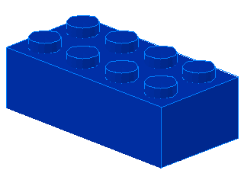
1.2L high
2L wide
4L long

Notice that the brick height is 1.2L. Since it takes three plates to be the same height as a brick, a plate must be 1/3 of the height of the basic brick, or 0.4L.
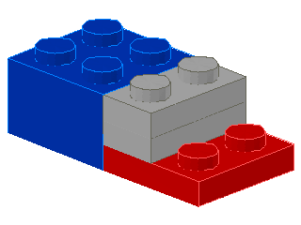
0.4L high

This might seem confusing but it actually works out quite nicely, as you will see.

Beams

Beams, like bricks are also 1.2L high. Another thing about beams is that the holes are spaced out by 1L increments. Therefore, the distance between the first and the last hole on a 4L beam is 2L.
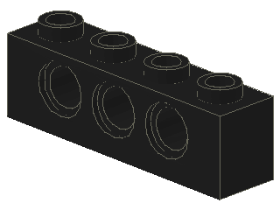
If you put two plates in between two beams, what is the vertical distance between the holes in the two beams? Let’s figure it out.
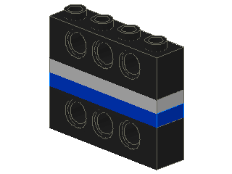
To make this easier to explain, I will give you one more measurement. On a beam, the hole centers are 0.7L from the bottom edge and 0.5L from the top edge. Therefore, the vertical distance between the holes are, 0.5L + 0.4L + 0.4L + 0.7L = 2.0L! That is why this fits so perfectly:
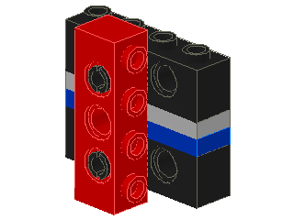
This structure is very strong and therefore very useful in making robots that don’t fall apart. Using longer vertical beams and more plates and beams stacked together, one can extend this as far up and down as you want. It can also be used to secure assemblies to large pieces like motors and the RCX.

Here is an example of how I secured the motors to the RCX brick on my LineTracker robot.

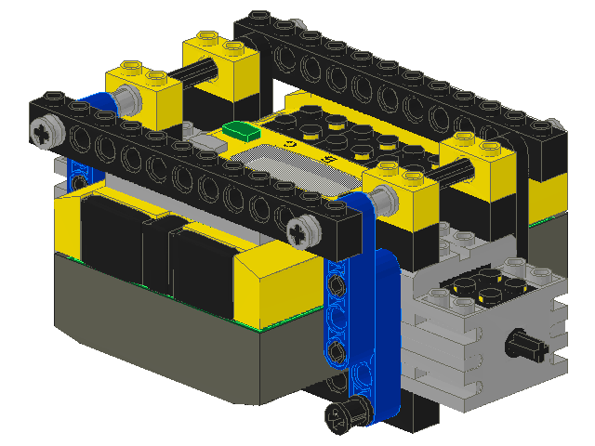
The back of the motor is the same height as 3 bricks (3.6L). Add this to the height of the 1x2 bricks on the motors (1.2L), and the partial beams from both the bottom and the top (1.2L), and you get 6.0L. Since the back of the RCX is exactly the same height as 4 bricks, it has the same height as the motors plus a brick. The height of the front of the RCX is one plate less then the back, so we had to add a plate between it and the beam. Since the vertical distance between the holes of the top beams and the bottom beams is 6.0L, everything is perfectly secured by the vertical beams.

Gears
The LEGO Mindstorms set comes with 8, 16, 24, and 40 tooth gears (and some bevel and crown gears). To determine the radius of the gears, simply put two of the same size gears next to each other on a beam and measure the distance between the axles. For example, if you put two 8 tooth gears next to each other on a beam, then they need to be placed one hole (1L) apart. Since the radius is the distance from the center of the gear to where it meshes with the other gear, the radius is 0.5L.
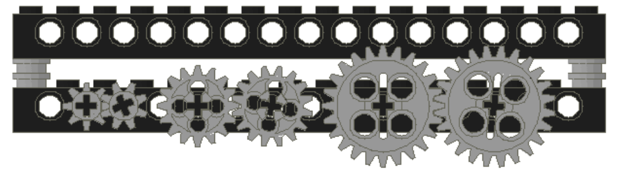
8 tooth gears
Radius = 0.5L
16 tooth gears
Radius = 1.0L
24 tooth gears Radius = 1.5L

Similarly, since 16 tooth gears need to be 2L apart, their radius is 1L. 24 tooth gears have a radius of 1.5L and 40 tooth gears have a radius of 2.5L. A general way to determine the radius of a gear is to divide the number of teeth by 16.

To mesh gears of different sizes, all you need to do is add the radii of the two gears to determine how far apart they need to be. For example, lets say you want to mesh an 8 tooth gear with a 40 tooth gear. Since the 8 tooth gear has a radius of 0.5L and the 40 tooth gear has a radius of 2.5L, the distance apart needs to be 3.0L.

What about meshing a 16 tooth gear with an 8 (or 24) tooth gear? This requires an offset of 1.5L. Obviously that cannot be done with a regular beam, but there are special beams that will make this work, here is one example:
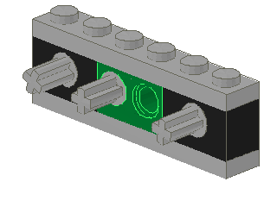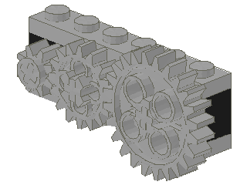
Some of the newer LEGO kits come with some odd looking gears. These gears are called double bevel gears and come in 12 tooth and 20 tooth sizes. Using the divide by 16 rule to determine the radii, we find that they are 0.75L and 1.25L respectively. Since 0.75L+1.25L is 2.0L, these gears will mesh nicely with each other on a beam.
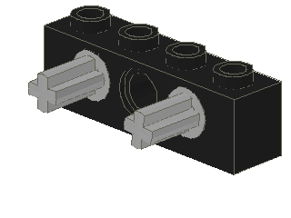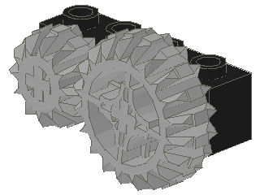

Diagonals
Usually, it is easiest to arrange beams and axles for gears either horizontally or vertically, but it is not the only way. For certain gear combinations, it is not even possible to find a horizontal or vertical arrangement that will work. For example, lets say you want to mesh a 20 tooth gear with a 16 tooth gear. Their radii are 1.25L and 1L respectively so they need to be 2.25L apart. Horizontally you can get a hole offset of either 2L or 2.5L, but neither will work. Vertically you can get an offset of either 2L or 2.4L, also, neither will work. One way that will work is a diagonal arrangement.

Here is one good way to mesh the 20 tooth with the 16 tooth gears:

To determine the diagonal distance between holes, one can use the Pythagorean Theorem:
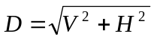
Where: D is the Diagonal distance
V is the Vertical offset
H is the Horizontal offset
In the example above, H is 1L and V is 2L, and D will be 2.236L. Since 2.236L is very close to the ideal offset of 2.25L, this arrangement will work very nicely.

When placing gears at diagonals, you need to be aware of how close the ideal offset is to the actual offset. If the gears are too close, they will bind and not turn freely and if they are too far apart they may skip. I have found that if the offset is within ± 0.05L of the ideal offset, it should be okay.

Besides gear arrangements, you can also put beams at diagonals, as long as the diagonal distance is close enough to the beam length being placed at a diagonal. Here is one example:

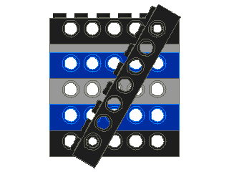
Using the Pythagorean Theorem, in this case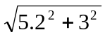= 6.003, you see that the actual diagonal is almost exactly the same as the beam. This is a very good fit.

Diagonals and Gear Chart
To make it easier to find the usable diagonals, for both gear arrangements and angled beams, I have created a chart that shows the diagonal distance given various horizontal and vertical offsets. Across the top of the chart are horizontal offsets in .5L increments and down the side of the chart are vertical offsets in .4L increments. For the vertical offsets I also show the equivalent number of bricks and plates, denoted with B for Bricks and P for Plates.

Each entry in the chart shows two numbers. The upper number shows the diagonal distance rounded to either the nearest quarter or the nearest half of a unit. If the diagonal is less then 4, then it is rounded to nearest quarter, otherwise it is rounded to the nearest half. The bottom number shows the correction in the rounding.

Here is a small sample of the chart:
 |  |  | 0 | 0.5 | 1 | 1.5 | 2 | 2.5 | 3 | 3.5 | 4 | 4.5 | 5 | 5.5 | 6
0B | 1P | 0.4 | .50  -.100 | .75  -.110 | 1.00  +.077 | 1.50  +.052 | 2.00  +.040 | 2.50  +.032 | 3.00  +.027 | 3.50  +.023 | 4.00  +.020 | 4.50  +.018 | 5.00  +.016 | 5.50  +.015 | 6.00  +.013
0B | 2P | 0.8 | .75  +.050 | 1.00  -.057 | 1.25  +.031 | 1.75  -.050 | 2.25  -.096 | 2.50  +.125 | 3.00  +.105 | 3.50  +.090 | 4.00  +.079 | 4.50  +.071 | 5.00  +.064 | 5.50  +.058 | 6.00  +.053
1B | 0P | 1.2 | 1.25  -.050 | 1.25  +.050 | 1.50  +.062 | 2.00  -.079 | 2.25  +.082 | 2.75  +.023 | 3.25  -.019 | 3.75  -.050 | 4.00  +.176 | 4.50  +.157 | 5.00  +.142 | 5.50  +.129 | 6.00  +.119
1B | 1P | 1.6 | 1.50  +.100 | 1.75  -.074 | 2.00  -.113 | 2.25  -.057 | 2.50  +.061 | 3.00  -.032 | 3.50  -.100 | 3.75  +.098 | 4.50  -.192 | 5.00  -.224 | 5.00  +.250 | 5.50  +.228 | 6.00  +.210
1B | 2P | 2 | 2.00  +.000 | 2.00  +.062 | 2.25  -.014 | 2.50  +.000 | 2.75  +.078 | 3.25  -.048 | 3.50  +.106 | 4.00  +.031 | 4.50  -.028 | 5.00  -.076 | 5.50  -.115 | 6.00  -.148 | 6.50  -.175
2B | 0P | 2.4 | 2.50  -.100 | 2.50  -.048 | 2.50  +.100 | 2.75  +.080 | 3.00  +.124 | 3.50  -.034 | 3.75  +.092 | 4.00  +.244 | 4.50  +.165 | 5.00  +.100 | 5.50  +.046 | 6.00  +.001 | 6.50  -.038

For example, if you look at the diagonal with a horizontal offset of 2L and a vertical offset of 1.6L, you will see that the diagonal is 2.5L plus a correction of .061. That means that the diagonal is actually 2.561L. The rounding is done to make it easier to find useful diagonals. In this case, 2.5L might be used to mesh a 24 tooth gear with a 16 tooth gear. Like this:

The bold entries on the chart note the diagonals that are within ± 0.05L of the rounded distance. These are the diagonals that are most likely to work for both gears and angled beams.

Below the diagonals chart is a small gear distance chart that shows the ideal distance between different sized gears. For example, the ideal distance between the 40 tooth gear and the 20 tooth gear is 3.75L. If you then want to find a usable diagonal for this combination you simply look for 3.75 on the main chart and with a small correction. One possibility is a horizontal offset of 1L and a vertical offset of 3.6L. Like this:
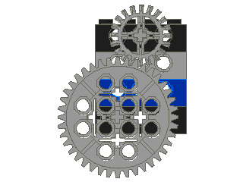
You might wonder why I show diagonals that are rounded to half a Lego unit since there are no beams with that offset, but here is one that has a horizontal offset of 3.5L and a vertical offset of 2.8L. The diagonal is 4.5L + correction of -.018.
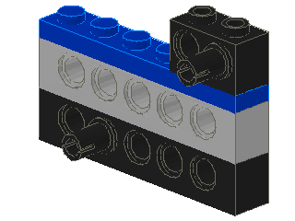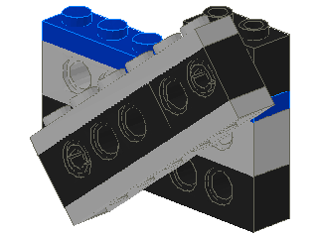

Other Angled Beams
Here one more way of doing angled beams that I have found to be useful. In my case I needed to mount my Light Sensors at a small angle. Here is the method I discovered:


This works out to be about a 10 degree angle.

