**Postgresql db operation Assigment:**

CREATE TABLE employees (

employee_id int PRIMARY KEY,

name VARCHAR(100) NOT NULL,

department VARCHAR(50)

);

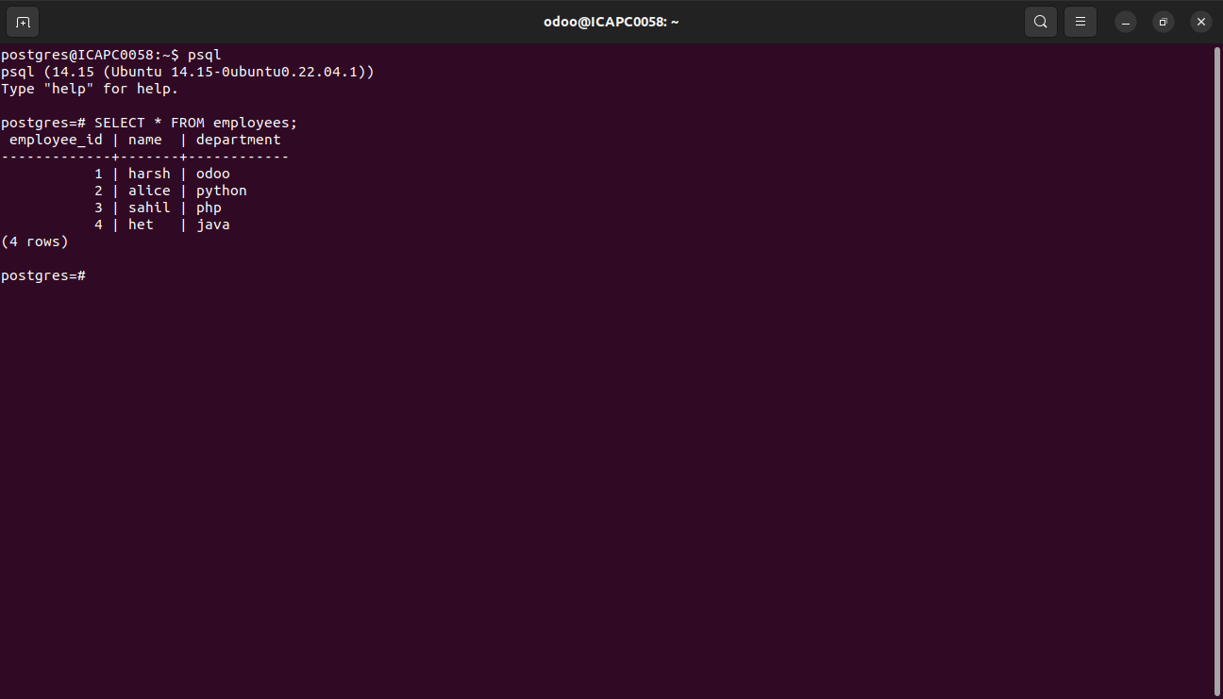

CREATE TABLE projects (

project_id SERIAL PRIMARY KEY,

project_name VARCHAR(100) NOT NULL,

employee_id INTEGER,

FOREIGN KEY (employee_id) REFERENCES employees(employee_id)

);

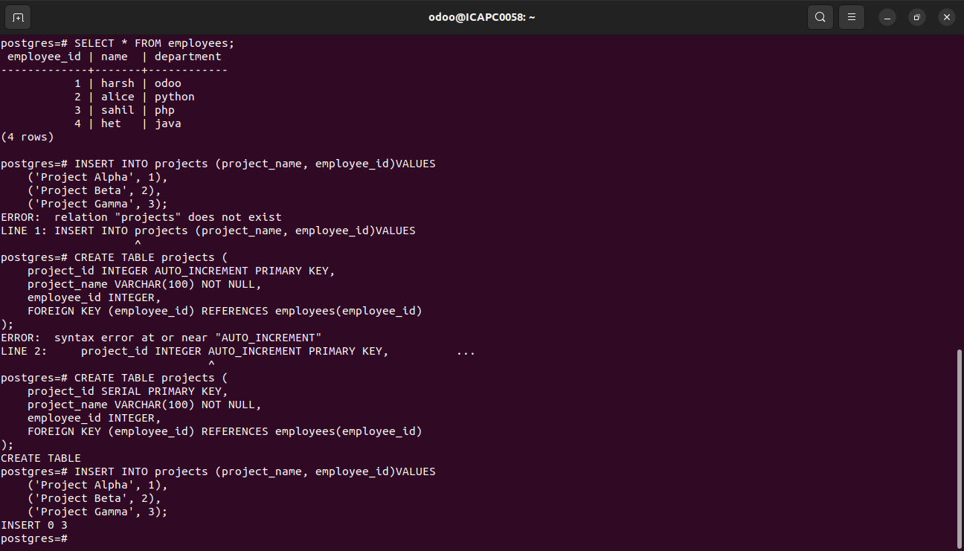

INSERT INTO employee (employee_id, name, department)VALUES

('1', 'harsh', 'odoo'),

('2', 'alice', 'python'),

('3', 'sahil', 'php'),

('4', 'het', 'java');

INSERT INTO projects (project_name, employee_id)VALUES

('Project Alpha', 1),

('Project Beta', 2),

('Project Gamma', 3);

inner join query

SELECT project_name, name

FROM projects

INNER JOIN employees ON projects.employee_id = employees.employee_id;

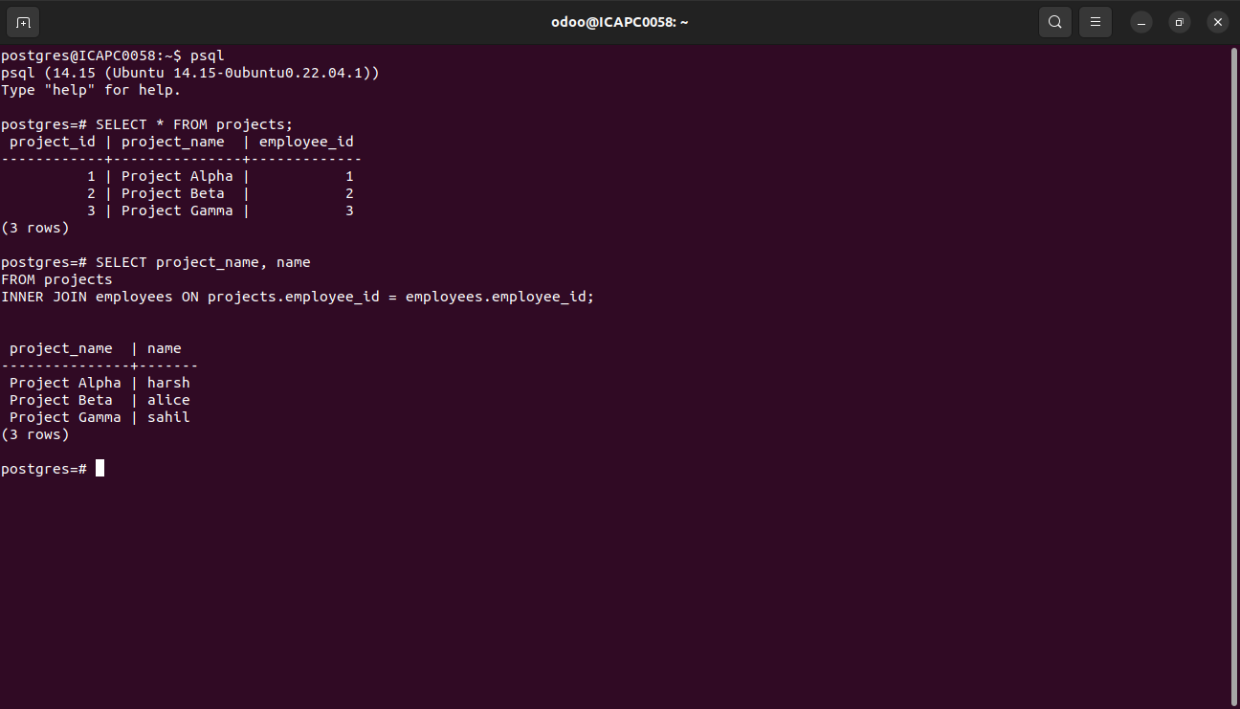

Drop Db

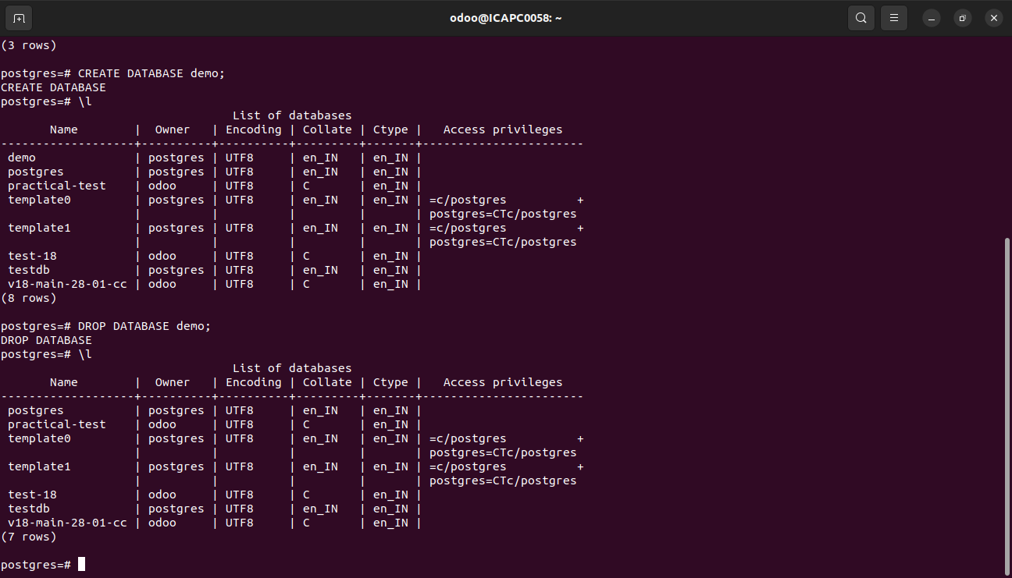

Alter commands:

1. add column

ALTER TABLE employees

ADD email VARCHAR(100);

2. Drop a Column

ALTER TABLE employees

DROP COLUMN email;

3. Modify a Column

ALTER TABLE employees

ALTER COLUMN name VARCHAR(150);

4. Rename a Column

ALTER TABLE employees

RENAME COLUMN department TO dept;

5. Rename a Table

ALTER TABLE employees

RENAME TO staff;

6. Drop a Foreign Key Constraint

ALTER TABLE projects

DROP CONSTRAINT employee_id;