**Session-4 Task**

Error code:

This code not give correct Output.

def decorator(func):

def wrapper(*args):

out = func(*args)

func(*args)

print(out)

func(*args)

return wrapper

@decorator

def user_input():

ans = input("Enter string: ")

return ans

@decorator

def pattern():

print("*****")

print("%%%%%")

user_input()

Output:

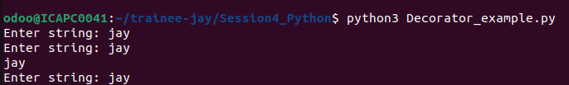

Error Resolve:

Code:

def decorator(func):

def wrapper():

out = func()

return out

return wrapper

def decorator_pattern(func):

def wrapper(*args):

func(*args)

print(args[0])

func(*args)

return wrapper

@decorator

def user_input():

ans = input("Enter string: ")

return ans

@decorator_pattern

def pattern(ans):

print("*****")

print("%%%%%")

ans = user_input()

pattern(ans)

Output:

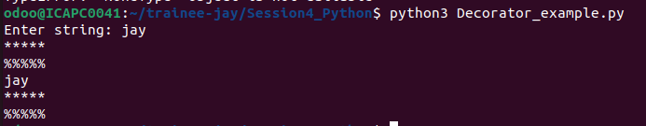

Code:

#Factorial using recursion

def fac(num):

if num == 0:

return 1

return num*fac(num-1)

number = int(input("Enter Number: "))

print(f"Factorial of {number} is: ",fac(number))

Output:

