EMPLOYEES TABLE

Crete table of employees:

CREATE TABLE employees(employee_id int PRIMARY KEY,
employee_name VARCHAR(100),
department VARCHAR(50));

Insert Records:

INSERT INTO employees(employee_id,employee_name,department) VALUES(
1001,'Kajal','Developing'),
(1002,'Riya','Management'),
(1003,'Shweta','Testing'),
(1004,'Bhavana','Marketing');
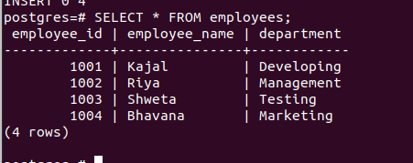

PROJECTS TABLE

Crete table of projects:

CREATE TABLE projects(project_id INT PRIMARY KEY,
project_name VARCHAR(100),
employee_id INT REFERENCES employees(employee_id));

Insert Records:

INSERT INTO projects(project_id,project_name,employee_id) VALUES(
2002,'Recruitment Drive',1002),
(2004,'Web Development',1001),
(2006,'Blog',1004);
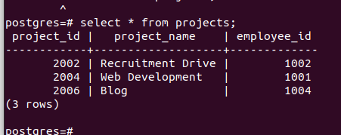

INNER JOIN QUERY:

SELECT employees.employee_name,project_name
FROM projects
INNER JOIN employees
ON employees.employee_id=projects.employee_id;
