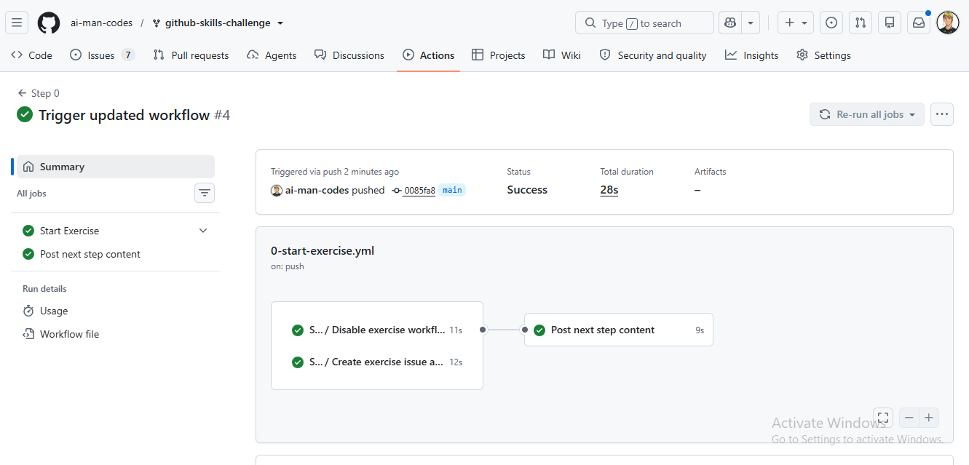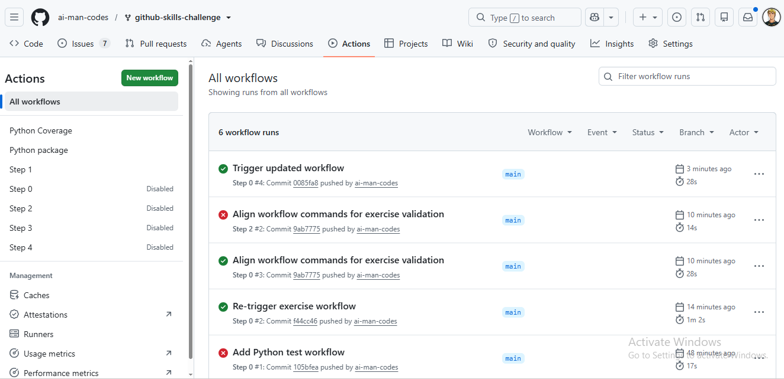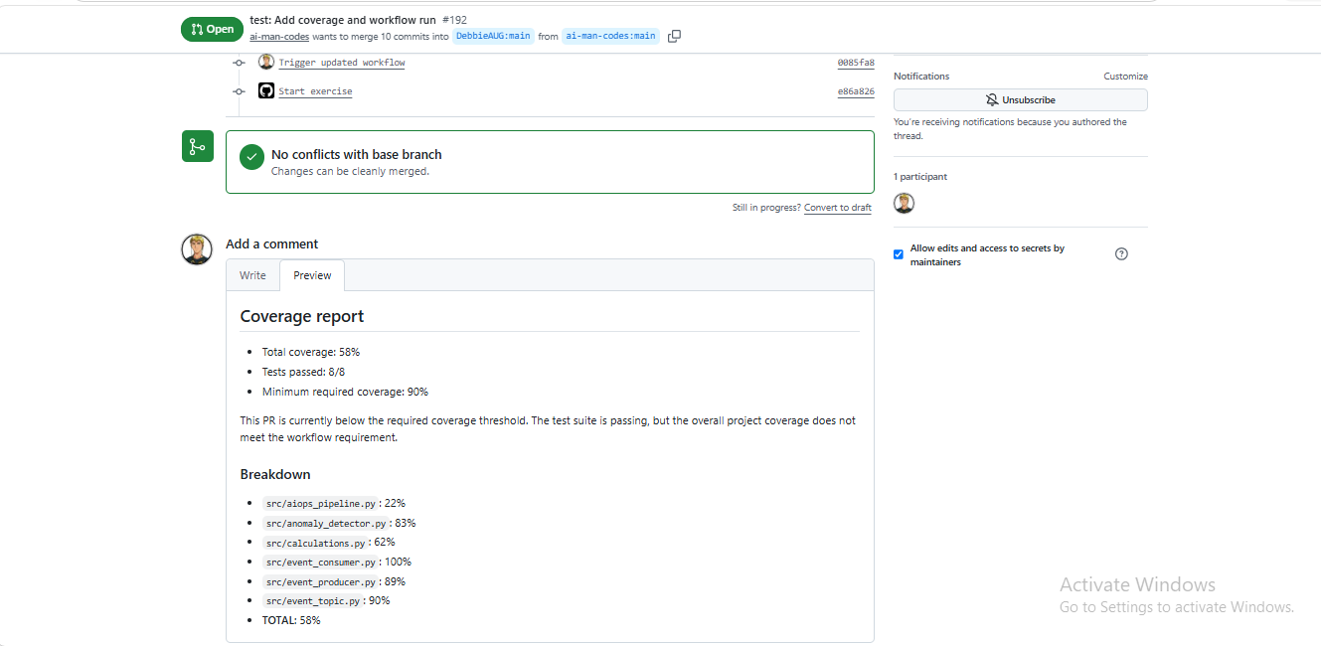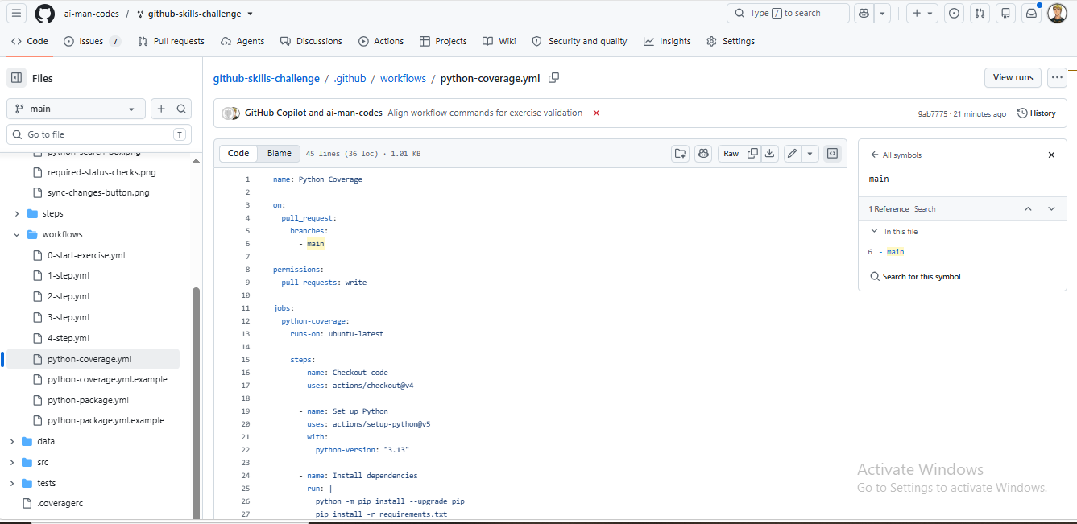

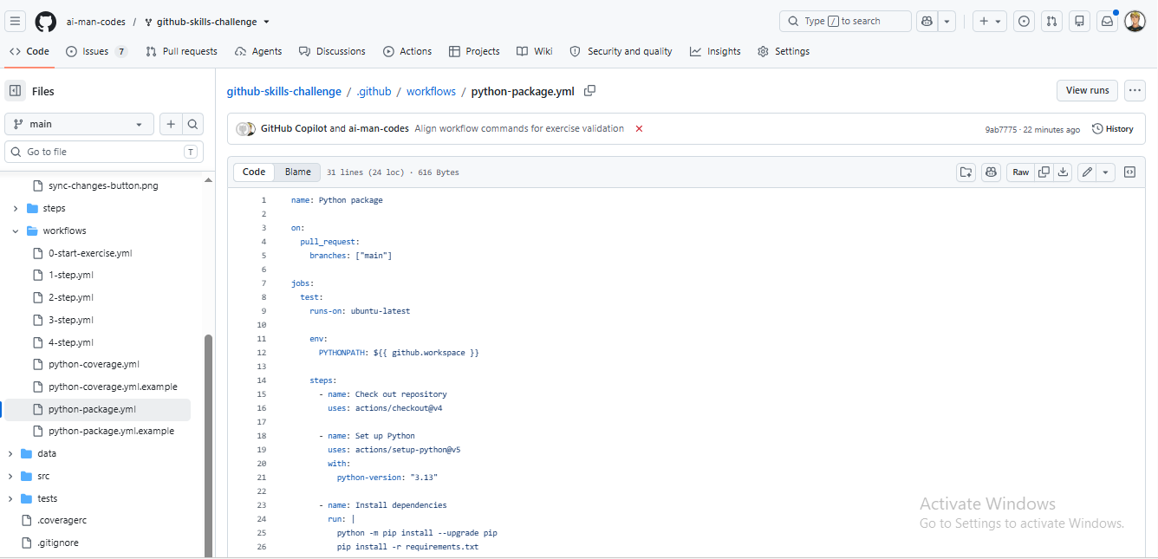

Gtihub: ai-man-codes/github-skills-challenge
PR url: test: Add coverage and workflow run by ai-man-codes · Pull Request #192 · DebbieAUG/github-skills-challenge

