RAG Chatbot Application
This project is a Retrieval-Augmented Generation (RAG) application built using the LlamaIndex framework and OpenAI models.
It allows users to:
- Paste text or upload a document
- Automatically generate a summary
- Ask questions about the document
- Chat with contextual memory
- Switch models and adjust temperature dynamically
It is a Generative AI application implementing a modular and session-based RAG pipeline. Like other RAG applications, this is a document-based LLM system with customizable options to configure model responses.

What This App Does
Instead of training a model, the app:
- Converts your document into embeddings
- Stores them in a vector index
- Retrieves relevant parts when you ask a question
- Sends the retrieved context + your question to the LLM
- Returns a grounded, document-based response

How It Works (Step by Step)
- Paste Text or Upload File
- Paste raw text
- OR upload .pdf, .txt, .docx, .csv, .md
- Click Process
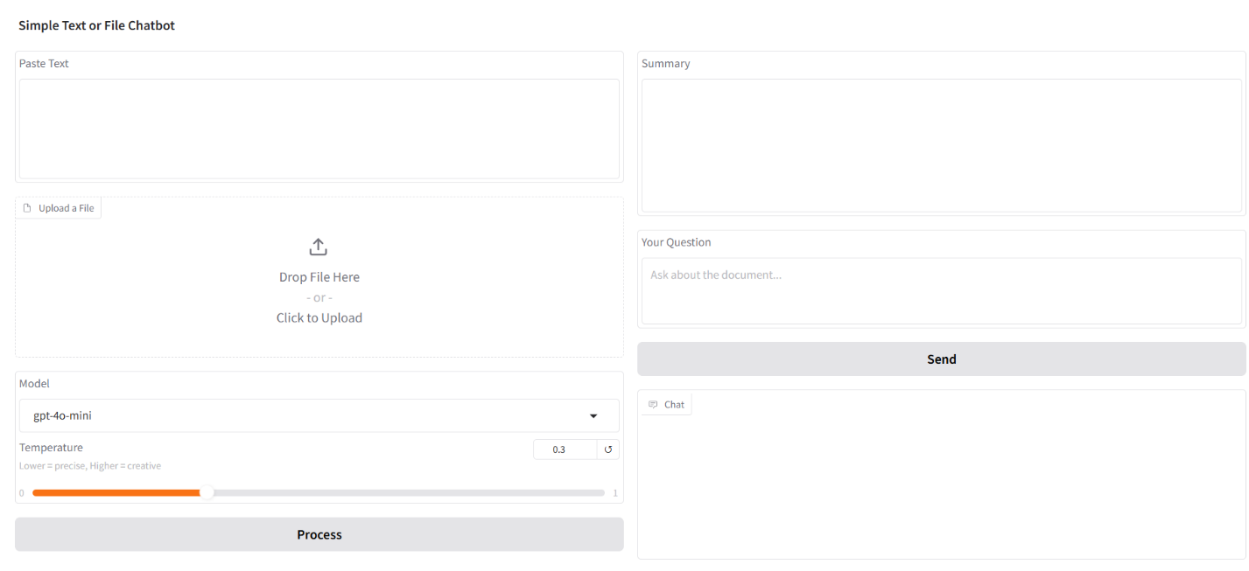

- Automatic Summary
After processing:
- The document is embedded
- A vector index is created
- A new session is generated
- A summary appears automatically
Previous chat history is cleared when a new document is processed.
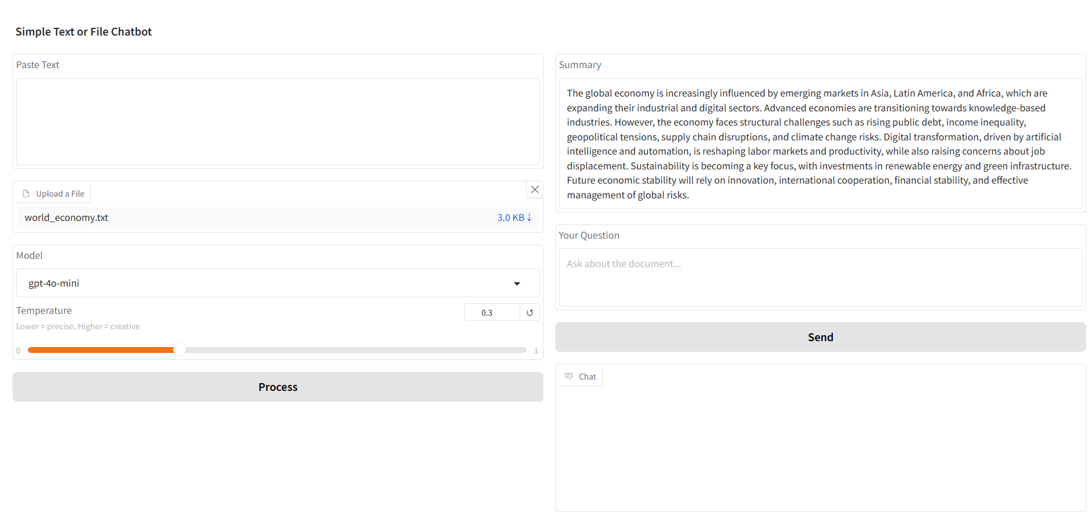

- Ask Questions & Chat with Memory
Type your question and click Send.
The system:
- Retrieves relevant document chunks
- Sends them to the LLM
- Returns a contextual answer
The app:
- Maintains conversation history
- Keeps context within the same document session
- Allows follow-up questions
Each document has its own isolated session.

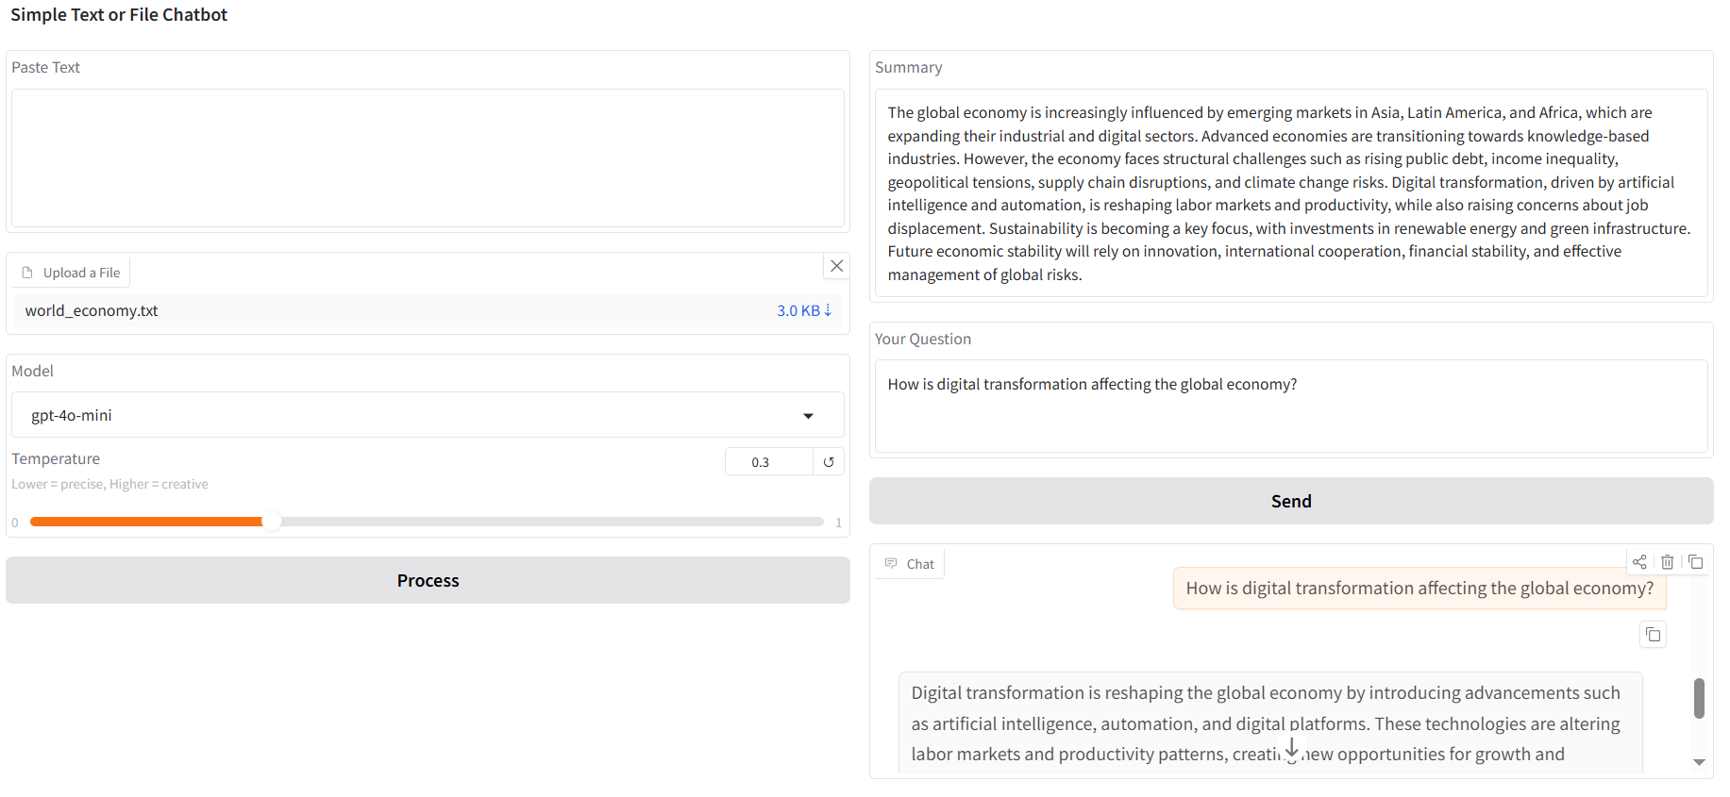

- Switch Model Anytime
You can change:
- The LLM model
- The temperature value
This allows:
- More precise answers (low temperature)
- More creative answers (high temperature)
- Easy model comparison without restarting the app

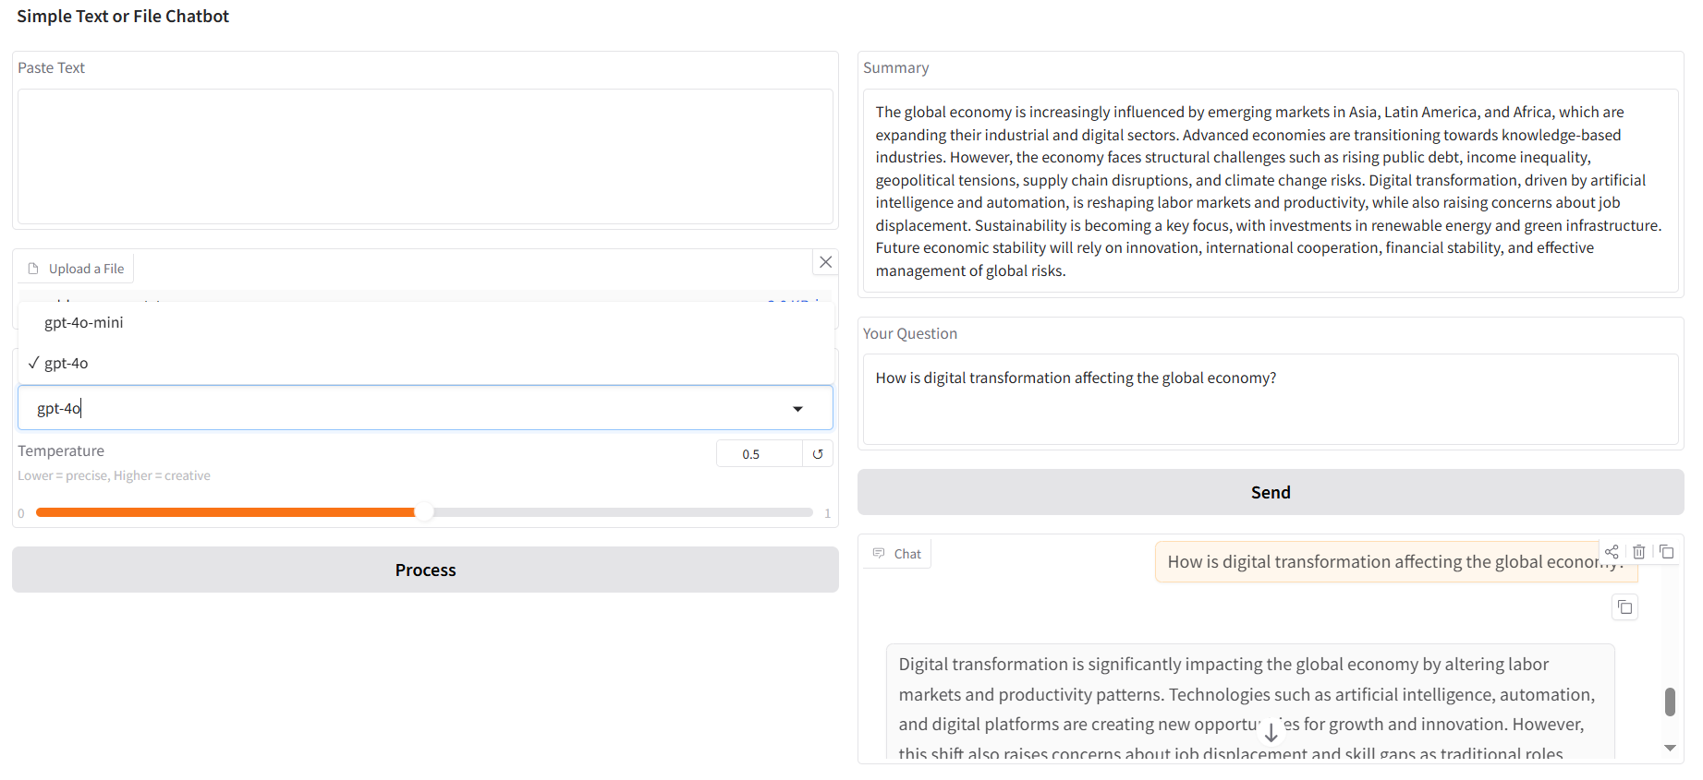

Architecture (Simple View)
Document → Embeddings → Vector Index → RAG Session → LLM Response
Main components:
- LLM Manager
- Vector Store Manager
- RAG Session Handler
- Gradio UI Layer

Installation
git clone
cd
pip install -r requirements.txt

Setup
Create a .env file in the project root:
OPENAI_API_KEY=your_api_key_here

Run
python app.py
The Gradio interface will open in your browser.

