**Pseudo Code Of Gmail**

* Feature Sign up and Sign in
* Sign up

Begin

SHOW (“Enter First name and last name”)

INPUT First name and last name

INPUT basic details

SHOW (“Enter user name”)

INPUT Username (email)

SHOW (“Enter Password”)

INPUT password

SHOW (“Enter phone number”)

INPUT phone number

INPUT G-Code (for verify your phone number)

Account details Save ( registered)

End

* Sign in

Begin

SHOW (“Enter email”)

INPUT email

IF CHECK email does not exits THEN

SHOW (“Email does not exits”)

END IF

SHOW (“Enter password”)

INPUT password

IF CHECK password is incorrect THEN

SHOW (“password is incorrect”)

ELSE

SHOW (“Successfully sign in”)

END IF

END

**Workflow Of Gmail**

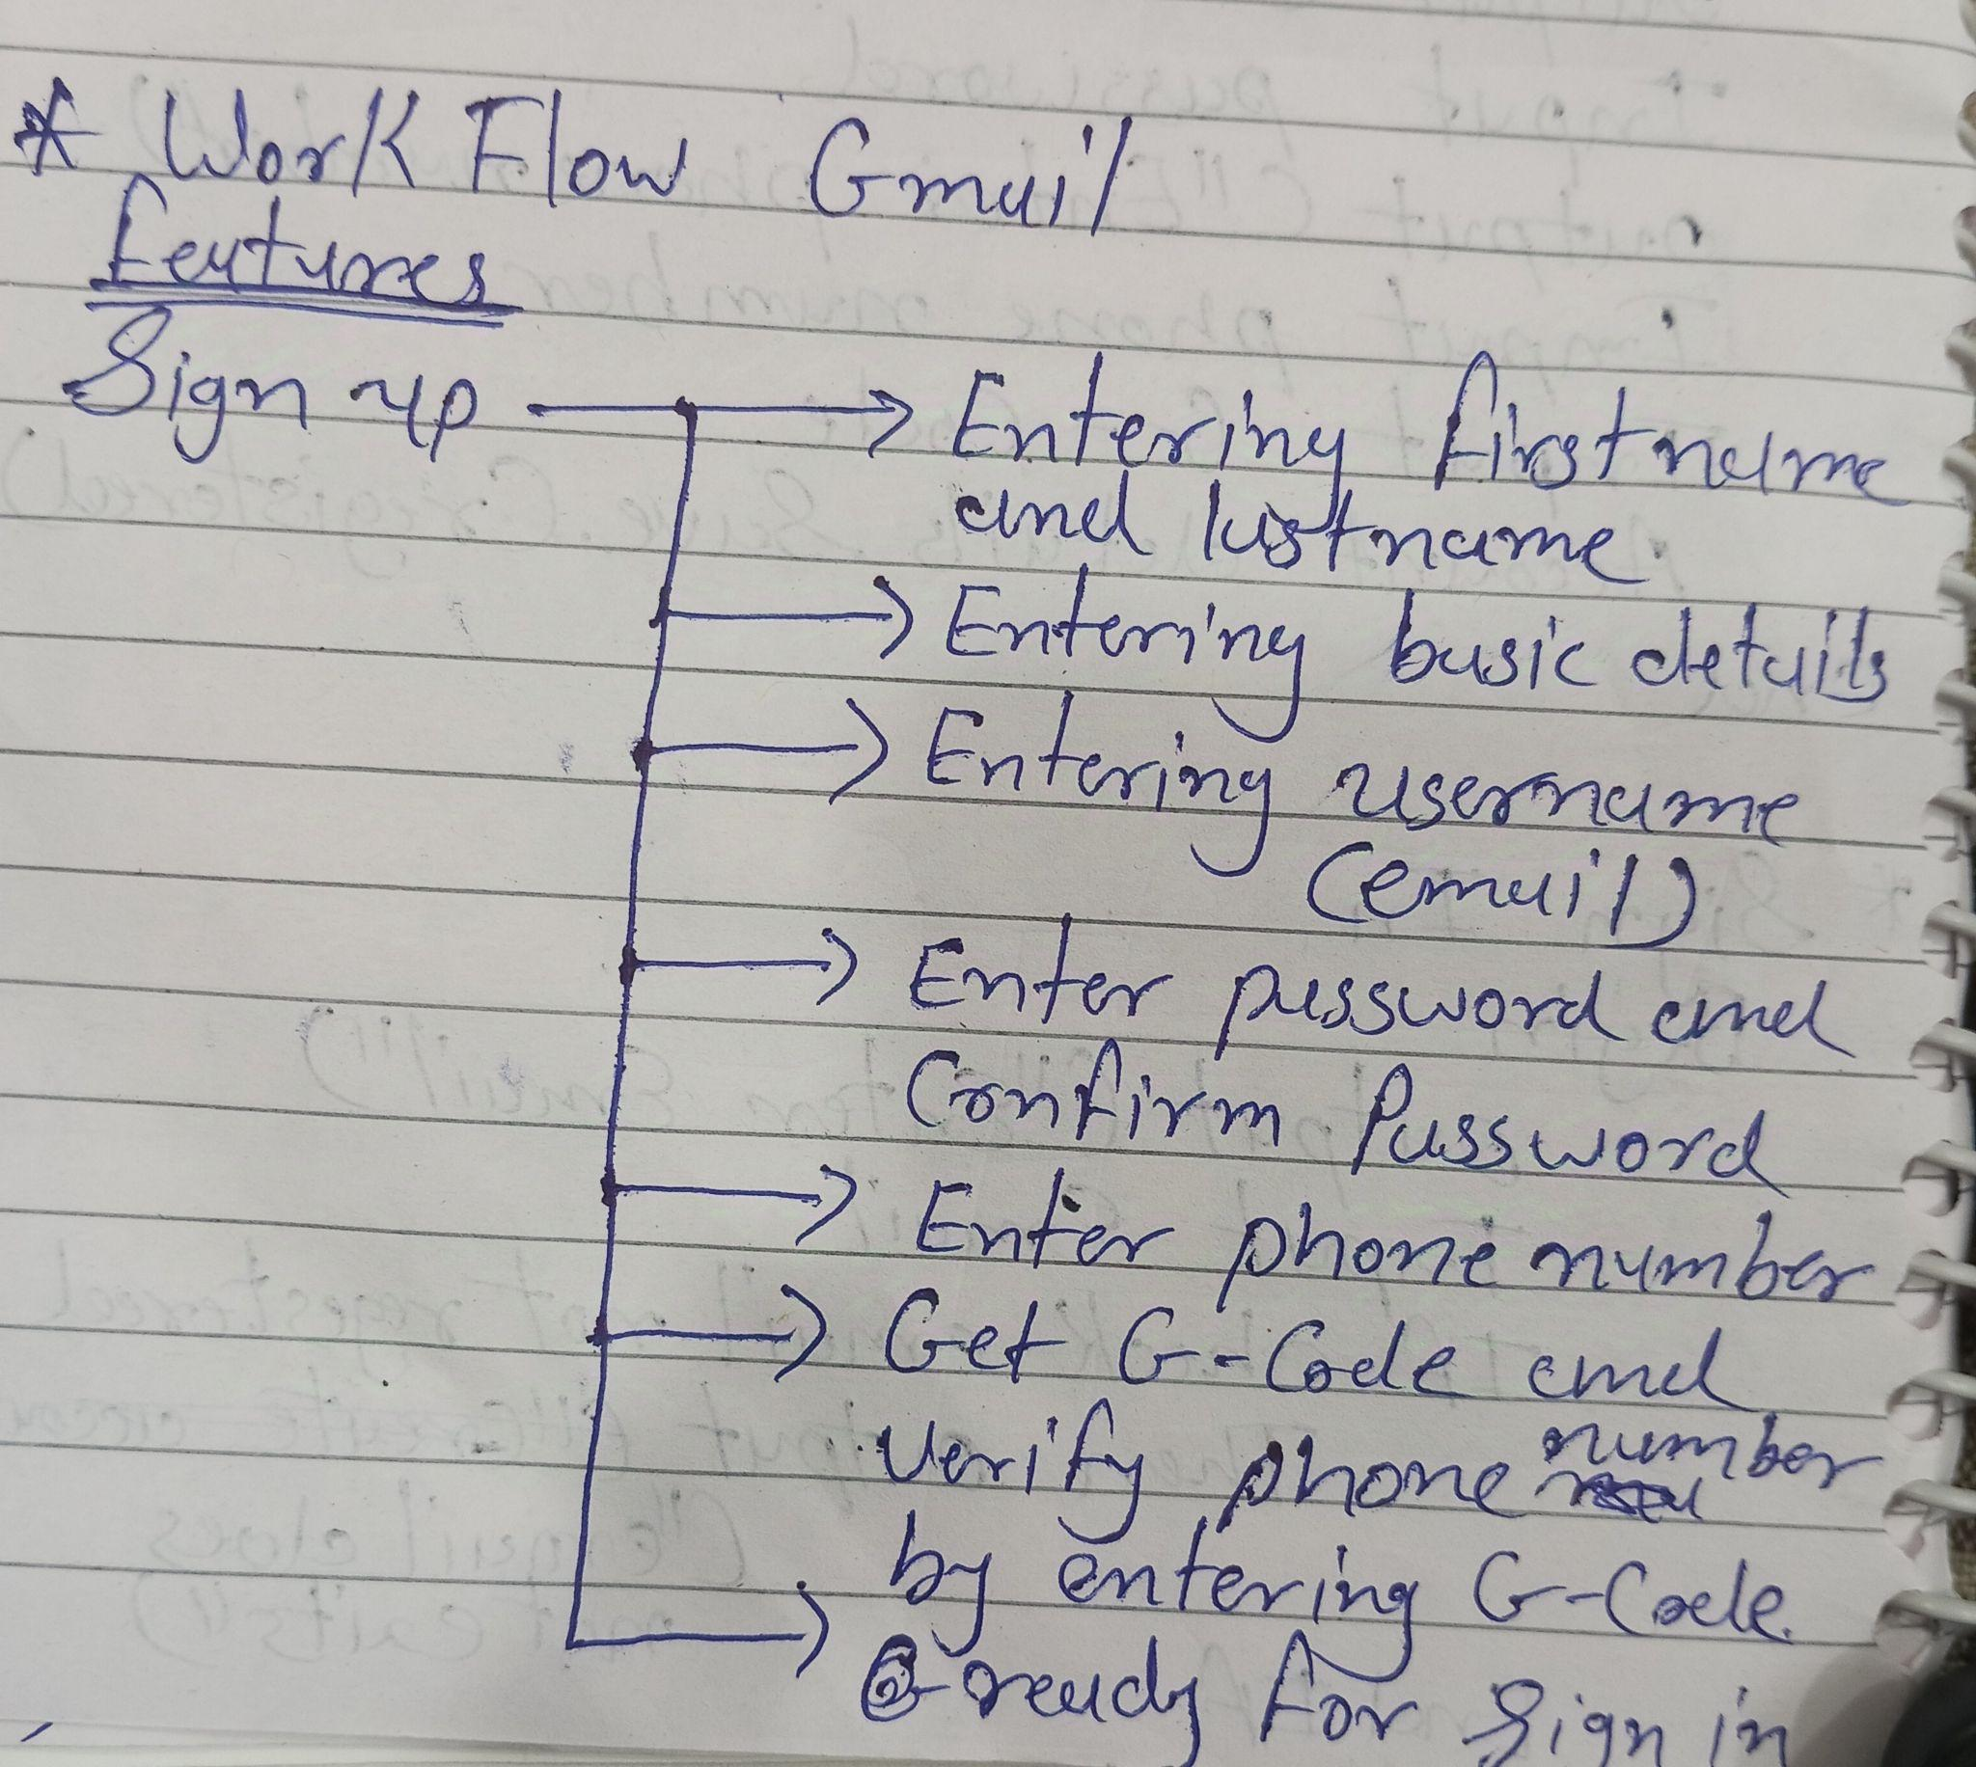

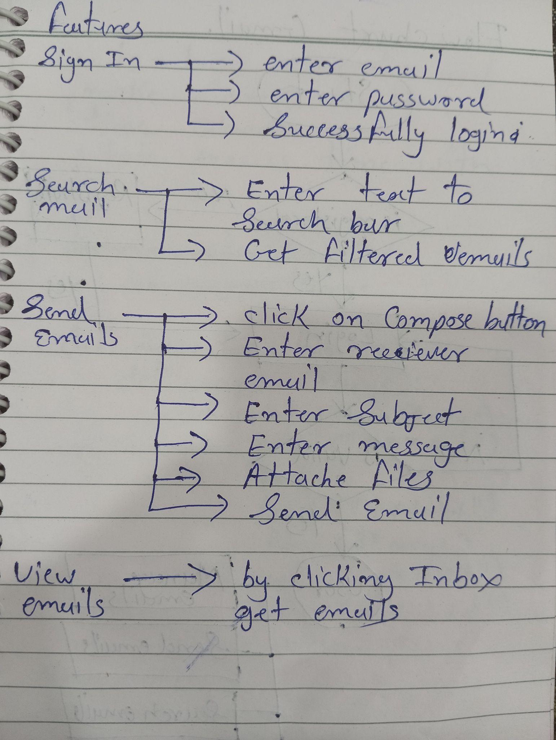

**Flowchart Of Gmail**

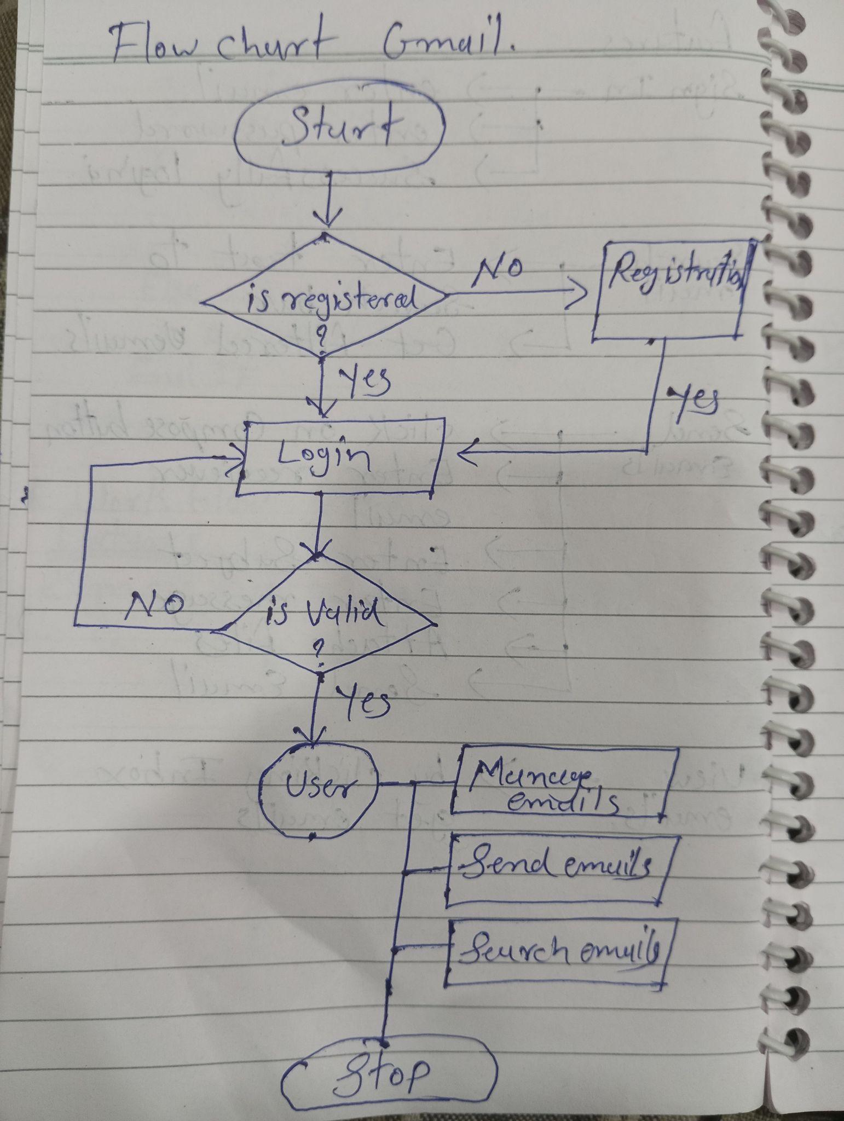

**Algorithm Of Fibonacci Series**

Step 1 : initialize list, fib = []

Step 2 : a = 0, b = 1

Step 3 : if n = 0 print(0)

Step 3 : if n = 1 print(0,1)

Step 4 : for i from 3 to n:

Step 5 : temp = a + b

Step 6 : fib.append(temp)

Step 7 : a = b

Step 8 : b = temp , end for loop

Step 9 : print(list)