1. what is difference between sql and psql list all

SQL is a standard language for storing, manipulating and retrieving data in databases. Whereas psql is a tool or database management system to store databases. It is a relational database management system.

1. install psql if not installed

Sudo apt-get install postgresql

1. create/delete multiple database

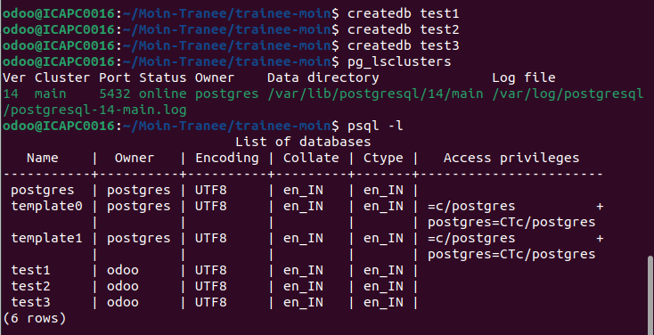

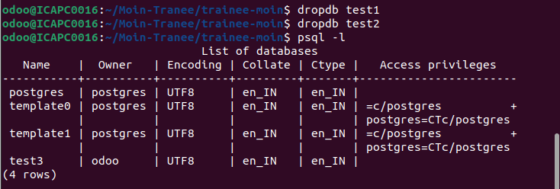

1. check use of alter command for tables



Step 1: Create Two Tables

Table: employees

employee_id integer

name​ Varchar(100)​

department Varchar(50)

Table: projects

project_id integerproject_name Varchar(100)​

employee_id Integer

project_id is the Primary Key.

employee_id is a Foreign Key referencing employees(employee_id).

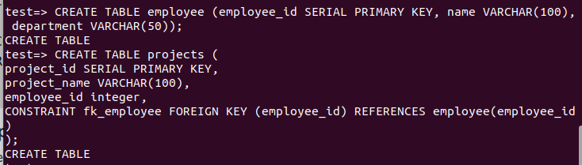

Step 2: Insert Records

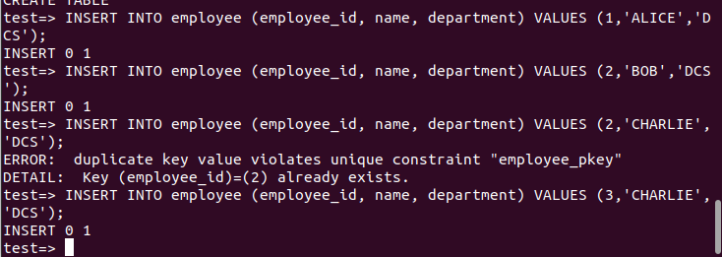

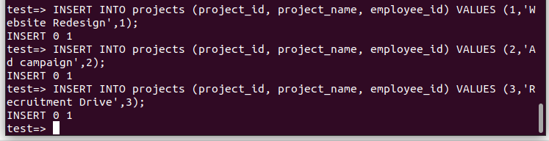

Step 3: Write a Join Query

Write a query to retrieve the names of employees and their project names, only for those who

are assigned to a project (using an INNER JOIN).

