**Notebook code**

def decorator(func):

def wrapper(*args):

def print_pattern(*args):

print("*****")

print("%%%%%")

func(*args)

print("*****")

print("%%%%%")

print_pattern(*args)

@decorator

def print_string(string):

string = input("enter string")

print(string)

print_string('this is a string')

**Error: Type Error**

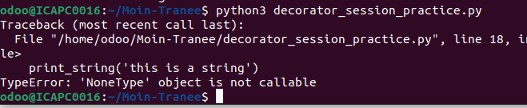

**Resolve: returning wrapper function and string, Getting string and assign into variable**

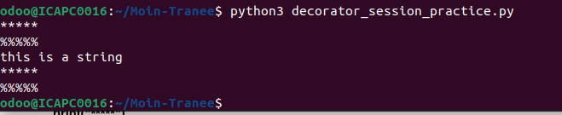

**def decorator(func):**

**def wrapper(*args):**

**print("*****")**

**print("%%%%%")**

**string = func(*args)**

**print(string)**

**print("*****")**

**print("%%%%%")**

**return string**

**return wrapper**

**@decorator**

**def print_string(string):**

**return string**

**print_string('this is a string')**