**Setup "Virtual Environment" with given commands.**

First we are installing virtualenvwrapper into the our system. Installing command is:

-Sudo apt install virtualenvwrapper

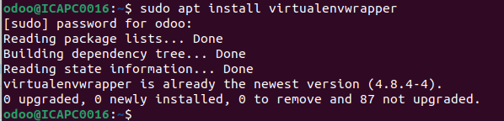

Second run the script or bash file into the your system

-source /usr/share/virtualenvwrapper/virtualenvwrapper.sh

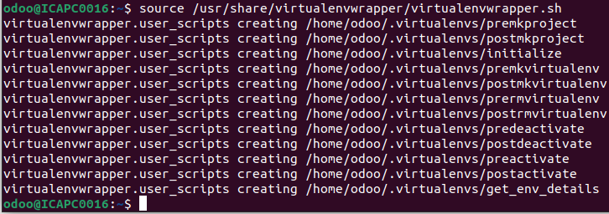

Finally make virtualenve and give it to path of python version and environment name

-mkvirtualenv -p /usr/bin/python3.10 environment_name

