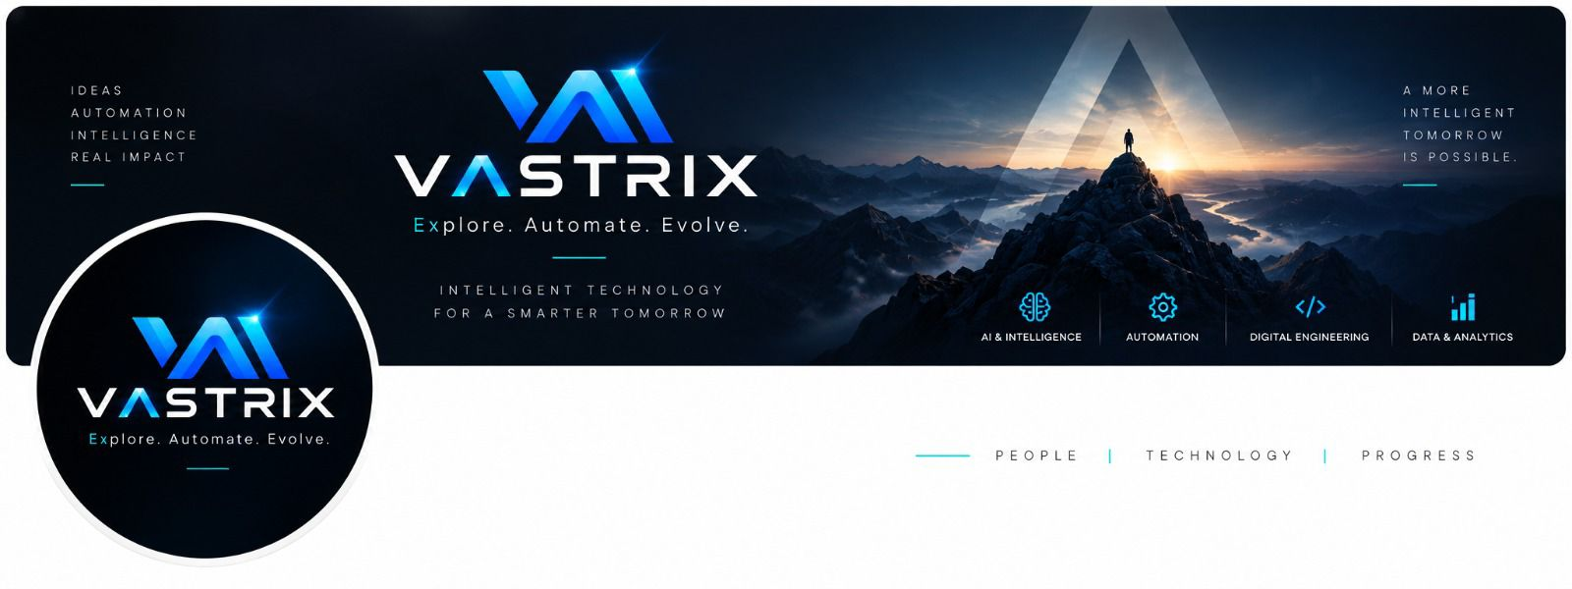
VASTRIX WEBSITE
DEVELOPMENT MASTER SPECIFICATION
Product • UX • Architecture • Engineering • Deployment • Security • Operations
Explore. Automate. Evolve.

Document purpose
Implementation-ready blueprint derived from the supplied VASTRIX service catalogue, brand material and architecture diagram. It is intended for product, UI/UX, frontend, backend, DevOps, QA and content teams.

Table of Contents
- 1. Executive Summary
- 2. Source Material & Constraints
- 3. Product Goals
- 4. Brand & Visual System
- 5. Information Architecture
- 6. Page-by-Page Specification
- 7. Services Architecture
- 8. Solutions & Industries
- 9. Products, Case Studies & Insights
- 10. UX/UI Component System
- 11. Open-Source Technical Stack
- 12. System Architecture
- 13. Frontend Engineering
- 14. Backend Engineering
- 15. CMS
- 16. Data Model
- 17. API Specification
- 18. Authentication
- 19. Future AI Layer
- 20. Deployment
- 21. CI/CD
- 22. Security
- 23. Performance / SEO / Accessibility
- 24. Observability & Backups
- 25. Environment Management
- 26. Repository Structure
- 27. Testing
- 28. Implementation Roadmap
- 29. Team Responsibilities
- 30. Acceptance Criteria
- 31. Content Governance
- 32. Future Scalability
- 33. Final Architecture

1. Executive Summary
VASTRIX should be implemented as a premium, engineering-led technology company website rather than a generic software-agency landing page. The supplied catalogue defines four core pillars—AI & Intelligence, Automation, Digital Engineering, and Data & Analytics—and extends the offering into Product & SaaS Engineering and Consulting & Technology Advisory.
The website must serve two purposes simultaneously: communicate the VASTRIX brand and capabilities clearly to prospective clients, and establish a maintainable technical foundation that can later support a CMS, lead-management system, client portal, SaaS products and a VASTRIX AI experience.
Core positioning
VASTRIX is an intelligent technology and engineering company. The website should lead with the four core pillars and extend into product engineering and advisory services.

2. Source Material and Constraints
The supplied VASTRIX service catalogue is the primary content source. It explicitly describes itself as the master service-definition draft for the website, proposals, capability decks and future sales material, and instructs the team to publish only capabilities VASTRIX is ready to deliver.
Recommended navigation from the supplied material:
- Home
- About
- Services
- Solutions
- Industries
- Products
- Projects / Case Studies
- Insights
- Contact
Non-negotiable content governance:
- Do not publish unverified government approvals, empanelments, certifications or marketplace registrations.
- Do not publish client logos or case studies without permission.
- Do not guarantee ROI, 100% automation or AI accuracy.
- Do not claim security/compliance certifications that VASTRIX does not hold.
- Do not use technology lists merely to make the company appear larger.
- Use “Coming Soon” for planned capabilities rather than presenting them as currently delivered.

3. Product Goals and Website Objectives
Goal | Implementation requirement | Outcome
Brand credibility | Premium visual language, clear positioning, engineering evidence | Fast comprehension and trust
Lead generation | Structured enquiry flows and contextual CTAs | Actionable enquiries
Service discovery | Pillar/category/detail architecture | Easy capability discovery
Enterprise readiness | Security, reliability and technical depth | Professional perception
Government readiness | Dedicated public-sector context without unsupported claims | Clear factual capability communication
Content growth | Self-hosted CMS for insights, projects and service content | No code change for routine publishing
Future AI | Clean API boundary and knowledge architecture | AI can be added without redesigning the site
Open source | Self-hostable core software and deployment | Reduced proprietary platform dependency

4. Brand and Visual Design System
Use the supplied VASTRIX logo and brand assets as the visual source of truth. The reference material combines a dark cinematic technology aesthetic with clean white space, blue/cyan accents, geometric typography and the message “Intelligent Technology for a Smarter Tomorrow.”
Design token | Value | Usage
Vastrix Blue | #2563EB | Primary actions/highlights
Neon Cyan | #06B6D4 | AI/future accents
Midnight | #0A0F1C | Hero/footer/dark sections
Slate | #64748B | Secondary text
Light | #F8FAFC | Light backgrounds
Typography | Manrope | Brand typography

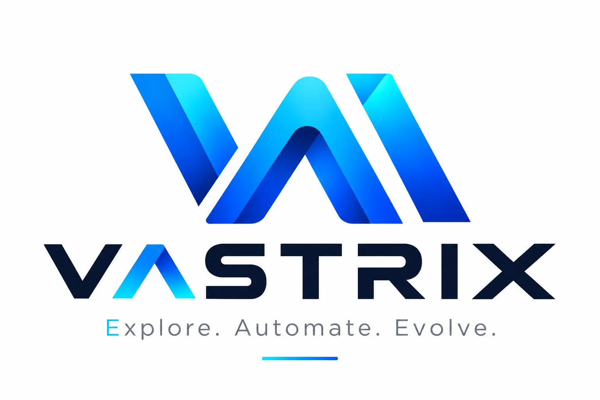

4.1 Visual rules
- Use generous whitespace and strong hierarchy.
- Use dark sections selectively; not every page should be dark.
- Use blue/cyan gradients as accents rather than full-page decoration.
- Prefer real project/product visuals, diagrams and UI screenshots over generic AI imagery.
- Keep motion purposeful and support prefers-reduced-motion.
- Use accessible contrast and visible keyboard focus states.
- Do not alter the supplied logo proportions or colors.

5. Information Architecture and Sitemap
/
├── Home
├── About
├── Services
│ ├── AI & Intelligence
│ ├── Automation
│ ├── Digital Engineering
│ ├── Data & Analytics
│ ├── Product & SaaS Engineering
│ └── Consulting & Technology Advisory
├── Solutions
├── Industries
├── Products
├── Projects / Case Studies
├── Insights
└── Contact

5.1 URL conventions
/services
/services/ai-intelligence
/services/automation
/services/digital-engineering
/services/data-analytics
/services/product-saas-engineering
/services/consulting

/solutions/<slug>
/industries/<slug>
/products/<slug>
/case-studies/<slug>
/insights/<slug>

6. Page-by-Page Specification

Home
Hero; four-pillar capability strip; What We Do; VASTRIX Difference; solution cards; industries; How We Work; selected work; final CTA. Primary CTAs: Discuss a Project, Explore Our Services.

About
Positioning; vision; mission; values; engineering principles; team/founding story; capabilities; contact CTA.

Services
Six service categories; category descriptions; representative capabilities; links to detailed service pages.

Service detail
Hero/value proposition; problem; what we do; capabilities; use cases; technology approach; how we work; expected outcomes; case study; FAQ; CTA.

Solutions
Outcome-oriented solution patterns. Each solution explains the problem, workflow, technical approach, expected outcomes and relevant services.

Industries
Industry context without pretending to hold unsupported domain credentials. Government/Public Sector is a dedicated target-market section.

Products
VASTRIX-owned or co-developed products. Show status such as Concept, Prototype, Beta or Live.

Case Studies
Problem; constraints; approach; architecture; implementation; evidence-backed outcome; technology; CTA. Require permission for client identity.

Insights
CMS-backed articles, tutorials and technical thought leadership with author, category, tags, dates and SEO metadata.

Contact
Structured enquiry form with name, email, organization, service interest, requirement, industry, timeline, optional budget and attachment, plus consent.

7. Services Architecture

AI & Intelligence
- Generative AI Solutions
- AI Agents & Agentic Automation
- Machine Learning
- NLP
- Computer Vision
- Document Intelligence
- AI Consulting & Integration

Automation
- Business Process Automation
- Python Automation
- Workflow Automation
- RPA & Task Automation
- API Integration & Orchestration
- Infrastructure & IT Automation
- Intelligent Automation

Digital Engineering
- Website Development
- Web Application Development
- Application Development
- Backend & API Development
- UI/UX Design
- Custom Software Development
- Cloud & DevOps Engineering

Data & Analytics
- Data Analytics
- Business Intelligence & Dashboards
- Data Engineering & ETL
- Predictive Analytics
- Reporting Automation
- Decision Intelligence

Product & SaaS Engineering
- SaaS Product Development
- MVP Development
- AI Product Development
- Internal Tools & Portals

Consulting & Technology Advisory
- Digital Transformation Consulting
- Automation Opportunity Assessment
- AI Readiness & Use-Case Assessment
- Solution Architecture

7.1 Service detail content model
Field | Type | Required
name | String | Yes
slug | String | Yes
category | Relation | Yes
shortDescription | Text | Yes
heroTitle | String | Yes
heroDescription | Text | Yes
problemStatement | Rich text | Yes
capabilities | Repeatable list | Yes
useCases | Repeatable list | Yes
technologyApproach | Rich text | No
outcomes | Repeatable list | No
caseStudies | Relation | No
faq | Repeatable list | No
seo | Object | Yes

8. Solutions and Industries Architecture
Layer | Purpose | Example
Services | What can VASTRIX do? | Document Intelligence
Solutions | How can it solve a problem? | Invoice-to-workflow automation
Industries | Where is it relevant? | Public-sector workflow
Case Studies | What evidence exists? | Approved project example
Products | What does VASTRIX build/own? | SaaS product

8.1 Government/Public-Sector capability areas
- Citizen-facing digital services—portals, applications, forms and accessible experiences.
- Department workflow automation—routing, approvals, notifications and repetitive administration.
- Data and analytics platforms—dashboards, reporting, integration and decision support.
- AI-enabled public services—document intelligence, classification and controlled information assistants.
- Infrastructure and operations automation—repeatable server, configuration and job automation.
- Custom software and modernization—modern applications, APIs and integrations for manual or legacy processes.

9. Products, Case Studies and Insights

9.1 Product lifecycle
Concept → Prototype → Beta → Production → Evolve

9.2 Case-study template
- Client/industry, if permitted
- Problem and constraints
- Discovery and solution approach
- Architecture/technology
- Implementation
- Evidence-backed outcomes
- Lessons learned
- CTA

9.3 Insight workflow
- Draft
- Technical/content review
- Brand/editorial review
- SEO review
- Publish
- Monitor and update

10. UX/UI Component System
- Header/navigation
- Services mega-menu
- Hero
- Primary/secondary CTA
- Capability card
- Service card
- Solution card
- Industry card
- Case-study card
- Product card
- Process timeline
- FAQ accordion
- Technology badge
- Contact form
- Newsletter form
- Breadcrumbs
- Footer
- Legal/privacy notice

10.1 Interaction standards
- No critical content should depend on hover.
- All interactive controls need keyboard focus states.
- Forms need labels, inline validation and accessible error messages.
- Animations must be subtle and support reduced-motion preferences.
- Use skeleton/loading states only for genuinely asynchronous content.
- Buttons should describe the action: Discuss a Project, Automate a Process, Explore an AI Use Case, Build a Digital Product, Talk to VASTRIX, Request a Consultation.

11. Open-Source Technical Stack
The baseline below is selected to satisfy the requirement that the development and deployment stack be open-source/self-hostable. Exact dependency versions and licenses must be recorded before production.
Layer | Technology | Purpose
OS | Ubuntu Server / Debian | Open-source Linux server
Frontend | Next.js + React + TypeScript | Web application
Styling | Tailwind CSS | UI styling
UI primitives | shadcn/ui + Radix UI | Accessible components
Animation | Framer Motion | Motion
Backend | Python + FastAPI | REST/API/business logic
Validation | Pydantic | Typed validation
ORM | SQLAlchemy | Database access
Database | PostgreSQL | Persistent relational data
Vector search | pgvector | Future RAG/semantic search
Cache | Redis | Caching and queue support
Jobs | Celery | Background tasks
CMS | Strapi Community Edition | Self-hosted content management
Storage | MinIO | Self-hosted object storage
Proxy | Nginx | Routing/TLS/rate limiting
Containers | Docker + Docker Compose | Reproducible deployment
CI/CD | GitLab CE + GitLab Runner | Self-hosted DevOps
Metrics | Prometheus | Metrics
Dashboards | Grafana | Visualization
Logs | Loki | Centralized logs
Errors | GlitchTip | Self-hosted error tracking
Identity future | Keycloak | OIDC/OAuth2
AI serving future | Ollama / vLLM | Self-hosted model serving

License discipline
Maintain an inventory of package versions and licenses and review them for commercial compatibility. “Open source” should be verified at the exact version used, not assumed.

12. System Architecture
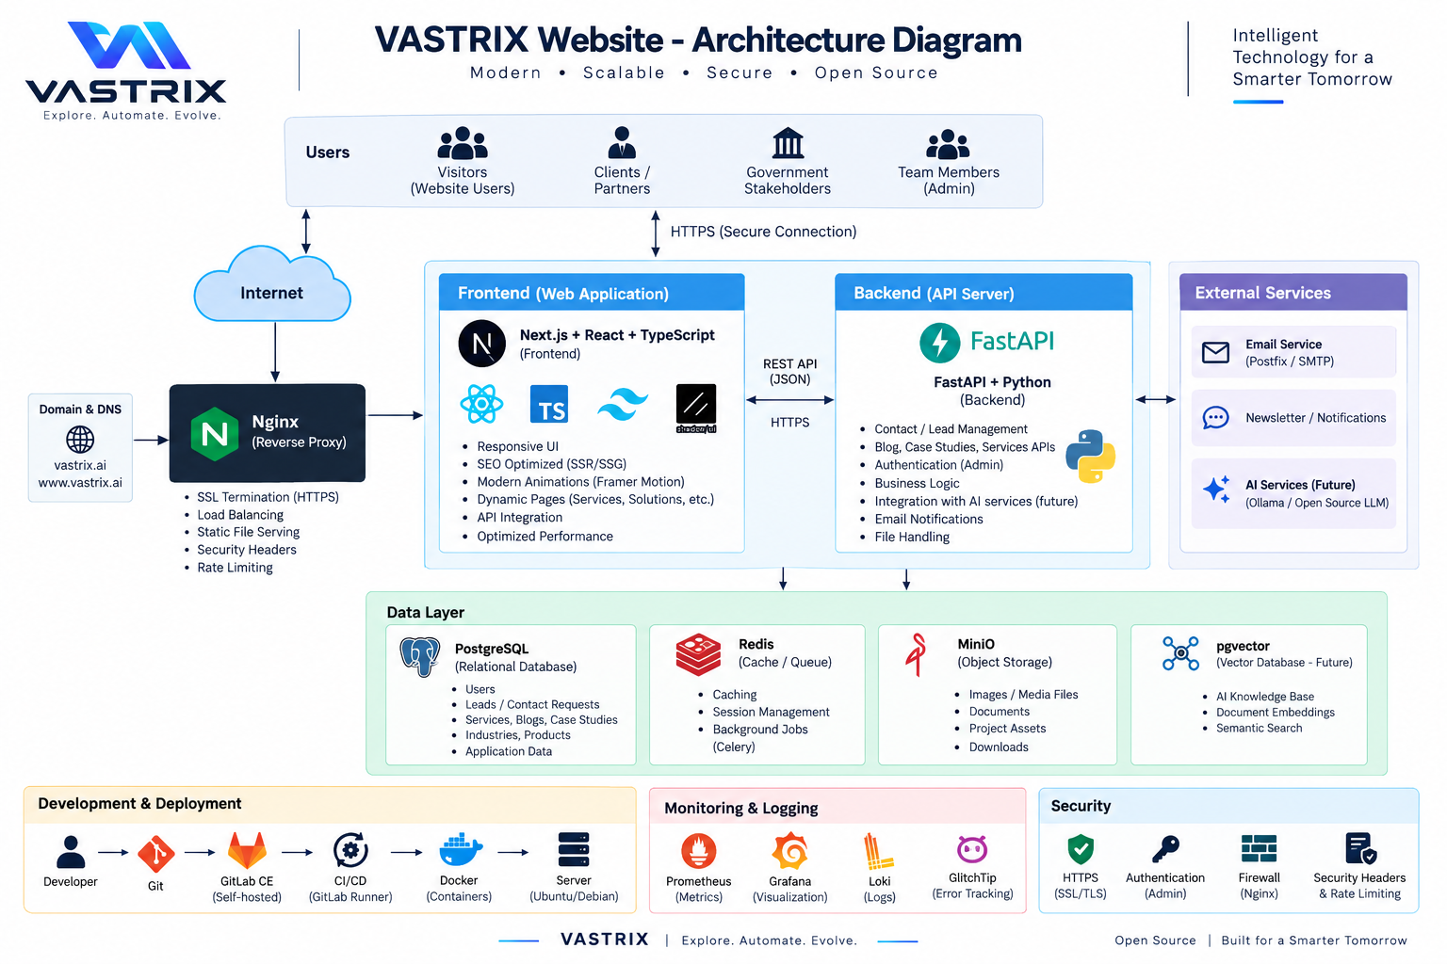
Users
↓
Internet / HTTPS
↓
Nginx Reverse Proxy
├── Next.js Frontend
│ ↓ REST/JSON
└── FastAPI Backend
├── PostgreSQL
├── Redis
├── MinIO
└── Future AI services

Development:
Developer → Git → GitLab CE → GitLab Runner → Docker → Linux Server

Operations:
Applications → Prometheus / Loki / GlitchTip → Grafana

Security:
HTTPS + Authentication + Firewall + Security Headers + Rate Limiting

12.1 Initial deployment topology
Internet
│
▼
Firewall
│
▼
Nginx
├── vastrix.ai → Next.js
└── api.vastrix.ai → FastAPI
├── PostgreSQL
├── Redis
└── MinIO

13. Frontend Engineering Specification
Content | Rendering approach
Home | Static/ISR where practical
About | Static
Services | Static/ISR
Service details | ISR from CMS
Solutions/Industries | ISR from CMS
Products | ISR
Case studies | ISR
Insights | ISR/static dynamic routes
Contact | Interactive form + API
Admin | Separate CMS

13.1 Frontend responsibilities
- Responsive rendering
- SEO metadata
- Sitemap/robots generation
- Image optimization
- CMS/API integration
- Form UX and validation
- Accessible components
- No private secrets in browser bundles
- Graceful API error handling

14. Backend Engineering Specification
apps/api/
├── app/
│ ├── main.py
│ ├── core/
│ │ ├── config.py
│ │ ├── security.py
│ │ └── logging.py
│ ├── api/v1/
│ │ ├── contact.py
│ │ ├── leads.py
│ │ ├── search.py
│ │ └── health.py
│ ├── models/
│ ├── schemas/
│ ├── services/
│ ├── repositories/
│ ├── workers/
│ └── db/
└── tests/
- Version APIs as /api/v1/.
- Keep business logic out of route handlers.
- Validate all inputs with Pydantic.
- Use migrations for schema changes.
- Apply rate limiting to public endpoints.
- Never log passwords, tokens or secrets.
- Expose health/readiness endpoints.
- Return consistent error structures.

15. CMS / Content Management
Use a self-hosted Strapi Community Edition instance to satisfy the open-source/self-hosted requirement while allowing non-developers to manage content.
Strapi
├── Services
├── Solutions
├── Industries
├── Products
├── Case Studies
├── Insights
├── FAQs
├── Authors
└── Site Settings
Role | Permissions
Administrator | Full configuration/user management
Editor | Create, edit and publish content
Author | Create drafts/edit permitted content
Reviewer | Review content if workflow is configured

16. Data Model and Database Design
site_settings
leads
newsletter_subscribers
contact_events

Content entities:
services
service_categories
solutions
industries
products
case_studies
insights
authors
faqs
media references
Entity | Important fields
leads | name, email, organization, service_interest, industry, requirement, timeline, budget, attachment_url, status, timestamps
newsletter_subscribers | email, consent_status, source, created_at
contact_events | lead_id, event_type, metadata, created_at
site_settings | company_name, tagline, contact_email, phone, updated_at

17. API Specification
Method | Endpoint | Purpose | Auth
GET | /api/v1/health | Health check | Public
POST | /api/v1/contact | Contact enquiry | Public + rate limit
POST | /api/v1/leads | Lead creation | Public + rate limit
GET | /api/v1/search | Approved public content search | Public
GET | /api/v1/site-config | Public configuration | Public
GET | /api/v1/admin/leads | List leads | Admin
PATCH | /api/v1/admin/leads/{id} | Update lead | Admin

POST /api/v1/contact
{
"name": "Example Person",
"email": "person@example.com",
"organization": "Example Organization",
"service_interest": "Automation",
"industry": "Enterprise",
"requirement": "Describe the problem",
"timeline": "3-6 months"
}

18. Authentication and Administration
- Public marketing pages require no login.
- Strapi handles CMS administration.
- Future client portals can use Keycloak for centralized identity.
- Use OIDC/OAuth2 where enterprise identity integration is needed.
- Implement RBAC and least privilege.
- Separate public and admin APIs.
- Log security-relevant administrative events.

19. Future AI Layer
The first website release should not depend on AI, but the architecture should provide a clean integration boundary for a future VASTRIX AI assistant, knowledge system or AI-powered lead qualification flow.
Visitor
↓
VASTRIX AI Assistant
↓
FastAPI AI Gateway
├── Retrieval → PostgreSQL + pgvector
├── Model server → Ollama / vLLM
├── Approved tools/APIs
└── Guardrails + logging
- Visitor describes a business problem.
- Assistant maps it to approved VASTRIX capability information.
- Assistant retrieves only approved public knowledge.
- Assistant explains a possible solution pattern.
- Assistant offers a contextual CTA.
- Lead creation occurs only through an explicit user action/consent flow.
AI governance
The future assistant must not invent credentials, case studies, certifications, client names or performance claims. It should distinguish examples from actual VASTRIX work and route uncertain/sensitive requests to a human.

20. Deployment Architecture
Production Linux Server
├── Docker Engine
├── Docker Compose
├── Nginx
├── Next.js
├── FastAPI
├── Strapi
├── PostgreSQL
├── Redis
├── MinIO
├── Prometheus
├── Grafana
├── Loki
└── GlitchTip

Future:
├── Keycloak
├── pgvector
└── Ollama / vLLM
Host | Purpose
vastrix.ai | Public website
www.vastrix.ai | Canonical/redirect alias
api.vastrix.ai | FastAPI
cms.vastrix.ai | Protected CMS
Internal monitoring host | Grafana/Prometheus/Loki, protected from public access

20.1 Initial infrastructure principle
Start with one Linux server and Docker Compose if traffic is modest. Do not introduce Kubernetes merely for appearance. Move to multi-server/container orchestration only when scale, isolation or operational requirements justify it.

21. CI/CD and Development Workflow
Developer
↓
Feature branch
↓
Merge Request
↓
GitLab CE
├── lint
├── type-check
├── unit tests
├── build
├── dependency/security checks
└── Docker image build
↓
GitLab Runner
↓
Staging
↓
Approval / release
↓
Production

21.1 Branches
- main — production-ready
- develop — optional integration branch
- feature/* — features
- fix/* — normal fixes
- hotfix/* — urgent production fixes

21.2 Commit convention
feat: add service page
fix: correct contact validation
docs: update deployment guide
refactor: simplify lead service
test: add API tests
chore: update dependencies

22. Security Architecture
Control | Implementation
Transport | HTTPS/TLS everywhere
Reverse proxy | Nginx
Headers | CSP, HSTS, X-Content-Type-Options, Referrer-Policy as appropriate
Rate limiting | Nginx/FastAPI
Input validation | Pydantic + frontend schema
Auth | CMS auth; Keycloak future
Authorization | RBAC/least privilege
Secrets | External environment/secret storage; never Git
Database | Private network binding where possible
Backups | Encrypted and tested
Dependencies | Automated scanning
Uploads | Size/type restrictions and safe storage

23. Performance, SEO and Accessibility

23.1 Performance
- Optimize hero imagery and use modern image formats.
- Lazy-load below-the-fold media.
- Minimize unnecessary client-side JavaScript.
- Prefer static/server rendering for content pages.
- Cache safe CMS responses.
- Compress assets.
- Monitor Core Web Vitals.
- Avoid heavy 3D effects unless they provide real communication value.

23.2 SEO
- Unique title/meta description per page.
- Canonical URLs.
- XML sitemap.
- Robots directives.
- OpenGraph metadata.
- Organization/Article structured data where applicable.
- Breadcrumb structured data where appropriate.
- Human-readable slugs.
- Internal links between Services, Solutions, Industries and Case Studies.

23.3 Accessibility
- Semantic HTML.
- Keyboard navigation.
- Visible focus states.
- Accessible form labels/errors.
- Meaningful alt text.
- No color-only communication.
- Reduced-motion support.
- Responsive mobile/tablet/desktop layouts.
- Aim for WCAG 2.2 AA principles.

24. Observability, Logging and Backup
Metrics → Prometheus → Grafana
Logs → Loki → Grafana
Errors → GlitchTip
Host/container metrics → Prometheus exporters
- HTTP request rate/latency/error rate.
- FastAPI health.
- Container CPU/memory/restarts.
- PostgreSQL storage/connections.
- Redis memory/queue depth if enabled.
- Disk usage.
- Certificate expiry.
- Backup success/failure.

24.1 Backup
- Daily PostgreSQL backup at minimum for production data.
- Separate backup storage from the primary server.
- Retain multiple recovery points.
- Back up CMS media/MinIO.
- Test restoration periodically.

25. Environment and Configuration Management
Environment | Purpose
local | Developer workstation
development | Shared integration
staging | Production-like validation
production | Live site

APP_ENV=production
DATABASE_URL=postgresql://...
REDIS_URL=redis://...
CMS_URL=https://cms.vastrix.ai
S3_ENDPOINT=https://...
S3_BUCKET=vastrix-media
SMTP_HOST=...
SMTP_USER=...
SMTP_PASSWORD=...
SECRET_KEY=...
Commit only .env.example with placeholders. Never commit real credentials, private keys, tokens or production connection strings.

26. Repository Structure
vastrix-website/
├── apps/
│ ├── web/ # Next.js
│ ├── api/ # FastAPI
│ └── cms/ # Strapi
├── packages/
│ ├── ui/
│ ├── types/
│ └── config/
├── infra/
│ ├── nginx/
│ ├── docker/
│ └── monitoring/
├── docs/
│ ├── architecture/
│ ├── api/
│ ├── deployment/
│ └── content/
├── .gitlab-ci.yml
├── docker-compose.yml
├── docker-compose.staging.yml
└── README.md

26.1 Frontend
apps/web/
├── app/
│ ├── (marketing)/
│ │ ├── page.tsx
│ │ ├── about/
│ │ ├── services/
│ │ ├── solutions/
│ │ ├── industries/
│ │ ├── products/
│ │ ├── case-studies/
│ │ ├── insights/
│ │ └── contact/
│ ├── sitemap.ts
│ └── robots.ts
├── components/
│ ├── layout/
│ ├── navigation/
│ ├── hero/
│ ├── cards/
│ ├── forms/
│ ├── sections/
│ └── ui/
└── lib/
├── api/
├── cms/
└── seo/

27. Testing Strategy
Layer | Testing
Frontend | Component, rendering, accessibility
TypeScript | Strict type checking
Backend | Unit + integration + validation/error tests
Database | Migration/repository tests
CMS | Content model/API tests
E2E | Critical navigation/contact/content flows
Security | Headers, auth/RBAC, dependency scan, upload controls
Performance | Load and page-performance checks
Deployment | Post-deploy smoke tests

27.1 Critical E2E flows
- Home → Services → AI & Intelligence → service detail.
- Services → Automation → Automate a Process → submit enquiry.
- Case Studies → case study → CTA.
- Insights → article → metadata/navigation.
- Invalid Contact form → validation.
- Valid Contact form → confirmation + lead record.
- Admin → login → review/update lead.

28. Implementation Roadmap

Phase 0 — Discovery
Finalize approved content, logo assets, domain, repository, architecture decision record and license register.

Phase 1 — Design system
Figma screens, typography, spacing, colors, components, responsive states and motion rules.

Phase 2 — Frontend foundation
Next.js, TypeScript, Tailwind, components, routing, SEO and responsive shell.

Phase 3 — Core website
Home, About, Services, service details and Contact.

Phase 4 — CMS
Strapi models, roles, media and frontend integration.

Phase 5 — Extended content
Solutions, Industries, Products, Case Studies and Insights.

Phase 6 — Backend
FastAPI, PostgreSQL, lead/contact APIs, email, rate limiting and health checks.

Phase 7 — Deployment
Docker, Nginx, Linux server, TLS, CI/CD and backups.

Phase 8 — Quality
Accessibility, SEO, performance, security, responsive and content QA.

Phase 9 — Observability
Prometheus, Grafana, Loki, GlitchTip and alerts.

Phase 10 — AI
Optional AI assistant, pgvector, model serving and controlled tools.
MVP boundary
Build first: Home + About + Services + service detail + Solutions + Industries + Contact + CMS + lead API + Docker/Nginx + HTTPS + backups. Build later: client portal, AI assistant, vector search, Keycloak, full observability and Kubernetes.

29. Team Responsibilities
Role | Responsibilities
Founder/Product Owner | Brand direction, business priorities, service validation, public-claim approval
UI/UX | IA, responsive design, design system, interaction
Frontend | Next.js, TypeScript, accessibility, SEO, CMS integration
Backend | FastAPI, PostgreSQL, APIs, security
DevOps | Linux, Docker, Nginx, CI/CD, TLS, backups, monitoring
Content | Services, case studies, insights, FAQs, metadata
QA | Functional, responsive, accessibility, E2E, regression
Security | Threat model, secrets, headers, access controls, dependency review

30. Acceptance Criteria
- All primary routes work on desktop and mobile.
- Homepage communicates the four core pillars clearly.
- Every published service has approved content and CTA.
- CMS-backed content can be updated without frontend code changes.
- Contact submissions are validated, rate-limited and recorded.
- No secrets are exposed in browser bundles or Git.
- HTTPS is enforced.
- Production deployment is reproducible with documented Docker configuration.
- Backups are configured and restoration is tested.
- Critical APIs have automated tests.
- Keyboard/accessibility blockers are resolved.
- SEO metadata exists on indexable pages.
- Images are optimized and meaningful images have alt text.
- Public claims comply with approved company information.
- Health checks/logging are available.
- Dependency versions/licenses are recorded.
- Deployment and rollback documentation exists.

31. Content Governance
Content type | Rule
Government credentials | Publish only after documentary verification
Certifications | Publish exact certification/status only when held
Client logos | Permission required
Case-study metrics | Evidence required
AI accuracy | No guaranteed accuracy claims
ROI | No guaranteed ROI
100% automation | Do not present as universal
Technology lists | Only technologies actually used/available
Planned capability | Label Coming Soon

32. Future Scalability
Stage 1 → Public corporate website
Stage 2 → CMS + lead management
Stage 3 → Client portal + project workspace
Stage 4 → VASTRIX AI assistant + knowledge system
Stage 5 → SaaS/product ecosystem
Stage 6 → Multi-tenant enterprise platform
Scaling trigger | Architecture response
High traffic | Caching, replicas/CDN strategy
High API load | Horizontal FastAPI replicas + Redis
Large database | PostgreSQL tuning/read replicas when justified
Many jobs | Dedicated Celery workers/queues
Many applications | Kubernetes/K3s or another orchestrator
Enterprise identity | Keycloak/OIDC
AI workloads | Dedicated inference service/GPU infrastructure
Large knowledge base | pgvector or dedicated vector database
Multi-client infrastructure | Infrastructure-as-code and stronger isolation

33. Final Recommended Architecture
VASTRIX open-source baseline
Next.js + React + TypeScript + Tailwind CSS + shadcn/ui on the frontend; FastAPI + Python + SQLAlchemy on the backend; PostgreSQL as the primary database; Strapi Community Edition as the self-hosted CMS; Redis/Celery only when asynchronous work is required; MinIO for object storage; Nginx as reverse proxy; Docker Compose for initial deployment; GitLab CE + GitLab Runner for self-hosted CI/CD; Prometheus + Grafana + Loki + GlitchTip for operations; and pgvector + open-source model serving when the VASTRIX AI layer is introduced.
The design deliberately keeps the initial public website simple enough to operate while establishing clean boundaries for future products, client portals and AI services. It follows the supplied project lifecycle—Discover → Define → Prototype → Build → Deploy → Evolve—and the supplied engineering principles of problem-first engineering, security/access control, scalability, observability, maintainability, human-in-the-loop where appropriate and measurable outcomes.

Appendix — Developer Kickoff Checklist
- Create GitLab repository and protected main branch.
- Create monorepo structure.
- Configure TypeScript strict mode and formatting/linting.
- Create VASTRIX design tokens.
- Add approved logo/brand assets.
- Implement responsive header/footer.
- Implement homepage and service templates.
- Implement Strapi content models.
- Implement FastAPI service and PostgreSQL migrations.
- Implement contact/lead API and rate limiting.
- Implement Docker Compose and Nginx.
- Configure TLS and backups.
- Configure CI/CD.
- Run accessibility, SEO, performance and security reviews.
- Perform production smoke test.
- Document deployment, backup and rollback procedures.

