Human Activity States (Body State) Modeling Using Hidden Markov Models
Alain Ishimwe Ngabo | Formative 2: Hidden Markov Models | Repository: github-repo

1. Background and Motivation
Fitness applications need to recognise user activities such as stillness, standing, walking, and jumping to support exercise tracking, inactivity reminders, and personalised feedback. Although smartphones already contain accelerometers and gyroscopes capable of capturing movement data, the activity patterns must be inferred from noisy sensor signals that also exhibit temporal continuity. Hidden Markov Models (HMMs) are well suitable to this task because activities can be represented as hidden states, sensor-derived features as observations, and transition probabilities as the likelihood of moving between activities over time. In this project, motion data were collected using a smartphone, and a Gaussian HMM was implemented from scratch in NumPy to classify four activities: still, standing, walking, and jumping.

2. Data Collection and Pre-processing
Setup arrangement: the data was collected using Sensor Logger 1.68 on an iPhone 13, using only the accelerometer and gyroscope (x, y, z). I recorded myself. The sampling rate was 50 Hz (each sample taken every 20 ms, although the measured rate was about 49.8 Hz). I carried out the procedure according to the assignment protocol, which involved standing with the phone firmly in place at waist level, walking at a steady pace, jumping continuously, and then remaining still with the phone on a flat surface.
Split | Recordings | Per activity | Length | Seconds per activity | Windows per activity
Training | 56 | 14 | 8 s | about 112 s | 98
Test (unseen) | 16 | 4 | 8 s | about 32 s | 28
All 72 files are named according to the activity (example: jumping_01.csv) and include a timestamp column together with the activity label. The original exports remain unaltered in the ‘raw_data/ directory’. The test recordings were obtained during a different session on 25 October 2026 and were never employed for training, tuning, or normalisation.

Videos (one per activity, full body and face visible): Standing: standing-video | Walking: walking-video |Jumping: jumping-video | Still: still-video
Pre-processing: Accelerometer and gyroscope data were aligned and resampled using linear interpolation to a uniform 50 Hz rate, correcting the original sampling rate of approximately 49.8 Hz. Only the middle 8 seconds of each recording were retained to remove start and stop artefacts. As shown in Figure 1, the activities exhibit distinct signal patterns: stillness produces a nearly flat signal, standing shows low-level noise, walking displays regular oscillations, and jumping generates large repeated peaks.
Windowing: The recordings were segmented into 2-second windows (100 samples at 50 Hz) with 50% overlap, producing 7 windows per recording. This window length captures multiple walking and jumping cycles (typically 1-3 Hz) while providing a 0.5 Hz frequency resolution and maintaining responsiveness to activity changes. Alternative window lengths of 1 s and 3 s were also evaluated during hyperparameter tuning.
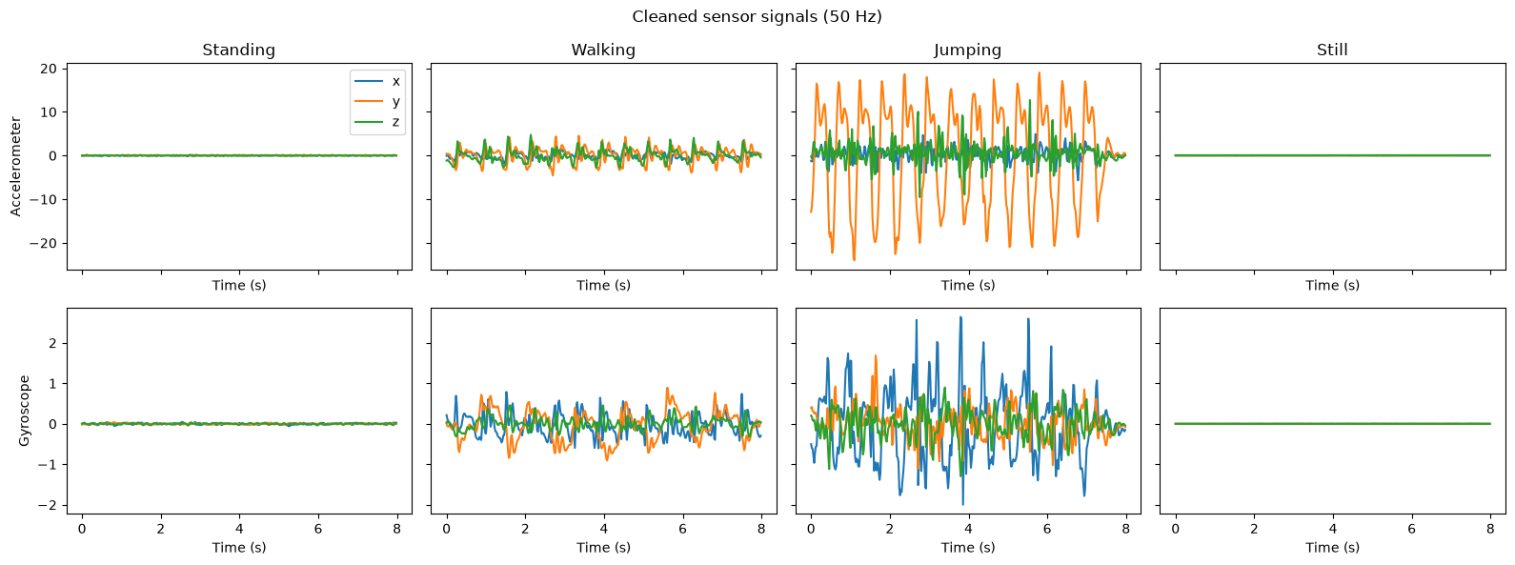
Figure 1: Cleaned accelerometer and gyroscope signals (50 Hz), one recording per activity.

3. HMM Setup and Implementation Details
Model components: The model's components include the hidden states Z, which are the four activities; the observations X, which consist of ten z-scored features for each window; the initial probabilities π, which represent the probability of beginning in each activity; the transition matrix A (4×4), which gives the probability of moving from one activity to another between consecutive windows; and the emission probabilities B, which involve a single diagonal Gaussian in each state (specifically, a mean and a variance for each feature). All of these elements are determined based on the data.
Features: A total of 10 features were extracted, consisting of 5 features per sensor: three time-domain features and two frequency-domain features derived from the FFT. The intensity-based features were log-transformed to account for the large magnitude differences between activities such as stillness and jumping. All features were z-score normalized using only the training-set mean and standard deviation, which were also applied to the test set to ensure a common scale and prevent data leakage.
Algorithms: The Baum-Welch algorithm was used to estimate the HMM parameters by maximizing the log-likelihood of the observation sequences. Training stopped when the change in log-likelihood was less than 0.001, reaching convergence after three iterations. The Viterbi algorithm was used to decode the most probable activity sequence, which was then used to compute accuracy, sensitivity, specificity, and the confusion matrix. Both algorithms were implemented in log space to avoid numerical underflow.
Training pipeline: Individual recordings containing a single activity were randomly concatenated to generate 40 training sequences, each consisting of 7 recordings and 49 windows. Emission parameters were initialized using the labelled activity windows, while the initial state probabilities and transition matrix started with neutral values, including a self-transition probability of 0.8, before being refined through Baum-Welch training.
Hyperparameter tuning: Model performance was evaluated using 7-fold cross-validation, with splits performed at the recording-session level to prevent overlapping windows from appearing in both training and validation sets. Feature normalization was recalculated for each fold using only the training data. Accuracy was used as the primary selection metric, while held-out log-likelihood served as a secondary criterion to distinguish between models with similar accuracy.
Hyperparameter | Values tested | CV accuracy | Chosen
Window size | 1 s / 2 s / 3 s | 1.000 / 0.997 / 1.000 | 2 s
Feature set | all 10 / without dom_freq / without corr / accelerometer only / gyroscope only | 0.997 / 1.000 / 0.997 / 0.997 / 0.977 | all 10
Variance floor | 0.0001 / 0.001 / 0.01 / 0.1 | 0.997 / 1.000 / 1.000 / 1.000 (held-out log-likelihood 0.79 / 0.73 / −0.41 / −4.31) | 0.001
Transition smoothing | 0.1 / 1 / 5 | 1.000 / 1.000 / 1.000 | 1
The accuracy for the window and that of the feature set differ by about one in every 392 cases, so I retained the 2 s window and all 10 features since they include both domains that are required. An extremely small variance floor led to an error since the Gaussians were too narrow, and higher floors reduced the held-out log-likelihood because the Gaussians became too wide. Hence, a value of 0.001 was selected.

4. Results and Interpretation
Unseen data: The data that could not be seen was obtained from 16 new test recordings (consisting of 112 windows, 28 for each activity) made during a separate session, using the same phone and app, and each of the recordings was decoded individually using Viterbi.
State (Activity) | Number of Samples | Sensitivity | Specificity | Accuracy
Standing | 28 | 1.000 | 1.000 | 1.000
Walking | 28 | 1.000 | 0.988 | 0.991
Jumping | 28 | 0.964 | 1.000 | 0.991
Still | 28 | 1.000 | 1.000 | 1.000
Overall | 112 | 0.991 | 0.997 | 0.991
The model was evaluated using 2-second windows. It correctly classified 111 of 112 windows (99.1%), which is very close to the cross-validation accuracy of 0.997, indicating good generalization to an unseen recording session. The per-class sensitivity, specificity, and one-versus-rest accuracy are summarized in the figure 2.
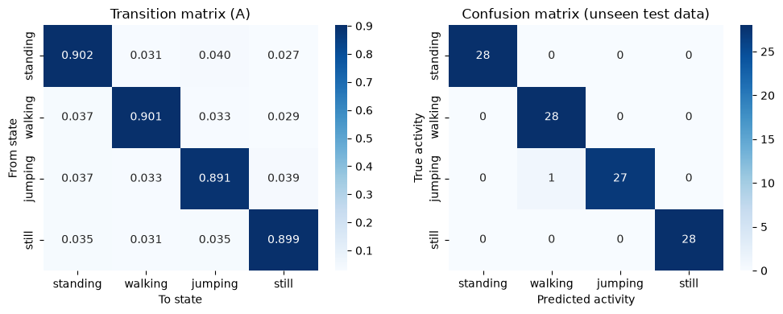
Figure 2: Learned transition matrix (left) and confusion matrix on the unseen test data (right).
Transition and emission probabilities: The learned transition matrix was strongly diagonal, with self-transition probabilities between 0.89 and 0.90, indicating that activities tended to persist across consecutive windows. Transitions to other activities each occurred with probabilities of approximately 3-4%. As shown in Figure 4, the feature ‘acc_log_std’ provided the clearest separation between activities, with mean z-scores of −1.3 (still), −0.6 (standing), 0.7 (walking), and 1.2 (jumping). Walking also exhibited a highly consistent dominant frequency (σ = 0.06), whereas still and standing showed much greater variability due to the absence of rhythmic movement.
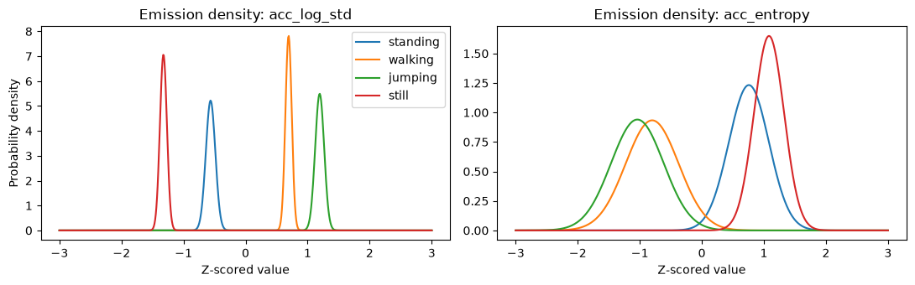
Figure 3: Emission densities of two features for each activity.
Decoded sequence: To evaluate sequence reconstruction, the test recordings were concatenated into a single session comprising 112 windows with four repetitions of the activity pattern. As shown in Figure 4 (top), the decoded sequence closely matched the true activity sequence, with activity transitions detected at the correct locations and an overall accuracy of 0.991.
Error analysis: One classification error was observed. The final window of recording jumping_18 was classified as walking because jumping stopped approximately 0.3 s into the 6-8 s window, leaving most of the window inactive. As illustrated in Figure 4 (bottom), this window represents a transition period rather than a pure jumping segment. The prediction was primarily influenced by the’acc_log_sma’ feature, making the error more reflective of label ambiguity than a systematic model weakness.
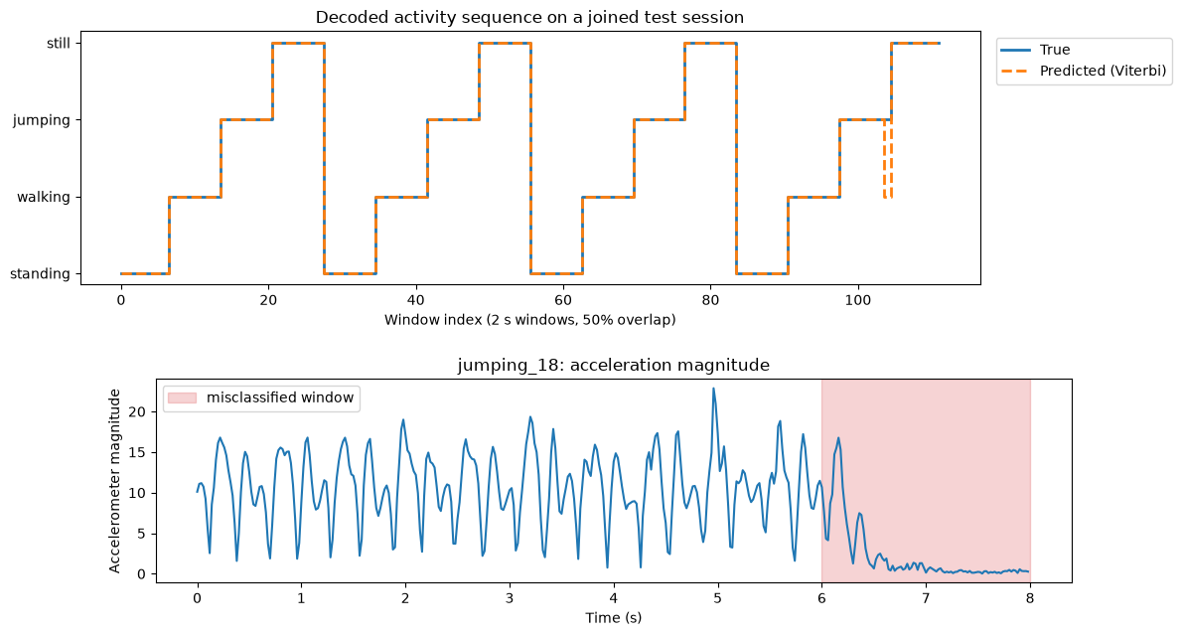
Figure 4: Top: decoded activity sequence on the joined test session. Bottom: acceleration magnitude of jumping_18, with the misclassified window shaded.

5. Discussion and Conclusion
Easiest and hardest activities: Still and standing achieved perfect classification performance because their motion intensities were substantially lower than those of walking and jumping. The logarithmic intensity features provide clear separation between these activities. Walking and jumping were the most challenging pair because both exhibit periodic motion, similar spectral entropy values, and comparable gyroscope intensities. The only test error occurred between these two classes.
Transition probabilities and realistic behavior: The high self-transition probabilities (89-90%) indicate realistic activity persistence, as individuals typically remain in the same activity for several seconds. However, the nearly uniform off-diagonal probabilities resulted from the random ordering of training recordings and therefore do not reflect real-world activity transitions.
Sensor noise and sampling rate: The phone sampled data at approximately 49.8 Hz, which was interpolated to a uniform 50 Hz grid. Since walking and jumping frequencies are well below the 25 Hz Nyquist limit, this sampling rate was sufficient. Noise mainly affected frequency-based features for still and standing activities, contributing to the wider feature distributions observed in Figure 3. Logarithmic scaling and the variance floor helped prevent overconfident predictions.
Improvements: Future work should include data from multiple participants, phone models, and device placements to improve generalizability. Additional features such as kurtosis, peak count, and jerk, as well as activities such as running and stair climbing, could further improve performance. Larger test sets and longer natural activity recordings would also provide a more robust evaluation.
Conclusion: A Gaussian HMM trained using the Baum-Welch algorithm and decoded using the Viterbi algorithm achieved 99.1% accuracy (111/112 windows) on previously unseen recordings, consistent with the cross-validation results. The findings demonstrate that smartphone motion sensors can effectively distinguish between stillness, standing, walking, and jumping. However, because the dataset was collected from a single participant using a single phone, further validation on larger and more diverse datasets is required.

