NeurIPS 2017 | Attention Is All You Need: Making Attention the Backbone
How the Transformer replaces recurrence and convolution with self-attention while improving translation quality and training efficiency
Before the Transformer, strong sequence transduction systems were usually built around recurrent models or CNN encoder-decoders. They worked, but their computation either unfolded step by step or moved through local convolutional paths. That made long-range dependencies harder to learn and limited parallel GPU training.
Attention Is All You Need asks a simple but consequential question: what if attention is not an add-on around an RNN, but the core computation of the whole encoder-decoder model? The paper's answer is the Transformer, which keeps the encoder-decoder framing but fills it with stacked self-attention and position-wise feed-forward layers.
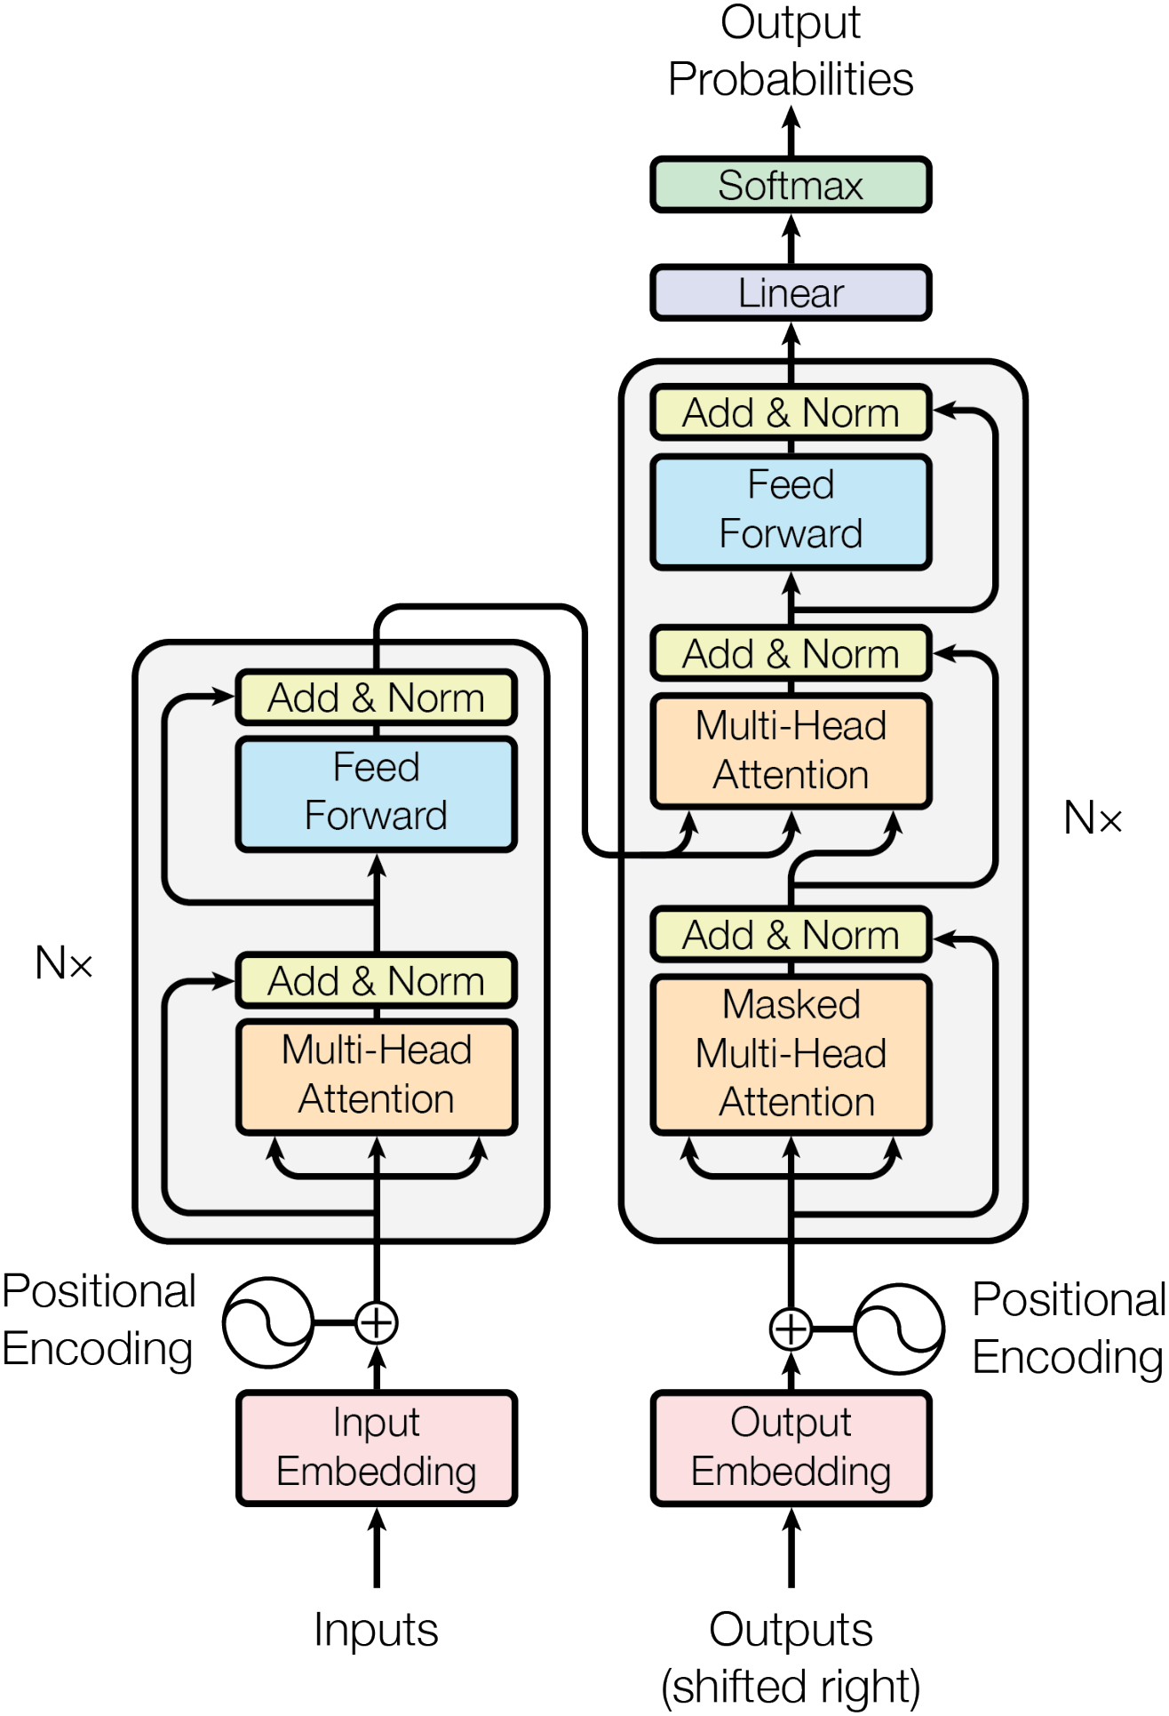
Figure 1. The Transformer architecture: encoder and decoder stacks built from self-attention and feed-forward layers, with masked self-attention and encoder-decoder attention in the decoder.

Why attention changes the path length
The motivation is both computational and representational. In RNN, information between distant tokens must pass through many intermediate states. Convolutions shorten that path, but still do not connect every token pair directly. Self-attention gives every token a one-hop route to every other token, making global relationships easier to model while keeping the computation highly parallel and scalable.
Multi-head attention is the central mechanism. Instead of attending once in a single representation space, the model projects representations into several subspaces, learns attention in each, and combines the results. The base Transformer uses dmodel = 512, eight heads, and dk = dv = 64 per head.
That framing makes the architecture diagram easier to read: it is not just a list of modules, but a map of where self-attention replaces recurrence, where masking preserves autoregressive decoding, and where feed-forward layers provide per-token computation inside each layer.

What the results show
The main experiments use WMT 2014 English-German and English-French translation. Transformer big reaches 28.4 BLEU on English-German, more than 2 BLEU above the previously reported best results in the paper, including ensembles. On English-French, it reaches 41.8 BLEU as a single model after 3.5 days of training on eight GPUs.
Table 1. Key numbers reported in the paper.
Item | Value
WMT 2014 English-German | 28.4 BLEU
WMT 2014 English-French | 41.8 BLEU
Training time | 3.5 days on 8 GPU devices
Model size | 65M base / 213M big
The ablations make the architectural choices less mysterious. Table 3 shows that reducing eight attention heads to a single head drops BLEU from 25.8 to 24.9, and shrinking the key dimension also hurts. Learned positional embeddings land within 0.1 BLEU of sinusoidal encodings, so the fixed encoding is a practical choice rather than a costly compromise.
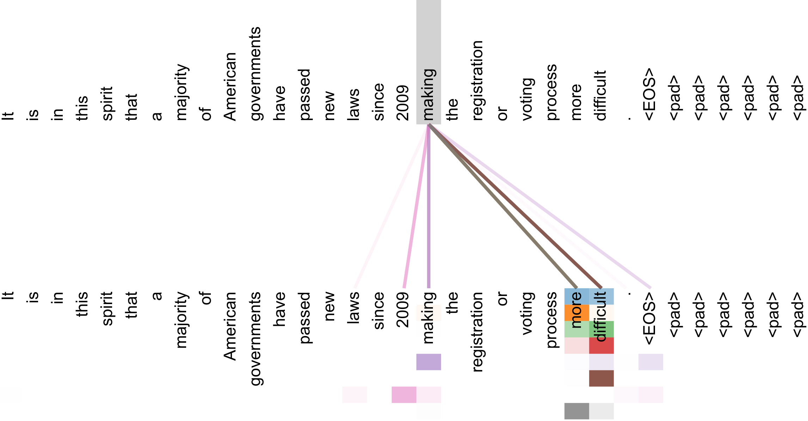
Figure 2. An attention visualization from the appendix: several heads attend to a long-distance dependency, illustrating the interpretability of self-attention.

The longer-term point
The paper's lasting claim is not just that one component works well. It shows that attention can be the backbone. By removing recurrence and convolution, the Transformer improves parallelism, shortens dependency paths, reaches state-of-the-art translation quality for its time, and sets the pattern for many later sequence models. The reported model-size comparison is 65M parameters for base and 213M for big.

