CREATE TABLE employees (employee_id SERIAL PRIMARY KEY, name VARCHAR(100), department VARCHAR(100));
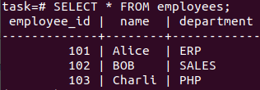

CREATE TABLE project (project_id SERIAL PRIMARY KEY, project_name VARCHAR(100) NOT NULL, employee_id INT, FOREIGN KEY (employee_id) REFERENCES employees(employee_id) );

