Q1.what is difference between sql and psql list all
SQL | PSQL
It is a database management system. | It is an object-relational database management system
Microsoft develops it. | The PostgreSQL global development group develops it.
It is a commercial tool. | It is an open-source tool.
Language : C++, PHP, C#, Go, Java, Python JavaScript (Node.js), PHP, R, Visual Basic, and Ruby. | Language : C, C++, Java, .Net, Perl, Python, Tcl, JavaScript (Node.js), and PHP
It is compatible with SQL language. | It support various programming languages.
It is highly scalable. | It support multiple feature of SQL.
SQL is not case sensitive. | PostgreSQL is case sensitive.
It is a platform independent. | It is free to download.
SQL is a Structure query language. | Psql is a advance tool.

Q2. create/delete multiple database.
ANS:-
Create database: createdb demo
Create database: createdb demo1
Create database: createdb demo2

Delete database: dropdb demo
Delete database: dropdb demo1
Delete database: dropdb demo2

Q3. insert data into the tables
ANS: INSERT INTO project (project_id, project_name) VALUES (101, 'Web redesign');
INSERT INTO project (project_id, project_name) VALUES (102, 'Ad campaign');

Q4. check use of alter command for tables
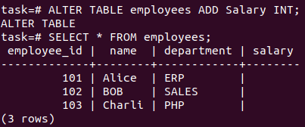
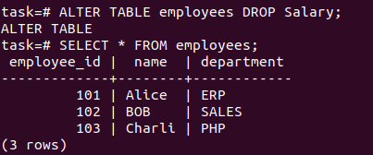
-> For adding a new column : ALTER TABLE employees
ADD COLUMN salary BOOLEAN;

->For dropping a column : ALTER TABLE employees
DROP COLUMN salary;

->For renaming a column : ALTER TABLE employees
RENAME COLUMN name TO e_name;

