Client frequencies:

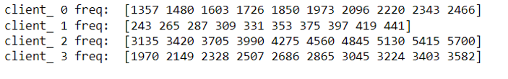

|  |  |  |
| --- | --- | --- |
|  | Accuracy | Loss |
| Norm |  |  |
| Gamma |  |  |
| Lognorm |  |  |
| Beta |  |  |
| Burr |  |  |

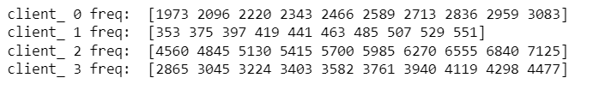**NON_IID DISTRIBUTIONS (4 clients : gender-income)**

|  |  |  |  |
| --- | --- | --- | --- |
| Distribution | frequency | accuracy | Loss |
| Gamma |  |  |  |
| Norm |  |  |  |
| Lognorm |  |  |  |
| Beta |  |  |  |
| Burr |  |  |  |

**Single-Batch Distributions**

**client_ 0**

loss: [0.04675943 0.22334448 0.3253662 0.3327828 0.32753864 0.30964363 0.30064547 0.2881389 0.30844659 0.29107651]

freq: [7895 7895 7895 7895 7895 7895 7895 7895 7895 7895]

acc [0.99366689 0.91247624 0.87321091 0.86865103 0.87473083 0.8781507 0.88081062 0.88777709 0.87941736 0.88448387]

**client_ 1**

loss: [0.44730943 1.00544584 1.24900603 1.09015918 1.2009567 1.20884359 1.11642206 1.12442636 1.07541847 1.10691833]

freq: [1435 1435 1435 1435 1435 1435 1435 1435 1435 1435]

acc [0.89128917 0.49756098 0.37770036 0.50522649 0.44808361 0.43135887 0.47804877 0.47456446 0.50662023 0.48989546]

**client_ 2**

loss: [0.03972216 0.02067855 0.01909248 0.02059607 0.02184644 0.02210405 0.0240159 0.02484704 0.02478325 0.02511534]

freq: [18259 18259 18259 18259 18259 18259 18259 18259 18259 18259]

acc [0.99611151 0.99989045 1. 1. 1. 0.99994522 0.99994522 0.99989045 0.99989045 0.99994522]

**client_ 3**

loss: [0.10719391 0.02389912 0.0262641 0.02447494 0.02615622 0.02859946 0.0283988 0.02978892 0.03104771 0.03117665]

freq: [11484 11484 11484 11484 11484 11484 11484 11484 11484 11484]

acc [0.98885405 0.99965167 0.99982584 0.99991292 0.99991292 0.99991292 0.99982584 0.99982584 0.99973875 0.99973875]

|  |  |  |
| --- | --- | --- |
| Distribution | Accuracy | Loss |
| Gamma | 0 and 1 5052963785.6386385  0 and 2 110213288418.12776  0 and 3 107785490295.07877  1 and 2 105160324655.85822  1 and 3 102732526518.81839  2 and 3 2427798137.039818  0 and global: 2170527.9642331777  1 and global: 5050793767.680869  2 and global: 110211118394.07294  3 and global: 107783320275.70663 | 0 and 1 9.308714649162779  0 and 2 11341.601002166437  0 and 3 4854633.798060776  1 and 2 11337.843632987884  1 and 3 4854630.040691596  2 and 3 4843350.173976158  0 and global: 6.269837293033752  1 and global: 13.414506742209406  2 and global: 11335.51733712475  3 and global: 4854628.48416662 |
| Norm | 0 and 1 6.675711374677921  0 and 2 286.15857542033956  0 and 3 94.18641588484508  1 and 2 292.8342867950175  1 and 3 100.86212725952299  2 and 3 191.97215953549448  0 and global: 1091.4961367516255  1 and global: 1098.1718481263035  2 and global: 805.337561331286  3 and global: 997.3097208667805 | 0 and 1 2.4057410423621155  0 and 2 54.555577640223106  0 and 3 10.220130044593963  1 and 2 56.96131868258523  1 and 3 12.62587108695608  2 and 3 44.33544759562915  0 and global: 6.002736887598183  1 and global: 8.408477929960299  2 and global: 49.369079300209755  3 and global: 5.281169731086335 |
| Lognorm | 0 and 1 20.848571350665924  0 and 2 68.43472489365098  0 and 3 78.13086556288947  1 and 2 89.2832962443169  1 and 3 98.97943691355539  2 and 3 84.68423389603093  0 and global: 1078.2990797532764  1 and global: 1099.1476511039423  2 and global: 1015.7192759065204  3 and global: 1000.1682141903868 | 0 and 1 2.396580615537854  0 and 2 88.29790770059965  0 and 3 79.39303651314505  1 and 2 90.69448831613751  1 and 3 81.7896171286829  2 and 3 32.77755483496762  0 and global: 6.029857038491165  1 and global: 8.426437654029018  2 and global: 82.74258355514098  3 and global: 74.39622381424006 |
| Beta | 0 and 1 1521748664975.6758  0 and 2 210969340692530.25  0 and 3 30110798953388.42  1 and 2 212491089357505.84  1 and 3 31632547618362.84  2 and 3 180858541739143.1  0 and global: 308744075720725.44  1 and global: 310265824385701.06  2 and global: 385995910701328.75  3 and global: 325709730121620.6 | 0 and 1 2314866766485.9023  0 and 2 10624594890126.223  0 and 3 4839861950005.761  1 and 2 12939461656612.125  1 and 3 7154728716486.841  2 and 3 5784732940125.554  0 and global: 4391291160872.917  1 and global: 2076424394391.9973  2 and global: 15015886050987.99  3 and global: 9231153110878.678 |
| Burr | 0 and 1 12.557451473326129  0 and 2 73.81034375812625  0 and 3 58.98077024145226  1 and 2 86.36779523145239  1 and 3 71.5382217147784  2 and 3 14.82957351667399  0 and global: 37.68286544026416  1 and global: 50.24031691359029  2 and global: 36.12747831786209  3 and global: 30.816360768026254 | 0 and 1 5.9800054838741215  0 and 2 85.11174054509708  0 and 3 14009025718706.021  1 and 2 91.09174602897119  1 and 3 14009025718712.0  2 and 3 14009025718739.184  0 and global: 2.2096049476649746  1 and global: 7.564232292959562  2 and global: 83.77601115000714  3 and global: 14009025718705.12 |

**NON_IID DISTRIBUTIONS (8 clients : gender-race(white/black)-income)**

client_ 0 freq: [154 173 193 212 231 250 270 289 308 327]

client_ 1 freq: [12 13 15 16 17 19 20 22 23 24]

client_ 2 freq: [1148 1291 1435 1578 1722 1865 2009 2152 2295 2439]

client_ 3 freq: [214 241 268 294 321 348 375 401 428 455]

client_ 4 freq: [ 900 1013 1125 1238 1350 1463 1575 1688 1800 1913]

client_ 5 freq: [42 47 52 57 62 68 73 78 83 88]

client_ 6 freq: [1921 2168 2415 2661 2908 3154 3401 3647 3894 4140]

client_ 7 freq: [1504 1529 1553 1577 1602 1626 1650 1675 1699 1724]

|  |  |  |  |
| --- | --- | --- | --- |
| Distribution | frequency | accuracy | Loss |
| Gamma | 0 and 1 0.061555536385285624  0 and 2 0.0041382116829178405  0 and 3 0.0013400631914867798  0 and 4 0.003961905318923298  0 and 5 0.013010983461184001  0 and 6 0.004406344593409131  0 and 7 0.00100519614650254  1 and 2 0.06569374806820347  1 and 3 0.0628955995767724  1 and 4 0.06551744170420892  1 and 5 0.048544552924101626  1 and 6 0.06596188097869476  1 and 7 0.06256073253178818  2 and 3 0.0027981484914310598  2 and 4 0.00017630636399454234  2 and 5 0.01714919514410184  2 and 6 0.0002681329104912907  2 and 7 0.0031330155364153  3 and 4 0.002621842127436518  3 and 5 0.014351046652670783  3 and 6 0.00306628140192235  3 and 7 0.00033486704498423994  4 and 5 0.016972888780107297  4 and 6 0.0004444392744858331  4 and 7 0.002956709172420758  5 and 6 0.017417328054593128  5 and 7 0.014016179607686542  6 and 7 0.003401148446906591  0 and global: 0.004620694721391866  1 and global: 0.0661762311066775  2 and global: 0.00048248303847402575  3 and global: 0.0032806315299050855  4 and global: 0.000658789402468568  5 and global: 0.017631678182575862  6 and global: 0.00021435012798273496  7 and global: 0.003615498574889326 | 0 and 1 3.5001817549856585e+23  0 and 2 7869143271.861214  0 and 3 357034.07862304547  0 and 4 518126.9362475103  0 and 5 165104.89760287738  0 and 6 19103681246.857594  0 and 7 392016643.4018573  1 and 2 3.50018175498558e+23  1 and 3 3.5001817549856585e+23  1 and 4 3.5001817549856585e+23  1 and 5 3.5001817549856585e+23  1 and 6 3.500181754985467e+23  1 and 7 3.500181754985655e+23  2 and 3 7868786239.209446  2 and 4 7868625147.615849  2 and 5 7869231109.581604  2 and 6 11234537976.059536  2 and 7 7477126628.530401  3 and 4 161100.1784975285  3 and 5 444871.7990126755  3 and 6 19103324215.268982  3 and 7 391659611.30970186  4 and 5 605962.197813923  4 and 6 19103163122.99236  4 and 7 391498519.3510584  5 and 6 19103769084.577984  5 and 7 392104481.1222469  6 and 7 18711664603.959282  0 and global: 41259533824.28781  1 and global: 3.5001817549852465e+23  2 and global: 33390390564.280167  3 and global: 41259176803.48961  4 and global: 41259015707.19073  5 and global: 41259621663.250084  6 and global: 22155852588.220627  7 and global: 40867517192.17992 | 0 and 1 0.22051657214227194  0 and 2 14774694.28399596  0 and 3 4717296587.966944  0 and 4 1661033.0837199779  0 and 5 0.1598046861121252  0 and 6 31.63787434757529  0 and 7 4686093.701512583  1 and 2 14774694.504512532  1 and 3 4717296588.187131  1 and 4 1661033.0432750282  1 and 5 0.06072497058341592  1 and 6 31.858060977126417  1 and 7 4686093.921699212  2 and 3 4702521897.798205  2 and 4 13113661.556582669  2 and 5 14774694.443800645  2 and 6 14774665.688301405  2 and 7 10088608.07593358  3 and 4 4715635555.235035  3 and 5 4717296588.126406  3 and 6 4717296562.071834  3 and 7 4712610502.249417  4 and 5 1661033.0135691038  4 and 6 1661030.5133884917  4 and 7 3025060.9600235075  5 and 6 31.797336006543002  5 and 7 4686093.860974241  6 and 7 4686063.665686254  0 and global: 7654705523.434952  1 and global: 7654705523.655138  2 and global: 7639930862.044109  3 and global: 2937408981.9449573  4 and global: 7653044490.611863  5 and global: 7654705523.594413  6 and global: 7654705517.384555  7 and global: 7650019469.851103 |
| Norm | 0 and 1 0.06155314818732709  0 and 2 0.0041382495420010145  0 and 3 0.0013401049330001278  0 and 4 0.003961938678467752  0 and 5 0.013011209351361921  0 and 6 0.004406379243408383  0 and 7 0.001005243975558933  1 and 2 0.06569139772932811  1 and 3 0.06289325312032723  1 and 4 0.06551508686579485  1 and 5 0.048541938835965165  1 and 6 0.06595952743073548  1 and 7 0.06255839216288603  2 and 3 0.0027981446090008864  2 and 4 0.00017631086353326104  2 and 5 0.017149458893362935  2 and 6 0.0002681297014073686  2 and 7 0.0031330055664420815  3 and 4 0.002621833745467625  3 and 5 0.014351314284362048  3 and 6 0.0030662743104082546  3 and 7 0.000334860957441195  4 and 5 0.01697314802982967  4 and 6 0.00044444056494062964  4 and 7 0.0029566947029088203  5 and 6 0.017417588594770304  5 and 7 0.014016453326920853  6 and 7 0.0034011352678494497  0 and global: 0.0046207285698786765  1 and global: 0.06617387675720578  2 and global: 0.0004824790278776623  3 and global: 0.003280623636878548  4 and global: 0.0006587898914109234  5 and global: 0.017631937921240598  6 and global: 0.0002143493264702938  7 and global: 0.003615484594319744 | 0 and 1 0.8325300686638157  0 and 2 10.459736423104237  0 and 3 1.698031063319809  0 and 4 0.6592378845059876  0 and 5 0.42290213571143564  0 and 6 18.528715177097837  0 and 7 13.219825443615902  1 and 2 9.627206354440421  1 and 3 0.8655009946559932  1 and 4 0.32002245930806605  1 and 5 0.4096279329523801  1 and 6 17.696185108434015  1 and 7 12.387295374952084  2 and 3 8.761705359784427  2 and 4 9.800498538598248  2 and 5 10.036834287392804  2 and 6 8.068978753993596  2 and 7 2.7600890205116646  3 and 4 1.0479685475623837  3 and 5 1.275128927608373  3 and 6 16.830684113778027  3 and 7 11.521794380296091  4 and 5 0.41552401074085465  4 and 6 17.86947729259185  4 and 7 12.560587559109912  5 and 6 18.105813041386398  5 and 7 12.796923307904466  6 and 7 5.308889733481931  0 and global: 116.55554794469576  1 and global: 115.72301787603195  2 and global: 106.09581152159153  3 and global: 114.85751688137596  4 and global: 115.89631006018978  5 and global: 116.13264580898432  6 and global: 98.02683276759791  7 and global: 103.33572250107987 | 0 and 1 0.2263963719578554  0 and 2 2.4129205474004163  0 and 3 1.2704907536330314  0 and 4 1.4787686693468602  0 and 5 0.16566362160853892  0 and 6 3.7632501494387287  0 and 7 2.9819330218239486  1 and 2 2.6393169193582717  1 and 3 1.496887125590887  1 and 4 1.7051650413047155  1 and 5 0.060732750349316474  1 and 6 3.9896465213965846  1 and 7 3.208329393781804  2 and 3 1.1424297937673844  2 and 4 0.9375641506137123  2 and 5 2.578584169008955  2 and 6 1.3503296020383129  2 and 7 0.569012474423533  3 and 4 0.3000020347142675  3 and 5 1.4361543752415704  3 and 6 2.492759395805697  3 and 7 1.7114422681909174  4 and 5 1.6444322909553992  4 and 6 2.2844814800918685  4 and 7 1.5031643524770888  5 and 6 3.9289137710472675  5 and 7 3.1475966434324874  6 and 7 0.7813171276147799  0 and global: 14.191481446599221  1 and global: 14.417877818557077  2 and global: 11.778560899198805  3 and global: 12.92099069296619  4 and global: 12.71271277725236  5 and global: 14.357145068207759  6 and global: 10.428231297160492  7 and global: 11.20954842477527 |
| Lognorm | 0 and 1 3057067514.6183133  0 and 2 6644.163376197016  0 and 3 1643282.336807157  0 and 4 26728.73118429474  0 and 5 172235.6442783698  0 and 6 94975.05676701889  0 and 7 2661220.4334895806  1 and 2 3057060870.462868  1 and 3 3055424232.288583  1 and 4 3057040785.895042  1 and 5 3056895278.9762454  1 and 6 3056972539.5695715  1 and 7 3054406294.191746  2 and 3 1636638.1742856344  2 and 4 20084.567826467424  2 and 5 165591.48662285908  2 and 6 88330.89339082188  2 and 7 2654576.2711217343  3 and 4 1616553.606459167  3 and 5 1471046.6937597056  3 and 6 1548307.2809887175  3 and 7 1017938.0968360996  4 and 5 145506.91879639166  4 and 6 68246.32558272415  4 and 7 2634491.7032952667  5 and 6 77260.59332594191  5 and 7 2488984.7904421296  6 and 7 2566245.377824817  0 and global: 331320.9079630696  1 and global: 3056736193.7184424  2 and global: 324676.74458687264  3 and global: 1311961.4298593567  4 and global: 304592.1767787749  5 and global: 159085.26491561832  6 and global: 236345.85119605073  7 and global: 2329899.526695457 | 0 and 1 6.109867828617498e+18  0 and 2 79709480807.47874  0 and 3 79709480814.391  0 and 4 79709480810.03777  0 and 5 1.6971964477274035e+17  0 and 6 79709480801.30351  0 and 7 79709480805.46625  1 and 2 6.10986790832698e+18  1 and 3 6.10986790832698e+18  1 and 4 6.10986790832698e+18  1 and 5 5.940148183844758e+18  1 and 6 6.10986790832698e+18  1 and 7 6.10986790832698e+18  2 and 3 8.798886019579744  2 and 4 9.620161192220916  2 and 5 1.6971972448222112e+17  2 and 6 8.064896234963543  2 and 7 2.608621289287474  3 and 4 6.763128366138591  3 and 5 1.6971972448222112e+17  3 and 6 16.863782254543285  3 and 7 11.407507308867217  4 and 5 1.6971972448222112e+17  4 and 6 14.00588899954047  4 and 7 11.04412293698373  5 and 6 1.6971972448222112e+17  5 and 7 1.6971972448222112e+17  6 and 7 5.456274945676069  0 and global: 79709480793.47607  1 and global: 6.10986790832698e+18  2 and global: 25.754946932579383  3 and global: 34.55383295215913  4 and global: 30.170699859880774  5 and global: 1.697197244822211e+17  6 and global: 17.690050697615845  7 and global: 23.14632564329191 | 0 and 1 0.22680003033273918  0 and 2 127642629847.09103  0 and 3 283325675686.15894  0 and 4 1.4824814062622755  0 and 5 0.16340965376444838  0 and 6 8451664.432559114  0 and 7 356762726052.7163  1 and 2 127642629847.27338  1 and 3 283325675686.31433  1 and 4 1.7092814365950144  1 and 5 0.06339136742791164  1 and 6 8451664.628246019  1 and 7 356762726052.90234  2 and 3 155683045839.19888  2 and 4 127642629846.15292  2 and 5 127642629847.21269  2 and 6 127634178217.18904  2 and 7 229120096205.629  3 and 4 283325675685.34314  3 and 5 283325675686.25916  3 and 6 283317224035.2745  3 and 7 73437050377.60309  4 and 5 1.645891060026724  4 and 6 8451663.329942504  4 and 7 356762726051.67145  5 and 6 8451664.564855643  5 and 7 356762726052.8389  6 and 7 356754274409.2717  0 and global: 14.149724143550477  1 and global: 14.376524173883215  2 and global: 127642629847.19232  3 and global: 283325675683.603  4 and global: 12.667242737288205  5 and global: 14.313133797314926  6 and global: 8451658.94373009  7 and global: 356762726049.0028 |
| Beta | 0 and 1 2.220652626228219  0 and 2 0.004581367677561024  0 and 3 0.0015114701017898443  0 and 4 0.1363751875820617  0 and 5 0.4612214831003908  0 and 6 1.582322789238371  0 and 7 0.0016017589952226825  1 and 2 2.22523399390578  1 and 3 2.222164096330009  1 and 4 2.0921404591245185  1 and 5 1.7594311431278284  1 and 6 0.6479308183370217  1 and 7 2.2222543852234415  2 and 3 0.003069897575771181  2 and 4 0.13309353478126132  2 and 5 0.4658028507779518  2 and 6 1.577923770185364  2 and 7 0.0037003509509938998  3 and 4 0.13509929088577144  3 and 5 0.46273295320218066  3 and 6 1.5808919225642308  3 and 7 0.0006908274096867855  4 and 5 0.33270931599669057  4 and 6 1.4459476016563093  4 and 7 0.13574246307004081  5 and 6 1.1500988775360375  5 and 7 0.4628232420956135  6 and 7 1.581569714172193  0 and global: 0.005978573520716108  1 and global: 2.226631199748935  2 and global: 0.0013972058431550838  3 and global: 0.0044671034189262635  4 and global: 0.13449074062441638  5 and global: 0.4672000566211069  6 and global: 1.5787003814119134  7 and global: 0.004376814525493426 | 0 and 1 7.307236233053098e+28  0 and 2 37600461648677.42  0 and 3 48198812766773.0  0 and 4 48968916937776.31  0 and 5 48844505240609.46  0 and 6 48978053403745.07  0 and 7 44051455739019.99  1 and 2 7.307236233053103e+28  1 and 3 7.3072362330531045e+28  1 and 4 7.307236233053104e+28  1 and 5 7.307236233053104e+28  1 and 6 7.307236233053104e+28  1 and 7 7.307236233053102e+28  2 and 3 10598351118113.635  2 and 4 11368455289108.766  2 and 5 11244043591950.123  2 and 6 11377591755067.637  2 and 7 6450994090353.064  3 and 4 770104171003.5665  3 and 5 645692473836.4873  3 and 6 779240636972.3181  3 and 7 4147357027763.732  4 and 5 124411697167.80614  4 and 6 9136465968.751783  4 and 7 4917461198761.089  5 and 6 133548163136.5579  5 and 7 4793049501600.219  6 and 7 4926597664725.075  0 and global: 238239896020545.4  1 and global: 7.307236233053075e+28  2 and global: 275840357669204.75  3 and global: 286438708787318.3  4 and global: 287208812958313.2  5 and global: 287084401261154.9  6 and global: 287217949424196.9  7 and global: 282291351759554.6 | 0 and 1 353086513869.58966  0 and 2 625704185007.5367  0 and 3 601345396248.4308  0 and 4 612308990252.4236  0 and 5 170051563451.07916  0 and 6 9619369512165.635  0 and 7 626150273442.9197  1 and 2 272617671156.7146  1 and 3 248258882397.76105  1 and 4 259222476400.81454  1 and 5 183034950419.6448  1 and 6 9972456026023.438  1 and 7 273063759591.8211  2 and 3 24358788759.46  2 and 4 13395194756.100967  2 and 5 455652621559.27655  2 and 6 10245073697172.484  2 and 7 446088435.6647787  3 and 4 10963594005.57126  3 and 5 431293832800.351  3 and 6 10220714908413.885  3 and 7 24804877195.124775  4 and 5 442257426803.36224  4 and 6 10231678502416.443  4 and 7 13841283191.108635  5 and 6 9789421075613.766  5 and 7 456098709994.3831  6 and 7 10245519785607.215  0 and global: 625549346868.8162  1 and global: 272462833009.92758  2 and global: 154838164.6307743  3 and global: 24203950621.944965  4 and global: 13240356616.392603  5 and global: 455497783417.7913  6 and global: 10244918859015.127  7 and global: 600926599.3623089 |
| Burr | 0 and 1 0.0687238736146832  0 and 2 0.0038440424886690577  0 and 3 0.001160969409141201  0 and 4 0.00367676196969297  0 and 5 0.012969043801782994  0 and 6 0.0041010915149884775  0 and 7 0.0007704665972037736  1 and 2 0.07256791610335224  1 and 3 0.06988484302382439  1 and 4 0.07240063558437616  1 and 5 0.0557548298129002  1 and 6 0.07282496512967165  1 and 7 0.06949434021188697  2 and 3 0.002683073079527857  2 and 4 0.00016728051897608721  2 and 5 0.016813086290452046  2 and 6 0.00025704902631942  2 and 7 0.0030735758914652842  3 and 4 0.0025157925605517697  3 and 5 0.014130013210924193  3 and 6 0.002940122105847277  3 and 7 0.0003958053079826416  4 and 5 0.01664580577147596  4 and 6 0.0004243295452955072  4 and 7 0.002906295372489197  5 and 6 0.017070135316771467  5 and 7 0.013739510398986767  6 and 7 0.0033306249177847045  0 and global: 0.004305008337911491  1 and global: 0.07302888195259467  2 and global: 0.00046096584924243286  3 and global: 0.00314403892877029  4 and global: 0.0006282463682185201  5 and global: 0.01727405213969448  6 and global: 0.0002039168229230128  7 and global: 0.0035345417407077174 | 0 and 1 9.632467572128582e+27  0 and 2 41444361615586.05  0 and 3 41444361615596.75  0 and 4 41444361615607.33  0 and 5 4.481935523269599e+19  0 and 6 41444361615584.23  0 and 7 41444361615585.336  1 and 2 9.632467572128622e+27  1 and 3 9.632467572128622e+27  1 and 4 9.632467572128622e+27  1 and 5 9.632467527309225e+27  1 and 6 9.632467572128622e+27  1 and 7 9.632467572128622e+27  2 and 3 17.405240826672046  2 and 4 30.113678715951945  2 and 5 4.481939667705761e+19  2 and 6 6.109357347514156  2 and 7 2.644867905478688  3 and 4 12.724712292977225  3 and 5 4.481939667705761e+19  3 and 6 23.5145981741862  3 and 7 20.050108732150733  4 and 5 4.481939667705761e+19  4 and 6 36.20399101750616  4 and 7 32.74869276729836  5 and 6 4.481939667705761e+19  5 and 7 4.481939667705761e+19  6 and 7 3.4644894420354695  0 and global: 41444361615583.23  1 and global: 9.632467572128622e+27  2 and global: 18.88400310048125  3 and global: 36.2892439271533  4 and global: 48.97863677047325  5 and global: 4.481939667705761e+19  6 and global: 12.774645752967094  7 and global: 16.239135195002564 | 0 and 1 nan  0 and 2 nan  0 and 3 nan  0 and 4 nan  0 and 5 nan  0 and 6 nan  0 and 7 nan  1 and 2 nan  1 and 3 nan  1 and 4 nan  1 and 5 nan  1 and 6 nan  1 and 7 nan  2 and 3 782038.2021019952  2 and 4 57506.06774511564  2 and 5 57507.474677920385  2 and 6 57493.267578002036  2 and 7 29269.100591399332  3 and 4 839533.6420631084  3 and 5 839534.5676024959  3 and 6 839506.9687639928  3 and 7 811282.6256697116  4 and 5 1.6507194556933353  4 and 6 58.50867120462314  4 and 7 28317.212255846658  5 and 6 60.01442353468633  5 and 7 28318.542849606303  6 and 7 28259.755804628818  0 and global: nan  1 and global: nan  2 and global: 57498.250617960235  3 and global: 839530.5720602596  4 and global: 16.234427795312904  5 and global: 17.88514725100624  6 and global: 47.140566428665224  7 and global: 28306.207042509108 |

**Non-IID distribution for a 10-client system using repaired (sensitive attributes dropped) data for training/ server side repairing**

sensitive attributes : {'age', 'race_Amer-Indian-Eskimo', 'race_Asian-Pac-Islander', 'race_Black', 'race_Other', 'race_White', 'gender_Female', 'gender_Male'}

CDFs for losses for individual clients:

client_ 0 client_ 1

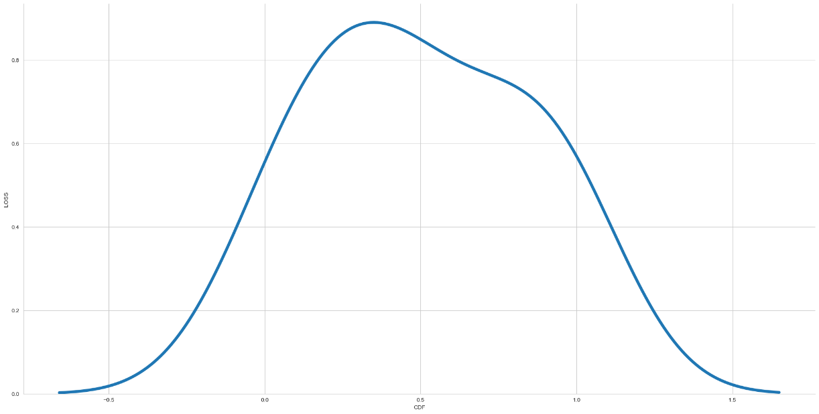

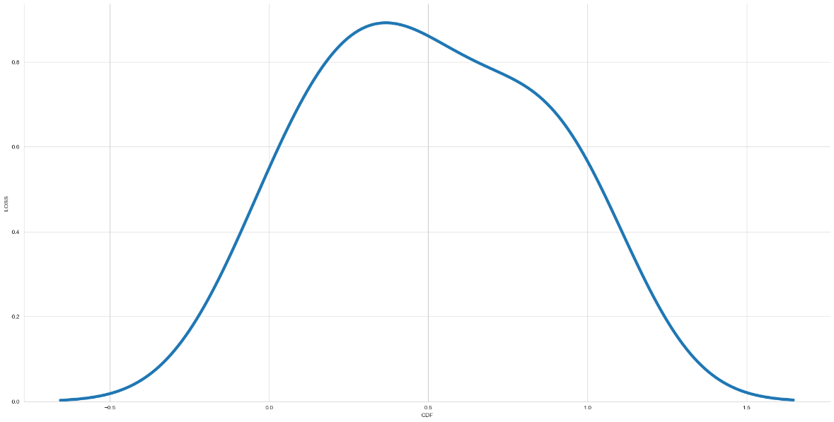

client_ 2 client_ 3

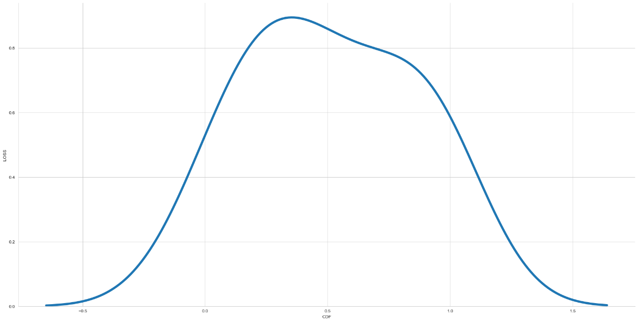

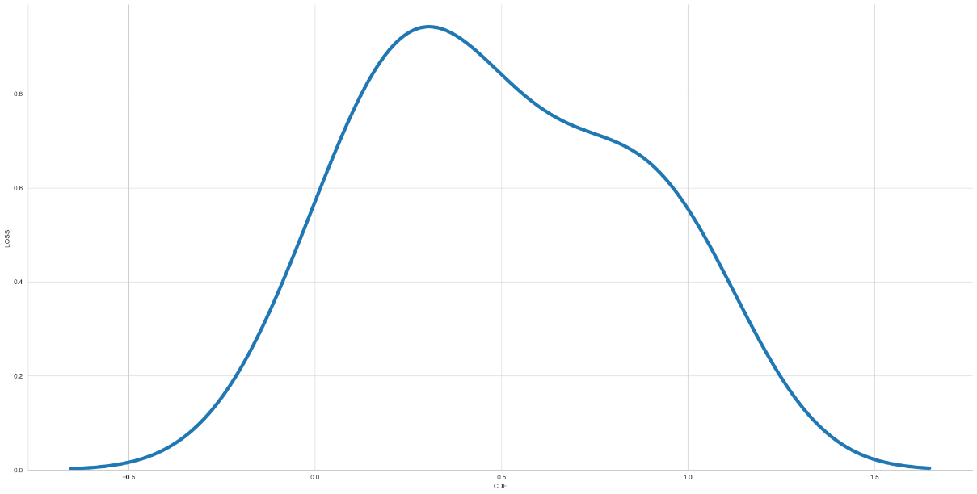

client_ 4 client_ 5

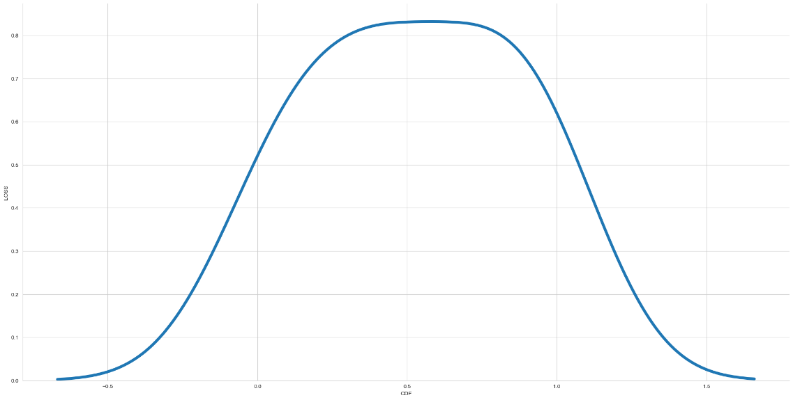

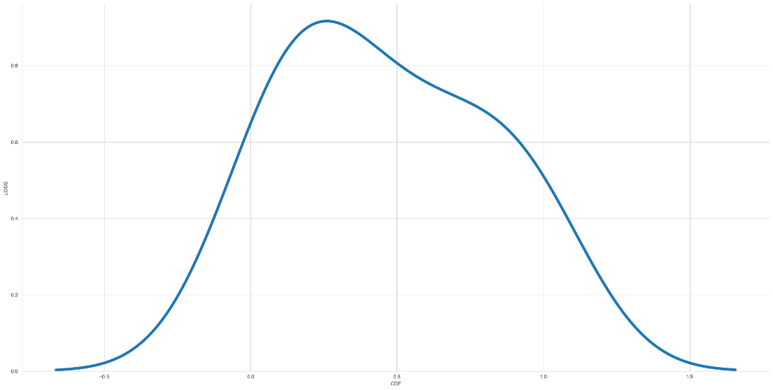

client_ 6 client_ 7

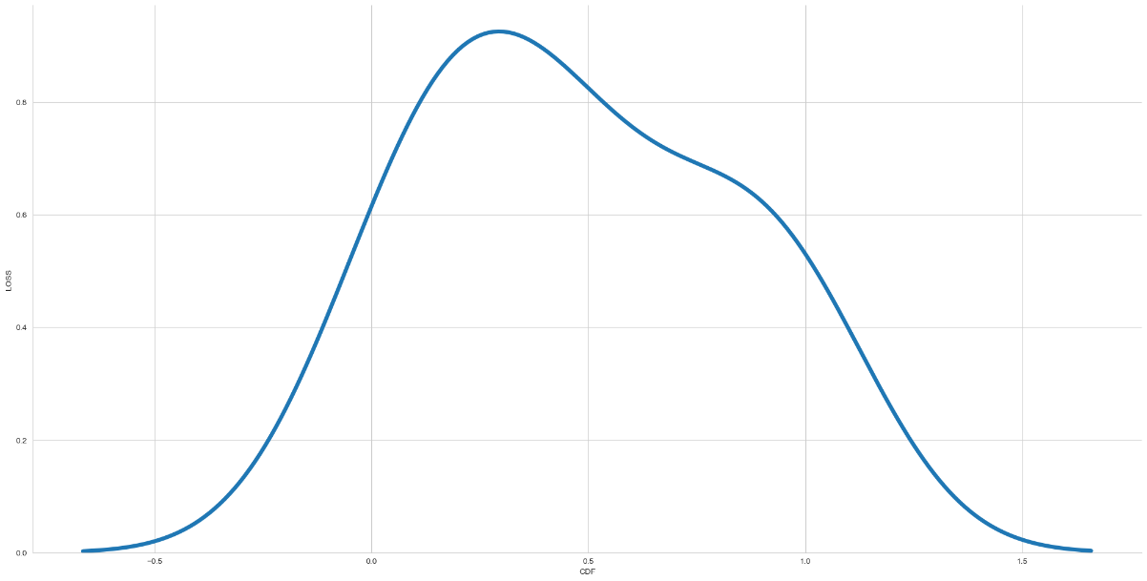

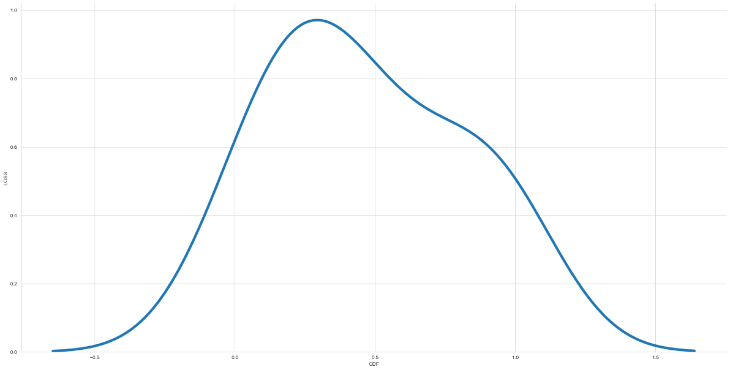

client_ 8 client_ 9

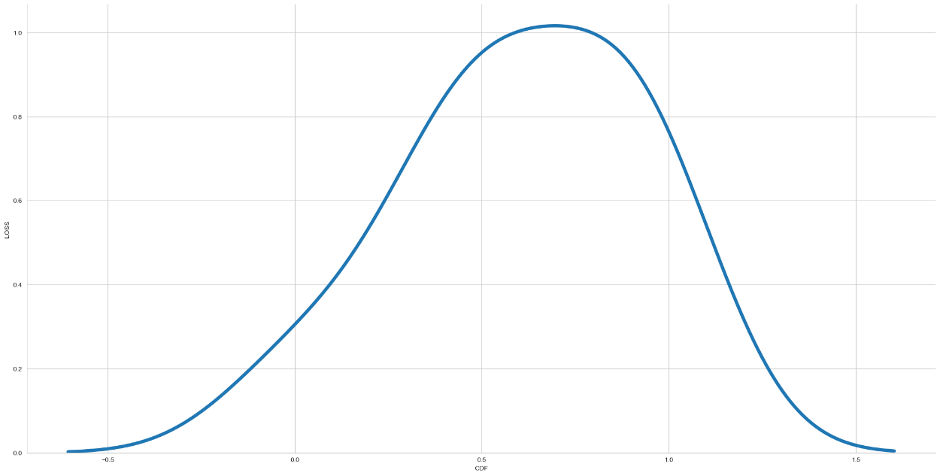

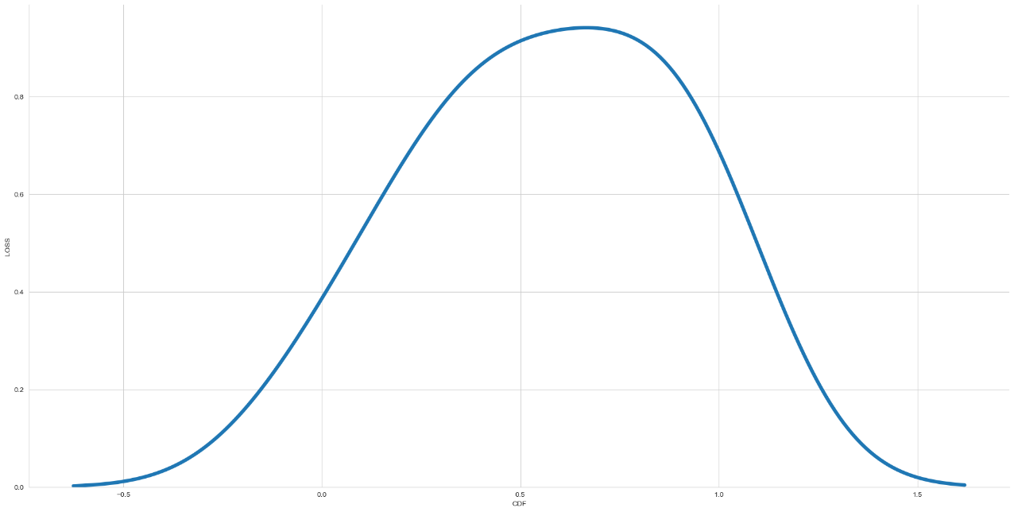

**Statistics:**

***client_ 0***

loss: [0.61086375 0.48895925 0.42192078 0.38538462 0.36777058 0.35811067 0.35217971 0.34762534 0.34223405 0.34042257]

freq: [ 34 63 89 99 135 136 155 198 253 310]

acc [0.68465227 0.80593437 0.82598567 0.83244336 0.83575219 0.83884007 0.84030771 0.84148592 0.84315759 0.84329736]

***client_ 1***

loss: [0.60810548 0.49124789 0.42425817 0.38594407 0.36823279 0.35871762 0.35395196 0.34909132 0.34512201 0.34348699]

freq: [ 38 72 80 100 154 175 210 265 301 304]

acc [0.6895178 0.80177778 0.82569444 0.83469224 0.83653253 0.83756828 0.83787876 0.83998203 0.84094632 0.84125489]

***client_ 2***

loss: [0.62629861 0.5121786 0.42389324 0.38565096 0.36983481 0.3597762 0.35359699 0.35081801 0.35046026 0.34585956]

freq: [ 26 28 61 119 128 167 202 222 248 308]

acc [0.64890963 0.78917378 0.81968504 0.83105296 0.83345747 0.83466476 0.83621299 0.83674204 0.83647132 0.83981413]

***client_ 3***

loss: [0.5920248 0.47583362 0.42313868 0.3866969 0.37091368 0.36190581 0.35488188 0.35127825 0.34916413 0.34639987]

freq: [ 49 102 104 119 124 138 185 201 215 265]

acc [0.70891088 0.80850899 0.8235566 0.83092368 0.83423078 0.83580887 0.83733851 0.83866507 0.83899999 0.83986813]

***client_ 4***

loss: [0.65826589 0.5169788 0.42765966 0.38794741 0.36735302 0.35774747 0.35061172 0.34742814 0.34490946 0.34517193]

freq: [ 11 26 53 78 123 172 209 224 249 315]

acc [0.6068182 0.78535825 0.82666665 0.83210254 0.83792883 0.84053552 0.84220952 0.84236926 0.84271133 0.84184933]

***client_ 5***

loss: [0.61959428 0.48596308 0.40170121 0.37713358 0.3615804 0.35094073 0.34597063 0.34304726 0.34170884 0.34019074]

freq: [ 31 74 155 190 254 301 345 408 456 501]

acc [0.66692913 0.80526882 0.82871795 0.83496648 0.83968699 0.84224683 0.84266943 0.84290451 0.84317309 0.84325564]

***client_ 6***

loss: [0.63035935 0.5015859 0.4151603 0.3802737 0.36296323 0.35536006 0.35027575 0.3468076 0.34330562 0.34104306]

freq: [ 23 48 91 135 164 209 225 248 287 306]

acc [0.6536842 0.79149997 0.83095866 0.83722717 0.84047621 0.84233409 0.84359521 0.84452999 0.84544194 0.84531045]

***client_ 7***

loss: [0.67178184 0.51838964 0.42784214 0.38460797 0.36651531 0.358017 0.35256788 0.34676394 0.34442586 0.34205738]

freq: [ 2 27 40 91 124 172 187 232 261 263]

acc [0.60666668 0.79030305 0.82404041 0.83298153 0.83513516 0.8371706 0.83821654 0.83956194 0.84028029 0.84116048]

***client_ 8***

loss: [0.58725697 0.49155888 0.41370627 0.38253722 0.36716944 0.35897282 0.35035193 0.34639585 0.34351107 0.34077337]

freq: [ 51 64 112 133 145 158 187 200 215 222]

acc [0.71806854 0.80588973 0.82985073 0.83530468 0.83838552 0.83816719 0.84089172 0.84224343 0.84337038 0.84474343]

***client_ 9***

loss: [0.58318889 0.45914096 0.40776464 0.37675032 0.36124367 0.35230872 0.34864539 0.3455101 0.34278136 0.34076509]

freq: [ 50 120 150 182 203 236 270 287 310 311]

acc [0.72603172 0.8139165 0.82998937 0.8375383 0.84057969 0.84284753 0.84299177 0.84381586 0.84391373 0.84510106]

Wasserstein distances using cdfs obtained by Gauss Distribution

LOSS

0 and 1 0.005099843692771721

0 and 2 0.029168742143768994

0 and 3 0.01673728178886089

0 and 4 0.02468398014305861

0 and 5 0.0373746450075483

0 and 6 0.036140018151634576

0 and 7 0.028665053938597328

0 and 8 0.07094406306916093

0 and 9 0.10712069218830675

1 and 2 0.026740294977832302

1 and 3 0.015227284812385774

1 and 4 0.026523474195558186

1 and 5 0.03557801152980067

1 and 6 0.034300524047937896

1 and 7 0.02623660678314112

1 and 8 0.07113419365352858

1 and 9 0.10731082277267437

2 and 3 0.027768096354225554

2 and 4 0.05070825878873159

2 and 5 0.028147621025904422

2 and 6 0.028575521799454447

2 and 7 0.02199452844068725

2 and 8 0.07755981645834968

2 and 9 0.11373644557749547

3 and 4 0.02679364615132102

3 and 5 0.04539567289068987

3 and 6 0.043453999386061204

3 and 7 0.036993995049395115

3 and 8 0.06053231823163545

3 and 9 0.09670894735078124

4 and 5 0.0620061554099333

4 and 6 0.06082399824349608

4 and 7 0.051765534090727

4 and 8 0.047076671088834524

4 and 9 0.08325320670748433

5 and 6 0.017362768264246622

5 and 7 0.017653783084014957

5 and 8 0.10570743706643954

5 and 9 0.14188406618558533

6 and 7 0.015268655832304056

6 and 8 0.10398631761769665

6 and 9 0.1401629467368425

7 and 8 0.09496837310117004

7 and 9 0.13114290834689338

8 and 9 0.03655223405200688

0 and global: 0.07096748921780578

1 and global: 0.0711576198021734

2 and global: 0.07915580924772436

3 and global: 0.06055574438028027

4 and global: 0.04808974564009074

5 and global: 0.10573086321508438

6 and global: 0.10400974376634148

7 and global: 0.09499489561765642

8 and global: 0.012243842958882761

9 and global: 0.036153202970500974

ACCURACY

0 and 1 0.16922599600770416

0 and 2 0.015600465325442597

0 and 3 0.3326675944011425

0 and 4 0.13311156524333806

0 and 5 0.002088637781454481

0 and 6 0.0029715160910101387

0 and 7 0.08490192281680213

0 and 8 0.377265077145193

0 and 9 0.05880820171523992

1 and 2 0.15362553068226154

1 and 3 0.1634415983934384

1 and 4 0.03611443077190012

1 and 5 0.16763187651343472

1 and 6 0.16917606708037777

1 and 7 0.08432407319486346

1 and 8 0.2080390811374888

1 and 9 0.22803419771725916

2 and 3 0.31706712907569995

2 and 4 0.11751109991968871

2 and 5 0.01400634583117321

2 and 6 0.015550536398116257

2 and 7 0.0693014574931528

2 and 8 0.3616646118197504

2 and 9 0.07440866703888924

3 and 4 0.19955602916533852

3 and 5 0.3310734749068731

3 and 6 0.33261766547381616

3 and 7 0.24776567158830184

3 and 8 0.04463201943717401

3 and 9 0.39147579611069744

4 and 5 0.1315174457439552

4 and 6 0.13306163630933018

4 and 7 0.04820964242653591

4 and 8 0.24415351190938892

4 and 9 0.19191976695857796

5 and 6 0.0022254298877297804

5 and 7 0.0833078033185713

5 and 8 0.37567095765092356

5 and 9 0.06040232121462274

6 and 7 0.08485199388551434

6 and 8 0.37721514821786667

6 and 9 0.05885813064924775

7 and 8 0.29236315433235227

7 and 9 0.14371012453204202

8 and 9 0.4360732788547479

0 and global: 0.045806577796085095

1 and global: 0.12341941821161903

2 and global: 0.030206112470642497

3 and global: 0.2868610166050574

4 and global: 0.08730518263439262

5 and global: 0.04421245830181571

6 and global: 0.04575664886875875

7 and global: 0.039095540207856716

8 and global: 0.33145849934910787

9 and global: 0.1046147795056401

FREQUENCY

0 and 1 0.060296525645336316

0 and 2 0.05905889378110912

0 and 3 0.06010973946227704

0 and 4 0.06992996869099012

0 and 5 0.046182048403765136

0 and 6 0.05193517557023589

0 and 7 0.06888461062958612

0 and 8 0.04853586469820127

0 and 9 0.04854032281454009

1 and 2 0.04800968023567024

1 and 3 0.06807515627193718

1 and 4 0.04009617256871384

1 and 5 0.028330873449552908

1 and 6 0.043004796816411985

1 and 7 0.027801567806504713

1 and 8 0.056813273523276586

1 and 9 0.0511193136268366

2 and 3 0.05141160226681113

2 and 4 0.02630102254374446

2 and 5 0.03326238326480497

2 and 6 0.029126543911198524

2 and 7 0.038381603994583416

2 and 8 0.0405598284248768

2 and 9 0.044781170697600514

3 and 4 0.057326507832012326

3 and 5 0.05410309845371015

3 and 6 0.06240157647590677

3 and 7 0.07086640829733468

3 and 8 0.05945147861368833

3 and 9 0.053241565948238666

4 and 5 0.033576330865139184

4 and 6 0.03322765547496947

4 and 7 0.031436071675332876

4 and 8 0.051646212766509415

4 and 9 0.042787990980283214

5 and 6 0.02419990111279453

5 and 7 0.02683451778912996

5 and 8 0.03360722030603758

5 and 9 0.03413198266481823

6 and 7 0.027490398927198987

6 and 8 0.0353251529902119

6 and 9 0.029541226404968975

7 and 8 0.05243720087541905

7 and 9 0.04174431968159501

8 and 9 0.024286348545042784

0 and global: 0.04866562419872061

1 and global: 0.02751780963852191

2 and global: 0.02677920412647137

3 and global: 0.04900749868526779

4 and global: 0.025705076625181462

5 and global: 0.012138943097059245

6 and global: 0.025810322939319924

7 and global: 0.022131667334606964

8 and global: 0.040736587535703486

9 and global: 0.04016497848099118