Guide to Install Anaconda for Ubuntu

Step 1:

<https://www.anaconda.com/distribution/>

Go to Downloads and then choose python installer 3.7 (As the version 2.7 can outdate anytime. )

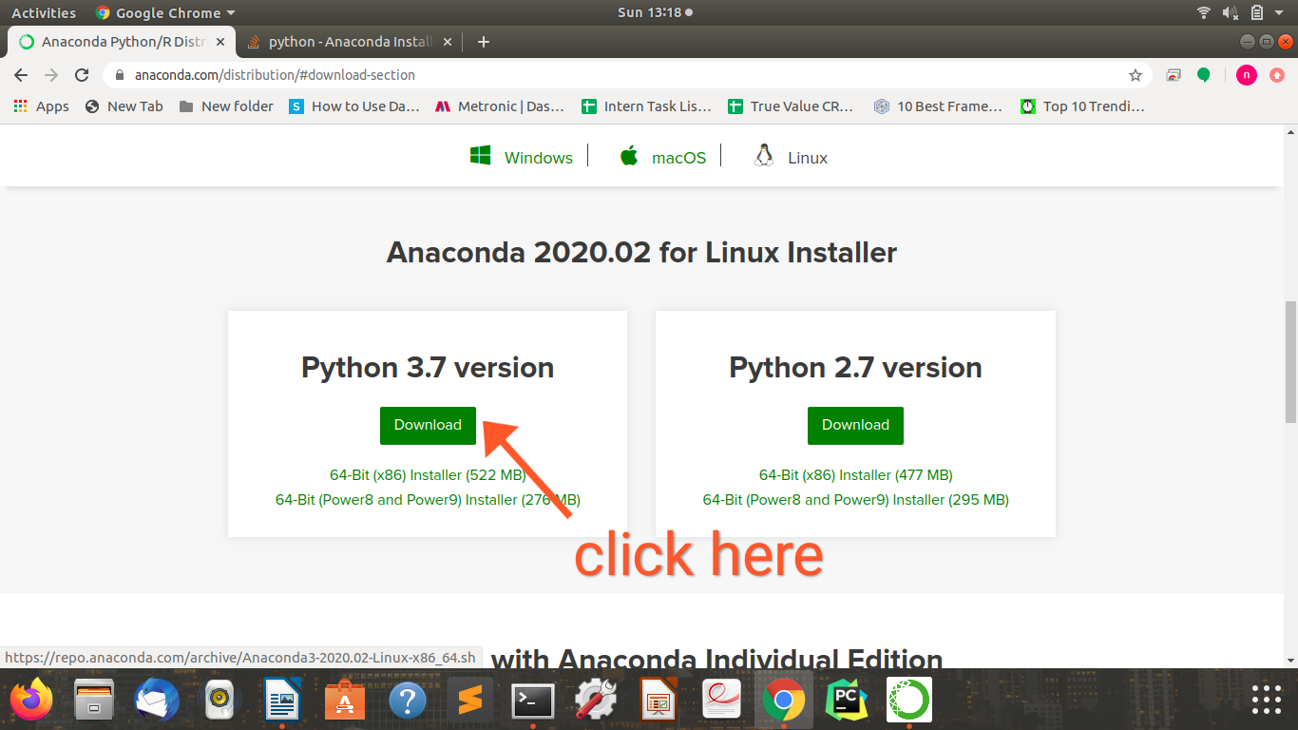

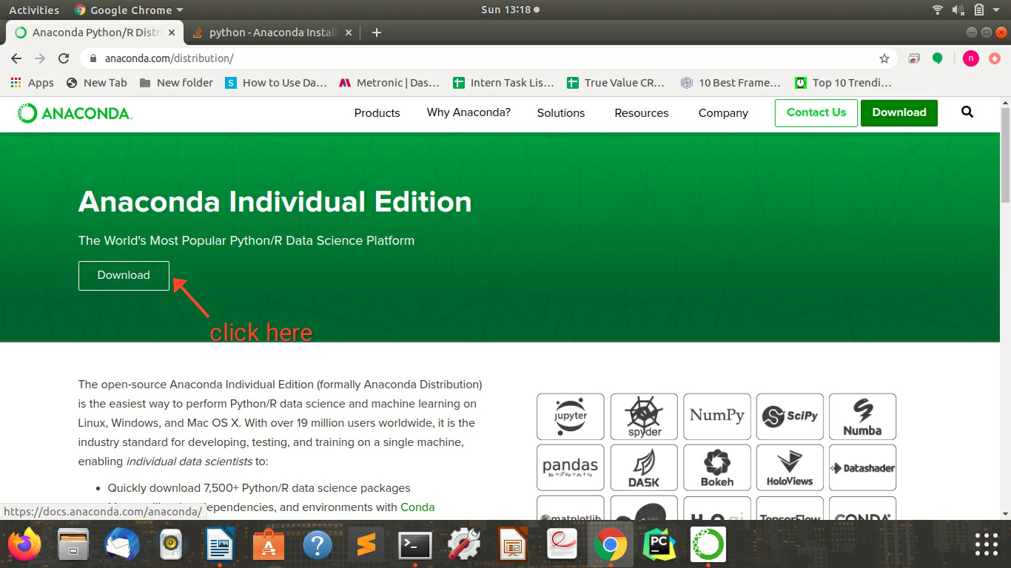

Step 2:

Once it is downloaded , open terminal and type this command

bash ~/Downloads/Anaconda3-2020.02-Linux-x86_64.sh

Press Enter when it will ask to do

It will take some while the More.. will be display on screen , again press enter continuously until

you get a message like this

Do you accept the license terms? [yes|no]

[no] >>>

Please answer 'yes' or 'no':'

>>>

Type yes and press enter

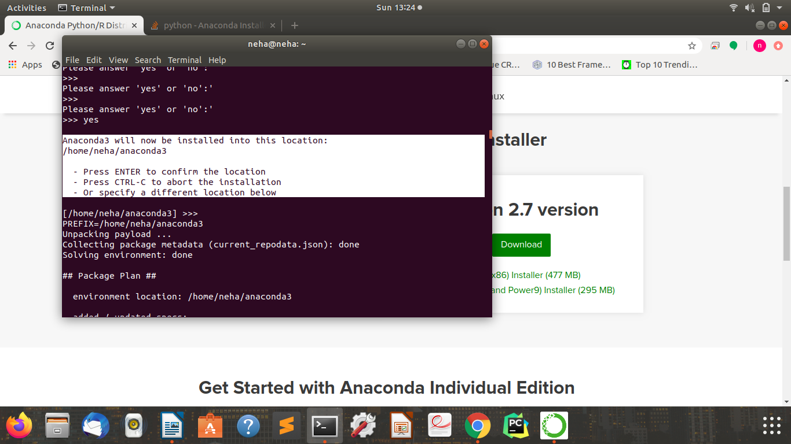

press enter to confirm the location

It will start unpacking the payload

Step 3:

source ~/anaconda3/bin/activate root

anaconda-navigator

Step 4:

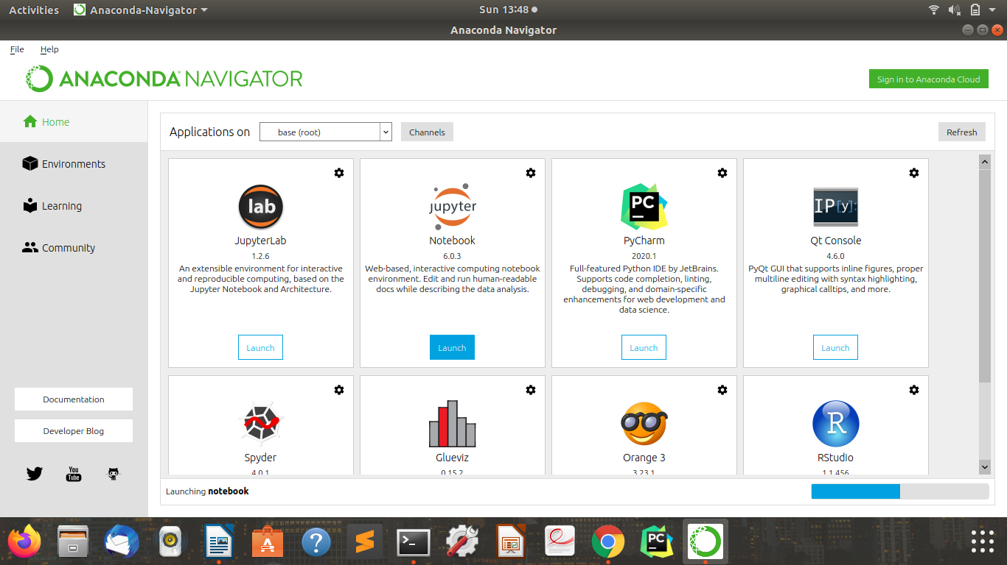

Launch Jupyter Notebook