病人病历报告

2019-10-09 Wed 21:10:40

# 病人信息

* 姓名:

Chener

* 性别:

Female

* 年龄:

43

# 肺结节情况

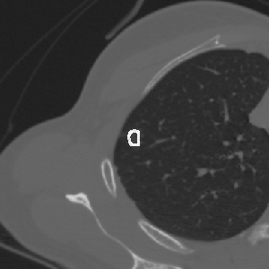  -694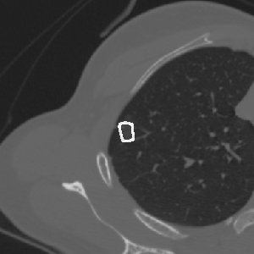  -661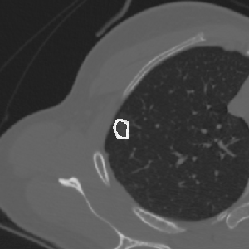  -659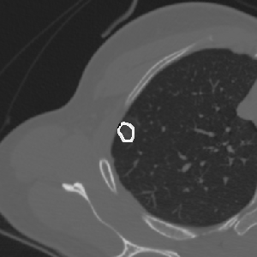  -643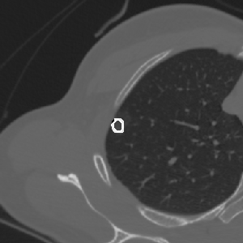  -608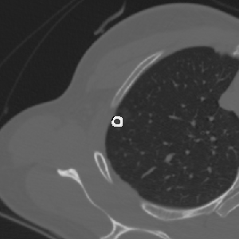  -589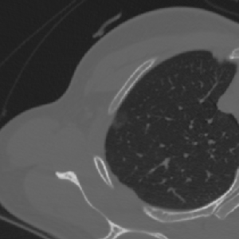  -581

|  |  |  |
| --- | --- | --- |
| Name | Volume | Mass |
| chener | 418 | 149.9 |