Design Journey Map

Name: Aleksandr Itskovich
NetID: ai223
Section Number:

Target Audience

My primary target audience will be families with young children who are interested in attending the Harvest Festival. They tend to be older, and might not be extremely tech-savvy. They may be local Ithacans, or outside visitors, who mainly want to spend a fun day doing family-friendly activities. In other words, they may or may not be familiar with the lay of the land.
My secondary audience will be younger residents of Ithaca (say 14 years old – mid 20’s) who are interested in attending local events when they’re around. It’s an occasion to get together with friends and do something fun. They may be high-school students, college students or young professionals. They would be interested more interested in things like social media or the local music scene.

Persona
In this part, create a persona that can represent your target audience, and describe him or her in details below, e.g., demographics, appearance, characteristics, hobbies, etc.
The Webbers are a middle-class family living in Freeville. The dad, Paul Webber (33), works as a technical-support specialist at Cornell. The mother, Cora Webber (34), is a social worker. They have two kids, aged 7 and 9½, a boy and a girl. Their names are Danny and Abigail. Paul and Dory together earn about $75,000/yr., so they are budget-conscious. Both parents work very hard and really value the time they have to spend with the family all together. They are excited about the Harvest Festival because it gives them a chance to do something new together as a family, but are slightly concerned about ending up spending too much money. Danny and Abigail generally get along, but can become grumpy with each other if they are bored or tired. Paul really enjoys listening to music, especially alternative rock, and Cora enjoys watching Peak TV shows. Abigail is going through a horse-phase. They all love pizza.

T.J. is 28 years-old living in Ithaca with his long-time boyfriend, Gary. He moved to Ithaca from the Midwest by himself when he was 17, attended Ithaca College and stayed in the area. He currently works at Greenstar, but is considered going to Grad school for a Master’s degree in Psychology or Sociology. T.J. is extremely outgoing and has a large number of friends in town. His partner is a middle-school teacher in Groton. T.J. loves Ithaca and, unless he’s busy at Greenstar, never misses local event as a chance to have a good time with his friends.

Needs
Needs  List your target audience’s needs and wants one by one. | Design Choices  Justify your design choices correspond to their needs. | Memo  Any additional comments you have to justify your design choices or things you want TAs to know.
FAMILY: need a comprehensive list of possible festival events, so they can plan out their day as much as possible, and make sure there is something for both of their kids | An easy-to-find, easy-to-read, well-organized event sections. Maybe keep more kid-oriented events and more adult-oriented events on separate pages. | Make sure to find/record as many events as possible.
FAMILY: need very clear information regarding things like address, date and times. | Display locations and date/time VERY clearly – so that if nothing else, that information is conveyed immediately and unambiguously. | Maybe a print-out map?
YOUNGER ITHACAN: likes to have easy access to social media. | Display links to Facebook, Twitter, YouTube, etc. clearly on the site. | Get official logos from somewhere.
YOUNGER ITHACAN: needs to know what local bands are playing. | Have a separate section for the concert line-up.
FAMILY: would be interested to know what the options for eating are | List food vendors associated with the harvest, or have a link to nearby Ithaca restaurants

Sketches / Screenshots / Storyboards
In this part, paste your 4 drawings, 4 screenshots or storyboards of the site below. To clarify, screenshots mean taking pictures of the site built in HTML/CSS. Sketches or storyboards can be your hand drawings, or mockups built by software like Illustrator, Photoshop, axure, etc.
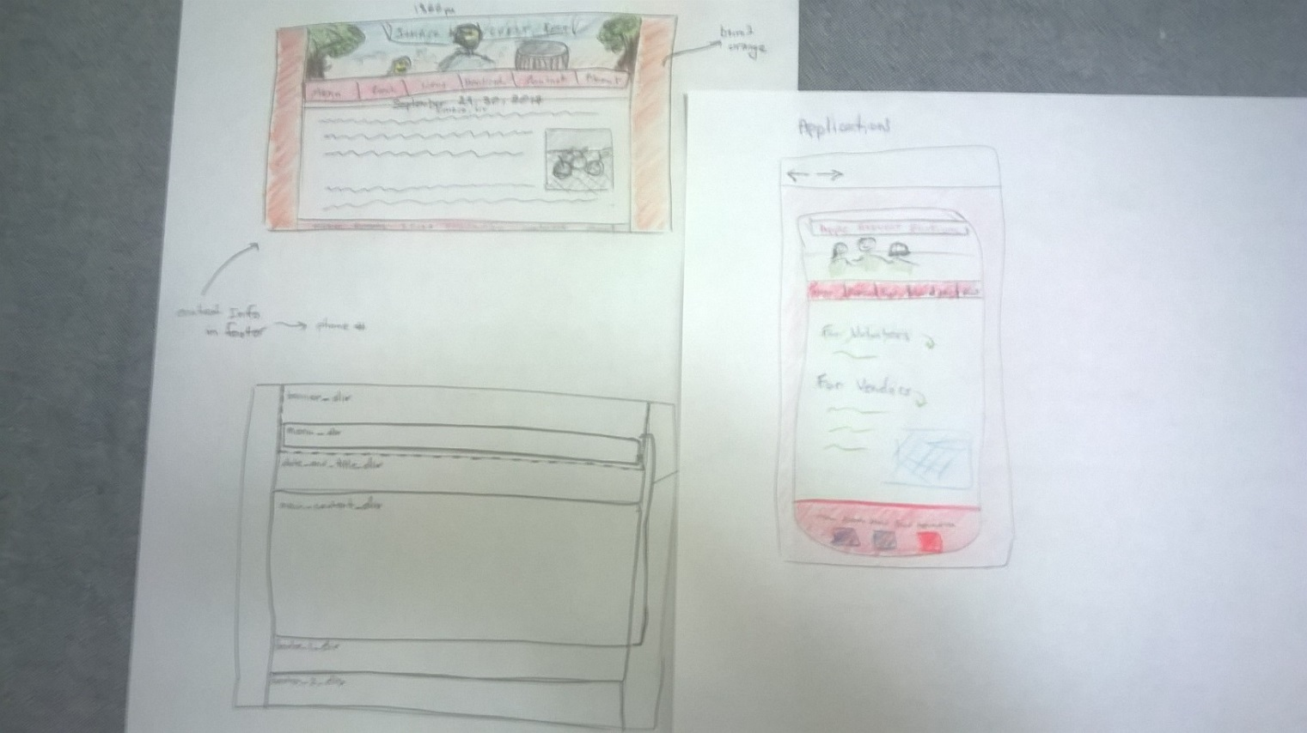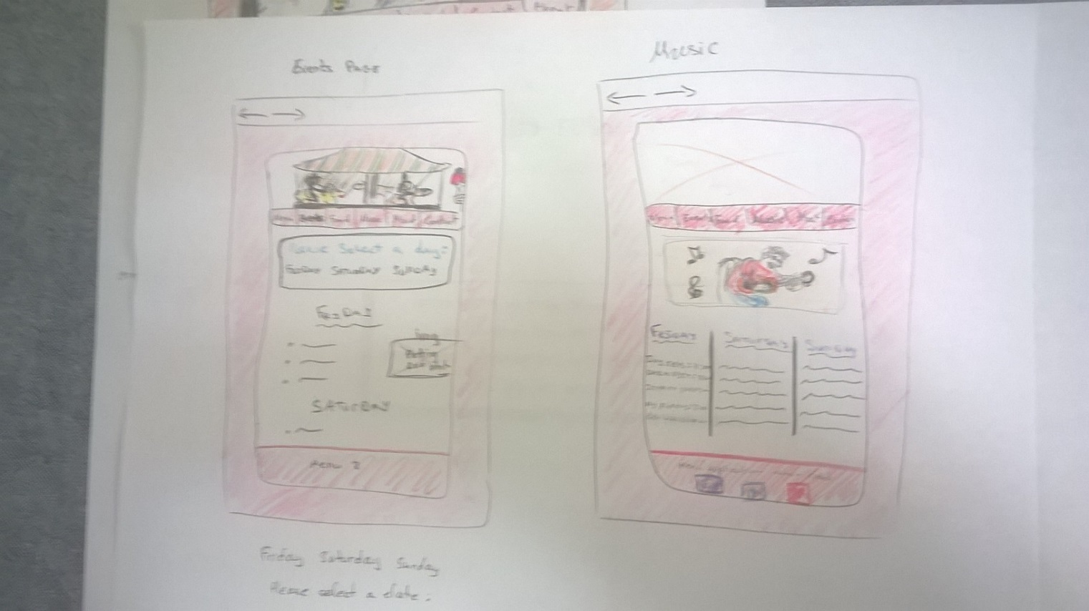

Additional Design Justifications
If you feel like you haven’t fully explained your design choices in the journey map part 1, or you want to explain some functions in your site (e.g., if you feel like you make a special design choice which might not meet P2M1 requirement), you can use the additional design justifications to justify your design choices. Remember, this is place for you to justify your design choices which you haven’t covered in the design journey part 1. Use it wisely. However, you don’t need to fill out this section if you think all design choices have been well explained in the design journey map part 1.
It probably goes without saying, but most of the photos I used in the site are placeholders. I plan on going to the Festival and taking the photos to replace them myself.
The sections I plan to have are clearly labelled, but I haven’t added content to them yet (except the home page).

