Supporting Information

CslA and GlxA from Streptomyces lividans form a functional cellulose synthase complex

Xiaobo Zhong, Simone Nicolardi, Ruochen Ouyang, Manfred Wuhrer, Chao Du, Gilles van Wezel, Erik Vijgenboom, Ariane Briegel, Dennis Claessen

Correspondence to: d.claessen@biology.leidenuniv.nl

This PDF files includes:

Supplementary Figures S1-S7
Supplementary Tables S1-S3

Figure S1. Sequence alignment of CslA from Streptomyces lividans and BcsA from Rhodobacter spaeroides. Sequence alignment was performed by ESPript 3.0 and annotated using Adobe Illustrator software. The sequence alignment shows that CslA of Streptomyces coelicolor (UniProt entry: Q9RDB5) and BcsA of Rhodobacter sphaeroides (UniProt entry: A0A3G6W9S6) share 27% sequence identity. Signature motifs of CslA are indicated,including the UDP-coordinating bases (D, D, D), the Mg²⁺ binding site (H), binding sites for the terminal disaccharide of the glucan (Q(Q/R)XRW), the gating loop (FXVTXK), and elements of a putative partial PilZ domain (RXXXR, indicated by black arrows).

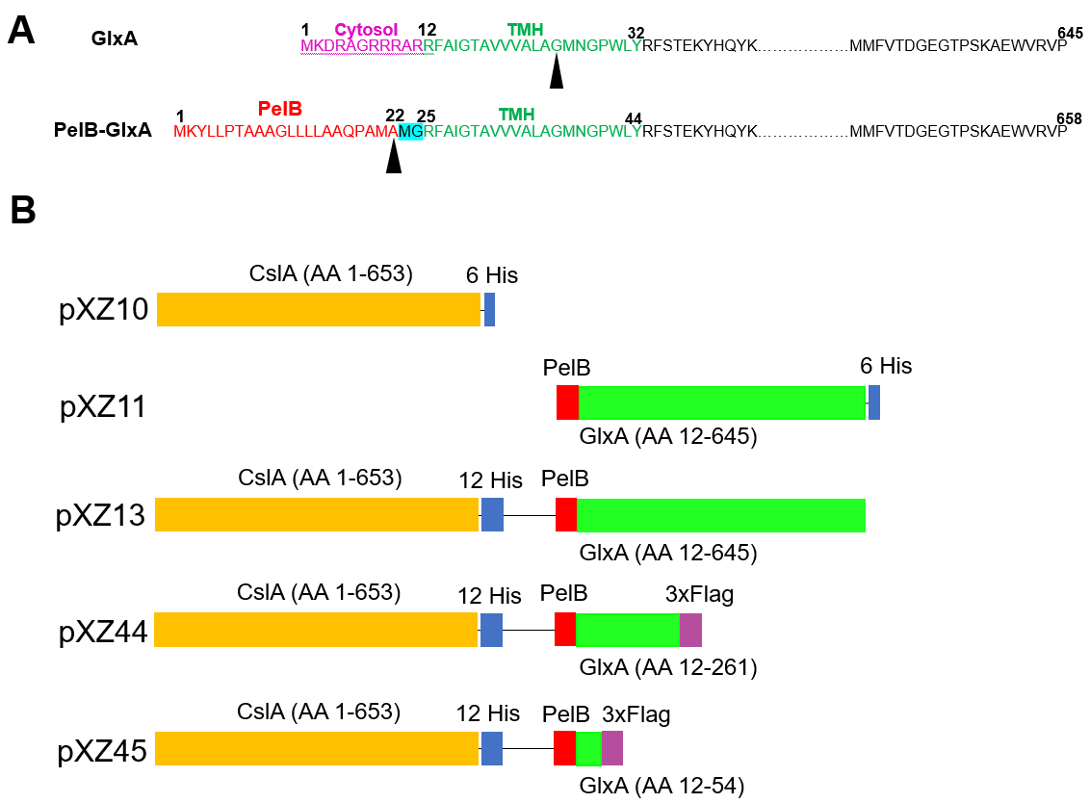

Figure S2. Strategy for expression of the CslA-GlxA complex. (A) Amino acid sequence of full length GlxA and the PelB-GlxA fusion. GlxA comprises a cytosolic part (AA 1-11), a transmembrane helix (TMH, AA 12-32) and an extracellular sequence (AA 33-645). In PelB-GlxA, the cytosolic sequence was replaced by a PelB leader peptide, in which PelB and GlxA are connected via a Met-Gly dipeptide (indicated in magenta) due to the NcoI restriction enzyme that was used. Arrows indicate the predicted peptidase cleavage sites. The transmembrane helices (TMH) were predicted using TMHMM-v2.0. (B) Inserts used to express CslA (in pXZ10), GlxA (in pXZ11), the CslA-GlxA complex (in pXZ13), the CslA-GlxA¹²⁻²⁶¹ complex (in pZX44) and CslA-GlxA¹²⁻⁵⁴ (in pXZ45).

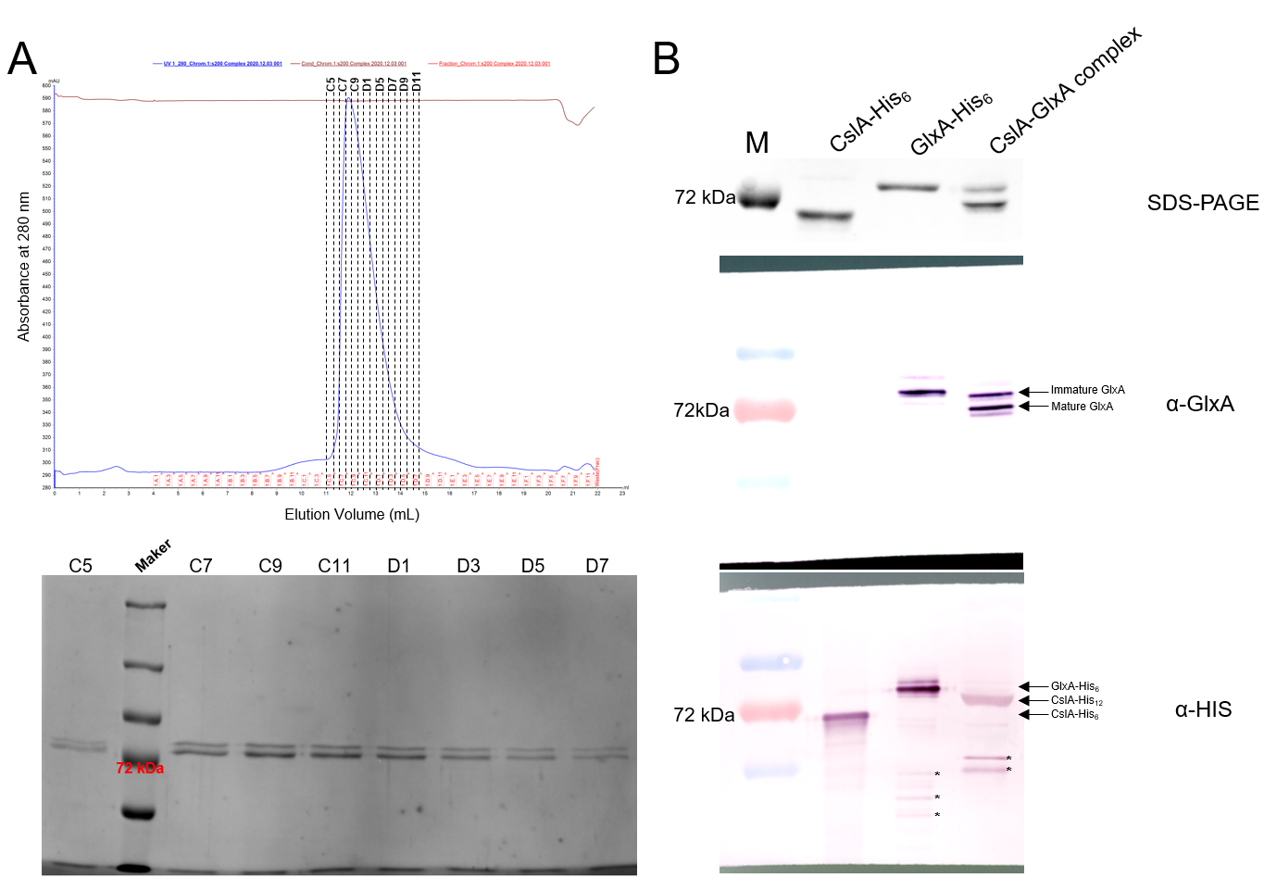

Figure S3. Analysis of the CslA-GlxA complex. (A) Size exclusion chromatography (SEC) analysis of the CslA-GlxA complex, which was done using a BioRad GNCTM system equipped with a Superdex 200 Increase 10/300 GL column. 10 µl of each fraction was separated on a 7.5% SDS-PAGE gel, which was subsequently stained with Coomassie Brilliant Blue (bottom panel). (B) Immunoblotting analysis of CslA (CslA-His₆), GlxA (GlxA-His₆), and the the CslA-GlxA complex (CslA-His₁₂-GlxA). Samples containing 5 µg protein were loaded and separated on 7.5% SDS-PAGE gels and subsequently stained with Coomassie Brilliant Blue (top panel) or analysed using immunoblotting with antibodies directed against GlxA (middle panel) or the His-tags (bottom panel). In the CslA-His₁₂-GlxA complex, two GlxA bands are visible corresponding to immature GlxA (without the Tyr-Cys cofactor, upper band) and mature GlxA (with the Tyr-Cys cofactor, lower band). Please note that CslA has a larger molecular weight in the complex due to the His₁₂-tag. * Asterisks mark non-specific signals or potential degradation products.

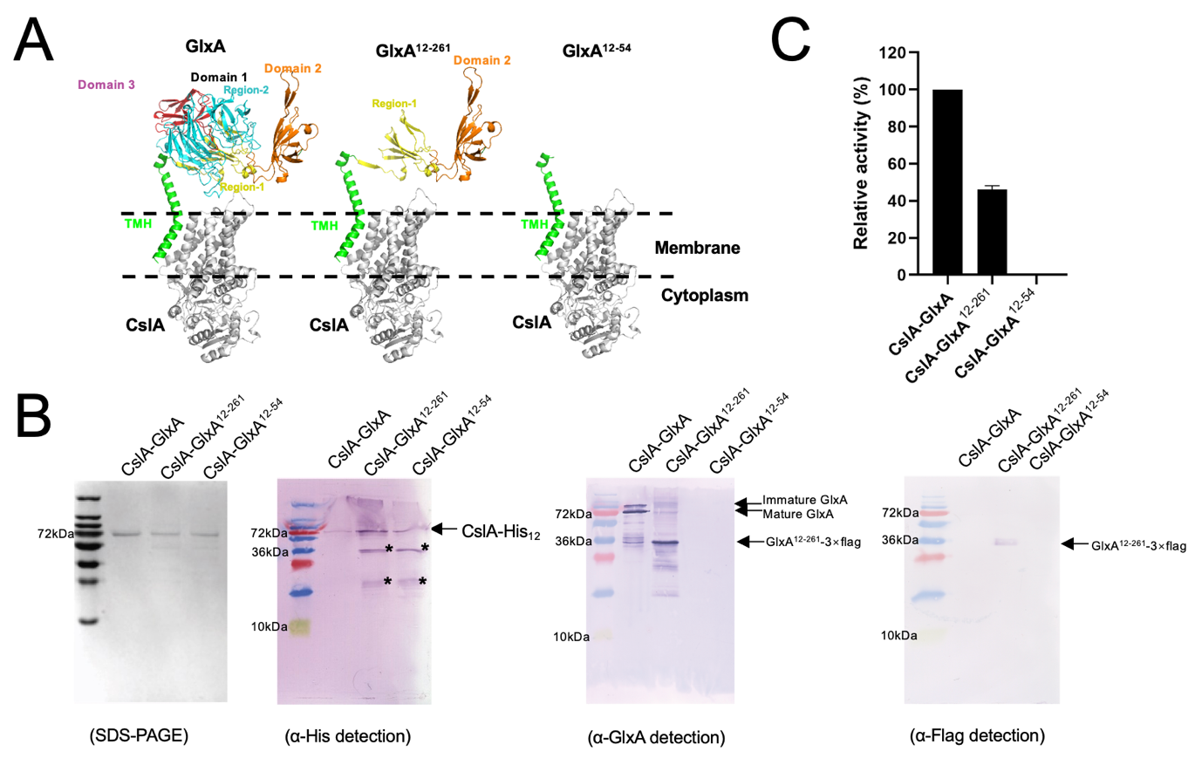

Figure S4. The TMH region of GlxA is not sufficient for formation of the GlxA-CslA complex. (A) Schematic overview of GlxA truncations (GlxA¹²⁻²⁶¹ and GlxA¹²⁻⁵⁴) used in pull-down assays with CslA. (B) Immunoblotting analyses of protein complexes obtained using pull-down assays. For each well, 2 µg protein was loaded. * Asterisks mark non-specific signals or potential degradation products. Please note that GlxA¹²⁻⁵⁴ is not sufficient to form a complex with CslA. (C) Activity analyses of purified complexes. Reactions were performed by incubating 0.05 mg mL⁻¹ of each protein complex with 5 mM UDP-Glc, 5 mM cellobiose, 20 mM MgCl₂ and 30 μM cyclic-di-GMP at 37°C for 60 min. The catalytic activity of enzymes was quantified by measuring free UDP with the UDP-GloTM glycosyltransferase assay. The catalytic activity impacted by GlxA truncations was assessed relative to the ClsA-GlxA complex. Every measurement was performed in triplicate. Error bars represent the standard error of the mean.

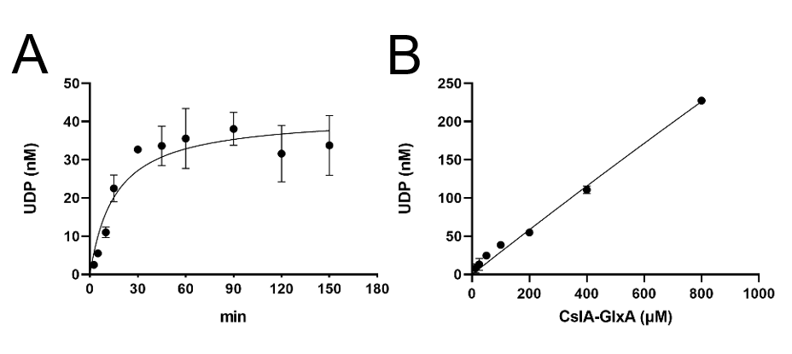
Figure S5. Kinetics of cellulose synthesis by the purified CslA-GlxA complex. (A) Time course of cellulose synthesis in vitro with UDP-Glc as the substrate. The data were fitted using Michaelis-Menten kinetics. A linear relationship is found between UDP release and protein concentration (0-1 mM) at 5 mM UDP-Glc (B). Catalytic activity of CslA-GlxA was determined by quantifying the amount of released UDP. All reactions were conducted in triplicate. Error bars represent the standard error of the mean.

Figure S6. MALDI-CID FT-ICR MS analysis of oligosaccharides from cellulase digests of cellulose and the in vitro synthesized glucan. Enlargement of MALDI FT-ICR mass spectra in the m/z-range 1011-8000 from the analysis of the cellulase digest of cellulose (top) or the in vitro synthesized glucan (bottom).

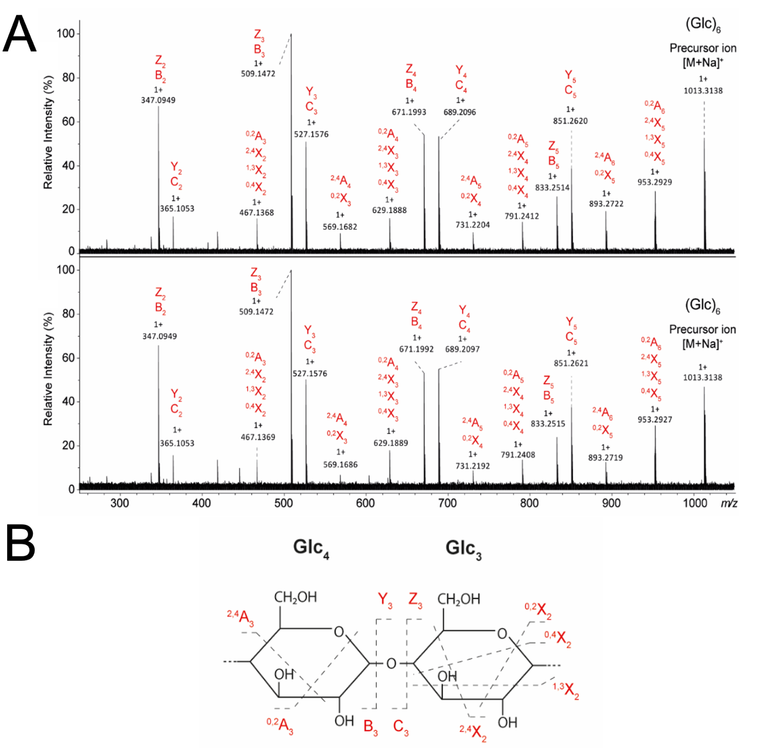

Figure S7. Linkage analysis of hexaglucose fractions from the cellulase digests of cellulose and the in vitro synthesized glucan. (A) Hexaglucose oligosaccharides obtained from Figure S7 were subjected to linkage analysis by MALDI-CID FT-ICR MS, in which top and bottom panels represent mass spectra of the analysis of the cellulase digest of cellulose and the in vitro synthesized glucan, respectively. Isomeric fragments are vertically aligned. The fragmentation scheme used for the assignments is indicated in (B).

Table S1. Primers used in this study

Name Sequence
3187-F | CATGCATATGATGACGTCGACGCCGACGGGCG
3187-R | CCCAAGCTTTTCCTTACGTCCCCCAAGTCCACCAAGGG
3188-F | CATGCCATGGGACGCTTCGCGATAGGTACGGCG
3188-R | CCCAAGCTTCGGCACCCGCACCCACTC
blaM-F | CCCAAGCTTGCGGTTCCACATGCTATAAGTTCCAGCCCATTACGCcacccagaaacgctggtgaaa
blaM_{FL}-F | GGAATTCCATATGATGAGTATTCAACATTTCCGTGTCG
blaM-R | CCGGAATTCTTACCAATGCTTAATCAGTGAGGC
glxA₁₋₉₆-F | GGAATTCCATATGAAAGACCGTGCCGGCCGC
glxA₁₋₉₆-R | CCCAAGCTTGTAGAGCCACGGCCCGTTCATCC
glxA_{Blam}-F | GGAATTCCATATGATGAAAGACCGTGCCGGCCGCCGC
glxA_{Blam}-R | CCCAAGCTTCGGCACCCGCACCCACTCCGCCTTAC
pglxA-F | GGGAATTGTGAGCGGATAACAATTCCCC
pglxA-R | CCTTAATTAACTA CGGCACCCGCACCCACTC
cslA-F | GGGAATTGTGAGCGGATAACAATTCCCC
cslA-R | CCGGAATTCTCAGTGGTGGTGGTGGTGGTGGTGGTGGTGGTGGTGGTGCTCGAGTGC
Flag-F | gattataaggatcatgatggtgattataaggatcatgatatcgactacaaagacgatgacgacaagTAGTGCTGCCACCGCTGAGCAATAAC
GlxA261-R | GAAGTCCTTCTTGTCGAGGGCGAGC
GlxA54-R | GCCGTTGGCGGCCTTGTACTC

Table S2. Plasmids used in this study

Name | Description | References
pXZ2 | pSET152 plasmid containing the gapAp_cslZ fragment. | (17)
pHJL401 | E. coli/Streptomyces shuttle vector containing the blaM gene | (33)
pXZ10 | pET21a plasmid used for expressing CslA-His₆ | This work
pXZ11 | pET22b plasmid used for expressing PelB-GlxA-His₆ | This work
pXZ12 | pETDueT-1 plasmid used for expressing PelB-GlxA in MCSII | This work
pXZ13 | pETDueT-1 plasmid used for expressing CslA-His₁₂ and PelB-GlxA in MCS I and II, respectively | This work
pXZ36 | pSET152 plasmid expressing blaM_{FL} from the constitutive gapAp promoter | This work
pXZ42 | pSET152 plasmid expressing glxA₁₋₉₆-blaM_{NS} from the constitutive gapAp promoter | This work
pXZ43 | pSET152 plasmid expressing glxA_{FL}-blaM_{NS} from the constitutive gapAp promoter | This work
pXZ44 | pETDueT-1 plasmid used for expressing PelB-GlxA¹²⁻²⁶²-3×Flag in MCSII and CslA-His₁₂ in MCSI | This work
pXZ45 | pETDueT-1 plasmid used for expressing PelB-GlxA¹²⁻⁵⁴-3×Flag in MCSII and CslA-His₁₂ in MCSI | This work

Table S3. Proteins used for the construction of the phylogenetic tree of Figure 1.

Abbreviation | Protein name | Organism | UniProt Entry
SCO_2836 | Cellulose synthase-like protein | Streptomyces coelicolor (strain ATCC BAA-471 / A3(2) / M145) | Q9RDB5
SVEN_5601 | Cellulose synthase-like protein | Streptomyces venezuelae (strain ATCC 10712) | F2R878
SCAB_57291 | Cellulose synthase-like protein | Streptomyces scabiei (strain 87.22) | C9Z2P5
SAV_5219 | Cellulose synthase-like protein | Streptomyces avermitilis (strain ATCC 31267) | Q82CW9
SGR_4704 | Cellulose synthase-like protein | Streptomyces griseus (strain JCM 4626/NBRC 13350) | B1VW22
SLI_3187 | Cellulose synthase-like protein | Streptomyces lividans 1326 | A0A7U9DT44
SCLAV_1986 | Cellulose synthase-like protein | Streptomyces clavuligerus (strain ATCC 27064) | B5H368
E_{C}BcsA | Bacterial cellulose synthase A | Escherichia coli (strain K12) | P37653
K_{X}BcsA | Bacterial cellulose synthase A | Komagataeibacter xylinus | P19449
PfBcsA | Bacterial cellulose synthase A | Pseudomonas fluorescens | P58931
RsBcsA | Bacterial cellulose synthase A | Rhodobacter sphaeroides | A0A3G6W9S6
AtCesA1 | Cellulose synthase A1 | Arabidopsis thaliana | O48946
AtCesA2 | Cellulose synthase A2 | Arabidopsis thaliana | O48947
AtCesA3 | Cellulose synthase A3 | Arabidopsis thaliana | Q941L0
AtCesA4 | Cellulose synthase A4 | Arabidopsis thaliana | Q84JA6
AtCesA5 | Cellulose synthase A5 | Arabidopsis thaliana | Q8L778
AtCesA6 | Cellulose synthase A6 | Arabidopsis thaliana | Q94JQ6
AtCesA7 | Cellulose synthase A7 | Arabidopsis thaliana | Q9SWW6
AtCesA8 | Cellulose synthase A8 | Arabidopsis thaliana | Q8LPK5
AtCesA9 | Cellulose synthase A9 | Arabidopsis thaliana | Q9SJ22
AtCesA10 | Cellulose synthase A10 | Arabidopsis thaliana | Q9SKJ5
AtCslA2 | Cellulose synthase-like protein A2 | Arabidopsis thaliana | Q9FNI7
AtCslA7 | Cellulose synthase-like protein A7 | Arabidopsis thaliana | Q9ZQN8
AtCslA9 | Cellulose synthase-like protein A9 | Arabidopsis thaliana | Q9LZR3
AtCslB1 | Cellulose synthase-like protein B1 | Arabidopsis thaliana | O80898
AtCslB2 | Cellulose synthase-like protein B2 | Arabidopsis thaliana | O80899
AtCslB3 | Cellulose synthase-like protein B3 | Arabidopsis thaliana | Q8RX83
AtCslB5 | Cellulose synthase-like protein B5 | Arabidopsis thaliana | Q0WT40
AtCslB6 | Cellulose synthase-like protein B6 | Arabidopsis thaliana | O23386
AtCslC2 | Cellulose synthase-like protein C2 | Arabidopsis thaliana | Q9ZQB9
AtCslC4 | Cellulose synthase-like protein C4 | Arabidopsis thaliana | Q9LJP4
AtCslC5 | Cellulose synthase-like protein C5 | Arabidopsis thaliana | Q9SB75
AtCslC6 | Cellulose synthase-like protein C6 | Arabidopsis thaliana | Q9SRT3
AtCslC8 | Cellulose synthase-like protein C8 | Arabidopsis thaliana | Q9SJA2
AtCslE1 | Cellulose synthase-like protein E1 | Arabidopsis thaliana | Q8VZK9
AtCslG1 | Cellulose synthase-like protein G1 | Arabidopsis thaliana | Q570S7
AtCslG2 | Cellulose synthase-like protein G2 | Arabidopsis thaliana | Q8VYR4
OsCesA1 | Cellulose synthase A1 | Oryza sativa | A2Y0X2
OsCesA2 | Cellulose synthase A2 | Oryza sativa | A2XN66
OsCesA3 | Cellulose synthase A3 | Oryza sativa | Q69V23
OsCesA4 | Cellulose synthase A4 | Oryza sativa | Q5JN63
OsCesA5 | Cellulose synthase A5 | Oryza sativa | Q851L8
OsCesA6 | Cellulose synthase A6 | Oryza sativa | Q6YVM4
OsCesA7 | Cellulose synthase A7 | Oryza sativa | Q9AV71
OsCesA8 | Cellulose synthase A8 | Oryza sativa | Q84ZN6
OsCesA9 | Cellulose synthase A9 | Oryza sativa | A2Z1C8
OsCesA11 | Cellulose synthase A11 | Oryza sativa | Q69XK5
OsCslA1 | Cellulose synthase-like protein A1 | Oryza sativa | Q7PC76
OsCslA2 | Cellulose synthase-like protein A2 | Oryza sativa | Q7PC67
OsCslA3 | Cellulose synthase-like protein A3 | Oryza sativa | Q67X45
OsCslA4 | Cellulose synthase-like protein A4 | Oryza sativa | Q8S7W0
OsCslA5 | Cellulose synthase-like protein A5 | Oryza sativa | Q7PC73
OsCslA6 | Cellulose synthase-like protein A6 | Oryza sativa | Q6Z2T9
OsCslA7 | Cellulose synthase-like protein A7 | Oryza sativa | Q7XIF5
OsCslA9 | Cellulose synthase-like protein A9 | Oryza sativa | Q67VS7
OsCslA11 | Cellulose synthase-like protein A11 | Oryza sativa | Q6YWK8
OsCslC2 | Cellulose synthase-like protein C2 | Oryza sativa | Q69L19
OsCslC9 | Cellulose synthase-like protein C9 | Oryza sativa | Q6AU53
OsCslD1 | Cellulose synthase-like protein D1 | Oryza sativa | Q8W3F9
OsCslD2 | Cellulose synthase-like protein D2 | Oryza sativa | A2YU42
OsCslD3 | Cellulose synthase-like protein D3 | Oryza sativa | Q7EZW6
OsCslD4 | Cellulose synthase-like protein D4 | Oryza sativa | Q2QNS6
OsCslD5 | Cellulose synthase-like protein D5 | Oryza sativa | Q5Z6E5
OsCslE1 | Cellulose synthase-like protein E1 | Oryza sativa | Q651X7
OsCslE2 | Cellulose synthase-like protein E2 | Oryza sativa | Q0DXZ1
OsCslF2 | Cellulose synthase-like protein F2 | Oryza sativa | Q84S11
OsCslF3 | Cellulose synthase-like protein F3 | Oryza sativa | A2YMH5
OsCslF4 | Cellulose synthase-like protein F4 | Oryza sativa | Q6ZF86
OsCslF6 | Cellulose synthase-like protein F6 | Oryza sativa | Q84UP7
OsCslF7 | Cellulose synthase-like protein F7 | Oryza sativa | Q94GM9
OsCslF9 | Cellulose synthase-like protein F9 | Oryza sativa | Q7XHV0
OsCslH1 | Cellulose synthase-like protein H1 | Oryza sativa | Q339N5
OsCslH2 | Cellulose synthase-like protein H2 | Oryza sativa | Q7PC71
OsCslH3 | Cellulose synthase-like protein H3 | Oryza sativa | Q7XUU0

