Supplementary information

Supplementary figure legends
Figure S1 Phylogenetic analysis of the substrate binding proteins (SBPs) affiliated with the putative choline ABC-type transporter found in marine bacteria. Reference sequences from characterised SBPs were added to the alignment. Characterised SBPs, related to osmolyte SBPs, based on the structural analysis conducted by Berntsson et al. (2010) were used as an outgroup. The tree was aligned in MEGA 5.2 using the neighbour-joining method using 500 replications for bootstrapping. The scale bar represents the number of substitutions per amino acid. Abbreviations: ChoX, SBP specific for choline; TmoX, SBP specific for trimethylamine N-oxide; BetX, SBP specific for glycine betaine; CaiX, SBP specific for carnitine.
Figure S2 Detailed phylogeny of ChoX from Figure S1 showing strain names and their corresponding accession numbers (Gene ID in IMG/JGI).
Figure S3 Phylogenetic analysis of choline dehydrogenase (BetA). The evolutionary history was inferred using the Neighbour-Joining method. For the major nodes, the percentage (>75%) of replicate trees in which the associated taxa clustered together in the bootstrap test (500 replicates) are shown. The tree is drawn to scale, with branch lengths in the same units as those of the evolutionary distances used to infer the phylogenetic tree. The evolutionary distances were computed using the p-distance method and are in the units of the number of amino acid differences per site. The analysis involved 101 amino acid sequences. All ambiguous positions were removed for each sequence pair. There were a total of 685 positions in the final dataset. Evolutionary analyses were conducted in MEGA6.
Figure S4 Gene neighbourhoods of fhs1 and fhs2. The scale bar represents the number of bases. Abbreviations: folD, 5,10-methylene-H₄F dehydrogenase/ methenyl-H₄F cyclohydrolase; tmm, trimethylamine monooxygenase; tdm, trimethylamine N-oxide demethylase; fhs, formyl-H₄F synthetase; tmoR, putative regulator of tmm; amt, unspecified ammonium transporter; ftsH, ATP-dependent metalloprotease; fhdA, formate dehydrogenase alpha subunit; fhdB, formate dehydrogenase beta subunit; PBP, uncharacterised HAAT family amino acid periplasmic binding protein.
Figure S5 Growth of the R. pomeroyi fhs null mutant on GBT (red squares), homocysteine (purple crosses) or GBT and homocysteine (green triangles) as the carbon source, respectively. A positive control consisted of glucose as a carbon source and the negative control had no added carbon. Cultures were grown in triplicate. Error bars denote s.d. Hcy: homocysteine.
Figure S6 Growth of R. pomeroyi wild-type and the fhs null mutant on glucose and GBT as the carbon and energy source and ammonium as the nitrogen source. Tetrahydrofolate (1 mM) was added to wild-type and mutant cultures at T=0 h and T=21 h and GBT consumption was recorded. Cultures were grown in triplicate. Error bars denote s.d.

Table S1. List of oligonucleotides used in this study
Primer | Sequence | Use
Spo1088_AF_HindIII | CAATAAGCTTGGCAGCAAGGAAAGACAGAC | Cloning 5' end (region A) of betA
Spo1088_AR_BamHI | CAATGGATCCGCTTCTCGCCGTTATAGTCG | Cloning 5' end (region A) of betA
Spo1088_BF_BamHI | CAATGGATCCAATGGCTGTTCACCAAGACC | Cloning 3' end (region B) of betA
Spo1088_BR_XbaI | CAATTCTAGAATTGGTGATCTGCGGAAAGA | Cloning 3' end (region B) of betA
Spo1087_Cho_perm_AF_PstI | CAATCTGCAGGATGTCCCGAATGCGTTT | Cloning 5' end (region A) of betT
Spo1087_Cho_perm_AR_XbaI | CAATTCTAGATTGTTGACCAGCTTCACC AG | Cloning 5' end (region A) of betT
Spo1087_Cho_perm_BF_XbaI | CAATTCTAGACCTTGGCGATCTGGTTCTC | Cloning 3' end (region B) of betT
Spo1087_Cho_perm_BR_HindIII | CAATAAGCTTACGATGACAAAATCCGCT TC | Cloning 3' end (region B) of betT
Spo0084_AF_PstI | CAATCTGCAGATTTTCAACTCTGCCCGTTT | Cloning 5' end (region A) of betB
Spo0084_AR_XbaI | CAATTCTAGAACGGACGGTATAGGCGAAAT | Cloning 5' end (region A) of betB
Spo0084_BF_XbaI | CAATTCTAGAATATGTCGACAAGGGCAAGG | Cloning 3' end (region B) of betB
Spo0084_BR_HindIII | CAATAAGCTTATTCCGGCTTCTTTCTGGTT | Cloning 3' end (region B) of betB
Spo1083 _AF_PstI | CAATCTGCAGTCCTGATCCTGATGGTGGAT | Cloning 5' end (region A) of betC
Spo1083_ AR_BamHI | CAATGGATCCGATCGTAAAGCTTGGCCTTG | Cloning 5' end (region A) of betC
Spo1083_BF_BamHI | CAATGGATCCACACGCCGGTTTCTACCAT | Cloning 3' end (region B) of betC
Spo1083_BR_XbaI | CAATTCTAGACCTCTGGCTTTCCTCCAGAT | Cloning 3' end (region B) of betC
Spo1557_AF_XbaI: | TCTAGAGTCACCTATCCCTCGCTCAG | Cloning upstream of 5' end (region A) of fhs1
Spo1557_AR_SalI | ATGCTGTCGACTACGCCATCTGATGATTTCC | Cloning upstream of 5' end (region A) of fhs1
Spo1557_BF_SalI | ATGCTGTCGACGATCGAGGGCTTGTTCTGAG | Cloning downstream of 3' end (region B) of fhs1
Spo1557_BR_HindIII | AAGCTTTTCAGCTCTGCCACATGTTC | Cloning downstream of 3' end (region B) of fhs1
Spo3103_AF_ | CAATTCTAGAATTTCCATGCGATCACCAGC | Cloning 5' end (region A) of fhs2
Spo3103_AR_ | CCAATGGATCCACGTAATCGGCCACTTTCA | Cloning 5' end (region A) of fhs2
Spo3103_BF_ | CAATGGATCCGGCGATCAACCATTTCGTTCA | Cloning 3' end (region B) of fhs2
Spo3103_BR_ | CCAATAAGCTTCATTCAACCGGATGGTCTCT | Cloning 3' end (region B) of fhs2
Spo1088_CON_F1 | CTATATCGCGGGCAATGTCG | Confirmation of ΔbetA::Gm
Spo1088_CON_R1 | GACAGGGATCAAATCGGGTG | Confirmation of ΔbetA::Gm
Spo1087_CON_F1 | CATGCAGGATCGACAACAGG | Confirmation of ΔbetT::Gm
Spo1087_CON_R1 | GTTGTTCAGATGCGGTTCGG | Confirmation of ΔbetT::Gm
Spo0084_CON_F1 | GATACCGGTCGAAGGGAGAG | Confirmation of ΔbetB::Gm
Spo0084_CON_R1 | GGCAGGACAATCTTTCACGG | Confirmation of ΔbetB::Gm
Spo1083_CON_F1 | CTGATCGACGGGCTCTACAT | Confirmation of ΔbetC::Gm
Spo1083_CON_R1 | GCCATCACGTAGGTTTCGAC | Confirmation of ΔbetC::Gm
Spo1557_CON_F1 | GAGATGAAGCGCAACATGAA | Confirmation of Δfhs1:Gm
Spo1557_CON_R1 | TACCCAGAAGACCCACGTTC | Confirmation of Δfhs1::Gm
Spo3103_CON_F1 | GACCATCGACATGGAAAACC | Confirmation of Δfhs2::Spc in Δfhs1::Gm
Spo3103_CON_R1 | TTCAGCTCTGCCACATGTTC | Confirmation of Δfhs2::Spc in Δfhs1::Gm
Fhs_promF1_KpnI | CAATGGTACCTCTTGTGGGCCAA | Cloning the promoter for the T4F-kinked oxidation pathway
Fhs_promR1_SalI | CAATGTCGACCCGTCAACACCTC | Cloning the promoter for the T4F-kinked oxidation pathway
Fhs-1_F1_SalI | CAATGTCGACATGGCGTACAAGA | Cloning the fhs in R. pomeroyi
Fhs_1_R1_BamHI | CAATGGATCCTCAGAACAAGCCCTCGATCTG | Cloning the fhs in R. pomeroyi

Figure S1

FIII cluster subgroups I, II, IV, V
BetX, CaiX and other non-characterised osmolyte SBPs found in marine bacteria
TmoX
ChoX
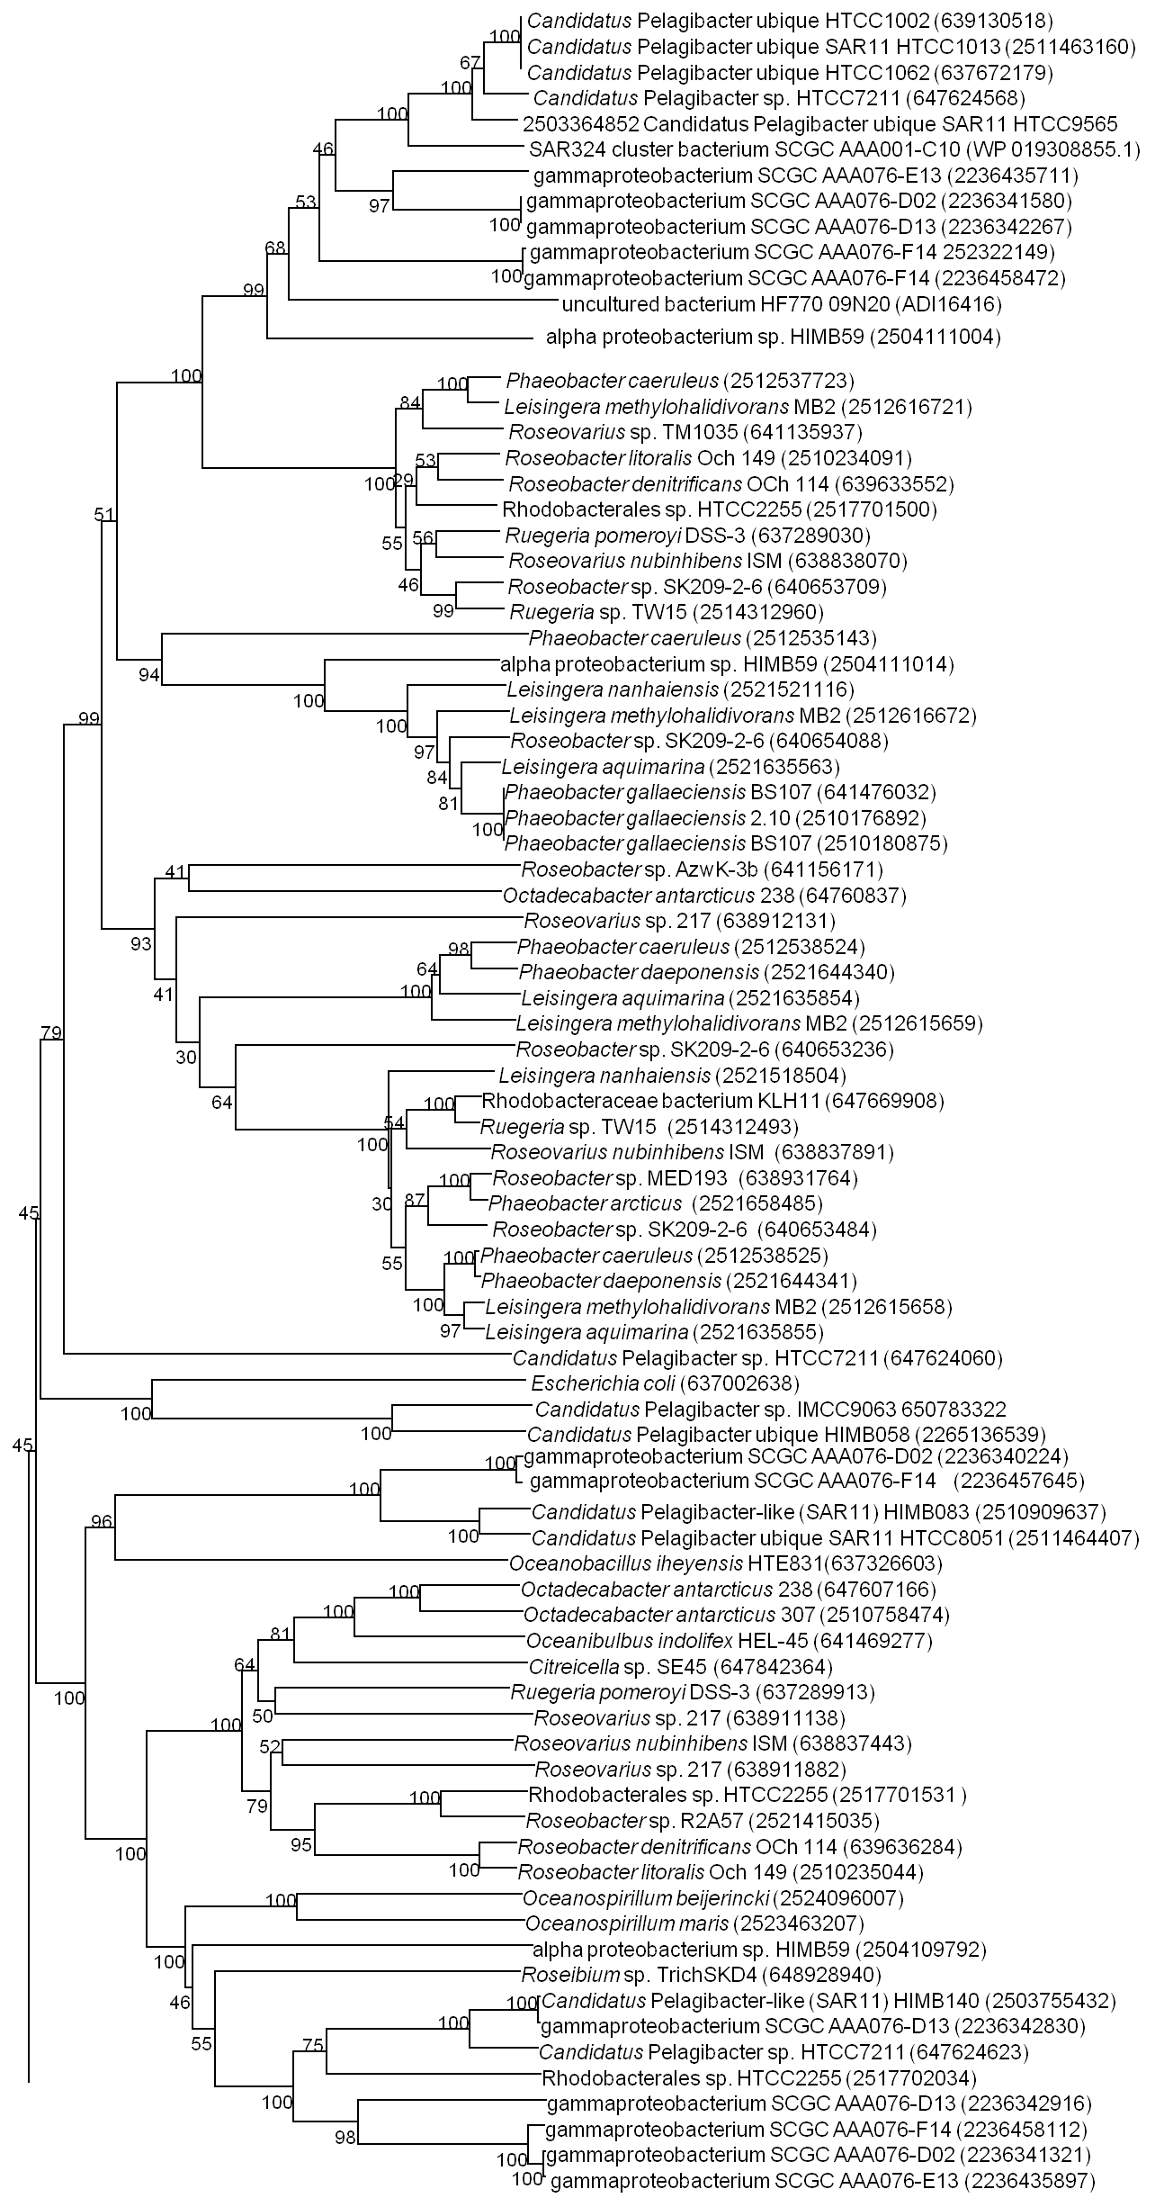
Figure S2
BetX
TmoX
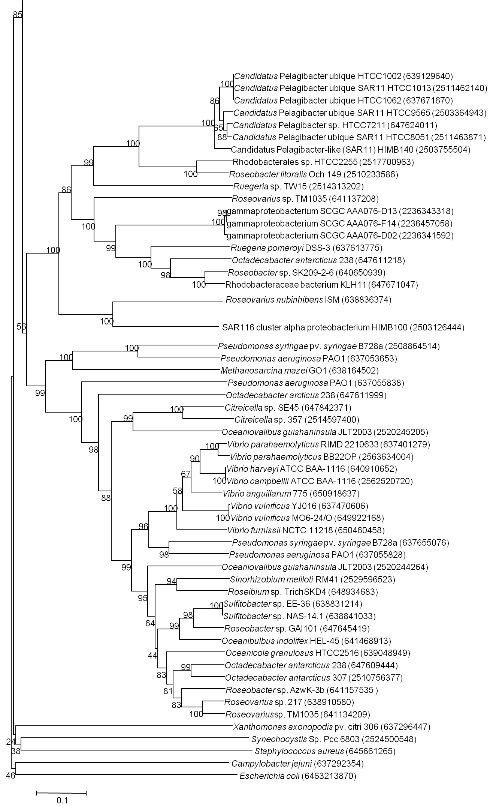
Cluster FIII
ChoX
CaiX
BetX

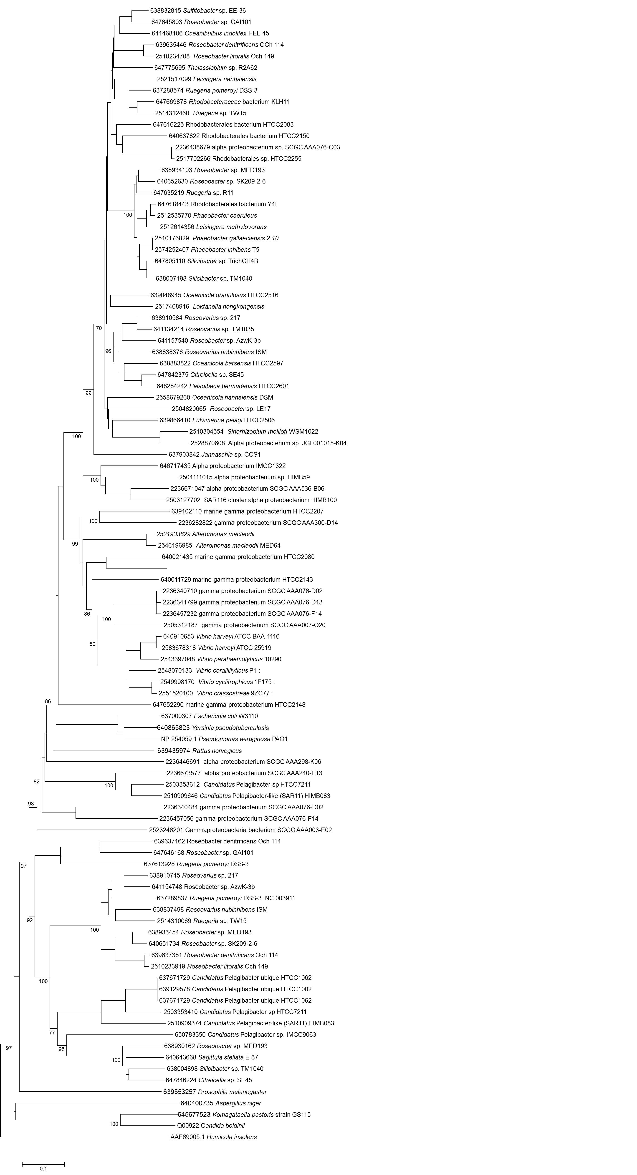
BetA
Figure S3
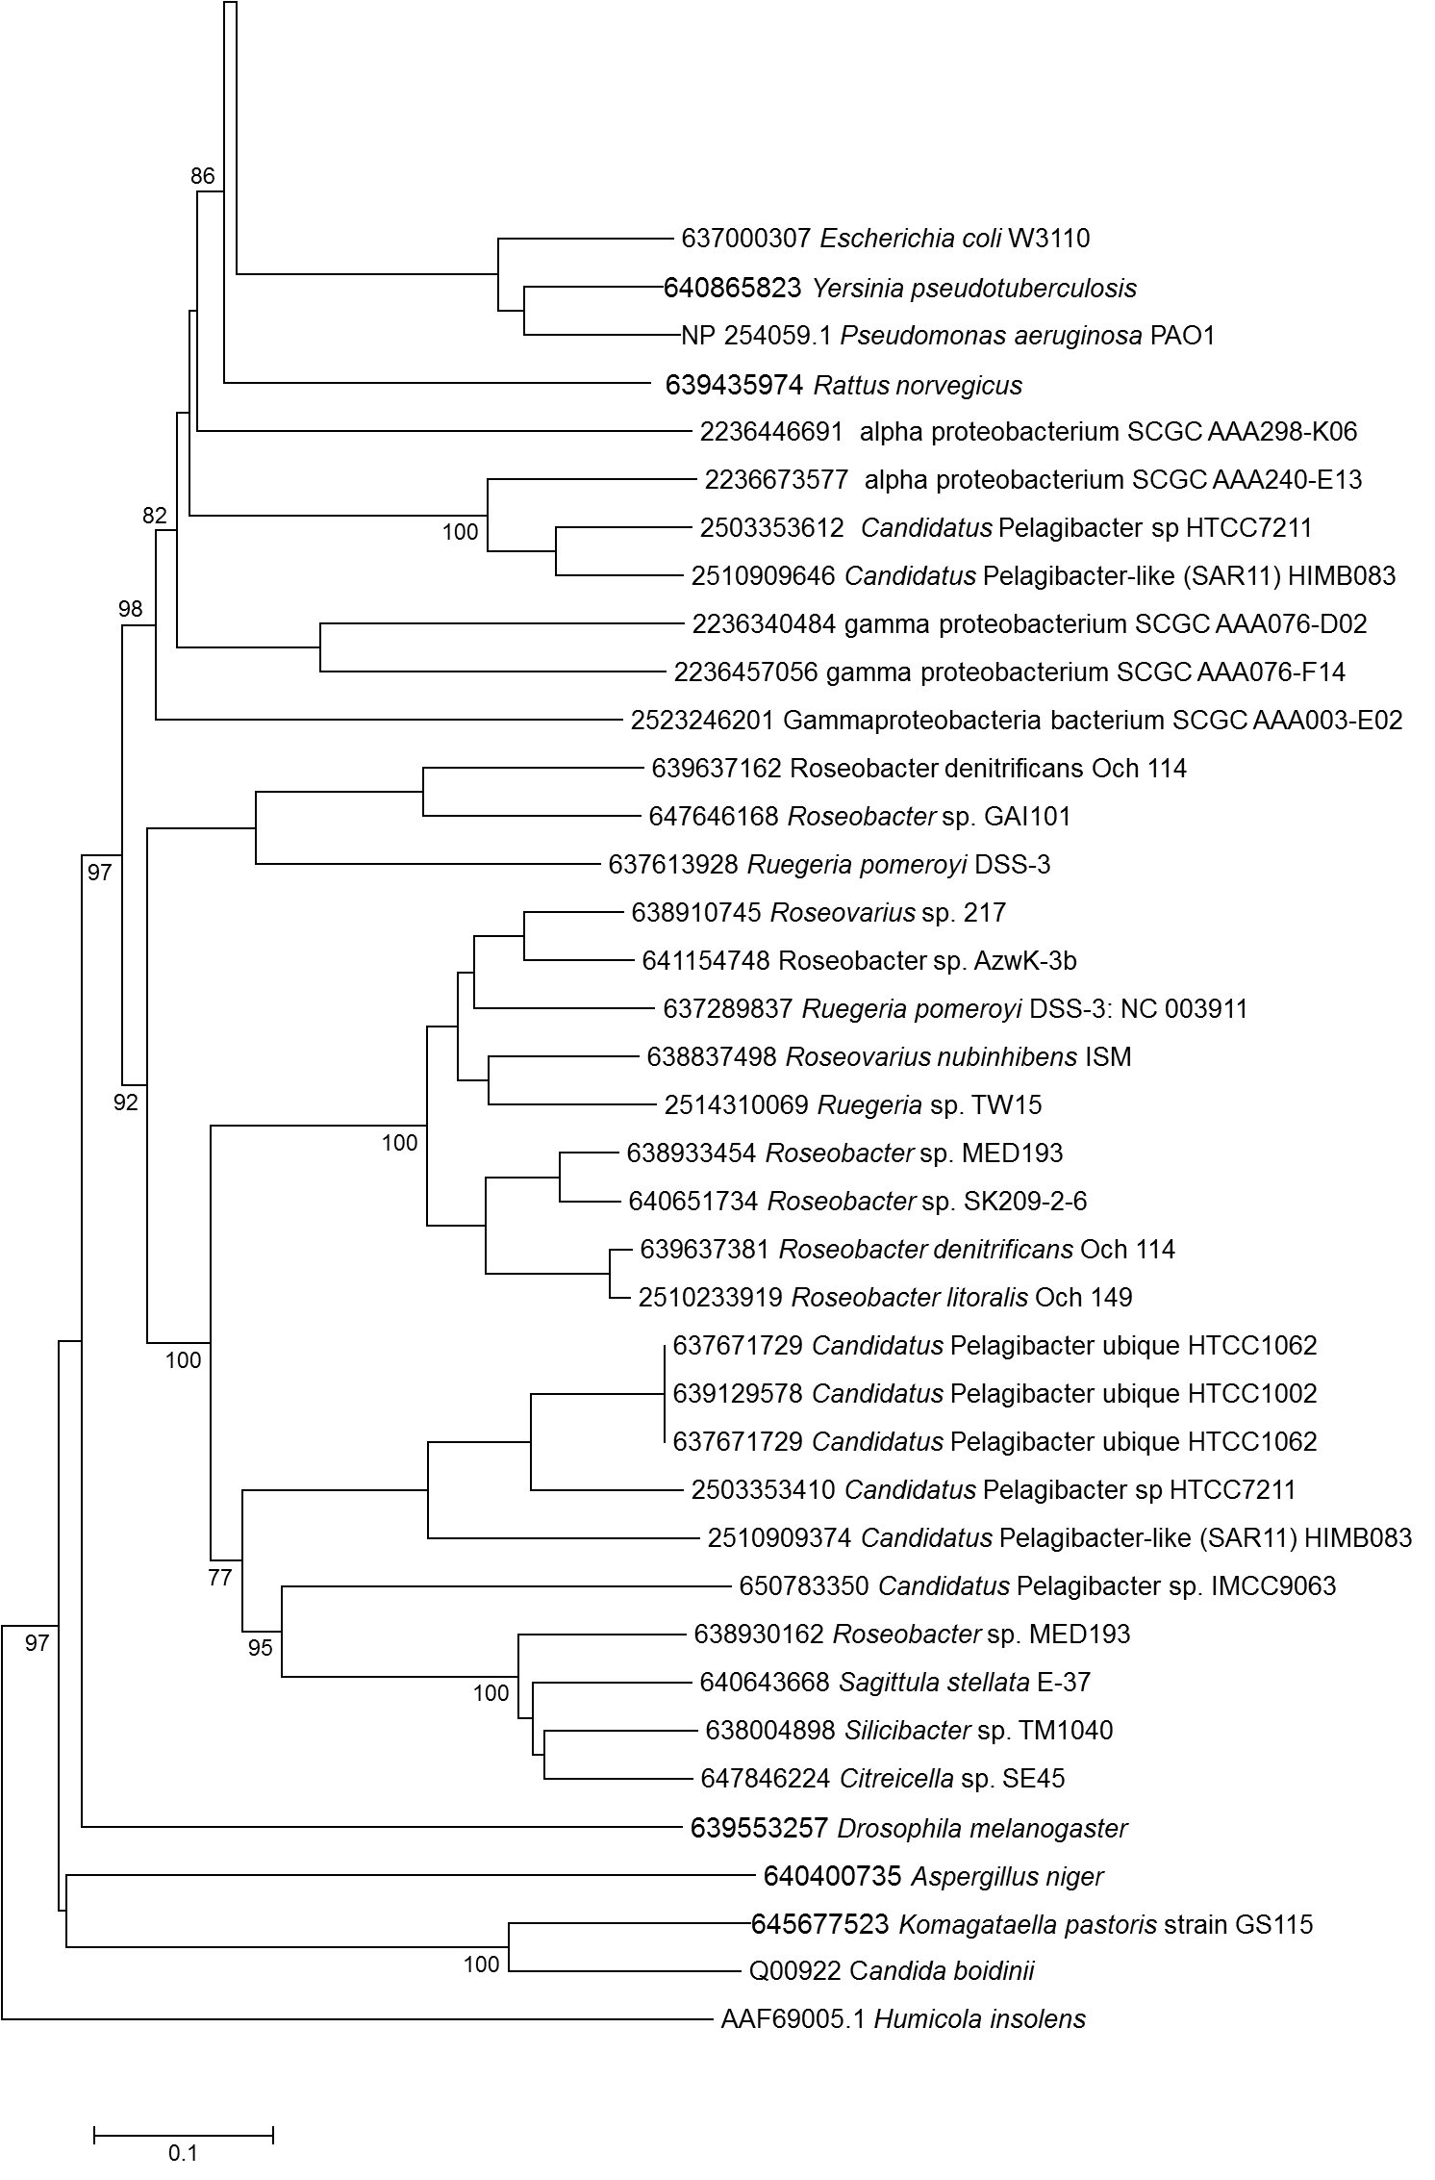
Un-characterised marine GMC oxioreductases
Characterised GMC oxioreductases
BetA
DddA

Figure S4

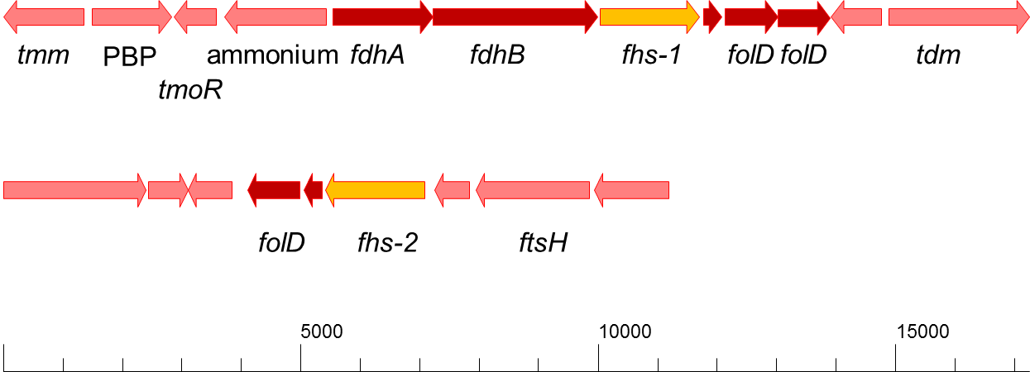
amt

Figure S5

H₄F
OD₅₄₀
OD₅₄₀
OD₅₄₀
Figure S6

H₄F

References
Dennis, J.J., and Zylstra, G.J. (1998) Plasposons: modular Self-cloning minitransposon derivatives for rapid genetic analysis of gram-negative bacterial genomes. Appl Environ Microbiol 64: 2710-2715.

Berntsson, R.P.A., Smits, S.H.J., Schmitt, L., Slotboom, D.-J., and Poolman, B. (2010) A structural classification of substrate-binding proteins. FEBS Letters 584: 2606-2617.

González, J.M., Covert, J.S., Whitman, W.B., Henriksen, J.R., Mayer, F., Scharf, B. et al. (2003) Silicibacter pomeroyi sp. nov. and Roseovarius nubinhibens sp. nov., dimethylsulfoniopropionate-demethylating bacteria from marine environments. Int J Syst Evol Micro 53: 1261-1269.

Kovach, M.E., Elzer, P.H., Steven Hill, D., Robertson, G.T., Farris, M.A., Roop Ii, R.M., and Peterson, K.M. (1995) Four new derivatives of the broad-host-range cloning vector pBBR1MCS, carrying different antibiotic-resistance cassettes. Gene 166: 175-176.

Schäfer, A., Tauch, A., Jäger, W., Kalinowski, J., Thierbach, G., and Pühler, A. (1994) Small mobilizable multi-purpose cloning vectors derived from the Escherichia coli plasmids pK18 and pK19: selection of defined deletions in the chromosome of Corynebacterium glutamicum. Gene 145: 69-73.

