**Supplementary Information:**

**Deep Q-learning for the selection of optimal isocratic scouting runs in liquid chromatography**

Alexander Kensert1, Gilles Collaerts1, Kyriakos Efthymiadis2, Gert Desmet3 and Deirdre Cabooter1,*

(1)University of Leuven (KU Leuven), Department for Pharmaceutical and Pharmacological Sciences, Pharmaceutical Analysis, Herestraat 49, 3000 Leuven, Belgium

(2)Vrije Universiteit Brussel, Department of Computer Science, Artificial Intelligence Lab, Pleinlaan 9, 1050 Brussel, Belgium

(3)Vrije Universiteit Brussel, Department of Chemical Engineering, Pleinlaan 2, 1050 Brussel, Belgium

(*) corresponding author:

e-mail: deirdre.cabooter@kuleuven.be

tel.: (+) 32 (0)16.32.34.42

**Abstract:** This supplementary information provides additional information to the main manuscript in the form of 2 additional figures and 4 additional tables.

**Table of contents:**

**Figure S-1:** The relationships between the Neue-Kuss parameters of the 57 experimentally evaluated compounds.

**Figure S-2:** Comparison between the retention factor (k) of the simulated compounds and the real experimental compounds, over the full range of ϕACN.

**Table S-1:** List of compounds used in this study, with their structure, Log P value, pKa value, stock solvent and supplier.

**Table S-2:** Experimentally obtained retention factors of the 57 compounds evaluated in this work for isocratic conditions and gradient conditions.

**Table S-3:** Scouting runs selected by the agent for the 57 compounds evaluated in this work.

**Table S-4:** Error comparison between the retention model based on the scouting runs selected by the agent, the retention model based on all (10) available isocratic datapoints, the retention model based on three randomly selected scouting runs, and the retention model based on the ‘chromatographer’s selection’, per compound.

**Table S-5.** InChI for each of the 57 compounds evaluated.

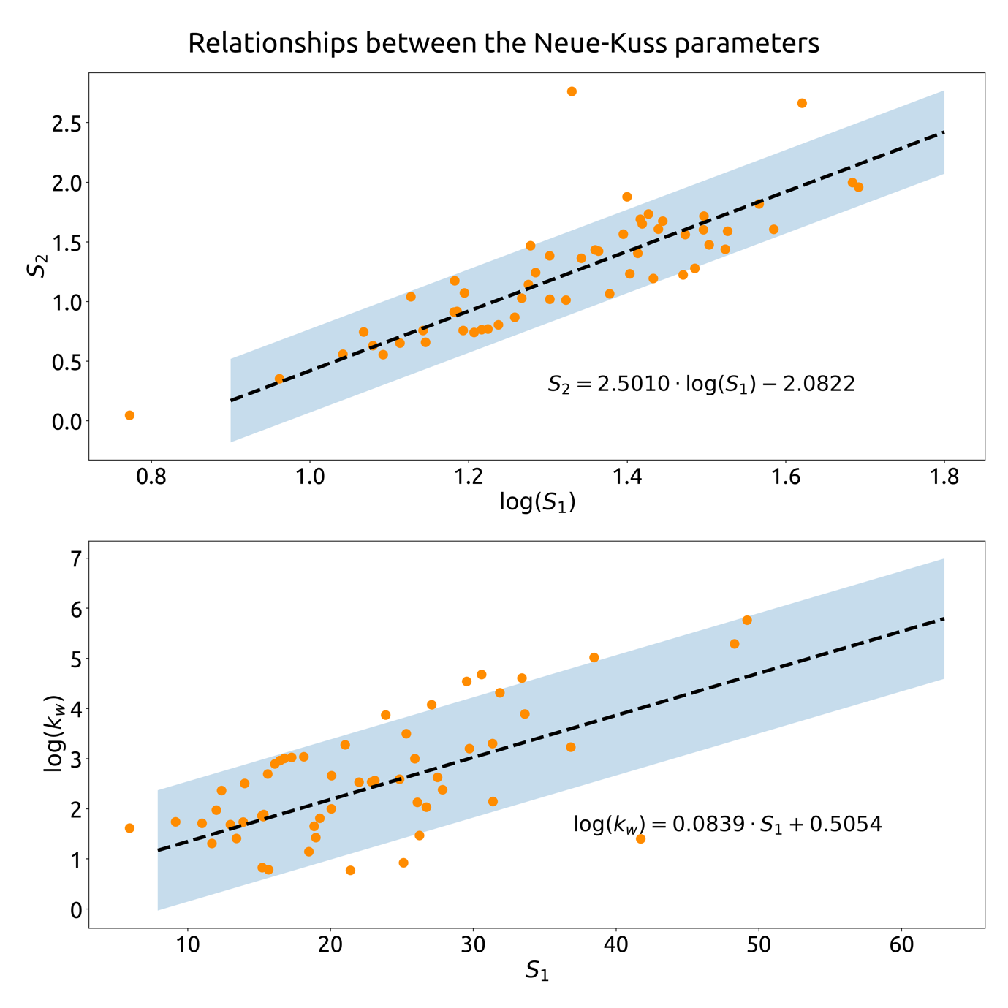

Figure S-1: The relationships between the Neue-Kuss parameters of the 57 experimentally evaluated compounds. The simulated compounds were based on these two linear functions; where the simulated parameters could take any value within the shaded area.

Figure S-2: Comparison between the retention factor (k) of the simulated compounds and the real experimental compounds, over the full range of ϕACN.

Table S-1: List of 82 compounds used in this study, with their structure, Log P value, pKa value, stock solvent and supplier. Structures were drawn in Marvin Sketch (v20.9.0, 2020, ChemAxon (www.chemaxon.com)) and values were gathered from PubChem.



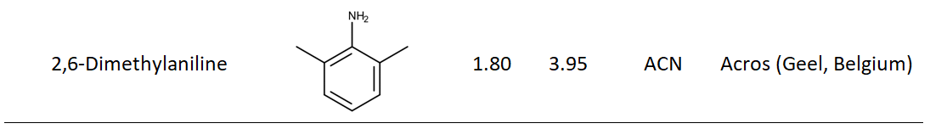

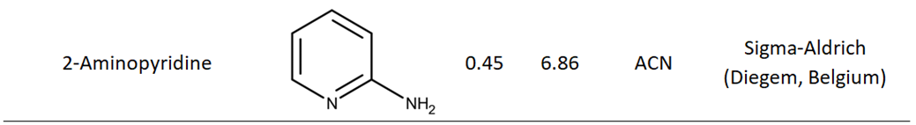

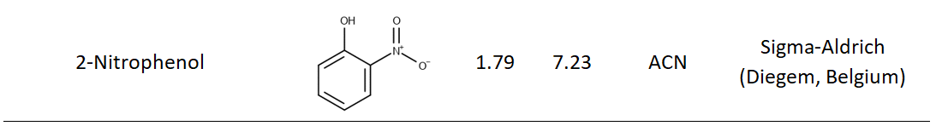

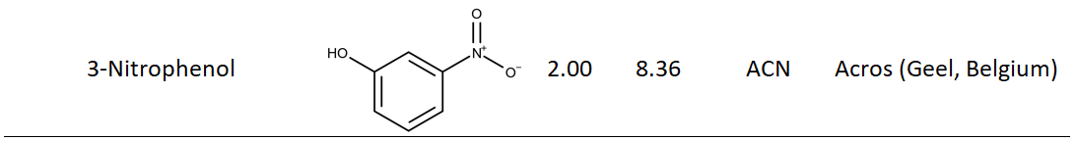

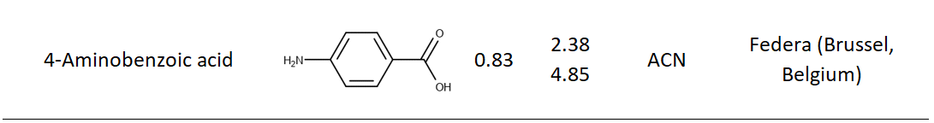

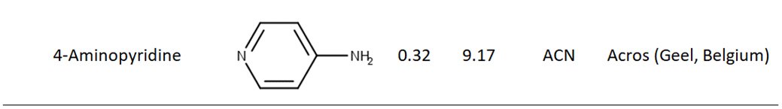

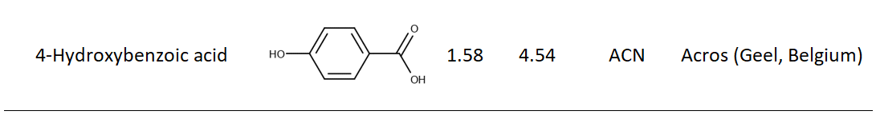

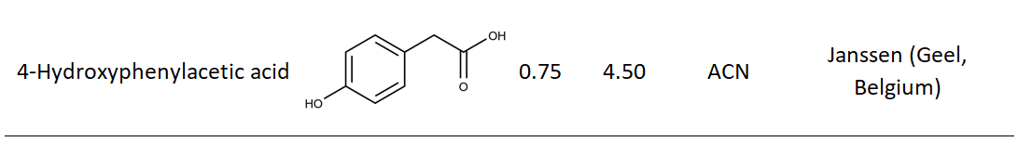

Table S-1 continued:



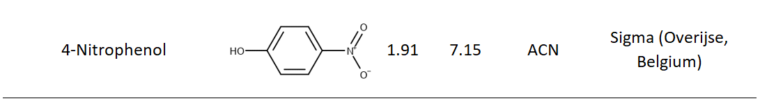

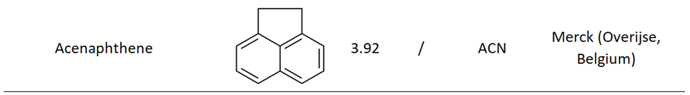

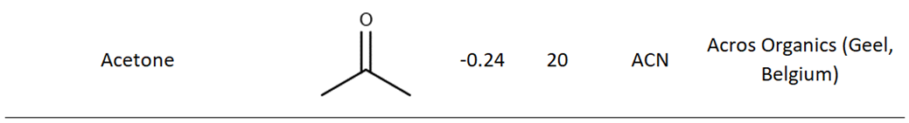

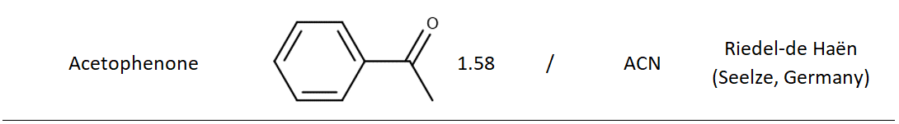

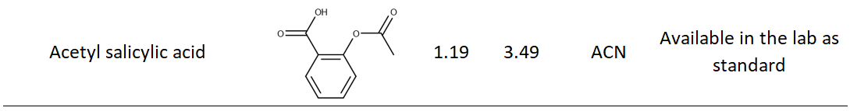

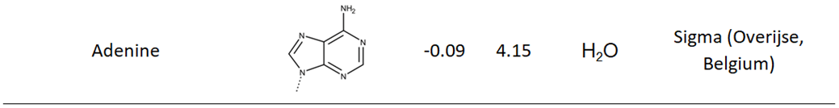

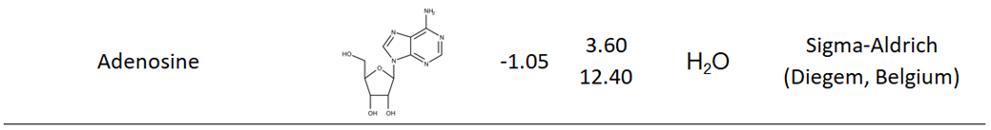

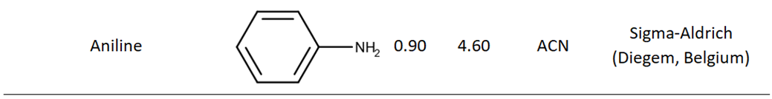

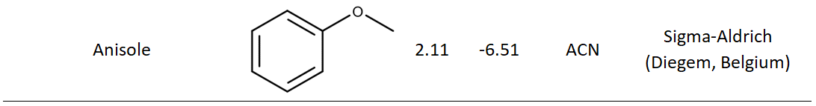

Table S-1 continued:



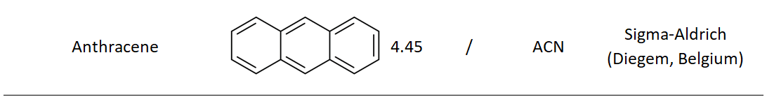

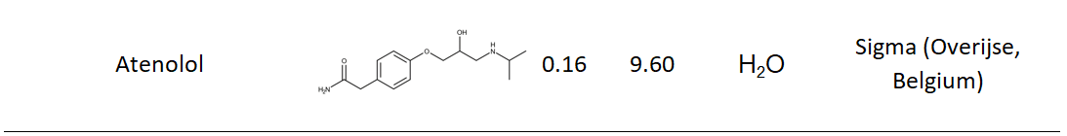

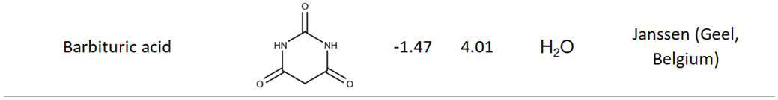

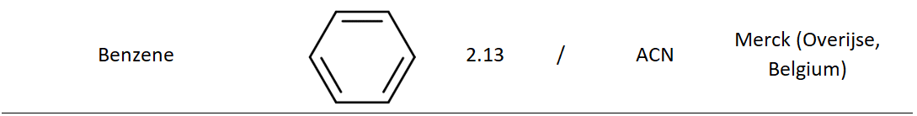

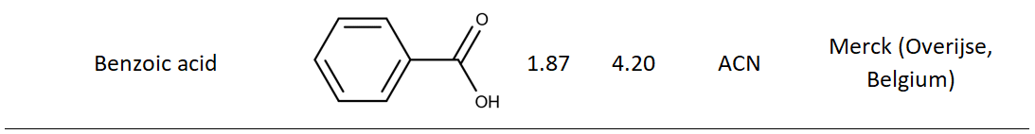

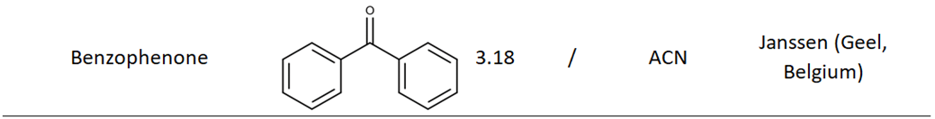

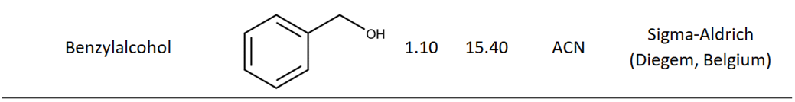

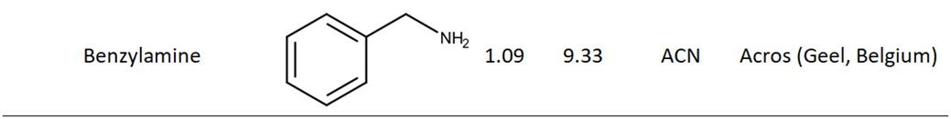

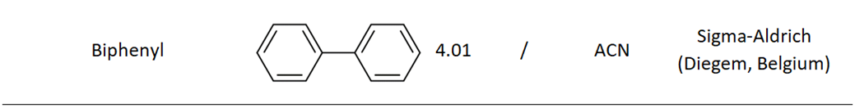

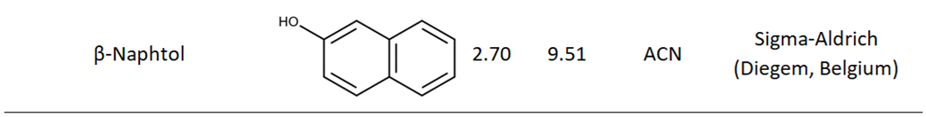

Table S-1 continued:



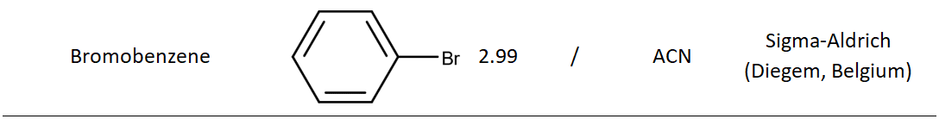

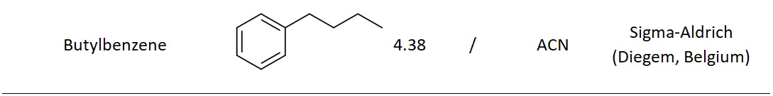

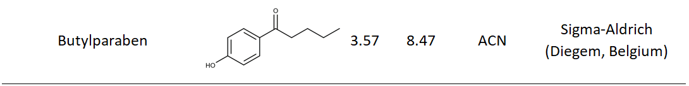

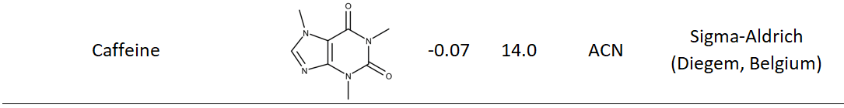

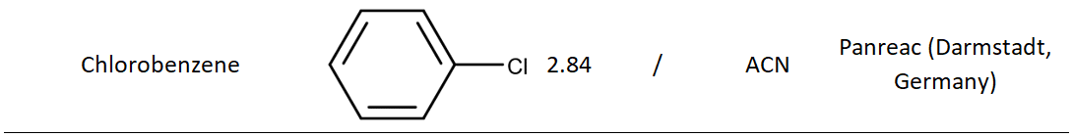

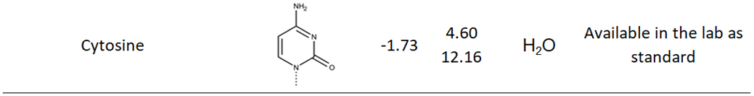

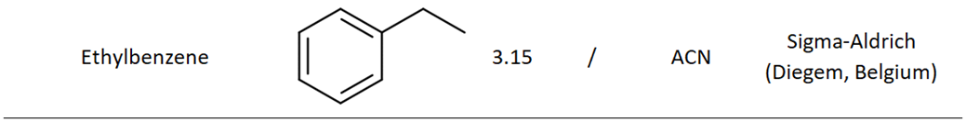

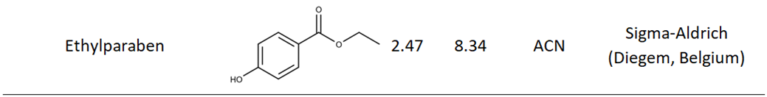

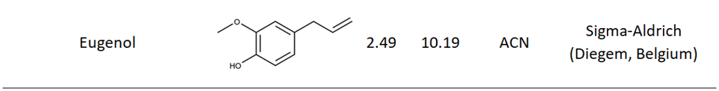

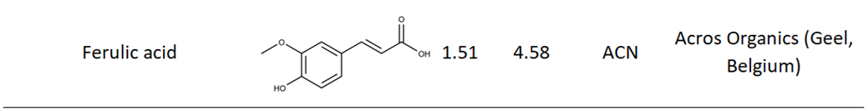

Table S-1 continued:



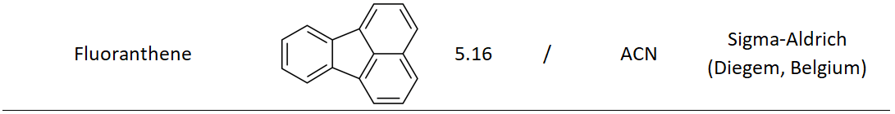

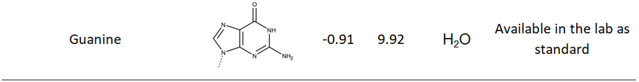

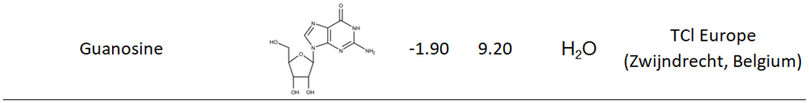

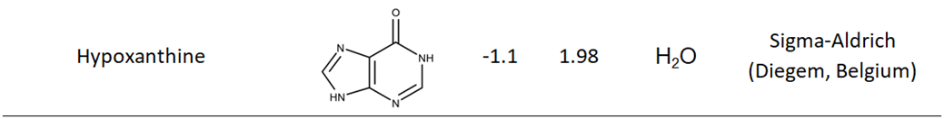

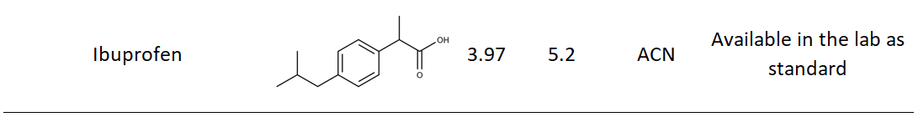

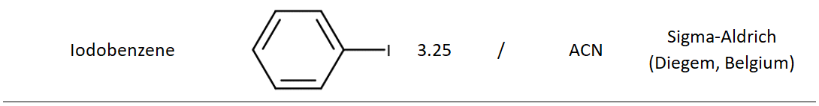

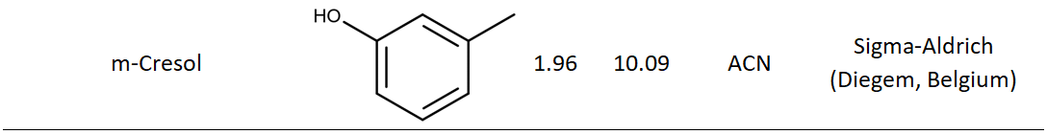

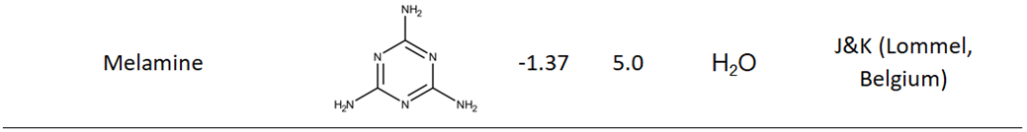

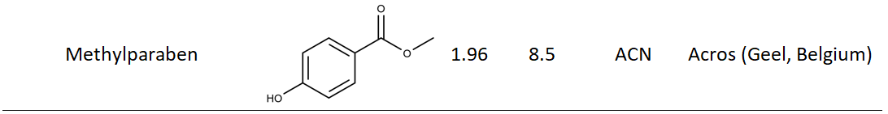

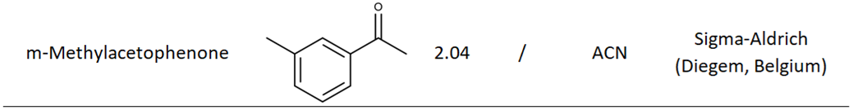

Table S-1 continued:



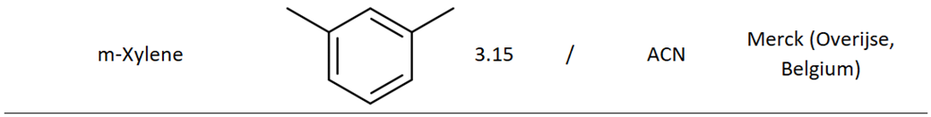

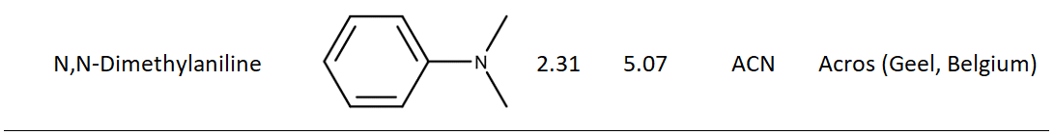

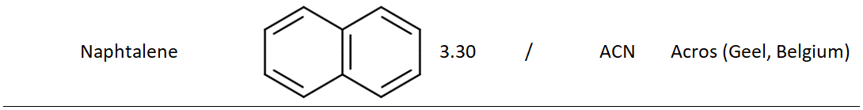

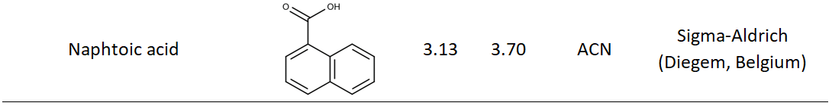

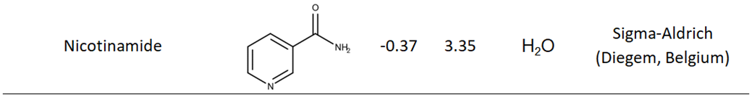

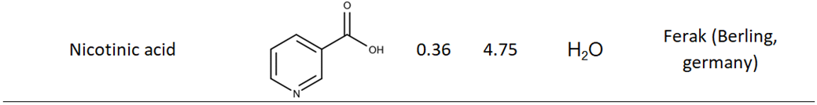

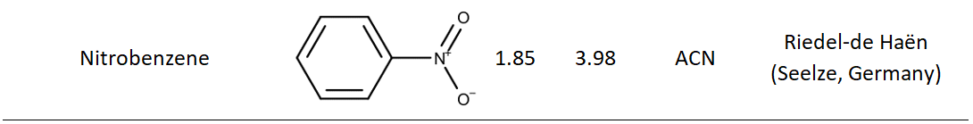

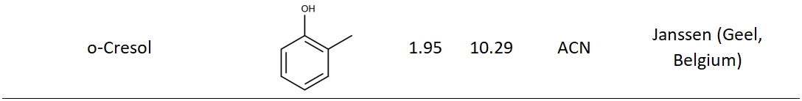

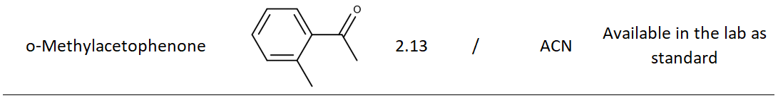

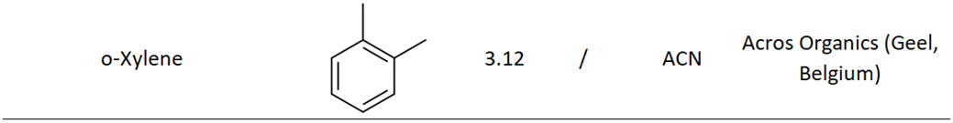

Table S-1 continued:



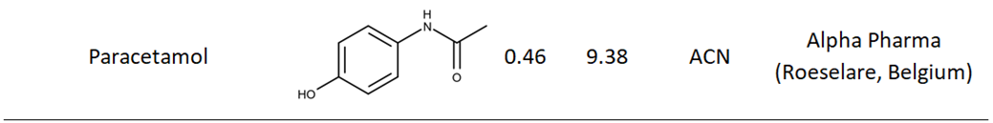

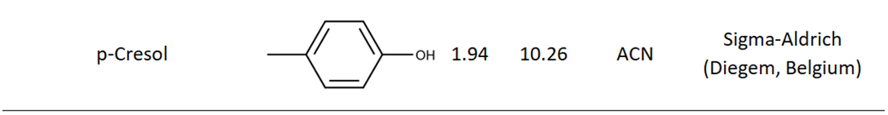

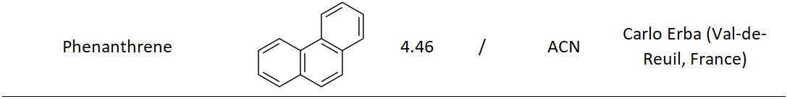

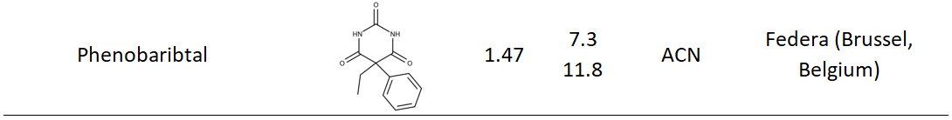

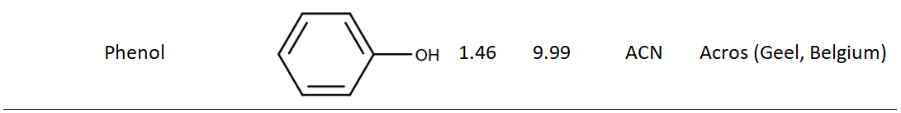

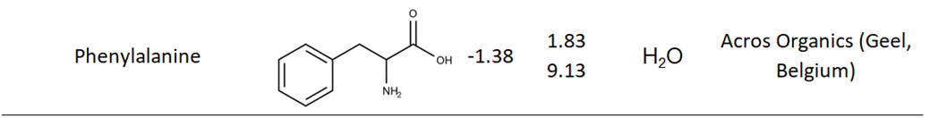

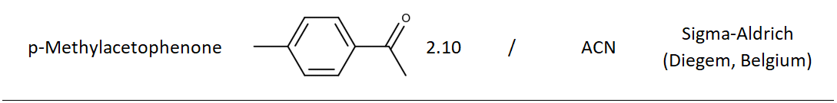

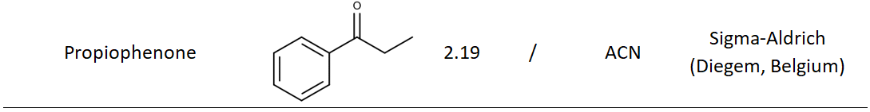

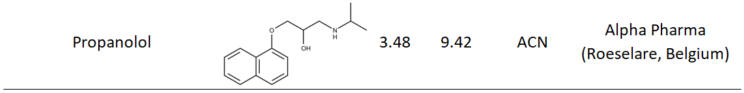

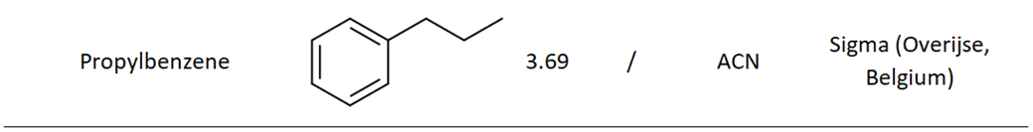

Table S-1 continued:



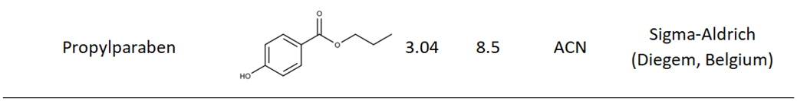

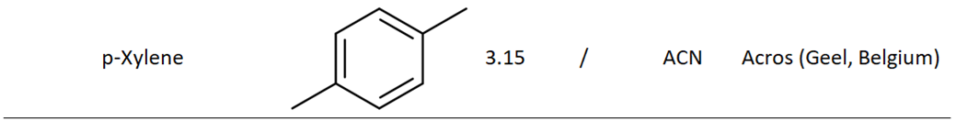

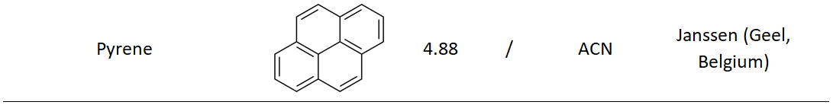

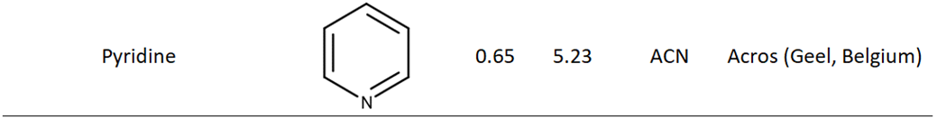

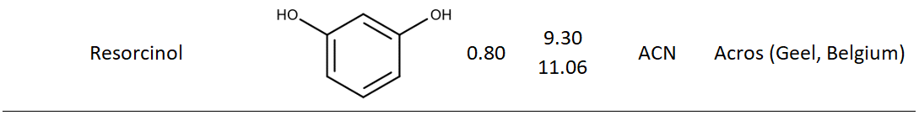

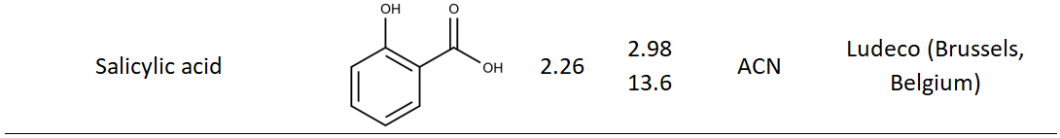

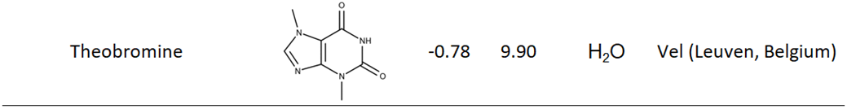

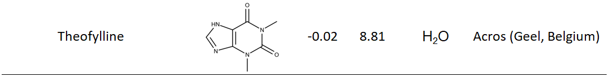

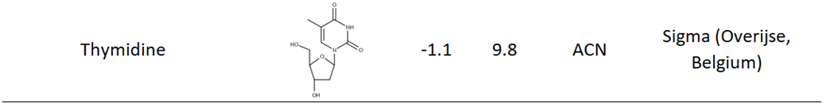

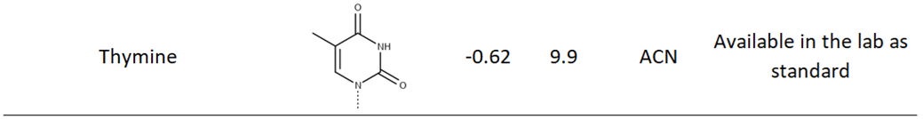

Table S-1 continued:



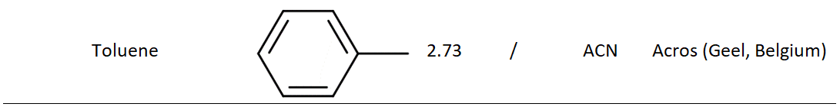

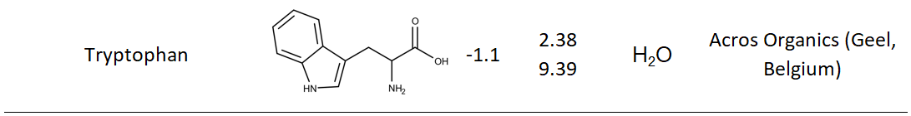

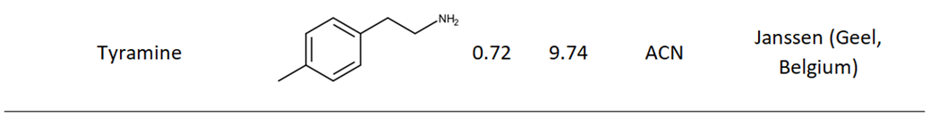

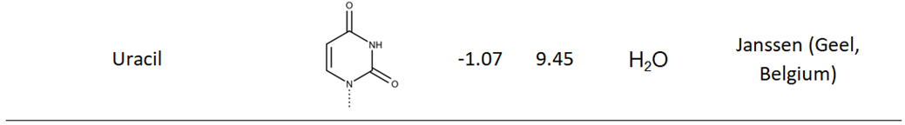

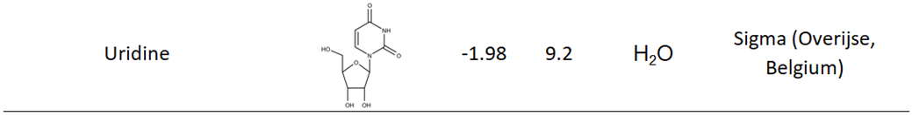

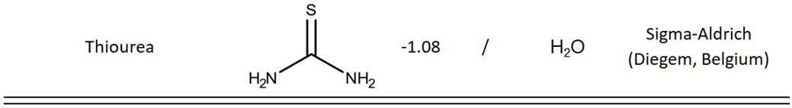

Table S-2: Experimentally obtained retention factors of the 57 compounds evaluated in this work for isocratic conditions and gradient conditions.

The retention factors highlighted in pink were too high to acquire experimentally and were therefore obtained by fitting the Neue-Kuss retention model to the other retention factors and calculating the pink retention factors based on the obtained retention parameters.

|  |  |  |  |  |  |  |  |  |  |  |  |  |  |  |
| --- | --- | --- | --- | --- | --- | --- | --- | --- | --- | --- | --- | --- | --- | --- |
| **Compound name** | **Isocratic data (retention factors)** | | | | | | | | | | **Gradient data**  **(retention factors)** | | | |
|  | **𝜑=0.05** | **𝜑=0.10** | **𝜑=0.20** | **𝜑=0.30** | **𝜑=0.40** | **𝜑=0.50** | **𝜑=0.60** | **𝜑=0.70** | **𝜑=0.80** | **𝜑=0.90** | **GRA4** | **GRA5** | **GRA6** | **GRA7** |
| **N,N-Dimethylaniline** | 3,00 | 1,56 | 0,91 | 0,88 | 1,02 | 1,11 | 1,01 | 0,76 | 0,50 | 0,29 | 3,01 | 3,14 | 2,89 | 2,84 |
| **Paracetamol** | 3,18 | 1,16 | 0,41 | 0,23 | 0,15 | 0,10 | 0,07 | 0,04 | 0,02 | 0,01 | 3,06 | 2,78 | 3,13 | 3,13 |
| **4-Aminobenzoic acid** | 3,23 | 1,58 | 0,68 | 0,39 | 0,26 | 0,17 | 0,12 | 0,07 | 0,04 | 0,02 | 3,18 | 2,98 | 3,18 | 3,22 |
| **Resorcinol** | 3,68 | 2,00 | 0,87 | 0,47 | 0,31 | 0,20 | 0,14 | 0,09 | 0,06 | 0,04 | 3,59 | 3,36 | 3,64 | 3,63 |
| **Theophylline** | 5,10 | 1,12 | 0,25 | 0,13 | 0,07 | 0,03 | 0,02 | 0,01 | 0,01 | 0,00 | 4,38 | 3,91 | 4,48 | 4,56 |
| **4-Hydroxybenzoic acid** | 6,38 | 3,09 | 0,94 | 0,44 | 0,27 | 0,17 | 0,11 | 0,06 | 0,03 | 0,01 | 5,45 | 5,11 | 5,27 | 5,69 |
| **4-Hydroxyphenylacetic acid** | 10,27 | 3,58 | 1,01 | 0,45 | 0,26 | 0,17 | 0,11 | 0,07 | 0,03 | 0,01 | 6,30 | 5,73 | 6,50 | 6,85 |
| **Phenol** | 12,48 | 7,80 | 3,52 | 1,75 | 1,01 | 0,62 | 0,41 | 0,27 | 0,17 | 0,10 | 8,03 | 7,32 | 8,30 | 8,77 |
| **Caffeine** | 12,49 | 2,56 | 0,53 | 0,22 | 0,14 | 0,08 | 0,07 | 0,05 | 0,04 | 0,04 | 6,06 | 5,47 | 6,28 | 6,65 |
| **Benzylalcohol** | 12,71 | 6,67 | 2,38 | 1,20 | 0,71 | 0,46 | 0,32 | 0,23 | 0,14 | 0,09 | 7,30 | 6,90 | 7,71 | 7,94 |
| **2,6-Dimethylaniline** | 15,01 | 8,35 | 4,07 | 2,63 | 1,79 | 1,17 | 0,77 | 0,50 | 0,31 | 0,19 | 8,59 | 7,83 | 8,94 | 9,42 |
| **Salicylic acid** | 20,43 | 10,42 | 3,13 | 1,23 | 0,60 | 0,32 | 0,18 | 0,09 | 0,04 | 0,04 | 8,68 | 7,75 | 8,89 | 9,78 |
| **p-Nitrophenol** | 27,56 | 15,58 | 6,22 | 2,56 | 1,27 | 0,69 | 0,42 | 0,25 | 0,14 | 0,08 | 10,20 | 8,90 | 10,83 | 11,75 |
| **Benzoic acid** | 29,48 | 15,04 | 4,62 | 1,78 | 0,90 | 0,51 | 0,33 | 0,21 | 0,13 | 0,08 | 9,60 | 8,45 | 10,00 | 11,05 |
| **3-Nitrophenol** | 30,06 | 17,37 | 6,48 | 2,78 | 1,40 | 0,77 | 0,46 | 0,28 | 0,16 | 0,09 | 10,62 | 9,19 | 11,26 | 12,29 |
| **Benzene** | 30,70 | 22,03 | 12,94 | 6,60 | 3,54 | 1,94 | 1,16 | 0,71 | 0,44 | 0,27 | 12,62 | 11,05 | 13,30 | 14,42 |
| **2-Nitrophenol** | 31,61 | 20,31 | 8,73 | 4,14 | 2,17 | 1,19 | 0,72 | 0,44 | 0,27 | 0,16 | 11,31 | 9,93 | 11,77 | 13,05 |
| **Nitrobenzene** | 36,10 | 23,57 | 11,32 | 5,38 | 2,74 | 1,46 | 0,87 | 0,53 | 0,31 | 0,18 | 12,19 | 10,58 | 12,93 | 14,25 |
| **p-Cresol** | 36,63 | 21,30 | 7,32 | 3,21 | 1,61 | 0,90 | 0,55 | 0,34 | 0,20 | 0,12 | 10,71 | 9,56 | 11,54 | 12,42 |
| **Acetyl salicylic acid** | 37,23 | 14,78 | 3,70 | 1,39 | 0,71 | 0,41 | 0,26 | 0,16 | 0,09 | 0,06 | 9,27 | 8,21 | 9,71 | 10,42 |
| **m-Cresol** | 38,37 | 21,07 | 7,77 | 3,23 | 1,61 | 0,89 | 0,56 | 0,35 | 0,21 | 0,13 | 11,00 | 9,54 | 11,67 | 12,85 |
| **Ferulic acid** | 38,66 | 11,82 | 2,35 | 0,82 | 0,41 | 0,23 | 0,14 | 0,07 | 0,03 | 0,01 | 8,60 | 7,57 | 8,97 | 9,92 |
| **o-Cresol** | 40,33 | 23,28 | 8,06 | 3,63 | 1,82 | 1,01 | 0,61 | 0,38 | 0,23 | 0,13 | 11,05 | 9,83 | 11,90 | 12,84 |
| **Acetophenone** | 44,68 | 21,34 | 7,03 | 3,27 | 1,73 | 1,01 | 0,64 | 0,42 | 0,26 | 0,16 | 10,73 | 9,57 | 11,53 | 12,44 |
| **Methylparaben** | 47,47 | 19,95 | 4,86 | 1,96 | 0,98 | 0,56 | 0,35 | 0,22 | 0,13 | 0,08 | 9,90 | 8,82 | 10,63 | 11,44 |
| **Anisole** | 56,19 | 33,49 | 14,22 | 6,58 | 3,33 | 1,78 | 1,06 | 0,64 | 0,39 | 0,24 | 13,25 | 11,39 | 13,97 | 15,62 |
| **Phenobarbital** | 77,70 | 29,11 | 6,57 | 2,08 | 0,95 | 0,50 | 0,31 | 0,19 | 0,11 | 0,07 | 10,68 | 9,17 | 11,39 | 12,71 |
| **Toluene** | 133,35 | 79,64 | 30,74 | 13,45 | 5,99 | 2,92 | 1,63 | 0,95 | 0,56 | 0,31 | 15,67 | 13,20 | 16,83 | 18,95 |
| **o-Methylacetophenone** | 135,12 | 57,16 | 16,16 | 6,23 | 2,97 | 1,57 | 0,95 | 0,58 | 0,36 | 0,22 | 13,44 | 11,45 | 14,30 | 16,17 |
| **Propiophenone** | 138,66 | 59,51 | 17,38 | 6,85 | 3,26 | 1,70 | 1,01 | 0,62 | 0,38 | 0,23 | 13,71 | 11,66 | 14,58 | 16,53 |
| **Ethylparaben** | 138,73 | 58,47 | 11,55 | 3,93 | 1,69 | 0,86 | 0,51 | 0,30 | 0,17 | 0,10 | 12,02 | 10,42 | 13,08 | 14,42 |
| **p-Methylacetophenone** | 142,47 | 56,19 | 15,19 | 5,67 | 2,66 | 1,42 | 0,86 | 0,54 | 0,33 | 0,21 | 13,18 | 11,26 | 14,03 | 15,83 |
| **m-Methylacetophenone** | 142,81 | 64,02 | 16,54 | 6,44 | 2,95 | 1,54 | 0,91 | 0,56 | 0,34 | 0,21 | 13,26 | 11,43 | 14,40 | 15,94 |
| **Chlorobenzene** | 173,77 | 98,08 | 34,68 | 14,25 | 6,07 | 2,89 | 1,60 | 0,93 | 0,54 | 0,30 | 15,88 | 13,38 | 17,06 | 19,31 |
| **B-Naphtol** | 194,13 | 87,94 | 23,58 | 7,05 | 2,75 | 1,30 | 0,73 | 0,43 | 0,24 | 0,14 | 13,83 | 11,73 | 14,83 | 16,73 |
| **Bromobenzene** | 251,88 | 135,02 | 43,99 | 17,08 | 6,91 | 3,22 | 1,74 | 1,00 | 0,57 | 0,32 | 16,41 | 13,83 | 17,76 | 20,17 |
| **Eugenol** | 339,94 | 132,45 | 28,62 | 8,54 | 3,38 | 1,59 | 0,89 | 0,53 | 0,31 | 0,17 | 14,41 | 12,18 | 15,52 | 17,51 |
| **Propanolol** | 375,05 | 105,22 | 14,28 | 2,70 | 0,84 | 0,37 | 0,19 | 0,09 | 0,05 | 0,04 | 11,85 | 10,07 | 12,74 | 14,39 |
| **o-Xylene** | 388,88 | 203,37 | 63,25 | 23,54 | 9,18 | 4,07 | 2,14 | 1,20 | 0,68 | 0,37 | 17,50 | 14,55 | 18,90 | 21,67 |
| **m-Xylene** | 406,23 | 217,85 | 69,91 | 26,58 | 10,30 | 4,53 | 2,32 | 1,29 | 0,72 | 0,40 | 17,80 | 14,78 | 19,32 | 22,11 |
| **Naphtalene** | 457,22 | 245,73 | 82,61 | 26,52 | 9,52 | 3,98 | 2,00 | 1,09 | 0,60 | 0,34 | 17,33 | 14,47 | 19,10 | 21,97 |
| **Ethylbenzene** | 459,97 | 239,58 | 73,78 | 26,90 | 10,52 | 4,57 | 2,35 | 1,29 | 0,71 | 0,39 | 17,84 | 14,72 | 19,31 | 22,18 |
| **Propylparaben** | 464,32 | 161,29 | 29,43 | 8,29 | 3,02 | 1,36 | 0,74 | 0,42 | 0,24 | 0,14 | 14,03 | 11,91 | 15,39 | 17,28 |
| **p-Xylene** | 467,38 | 240,51 | 72,76 | 26,41 | 10,16 | 4,40 | 2,29 | 1,26 | 0,71 | 0,38 | 17,79 | 14,71 | 19,33 | 22,10 |
| **Iodobenzene** | 488,25 | 239,73 | 68,23 | 23,64 | 9,19 | 4,03 | 2,08 | 1,16 | 0,66 | 0,36 | 17,41 | 14,47 | 18,87 | 21,58 |
| **Naphthoic acid** | 544,26 | 177,26 | 30,09 | 7,14 | 2,45 | 1,10 | 0,61 | 0,35 | 0,20 | 0,11 | 13,90 | 11,73 | 14,96 | 17,06 |
| **Benzophenone** | 1.027,15 | 403,72 | 83,91 | 23,00 | 7,85 | 3,26 | 1,63 | 0,90 | 0,49 | 0,28 | 16,80 | 14,04 | 18,53 | 21,11 |
| **Butylparaben** | 1.432,72 | 485,08 | 82,26 | 17,04 | 5,37 | 2,15 | 1,07 | 0,58 | 0,32 | 0,18 | 15,77 | 13,20 | 17,41 | 19,89 |
| **Biphenyl** | 2.396,02 | 1.028,89 | 230,13 | 58,94 | 17,57 | 6,28 | 2,83 | 1,42 | 0,74 | 0,40 | 19,13 | 15,76 | 21,20 | 24,51 |
| **Propylbenzene** | 2.754,73 | 1.072,42 | 213,96 | 56,95 | 18,89 | 7,25 | 3,41 | 1,77 | 0,94 | 0,49 | 19,71 | 16,08 | 21,49 | 24,94 |
| **Fluoranthene** | 4.523,10 | 2.056,29 | 465,65 | 129,38 | 30,53 | 9,41 | 3,92 | 1,86 | 0,93 | 0,49 | 20,49 | 16,73 | 22,74 | 26,53 |
| **Acenapthene** | 5.444,84 | 1.692,78 | 251,36 | 56,86 | 17,42 | 6,46 | 3,03 | 1,58 | 0,87 | 0,50 | 19,48 | 15,78 | 21,43 | 24,86 |
| **Phenanthrene** | 9.431,90 | 2.796,01 | 375,73 | 77,23 | 21,54 | 7,25 | 3,18 | 1,57 | 0,81 | 0,44 | 19,64 | 16,11 | 21,80 | 25,30 |
| **Butylbenzene** | 13.432,05 | 4.112,77 | 574,06 | 119,61 | 33,53 | 11,33 | 4,92 | 2,41 | 1,22 | 0,60 | 21,26 | 17,23 | 23,35 | 27,21 |
| **Anthracene** | 23.934,79 | 5.511,42 | 537,52 | 92,99 | 23,62 | 7,88 | 3,46 | 1,70 | 0,87 | 0,44 | 20,14 | 16,41 | 22,08 | 25,66 |
| **Ibuprofen** | 34.127,28 | 5.697,19 | 384,34 | 56,24 | 13,31 | 4,41 | 1,98 | 1,00 | 0,53 | 0,27 | 18,42 | 15,02 | 20,16 | 23,42 |
| **Pyrene** | 99.616,81 | 15.687,19 | 961,94 | 130,65 | 29,18 | 9,19 | 3,98 | 1,95 | 1,00 | 0,49 | 20,78 | 16,87 | 22,80 | 26,66 |

Table S-3: Scouting runs selected by the agent for the 57 compounds evaluated in this work. Note that the fraction of modifier in Table S-3 is expressed in vol%. The resulting Neue-Kuss parameters, obtained by fitting the selected three scouting runs to the Neue-Kuss model are also shown. The mean relative percentage error (MRPE) between the retention factors predicted by the model and the experimental retention factors in isocratic (10) and gradient (4) conditions are also given.

|  |  |  |  |  |  |  |  |  |  |  |  |  |
| --- | --- | --- | --- | --- | --- | --- | --- | --- | --- | --- | --- | --- |
|  | **Neue-Kuss parameters** | | | **Actions selected a teach step (% of ACN)** | | | | | | | **MRPE (%)** | |
|  | **S1** | **S2** | **kw** | **step 1** | **step 2** | **step 3** | **step 4** | **step 5** | **step 6** | **step 7-10** | **isocratic** | **gradient** |
| **N,N-Dimethylaniline** | 21,39 | 2,76 | 5,92 | 20% | 5% | 90% | STOP |  |  |  | 16,06 | 8,78 |
| **Paracetamol** | 25,11 | 1,88 | 8,37 | 20% | 5% | 90% | STOP |  |  |  | 3,34 | 6,76 |
| **4-Aminobenzoic acid** | 15,65 | 1,07 | 6,11 | 20% | 5% | 90% | STOP |  |  |  | 4,07 | 2,25 |
| **Resorcinol** | 15,22 | 1,17 | 6,73 | 20% | 5% | 90% | STOP |  |  |  | 2,78 | 2,14 |
| **Theophylline** | 41,73 | 2,66 | 25,06 | 20% | 5% | 90% | STOP |  |  |  | 2,78 | 8,19 |
| **4-Hydroxybenzoic acid** | 18,49 | 1,03 | 13,90 | 20% | 5% | 90% | STOP |  |  |  | 3,80 | 3,04 |
| **4-Hydroxyphenylacetic acid** | 26,23 | 1,65 | 29,43 | 20% | 5% | 90% | STOP |  |  |  | 4,90 | 3,55 |
| **Phenol** | 11,69 | 0,74 | 20,37 | 20% | 5% | 90% | STOP |  |  |  | 2,11 | 1,21 |
| **Caffeine** | 63,97 | 4,61 | 111,03 | 20% | 5% | 90% | STOP |  |  |  | 1,71 | 2,92 |
| **Benzylalcohol** | 18,97 | 1,47 | 26,69 | 20% | 5% | 90% | STOP |  |  |  | 3,95 | 2,58 |
| **2,6-Dimethylaniline** | 13,41 | 1,04 | 25,65 | 20% | 5% | 90% | STOP |  |  |  | 10,17 | 1,08 |
| **Salicylic acid** | 18,85 | 1,14 | 44,58 | 20% | 5% | 90% | STOP |  |  |  | 1,73 | 1,06 |
| **p-Nitrophenol** | 12,99 | 0,65 | 48,47 | 20% | 5% | 90% | STOP |  |  |  | 2,12 | 1,04 |
| **Benzoic acid** | 19,25 | 1,24 | 64,66 | 20% | 5% | 90% | STOP |  |  |  | 1,95 | 1,07 |
| **3-Nitrophenol** | 13,88 | 0,76 | 54,48 | 20% | 5% | 90% | STOP |  |  |  | 2,25 | 1,86 |
| **Benzene** | 5,92 | 0,05 | 41,07 | 20% | 5% | 90% | STOP |  |  |  | 6,51 | 3,28 |
| **2-Nitrophenol** | 11,00 | 0,56 | 51,08 | 20% | 5% | 90% | STOP |  |  |  | 1,60 | 0,99 |
| **Nitrobenzene** | 9,15 | 0,35 | 54,65 | 20% | 5% | 90% | STOP |  |  |  | 1,66 | 1,15 |
| **p-Cresol** | 15,30 | 0,91 | 69,62 | 20% | 5% | 90% | STOP |  |  |  | 3,32 | 0,77 |
| **Acetyl salicylic acid** | 26,71 | 1,73 | 107,77 | 20% | 5% | 90% | STOP |  |  |  | 3,68 | 1,20 |
| **m-Cresol** | 15,20 | 0,91 | 72,61 | 20% | 5% | 90% | STOP |  |  |  | 1,79 | 0,85 |
| **Ferulic acid** | 31,38 | 1,72 | 139,08 | 20% | 5% | 90% | STOP |  |  |  | 5,60 | 0,97 |
| **o-Cresol** | 15,32 | 0,92 | 76,70 | 20% | 5% | 90% | STOP |  |  |  | 3,91 | 0,58 |
| **Acetophenone** | 20,05 | 1,38 | 99,83 | 20% | 5% | 90% | STOP |  |  |  | 6,05 | 0,51 |
| **Methylparaben** | 26,09 | 1,69 | 134,37 | 20% | 5% | 90% | STOP |  |  |  | 4,95 | 0,46 |
| **Anisole** | 12,00 | 0,63 | 94,49 | 20% | 5% | 90% | STOP |  |  |  | 2,05 | 0,56 |
| **Phenobarbital** | 27,85 | 1,67 | 239,14 | 20% | 5% | 90% | STOP |  |  |  | 2,65 | 1,06 |
| **Toluene** | 12,36 | 0,55 | 230,49 | 20% | 5% | 90% | STOP |  |  |  | 1,77 | 0,16 |
| **o-Methylacetophenone** | 22,88 | 1,43 | 342,20 | 20% | 5% | 90% | STOP |  |  |  | 5,68 | 2,24 |
| **Propiophenone** | 21,99 | 1,36 | 340,17 | 20% | 5% | 90% | STOP |  |  |  | 6,06 | 2,46 |
| **Ethylparaben** | 27,49 | 1,61 | 424,36 | 20% | 5% | 90% | STOP |  |  |  | 5,38 | 1,26 |
| **p-Methylacetophenone** | 24,84 | 1,56 | 387,74 | 20% | 5% | 90% | STOP |  |  |  | 5,61 | 2,11 |
| **m-Methylacetophenone** | 23,10 | 1,42 | 365,93 | 20% | 5% | 90% | STOP |  |  |  | 5,46 | 1,56 |
| **Chlorobenzene** | 13,99 | 0,66 | 320,69 | 20% | 5% | 90% | STOP |  |  |  | 1,87 | 0,47 |
| **B-Naphtol** | 20,07 | 1,02 | 456,48 | 20% | 5% | 90% | STOP |  |  |  | 3,24 | 0,56 |
| **Bromobenzene** | 15,60 | 0,76 | 496,06 | 20% | 5% | 90% | 50% | 80% | STOP |  | 2,01 | 0,81 |
| **Eugenol** | 25,90 | 1,41 | 995,32 | 20% | 5% | 90% | STOP |  |  |  | 3,70 | 1,44 |
| **Propanolol** | 36,83 | 1,82 | 1705,36 | 20% | 5% | 90% | STOP |  |  |  | 3,07 | 0,83 |
| **o-Xylene** | 16,10 | 0,74 | 787,72 | 20% | 5% | 90% | 40% | STOP |  |  | 2,22 | 1,36 |
| **m-Xylene** | 16,46 | 0,76 | 915,32 | 20% | 90% | 50% | STOP |  |  |  | 2,36 | 1,52 |
| **Naphtalene** | 21,02 | 1,01 | 1886,01 | 20% | 5% | 90% | STOP |  |  |  | 5,87 | 1,21 |
| **Ethylbenzene** | 16,77 | 0,77 | 1012,05 | 20% | 90% | 50% | STOP |  |  |  | 2,29 | 1,19 |
| **Propylparaben** | 29,73 | 1,56 | 1586,63 | 20% | 90% | 50% | STOP |  |  |  | 3,95 | 1,32 |
| **p-Xylene** | 17,28 | 0,80 | 1058,56 | 20% | 90% | 50% | STOP |  |  |  | 2,68 | 1,64 |
| **Iodobenzene** | 18,12 | 0,87 | 1087,74 | 20% | 5% | 90% | STOP |  |  |  | 1,92 | 1,15 |
| **Naphthoic acid** | 31,35 | 1,60 | 1990,93 | 20% | 90% | 50% | STOP |  |  |  | 2,65 | 0,52 |
| **Benzophenone** | 25,31 | 1,23 | 3132,15 | 20% | 90% | 50% | STOP |  |  |  | 1,62 | 0,85 |
| **Butylparaben** | 33,61 | 1,59 | 7774,12 | 20% | 90% | 50% | STOP |  |  |  | 4,54 | 0,50 |
| **Biphenyl** | 27,09 | 1,19 | 11897,98 | 20% | 90% | 50% | STOP |  |  |  | 5,44 | 2,21 |
| **Propylbenzene** | 23,87 | 1,06 | 7451,49 | 20% | 90% | 50% | STOP |  |  |  | 2,46 | 2,11 |
| **Fluoranthene** | 29,54 | 1,22 | 34627,30 | 20% | 90% | 50% | STOP |  |  |  | 5,34 | 2,97 |
| **Acenapthene** | 31,86 | 1,47 | 20550,57 | 20% | 90% | 50% | STOP |  |  |  | 2,21 | 2,73 |
| **Phenanthrene** | 33,40 | 1,44 | 40559,35 | 20% | 90% | 50% | STOP |  |  |  | 2,21 | 2,47 |
| **Butylbenzene** | 30,58 | 1,28 | 47517,41 | 20% | 90% | 50% | STOP |  |  |  | 3,68 | 3,14 |
| **Anthracene** | 38,46 | 1,60 | 104124,84 | 20% | 90% | 50% | STOP |  |  |  | 3,51 | 2,96 |
| **Ibuprofen** | 48,30 | 2,00 | 195272,44 | 20% | 90% | 50% | STOP |  |  |  | 3,56 | 2,23 |
| **Pyrene** | 49,18 | 1,96 | 582277,45 | 20% | 90% | 50% | STOP |  |  |  | 4,84 | 3,94 |

Table S-4: Error comparison between the retention model based on the scouting runs selected by the agent, the retention model based on all (10) available isocratic datapoints, the retention model based on three randomly selected scouting runs, and the retention model based on the ‘chromatographer’s selection’, per compound. The error is the mean relative percentage error (MRPE) between experimental data and the predictions of the retention models.

|  |  |  |  |  |  |  |  |  |  |
| --- | --- | --- | --- | --- | --- | --- | --- | --- | --- |
|  |  | Mean relative percentage error (MRPE) | | | | | | | |
|  |  | Agent Selection | | All Selection | | Random Selection | | Chromatographer’s selection | |
|  | retention factor  (5% ACN) | isocratic | gradient | isocratic | gradient | isocratic | gradient | isocratic | gradient |
| **N,N-Dimethylaniline** | 3,00 | 16,056 | 8,782 | 12,749 | 40,105 | 19,335 | 6,856 | 12,662 | 32,706 |
| **Paracetamol** | 3,18 | 3,336 | 6,762 | 4,740 | 61,774 | 3,542 | 18,454 | 5,701 | 92,193 |
| **4-Aminobenzoic acid** | 3,23 | 4,070 | 2,248 | 4,594 | 38,343 | 13,086 | 74,435 | 5,123 | 37,773 |
| **Resorcinol** | 3,68 | 2,783 | 2,144 | 3,131 | 14,225 | 9,204 | 65,938 | 3,962 | 21,280 |
| **Theophylline** | 5,10 | 2,781 | 8,191 | 5,142 | 33,470 | 8,457 | 9,849 | 5,162 | 73,973 |
| **4-Hydroxybenzoic acid** | 6,38 | 3,795 | 3,038 | 7,346 | 21,183 | 2,538 | 2,713 | 6,820 | 11,612 |
| **4-Hydroxyphenylacetic acid** | 10,27 | 4,899 | 3,547 | 6,548 | 8,912 | 9,059 | 33,128 | 8,438 | 12,506 |
| **Phenol** | 12,48 | 2,114 | 1,206 | 2,025 | 1,112 | 3,257 | 3,381 | 2,152 | 1,128 |
| **Caffeine** | 12,49 | 1,710 | 2,923 | 2,474 | 1,988 | 4,338 | 5,768 | 4,255 | 5,132 |
| **Benzylalcohol** | 12,71 | 3,954 | 2,577 | 3,447 | 2,086 | 3,395 | 1,921 | 4,573 | 1,644 |
| **2,6-Dimethylaniline** | 15,01 | 10,167 | 1,082 | 6,234 | 1,963 | 7,571 | 0,848 | 6,296 | 2,985 |
| **Salicylic acid** | 20,43 | 1,730 | 1,059 | 2,710 | 1,352 | 9,068 | 3,110 | 6,560 | 2,543 |
| **p-Nitrophenol** | 27,56 | 2,122 | 1,043 | 2,161 | 1,176 | 8,363 | 7,256 | 1,952 | 1,220 |
| **Benzoic acid** | 29,48 | 1,952 | 1,069 | 2,179 | 1,413 | 1,343 | 1,125 | 2,410 | 2,057 |
| **3-Nitrophenol** | 30,06 | 2,253 | 1,864 | 2,379 | 1,490 | 4,846 | 2,920 | 2,413 | 1,264 |
| **Benzene** | 30,70 | 6,512 | 3,281 | 2,044 | 0,318 | 1473,258 | 7,639 | 2,763 | 1,147 |
| **2-Nitrophenol** | 31,61 | 1,600 | 0,991 | 1,491 | 1,511 | 1,532 | 1,881 | 0,917 | 1,407 |
| **Nitrobenzene** | 36,10 | 1,659 | 1,146 | 1,261 | 0,786 | 2,459 | 1,259 | 1,724 | 1,028 |
| **p-Cresol** | 36,63 | 3,316 | 0,767 | 2,617 | 2,056 | 2,037 | 1,602 | 2,396 | 2,823 |
| **Acetyl salicylic acid** | 37,23 | 3,678 | 1,202 | 4,018 | 2,862 | 2,545 | 1,182 | 6,350 | 3,984 |
| **m-Cresol** | 38,37 | 1,792 | 0,854 | 1,692 | 1,058 | 1,582 | 1,056 | 1,479 | 1,000 |
| **Ferulic acid** | 38,66 | 5,604 | 0,974 | 7,578 | 2,300 | 5,673 | 4,251 | 11,638 | 4,244 |
| **o-Cresol** | 40,33 | 3,912 | 0,584 | 2,708 | 2,130 | 2,946 | 0,633 | 2,472 | 2,819 |
| **Acetophenone** | 44,68 | 6,054 | 0,509 | 4,199 | 2,807 | 14,473 | 8,104 | 4,899 | 3,383 |
| **Methylparaben** | 47,47 | 4,949 | 0,459 | 4,305 | 2,673 | 39,147 | 22,291 | 6,630 | 4,471 |
| **Anisole** | 56,19 | 2,054 | 0,558 | 1,493 | 0,579 | 1,002 | 0,591 | 1,072 | 0,612 |
| **Phenobarbital** | 77,70 | 2,648 | 1,059 | 2,942 | 1,119 | 4,203 | 1,268 | 4,400 | 1,710 |
| **Toluene** | 133,35 | 1,773 | 0,164 | 1,637 | 0,318 | 20,628 | 36,763 | 2,556 | 0,782 |
| **o-Methylacetophenone** | 135,12 | 5,681 | 2,242 | 3,862 | 0,479 | 2,725 | 0,845 | 4,046 | 0,669 |
| **Propiophenone** | 138,66 | 6,059 | 2,461 | 3,965 | 0,516 | 3,493 | 0,843 | 4,070 | 0,672 |
| **Ethylparaben** | 138,73 | 5,380 | 1,263 | 3,850 | 1,434 | 17,845 | 9,759 | 4,483 | 3,001 |
| **p-Methylacetophenone** | 142,47 | 5,614 | 2,112 | 3,966 | 0,387 | 5,313 | 0,716 | 4,425 | 0,670 |
| **m-Methylacetophenone** | 142,81 | 5,463 | 1,565 | 3,169 | 1,142 | 2,473 | 0,701 | 3,636 | 1,871 |
| **Chlorobenzene** | 173,77 | 1,869 | 0,475 | 1,743 | 0,217 | 2,884 | 1,116 | 2,619 | 1,207 |
| **B-Naphtol** | 194,13 | 3,239 | 0,564 | 2,480 | 0,233 | 11,369 | 4,320 | 1,865 | 0,911 |
| **Bromobenzene** | 251,88 | 2,012 | 0,808 | 1,931 | 0,493 | 396,283 | 8,974 | 2,658 | 1,469 |
| **Eugenol** | 339,94 | 3,698 | 1,443 | 2,730 | 0,290 | 2,351 | 0,884 | 1,982 | 0,443 |
| **Propanolol** | 375,05 | 3,074 | 0,826 | 2,247 | 0,598 | 2,825 | 1,605 | 3,690 | 1,347 |
| **o-Xylene** | 388,88 | 2,223 | 1,355 | 1,953 | 0,984 | 3,870 | 0,245 | 3,188 | 2,007 |
| **m-Xylene** | 406,23 | 2,363 | 1,520 | 1,902 | 0,810 | 2,902 | 1,633 | 3,113 | 1,780 |
| **Naphtalene** | 457,22 | 5,868 | 1,212 | 3,520 | 0,610 | 4,243 | 0,418 | 4,512 | 1,921 |
| **Ethylbenzene** | 459,97 | 2,290 | 1,189 | 1,578 | 0,535 | 1,655 | 0,689 | 2,886 | 1,414 |
| **Propylparaben** | 464,32 | 3,952 | 1,316 | 2,377 | 0,486 | 5,947 | 2,425 | 2,191 | 0,556 |
| **p-Xylene** | 467,38 | 2,678 | 1,641 | 1,945 | 0,897 | 2,375 | 1,070 | 3,418 | 1,942 |
| **Iodobenzene** | 488,25 | 1,916 | 1,155 | 1,494 | 0,662 | 1,689 | 0,968 | 2,397 | 1,411 |
| **Naphthoic acid** | 544,26 | 2,649 | 0,523 | 2,265 | 0,576 | 4,306 | 1,208 | 1,887 | 0,945 |
| **Benzophenone** | 1.027,15 | 1,616 | 0,851 | 1,445 | 0,548 | 1,954 | 0,777 | 1,671 | 1,072 |
| **Butylparaben** | 1.432,72 | 4,544 | 0,505 | 3,207 | 0,479 | 5,133 | 1,469 | 2,204 | 0,961 |
| **Biphenyl** | 2.396,02 | 5,436 | 2,207 | 3,257 | 1,183 | 3,076 | 1,596 | 4,501 | 2,343 |
| **Propylbenzene** | 2.754,73 | 2,458 | 2,112 | 2,172 | 1,684 | 236,686 | 13,771 | 2,380 | 2,056 |
| **Fluoranthene** | 4.523,10 | 5,344 | 2,975 | 7,509 | 1,307 | 119,031 | 11,298 | 8,916 | 2,919 |
| **Acenapthene** | 5.444,84 | 2,210 | 2,726 | 1,593 | 2,367 | 2,868 | 2,425 | 1,864 | 2,724 |
| **Phenanthrene** | 9.431,90 | 2,210 | 2,474 | 1,359 | 1,957 | 38,719 | 10,195 | 2,829 | 2,434 |
| **Butylbenzene** | 13.432,05 | 3,684 | 3,142 | 2,870 | 2,630 | 17,403 | 18,051 | 2,858 | 2,839 |
| **Anthracene** | 23.934,79 | 3,510 | 2,955 | 3,001 | 2,650 | 42,165 | 2,907 | 2,530 | 2,809 |
| **Ibuprofen** | 34.127,28 | 3,558 | 2,233 | 2,780 | 2,132 | 2,482 | 1,706 | 2,124 | 2,326 |
| **Pyrene** | 99.616,81 | 4,836 | 3,938 | 3,834 | 3,659 | 11,313 | 4,220 | 3,036 | 3,647 |
|  |  |  |  |  |  |  |  |  |  |
| Summary |  | Agent Selection | | All Selection | | Random Selection | | Chromatographer’s selection | |
|  | Number of compounds | isocratic | gradient | isocratic | gradient | isocratic | gradient | isocratic | gradient |
|  | 57 | 3,77 | 1,93 | 3,26 | 4,97 | 46,22 | 7,60 | 3,86 | 6,66 |

Table S-5: InChI for each of the 57 compounds evaluated.

|  |  |
| --- | --- |
| **Compound name** | **InChI** |
| **N,N-Dimethylaniline** | InChI=1S/C8H11N/c1-9(2)8-6-4-3-5-7-8/h3-7H,1-2H3 |
| **Paracetamol** | InChI=1S/C8H9NO2/c1-6(10)9-7-2-4-8(11)5-3-7/h2-5,11H,1H3,(H,9,10) |
| **4-Aminobenzoic acid** | InChI=1S/C7H7NO2/c8-6-3-1-5(2-4-6)7(9)10/h1-4H,8H2,(H,9,10) |
| **Resorcinol** | InChI=1S/C6H6O2/c7-5-2-1-3-6(8)4-5/h1-4,7-8H |
| **Theophylline** | InChI=1S/C7H8N4O2/c1-10-5-4(8-3-9-5)6(12)11(2)7(10)13/h3H,1-2H3,(H,8,9) |
| **4-Hydroxybenzoic acid** | InChI=1S/C7H6O3/c8-6-3-1-5(2-4-6)7(9)10/h1-4,8H,(H,9,10) |
| **4-Hydroxyphenylacetic acid** | InChI=1S/C8H8O3/c9-7-3-1-6(2-4-7)5-8(10)11/h1-4,9H,5H2,(H,10,11) |
| **Phenol** | InChI=1S/C6H6O/c7-6-4-2-1-3-5-6/h1-5,7H |
| **Caffeine** | InChI=1S/C8H10N4O2/c1-10-4-9-6-5(10)7(13)12(3)8(14)11(6)2/h4H,1-3H3 |
| **Benzylalcohol** | InChI=1S/C7H8O/c8-6-7-4-2-1-3-5-7/h1-5,8H,6H2 |
| **2,6-Dimethylaniline** | InChI=1S/C8H11N/c1-6-4-3-5-7(2)8(6)9/h3-5H,9H2,1-2H3 |
| **Salicylic acid** | InChI=1S/C7H6O3/c8-6-4-2-1-3-5(6)7(9)10/h1-4,8H,(H,9,10) |
| **p-Nitrophenol** | InChI=1S/C6H5NO3/c8-6-3-1-5(2-4-6)7(9)10/h1-4,8H |
| **Benzoic acid** | InChI=1S/C7H6O2/c8-7(9)6-4-2-1-3-5-6/h1-5H,(H,8,9) |
| **3-Nitrophenol** | InChI=1S/C6H5NO3/c8-6-3-1-2-5(4-6)7(9)10/h1-4,8H |
| **Benzene** | InChI=1S/C6H6/c1-2-4-6-5-3-1/h1-6H |
| **2-Nitrophenol** | InChI=1S/C6H5NO3/c8-6-4-2-1-3-5(6)7(9)10/h1-4,8H |
| **Nitrobenzene** | InChI=1S/C6H5NO2/c8-7(9)6-4-2-1-3-5-6/h1-5H |
| **p-Cresol** | InChI=1S/C7H8O/c1-6-2-4-7(8)5-3-6/h2-5,8H,1H3 |
| **Acetyl salicylic acid** | InChI=1S/C9H8O4/c1-6(10)13-8-5-3-2-4-7(8)9(11)12/h2-5H,1H3,(H,11,12) |
| **m-Cresol** | InChI=1S/C7H8O/c1-6-3-2-4-7(8)5-6/h2-5,8H,1H3 |
| **Ferulic acid** | InChI=1S/C10H10O4/c1-14-9-6-7(2-4-8(9)11)3-5-10(12)13/h2-6,11H,1H3,(H,12,13)/b5-3+ |
| **o-Cresol** | InChI=1S/C7H8O/c1-6-4-2-3-5-7(6)8/h2-5,8H,1H3 |
| **Acetophenone** | InChI=1S/C8H8O/c1-7(9)8-5-3-2-4-6-8/h2-6H,1H3 |
| **Methylparaben** | InChI=1S/C8H8O3/c1-11-8(10)6-2-4-7(9)5-3-6/h2-5,9H,1H3 |
| **Anisole** | InChI=1S/C7H8O/c1-8-7-5-3-2-4-6-7/h2-6H,1H3 |
| **Phenobarbital** | InChI=1S/C12H12N2O3/c1-2-12(8-6-4-3-5-7-8)9(15)13-11(17)14-10(12)16/h3-7H,2H2,1H3,(H2,13,14,15,16,17) |
| **Toluene** | InChI=1S/C7H8/c1-7-5-3-2-4-6-7/h2-6H,1H3 |
| **o-Methylacetophenone** | InChI=1S/C9H10O/c1-7-5-3-4-6-9(7)8(2)10/h3-6H,1-2H3 |
| **Propiophenone** | InChI=1S/C9H10O/c1-2-9(10)8-6-4-3-5-7-8/h3-7H,2H2,1H3 |
| **Ethylparaben** | InChI=1S/C9H10O3/c1-2-12-9(11)7-3-5-8(10)6-4-7/h3-6,10H,2H2,1H3 |
| **p-Methylacetophenone** | InChI=1S/C9H10O/c1-7-3-5-9(6-4-7)8(2)10/h3-6H,1-2H3 |
| **m-Methylacetophenone** | InChI=1S/C9H10O/c1-7-4-3-5-9(6-7)8(2)10/h3-6H,1-2H3 |
| **Chlorobenzene** | InChI=1S/C6H5Cl/c7-6-4-2-1-3-5-6/h1-5H |
| **B-Naphtol** | InChI=1S/C10H8O/c11-10-6-5-8-3-1-2-4-9(8)7-10/h1-7,11H |
| **Bromobenzene** | InChI=1S/C6H5Br/c7-6-4-2-1-3-5-6/h1-5H |
| **Eugenol** | InChI=1S/C10H12O2/c1-3-4-8-5-6-9(11)10(7-8)12-2/h3,5-7,11H,1,4H2,2H3 |
| **Propanolol** | InChI=1S/C16H21NO2/c1-12(2)17-10-14(18)11-19-16-9-5-7-13-6-3-4-8-15(13)16/h3-9,12,14,17-18H,10-11H2,1-2H3 |
| **o-Xylene** | InChI=1S/C8H10/c1-7-5-3-4-6-8(7)2/h3-6H,1-2H3 |
| **m-Xylene** | InChI=1S/C8H10/c1-7-4-3-5-8(2)6-7/h3-6H,1-2H3 |
| **Naphtalene** | InChI=1S/C10H8/c1-2-6-10-8-4-3-7-9(10)5-1/h1-8H |
| **Ethylbenzene** | InChI=1S/C8H10/c1-2-8-6-4-3-5-7-8/h3-7H,2H2,1H3 |
| **Propylparaben** | InChI=1S/C10H12O3/c1-2-7-13-10(12)8-3-5-9(11)6-4-8/h3-6,11H,2,7H2,1H3 |
| **p-Xylene** | InChI=1S/C8H10/c1-7-3-5-8(2)6-4-7/h3-6H,1-2H3 |
| **Iodobenzene** | InChI=1S/C6H5I/c7-6-4-2-1-3-5-6/h1-5H |
| **Naphthoic acid** | InChI=1S/C6H5NO2/c8-6(9)5-2-1-3-7-4-5/h1-4H,(H,8,9) |
| **Benzophenone** | InChI=1S/C13H10O/c14-13(11-7-3-1-4-8-11)12-9-5-2-6-10-12/h1-10H |
| **Butylparaben** | InChI=1S/C11H14O3/c1-2-3-8-14-11(13)9-4-6-10(12)7-5-9/h4-7,12H,2-3,8H2,1H3 |
| **Biphenyl** | InChI=1S/C12H10/c1-3-7-11(8-4-1)12-9-5-2-6-10-12/h1-10H |
| **Propylbenzene** | InChI=1S/C9H12/c1-2-6-9-7-4-3-5-8-9/h3-5,7-8H,2,6H2,1H3 |
| **Fluoranthene** | InChI=1S/C16H10/c1-2-8-13-12(7-1)14-9-3-5-11-6-4-10-15(13)16(11)14/h1-10H |
| **Acenapthene** | InChI=1S/C12H10/c1-3-9-4-2-6-11-8-7-10(5-1)12(9)11/h1-6H,7-8H2 |
| **Phenanthrene** | InChI=1S/C14H10/c1-3-7-13-11(5-1)9-10-12-6-2-4-8-14(12)13/h1-10H |
| **Butylbenzene** | InChI=1S/C10H14/c1-2-3-7-10-8-5-4-6-9-10/h4-6,8-9H,2-3,7H2,1H3 |
| **Anthracene** | InChI=1S/C14H10/c1-2-6-12-10-14-8-4-3-7-13(14)9-11(12)5-1/h1-10H |
| **Ibuprofen** | InChI=1S/C13H18O2/c1-9(2)8-11-4-6-12(7-5-11)10(3)13(14)15/h4-7,9-10H,8H2,1-3H3,(H,14,15) |
| **Pyrene** | InChI=1S/C16H10/c1-3-11-7-9-13-5-2-6-14-10-8-12(4-1)15(11)16(13)14/h1-10H |
|  |  |
|  |  |
|  |  |