AI4SWENG — Observability Integration Guide
Version 2.3 · BitNet
This guide explains how to connect KIO microservices to the central AI4SWENG observability platform. By integrating OpenTelemetry and Langfuse into these services, you allow the platform to monitor orchestrator and worker health, request latency, execution paths across services, and LLM token usage.

1. High-level end-to-end flow
This section represents the high-level execution cycle with telemetry routing across the KIO microservices.
Note (v2.3): the NATS / Workflow API / Planner path shown below is one reference way to dispatch a task to a KIO. Participating in it is optional — a KIO only needs to send the telemetry described in Section 5 to be onboarded onto the observability platform; it does not need to be triggered via POST /workflow/run.
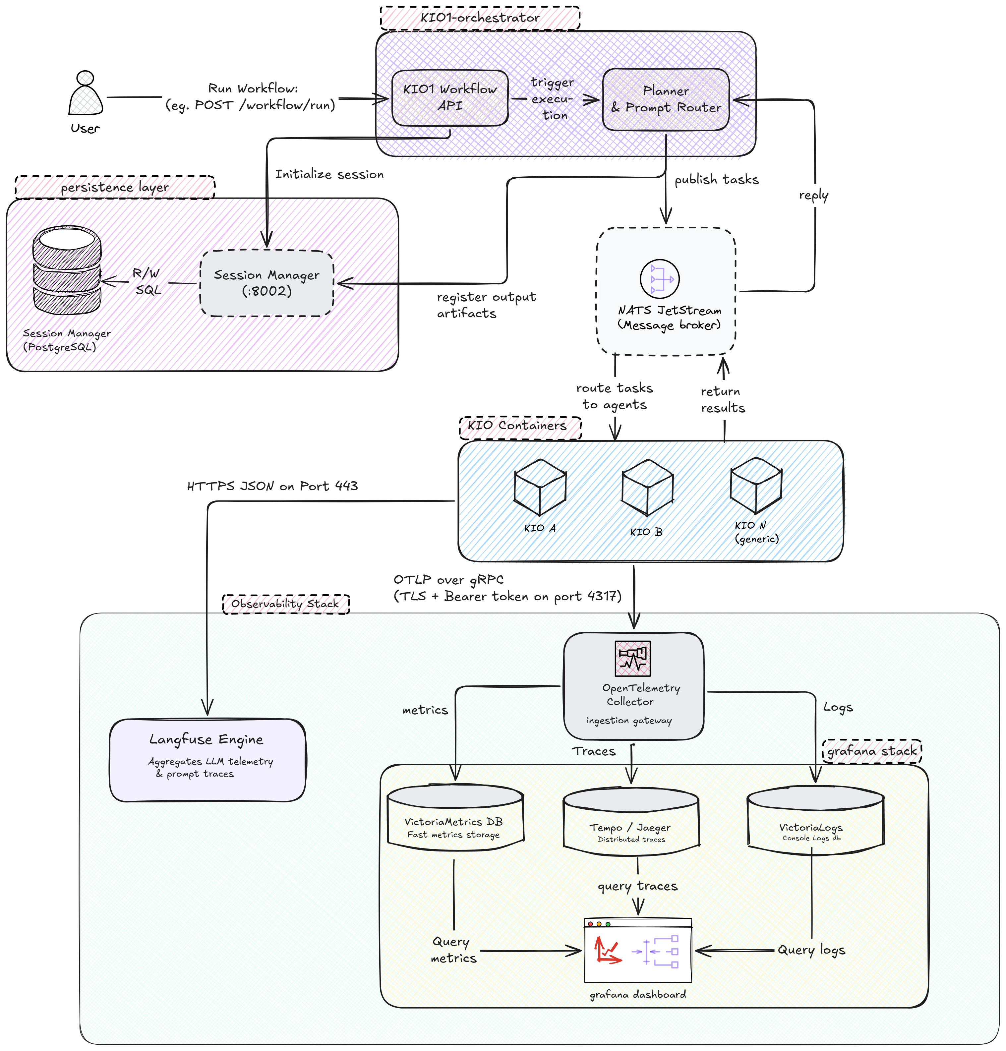
Figure 1: High-level end-to-end flow diagram.
Note (v2.3): on the current shared-LAN deployment this transport is secured by the bearer token only, without TLS (see Section 4, Step 2); TLS applies to a public/production deployment.

1.A End-to-end execution process, step by step
- Workflow triggering: a client initiates a task by sending an HTTP request (for example POST /workflow/run) to the KIO1 Workflow API.
- Session initialisation: the Workflow API immediately calls the Session Manager microservice to register the start of this execution. The Session Manager writes a new session record into the PostgreSQL database and generates a unique session id. The API returns this identifier to the client with an HTTP 202 Accepted status so that the client can track progress.
- Task routing: the Planner and Prompt Router takes over the execution. It constructs the workflow graph and publishes the first task payload over NATS JetStream. This payload is wrapped inside a standardised KIOEnvelope schema that carries the active session id and the target kio id.
- Agent execution: NATS JetStream routes the envelope to the appropriate worker container (for example KIO5). The worker container’s application code extracts the session id from the envelope and begins executing the task, such as running LLM completions or code execution tools.
- Telemetry transmission: during execution the worker container actively transmits telemetry over two network streams — the OpenTelemetry stream, in which the SDK aggregates metrics and traces in memory and pushes OTLP data OTLP data to the central OTel Collector over gRPC (port 4317) or HTTP (port 4318), authenticated with a bearer token; and the Langfuse stream, in which the SDK captures prompt inputs, completions, token usage and costs and pushes them to the Langfuse server over HTTP(S). All OpenTelemetry signals — metrics, traces and logs — are pushed by the KIO over OTLP; the Collector does not scrape container stdout.
- Telemetry routing: the OTel Collector fans out the incoming OTLP signals to their respective stores — metrics to VictoriaMetrics, traces to Tempo, and logs to VictoriaLogs.
- Task completion: once the worker container finishes its task it publishes the results and output artefacts back to NATS JetStream.
- Lineage registration: NATS routes the worker’s reply back to the LangGraph Planner. The planner reads the results and calls the Session Manager to write the output artefacts and register their lineage history into the PostgreSQL database.

1.B The observability and Grafana stack components
- VictoriaMetrics: a highly optimised time-series database. It stores all numeric metrics such as CPU usage, request counts and execution durations, and is queried by Grafana using the PromQL query language.
- Tempo: a distributed tracing storage backend. It records timing spans showing the exact execution timeline and code path across multiple containers, and is queried by Grafana using the TraceQL query language.
- VictoriaLogs: the log store for the KIOs' unstructured/string telemetry. It ingests OTLP logs pushed by the KIOs and indexes labels such as session id and kio id, and is queried by Grafana using the LogsQL query language.
- Grafana dashboard: the single web portal that connects all three databases. It queries VictoriaMetrics, Tempo and VictoriaLogs dynamically based on the dropdown filter variables, drawing the graphs and log viewer on a single interactive screen.

2. In-process SDK flow
This section describes the internal telemetry lifecycle inside the memory space of a single KIO worker container (for example KIO5) as it processes a task.
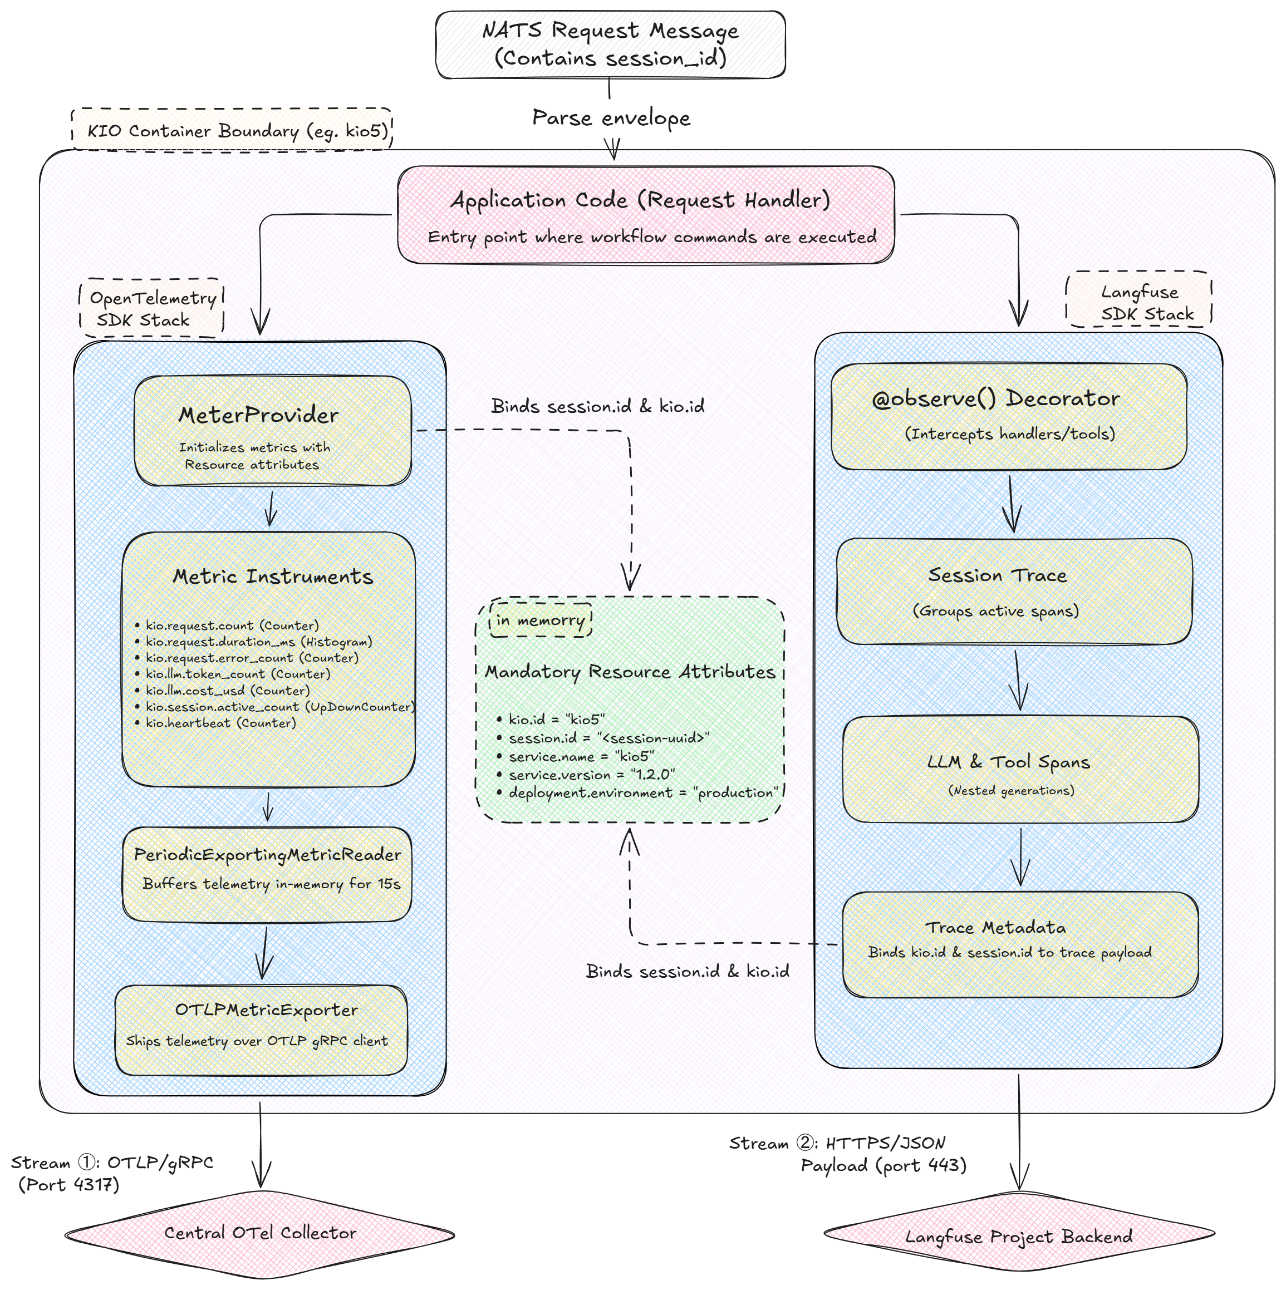
Figure 2: In-process SDK flow diagram.

2.A The in-process execution process, step by step
1. Request ingestion: the container’s application entry point receives a task message from NATS JetStream. This message is wrapped inside the KIOEnvelope containing the session id.
2. Context extraction: the application handler extracts the session id string from the incoming envelope.
3. OpenTelemetry initialisation: the container’s OTel MeterProvider reads the session id from the request, along with the container’s static environment properties (kio.id, service.name, service.version and deployment.environment), and binds them to the active mandatory resource attributes namespace in memory.
4. Metric recording: as the handler code runs it updates the OTel metric instruments, for example incrementing the request counter, recording durations or setting active session concurrency.
5. Metric buffering and export (stream 1): the PeriodicExportingMetricReader collects these recorded metrics and buffers them in memory for up to 15 seconds. When the window expires the OTLPMetricExporter packages the buffer and pushes it to the OTel Collector as OTLP — over gRPC (port 4317) or HTTP (port 4318), authenticated with a bearer token.
6. Langfuse interception: simultaneously the @observe() decorator intercepts the function entry point. It creates a new session trace bucket in memory and associates it with the active session id.
7. Recording AI operations: as the container executes internal prompt logic, child decorators capture the prompt text, model details, token consumption and execution durations for each LLM and tool call as child LLM and tool spans.
8. Stamping metadata: during execution the code calls langfuse_context.update_current_trace to stamp the session id and static kio id as trace metadata on the trace payload, matching the exact attributes bound in OpenTelemetry.
9. Langfuse payload export (stream 2): when the handler completes, the Langfuse SDK serialises all spans and metadata into a JSON payload and transmits it to the Langfuse server over HTTP(S), at the configured LANGFUSE_HOST. .

3. Grafana dashboard layout
The central Grafana dashboard visualises the telemetry collected from the KIO microservices. The layout is organised into rows covering system liveness and concurrency, request performance and volumes, error tracking and raw console logs, and LLM operational economics, dynamically filtered by container identifier and session UUID variables.
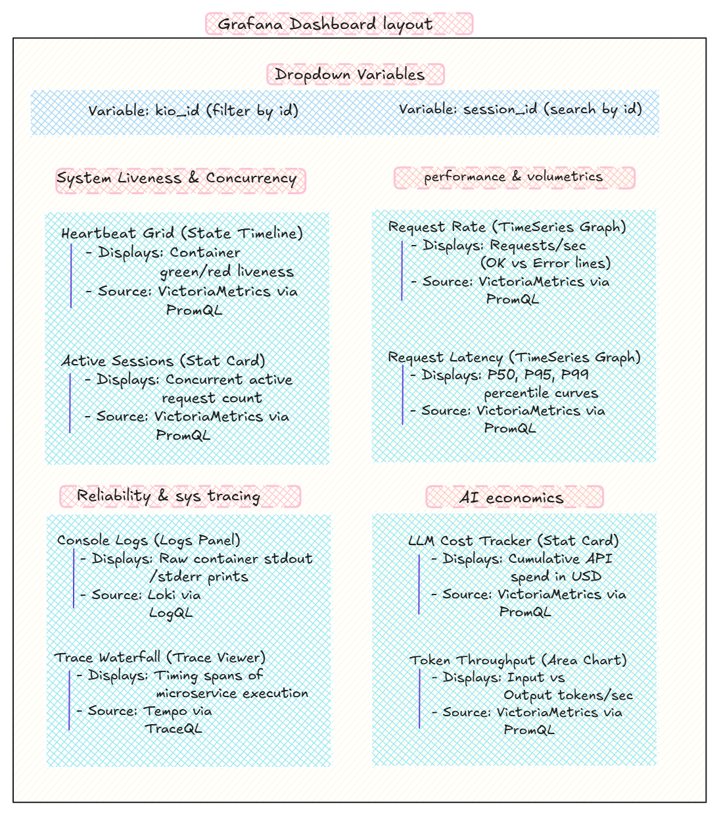
Figure 3: Grafana dashboard layout.
Note (v2.3): the Console Logs panel is sourced from VictoriaLogs via LogsQL, not Loki/LogQL as labelled in the figure above.

4. Onboarding steps
Step 1 — Request credentials: contact the platform team for your OTLP bearer token and Langfuse project keys (public and secret). Also request your unique kio.id at this time — never invent one locally, since a collision silently merges two KIOs’ data in Grafana.
Step 2 — Configure environment variables: set these variables in your container environment.
OTEL_EXPORTER_OTLP_ENDPOINT="http://<collector-host>:4318" # OTLP/HTTP; use :4317 for gRPC
OTEL_EXPORTER_OTLP_HEADERS="Authorization=Bearer <YOUR_OTLP_TOKEN>"
OTEL_RESOURCE_ATTRIBUTES="service.name=kio5,service.version=1.2.0,kio.id=kio5,deployment.environment=production"
LANGFUSE_PUBLIC_KEY="pk-lf-..."
LANGFUSE_SECRET_KEY="sk-lf-..."
LANGFUSE_HOST="http://<langfuse-host>:3001"
The Collector accepts both OTLP/gRPC (4317) and OTLP/HTTP (4318) — use whichever your SDK speaks. On the shared LAN deployment the transport is plain HTTP secured by the bearer token (no TLS); a public deployment would use https://. The bearer token is required — the Collector rejects unauthenticated exports. Two further resource attributes are optional but recommended: llm (e.g. claude-sonnet) and task_type (e.g. code-analysis) — several Grafana panels filter and group by these labels.
Step 3 — Install the required packages: add opentelemetry-api, opentelemetry-sdk, an OTLP exporter (opentelemetry-exporter-otlp-proto-grpc for gRPC, or opentelemetry-exporter-otlp-proto-http for HTTP), and langfuse to your project.
Step 4 — Initialise the SDKs in code: initialise the global MeterProvider at start-up.
Step 5 — Verify connectivity: run a test and verify that kio.heartbeat appears in Grafana and that traces appear in Langfuse.
Note (v2.3): some KIOs are additionally required to report project-level D1.1 KPIs (bug-fix time, code quality, developer productivity, etc.) on top of the telemetry above — see “D1.1 Project KPIs (informational)” in the Appendix (Section 6) for the full list, each metric’s type/unit, and which KIO owns which KPI.

4.A Connecting Observability platform from a separate machine (remote KIO)
A KIO need not run on the same host as the platform. Because telemetry is push-based, a KIO on another machine — same LAN, or across networks via a VPN such as Tailscale — connects the same way; only the endpoint host changes:
- Point OTEL_EXPORTER_OTLP_ENDPOINT at the platform host's reachable address, e.g. http://<platform-ip>:4318 (LAN) or http://<tailscale-ip>:4318.
- The platform host must allow inbound traffic on the OTLP port (4317/4318): add a firewall rule, or put both machines on the same VPN.
- Send the same bearer token via OTEL_EXPORTER_OTLP_HEADERS.
- Verify: a TCP check to the port, then confirm kio.heartbeat shows up in Grafana (KIO Detail).
Telemetry is independent of how the KIO is triggered (NATS-dispatched or standalone) — moving a KIO between machines needs no code change, only this endpoint value.

5. Telemetry details
Mandatory metrics schema. Every metric must carry the kio.id label.
Metric name | Type | Unit | Description and metric labels
kio.request.count | Counter | 1 | Total requests processed (labels: status = ok | error)
kio.request.duration_ms | Histogram | ms | End-to-end request execution latency
kio.request.error_count | Counter | 1 | Total error count (labels: error_type) — error_type must be a small, bounded set you define (e.g. timeout, internal, rate_limit), never an unbounded value such as an id or a message.
kio.llm.token_count | Counter | tokens | Input and output tokens processed (labels: direction)
kio.llm.cost_usd | Counter | USD | Estimated LLM API transactional cost
kio.session.active_count | UpDownCounter | 1 | Concurrent active requests inside the container
kio.heartbeat | Counter | 1 | Container liveness tick, every 60 seconds

Rules and conventions
- Metric naming: use dot notation, kio.<domain>.<metric>. Do not change metric names once they are established.
- Low cardinality for metric labels: do not use unique values such as session identifiers, user names or full URLs as metric labels, since this degrades the performance of the VictoriaMetrics database. Use session identifiers only in trace metadata.
- Secrets and personal data: never include API keys, passwords, e-mail addresses or personal data in metric labels or Langfuse payloads.
- Heartbeat task: run the kio.heartbeat counter in a background thread or loop. If the platform does not receive a heartbeat for more than 120 seconds your service is flagged as offline.
- Self-service metrics: beyond the 7 mandatory metrics above, a KIO may define additional domain-specific metrics, provided they follow the same kio.<domain>.<metric> naming and the low-cardinality/secrets rules on this page.
- Naming once ingested: dots become underscores and no _total suffix is added, so kio.request.count is queried in Grafana/VictoriaMetrics as kio_request_count.
- Traces and logs: at least one root span per request is recommended so the request shows up in the Tempo trace view; free-text logs to VictoriaLogs are optional. Neither is part of the 7 mandatory metrics.

6. Appendix — reference implementation
This Python snippet registers a globally configured OpenTelemetry MeterProvider with periodic OTLP gRPC export, and wraps the request logic with Langfuse tracing.
import os, time, asyncio
from opentelemetry import metrics
from opentelemetry.sdk.metrics import MeterProvider
from opentelemetry.sdk.metrics.export import PeriodicExportingMetricReader
from opentelemetry.exporter.otlp.proto.grpc.metric_exporter import OTLPMetricExporter
from opentelemetry.sdk.resources import Resource
from langfuse.decorators import observe, langfuse_context
# 1. OpenTelemetry setup
resource = Resource.create({
k: v for attr in os.environ.get("OTEL_RESOURCE_ATTRIBUTES", "").split(",")
for k, v in [attr.split("=")] if "=" in attr
})
exporter = OTLPMetricExporter(insecure=False) # use insecure=True for a plain-HTTP (non-TLS) endpoint
reader = PeriodicExportingMetricReader(exporter, export_interval_millis=15000)
metrics.set_meter_provider(MeterProvider(resource=resource, metric_readers=[reader]))
meter = metrics.get_meter("kio.instrumentation")
# 2. Mandatory instruments
request_counter = meter.create_counter("kio.request.count", unit="1")
request_duration = meter.create_histogram("kio.request.duration_ms", unit="ms")
error_counter = meter.create_counter("kio.request.error_count", unit="1")
llm_token_counter = meter.create_counter("kio.llm.token_count", unit="tokens")
llm_cost_counter = meter.create_counter("kio.llm.cost_usd", unit="USD")
active_sessions = meter.create_up_down_counter("kio.session.active_count", unit="1")
heartbeat_counter = meter.create_counter("kio.heartbeat", unit="1")
KIO_ID = os.environ.get("KIO_ID", "kioN")
# Background heartbeat task
async def _heartbeat_loop():
while True:
heartbeat_counter.add(1, {"kio.id": KIO_ID})
await asyncio.sleep(60)
# Request handler metrics wrapper
async def handler(envelope):
session_id = envelope.get("session_id", "unknown")
labels = {"kio.id": KIO_ID}
active_sessions.add(1, labels)
start = time.monotonic()
try:
result = await _do_llm_work(session_id, envelope)
request_counter.add(1, {**labels, "status": "ok"})
request_duration.record((time.monotonic() - start) * 1000, labels)
return result
except Exception as exc:
request_counter.add(1, {**labels, "status": "error"})
request_duration.record((time.monotonic() - start) * 1000, labels)
error_counter.add(1, {**labels, "error_type": "internal"})
raise
finally:
active_sessions.add(-1, labels)
@observe(name="llm_call")
async def _do_llm_work(session_id: str, envelope: dict):
langfuse_context.update_current_trace(
session_id=session_id,
metadata={"kio.id": KIO_ID, "session.id": session_id},
)
# LLM completion call goes here ...

D1.1 Project KPIs (informational)
Six KIO roles additionally report project-level KPIs from the D1.1 Project Management Handbook, on top of the 7 mandatory metrics in Section 5. These are self-service metrics (rule G7, not part of the mandatory set) — a KIO emits its row(s) below only when its KIO_REAL_KPI_ROLE environment variable matches the owning role; most KPI values are reported as a percentage of an SoTA baseline (100% = baseline).
KPI ID | Metric name (OTLP) | Type | Unit | Reporting role (KIO_REAL_KPI_ROLE)
1.1 | kio.kpi.codegen_speed.pct_of_baseline | Histogram | % | nlp-requirements, architecture-to-code
1.2 | kio.kpi.issue_resolution.pct_of_baseline | Histogram | % | bugfix
2.1 | kio.kpi.lifecycle_energy.pct_of_baseline | Histogram | % | green-deploy
2.2 | kio.kpi.deploy_energy_efficiency.pct_of_baseline | Histogram | % | green-deploy
3.1 | kio.kpi.code_quality.pct_of_baseline | Histogram | % | nlp-requirements, architecture-to-code
3.2 | kio.kpi.review_score.pct_of_baseline | Histogram | % | architecture-to-code
4.1 | kio.kpi.dev_productivity.pct_of_baseline | Histogram | % | ai-sysdev
5.1 | kio.kpi.time_to_market.pct_of_baseline | Histogram | % | ai-sysdev
6.1 | kio.kpi.bugfix_time.pct_of_baseline | Histogram | % | bugfix
6.2 | kio.kpi.customer_reported_issues.pct_of_baseline | Histogram | % | bugfix
7.1 | kio.kpi.annual_cost.pct_of_baseline | Histogram | % | ai-sysdev
8.1 | kio.kpi.adoption_rate.pct | Histogram | % | adoption
8.2 | kio.kpi.active_usage.pct | Histogram | % | adoption
8.2 | kio.kpi.satisfaction.mos | Histogram | 1 (MOS 1–5) | adoption
8.3 | kio.kpi.cross_arch_build.success_count | Counter | 1 | green-deploy
9.1 | kio.kpi.refactoring_effort.pct_of_baseline | Histogram | % | ai-sysdev
9.2 | kio.kpi.technical_debt.pct_of_baseline | Histogram | % | ai-sysdev
WP3 | kio.slicing.success_rate | Histogram | 1 (ratio) | bugfix

