Executive Summary

Background and Motivations
This position paper is an output from efforts conducted by the AIAA Digital Engineering Integration Committee Subcommittee on Computational Design and Analysis for Digital Engineering (DEIC-CoDADE). Digital engineering, as defined by DoD Instruction 5000.97, “is a means of using and integrating digital models and the underlying data to support the development, test and evaluation, and sustainment of a system” [1]. The DEIC is an AIAA integration committee that
The origin of DEIC-CoDADE stems from DEIC-CoDADE co-chair Rick Arthur’s identification of topics and subject areas that the other DEIC subcommittees and technical initiatives were not covering. These topics included discussions of interoperability with computational methods, high performance computing, and enabling technologies and methodologies of these. This further evolved into DEIC-CoDADE representing both the digital architects of the DEIC and those who are stakeholders to DEIC outputs – teams conducting computational design and analysis and those who are stakeholders to computational design and analysis efforts (e.g., program management, end-product users, direct customers, tool vendors, regulatory bodies).

Purpose of DEIC-CoDADE
The main roles that DEIC-CoDADE fit with respect to the DEIC and those who are stakeholders to DEIC outputs are:
- Acting as an information loop between digital architects and those who utilize digital engineering.
- Monitoring and tracking the kinds of question and areas of study that those who would utilize digital engineering are investigating.
- Generating, collating, and reporting on engineering guidelines and best practices for addressing open questions and areas of study that those who utilize digital engineering are investigating.
- Providing digital architects recommendations on high-utility problems and gaps those who utilize digital engineering are experiencing.
The specificity of focusing on CoDADE stems from the impacts that computational design and analysis (CoDA) have on the aerospace industry overall. CoDA impacts how aerospace-related design is conducted (Figure 1), but it also introduces other requirements for enabling computational design and analysis (Figure 1). One of CoDADE’s objectives is to demonstrate how digital engineering can be used to support the positive impacts of CoDA and provide recommendations to mitigate the drawbacks of using CoDA.
Figure 1:
e.g., supporting various aircraft certifications, optimization of a multi-scale complex design space, the mitigation of the severity of consequences of hazardous system behavior, optimizing SWaP
e.g., managing intellectual property and secure information, data quality and integrity requirements, hardware and software infrastructure, willingness to buy in, ensuring confidence in models, uncertainty quantification, trust

This position paper is intended to contribute to CoDADE being a “bridge” between DEIC and those would benefit from the outputs of the DEIC (i.e., those who would utilize digital engineering to conduct CoDA). As a result, this position paper is intended to:
- Provide a set of guidelines, standards, and best practices for people to utilize to realize the full benefits of digital engineering.
- Identify current gaps in knowledge or practice that can become avenues of further research and development.
Considering the vast field that is CoDA for aerospace design, DEIC-CoDADE sought input and feedback from those would utilize digital engineering to conduct CoDA for aerospace problems. This effort is discussed in Section 2.2.

Scoping This Position Paper
Based on the charter of the DEIC-CoDADE subcommittee, an approach for scoping this position paper is to review existing published gap analyses and vision statements made by different entities within the aerospace community. Another approach for scoping the position paper is to directly survey those who utilize digital engineering for computational design and analysis. For scoping the topics of discussion in this position paper, the authors employed both approaches.

Existing Visions, Positions, and Publications
DEIC-CoDADE utilizes the following definitions for various aspects of digital engineering, including:
- Digital engineering - A means of using and integrating digital models and the underlying data to support the development, test and evaluation, and sustainment of a system [1].
- Digital twin - A set of virtual information constructs that mimics the structure, context and behavior of an individual / unique physical asset, or a group of physical assets, is dynamically updated with data from its physical twin throughout its life cycle and informs decisions that realize value [2, 3].
- Digital thread: A collection of linked authoritative digital information pertaining to a process, product, or system, whose consistency is actively managed throughout the life cycle. This enables accessibility, traceability, currency, applicability, and credibility of information, thus facilitating the capture, communication, and use and reuse of knowledge to efficiently inform decisions that realize value [4].
- Digital ecosystem: (INCLUDE DEFINITION FROM THEIR POSITION PAPER)

With these definitions in mind, DEIC-CoDADE next scoped the topics that would be covered within CoDA. One source of this scoping was NASA’s 2040 Vision: A Roadmap for Integrated, Multiscale Modeling and Simulation of Materials and Systems. The 2040 Vision’s desired realized state is “a cyber-physical-social ecosystem that impacts the supply chain to accelerate model-based concurrent design, development, and deployment of materials and systems throughout the product life cycle for affordable, producible aerospace applications” [5]. The 2040 Vision identified 9 key development areas, and within those, 117 technical gaps, 180 recommended actions to close those gaps, and 9 interdisciplinary engineering challenge problems. The 9 key development areas and the critical gaps within those areas are in Table 1.
Table 1: Key elements for realizing the NASA 2040 Vision State, descriptions of each key element and the critical gaps for each key element [5, 6].
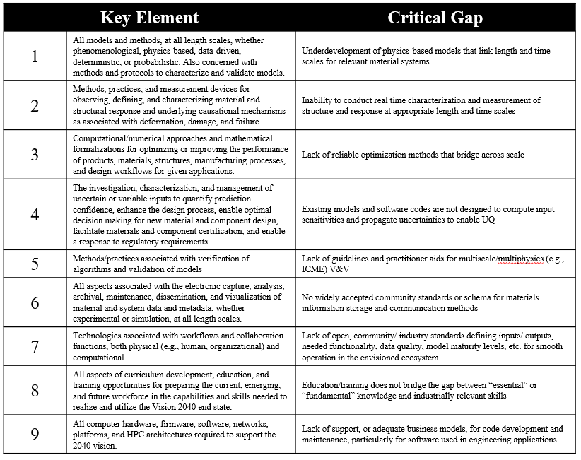
These key elements were further distilled into four high-level disciplines to study, which are CoDA framework analysis development, data management, hardware/software infrastructure co-design, and the role of organization strategy and culture. Further discussion on the topics within each of these disciplines that will be within this position paper are in Section 2.4.
Although the position paper is now able to target four high-level disciplines, additional refinement of scope was required. Further refinement came from the results of the AI Readiness Survey that was distributed by NAFEMS in 2024. There were 802 respondents to the survey, and the respondents were asked questions related to how their organization uses AI/ML for engineering simulation, level of AI maturity within the organization, and barriers to AI adoption, among other questions. Ultimately, the survey results demonstrated that most of the respondents’ organizations do not have a mature AI capability, and the vast majority is not utilizing ML/AI in an ethical and responsible manner. Based on these findings, the DEIC-CoDADE further concentrated their topics of interest to address concerns of interoperability and appropriate use of digital engineering with methods and technologies within each high-level discipline. The definitions of appropriate use and interoperability are as follows:
- Appropriate use - A subset of considerations within responsible use of methods, appropriate use considers the following: 1) Are the models, data, and decision-making process validated for the desired application? (2) Are the models, data, and decision-making process sufficiently mature for quantification of uncertainty and establishing trust?
- Interoperability - The ability of systems, units, or forces to provide data, information, materiel, and services to, and accept the same from, other systems, units, or forces, and to use the data, information, materiel, and services exchanged to enable them to effectively operate together. In the context of non-deterministic methods (including, but not limited to, AI), the goal is to emphasize how interoperability of these methods with other digital infrastructure can be supported in an appropriate manner [7].
Considering the above definitions for digital engineering constructs, the high-level subject areas that will compose chapters of this position paper, and critical characteristics for supporting CoDADE, Section Error! Reference source not found. will review the survey that DEIC-CoDADE circulated and the results from it.

AIAA DEIC-CoDADE Survey
DEIC-CoDADE generated a survey that was fielded between October and November 2024. The survey overall was intended to elicit inputs from those who utilize digital engineering on whether they believe that the DEIC-CoDADE’s position on digital engineering would apply to a variety of different technical topics. Further discussion on the survey, survey topics and questions, and detailed discussion of the result will be in (SURVEY WHITE PAPER CITE HERE).
Ultimately, the survey was able to yield a statistically significant number of responses, and these responses demonstrated shared challenges among them. One of these shared challenges is that respondents identified the use of AI/ML and tradition modeling/simulation methods in a hybrid, integrated fashion and AI/ML applied to automation and data analysis as areas of desired study. Respondents believe that these AI/ML topics are currently gaining the least benefit from digital engineering and that these topics need additional guidelines for maximizing interoperability and appropriate use.
Respondents also noted the need and importance and standardization and suggestions of guidelines and best practices across all subject areas discussed in the survey to better support the realization of digital engineering. With respect to data management, respondents emphasized the need for additional standardization and guidelines in managing simulation verification and validation data, unstructured text data, and metadata. Another respondent observed the need for standardization of methodologies for incorporating process-driven tools that are needed across the product life cycle in a digital environment. Another respondent also highlighted that guidelines between interoperability and appropriate use of digital engineering and open stands of model and data management would support adoption of these open standards and fully realize the promise of digital engineering.
However, according to respondents, the greatest challenges for advancing and fully realize digital engineering include training developers, educating leadership, and aligning needs/goals across their respective organizations. One respondent noted that “senior staff members view hardware in the loop testbeds as more reliable than digital twins. Digital twin developers are younger and have less experience with HW and SW issues that they should model.” Consequently, additional guidelines on how to demonstrate utility, validation, and trust in digital twin development would support educating leadership in technical roles.
Another respondent noted that it “(…) appears that systems architecture is what folks are focused on as opposed to connecting the digital thread to everyday tasking” and that “Digital engineering workflows and culture shifts in corporations need to happen at the working level in order to meet the demand customers have for aerospace products.” This implies that those would utilize digital engineering need examples on how to use digital engineering constructs to solve problems they regularly face, as opposed to just emphasis on digital engineering architectures.

AI is a Metaphor
Before considering how to use AI in an interoperable and appropriate manner, one must first define what AI is. INSERT REFERENCE TO TABLE HERE A common theme across all these definitions is that AI is a mimicry of human cognitive function. However, considering that human beings have an evolving, but incomplete, understanding of their own cognition, how can individuals utilizing AI in their aerospace applications ensure they are using it in an interoperable and appropriate manner?
Definition of Artificial Intelligence (AI) | Source of Definition
The ability of machines to perform tasks that normally require human intelligence. For example: recognizing patterns, learning from experience, drawing conclusions, making predictions, and taking action – whether digitally of as the smart software behind autonomous physical systems. [8, 9] | Summary of the 2018 DoD AI Strategy
The term artificial intelligence includes the following: (1) Any artificial system that performs tasks under varying and unpredictable circumstances without significant human oversight, or that can learn from experience and improve performance when exposed to data sets. (2) An artificial system developed in computer software, physical hardware, or other context that solves tasks requiring human-like perception, cognition, planning, learning, communication, or physical action. (3) An artificial system designed to think or act like a human, including cognitive architectures and neural networks. (4) A set of techniques, including machine learning, that is designed to approximate a cognitive task. (5) An artificial system designed to act rationally, including an intelligent software agent or embodied robot that achieves goals using perception, planning, reasoning, learning, communicating, decision making, and acting. [8, 10] | John S. McCain National Defense Authorization Act for FY2019 9 – Sub B/Sect 238g
A machine-based system that can, for a given set of human-defined objectives, make predictions, recommendations or decisions influencing real or virtual environments. Artificial intelligence systems use machine and human-based inputs to—(A) perceive real and virtual environments; (B) abstract such perceptions into models through analysis in an automated manner; and (C) use model inference to formulate options for information or action. [8, 11] | National AI Initiative Act of 2020 (FY2021 NDAA)
Any artificial system that performs tasks under varying and unpredictable circumstances without significant human oversight, or that can learn from experience and improve performance when exposed to data sets. [8, 12] | 10 U.S. Code § 2358
Software and/or hardware that can learn to solve complex problems, make predictions, or undertake tasks that require human-like sensing (such as vision, speech, and touch), perception, cognition, planning, learning, communication, or physical action. [8] (NEED SOURCE HERE) | National Institute for Standards and Technology
The science and engineering of making intelligent machines, especially intelligent computer programs. It is related to the similar task of using computers to understand human intelligence, but AI does not have to confine itself to methods that are biologically observable. [13] | Professor Emeritus John McCarthy, Who Originally Coined the Term “Artificial Intelligence”
While there is no singular answer to this question, Section 2.3 will provide a DEIC-CoDADE position on this question. AI is really a metaphor for human cognition in the way that it is based on our understanding of human cognition, as opposed to cognition itself. Neural networks, for example at a high level, are ontological representations of how different models relate to each other via inputs and outputs. The nodes in neural networks are akin to individual points of cognition (i.e., an individual task) and the nodes are laid out in a topological manner to demonstrate how they relate to each other.
With this approach for describing artificial intelligence, one can simplify how to establish confidence via validation that AI is being used in an interoperable and appropriate manner. Validation of the application of the AI model relies on a clear understanding of the intent and purpose of applying the AI. Intent and purpose of application drives the requirements of applying the AI in an appropriate and interoperable manner and it also drives how to demonstrate that those requirements are met. In the context of the neural network example from before, validating the application of the AI model results in validating the topological component: how individual nodes of the artificial intelligence relate to each other. The other component to validation is model validation, which is covered in more detail in Section 3.

When to Use the Term “AI” and When Not to
- Perhaps a sort of ordering of “in-your-face” AI across a spectrum to “under-the-covers” AI
- Address long-established methods that are sometimes mistakenly bundled with AI, but are long-applied methods for clever adaptation and data-derived inference.
- Regression, rules engines, …
- Levels of decision-making (strategic vs. operational vs. exploratory)

High-Level Questions to Address Using Digital Engineering
AI/ML + Traditional Mod/Sim & AI/ML applied to data analysis open questions

- Machine Learning, Decision Making, and Trust (Method Independent)
  - Role of Digital Engineering in Decision Making (e.g., AI-derived decisions vs. human expectations) Rekha
  - Debate on Model Correctness (George Box vs. “All models are correct” vs. “All models are incomplete”) Rick, Steve, Alicia

    - New twist on Box quote: models always hallucinate, but sometimes hallucination aligns with reality
    - All LLMs to date only know aleatoric uncertainties (statistical randomness) - not epistemic (lack of knowledge)
    - Hallucination and "Approximate Retrieval"
    - Steve has been pushing “idealization consistency”, which requires consistency for how you perform calibration and characterization of model parameters and coefficients (capturing model pedigree)
    - Agentic workflows (improving explainability of steps within hierarchy of activities to make clear what is being passed from one agent to another (each agent corresponding to a single step))
    - Microsoft – lists out the steps that each agent does ahead of time and provides the users the opportunity to fix the prompts
    - For building trust (key point independent of model correctness debate): traceability of inputs and outputs, transparency of design-making, verification (did we build the right model) vs. validation (did we build the model right?), consistency (“idealization consistency”)
    - Cite: NAFEMS ESMS (engineering simulation metadata specification)
(link NAFEMS member-restricted, perhaps Olivia can help get open access)
    - Fly-by-wire standards (flight controls technical subcommittee, Chris Elliot, SAE)
    - Cite: model maturity: gap assessment and prioritization
(https://richardarthur.medium.com/co-design-web-6f37664ac1e1) and slides (https://drive.google.com/file/d/19URWTkIOJ01j62dqnNjIQrlQv_pnEX0J/view) – 4 pieces: validation (matching experimental), confidence (includes UQ, can bound uncertainty), realism (degree to which you are not simplifying or removing effects within the model), and robustness (numerical, stability and certibility of the digital emulator, requires the ability to bound the region of competence)
    - Worthwhile topic – your prediction horizon, ML is great at interpolation, not necessarily at extrapolation. How do you appropriately use your models to solve different problems, especially as they relate to DTw development – Alicia
      - Decomposition of complex systems (e.g., engine modeling)
      - Surrogate modeling is your best friend (how it facilitates multiscale and high-fidelity modeling)

  - Transparency and trust in AI modeling Abhi
    - Think of human beings. AI is just a tool it has no mind of its own, everything it knows is based on an amalgamation of what it is and what it has been trained to do. This is analogous to human beings no two humans are the same; they are a mixture of their genetic encoding and their experiences. At the end of the day, as AI is a mimicry of human cognition, where everything it knows is based on what humans tell it, transparency and trust in AI modeling lies not with the AI, but with the humans developing, managing, and using it.
- Contextualizing Different Computational Methods and Model Development Standardization
  - Physics-based methods
  - Human-created models
  - Data-derived models
- Complexity of Multi-Physics and Nonlinearity Abhi/Ian
  - Decomposition of complex systems (e.g., engine modeling)
  - Surrogate modeling is your best friend (how it facilitates multiscale and high-fidelity modeling)
Add the above ^ to the background and motivations section. The reason we are working on these methods and vision is to enable multi-X
We are great at handling linear scenarios, but what about non-linear scenarios? Ian

Data Management – Vladimir, Chris J
- How to manage simulation and verification data
- How to manage unstructured text data
- How to manage metadata
- Consistency management of data
Hardware/Software Infrastructure Co-Design
- Artificial constraints of traditional computational approaches (esp., AI)
- Theoretical idea: infinite computational resources vs. practical applications
- How to incorporate process-driven tools across the life cycle
- How digital engineering can impact different kinds of scaling
- How to adopt open standards for hardware/software co-design
- How to best incorporate high-performance computing
Role of Organization Strategy and Culture
- Digital engineering within a larger ecosystem Marlon, Chad, Steve, Abhi, Rick, Michael, Hugh
  - Defining a digital culture (difference between enterprise digitization and enterprise digital transformation) start with level-setting this definition so everything else flows from this COMPLETE
    - Digital transformation involves changing how decision-making and strategy is generated
    - Culture looks like innovation, collaboration and communication if want transformation
  - Role ML/AI has in your digital culture (maintaining and tracking progress, upholding standards of practice) Aruna
  - Digital Engineering vs. Data Engineering Chad + Marlon, completed and to be merged
    - Not too much progress in digital twins, mostly in data engineering due to speed that AI is progressing
    - Need to incorporate the flexibility, agility, and other inputs required for digital engineering
  - Challenges to adoption
  - Paper on MBSE/MDAO adoption Michael Belisle will send it
  - Supply chain
  - Vision: Awakened Enterprise: Decision Provenance and Systemic Mindfulness
(Cite:https://www.linkedin.com/pulse/awakened-enterprise-rick-arthur-kwitc/ and related articles)
- Relationship between digital twins and digital engineering Marlon, Chad, Abhi
  - Strategic alignment between the two, what investment and resources look like
    - Key challenges: often generated independent of each other.
    - Challenge with digital engineering: its mostly what you do to create AI applications
    - Compare AIAA definitions of DE vs. digital ecosystem vs. DTw foundationally speaking, demonstrate how they’re interconnected
    - Practical applications across industry
  - Navigating the relationship between those who use digital engineering and digital architects interdependent and symbiotic
    - Digital architects build digital ecosystems. Those who use digital engineering build digital twins. How to build the bridge between them. (Essentially, create inputs for CoDA Framework, data management, co-design, etc.)
    - Establish a common language or thinking for bridging these too, including but not limited to, leveraging:

      - Training developers and DE novices on the actual applications
      - Proving value to leadership
      - Ensuring goals are aligned across the organization
      - Data privacy and security requirements
      - Iterative deployment/investment long-term profits from immediate investments
- Digital engineering community of practice Marlon, Steve
- How to train developers and digital engineering novices Rick, Steve
  - (Cite AIAA DEIC Workforce Development paper):
https://aiaa.org/resources/digital-engineering-workforce-development-white-paper
    - Highlight its content as relevant to this topic area
    - Do not summarize or replicate
  - Highlight lack of digital-driven education in K-12, how to overcome that in UG/first job look at ways that AIAA supports K-12 education
  - Generating digital engineering requirements
  - Skill-based training on how to best conduct digital engineering in general
  - How-to guide on navigating digital engineering credentials being proposed
  - Different workshops available / proposed K-12 workshops included
- How to educate stakeholders and prove value Marlon
  - Provide examples of programmatic value derived from digital engineering efforts (e.g., SWaP optimization, sustainment)
  - Relevant use cases things they’d like to see, especially w.r.t. competitive advantage (faster, cheaper, more-with-less)
  - Tie role of digital engineering with metrics and KPIs, business goals (SMART goals), tangible ROI from implementing digital engineering, tie to customer utility e.g., data-driven insights
  - Looking at different case studies
- How to ensure goals are aligned across the organization Marlon, Bala, Chad, Abhi
  - Aligning UI/UX with business goals
  - Set up a call
- Generate a closed loop between digital engineering and the design, test, and evaluation community Abhi, Greg Roth, Hugh, Rekha

Computational Design and Analysis (CoDA) Framework Development (Alicia and Alex)
Computational methods and tools have been extensively developed and utilized in aerospace engineering and across major disciplines of engineering, which has enabled the era of digital engineering. Ever since the birth of the Turing machine, computing power has been exploited to conduct calculations more quickly and more accurately. The modern-day computing technology enabled numerical methods to solve a discretized system of previously unsolvable problems, taking advantage of (much) faster-than-human computing capabilities. The increase in processing speed, memory, and storage has paralleled a corresponding leap in the scale and fidelity of problems engineers can solve.
These approaches are a long series of equations that would be considered too long to be solved by a human, and given the number of times these equations need to be solved, considered unsolvable. The examples include the Monte Carlo method for uncertainty quantification and the finite element method for mechanics. Computers also provided the means to store a lot of information which can then be organized and manipulated via the numerical methods. Over the several decades of computer technology development, a vast range of numerical and computational methods have emerged to assist engineering, e.g. drawing and manipulating 3D geometry, simulating the behavior of a well-defined system, a range of fidelity models and surrogate models for forward simulation, management and analysis of large amounts of data, and inverse optimization to generate the optimum system or configurations which can be considered as an inverse problem of a simulation model. Alongside the methods themselves, advances in numerical and computational fluency have brought workflows and tools to track how geometry, mesh, analyses, and results flow through long-running studies using enterprise resource planning systems. Automation of these processes has dramatically shortened design cycles and enabled rapid iteration, which is critical in competitive industries such as aerospace.
As complexity of engineering systems increased, efforts increased in integrating these numerical methods to predict and design ever more challenging systems which can no longer be engineered by one or a few engineers, exemplified in modern aerospace structures amongst numerous examples. The primary challenge here being that the effects of changing one design feature on the entire system are not fully understood a priori. Disciplines such as systems engineering and multidisciplinary design optimization have emerged to incorporate numerical and computational methods to predict the effects of a design change on the whole system and balance the conflicting criteria. While these system-level or top-down approaches have long been adopted in engineering, they were initially composed of lower fidelity models and the efforts are continuing to enable the adoption of multiple higher fidelity models earlier in the design process. There have been many case studies where the design optimization has generated novel designs that had been unknown or discovered new ways to manage the trade-offs, leading to more competitive engineering design. In recent years, machine learning and artificial intelligence (ML/AI) have become increasingly popular in the family of computational methods. Another parallel development is the advances in hardware design together with software development, either tailoring software to a given hardware (e.g. GPU vs. CPU parallelization) or tailoring hardware architecture optimized for a series of calculations that are needed - sometimes referred to as codesign, although the word is also commonly used for non-computational design approaches, i.e. collaborative or team approach or design which simultaneously consider multiple disciplines.
The vision of digital engineering is an ultimate integration of all computational models beyond design - it spans the entire life-cycle of an asset. The initial model that behaves like a designed system is critical in enabling sensors to accurately update and predict its operational and aging behavior. Therefore, the computational methods used in the design process would form the fundamental model and data for digital engineering. This integration enables the realization of true digital twins, where physical assets and their virtual counterparts co-evolve throughout the lifecycle. This position paper aims to reflect on the computational methods that enable modeling and design, hence to provide a perspective on the state of the art computational methods in engineering, their challenges and the future.

Role of CoDA in Digital Engineering
Before reviewing the landscape of computational models for digital engineering, digital twin is being considered across all sectors, from engineering to climate to life sciences and many others. We note that many of the computational models share the same fundamentals across disciplines although we choose to focus on the methods common in engineering in this paper. For further reading on high level perspective on future direction for digital twins, the readers are referred to the National Academies consensus report on Foundational Research Gaps and Future Directions for Digital Twins (2024). When the digital twin concept is applied to materials and structural engineering, it becomes what the field of Integrated Computational Materials and Engineering (ICME) has been striving for a few decades. The NASA Vision 2040 paper on a Roadmap for Integrated Multiscale Modeling and Simulation of Materials and Systems (2024) identifies nine key enabling elements, eight of which relate also to digital engineering: modeling; optimization; uncertainty quantification and management; verification and validation; data informatics and visualization; workflows; training; and computational infrastructure. We will base our discussions on these key elements. By doing so, we aim to provide a structured framework for analyzing the maturity, challenges, and opportunities of computational methods in digital engineering.

Role of Modeling in CoDA in Digital Engineering
Model here, is the computational models that form the foundation of a digital twin. One representative field of research that advances modeling is computational mechanics including surrogate modeling. They have been serving engineers to (i) to estimate a quantity of interest which can be measured experimentally but saves time and cost by simulation, (ii) enabling an engineer to investigate many what-if scenarios to inform unique insights of system behavior, or (iii) to compute a quantity which is very difficult or impossible to measure experimentally. One major goal of computational mechanics has been to develop mathematical formulations and solvers to estimate the quantities of interests more accurately, while balancing with computational resources. Surrogate models, in particular, have become indispensable for enabling real-time or many-query analyses, such as uncertainty quantification, optimization, and control. The increasing integration of data-driven techniques, such as neural networks, is complementing traditional physics-based modeling approaches and offering new capabilities for handling highly nonlinear and/or multiscale problems. Reviewing NASA’s CFD Vision 2030 Roadmap (2020) offers a good insight in typical model development strategy: To enable physics-based modeling of 3D unsteady maneuvering flight and combustion by 2030. In addition to the physics-based modeling, they identify 5 key enabling domains which also require advances, (i) high performance computing (HPC); (ii) algorithms; (iii) geometry and grid generation; (iv) knowledge extraction and visualization; and (v) multidisciplinary design analysis and optimization (MDAO) with uncertainty quantification (UQ). The recent trends in computational mechanics are to exploit neural networks (NNs) and data-driven approaches to improve accuracy and/or add complexity without a substantial increase in computational resources. The overall goal remains to model complex flow that cannot currently be analyzed. Here, the complexity arises within a single discipline, which may require limited input from one other discipline (chemistry kinetics for combustion in the case of CFD). This means many of the numerical specifics of the computational models and algorithms are tailored to the specific quantities within a single discipline, and cannot easily be generalized. In other words, the computational models rely on a trained engineer with experience to construct and utilize for their use of the quantities (thus the accuracy need is defined by the engineer). This knowledge and insights are not easily generalized nor abstracted. Hence there are substantial challenges in constructing a single model for general purpose. (i.e. the quantity of interests are unknown a priori.) Such a model in today’s technology, if possible to create, would require unreasonable computational resources (e.g. extremely fine mesh, small time-steps). Research efforts are seen in training AI agents to perform the engineers' tasks to accelerate the design process. In parallel, researchers are developing computational methods that can communicate important information between the models such that the composition of the models can address the complexity challenges arising from multidisciplinary interactions and conflicts.

Role of Optimization in CoDA in Digital Engineering
Mathematical optimization has widely been in use for many complex decision makings, from preliminary aircraft design to financial investments. Generative AI also solves an optimization problem, thus considered as a subclass of optimization here. Optimization is fundamentally based on metric(s) to minimize/maximize given requirements or constraints, and outputs a set of parameters that optimally satisfy the problem statement. In the context of a complex system, it offers the quantitative tool that can evaluate the full consequences of each solution and balance conflicting criteria, which can thus guide decision-making systematically extracting important information from a digital twin.
However, an important limitation here is that mathematical optimization finds an optimum solution to a given problem statement, which is usually unknown a priori as a complex system engineering problem is ill-defined. In other words, the quality of an optimum solution is critically dependent on formulating a “correct” problem for which there are several barriers. One relates to the state-of-the-art models which are tailored to estimate the pre-defined quantities of interest. However, which quantity(-ies) has(-ve) significant influences on decision-making and their accuracy requirements can change as the decision itself changes. Therefore, it is unknown which model should be selected for optimization, and consequently the full implications of the assumptions and approximations cannot be clearly understood. Furthermore, significant quantities themselves may change as various decisions are considered, requiring multiple integrated models to communicate, which is an outstanding challenge as discussed earlier. Given the complexity of multiple fidelity models and various assumptions, a generalized approach to model integration is likely to be far from achievable. Another challenge is that an optimization problem statement of a complex system may not have an optimum solution or may have many optima. For a complex system, this is not known a priori. This means when a numerical method fails to converge to a solution, it may be that the problem statement does not have a solution. There is little abstracted knowledge that can guide how to formulate a “correct” optimization problem, which is currently considered expert knowledge, limiting usability of a digital twin. When an optimum solution is obtained by NN-based methods, the insights into the solution can be limited due to lack of explainability, presenting further challenges to use in decision-making. There is also the challenge of verifying and validating the solution as it is not intuitive to identify all the edge cases.

Verification, Validation, and Uncertainty Quantification in CoDA for Digital Engineering
Verification, Validation, and Uncertainty Quantification (VVUQ) is another important class of computational methods in digital engineering. As alluded in the previous paragraph, verification and validation is critical in a complex system, which is not a straightforward task. The challenge is further exacerbated by the inherent uncertainties in a digital system. By the virtue of computational methods, they are discrete and the solution accuracy is a function of discretization, parameterization, mesh density, numerical parameters, and hyperparameters. They are subject to precision errors, which can be difficult to minimize when a range of quantities in a system can vary many orders of magnitude. Solvers are usually iterative, hence their accuracy is defined by the solver tolerances. When a system contains quantities across many orders of magnitude, the system matrix can be ill-conditioned leading to an inaccurate solution or divergence. Again, a generalized solver that is sufficiently fast and insensitive to these numerous factors has long been studied but not been found. In addition, for a general purpose digital twin, it is unknown a priori how a result would be interpreted. The only option therefore, is to store the highest precision possible, which can drastically increase the data storage requirements, much of which may be wasteful.
There are many sources of uncertainties in practice. The operating and environment conditions are uncertain. Material properties are stochastic at their low scales and experimental validations contain unknowns throughout the scales. Processing and manufacturing introduce uncertainties. Edge cases and human interaction with a physical twin are also uncertain. With so many sources of uncertainties and their effects unexpected in a typical complex system, it is critical that these are properly propagated and managed in verification and validation, before they can be used in decision-making. There has been a consistent and strong level of research activities over many years to address the challenge of reducing the prohibitive computational resources in computing for all possible uncertain cases by minimizing the number of samples required. The range of approaches include stochastic and probabilistic methods and surrogate modeling. The quality of sampling and accuracy of uncertainty calculation are again determined by an engineer based on how they intend to use the results. Again, this presents a fundamental challenge in generalization. Many VVUQ methods are specific to the characteristics of problem classes with a view to embed in modeling and optimization.

Role of ML/AI in CoDA for Digital Engineering (Rekha)
Digital engineering represents a major shift from traditional engineering and computational design and analysis by embedding advanced digital technologies—such as AI, data analytics, simulation models, and digital twins—into every stage of the engineering process. This transformation has important implications for the relationship between AI-driven insights and human expectations in engineering projects.

Role of ML/AI in Data-Driven Decision-Making
Digital engineering enables real-time analysis and simulation of designs before they are physically built. AI-powered models can rapidly process massive data sets, identify optimal solutions, and predict potential issues much earlier than traditional manual methods would allow. This leads to more informed, evidence-based decisions throughout the engineering lifecycle.^{[1][2]} By modeling entire systems virtually, teams also gain insight into complex interactions. AI can also uncover patterns, and outlier risks that humans might overlook, facilitating proactive mitigation and enabling faster innovation.^{[2][3]} Additionally, automated processes, AI-driven optimizations, and virtual testing reduce the need for costly physical prototypes and lengthy manual adjustments. Collaboration is enhanced because all stakeholders work with centralized, up-to-date models, streamlining workflows and minimizing rework.^{[3][1][2]} Digital engineering connects all phases—design, testing, manufacturing, operation—through digital “threads” that unify data, support traceability, and enable interdisciplinary teams to act on AI-generated insights in real time.^{[2]}

Comparing AI Insights to Human Expectations for CoDA
AI excels at pattern recognition, anomaly detection, rapid simulation, and optimization within vast, complex datasets. It offers predictive insights, scenario analysis, and automated design suggestions. AI can also reveal unexpected vulnerabilities or optimization opportunities, supporting adaptive design and rapid iteration. ML tools automate schema matching, error detection, and even adaptive aggregation, making integration and decision-making more robust and less error prone.
In contrast, humans often expect engineering results to align with intuition, past experience, or incremental improvements relative to established norms. Human decision-makers can misinterpret AI-derived “unexpected” recommendations or optimizations as counterintuitive or risky, especially if transparency is lacking. Trust and understanding must be cultivated—effective collaboration relies on engineers being able to interpret, challenge, and validate AI insights with their practical knowledge and ethical judgment.
The visual, model-based nature of digital engineering improves clarity and fosters consensus, helping teams align on AI-enabled design choices and outcomes. Ensuring AI insights are interpretable and explainable to human stakeholders is crucial for adoption, confidence, and accountability. Digital engineering succeeds when AI augments (not replaces) human expertise—managing computational speed and holistic system views, while humans set objectives, constraints, and exercise critical oversight.
In summary, digital engineering empowers organizations to merge the speed, depth, and adaptability of AI-powered analysis with the creativity, context, and judgment of human engineers. Achieving synergy between AI insights and human expectations is pivotal for unlocking the full potential of digital transformation in engineering.^{[1][3][2]}

- https://avian.com/avian-media-network/post?How-Digital-Engineering-Transforms-Traditional-Engineering-Practices-76
- https://www.sodiuswillert.com/en/blog/mastering-the-complexity-of-systems-with-digital-engineering
http://noblis.org/digitalengineering-trhodes/

Alicia and Alex: I think the following paragraph could be helpful so I am writing it. It may belong in a different section.

For connecting and coupling models and methods, it can be useful to remark on the following classification of approaches based on their intrusiveness. There is active research in all approaches below and it is anticipated that they will all be utilized in digital engineering.

Codesign [add the DOE report that defines this word] is the most intrusive approach where hardware and/or software are at least tailored to their specifics or designed together. In other words, software performance is highly dependent on hardware design. The economic viability of this approach in today’s business model of mass-producing computing devices, mostly agnostic to software limits its applications to problems where the potential is substantial, e.g. the model cannot be solved or fast enough with commonly available hardware. Technologies such as FPGA (Field Programmable Gate Array) can also be included here, providing a means of configuring the hardware after manufacturing and improving accessibility to hardware codesign. It is not uncommon to see efforts in developing alternative algebra and/or algorithms to tailor to a class or configuration of hardware, e.g. specialized large-scale parallel computing on GPU. In addition to large-scale computing, another useful application would be edge device computing, where real-time analysis is needed or where it directly connects physical and digital twins in a localized way for fast response. This may present a new market opportunity.

Mathematical refers to approaches where a new mathematical equation system is developed. When two models are tightly coupled and the effects on each other are substantial, it can be beneficial to derive the mathematics to include these effects on each other, which may increase degrees of freedom and may require a different solver as the system is fundamentally different. This is an intrusive approach as legacy software cannot be applied directly. It requires research and development to be accessible, but hasthe potential to be more robust than the computational approach.

Computational refers to approaches where the existing software can be used to connect two models. This is less intrusive than the mathematical approaches and can also be non-intrusive. The use of legacy software in digital engineering is advantageous as the expertise already exists in an organization. In a certification-critical engineering environment, this can also mean substantial resource saving, which can decide its feasibility. In the classification here, we include software in the form of commercial and open-source software, although commercial software may be significantly limited in the way it can be connected or integrated in a digital environment. This limitation commonly arises from a number of reasons, including limited input and output parameters; their data management can be extremely inefficient; insufficient numerical methods and parameters are exposed to connect another model to achieve robust outcome. We note that the black-box software philosophy is unlikely to provide sufficiently useful information, as the reasons behind and sensitivity of the output are often more useful to an engineer than the values themselves. This is where explainable AI becomes an essential component in digital engineering. Non-open-source software can also be readily used in digital engineering. Sufficient exposure to the methods and flexibility of input/output parameters is an important deciding factor, as it can influence the required computational resources by as much as order(s) of magnitude.

Workflow and platform approaches refer to software that enables the creation of a workflow by putting together a series of models. They come under several classifications, such as process integration and design automation platform (PIDA), workflow automation, systems engineering, computer-aided engineering (CAE). In addition to those classifying themselves as digital engineering solutions, there are many existing examples such as ModelCenter, OpenMDAO, and MATLAB simulink. These software have different sets of functionalities and the associated pros/cons. Many believe an appropriate workflow tool/platform for the vision of digital engineering is yet to come. As the common philosophy of software is black-box defined by input/output parameters, the existing platform relies heavily on robust output from each model or software.

Data Management

Hardware and Software Infrastructure Co-Design
- 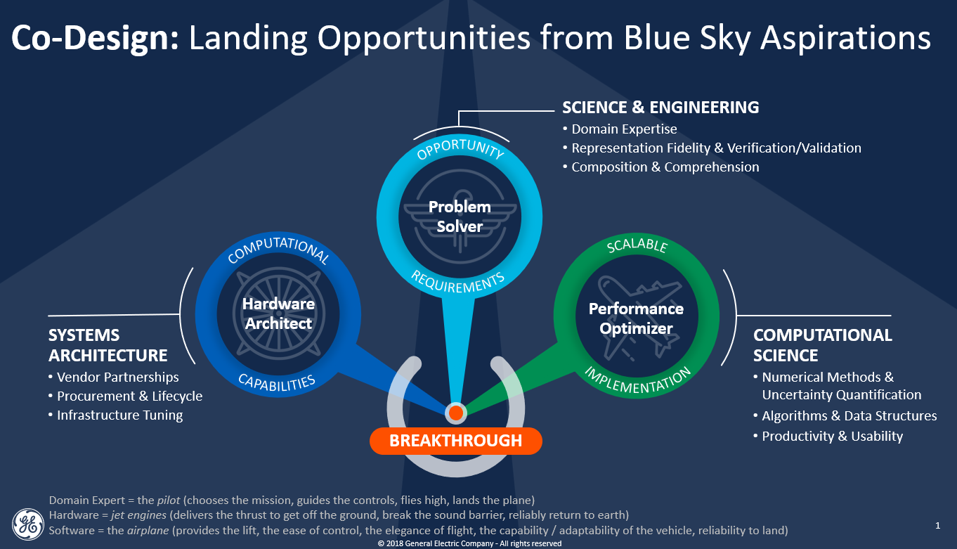
  - Breakthrough Application Paradigms:
    - More geometry, more system
    - More fidelity, more physics
    - Wider parametric exploration
    - Statistical Convergence
  - Breakthrough Software Scalability:
    - Algorithms, Libraries & Runtimes
    - Data Management, Visualization, Machine Learning & Automation
  - Breakthrough Hardware Capabilities:
    - Cost-effective Capacity & Capability (Computation and Storage)
    - High-Performance Bandwidth, Latency, Concurrency & Acceleration
- Science & Engineering Domain Expertise
  - Compose representation and application (model, simulation, analytics)
  - Determine threshold fidelity and confidence required for impact
  - Comprehend solution space (visualization, parametric trade-off space)
- Computational Science Software Expertise
  - Performance-portable programming model and tuning toolchain
  - Processing and I/O optimization via algorithm, data structure, numeric methods
  - Reuse and productivity workflow, automation, provisioning, libraries and tools
- Hardware Systems Architecture Expertise
  - Influence and adapt technology roadmaps through vendor partnerships
  - Prototypes/hardware emulators, hardware-targeted toolchain readiness
  - Procurement specification and capability/cost trade-off assessment
- Key points:
  - Co-design is a practice through which applications can break through perceived limitations of their present implementation.
  - The problem solvers are domain experts who
    - compose the problem statement,
    - specify needed fidelity and confidence in the solution, and
    - what is critical to comprehend from the solution to communicate to decision-makers.
  - The hardware architects continually procure and invest in infrastructure matching the value-to-cost opportunities based on the evolving workloads run across systems.
  - The computational scientists
    - apply numerical methods in algorithms and data structures,
    - implemented in software to optimize performance, and
    - packaged to improve the productivity of users.
  - Each field of expertise advances on its own and it can be difficult for one to opportunistically harness innovations in the others.
  - Rather than over-conservatively pre-supposing the limitations or requirements of the other fields, co-design unifies these stakeholders into a collaborative effort.
    - Problem solvers can advise on acceptable and valuable trade-offs between scale, fidelity, confidence and turnaround time.
    - Computational scientists can then explore a wider set of alternatives for implementation, with improved clarity of value.
    - Hardware architects can similarly offer trade-offs and guide implementations and vendor roadmaps toward overcoming performance bottlenecks and resource constraints.
  - Continually mutually challenging each others’ assumptions, co-design strategically aligns innovation with valuable opportunities.
- See also: Co-Design Web (maturity evaluation tool)
Modeling Literacy & Engineer of the Future (e.g., learning rubric)
- https://asc.llnl.gov/sites/asc/files/2020-06/ASC_Co-design.pdf
  - 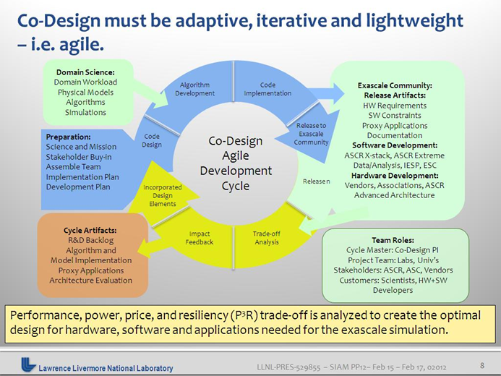
- https://doi.org/10.2172/1822198 (Reimagining Codesign for Adv Scientific Comp)
- https://www.exascaleproject.org/research-group/co-design-centers/
  - Co-designed computational motifs are a foundational element of ECP, with the goal of distilling common components and practices spanning computing and communication patterns.
  - Re-use of these components and learnings improve capability, consistency and confidence.
  - Co-design aims to make breakthroughs possibly by way of disciplined integration of:
    - co-evolving software from a diverse ecosystem into a coherent stack with
    - emerging hardware also co-evolving to meet software application needs,
    - applied within a set of explicit mission-driven impact domains.
  - This co-design process must balance application requirements with
constraints imposed by the hardware and what is feasible in the software stack to facilitate performant Exascale applications
  - 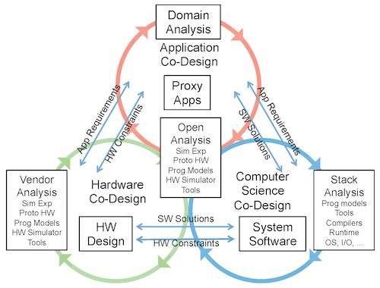
  - 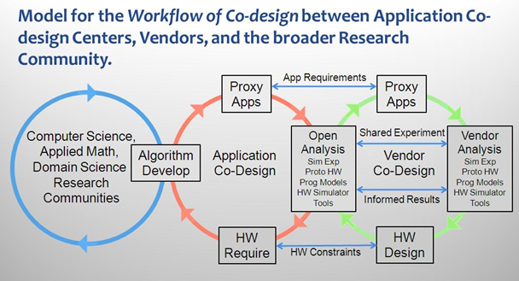

Role of Organization Strategy and Culture

Defining a Digital Culture
Consider the notion that a digital culture is the output of conducting digital transformation. Digital transformation, as defined by…. To further elucidate what is enabled by conducting digital transformation, consider what would happen by supporting the exact opposite: analog preservation. On a high-level, Tamplin argues that analog preservation would constitute of choosing complete conformity over flexibility, removing transparency and obfuscating data, applying change only top-down, ignoring standardization, disable automatic/autonomous processes, and if absolutely, only digitize analog information.
In principle, a digital culture would inhabit many, if not all, of the aspects of operation that analog preservation would not. As a result, a digital culture encompasses the values, behaviors, and practices required for establishing proficiency and fluency by adopting and utilizing evolving digital technologies and tools by fostering a shared strategy of continuous learning, adaptability, agility, collaboration, standardization, traceability, transparency, and accountability.
It is important to note that establishing a digital culture does not automatically mean analog preservation is completely inutile. A digital culture should leverage analog and digital practices in a manner that enhances their collective accessibility, traceability, usability, and maturity. Mankind has utilized analog preservation since its own inception, and it still encompasses how many individuals think. Part of incorporating analog practices is conducting digitization of said analog practices. However, digitization is only a part of having a digital culture – one cannot conduct solely digitization of analog materiel and claim to have a digital culture. When it comes to completing a digital culture, it is best to consider the following principle: the operational capabilities and culture that got an organization here are not all the transformation capabilities and culture to get or keep the organization there.

A Future Engineering Singularity (or Asymptote) Driven By Your Digital Culture Ian Marks
- Machines can handle much higher levels of complexity than human beings – how will this teaming relationship impact intellectual debt and human agency?
- What to be mindful of to avoid becoming overly reliant/complacent? Best practices for human-machine teaming
- How much AI is too much AI?
- Impacts on safety-critical, highly-reliable systems?
- Consider pessimistic/optimistic scenarios and pitfalls and considerations of both

Aligning UI/UX with Business Goals
Bala, Chad, Ian, Marlon, Abhi
Chad
- Business strategies, top three imperatives
- What are the requirements from SMEs and users
- Converting requirements to loq fidelity wireframes
- Reintegratingwith community to finetune and create a high fidelity wireframe
Bala
- Agrees with above, but must consider what several different kinds of stakeholders need much more generic
- Oriented more around user research and contextual interfaces
- Businesschallenge is to make sure everyone is as delighted with what they get as possible in a generic, optimized manner
Marlon
- UX encompassed within everything
- Good to approach from a design thinking, user-centric approach
- Everything mustcome back touser needs
- Ensure there is a clearly defined problem
Ian
- Question is: how to communicate results to inform decisions in a clear, succinctmanner
- Explainability of UI

What do we expect of our users?
- High levels of engagement
- Continuous check-in along life cycle
- Aim to identify least-common components and outputs to share between software/hardware systems (optimized transferability again the whole suite of possible outputs)
- Further weight against criticality of workflows (consider the 80/20 rle)
- Consider Nielsen-Norman, industrial design standards
What do we expect of our vendors?
- Provided technologies should always be operational
- Lean towards standardization and traceability of objects as an important element of a good UI
- Consistency from the vendor with respect to product support, feedback loop for continuous improvement
UI/UX should be included in the requirements stage, not in the middle or at the end.
What is a sample cutset of requirements for a good UI/UX?
- Flexibility to scale
- Modularity
- Reusability
- Traceability
- Usability
- Accessibility (with respect to people’s disabilities, e.g., color, font, typography, three-click rule)
- Determine what canbe fixed by good UI/UX vs. what can be avoided?
- Interaction design for users
- Highlight requirements driven by user needs
- Consistency

