
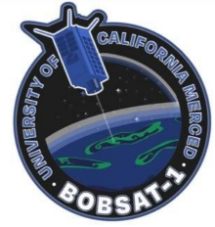

Controls

Table of Contents
- Purpose
- Positioning

Purpose
Goes over everything regarding the Controls of the system

Guidance
“How do I get there?”

Navigation
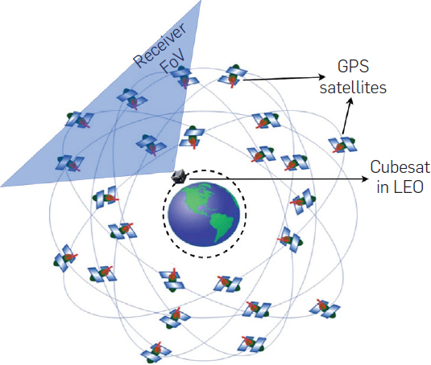
Global Navigation Satellite System (GNSS) aka GPS:
Similar to how your phone can know your location, the satellite uses a similar, although lower power, receiver to know its exact position. These satellites are in a farther orbit, and receiving multiple signals from these satellites gives our satellites position.
https://cacm.acm.org/research/hummingbird/

Conclusion

Last Known Author(s)

Name: Zander Abid
Email: zabid@ucmerced.edu
Date last Edited: 2/6/2025

