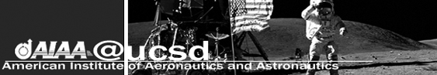
Fall Quarter 2006, Issue 1 Thursday, September 28, 2006

Welcome to AIAA at UCSD!
This year is going to be a great year for our club and its members, old and new. Current plans include the enhancement of pre- professionalism through association with the San Diego section, as well as numerous networking opportunities with aerospace companies. Furthermore, we look forward to the continued success of the DBF and AUVSI teams. The continued development of a rocket project will also be a highlight of this year’s activities. This year’s AIAA student board is hard at work to bring the excitement of aerospace to UCSD. We are looking forward to this year and hope you will become a part of AIAA at UCSD!
Jenny Rhymer
Chair

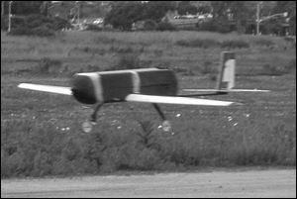
Design, Build, Fly!
DBF is starting up again! Find out more how you can: get leadership skills, meet fellow engineering students, get hands on work experience in composites, and have fun! Hope to see you there!
Jeremy Stromsoe
DBF Project Manager
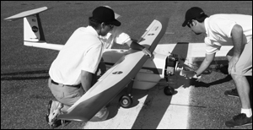
AUVSI UAV Project
AUVSI is a student run project under the AIAA that engineers and flies a UAV (Unmanned Autonomous Vehicle). The competition we work all year preparing for is held in Maryland in the summer. In our rookie season this past year, UCSD placed 5th out of the 22 enrolled teams. The objective of the competition is to take-off and transition the aircraft to autonomous flight having the aircraft fly to specified waypoints and autonomously identify targets on a field. This past year our competition package included an aircraft and a Piccolo autopilot. This upcoming year we plan to add an onboard computer to analyze targets, a gimbal to stabilize an onboard camera and a dynamic wireless link between the ground station and the aircraft. We also have an active resume database which we distribute to our top sponsors. We are hopping to attract students to both teach us and to learn along with us. RC enthusiasts will be more than welcomed☺. Come and get a taste of engineering with AUVSI at UCSD.
Morgan Machado
AUVSI Project Manager
First AUVSI GBM: Tuesday, October 3, 2006
7:00pm, Location TBA
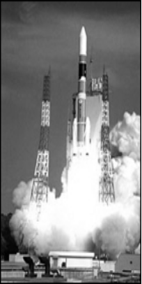Rocket
Interested in rockets? Want to win the next X-Prize? Then the UCSD Hybrid Rocket Project is for you! This is the first year AIAA is supporting a rocket project. Our goals for this year are to design and build a hybrid rocket capable of carrying a 10 pound payload up to 10,000 feet in the air and to enter a competition taking place in Utah next year. We are currently pursuing a corporate sponsorship and looking for industry mentors. This promises to be an exciting, hands-on experience, so contact us if you have any questions or want more information!
Samina Bhatia
Rocket Project Manager

Out-of-this-World AIAA Scholars
Congratulations to Stephanie Sukhram, Nadia Cheng, and last year’s AUVSI Project Manager, David Klein for receiving the 2006 Reuben H. Fleet Scholarship! Scholarships are presented to 8 AIAA student members from UCSD or SDSU that demonstrate scholarship, promise, and excellence in character.

Upcoming Events
OCTOBER
- Miramar Airshow & BBQ
Saturday, October 14, 2006
- JPL Info Session and Interviews
Monday, October 16 - Tuesday, October 17, 2006
- X-prize Cup
Friday, October 20 - Saturday, October 21, 2006
Las Cruces, New Mexico
- A Tour to JPL
Friday, October 27, 2006
1:00pm-3:00pm
- Edwards AFB Airshow
Saturday, October 28 - Sunday, October 29, 2006

NOVEMBER
- 2nd General Body Meeting
Panel Discussion
Tuesday, November 14, 2006
7:00pm, Location TBD
- Convair Wind Tunnel Trip
Thursday, November 16, 2006
5:00pm

Meeting Agenda  - Introductions of the Board  - A Word from the UCSD Faculty Advisor: Dr. Nomura  - Greg Marien, SD Professional Chapter Chair  - AIAA Design/Build/Fly Competition  - Rocket Project  - AUVSI UAV Project  - Upcoming Events | E-mail us with questions or ideas: aiaaucsd@ucsd.edu  Check the website regularly! – http://acs.ucsd.edu/~aiaaucsdu/
2006-2007 Officers
Position | Name | E-mail
Chair | Jenny Rhymer | jrhymer@ucsd.edu
Vice-Chair, Internal | Betty Chuong | bettychuong@hotmail.com
Vice-Chair, External | Nadia Villalobos | nvillalo@ucsd.edu
Treasurer/ Rocket Project Manager | Samina Bhatia | sabhatia@ucsd.edu
Secretary/Webmaster | Irene Chan | ichan@ucsd.edu
TESC Representative | Timothy Havard | timwillhav@gmail.com
DBF Project Manager | Jeremy Stromsoe | nofearjer1@msn.com
AUVSI Project Manager | Morgan Machado | mrmachad@ucsd.edu

