UNIVERSITY OF CALIFORNIA, SAN DIEGO

Proposal Phase Design Report

Submitted March 13, 2001

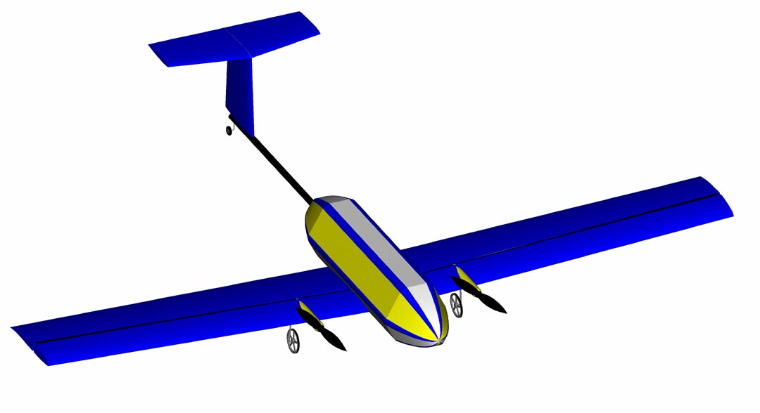
TLAR II
Table of Contents
1 Executive Summary 2
1.1.1 Objectives 2
1.1.2 Analytical Tools 2
1.1.3 Conceptual Design Phase Outline 2
1.1.4 Preliminary Design Phase Outline 2
1.1.5 Detail Design Phase Outline 2
2 Management Summary 2
2.1.1 Team Architecture 2
2.1.2 Task Scheduling 2
2.1.3 Milestone Chart 2
3 Conceptual Phase 2
3.1 Stage I – Feasibility Analysis 2
3.1.1 Airfoil 2
3.1.2 Wings 2
3.1.3 Empennage 2
3.1.4 Fuselage 2
3.1.5 Landing Gear 2
3.1.6 Propulsion and Power System 2
3.1.7 Structural System 2
3.1.8 Conceptual Design Phase – Stage I Summary 2
3.2 Stage II – Generalized Analysis 2
3.2.1 Wings 2
3.2.2 Empennage 2
3.2.3 Fuselage 2
3.2.4 Landing Gear 2
3.2.5 Propulsion and Power System 2
3.2.6 Structural System 2
3.2.7 Conceptual Design Phase – Stage II Summary 2
4 Preliminary Design Phase 2
4.1.1 Wings 2
4.1.2 Empennage 2
4.1.3 Fuselage 2
4.1.4 Landing Gear 2
4.1.5 Propulsion and Power System 2
4.1.6 Structural System 2
4.1.7 Preliminary Design Phase Summary 2
5 Detail Design 2
5.1 General Sizing 2
5.1.1 Weight Estimate 2
5.1.2 Wing Performance 2
5.1.3 Motor Thrust Available 2
5.2 Flight Performance Calculations 2
5.2.1 Takeoff Performance 2
5.2.2 Rate of Climb 2
5.2.3 Turning Radius 2
5.2.4 Range and Endurance 2
5.2.5 Static Stability 2
5.2.6 Systems Architecture 2
5.2.7 Detail Design Summary 2
5.3 Drawing Package 2
5.3.1 Three View 2
5.3.2 Structural Component Dimensions 2
5.3.3 Flight Component Dimensions 2
5.3.4 Conceptual Configurations 2
5.3.5 Detailed Confguration, Tennis Ball Packing, and Flight Equipment Location 2
6 Manufacturing Plan 2
6.1 FOM Reasoning/Discussion 2
6.2 Component Manufacturing Description 2
6.2.1 Spar Structure 2
6.2.2 Wing Joiner 2
6.2.3 Wing Joiner Carrier Box 2
6.2.4 Torsion Rod 2
6.2.5 Wing Airfoil 2
6.2.6 Wing Cores 2
6.2.7 Spar Assembly 2
6.2.8 Wing Skins 2
6.2.9 Final Wing Assembly 2
6.2.10 Stabilizers 2
6.2.11 Main Landing Gear Strut 2
6.2.12 Gear Blocks 2
6.2.13 Wheels 2
6.2.14 Tail Landing Gear 2
6.2.15 Speed Loaders 2
6.2.16 Fuselage 2
6.2.17 Boom 2
6.3 Assemblies 2
6.3.1 Wing Core Assembly 2
6.3.2 Wing panel Assembly 2
6.3.3 Boom Assembly 2
6.4 Manufacturing Timeline 2
7 Proposal Phase References 2

List of Figures
Figure 2-1 Milestone Chart 2
Figure 6-1 Manufacturing Timeline 2

List of Tables
Table 1-1 Final Design Specifications 2
Table 2-1 Team Member Profiles and Assignment Areas 2
Table 3-1 Design Parameter FOM analysis – Stage I 2
Table 3-2 Design Parameter FOM Analysis – Stage II 2
Table 5-1 General Sizing 2
Table 5-2 Systems Architecture 2
Table 5-3 Flight Performance Data 2

Executive Summary
Student members of the American Institute of Aeronautics and Astronautics (AIAA) at the University of California, San Diego designed and built a remote-controlled aircraft for the 2001 AIAA Design/Build/Fly Competition to apply and broaden their knowledge of aircraft design and manufacture.
Certain design aspects of the aircraft were dictated by restrictions imposed by the rules of competition, but within those restrictions, there was freedom for individualized design of a remote controlled electrically powered aircraft. The aircraft must fly sorties consisting of a light, high volume payload alternating with a heavy, low volume payload. The high volume payload is limited to no fewer than 10 and no more than 100 tennis balls, while the high weight payload is comprised of at least 5 lbs. of steel. It must also have a take-off distance of less than 200 ft., a wingspan of no more than 10 ft., and a total dry weight of less than 50 lbs. The power limitations dictate that the aircraft use less than 5 lbs. of batteries.

Objectives
In order to meet these requirements, the team first established a set of design goals that the final aircraft configuration should meet. To maximize the score, it was decided to design the aircraft to carry a maximum of 20 lbs. of steel, 100 tennis balls, and cruise at 60 MPH. Ideally, the aircraft would complete three light and two heavy sorties within the time allotted, while meeting the functional requirements of the design as specified by the rules stated above.
Experience gained from the previous year’s entry, “TLAR I”, was beneficial in designing the new aircraft. This year, the team began the project with a better overall understanding of the design process, materials, design trade-offs and time constraints. This experience and knowledge, coupled with the Figures of Merit (FOMs) and design parameters, enabled the team to work more efficiently and effectively.

Analytical Tools
Several analytical tools were used throughout the entire design process. The most important was Microsoft Excel, which was used for everything from calculations of weight-and-balance, number of sorties expected, climb rate, take-off distance, and turn radius, to financial analysis and Rated Aircraft Cost (RAC). General aviation design principles and equations were used in determining exact dimensions and specifications. The mathematical toolbox, Matlab 5.1, was used to perform numerical analysis of flight performance of the chosen wing configuration. Finally, the programs AutoCAD 2000 and PRO/E 2000i were crucial tools used to visualize and present aircraft design ideas.
FOMs and Design Parameters were chosen to provide requirements to ensure that the design would meet the functional requirements dictated by the contest administrators, as well as the design goals as defined by the UCSD AIAA team. They were applied to each stage within the entire design process to analyze the strengths and weaknesses of each component as well as those of the overall aircraft configurations. The design process used to determine the final configuration began with the Conceptual Design Phase (CDP). Next was the Preliminary Design Phase (PDP) followed by the Detail Design Phase (DDP), from which emerged the final configuration of the aircraft.

Conceptual Design Phase Outline
The CDP consists of two stages, Stage I and Stage II. Stage I incorporates a range of ideas for each component that was considered. The FOMs of Stage I were geared towards eliminating ideas that were intuitively and/or obviously impractical. These FOMs centered on material availability, handling characteristics, RAC, ease of transportation and complexity of manufacture in relation to time and skill level required. Stage I analysis resulted in component concepts that were determined to be viable. These components were assembled into three different configurations that initially met the design parameters and FOMs. The three configurations were then progressed into Stage II.
The goals of applying Stage II FOMs were to maximize the overall flight score, minimize the RAC, and develop a preliminary aircraft design. Stage II FOMs focus on an in depth analysis of the components, with specific attention to payload access, construction feasibility, propulsion and maximizing strength to weight ratios, operator and component safety, difficulty of repairs, component and interfacing strength, and payload capacity. The analysis of Stage II resulted in a single overall design configuration, at which point, the question was raised of whether it met the functional and design goal requirements. If it was determined that the configuration met these requirements, it continued into the PDP. Otherwise, it was reiterated through Stage II of the CDP in an attempt to optimize the configuration with alternate component designs.

Preliminary Design Phase Outline
Once an overall design configuration was decided upon, the next step was to conduct a more thorough and detailed analysis of the configuration using the PDP FOMs. The main purpose of the PDP was to optimize sortie performance, RAC, and structural integrity of each component individually, and as part of the entire configuration. Specific design parameters, such as sizing, materials, connection interfaces, and exact location of each part within the assembly were also determined. These, combined with optimization of power requirements, led to a complete detailed aircraft configuration.

Detail Design Phase Outline
The DDP was less focused on actual aircraft configuration design as compared to the previous two phases. The focus in this section was on determining the flight performance of the detail configuration to discern whether or not the design met the functional requirements. To complete these calculations the team made use of performance analysis techniques suited to propeller driven general aviation and radio controlled aircraft. These techniques were validated by the previous year’s design, “TLAR I” and used to determine characteristics such as takeoff distance, turn radius, stall speed and sortie times.
Though manufacturing related FOMs had been applied to eliminate ideas throughout the both the Conceptual and Preliminary Design Phases, in the Manufacturing Phase, each component underwent a rigorous investigation as to the best method of construction possible. Specific FOMs were developed to take into consideration the restrictions of skill level, availability of materials and machinery as well as time constraints and cost.
The final product of the design process was a configuration in which each component satisfied the contest functional requirements, design goals as well as the FOMs of each category. The resulting design was a simple, two-engine, single fuselage, low mono-wing aircraft with a 10 ft. wingspan and a 74 in. nose-to-tail length. The specific details of the aircraft are given in Table 1.1.
Table 1-1 Final Design Specifications
Design Parameter | Specification
Aircraft Dry Weight | 19.6 lbs.
Light Payload Capacity/Weight | 100 Tennis Balls/12.85 lbs.
Heavy Payload Capacity/Weight | Steel/15 lbs.
Main Wing Configuration | Low Mono-Wing
Main Wing Airfoil | Eppler-214
Wing Span | 10 ft.
Length | 74 in.
Motor | Graupner Ultra 3300/7 (x2)
Rated Aircraft Cost | 6.54
Final Flight Score | 98.1

Management Summary

Team Architecture
The 2001 UCSD Design/Build/Fly project team consisted of sixteen undergraduates with diverse backgrounds. At the first general project meeting, an open discussion took place on how to best approach the task. The project manager, Andrew Mye, discussed the importance of utilizing the strengths of each member while emphasizing the importance of equal contributions to the project in order for success to be achieved. The team was broken down into the various subgroups of wings, tail, airfoil, fuselage, structural system, landing gear, propulsion & power plant and fundraising. The team member profiles and assignment areas are shown in Table 2.1.
Table 2-2 Team Member Profiles and Assignment Areas
Name | Year | Major | CAD Programs |  |  | Matlab | Technical Writing | Machining | Assignment  Area
Name | Year | Major | Pro/Engineer | AutoCAD | SolidWorks
Andrew Mye | Sr | ME | x | X | x | x | x | x | Structural system, Fuselage
Justin Smith | Sr | AE | x | X | x | x | x | x | Empennage, Propulsion & Power Plant
Kari Goulard | Sr | ME | x | X |  | x | x | x | Landing Gear
Guy Watanabe | Sr | AE |  | X | x | x | x | x | Wings
Maziar Sefidan | Sr | ME |  | X |  | x | x | x | Landing Gear
Joshua Adams | Sr | ME |  | X |  | x | x | x | Empennage
Joshua Hu | Sr | AE |  | X |  | x | x | x | Airfoils
Chad Valenzuela | Jr | AE | x | X |  |  | x |  | Airfoils
Annie Powers | So | AE |  | X |  | x | x | x | Wings, Fundraising
Mark Shtayerman | So | AE |  | X |  |  |  |  | Wings
Tyson Wooten | So | AE |  | X |  | x |  |  | Fundraising
Gregory Burton | So | ME |  | X |  | x |  |  | System Architecture
David Tamjidi | So | BE |  | X |  | x |  |  | System Architecture
John Moretti | Fr | AE |  | X |  | x |  |  | Fundraising
Andrew Tchieu | Fr | AE |  | X |  |  |  |  | Fundraising
Weekly meetings were set in which the team could discuss design ideas, obstacles and possible alternatives for further optimization. Each meeting was documented in order to keep everyone up-to-date and ensure that progress stayed on schedule. This management structure provided an efficient means of accomplishing necessary goals, overcoming design challenges and subgroup collaboration. In addition, this structure was conducive to timely completion of each subgroup’s particular responsibility.

Task Scheduling
In early September, the group decided upon a schedule of completion dates. Each subgroup was expected to complete tasks by a certain deadline. The chart below (Figure 2.2) depicts the planned and actual dates of completion (D.O.C.) of each major event. Problems that were encountered completing these tasks were quickly resolved through teamwork and subgroup collaboration. The subgroup dependencies were as follows
Flight Characteristics & Performance:
Airfoil ⇔ Wings ⇔ Empennage ⇔ Propulsion & Power Plant
Component Interfaces:
Wings ⇔ Structural System ⇔ Fuselage ⇔ Empennage
Structural System ⇔ Landing Gear

Milestone Chart
Figure 2-1 Milestone Chart
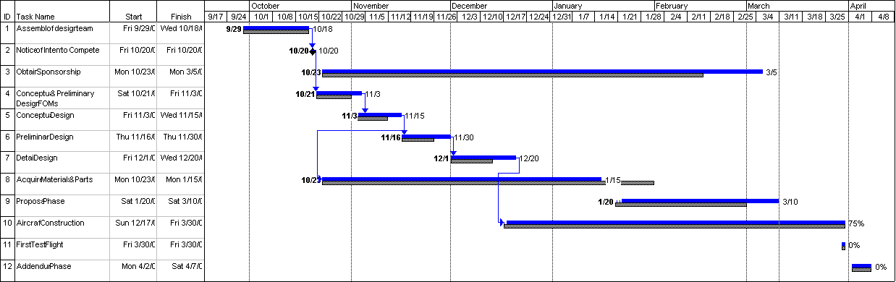

Legend: Grey dotted lines = Proposed duration of task. Proposed start and finish dates are indicated in the cells on the left.
Blue solid lines = Actual duration of task. Actual start and finish dates are indicated on both ends of line.
Percentage = Percentage of task completed.

Conceptual Phase

Stage I – Feasibility Analysis
Table 3-3 Design Parameter FOM analysis – Stage I
 |  | Figures of Merit – Stage I (x weighting)
 |  | Ease of Manufacture (x2) | Material Availability (x1) | Strength to Weight Ratio (x2) | Handling Characteristics (x1) | Ease of Transportation (x1) | Rated Aircraft Cost (x1) | Cost (x1) | Motor Power Limitations (x1) | Thrust Ratings (x2) | Motor Installation Flexibility (x1) | Sum of Ratings | Decision
(-) - Not Applicable
(r) - Rejected
(K) - Kept
Design Parameters – Stage I
Wing Configuration | Low | 1 | - | - | 0 | 0 | 0 | 0 | - | - | - | 2 | K
Wing Configuration | Mid | -1 | - | - | 0 | 0 | 0 | 0 | - | - | - | -2 | r
Wing Configuration | High | 1 | - | - | 0 | 0 | 0 | 0 | - | - | - | 2 | K
Wing Configuration | Bi-plane | 0 | - | - | 0 | 1 | -1 | 0 | - | - | - | 0 | K
Wing Planform | Delta | -1 | 0 | -1 | -1 | 0 | -1 | 0 | - | - | - | -6 | r
Wing Planform | Elliptical | -1 | 0 | 1 | 1 | 0 | 1 | 0 | - | - | - | 2 | r
Wing Planform | Rectangular | 1 | 0 | 1 | 1 | 0 | 0 | 0 | - | - | - | 5 | K
Airfoil | SD7003 | 0 | - | - | -1 | - | - | - | - | - | - | -1 | r
Airfoil | SD7037 | 0 | - | - | -1 | - | - | - | - | - | - | -1 | r
Airfoil | E214 | 1 | - | - | 1 | - | - | - | - | - | - | 3 | K
Structural System | One Piece | -1 | - | - | - | -1 | - | - | - | - | - | -3 | r
Structural System | Two Piece | 0 | - | - | - | 0 | - | - | - | - | - | 0 | K
Structural System | Three Piece | 0 | - | - | - | 0 | - | - | - | - | - | 0 | K
Structural System | Strut Braced | -1 | - | - | - | 0 | - | - | - | - | - | -2 | r
Structural System | Bending Beam | 0 | - | - | - | 0 | - | - | - | - | - | 0 | K
Structural System | Ring Frame | 0 | - | - | - | 0 | - | - | - | - | - | 0 | K
Tail Structure | Conventional | 1 | - | - | 1 | - | 0 | -1 | - | - | - | 2 | r
Tail Structure | Canard | -1 | - | - | 0 | - | -1 | -1 | - | - | - | -4 | r
Tail Structure | T-tail | 1 | - | - | 1 | - | 0 | 0 | - | - | - | 3 | K
Tail Structure | Cruciform | 0 | - | - | 0 | - | 0 | 0 | - | - | - | 0 | r
Tail Structure | V-tail | 1 | - | - | -1 | - | 0 | 0 | - | - | - | 1 | r
Tail Structure | Inverted V-tail | 1 | - | - | 1 | - | 0 | 0 | - | - | - | 3 | K
Tail Structure | H-tail | -1 | - | - | 1 | - | -1 | -1 | - | - | - | -3 | K
Fuselage Structure | Trusses | -1 | - | 0 | 1 | 0 | - | 1 | - | - | - | 0 | r
Fuselage Structure | Monocoque | 1 | - | -1 | -1 | 0 | - | 0 | - | - | - | 0 | r
Fuselage Structure | Semi-monocoque | 0 | - | 1 | 1 | 0 | - | 0 | - | - | - | 3 | K
Landing Gear | Tail-Dragger | 1 | - | - | 1 | - | - | - | - | - | - | 3 | K
Landing Gear | Tricycle | 0 | - | - | 1 | - | - | - | - | - | - | 1 | K
Landing Gear | Bicycle | -1 | - | - | 0 | - | - | - | - | - | - | -2 | r
Landing Gear | Quadracycle | 0 | - | - | -1 | - | - | - | - | - | - | -1 | K
Power Plant | 1 motor 19 cells | - | - | - | - | - | - | - | 1 | -1 | 1 | 0 | r
Power Plant | 1 motor 38 cells | - | - | - | - | - | - | - | 0 | 1 | 1 | 3 | K
Power Plant | 2 motors/19 cells ea. | - | - | - | - | - | - | - | 1 | 0 | 0 | 1 | K
Power Plant | 2 motors/38 cells | - | - | - | - | - | - | - | 0 | 0 | 0 | 0 | r
The purpose of Stage I was to apply FOMs to eliminate and analyze concepts for aircraft components that were proposed during brainstorming sessions at the beginning of the design process. The goal was to produce a set of desirable components to incorporate into three conceptual aircraft designs. The Stage I FOMs consisted of five primary areas. First, material availability required that any material not commercially available or unreasonably expensive be ruled out. Second, handling characteristics were used to eliminate concepts that were initially thought to have poor ground or flight performance. Third, designs that did not promote ease of transportation were dismissed from consideration. The fourth consideration for Stage I was simplicity and tooling. Simple structures are easier to analyze and build without necessarily losing functionality or performance characteristics. These guidelines established a solid set of conceptual components to consider for the aircraft.

Airfoil
When choosing an airfoil, the lift to drag ratio was the most important feature to be considered. For the final design, an aircraft constrained by take-off distance, an airfoil that maximized lift while minimizing drag was necessary. Three airfoils were analyzed in order to obtain their respective coefficients of lift and drag. The three airfoils considered were SD7003, SD7037 and E214. When calculating the C_{L} and C_{D} coefficients, a Reynolds number of between 200,000 and 300,000 was considered, which was determined by an average cruise velocity of 60 MPH.
The maximum lift and drag coefficients calculated for airfoil SD7003 were 0.79 and 0.0142, respectively. The maximum lift and drag coefficients calculated were 0.78 and 0.012, respectively, for airfoil SD7037. For the E214, the maximum lift and drag coefficients were found to be 1.43 and 0.017, respectively. While the SD airfoils have excellent drag values, they fall short of the Eppler airfoil with regards to maximum lift. The lift created by this airfoil was determined to be sufficient for the application of flight given the 200 ft. takeoff distance limit.
An added benefit in choosing this airfoil was that it was used in the design of last year’s aircraft and preformed well. Also, the templates for this airfoil were kept from last year and reduced tooling time and cost.

Wings
The wings are a primary defining characteristic of an aircraft. In this year’s design, they were optimized to the role of the aircraft’s flight objectives. Other primary, secondary and tertiary structures were designed around the general wing structure. In this design process, there were limitations imposed by contest rules, flight conditions, and structural feasibility. The initial design parameters being investigated were wing configuration and wing planform. The available wing configurations included a bi-wing and a high, mid, and low placement mono-wing. The considered wing types were delta, elliptical, and rectangular. The intent of the Stage I wing analysis was to eliminate design parameters based on FOMs to determine their applicability to the design goals. FOMs that were used consisted of handling characteristics, RAC, ease of transportation, and complexity of manufacture.

Transportability
Transportation was a major concern that needed to be addressed early in the design phase. All parts had to be sufficiently compact to be transported via air. The wings of the aircraft, with a maximum wingspan of 10 ft., would require a box inconveniently large and costly to ship. Thus, it was determined during Stage I that the wings would have to be constructed in at least 2 (half-span) parts.

Wing Configuration
The wing configurations presented as options represented the traditional configurations that were well documented. One of the basic limitations was that the payload was to be carried within the fuselage. Thus the mid-wing was immediately eliminated as it would restrict the useable fuselage volume and complicate the construction of a speed loader. The other configurations would not pose this problem and were therefore left for further analysis.

Wing Planform
Delta: A delta wing was eliminated immediately as a design possibility due to the fact that it is optimized for transonic and supersonic flight.
Elliptical: Elliptical wings, which feature a constantly varying chord length, were eliminated due to their difficulty of manufacture.
Rectangular: Only a rectangular wing satisfied the initial set of FOMs and was selected for further analysis in Stage II.

Empennage
The tail surfaces of TLAR II will be referred to as empennage, and are an essential part of an aircraft’s control and stability. The primary function of empennage is crucial to the operation of the aircraft and must be subjected to the most critical and fundamental FOMs.
Existing empennage configurations were selected from documented styles. They were analyzed based on the experience of the team members gained in last year’s competition and through application of basic FOMs. The goal of the first stage of the CDP was to complete the analysis of proven empennage configurations so as to select three designs to investigate further in the second stage.
The purpose of empennage is to provide stability, and pitch/yaw control. The three main FOMs were handling characteristics, RAC, and ease of manufacture. Other FOMs, such as material availability, ease of transportation, and reparability were not considered explicitly in this section, as the materials of all designs were understood to be the same, and the types of tails were assumed to be equally transportable and repairable.

Tail Configuration
Canard: A canard configuration would reduce the required control surfaces at the rear of the aircraft to a single vertical stabilizer. The benefit of a reduction in control surfaces at the rear, however, would be negated by the complexity of both pitch and roll capabilities integrated into the aileron control. While this configuration had benefits that included main wing stall prevention and less control surface actuators, the design, analysis and fabrication was complex and was eliminated for these reasons.
Conventional: Major benefits of a conventional design were ease of construction and lightweight design. However, the low placement of the horizontal stabilizer usually puts it in the wake of the main wing, “washing out” the airflow over the horizontal stabilizer and rendering elevator control ineffective. This configuration was eliminated due to its poor efficiency, susceptibility to damage and loss of control.
”T”: The most important benefit of the “T”-Tail design is that the horizontal stabilizer is above the turbulence from the body and main wing, thus allowing the horizontal control area to be reduced. It also acts as an endplate for any control deflections caused by the vertical fin, which increases the vertical fin’s efficiency and allows a reduction in the fin’s area. This allowed a large reduction in weight and the “T” style tail was deemed the first design to be considered in Stage II.
Cruciform: The fourth concept examined was the cruciform design, a hybrid of the Conventional and the “T”-Tail. It was determined that this style shared several benefits of both, but was difficult to construct and the end plate effect from the “T” was lost. For those reasons, this design was eliminated.
“V”: The next configuration investigated was the “V”-Tail design, which was efficient because it eliminates one wing tip vortex, decreasing induced drag. The design was discarded due to its many disadvantages, including high control surface complexity, and an induced opposite roll when given rudder input.
Inverted “V”: The inverted “V”, by contrast, produces favorable yaw-roll coupling. Elevator control was less affected by turbulent wake from the fuselage and main wing, and the use of only two control surfaces reduced the number of servos needed for both rudder and elevator control. This design had bad ground clearance and complex control surface design. However, it was kept for further analysis because of the good turning characteristics and the reduced drag of one less wing tip vortex.
“H”: This was deemed a good design, as turbulence from the fuselage does not flow around the vertical fins. The vertical fins also prevent spillover of the elevator with an end plate effect, therefore eliminating drag from tip vortices induced by elevator input. Although this design is complex, it was kept for further analysis as it worked well with a twin-body design.

Fuselage
The fuselage serves as a primary structure of the aircraft and acts as a critical load path for the aircraft to transmit forces between the tail and wings, in addition to housing flight equipment and payload. Design of the fuselage is somewhat dependent on the design of the wing and tail because it links the components. The FOMs that were used to optimize the design parameter of structural reinforcement were ease of manufacture, strength to weight ratio, handling characteristics, and cost. The three types of fuselage structural reinforcement investigated were trusses, monocoque, and semi-monocoque.

Structural Reinforcement
Truss: A truss structure in the fuselage has a relatively good strength to weight ratio, but may interfere with the payload volume. Trusses are very difficult to manufacture, so it was immediately dismissed as means of reinforcement in the fuselage.
Monocoque: A monocoque design has good torsional strength, but it is weak in bending, which is the type of load transferred by the tail to the fuselage. The required skin thickness needed to support these bending loads would increase the weight significantly and therefore it was eliminated as a design parameter.
Semi-Monocoque: A semi-monocoque structure combines the torsional strength of the skin with bending strength that can be customized for the aircraft by means of stringers and ribs. This type of configuration allows the strength to be customized for specific loads. A semi-monocoque fuselage has the best attributes and was the choice for structural reinforcement of the fuselage.

Landing Gear
The functional requirement of the main landing gear is to absorb and dissipate landing loads effectively. The design parameters considered included tail dragger, quadracycle, bicycle and tricycle. During Stage I of the CDP various landing gear configurations were screened according to the established FOMs, such as ease of manufacture and ground handling characteristics.

Landing Gear Configurations
Bicycle: The bicycle landing gear configuration consisted of two in-line wheels straddling the CG of the fuselage and another wheel on each wing for balance. Due to complexity of manufacture and poor ground handling characteristics, the bicycle design was immediately eliminated.
Others: At this stage of the design, the remaining three landing configurations were all kept for further evaluation in Stage II.

Propulsion and Power System
The propulsion design began with little knowledge about the overall configuration of the aircraft, so the initial decisions related to propulsion choices were based on experience gained from last year’s project.
The amount of power available to propel the aircraft is dependent upon the total power of the system and the efficiency of the entire propulsion system. To maximize this number, given that the battery power was limited by weight restrictions, a maximally efficient engine/propeller combination was chosen. Optimizing the efficiency of the motor as well as motor configurations while lowering the REP was the goal of the propulsion design portion of the conceptual phase.
The battery weight restriction of 5 lbs. limited the number of battery cells to 38, which amounted to approximately 40 volts. For standard radio controlled propulsion systems, 40 volts exceeded the rated power of many motor possibilities. While a motor’s power is related to the input voltage, they can normally withstand higher voltages. Problems experienced in last year’s competition showed that this was not a desirable arrangement, yet it was determined that a single motor design was still a valid concept. Concerns for power as well as those regarding additional weight of this year’s design did necessitate that a dual-motor configuration also be proposed.
Dual-Motor: The dual-motor configuration featured the simple option of powering both motors with a single 38-cell battery pack or two separate propulsion systems, each with 19 cells. The concern with over powering the motors determined that the two separate packs was the most reliable configuration.
Single-Motor: Initially, due to concerns with overpowering the single motor, the single motor configuration was developed with a maximum of 19 cells connected to the motor. However, due to the lower thrust of this configuration, the single motor connected to 38 cells was considered instead. This design was included along with the dual-motor configuration for analysis in Stage II.

Structural System
The structural system was required to provide efficient “load paths” which resolve forces experienced during landing and flight sequences. The spar structure, which reinforces the wings, and the wing carry-through, which transmits the bending loads through the fuselage, are the two major components of the structural system. When considering viable structural configurations it was noted that several options placed constraints on other component design solutions. These affected components included the wing planform (swept and tapered), wing configuration (biplane, delta and monoplane) and fuselage parameters. Several of these concepts were analyzed during Stage I of the CDP to effectively meet the various requirements of the structural system. Various spar cross-sectional geometric shapes were also considered for each of the competing component designs. These included the box beam, hollow cylindrical, solid rectangular and I-beam cross-sections.
The primary objective of the Stage I screening process was to eliminate design concepts that were complex, difficult to transport, raised the RAC, or difficult to repair or replace. The structural system design ideas that remained following the application of the Stage I FOMs are as follows:
Spar Structure: Initial concepts that were considered were the one, two, and three piece spars. The only design that failed to satisfy the transportation and ease of manufacture FOMs was the one piece model and was therefore discounted. The remaining concepts are described in detail during the CDP Stage II.
Wing Carry-through: The strut braced concepts that were initially proposed were disposed of due to poor manufacturing and strength to weight ratio ratings. The remaining design concepts were the bending beam and ring frame carry-through models.

Conceptual Design Phase – Stage I Summary
The CDP Stage I was focused on the development of initial aircraft designs that feature various component concepts that were determined to have merits applicable to the mission goal. By the end of the first stage, concepts that were immediately discernable as inadequate had been eliminated. Any remaining concepts were combined into several configurations. These configurations would be evaluated further in the second stage of the CDP as to their individual component interactions and total system performance.
The decisions made when combining the components into complete configurations were somewhat arbitrary. However, each component that survived the first stage was examined to determine its ability to interact with other components. For example, it was immediately clear that an inverted V tail configuration could not be combined with a tail-dragger landing gear configuration. Equally obvious was the fact that an “H” tail configuration was well suited to a twin fuselage design. For each component, this process was done to piece compatible components together and develop three aircraft configurations.
The first configuration, designated “C-01”, featured twin fuselages mounted over a low mono-wing. The twin motor powerplant concept fit this configuration as well as the “H” tail concept. The tail dragger concept was modified to include two tail wheels and the payload was accessed through twin hinged hatches.
“C-02”, the second configuration employed a single fuselage with a high mono-wing concept. The high wing necessitated the use of the tricycle landing gear concept and allowed, due to the height of the fuselage, an inverted “V” tail mounted to a tail boom. The single motor mounted to the front of the fuselage also required that the payload access be from the rear of the fuselage.
“C-03”, the third configuration was built around the implementation of a bi-plane wing concept. For this concept, wing spacing was known to be a concern with regards to fuselage height and susceptibility to crosswinds. To reduce this weakness, the fuselage was split into to canted pieces, which fit very well with the application of the quadracycle landing gear concept. To allow the payload access on the front of the fuselage, the single motor powerplant was implemented in a separate nacelle mounted under the upper wing. The remaining tail concept was a “T” tail and was well suited to this configuration due to the raised position of the horizontal stabilizer away from the wake of the two main wings.
These designs were taken as the concepts examined in the second stage of the CDP. There, they are analyzed with regards to component interaction and initial flight characteristics while further determination of RAC and ease of manufacture was performed.

Stage II – Generalized Analysis
Table 3-4 Design Parameter FOM Analysis – Stage II
 |  | Figures of Merit – Stage II (x weighting)
 |  | Ease of Construction (x2) | Ease of Transport (x1) | Personnel Safety (x1) | Component Safety (x1) | Component Interactions (x2) | Sortie Performance (x2) | Difficulty of Repairs (x1) | Rated Aircraft Cost (x1) | Cost (x1) | Motor Aerodynamic Flow (x2) | Motor Access/Mounting Ease (x1) | Motor Cooling (x1) | Sum of Ratings | Decision
(-) - Not Applicable
(r) - Rejected
(K) - Kept
Design Parameters – Stage II
Wing Types | Low Mono-wing | 1 | - | - | - | 1 | 0 | 0 | 0 | 0 | - | - | - | 4 | K
Wing Types | Bi-plane | -1 | - | - | - | -1 | 0 | 0 | 0 | 0 | - | - | - | -4 | r
Wing Types | High Mono-wing | 1 | - | - | - | 0 | 0 | 0 | 0 | 0 | - | - | - | 2 | r
Wing Structure and Materials | Rib Structure | -1 | 0 | 0 | -1 | -1 | 0 | - | - | 1 | - | - | - | -3 | r
Wing Structure and Materials | Foam Core | 1 | 0 | 0 | 0 | 0 | 0 | - | - | 0 | - | - | - | 2 | K
Structural System | Two Piece | 0 | - | - | - | 0 | - | 0 | 0 | - | - | - | - | 0 | r
Structural System | Three Piece | 0 | - | - | - | 1 | - | 0 | 0 | - | - | - | - | 2 | K
Structural System | Bending Beam | 1 | - | - | - | 1 | - | 0 | 0 | - | - | - | - | 4 | K
Structural System | Ring Frame | -1 | - | - | - | -1 | - | 0 | 0 | - | - | - | - | -4 | r
Tail Structure | Twin Body H | 0 | 0 | 0 | 0 | -1 | 0 | 0 | 0 | 0 | - | - | - | -2 | r
Tail Structure | Inverted V-tail | 0 | 0 | 0 | -1 | 0 | 0 | 0 | 0 | -1 | - | - | - | -2 | r
Tail Structure | T-tail | 1 | 0 | 0 | 0 | 1 | 1 | 0 | 0 | 0 | - | - | - | 6 | K
Fuselage Configuration | Single | 1 | 0 | - | - | 0 | 1 | 0 | 0 | 0 | - | - | - | 4 | r
Fuselage Configuration | Dual | -1 | 0 | - | - | -1 | 0 | -1 | -1 | 0 | - | - | - | -6 | r
Fuselage Materials | Fiberglass | 0 | 0 | - | -1 | 0 | 1 | 1 | 0 | 0 | - | - | - | 2 | r
Fuselage Materials | Aircraft Grade Plywood | -1 | 0 | - | -1 | 0 | 1 | 0 | 0 | 1 | - | - | - | 0 | r
Fuselage Materials | Kevlar | 0 | 0 | - | 1 | 0 | -1 | 1 | 0 | -1 | - | - | - | -1 | r
Fuselage Materials | Carbon Fiber Reinforced Kevlar | -1 | 0 | - | 1 | 1 | 1 | 1 | 0 | -1 | - | - | - | 3 | K
Landing Gear | Tail-Dragger | 1 | - | - | - | 0 | 1 | - | 0 | 0 | - | - | - | 4 | K
Landing Gear | Tricycle | -1 | - | - | - | -1 | 0 | - | -1 | -1 | - | - | - | -6 | r
Landing Gear | Quadracycle | -1 | - | - | - | -1 | 1 | - | -1 | -1 | - | - | - | -5 | r
Power Plant | 1 motor 38 cells | - | - | - | - | - | - | - | - | - | -1 | 0 | 0 | -2 | r
Power Plant | 2 motors 19 cells each | - | - | - | - | - | - | - | - | - | 0 | 1 | 1 | 2 | K

Stage II of the CDP was necessary to obtain our final aircraft characteristics. This stage rendered the designs that promoted a finished product which satisfied all of the design parameters. FOMs for Stage II included ease of construction, payload access and capacity, strength to weight ratio, difficulty of repair, component and interfacing strength, and component/personnel safety. The application of these FOMs to specific design parameters resulted in a final set of components that, when assembled, produced an aircraft design with all of the desired characteristics.

Wings
Wing FOMs in Stage II focused mainly on structural complexity and construction. The FOMs were applied to the determination of the best wing type.

Wing Type
Bi-wing: The bi-wing implemented in “C-03” failed to satisfy the ease of manufacture FOM as it required the fuselage to be reinforced in multiple places and had the possible necessity of external bracers. The increased difficulty of manufacturing and additional induced drag thus eliminated it as a design concept.
High Mono-wing: “C-02” featured a high mono-wing design. This carried the benefit of large ground clearances for propellers (for wing mounted motors). It was however, a major challenge in terms of designing fuselage mounted landing gear which would not interfere with the payload. This was therefore eliminated due to the structural stipulations.
Low Mono-Wing: “C-01” configuration featured the low mono-wing which was demonstrated effective in TLAR I. Landing gear length was minimized, allowing for lighter and/or stronger struts. Torsion load transfer can be accomplished with limited interference with fuselage layout. The drawback of low propeller clearance was shown to be inconsequential compared to the benefits, thus this configuration was selected for further development.

Empennage
The goal for the second stage of the CDP of empennage was to analyze the interaction of the surviving Stage I conceptual designs as combined with the rest of the aircraft. The primary focus areas were the structural and aerodynamic dependencies and interactions with other components in the design under the application of further FOMs.
The sorties that TLAR II will fly consist of steep climbs, tight turns and short landings. And, as the wetted surface area of a particular design is very much constrained by the stability desired for the aircraft, the focus of the empennage design moved to the reduction of drag from wingtip vortices rather than viscous drag.
“Twin Body H”: In the conceptual design “C-01”, the “Twin Body H” configuration was implemented. While the construction was viewed as reasonably simple and sturdy, a couple of disadvantages were immediately apparent. This design required having two fuselages and an additional servo, both of which effect the RAC and add to the aircraft weight. While the structural and aerodynamic properties of this design were favorable, the added cost to the overall weight and RAC of the aircraft was too much to consider it further for the final design.
Inverted “V”: The second design, “C-02,” which featured a tricycle landing gear and high tail boom, provided the opportunity to apply the “Inverted V” configuration due to the fact that it would have enough ground clearance. Aerodynamically, the concept was free of major concerns related to interaction with the fuselage and main wing. Some structural concerns, stemming from experience with tail booms not being rigid enough in last year’s competition, were brought up with this design; however, the experience gained last year enabled more accurate analysis of design requirements for stability.
While the aerodynamic and structural constraints were satisfied by this configuration, there were distinct drawbacks related to the complexity of the control design and the ease of manufacture. This increased complexity eliminated the possibility of an Inverted “V” configuration.
“T” Tail: The third Stage I conceptual design “P-03” featured the “T-tail” configuration. To prevent tail surface washout and related loss of stability, the high placement of the horizontal stabilizer was essential. The fact that this configuration was proven in the flight competition last year added to the simplicity and efficiency of this design and led to the decision that it would be the final choice as a tail configuration for TLAR II.

Fuselage
Stage II fuselage design involved the evaluation of the fuselage design possibilities within the various configurations. The FOMs used to ensure that the design goals were met included ease of construction, payload access, RAC and component and interfacing strength. The three aircraft configurations considered were titled “C-01”, “C-02”, and “C-03” and each inspired unique fuselage design styles. The three design styles were: Dual fuselage for “C-01”, single fuselage for “C-02”, and a custom designed twin canted fuselage for “C-03”. An analysis of the characteristics of these three styles was necessary to decide which will best satisfy the FOMs.
“C-01” Dual Fuselage: Two fuselages allow for each fuselage to have less projected area which, with a streamlined design, reduces drag. The problems with this design included a dramatic increase in the RAC, complexity, interfacing strength concerns and possible construction difficulty. This design was dismissed due to failure to satisfy the FOMs.
“C-02” Single Fuselage: The second design style featured a single fuselage that would house the payload and flight equipment. This configuration was considered because it provides good airflow around the fuselage, maintains interfacing strength and would not affect the RAC drastically. In addition, efficient access to the payload is granted via a hatch located at the end of the fuselage. This design meets all the FOMs and was thus considered a viable design option.
“C-03” Dual Fuselage: The third style considered was the dual diagonal fuselage design of configuration P-03. This design provides good airflow around the fuselage and, due to canting, is less susceptible to crosswinds. It was a variation on the dual fuselage, and would also be difficult to manufacture, increase RAC and raise concerns about payload capacity and access. This design failed to satisfy many of the FOMs and was duly eliminated.

Landing Gear
In Stage II of the CDP, advantages and disadvantages of each remaining landing gear configuration were explored as they related to specific design choices made for other components of the aircraft. The two major considerations focused on were ground handling, and minimization of weight and drag.

Landing Gear Configuration
Tricycle: “C-02” featured the tricycle arrangement. Because the center of gravity is ahead of the main wheels, the aircraft would be inherently more stable on the ground and can be landed at a fairly large “crab” angle. In addition, this configuration required one extra gear block and steering servo for the nose landing gear, which added more weight to the design and increased the RAC. This concept therefore did not satisfy the Stage II FOMs and thus was not a feasible landing gear configuration.
Quadracycle: This configuration has good ground handling stability and an improved strength to weight ratio due to the lack of struts. However, two wheels require servos for steering ability, thereby increasing the RAC greatly. Because of these reasons, the Quadracycle was eliminated as a viable configuration.
Tail dragger: The tail dragger landing configuration provided ample propeller clearance by angling the nose off the ground. In addition, it was more simple to configure, as connecting the tail wheel to the same servo that controls the rudder, the aircraft is more easily controlled on the ground and construction was simplified. This dual use for a servo provided an excellent reduction in RAC, and therefore the tail dragger design was chosen as the final landing configuration.

Propulsion and Power System
The three configurations developed in Stage I of the CDP provide a basis for the propulsion requirements that needed to be met. At this stage however, thrust or specific efficiency requirements were not determined. Instead, FOMs such as power limitations of the motor and a low REP were applied to the design parameters such as number of motors and number of batteries per motor. This was similar to the FOM/design parameter process applied during Stage I of the conceptual phase, however here it was applied in parallel with analysis of the interaction with the other components in the design. This was accomplished by applying FOMs relating to aerodynamic flow of the thrusting air, ease of construction and motor/controller cooling to determining the final rating of each design.
Twin Motor: The conceptual aircraft configuration “C-01” featured a twin engine design mounted to twin separate fuselages. This lent itself excellently to the two-motor/two battery pack configuration. There were no power limitation concerns with this configuration as 20 volt motors were readily available for radio controlled aircraft applications. It had excellent access to clean air into the prop but the thrusting flow was disturbed by the fuselage that was located immediately behind the propeller. It was clear that the fuselage design was a drawback to many of the benefits of having two motors. Attaching the motors directly to the wings on each side of a single fuselage would give all of the benefits of having twin motors without any of the disadvantages of the twin fuselage design.
Single Motor: The two concepts “C-02” and “C-03” featured very similar implementations of the single motor design which resulted in very similar FOM/Design Parameter analyses. The major concern, as noted before, with the single engine configuration was running radio-controlled motors at higher voltages than designed for. The thrust, mounting/access ease, cooling and REP were all comparable to the two-motor configuration discussed previously and there was only a slightly lesser rating given to the aerodynamic flow properties due to larger fuselage interference.
Summary: The most important factor in analyzing these configurations was the REP. With two motors connected to smaller individual packs, the basic REP was identical to a single motor connected to a single larger battery pack. Combined with the realization that wing mounted twin engines would have better cooling, aerodynamic flow and mounting/access ease, it was determined that the best power plant configuration was a wing-mounted twin-motor design with each motor connected to its own 19-cell power supply.

Structural System
The purpose of Stage II for the structural system was to evaluate the individual strength as well as the interface strength within the various configurations. The Stage II FOMs that were pertinent to the structural system were RAC, component interaction and ease of construction. Through the application of these FOMs the individual structural components remaining from Stage I are evaluated. The structural system components were evaluated as follows:

Spar Structure
The shear and bending stress increases approaching the fuselage interface, therefore in the interest of weight conservation, the size of the spar structure could be made to vary. In all CDP aircraft configurations, it was also determined that torsional loads were a major concern, needing to be addressed by the design of the spar structure.
Two piece: The two piece spar model consisted of two separate spar lengths, one from the wing tip to half of the wing span, and the other continuing to the wing’s root. The exact size would be determined by the existing stresses due to the shear and moment. However, the required torsional strength was not sufficient enough to consider this design further.
Three-piece: The three piece model is a variation of the two piece model, the only difference being the addition of a small torsion pin near the leading or trailing edge. The size, and therefore weight, of the main spar could be further reduced, since the pin would absorb the torsional stresses. An additional benefit of the pin was its ability to accurately maintain the wing angle of attack. This model satisfied the Stage II FOMs and thus was considered a feasible spar design.

Wing Carry Through
The wing carry through component is required to absorb the maximum stresses due to lift without having to rely upon the fuselage for additional strength.
Ring frame: The ring frame design is composed of several bulkheads, which absorb and transmit the stresses produced by the wings. The weight and volume of these bulkheads did not satisfy the Stage II FOMs and was eliminated.
Bending beam: The bending beam’s sole purpose is to absorb the bending stresses produced by the wings. The ability to vary the shape and required volume required make it an optimal choice for this structural component. Consequently, this concept remained as a viable design option within the various aircraft designs.

Conceptual Design Phase – Stage II Summary
The combined Conceptual Stage I and Stage II had the goal of determining a final configuration for the aircraft design. For each possible component of the configuration: airfoil; wing; tail; fuselage; landing gear and power supply, design parameters were defined and then eliminated through the application of FOM to determine the best final choices for the preliminary aircraft design.
The result of this process was the aircraft designated as “TLAR 1.9”, a design very close to the final design, “TLAR II”, though lacking final sizing and optimization of the components. “TLAR 1.9” features a single aerodynamically faired cylindrical fuselage riding over a low mono-wing. The payload access, through the nose of the fuselage, was facilitated by the symmetric mounting of two motors to the leading edges of the wings. Similar to last year’s design was the implementation of a “T” tail configuration on a tail boom extending from the center of rear of the fuselage. This lengthened design allowed the use of the tail dragger landing gear to increase the lateral stability of the aircraft on the ground. Overall the preliminary design was simple and efficient and reflects the great effort put forth in the conceptual design to determine the best choice for each concept.

Preliminary Design Phase
As the design of the aircraft progresses, estimates for actual design specifications need to be made. The PDP of the design focuses on completing the initial calculation and estimation of general sizing, performance, and configuration with regards to the final aircraft design created in the second stage CDP.
During this process, techniques developed for the design of propeller driven general aviation aircraft were used to a large extent. Standard aerodynamic theories, such as Prandtl’s lifting line method, were also implemented in computer algorithms to analyze the aerodynamic properties of the wing. While these techniques are not expected to be exact, they were implemented with confidence as their accuracy was validated by TLAR I in last year’s competition. Overall, these proven methods provided excellent analysis results while directly exposing the design team to the fundamental principles of aircraft design.
As the CDP was highly focused on determining design parameters and FOMs to apply to the design process, so was the PDP. Here, however, the considerations that need to be made are more related to the optimization of flight performance and aircraft component interaction, than with the broader concerns examined in the previous sections. For each area of the preliminary phase, design parameters and FOMs will be applied as suit that particular area, and will be described locally. Overall, we are still concerned with component and personnel safety, structurally and aerodynamically favorable component interaction, ease of manufacture and construction, and a low RAC.

Wings
The wings PDP deals with the general sizing of the wing and associated components as well as materials selection. Wing geometry was chiefly governed by necessary flight characteristics and optimized by RAC concerns.
Materials: Strength to weight ratio was a primary FOM in this stage, as was cost. The goal was to maximize the strength to weight ratio, while also considering the implications to construction. Aircraft grade plywood is relatively cheap and lightweight. Manufacturing a wing with this material, however, is a complicated task. The wing would have to be made out of a series of ribs, each of which had to be individually assembled and shaped. The difficulty of this fails to satisfy the ease of construction FOM. A composite wing holds several advantages over the plywood wing. It was easier to construct and was considerably stronger while being comparable in weight. The structure and procedure were established by TLAR I in the 2000 competition. Composite wings are somewhat more expensive than plywood, but the increased ease of construction caused their use for the final wing structure.
Wing Geometry: The rectangular wing planform selected out of the CDP required optimization to reduce unnecessary drag and maximize lift and stability. Many geometric characteristics either had an adverse impact on performance or simply were not applicable to a model aircraft. Adaptations such as sweep and wing twist were not considered due to complexity of design and manufacture.
The wing sizing was begun with a desired aspect ratio of at least 8. Given the span limitation of 10 ft., this gave an initial root chord value of 15 in. However, minimizing drag due to vortices at the wingtips was a major concern. Therefore, taper ratio was introduced to approximate the lift distribution of an elliptical planform. Reduced lift at the wing tips reduces the pressure gradient and the tendency of air to move from high to low pressure areas. Due to the complexity of tooling a template in the suitable airfoil shape, only relatively high ratios were deemed practical. A taper ratio of 0.9 was settled on as a compromise between performance and practicality, which gave a tip chord of 13.5 in.
Stability: Documented performance characteristics of the chosen planform and low wing configuration led to some concern over roll axis stability. The low wing configuration creates a pressure buildup during a banked turn due to side-slipping (the fuselage interferes with airflow over the upwind wing). This causes a tendency for the aircraft to roll into a turn as the leading wing loses lift. To compensate for this, a dihedral angle was introduced to roll the aircraft back to its stable flight position. Due to the lack of a simple method to calculate the appropriate dihedral angle, empirical data was used to determine that, for radio controlled aircraft design, a 3º dihedral is most effective.
Control Surfaces: The type and location of control surfaces were dependent, in part, upon the rest of the primary aircraft structures. The available options included flaps, ailerons, or a hybrid control surface. Achieving the necessary level of control was the principal concern, followed by the impact to the RAC and building complexity.
Flaps were considered to increase lift during takeoff in order to minimize the takeoff distance. However, initial calculations on the lifting capacity of the wing suggested that the aircraft would have no trouble lifting off in 200 ft. Additionally, the inclusion of flaps would add significantly to the RAC (+6 hrs for 2 flaps +4 hrs for 2 servos). Spoilerons were chosen in place of ailerons to ensure control of the rolling/turning of the aircraft at low airspeeds. They are hybrid structures combining spoiler effects with aileron control surfaces. They help the flow stay attached to the wing during slow, high AOA flight, ensuring that the ailerons do not stall before the main part of the wing. They can also be used after touch down to reduce the lift of the main wing and ensure that the aircraft stays on the ground. Typical sizing of an aileron structure is approximately 25% of the span, extending to the outer edge of the wing. Thus our initial control surfaces were each 30 inches long.

Empennage
The preliminary phase of the Tail design focused on the initial determination of the sizes of the vertical and horizontal members, the size of the control surfaces, and the placement of the tail surfaces away from the aircraft’s CG. Other design parameters considered at that point in the design were material choices, and manufacturing techniques. The main FOMs that were applied to these design parameters were ease of construction and stability.
General Sizing: The Tail sizing calculations used were a combination of general aviation and R/C aviation empirical data relations. Specifically to design the volume coefficient of both the horizontal and vertical members as well as the size of the elevator and rudder control surfaces.
The sizes of the tail components are functions of their distance from the CG of the aircraft and main wing size. Empirical data gives a function for tail volume coefficient, which is the standard method of approximating initial tail size, dependant on these parameters (equations shown below). Modifications to this empirical relationship for a T-tail allowed the vertical coefficient to be reduced by approximately 5% due to end plate effect of the horizontal member. Also, with the engines mounted on the leading edge of the wings, the tail arm was given to be 50% of the fuselage length as measured from the mean aerodynamic chord of the main wing.
Typical values used for the volume coefficients depend on the type of aircraft and, from experience for homebuilt aircraft, are approximated as 0.5 and 0.03 for the horizontal and vertical respectively. With these available parameters, and the size of the aircraft configuration at this stage giving an arm of 36 in, the initial sizes of the tail sections were determined to be 310 in² for the horizontal and 125 in² for the vertical.
An empirical approach was utilized in the preliminary sizing of the tail control surfaces. Guidelines derived from empirical data suggest that the rudders and elevators be approximately 25% of the tail chord, while extending from the tail boom to about 80-90% of the tail span. Given these areas and control surface relationships, as well as an Aspect Ratio and Taper Ratio of 4.2 and 0.77 proven successful for TLAR I, the horizontal stabilizer was determined to need a span, root chord, tip chord and elevator chord and span of 36.0, 9.6, 7.4, 2.5, and 36.0 inches respectively. With the Aspect Ratio and Taper Ratio of 1.5 and 0.8, again from TLAR I, the vertical stabilizer was determined to need a span, root chord, tip chord and elevator chord and span of 13.5 in, 10.25 in, 8.25 in, 3.0 in, 11.25 in respectively.
Manufacturability: A major design parameter for the tail preliminary design was material choice. Similar to the main wings, FOMs such as availability, workability and strength to weight ratio must be applied to all material choices.
Materials such as Steel were eliminated directly due to the high weight and poor workability. Aluminum has better workability, is lighter in weight, but its complexity of manufacturing was the reason it was eliminated. Another considered technique was a rib/spar structure of aircraft ply, which is lightweight and strong, but again very complex and time consuming to manufacture. The materials that were finally chosen fitted well with the most simple of available manufacturing techniques which was a foam core, fiberglass skin structure. These materials provide excellent strength to weight ratios and the ability to manufacture the components quickly with tools already available from the construction of TLAR I.

Fuselage
Optimization of the fuselage included determining a viable support structure and the necessary dimensions for maximum payload capacity. In order to determine the necessary dimensions for the fuselage a packing structure for the tennis ball speed loader was needed. The FOMs that were considered pertinent during this design phase were interfacing and component strength, weight and payload access.
A satisfactory packing arrangement was found following several attempts to find an arrangement that was not too long or too wide. This arrangement consisted of three balls side by side on the bottom row, four in the middle row and three on the top row. This arrangement of ten formed a single cross section (See Drawing Package), therefore ten of these sections met the design goal of one hundred T-balls. The dimensions of this packing arrangement and, thus the speed loader, were 26” in length, 10.4 in width and ~7.5” in height. At this point the fuselage dimensions can be determined and a support structure can be designed.
In order to avoid payload access problems, the fuselage dimensions would have to be slightly larger to accommodate the batteries and flight equipment. The room created would also have to accommodate a support structure for the wing carry-through and boom interfaces. Working closely with the structural system group allowed for mutually beneficial solutions. This provided room for a support structure. The support structures considered were a keelson, longeron and box & stringer arrangement. The FOMs were individually applied to determine the feasibility of the support structure design concepts.
Keelson: The first design concept considered was the keelson, which is essentially a panel that runs along the length of the bottom of the fuselage. This panel would have to be quite strong and large in order to transfer and absorb loads effectively, which raised concerns of weight and payload accessibility. Thus the keelson design concept was dismissed.
Longerons: The next design concept that was considered was the longeron support structure. Longerons are planks that run longitudinally along the fuselage wall. Similar to the keelson design concept, weight and payload access were questionable and thus this design concept was dismissed.
Box & Stringer Arrangement: The box and stringer arrangement consists of a box type structure at the wing interface and stringers that run laterally and axially. Working closely with the structural system team, the wing interface was designed such that the fuselage actually "rode” on the wing joiner, thus reducing the needed strength of the fuselage. The stringers would provide the strength necessary to absorb bending stress from the boom as well as provide stiffness for the fuselage skin. Two plates at the rear of the fuselage would provide a means of attaching the boom and transferring loads to the stringers. This design concept met all of the FOMs and was thus chosen as the support structure for the fuselage.
Final Sizing: The final size of the fuselage was determined to be 45” in length, 10.75” in width and 9.75” in height. The box structure consisted of two plates on each wall of the fuselage running the length of the wing root (15”), two running across the fuselage, where the spar structure enters, forming a box. The boom interface plates are located 2” and 4” inches from the rear of the fuselage across the entire structure.

Landing Gear
At this stage, more emphasis was placed on general sizing to limit minimize weight and drag. It was necessary to optimize the landing gear configuration as well as specific components associated with the landing gear including gear struts, wheels, and gear blocks.
Landing Configuration: At this point, the preliminary calculations and design of the tail dragger could be completed. The tail-down angle of the tail dragger should be about 8-10 degrees with the gear in static position. To prevent the aircraft from overturning, the main wheels should be laterally separated beyond 25 degrees angle off the center of gravity as measured from the rear in a tail-down attitude. This was evaluated to be a distance of approximately 20 in. from the aircraft centerline at the spar location.
Gear Struts: A number of materials were considered for the gear strut, which was designed to interface with the wing spar, including steel, aluminum, and carbon. Carbon and steel would provide the most strength, while aluminum and carbon would be the lightest. Due to the difficulty of manufacturing and lack of impact strength, carbon struts were eliminated as a feasible option. Aluminum, despite its reduced weight, would not guarantee the performance requirements needed and was also eliminated. Due to the proven performance of the previous year’s struts, a steel piano wire torsional configuration was chosen for the design of the struts. With this design, the majority of the force of the impact of landing would be absorbed by the torsional loading of the piano wire, and would not be directly transferred to the gear block and ultimately the wing.
Wheels: For the construction of the wheels, rubber and aluminum were considered. Due to the weight of the rubber and the fact that traction was not a major concern, the front wheels were constructed from aluminum. Due to the fact that the expansion joints in the runway could cause takeoff problems if the front wheels were too small, the wheels were designed to be 4 in. in diameter and ¼ in. in thickness. The rear wheel, however, would only absorb 10% of the impact of the landing, so its size could be considerably smaller. For this reason, and to simplify construction, a standard rubber model aircraft wheel of 1.5 in. diameter was chosen.

Propulsion and Power System
The propulsion choices that were made in the conceptual phase of the paper were based on general power management, motor life, and RAC concerns. In the PDP, there was a lot more known about the aircraft configuration and more precise propulsion system design could be conducted.
In limiting the motor type and manufacturer, the contest organizers made the determination of motor type a fairly narrow search. From efficiency data of Astro and Graupner motors, the Astro motors were eliminated immediately. Upon analysis of the available Graupner motors, the only class that were seen as applicable due to thrust requirements and power available were the Ultra 3300 series. These motors are designed to run off of 20 volts and turn a direct drive propeller.
With the class of motor selected, manufacturer supplied data relating motor current draw to the efficiency, output wattage and RPM was used to determine exactly which 3300 series model would be used. Assuming a maximum current draw of 35 Amps, safely below the 40 Amp limit, the 7 wind series was compared to the 8 wind. At this current level, the efficiency, output wattage and RMP were found to be 81.4%, 565 Watts, and 7000 RPM, respectively, for the 8 wind motor. By contrast, at the same current level, the 7 wind motor gave an efficiency, output wattage and RPM of 83.5%, 650 Watts, and 8300 RPM, respectively. Given the added efficiency and RPM output of the 7 wind model, it was chosen as the motor for the final design.
The propeller choice was made from a decision for a cruise speed of 60 mph, at a current setting below maximum. The Graupner Ultra 3300/7 motor operates most efficiently at a current draw between 23 and 29 Amps. At this setting and RPM, a 14” diameter x 12” pitch propeller gives a speed of approximately 70 mph. This factor of safety will be verified during flight testing to determine if an alternate propeller will be needed. For efficiency during glides and descents, experience gained during last year’s competition dictated the use of a thin carbon fiber folding propeller, which is durable, light and has less drag in flight when not powered.
The final step in determining the power system was the choice of batteries. The weight, voltage and current limit was dictated in the rules, so the batteries were chosen based on durability, availability and cost. The Sanyo 2400 batteries that were used in last year’s competition performed very well under raised current levels and fast discharging, so their reliability had been proven. This fact, combined with their increased availability and reduced cost this year, led to them being selected.
The final configuration for the power plant of TLAR II featured two Graupner 3300/7 motors, each separately powered and controlled, by 19 Sanyo 2400 batteries and turning carbon fiber thin folding props of 14” diameter and 12” pitch.

Structural System
The principal objectives of the PDP for the structural system were to maximize the strength to weight ratio without adversely affecting the payload capacity and access. Focus was placed on structural integrity, to avoid failure under flight and landing loads and component interfacing, as most systems fail at joints and interfaces.
Application of theory from solid mechanics and statics provided the basis upon which necessary design adjustments were made. These adjustments were the variation of the cross-section of the spar structure and the fuselage/wing interface method. In order to determine the best cross-section for the spar structure, stress and static analyses were conducted via the use of Microsoft Excel. Optimization of the fuselage/wing interface involved the determining the maximum stresses, for which it was necessary to determine the maximum load experienced (during banked turns). The following equations were utilized to determine the necessary values of maximum moment and bending loads:
Newton’s Law: 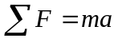
Moment Equation: 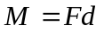
Maximum Bending Stress: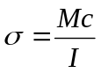
Moments of Inertia: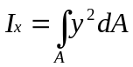 & 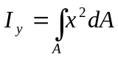

Spar Structure Optimization:
The wing’s thickest point was chosen as the location for the spar structure so as to allow the furthest distance, ’c’, from the neutral axis for bending. At the wing root and tip the thicknesses were 1.6875” and 1.4”, respectively. At specific points along the span, the values of ‘c’ and ‘M’ were fixed thus allowing for variation of the moment of inertia by varying the cross-sectional area. The above equations were used, along with values for a 35 lb. aircraft travelling at 60 mph, to calculate the following load values:
Maximum G Force (with safety factor): 9.35
Maximum Load (per wing panel): 1410.9018 oz.
Maximum Moment: 38873.284 in.-oz.
Moments of Inertia: Ι-Beam: 0.0348635 in⁴ Rectangle: 0.059582 in⁴
Maximum Bending Stress: Ι-Beam: 57173.497 psi Rectangle: 33454.2 psi
Although the maximum bending stress can be taken by both the rectangular and I-beam sections, the Ι-Beam cross-section was chosen due to the weight savings that it would provide.

Wing Carry Through Optimization:
Optimization of the bending beam involved evaluating possible methods of interfacing with the spar structure. Inserting a wing joiner with a wing carrier box internal to the wing and extending the spar structure into the fuselage were the only method that were deemed feasible.
Weight savings could be attained by several methods, including replacing the shear web in the spar structure with a box carrier. The joiner could also be made from lightweight composite materials. Fuselage weight could also be reduced as its required strength is minimized due to the isolation from bending loads.
Through the application of the FOMs, specifically strength to weight ratios and overall component weight, the wing joiner with wing carrier box proved to be the best method to optimize the wing carry through component of the structural system. Integration of the carrier box with the I-beam cross-section was accomplished by allowing the carrier box to replace the shear web of the I-beam cross-section. The flange of the I-beam (spar cap), would run from wing tip to root, thus providing a method of connecting the two separate entities. The required spar cap thickness was calculated at various stations along the span, which determined the height of the shear web as well as the carrier box.
The moment and shear calculations determined the carrier box wing dimensions to be 10” length, .5” width, 1.24” height and wall thickness of .0625”. I-beam shear web would taper from 1.24” at the carrier box interface to 1.35” at the wing tip and have a constant thickness of .375”. The difference in height between the wing and web, being the spar cap thickness, provided a lay-up schedule for the material chosen during the manufacturing phase. The wing joiner dimensions were calculated as 1.24” in height, .375” in width, with a 26.75” horizontal length.

Preliminary Design Phase Summary
The PDP analyzed the preliminary configuration as developed in the CDP with regard to the determination of exact sizing and component interaction. Design parameters were that were related to the purpose of sizing the components were defined locally. FOMs such as component and personnel safety, structurally and aerodynamically favorable component interaction, ease of construction, and a low RAC were the primary factors determining much of the component design. Most general sizing calculations that were done were based upon those used in designing propeller driven general aviation and radio controlled aircraft. Precise calculations on flight performance will be completed during the DDP now that the detail configuration of TLAR II has been established.

Detail Design
The goal of the DDP was to optimize the sizing and design parameters that were developed in the PDP with regard to flight and takeoff performance. Similar to the PDP, the primary performance analysis techniques used were those applied to propeller driven general aviation aircraft. The calculation of basic characteristics, such as lift and thrust, allowed for the computation of more specific flight characteristics such as takeoff distance, rate of climb and endurance. In each section of the PDP, individual component weights were estimated.

General Sizing

Weight Estimate
Estimates based on experience gained from last year’s design were assembled into a preliminary weight estimate of 30 lbs. Upon completion of the DDP and construction of the aircraft, the final value for aircraft weight was 32.3 lbs. While heavier than first estimated, it was still well within the competition rules and design limitations of the aircraft.

Wing Performance
The detailed performance calculations of the main wing were based upon Prandtl’s classic lifting line theory. Prandtl’s theory was implemented numerically in Matlab code and run with the sizing parameters developed in the PDP. When given inputs for wing dimensions of span, root chord length, aspect ratio, α_{CL=0}, the program gave an output of C_{Lα=0} of 0.324, and a C_{Lmax} of 1.05. These values were reduced from the theoretical infinite wing data by approximately 26%, which was relatively efficient despite the low aspect ratio and a high taper ratio. However, by altering the values of the taper ratio, it was possible to achieve an 20% reduction. Any further reduction in tip chord could result in a weak wing structure and ineffective control surface area. The final values for C_{Lα=0} and C_{Lmax} of 0.325 and 1.136 respectively, were realized with a root chord of 15 in. and tip chord of 13 in. This gave the final wing an aspect ratio of 8.6, taper ratio of 0.867, planform area of 1680 in². An important quantity resulting from these refined sizing and performance characteristics was a wing loading, W/S, of 2.77 lbf/ft².

Motor Thrust Available
While the static thrust of an engine was a necessary calculation related to the determination of performance characteristics such as takeoff distance and rate of climb. Analysis of power supplied being reduced by the inefficiency of the motor and propeller was used to indicate the amount of power available to actually propel the aircraft. Having determined the number of cells to power each motor in the preliminary phase, the total power available to the motor was calculated using the equation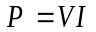, giving an available power of 712 Watts. With a combined efficiency of 0.75, the thrust developed per engine was 4.75 lbs. This gave a final thrust-to-weight ratio of 0.29.

Flight Performance Calculations
In optimizing sortie performance, it was necessary to evaluate takeoff, rate of climb and range/endurance characteristics as well as static stability. While dynamic stability was also a concern, for a fairly conventional design as TLAR II, dynamic instability has proved to be highly transient in modes that are easily controlled by a skilled pilot.

Takeoff Performance
The takeoff profile for TLAR II was essential, as it was a competition constraint. It was determined for takeoff that the rotate/stall speed needed was 45.3 ft/s, while the actual takeoff speed was 49.8 ft/s.
For the Reynold’s number (~200,000 to 300,000 based on M.A.C.) at which the takeoff was performed, the induced drag of the aircraft was small enough to be approximated to zero. This enables the approximation of integrating Newton’s second law over the ground run of the aircraft. This integration of the acceleration can be reduced to the following equations from reference 1:
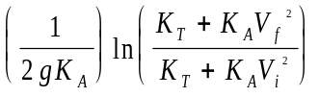 with 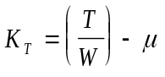, and 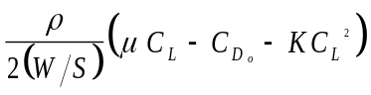
A ground roll of 165 ft was calculated for a rolling resistance factor (μ) of 0.05 and a total takeoff distance of 185 ft with a 1.0 rotate factor. While this seems close to the distance limit, the likelihood of winds being present during the competition will shorten the actual takeoff distance. If this is not the case, and taking off within the limit proves difficult, reducing the payload may be considered.

Rate of Climb
The rate of climb (R/C) is the vertical component of the aircraft velocity. It can be expressed in terms of weight (W), perpendicular component of drag (W_{D}) and velocity (V). W_{D} is a function of thrust (T) and drag (D), therefore yielding:
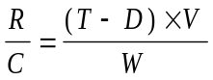
The best climb rate will occur at the velocity for maximum lift to drag ratio, L/D_{max}. Although the thrust produced by the propeller and corresponding power available changes with the airspeed, an approximation was made to show that the maximum lift to drag depends only on the values for the parasite drag coefficient, C_{D} and the wing’s aspect ratio, AR.
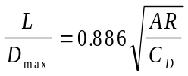
Using these formulas, the rate of climb for the aircraft was calculated to be 710 ft/min.

Turning Radius
The turning radius gives an indication of how much distance, time and power are needed to perform a turn and is necessary because it affects sortie flight time and power management.
The turn radius calculations began with the assumption that the turn will be made at the cruise speed of 60-MPH. The equation
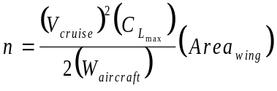
gave a load factor of 3.78 for the turn. From this, and geometry, a bank angle of 74 degrees and turn radius value of 66 ft was calculated.

Range and Endurance
Range and endurance characteristics are essential performance indicators for an aircraft designed to participate in timed, limited fuel flight profiles. The range figure of TLAR II was based on the power available and the power that the flight profile will require, so that a determination of the number of sorties possible can be made.
Initially, this was done by examining TLAR II in steady flight. The power available is the number of cells multiplied by the power rating for each cell. This equated to 1 battery pack multiplied by 2400 milliAmp-hours for at total of 2.4 Amp-hours. This allows 6.4 minutes of flight time at the current setting of 22.6 Amps, which subsequently gave a cruise range of 7.0 miles.
While this flight time was less than the flight period, an Excel spreadsheet was used to determine the detailed flight plan and current setting breakdown for the entire mission profile, with gliding and powered back cruises to be ample for the completion of a ten minute flight period. The final estimate for the number of flight sorties possible was five.

Static Stability
The ability of the aircraft to return to trimmed flight, if it was somehow deflected, was an important consideration. Due to the symmetry of the aircraft about the centerline of the fuselage, it was possible to achieve some roll stability of the design, with the selection of 3º dihedral in the preliminary phase. The focus was placed on the pitch stability (the directional stability was already addressed in the sizing of the vertical tail stabilizer). A well designed aircraft that has good static stability, historically will also behave well dynamically.
The pitch stability is related to how the main wing and horizontal stabilizer work together to correct pitch deflection. For TLAR II, this was especially critical due to the choice of a symmetrical airfoil for the tail. To prevent excessive corrective elevator deflection during steady flight, the pitching moment of the airfoil needs to be balanced by the placement of the center of gravity relative to the center of pressure of the wing. Assuming that any pitch deflections would be small, the pitch static stability is directly dependent on the horizontal stabilizer. The calculations focused on determining the exact placement of aircraft CG for a desired Stability Margin of 0.3. This margin is the geometrical distance between the location of the CG and the location of the neutral point. The neutral point was determined with the following equation along with design parameters defined earlier in the paper.
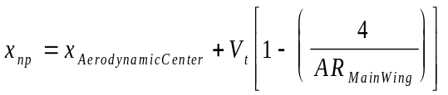
With a few iterations, this allowed the placement of the wing at the optimum position for stability. The main wing leading edge was located at 18 in from the nose of the aircraft, which places the CG directly on the spar location. Additional pitch stability was achieved through decalage (angle between the horizontal stabilizer and the main wing), which was initially set at 1º and will be finalized during flight testing.

Systems Architecture
The Systems Architecture describes the electrical components used to fly the aircraft including the batteries, servos, receivers, and handset. The number, location, and type of motors and batteries were determined in the propulsion section of the PDP. Determining the types of servos remained.
Given the values obtained for the torque required by each servo, two different servos (HS-225MG and HS-545BB) manufactured by Hitec RCD Inc. were chosen for the rudder, elevator, and aileron controls. The HS-225MG, capable of 55-67 ^{oz}/_{in} of torque was used to control the elevator. The HS-225MG was also used for the rudder, despite the rudder having less control surface area than the elevator, because the same servo controls both the rudder and the rear wheel. The spoilerons however require more torque to control due to higher surface area, therefore a more powerful servo, HS-545BB, capable of 62-73 ^{oz}/_{in} of torque was used.
(Tables on Next Page)

Detail Design Summary
Table 5-5 General Sizing
Design Parameter | Size
Aircraft Dry Weight | 20.9 lbs.
Light Payload Capacity/Weight | 100 Tennis Balls/12.85 lbs.
Heavy Payload Capacity/Weight | Steel/15 lbs.
Battery Pack Weight | 5 lbs.
Main Wing Configuration | Low Mono-Wing
Main Wing Airfoil | E214
Main Wing Area | 1680 in²
Taper Ratio | 0.867
Aspect Ratio | 8.57
Number of Motors | 2
Propeller Size | 14” x 12” (x2)
Total Thrust | 9 lbs.
Horizontal Stabilizer Area | 310 in²
Vertical Stabilizer Area | 125 in²
Tail Airfoil | NACA 0009
Fuselage Height | 9.75 in
Fuselage Length | 45 in
Fuselage Width | 10.75 in
Table 5-6 Systems Architecture
Component | Description (Amount)
Motors | Graupner Ultra 3300/7 (2)
Servos | HS-225MG (2), HS-545BB (2)
Batteries | Sanyo 2400 (2 sets * 19 cells = 38 total)
Receiver | HPD-07RB (PCM)
Handset (Radio) | Prism 7X (PCM)
Table 5-7 Flight Performance Data
Design Parameter | Performance
Cruise Speed | 60 mph (88 ^{ft}/_{s})
Takeoff Distance | 185 ft
Climb Rate | 710 ^{ft}/_{min}
Turning Radius | 66 ft
Payload/Gross Weight Ratio | 0.39
Cruise Endurance | 6.4 min
Sortie Endurance (# of Sorties Flown) | 5
Rated Aircraft Cost | 6.54
Final Flight Score | 98.1

Drawing Package

Three View

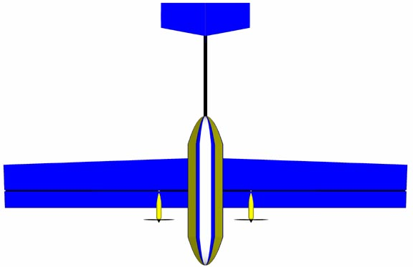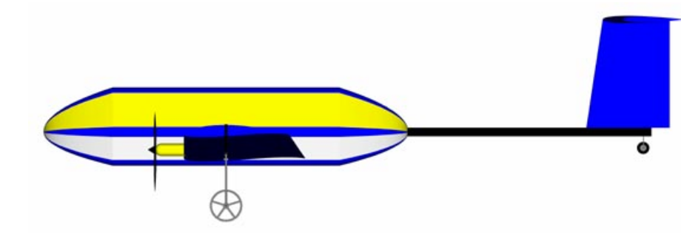

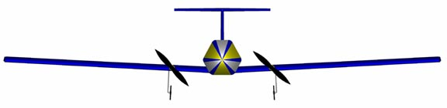

Structural Component Dimensions
BOOM:
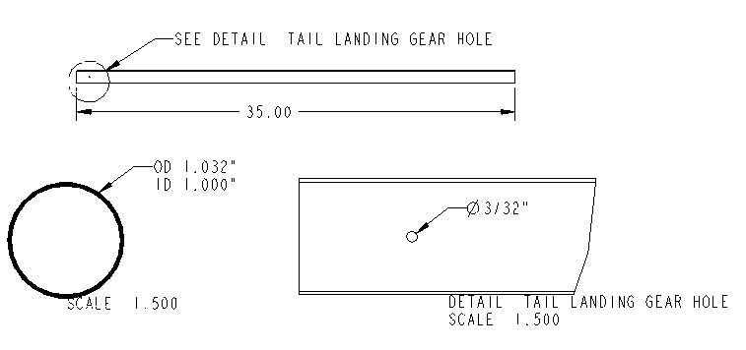

Wing Joiner:
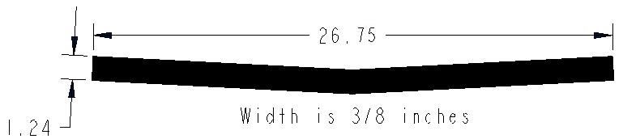

main landing gear strut and wheel:

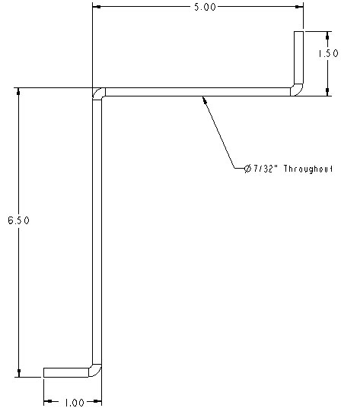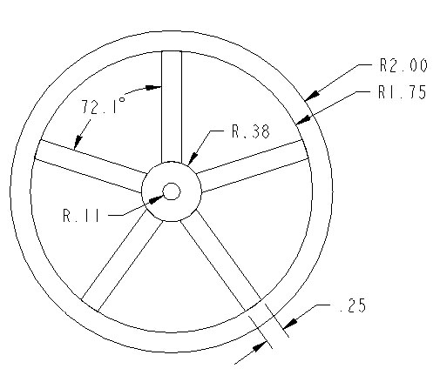

Flight Component Dimensions

WING PANEL:
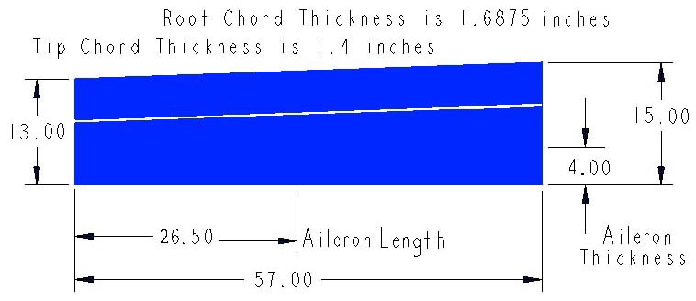

HORIZONTAL STABILIZER:
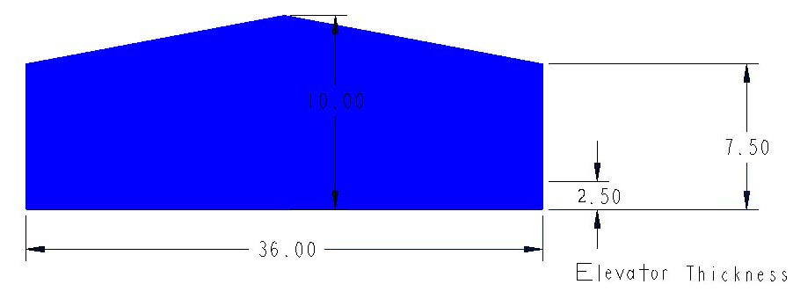

VERTICAL STABILIZER:
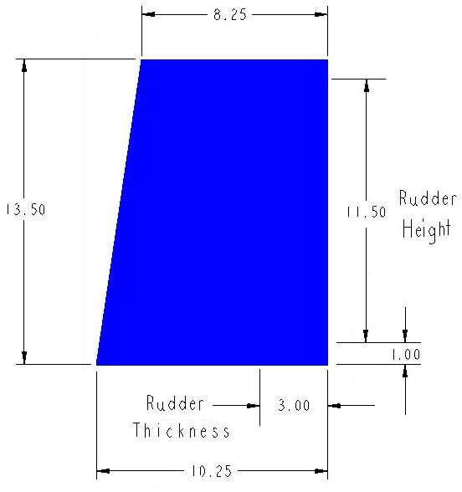

Conceptual Configurations

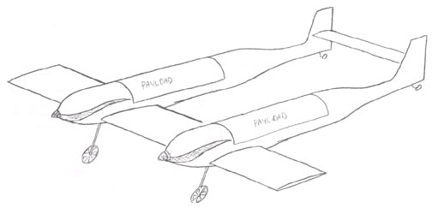
“C-01”

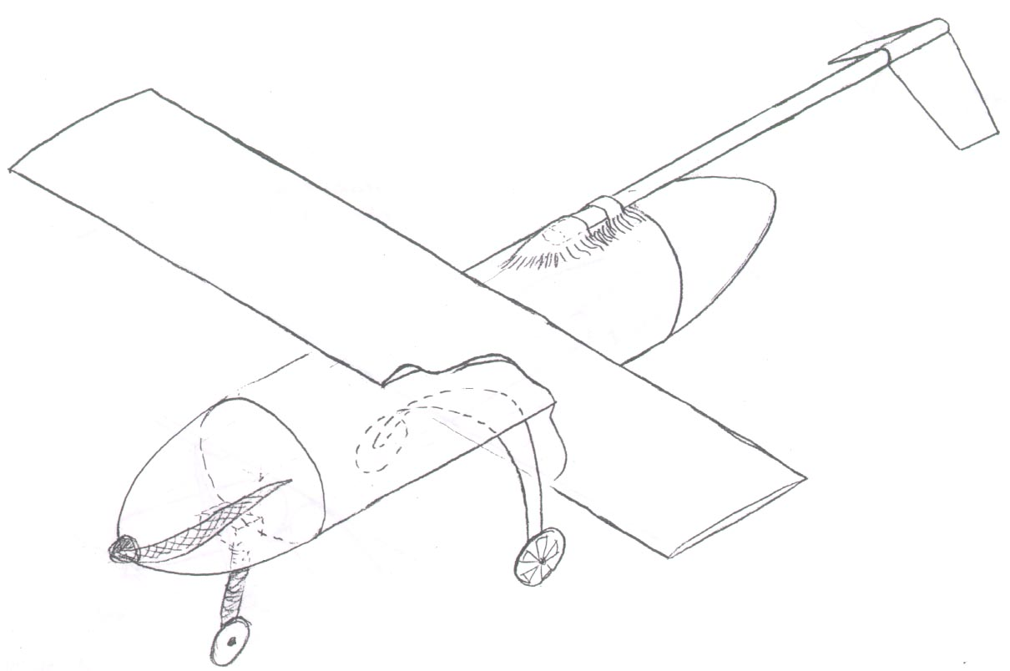
“C-02”

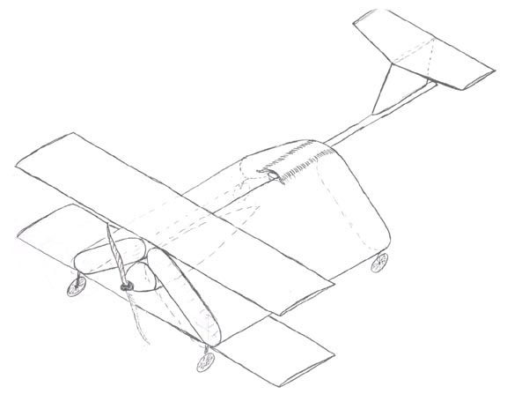
“C-03”
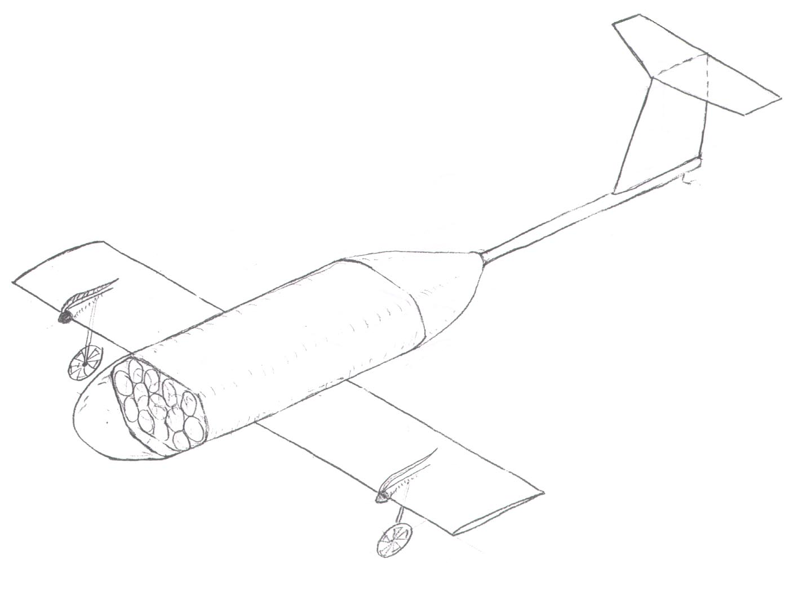
“TLAR II”

Detailed Confguration, Tennis Ball Packing, and Flight Equipment Location

Tennis Ball Packing Arrangement
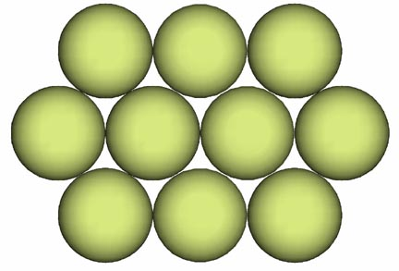

Flight Equipment Locations
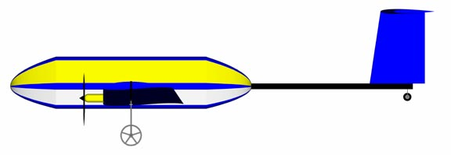
Receiver
Speed Controller and Fuse
Battery Packs

Manufacturing Plan
Logistics and required skill level to manufacturing component design ideas imposed constraints on design options. The manufacturing constraints were continually considered in order to avoid conflicts between a chosen design idea and the ability to construct it. The manufacturing FOMs were used to screen construction techniques and materials based on skill level, physical properties, component and interfacing strength, and logistics. The material FOMs were sometimes used to eliminate construction methods, while construction FOMs were sometimes used to eliminate materials. The order in which the various components and assemblies were completed are shown in the manufacturing timeline presented in section 6.4.

FOM Reasoning/Discussion
Materials: Materials were screened due to their strength-to-weight ratios, availability, cost and required skill level.
Construction Techniques: “Home-built” construction with limited techniques were the only methods available to the team due to limited experience with an autoclave, time restrictions, and the unavailability of a large CNC machine. Construction FOMs are composed of required skill level, machinery, tools, tooling time, robustness and ease of repair.

Component Manufacturing Description

Spar Structure
The spar structure assembly consists of the torsion rod, shear web, spar cap, wing joiner, and the wing joiner carrier box.
Spar Cap Materials: The spar cap absorbs the majority of the bending stress and is of variable thickness. A carbon material was best suited for this component because of its high axial load capacity.
Spar Cap Construction Techniques: 12 K carbon tows were cut into the required lengths to match the required thickness at the various stations along the wing. The lengths that were required were determined by the lay-up schedule in the structural system PDP. The strands of 12 K carbon tow were wet-out with epoxy and then laid into the groove between the shear web and wing surfaces.
Shear Web Materials: The shear web is only required to give spacing between the spar caps and to absorb a nominal amount of shear stress. Material FOMs were applied to various lightweight materials in order extract the best material. The materials investigated for the shear web were carbon plate, balsa, and Aircraft plywood. Despite the high tensile strength of carbon, the thinness a plate raised concerns about buckling and was eliminated. Aircraft plywood was eliminated due to its high relative weight, leaving the balsa wood board as the ideal choice since it was light, required low skill level, and was the cheapest of the three choices. The specific type of board used was vertical end-grain balsa wood.
Shear Web Construction Techniques: The only construction technique explored was to cut it to the required dimensions and epoxy the end-grain balsa pieces together. The wood was cut into 2-inch tall sections, which were then glued together with Cyano-Acrylate (CA) to make two 60-inch lengths. The shear webs were then cut to the height specified by the spar cap thickness at the particular station along the span.

Wing Joiner
This component joins the wing halves and must be strong enough to withstand the concentrated bending loads from landing and turning.
Materials: The materials investigated for the wing joiner were 12K-carbon tow and 6061 aluminum. The aluminum was quickly eliminated in favor of the carbon tow due to the skill level required to machine the necessary geometry as well as tooling time. The light-weight and high strength characteristics of the carbon tow made it the ideal choice for the wing joiner.
Construction Techniques: The methods that were considered for fabrication of a wing joiner were to use an autoclave or to do a manual “wet-lay up”. The autoclave required that a complex mold be made. The “wet-lay up” process was chosen since it satisfied the required skill level and tooling time FOMs. Construction of the “wet-lay up” mold began by using the LaserCAMM in the Undergraduate Machine Shop to cut an acrylic sheet into the proper shapes. After the acrylic pieces were bolted to a melamine board, approximately 350 yarns of 12K-carbon tow were whetted with epoxy and placed in the gap. Once the carbon was laid properly, another melamine board was clamped over the newly laid spar. Once the epoxy had hardened, the wing joiner was removed and the surfaces finished to ensure exact dimensions.

Wing Joiner Carrier Box
The purpose of the wing joiner carrier box is to act as a stiff sheath for the wing joiner while transferring loads from the wings.
Materials: The materials considered for the wing joiner carrier box were carbon tow, Kevlar, and fiberglass cloth. Since all three had desirable properties, a combination of the three was used. Unidirectional 12K carbon and 1.2-oz/yd² fiberglass cloths provided strength and structural stiffness, while two layers of 1.8-oz/yd² Kevlar increased impact strength of the carrier box.
Construction Techniques: The only method investigated for the wing joiner carrier box was to mold it around the wing joiner itself. This ensured a tight fit and reduced the chance of failure due to fatigue at the joint. A single layer of fiberglass was wrapped around the wing joiner. Once cured, the fiberglass sheath was cut off of the wing joiner and bonded back together using CA. Coating the wing joiner with a mold release, the fiberglass sheath was slid onto the joiner. Unidirectional 12K carbon tow was cut and bonded to the fiberglass, with the carbon laid along the length of the wing joiner. After the carbon had cured, two layers of Kevlar were wrapped around the existing lay up. After the lay up hardened, the edges were cut to ensure the proper dimensions and the sides were “roughened” to create a good bonding surface.

Torsion Rod
The torsion rod serves to absorb wing torsion loads.
Materials: The materials considered for the torsion rod were a 1095 cold rolled steel piano wire with a ⁷/₃₂-inch diameter and a 1/4-inch diameter 6061 aluminum rod. The aluminum was chosen because of the larger diameter (to increase moment of inertia) and lower weight.
Construction Techniques: Cutting the aluminum rod into two 6-inch lengths was the only necessary tooling required.

Wing Airfoil
Airfoil Templates: The first step in the process of fabricating the wings was to make Eppler 214 airfoil templates.
Materials: The materials considered for the airfoil templates were 6061 aluminum, aircraft plywood and Formica. Since the hot wire method was the desired cutting process for the wing cores, it was necessary for the chosen material to be smooth for the wire path, and not melt under hot wire temperatures. Formica was the clear choice due to smooth surface finish and low thermal conductivity.
Construction Techniques: The two techniques for construction of airfoil templates considered were the “cut-and-paste” and a CNC machine cutting method. The “cut-and-paste” process was used because it was easier. Using data points obtained from the UIUC Database, printouts of the airfoil for chord lengths of 15, 14, and 13 inches were created. This included the root, tip, and midpoint of the spans of the airfoils. Printouts were bonded to the Formica, which were then cut into the shape of the airfoil.

Wing Cores
The purposes of the wing core are to maintain the airfoil cross-sectional shape and to contribute to the composite strength.
Materials: The materials considered were aircraft ply, and blue and EPS foam. Using aircraft ply, would result in a design using a rib structure overlaid with MonoKote, while the foam design could form a solid core for composite lay up. The foam was chosen because a solid core was more structurally sound and required less construction. The stiffness and compressive strength of the blue foam and low weight of the EPS foam made both of them viable choices for the core. A combination of blue and white EPS foam was used. The dense blue foam provides stiffness and the less dense white EPS foam conserves weight.
Construction Techniques: The two construction techniques investigated for cutting the foam core were utilization of a large CNC machine and a hot-wire cutting process. The CNC machine was immediately eliminated due to the unavailability. The hot-wire technique satisfied the logistical issues and the skill level requirements.
In order to accommodate the length of the hot-wire bow, the foam blocks were cut into quarter span sections. Blue foam was used from the leading edge to the thickest point of the wing, while EPS foam was used from the thickest point to the trailing edge. The blue and white foam sections were set against each other and the wing templates were set in the foam. After the reference pins were inserted into the foam blocks, the hot wire was drawn through the foam, following the template, creating the desired E214 airfoil cross-section.

Spar Assembly
The spar assembly, which consists of the shear web, carrier box, and two landing gearblocks, was coated with epoxy and pressed between the blue and EPS foam wing halves. Epoxy was used to bond the 12K-carbon tow spar caps to the balsa shear web and carbon/Kevlar carrier box. The aircraft ply hard points for the motor nacelles, torsion rod, and fuselage interface were placed in the wings. The entire wing structure was vacuum bagged to extract the excess resin and to ensure optimum bonding strength.

Wing Skins
The functional requirement of the wing skin is to provide a smooth surface for airflow over the wings, which reduces parasitic drag. The skin is also required to provide torsional strength to dissipate stresses generated during flight.
Materials: Carbon and fiberglass cloths were the materials considered for the wing skins. Carbon cloth was eliminated due to high cost and difficulty of working with the dimensions that were required. Fiberglass cloth was chosen because it was cheap and easy to work with.
Construction Techniques: The use of foam as the core excluded the possibility of using an autoclave, therefore a wet lay up process was needed. Fiberglass was laid at a 45° bias over Mylar. Each wing core was then sandwiched between the sheets of fiberglass/Mylar. The whole assembly was then placed in a vacuum bag to compress the fiberglass/Mylar. After the epoxy had finished curing, the wings were removed from the vacuum bag, the Mylar was peeled off and the excess fiberglass was trimmed or sanded off.

Final Wing Assembly
The fiberglass covering the hard points was trimmed off, allowing access to the plywood below. The spoilerons were cut out and trimmed to allow enough clearance for full range of motion. The recesses to hold the servos were cut into the wings and the wing tips were cut at a 45-degree angle. Fiberglass was then adhered to the exposed core surfaces to provide strength.

Stabilizers
The airfoil decided on for the horizontal and vertical stabilizers was the NACA 0009. The same materials and construction techniques were chosen for the two stabilizers.
Materials: The horizontal and vertical stabilizers were made from foam and fiberglass for the cores and skins, respectively. The only difference from the wings was that only blue foam was used. To provide stiffness and strength unidirectional carbon cloth was laid along the span at half the chord length. The final material used in the tail was aircraft ply that acted as hard points at the interface with the boom.
Construction Techniques: The final lay-up of the stabilizers was exactly the same as the wings.

Main Landing Gear Strut
The gear struts need to withstand fatigue and to absorb the majority of the loads applied at landing.
Materials: The materials considered were carbon, 6061 aluminum and 1095 cold rolled steel piano wire. The carbon was eliminated due to lack of impact strength and tooling time. Aluminum was eliminated due to strength and stiffness concerns. Cost, prior experience, high strength and durability made piano wire the ideal choice.
Construction Techniques: Prior experience with 1095 cold rolled steel piano wire eliminated the need to investigate other construction techniques. In order to obtain the necessary strength and shape the piano wire was (cold) bent then stress relieved at 600°F. This was repeated until the desired shape had been obtained. The strength of the steel was thus preserved and the residual stress at the joints was relieved.

Gear Blocks
Materials: The two possible materials investigated were aluminum and aircraft ply. Tooling time required caused the aluminum to be eliminated. Aircraft ply was chosen since tooling time, cost and skill level were nominal.
Construction Techniques: Prior experience with the materials and component design eliminated the need to investigate construction techniques. The aircraft ply was cut into the required dimensions and then stacked together and bonded with epoxy. A second layer of plywood consisted of two pieces, thinner than the first layer, for the landing gear strut. Epoxy was applied to T-nuts that were pressed into the wood to hold the bolts that would keep the piano wire in place.

Wheels
Materials: Two possible materials for the wheels were aluminum and high-density rubber. The rubber was easily eliminated as a viable material due to weight and strength issues. The aluminum had a lower weight while meeting the strength and durability requirements. Thinner aluminum wheels, compared to thick rubber, decreased aerodynamic drag.
Construction Techniques: Two possible methods for constructing the wheels were by hand or with a small CNC that was available. The tooling time and skill level required to machining the aluminum by hand was excessive thus the CNC method was chosen. In addition, use of the CNC made it possible to decrease the wheel weight since a more complex geometry could be cut. After the wheels had been drafted with Pro-Engineer, the drawings were converted to a file that was read by the CAM program, MasterCAM, which directed the machine’s movements. The 6061 aluminum pieces were cut into five-spoked wheels. The spokes converged at a hub at the center of the wheel into which two bearings could be inserted. A rubber O-ring was placed in the grooves cut into the outer edge of the wheels to act as a “tire” in order to provide traction and increase ground handling.

Tail Landing Gear
Materials: The tail landing gear strut was made from 1095 cold-rolled steel piano wire because of cost and strength FOMs. It was decided that a standard 1.5-inch RC model aircraft wheel would suffice as the tail wheel, because it saved construction cost and time.
Construction Techniques: The cold bend and stress relief technique was employed for fabricating the tail gear strut. After the final shape had been achieved, the wheel was attached to one end of the strut, which was then connected to the servo by an additional control arm. Milled fiber mixed with epoxy was used to attach the tail gear assembly to the rudder.

Speed Loaders
Materials: Carbon tow and cloth, Kevlar, and fiberglass cloth were viewed as the only viable materials. The carbon cloth and fiberglass were both eliminated due to issues concerning durability, cost and required skill level. Kevlar met durability and cost requirements and was therefore the ideal choice of materials for the speed loaders.
Construction Techniques: A mold was needed to fabricate the speed loader. The two construction methods considered were the use of a CNC machine and taping the tennis balls together to attain the required geometry. The taping method required the least tooling time and skill level and consequently was chosen.
Tennis balls were taped together over which Mylar sheets were laid to provide a smooth surface to which the epoxy and the Kevlar cloth would not adhere. Two plies of Kevlar were used to construct the loader, which was then stiffened with carbon tow.

Fuselage
Materials: The three materials investigated for the fuselage were Kevlar, carbon cloth, and fiberglass cloth. The need for a stringer arrangement within the fuselage made carbon cloth a viable choice. Kevlar was also kept as a possible material since it met durability requirements. The fiberglass was eliminated since strength and impact strength requirements were not met.
Construction Techniques: The two possible methods for construction of a mold were a CNC machine or by forming one using the tennis ball speed loader and a pieces of foam to obtain the necessary cross-sectional shape. The CNC machine was eliminated due to the unavailability of a large enough machine and the time required to program. Therefore the loader/foam method for constructing the fuselage was used. The foam blocks were cut and sanded to form the desired shape of the nose cones. Three-plies of 1.8-oz/yd² Kevlar and one-ply of 2-oz/yd² fiberglass were to be used to form the fuselage skin. A speed loader, wrapped in plastic, and a female mold made from mylar, were used to form the Kevlar and glass plies in the required shape. The nose and tail cone structures were formed from sections of blue foam, which were then attached to the loader/mold assembly. Aircraft plywood bearing walls and 12 K carbon tow stringers were incorporated to increase structural stability.

Boom
The functional requirements for the boom were stiffness and bending strength to support loads from the tail and landing gear.
Materials: Two materials that were considered for the boom were carbon and aluminum. The carbon was chosen over the aluminum due to issues with weight and stiffness.
Construction Techniques: Due to prior experience with carbon tubes, no addition construction techniques were investigated. A 60” long (1” ID x .032” WT) carbon tube was cut to the necessary 35” length. Aircraft ply was bonded to the inner diameter to provide strength for the connection to the vertical stabilizer and tail gear.

Assemblies

Wing Core Assembly
The spar cap thickness, landing gearblocks, and the wing halves were needed to assemble the main spar. Niches in the balsa shear web were cut where the landing gear blocks would be attached. Shims were used to bond the shear web to the wing cross-section at the correct height, which, at the half-span length, is equal to the spar cap thickness. Epoxy was applied to the landing gear blocks, which were then connected to the carrier box.

Wing panel Assembly
12 K carbon tow was cut in the lengths required by the lay-up schedule that was determined during the spar structure preliminary design phase. The lengths were then wet out and layed on top of the shear web within the wing core assembly. Motor nacelle hard points were installed and Mylar was layed over the wet carbon tow and the whole assembly was placed in a vacuum bag.

Boom Assembly
Using an epoxy and cavasil mixture, aircraft plywood was installed in the tail of the fuselage. The boom was then bonded to this structure to provide a load transfer path.

Manufacturing Timeline
Figure 6-2 Manufacturing Timeline
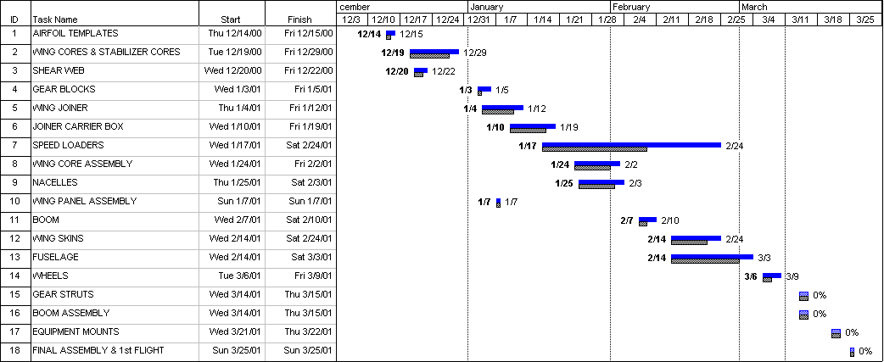

Legend: Grey dotted lines = Proposed duration of task. Proposed start and finish dates are indicated in the cells on the left.
Blue solid lines = Actual duration of task. Actual start and finish dates are indicated on both ends of line.
Percentage = Percentage of task completed.

Proposal Phase References

1. Raymer, D.P., Aircraft Design: A Conceptual Approach, AIAA Education Series, 1989.
2. Simons, M., Model Aircraft Aerodynamics, Argus Books, 3rd edition, 1994.
3. Lennon, A., The Basics of R/C Model Aircraft Design, Air Age Inc., 1996.
4. McCormick, B.W., Aerodynamics Aeronautics and Flight Mechanics, John Wiley and Sons, 2nd edition, 1995.
5. Nelson, R., Flight Stability and Automatic Control, McGraw Hill, 1989.
6. Stinton, D., The Design of the Airplane, Van Nostrand Reinhold, 1983.

