Many assumptions were made from the experience of members of AIAA design/build/fly competition, common mediums, and theoretical software such as VisualFoil, version 4.0. VisualFoil is simulation software that can analyze and compare airfoils. It generates realistic aerodynamic data for general airfoil shapes in air and water. The majority of the preliminary aerodynamic features on our design/build/fly airplane came from the results of VisualFoil.
The environmental properties and flight conditions were the first assumptions determined. Air properties were taken at sea level. From the experience of flying previous design/build/fly airplanes, a predicted cruise velocity of this years designed airplane was estimated to be 50 miles per hour. The Reynold’s number was calculated from the estimated flight conditions and the estimated cruise velocity.

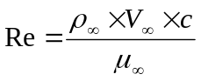 where 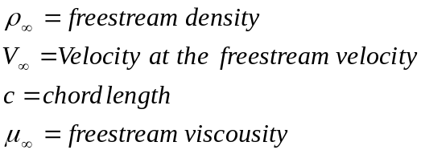

The Reynold’s number calculation determined the airfoil the final airfoil. With VisualFoil, different airfoil properties were observed by the members of the aerodynamic group. The S4022 showed a low drag coefficient, a high maximum lift, and good stall characteristics for the predicted Reynold’s number. Therefore, the aerodynamic group agreed the S4022 would give the best aerodynamic qualities in the airplane design.
The VisualFoil software produced data for the coefficient of lift, the coefficient of drag, and the coefficient of the pitching moment at the quarter chord at various speeds. To see changes in the coefficient properties from 50 miles per hour, 30 miles per hour and 40 miles per hour were the other chosen speeds to take coefficient. Through Microsoft Excel 2002, data tables and plots were created for the coefficient of lift, the lift to drag ratio, and the center of pressure against each angle of attack.

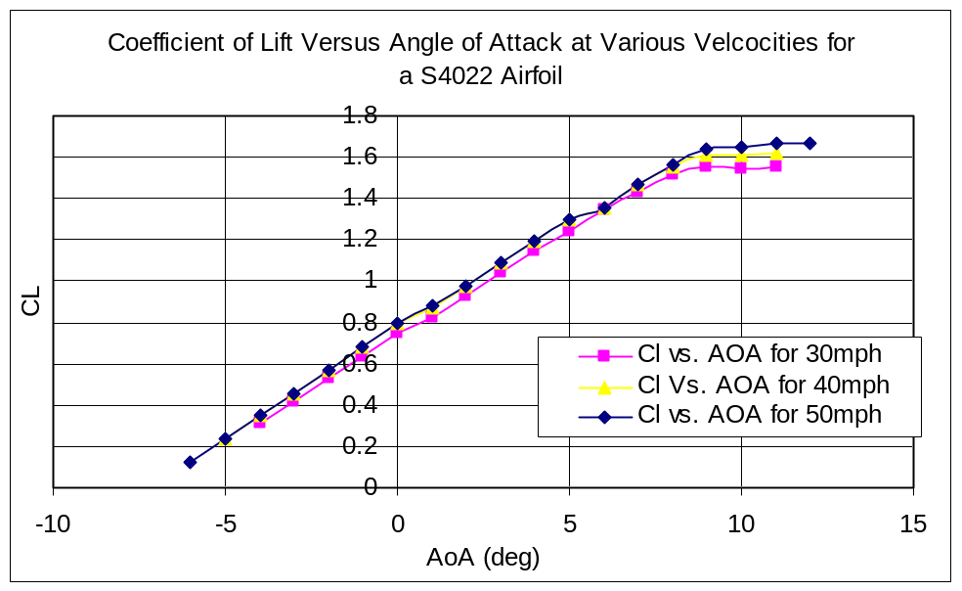

The maximum coefficient of lift occurs just when right before the curve on the C_{L} versus Angle of Attack plot peaks. The angle of attack where the maximum coefficient of lift occurs shows the maximum angle of attack the airfoil can go to maintain the greatest lift. When the curve peaks stalling occurs. The maximum coefficient of lift for 30mph, 40mph and 50mph averages to 1.6.
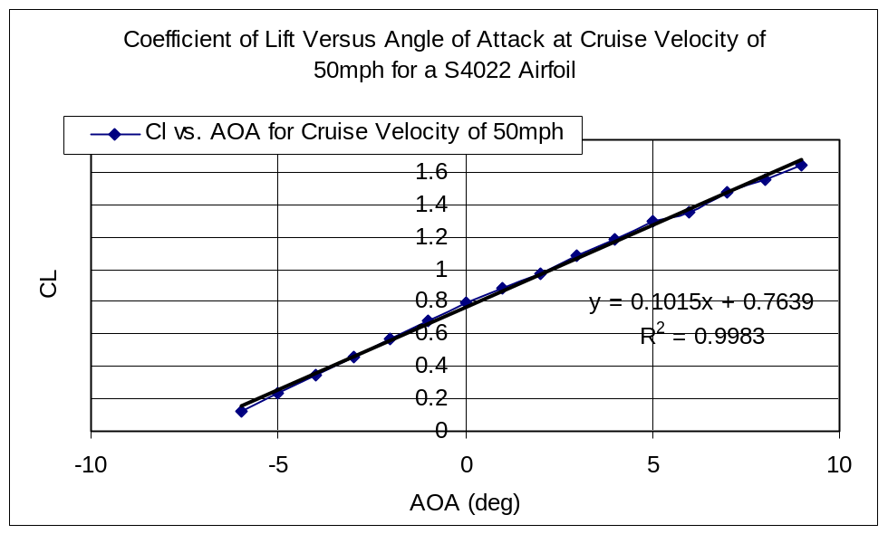
The coefficient of lift versus angle of attack at cruise velocity of 50 miles per hour is singled out here to create a best fit line. The best fit line is used in calculations of finite wing.
To plot the lift to drag ratio, an aerodynamic group member had to derive the equation from the VisualFoil data given:

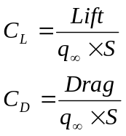 where 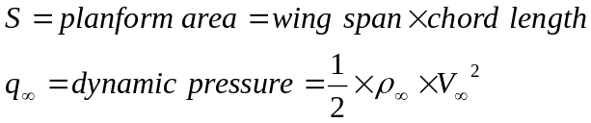
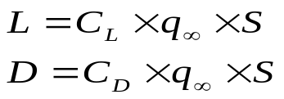 Lift to Drag Ratio = 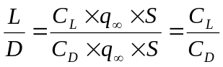

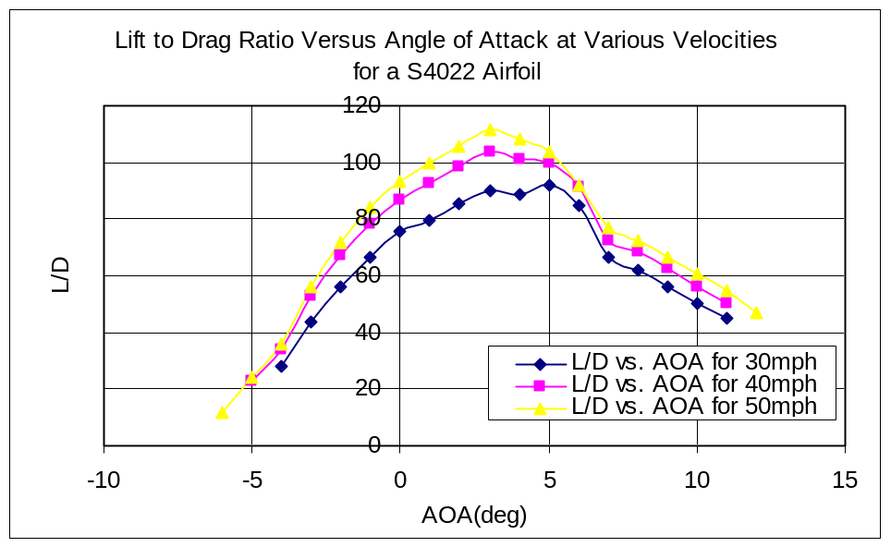
From the lift to drag ratio versus angle of attack plot, a new plot of maximum lift to drag ratio versus velocity was created.
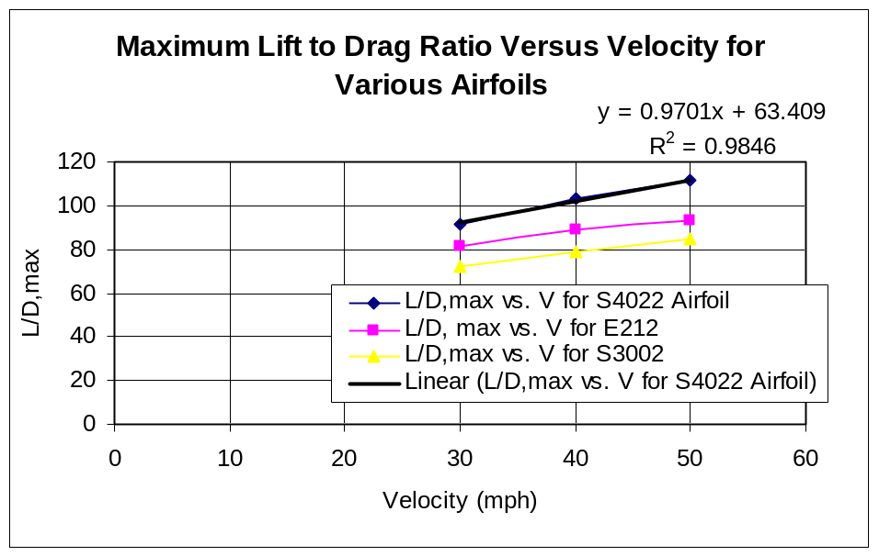
Other maximum lift to drag ratios for different velocities was done for the E212 airfoil and the S3002 airfoil to compare the better aerodynamic properties of the S4022 airfoil that was chosen. The lift to drag ratio is a true measure of the aerodynamic efficiency of a body shape. The higher (L/D)_{max} for any given velocity, the more aerodynamically efficient is the body. This analysis of the lift to drag ratio only corresponds to the S4022 airfoil alone. The actual body of the airplane will cause the maximum lift to drag ratio to reduce for each speed.
The center of pressure was calculated for each angle of attack using the equation:
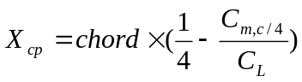
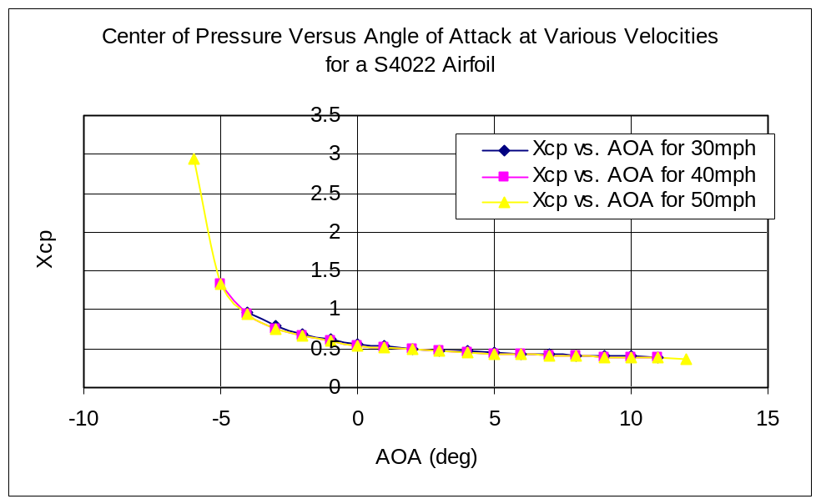
The center of pressure is the location where the resultant of a distributed load effectively acts on the body. It is also a point on the body about which the aerodynamic moment is zero. The center of pressure changes with the angle of attack. In general, from the plot, the center of pressure moves closer to the leading edge as the angle of attack increase. The center of pressure seems to stabilize a certain distance from the leading edge before stalling, and the center of pressure never goes beyond the leading edge or trailing edge. From this interpretation and analysis, the airfoil is very stable in flight.
The assumed weight of the airplane was estimated from how many components we had, each size of those components, and the assumed material. The airfoil for this year’s airplane, the S4022, showed that it has better lift properties than the E212 airfoil from last year’s design/build/fly airplane as evident in the results of the lift to drag ratio plot. A trade study analysis was done to get a better idea on the dimensions of the wing and how it would benefit the team the most.
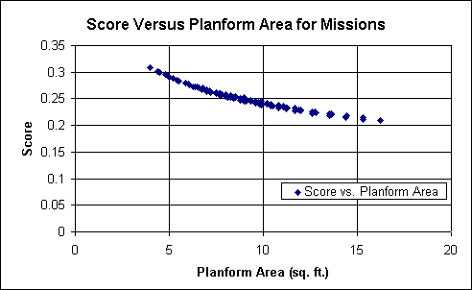

Even though the smallest planform area would benefit the single flight score the most, there is a minimum planfrom area limit that would be unacceptable. If the planform area is too small it will not be able to lift the airplane weight; therefore, a planform area of approximately 6 square feet would definitely be irrelevant. Also with a smaller planform area there would not be enough lift for the airplane to take off in the limited runway length of 120 feet. Thus, anything less than a planform area of approximately 7 square feet would seem irrelevant. As a result the team chose the minimum planform area that would give the proper amount of lift for the airplane to take off at 120 feet as well as this result corresponded to the trade study of the aspect ratio.
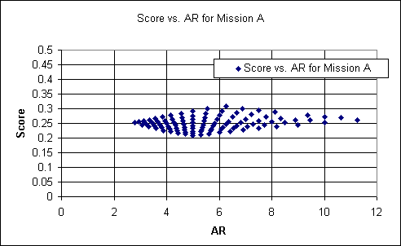

The aspect ratio peaked around 6.3 which corresponded to the assumed planform area. From both trade studies, the optimal planform area is approximately 7.7 square feet, and the optimal aspect ratio is approximately 6.3. The chord length was finalized to be 1.125 feet, and the wing span was finalized to be 7 feet.

