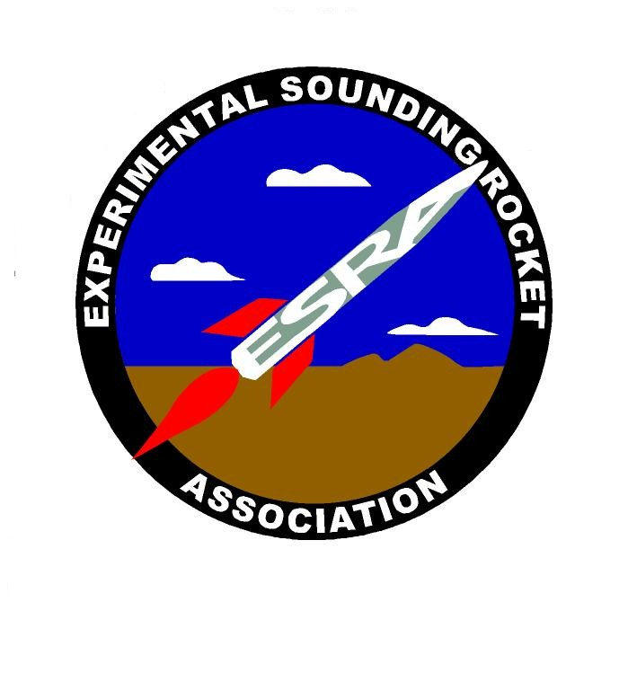
EXPERIMENTAL SOUNDING ROCKET ASSOCIATION
__________________________________________________________
665 N 400 E Logan UT 84321 Phone (435) 797-3536

28 Aug 06

Dear Potential Rocket Launch Competition Participant:
We are starting to put together the plans for the 2nd Annual University Rocket Launch Competition. Please respond within two weeks with your interest in participating (as observers or contestants) and your comments on the following tentative plans:

- Location and Date. Some teams had expressed an interest in a competition in January, some preferred late spring. We could potentially do both, but frankly it would be much easier to have just one. Please indicate your preference:

Near Green River, UT, early January 2007

Near Bozeman, MT, mid-April 2007

Near Green River, UT, mid- to late June 2007

- Daily Schedule. The basic approach is to launch when we can (based on readiness and weather), and give oral presentations when we can’t fly. Since one of the ideas of the competition is to learn about the other schools’ rocket programs, no one will be allowed to work on their rockets during the oral presentations (so the students will have nothing else to do except go to the presentations!) This schedule assumes 4-5 rocket launches:

Thursday morning: registration, rocket preparation
Thursday afternoon: launch decision, launches or oral presentations
Thursday evening: screening of “October Sky”?

Friday morning: launch decision, launches or presentations
Friday afternoon: launch decision, launches or presentations
Friday evening: Awards Banquet

Saturday: backup launch day/Awards Banquet if needed -or- teams depart

Sunday: teams depart if Saturday used for launches

- Competition criteria. The basic criteria will be to launch a 10-lb payload closest to 10,000 feet AGL and recover all rocket components intact. Rocket will record and/or telemeter its altitude vs. time data, and that data will be presented to the judges with 1 hour of rocket retrieval. Rockets will also carry an ESRA-supplied altitude recorder that the judges will use for altitude determination. A large percentage of total points will be for oral presentation, the written paper, and student design/knowledge/professionalism (see judging sheet).

Thank you for your interest,

Paul Mueller, PhD
Chief Engineer

1 atch: Judging Sheet

