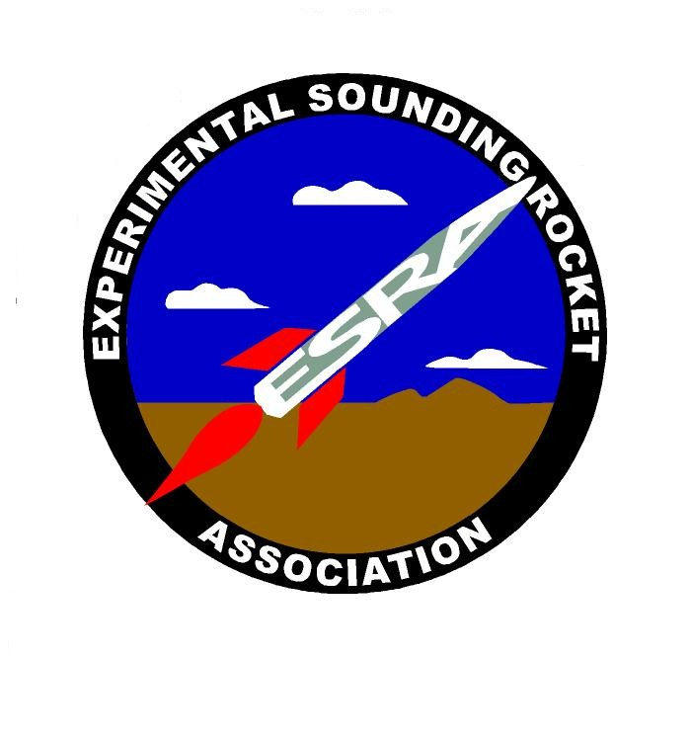
2nd Annual University Rocket Launch Competition Judging Sheet

School:_____________________________________________
Judge’s Name: ______________________________________

Criterion | Maximum Points | Points Awarded
Launch with 10-lb payload  Rocket clears rail, includes 10-lb payload | Qualify/  Disqualify
Written Report  Conciseness (<12 pages), completeness, adequacy of tables and figures, grammar and punctuation, organization, readability. | 200
Oral Presentation  Conciseness (45 min + questions), completeness, adequacy of tables and figures, grammar and punctuation, organization, readability, professionalism. | 150
Student Design  Proportion of rocket designed by students. | 150
Student Knowledge/Operations  Student knowledge about rocket systems, clear assignments of personnel, use of checklists, communication discipline, level of preparation/readiness for launch. | 100
Recovery  Successful recovery of all rocket components. | 100
Trajectory Data  Presented in form readable by judges within one hour of rocket retrieval. | 100
Peak Altitude as read by ESRA sensor  Goal: 10,000 feet AGL.  0 points if max alt < 5000 feet or >12,000 feet  Points = 200 – |10000-max alt|/25 | 200
Bonus points for payload functionality/innovation | 100
Total | 1000 + 100 bonus

Additional comments:

