编号：
2020-2021学年第 1 学期




实 验 报 告

实验课程名称 物联网技术与应用

专 业 班 级 计算机1803

学 生 姓 号 31801150

学 生 姓 名 张帅

实验指导教师 蔡建平

“物联网技术与应用”大作业实验报告

- MQTT基本信息
实际Broker的IP地址或EMQ Cloud地址 | 47.100.136.15
实际Broker的端口或EMQ Cloud端口 | 8083
用户名 | admin
密码 | 123456
多节点支持 | 是

设备端发送给后台
Topic | 说明 | 内容格式 | 举例
ZUCC-ZS/init | 开机发送初始化信息 | {  设备ID  } | {  “zs/1”  }
ZUCC-ZS/warning | 设备发送异常报警 | {  “ename”:设备号,  “msg”:报错信息  } | {  “ename”: “zs/1”,  “msg”: “环境异常”  }
ZUCC-ZS/warning  recover | 设备发送异常恢复信息 | {  “ename”:设备号,  “msg”:恢复信息  } | {  “ename”: “zs/1”,  “msg”: “环境异常恢复”  }
ZUCC-ZS/tah | 设备发送给后台温湿度信息 | {  “ename”:设备号,  “humi”:湿度信息，  “temp”:温度信息  } | {  “ename”: “zs/1”,  “humi”:34，  “temp”:21  }
设备端发送给微信小程序
Topic | 说明 | 内容格式 | 举例
ZUCC-ZS/WX/设备号 | 设备实时传输给微信小程序的温湿度信息 | {  “ename”:设备号,  “humi”:湿度信息，  “temp”:温度信息  } | {  “ename”: “zs/1”,  “humi”:34，  “temp”:21  }
后台发送给设备端
Topic | 说明 | 内容格式 | 举例
ZUCC-ZS/init/设备号 | 后台接收到初始化数据后传递给设备的信息 | {  “deleteflag”:是否接受保护,  “lowert”:最低温度，  “hight”:最高温度，  “lowerh”:最低湿度，  “highh”:最高湿度  } | {  “deleteflag”:0,  “lowert”:12，  “hight”:67，  “lowerh”:2，  “highh”:90  }
后台发送给微信小程序
ZUCC-ZS/update | 提示微信小程序传感器状态可能发送改变 | {  update  } | {  update  }
微信小程序发送给设备端
ZUCC-ZS/check/设备号 | 提示设备保护状态发送改变 | {  状态号  } | {  “0”  }

- 系统架构图
展示出系统由哪几部分构成，连接所用的网络、协议等
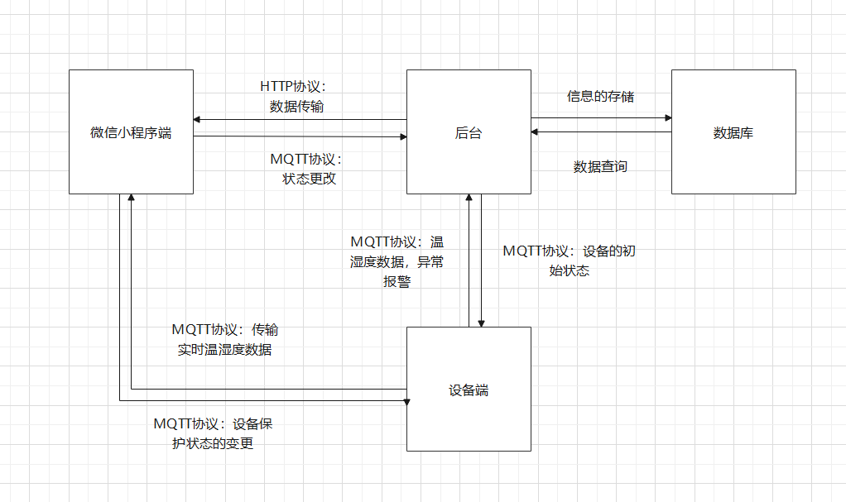
数据库建表脚本
SET FOREIGN_KEY_CHECKS=0;

-- ----------------------------
-- Table structure for admin
-- ----------------------------
DROP TABLE IF EXISTS `admin`;
CREATE TABLE `admin` (
`id` int(32) NOT NULL AUTO_INCREMENT,
`username` varchar(128) DEFAULT NULL,
`passage` varchar(128) DEFAULT NULL,
PRIMARY KEY (`id`)
) ENGINE=InnoDB AUTO_INCREMENT=2 DEFAULT CHARSET=utf8;

-- ----------------------------
-- Table structure for equipment
-- ----------------------------
DROP TABLE IF EXISTS `equipment`;
CREATE TABLE `equipment` (
`id` int(32) NOT NULL AUTO_INCREMENT,
`ename` varchar(128) DEFAULT NULL,
`state` int(1) DEFAULT NULL,
`deleteflag` int(1) DEFAULT NULL,
`lowert` int(32) DEFAULT NULL,
`hight` int(32) DEFAULT NULL,
`lowerh` int(32) DEFAULT NULL,
`highh` int(32) DEFAULT NULL,
PRIMARY KEY (`id`)
) ENGINE=InnoDB AUTO_INCREMENT=3 DEFAULT CHARSET=utf8;

-- ----------------------------
-- Table structure for manager_equip
-- ----------------------------
DROP TABLE IF EXISTS `manager_equip`;
CREATE TABLE `manager_equip` (
`id` int(32) NOT NULL AUTO_INCREMENT,
`eid` int(32) DEFAULT NULL,
`deleteflag` int(1) DEFAULT NULL,
`uid` int(32) DEFAULT NULL,
PRIMARY KEY (`id`)
) ENGINE=InnoDB AUTO_INCREMENT=6 DEFAULT CHARSET=utf8;

-- ----------------------------
-- Table structure for recover
-- ----------------------------
DROP TABLE IF EXISTS `recover`;
CREATE TABLE `recover` (
`id` int(128) NOT NULL AUTO_INCREMENT,
`eid` int(32) DEFAULT NULL,
`temp` int(32) DEFAULT NULL,
`humi` int(32) DEFAULT NULL,
`send_time` timestamp NULL DEFAULT NULL,
PRIMARY KEY (`id`)
) ENGINE=InnoDB AUTO_INCREMENT=19 DEFAULT CHARSET=utf8;

-- ----------------------------
-- Table structure for warning
-- ----------------------------
DROP TABLE IF EXISTS `warning`;
CREATE TABLE `warning` (
`id` int(128) NOT NULL AUTO_INCREMENT,
`eid` int(32) DEFAULT NULL,
`msg` varchar(128) DEFAULT NULL,
`send_time` timestamp NULL DEFAULT NULL,
`deal` int(32) DEFAULT NULL,
PRIMARY KEY (`id`)
) ENGINE=InnoDB AUTO_INCREMENT=256 DEFAULT CHARSET=utf8;

云服务器信息截图（阿里云管理界面等）

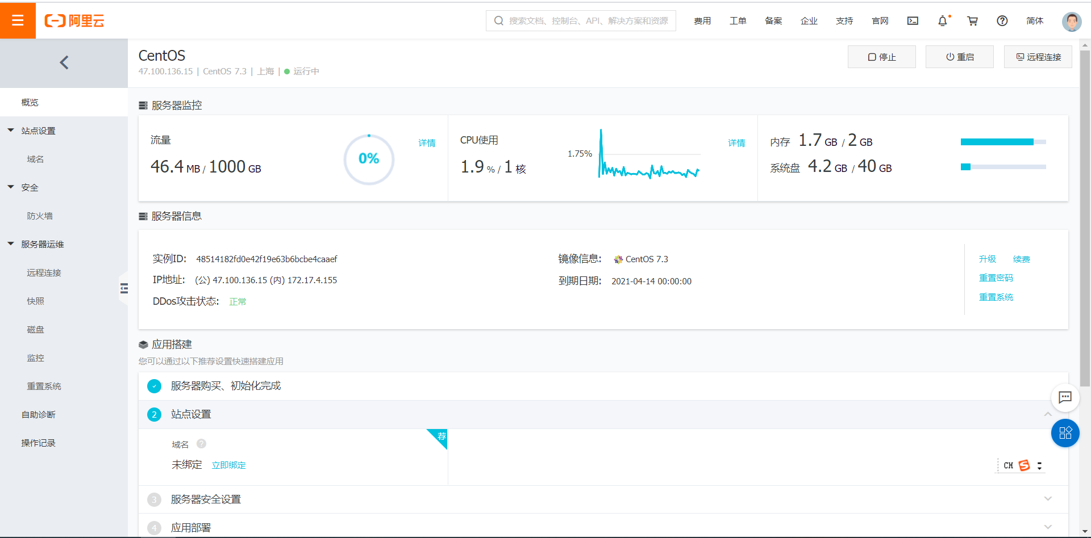
- 各部分详细设计
代码和界面截图
设备端：连接wifi模块并之后连接mqtt服务器，连接成功后向后台发送一个init请求，后台收到后将设备的信息传送给设备，设备将最高温度，最低温度，最高湿度，最低湿度和是否保护状态写入。实时监测当前的温湿度，将温湿度情况实时传输到指定的主题。当温湿度的情况异常时，将向指定的主题发送一条报警信息，温湿度回复正常时，发送一条温湿度恢复的信息。设备端实时监测三轴传感器的状况，如果连续三次监测显示移动异常，在向后台发送报警信息，在异常移动的状态，连续三次监测正常，则发送异常移动恢复的信息。每隔一定时间向后台发送温湿度信息并且保存，如果发现温湿度异常，则立即发送温湿度信息。

#include <ESP8266WiFi.h>
#include "Adafruit_MQTT.h"
#include "Adafruit_MQTT_Client.h"
#define WLAN_SSID "Mi 10000 Ultra"
#define WLAN_PASS "88888888"
#define AIO_SERVER "47.100.136.15"
#define AIO_SERVERPORT 1883
#define AIO_USERNAME ""
#define AIO_KEY ""
#include"SSD1306Wire.h"
SSD1306Wire display(0x3c,2,14);
#include<dht11.h>
#include<ArduinoJson.h>

#include<Wire.h>
#include<math.h>
#define Addr 0x53
const uint8_t scl=2;
const uint8_t sda=14;

unsigned int data[6];
int xAccl;
int yAccl;
int zAccl;

int check=0;
int tahwarning=0;
int movewarning=0;
int count=0;
int movecount=0;
int lowert=0;
int hight=100;
int highh=100;
int lowerh=0;

dht11 DHT11;
// Create an ESP8266 WiFiClient class to connect to the MQTT server.
WiFiClient client;
// or... use WiFiClientSecure for SSL
//WiFiClientSecure client;

StaticJsonDocument<200> doc;
StaticJsonDocument<200> warnmsg;
StaticJsonDocument<200> warnmsgrecover;
StaticJsonDocument<200> initmsg;
StaticJsonDocument<200> tah;

// Setup the MQTT client class by passing in the WiFi client and MQTT server and login details.
Adafruit_MQTT_Client mqtt(&client, AIO_SERVER, AIO_SERVERPORT, AIO_USERNAME, AIO_KEY);
// Setup a feed called 'photocell' for publishing.
// Notice MQTT paths for AIO follow the form: <username>/feeds/<feedname>

Adafruit_MQTT_Publish photocellwarn = Adafruit_MQTT_Publish(&mqtt, AIO_USERNAME "ZUCC-ZS/warning");

Adafruit_MQTT_Publish photocellwarnrecover = Adafruit_MQTT_Publish(&mqtt, AIO_USERNAME "ZUCC-ZS/warningrecover");

Adafruit_MQTT_Publish photocell = Adafruit_MQTT_Publish(&mqtt, AIO_USERNAME "ZUCC-ZS/WX/zs/1");

Adafruit_MQTT_Publish photocellinit = Adafruit_MQTT_Publish(&mqtt, AIO_USERNAME "ZUCC-ZS/init");

Adafruit_MQTT_Publish photoceltah = Adafruit_MQTT_Publish(&mqtt, AIO_USERNAME "ZUCC-ZS/tah");

// Setup a feed called 'onoff' for subscribing to changes.
Adafruit_MQTT_Subscribe onoffbutton = Adafruit_MQTT_Subscribe(&mqtt, AIO_USERNAME "ZUCC-ZS/init/zs/1");

Adafruit_MQTT_Subscribe oncheck = Adafruit_MQTT_Subscribe(&mqtt, AIO_USERNAME "ZUCC-ZS/check/zs/1");

// Bug workaround for Arduino 1.6.6, it seems to need a function declaration
// for some reason (only affects ESP8266, likely an arduino-builder bug).
void MQTT_connect();

void setup() {

Serial.begin(115200);
delay(10);
display.init();

Serial.println(F("Adafruit MQTT demo"));

// Connect to WiFi access point.
Serial.println();
Serial.println();
Serial.print("Connecting to ");
Serial.println(WLAN_SSID);

WiFi.begin(WLAN_SSID, WLAN_PASS);
while (WiFi.status() != WL_CONNECTED) { delay(500);
Serial.print(".");
}
Serial.println();

Serial.println("WiFi connected");
Serial.println("IP address: "); Serial.println(WiFi.localIP());

// Setup MQTT subscription for onoff feed.
mqtt.subscribe(&onoffbutton);
mqtt.subscribe(&oncheck);

}
uint32_t x=0;
void loop() {
int chk = DHT11.read(5);
// Ensure the connection to the MQTT server is alive (this will make the first
// connection and automatically reconnect when disconnected). See the MQTT_connect
// function definition further below.
MQTT_connect();

// this is our 'wait for incoming subscription packets' busy subloop
// try to spend your time here

Adafruit_MQTT_Subscribe *subscription;
while ((subscription = mqtt.readSubscription(5000))) {
if (subscription == &onoffbutton) {
Serial.println((char *)onoffbutton.lastread);
deserializeJson(initmsg,(char*)onoffbutton.lastread);
check=initmsg["deleteflag"];
lowert=initmsg["lowert"];
hight=initmsg["hight"];
lowerh=initmsg["lowerh"];
highh=initmsg["highh"];

}else if(subscription == &oncheck){

if( strcmp((char *)oncheck.lastread,"1" )==0 )
{
check=1;
}else{
check=0;
}

}
}
// Now we can publish stuff!

String output;
String output2;
String output3;
String output4;
String output5;

float nowhumidity=(float)DHT11.humidity;
float nowtemperature=(float)DHT11.temperature;

if(nowhumidity>highh||nowhumidity<lowerh||nowtemperature>hight||nowtemperature<lowert)
{

warnmsg["ename"] = "zs/1";
warnmsg["msg"]="环境异常";

serializeJson(warnmsg ,output);
if (! photocellwarn.publish(output.c_str()))
{
Serial.println(F("Failed"));
} else {
Serial.println(F("OK!"));
delay(200);
}

if(tahwarning==0)
{
tah["ename"] = "zs/1";
tah["humi"] = nowhumidity;
tah["temp"] = nowtemperature;
serializeJson(tah ,output5);
if (! photoceltah.publish(output5.c_str()))
{
Serial.println(F("Failed"));
} else {
Serial.println(F("OK!"));
delay(200);
}
count=0;
}

tahwarning=1;
}else{

if( tahwarning==1)
{
warnmsgrecover["ename"] = "zs/1";
warnmsgrecover["msg"]="环境异常恢复";

serializeJson( warnmsgrecover ,output3);
if (! photocellwarnrecover.publish(output3.c_str()))
{
Serial.println(F("Failed"));
} else {
Serial.println(F("OK!"));
delay(200);
}
tahwarning=0;

tah["ename"] = "zs/1";
tah["humi"] = nowhumidity;
tah["temp"] = nowtemperature;
serializeJson(tah ,output5);
if (! photoceltah.publish(output5.c_str()))
{
Serial.println(F("Failed"));
} else {
Serial.println(F("OK!"));
delay(200);
}
count=0;

}
}

doc["humidity"] = nowhumidity;
doc["temperature"] = nowtemperature;
serializeJson(doc ,output2);
if (!photocell.publish(output2.c_str()))
{
Serial.println(F("Failed"));
} else {
Serial.println(F("OK!"));
delay(200);
}

Wire.beginTransmission(Addr);
Wire.begin(sda,scl);
Wire.write(0x2C);
Wire.write(0x0A);
Wire.endTransmission();

Wire.beginTransmission(Addr);
Wire.write(0x2D);
Wire.write(0x08);
Wire.endTransmission();

Wire.beginTransmission(Addr);
Wire.write(0x31);
Wire.write(0x08);
Wire.endTransmission();

for(int i=0;i<6;i++)
{
Wire.beginTransmission(Addr);
Wire.write((50+i));
Wire.endTransmission();
Wire.requestFrom(Addr,1);

if(Wire.available()==1)
{
data[i]=Wire.read();
}
}
int x,y,z;

x=(((data[1]&0x03)*256)+data[0]);
if(x>511){
x-=1024;
}
y=(((data[3]&0x03)*256)+data[2]);
if(y>511){
y-=1024;
}
z=(((data[5]&0x03)*256)+data[4]);
if(z>511){
z-=1024;
}

int maxx,maxy,maxz;

maxx=abs(x-xAccl);
maxy=abs(y-yAccl);
maxz=abs(z-zAccl);

xAccl=x;
yAccl=y;
zAccl=z;

if(maxx>50||maxy>50||maxz>50)
{

if(movewarning==0)
{
movecount+=1;
if(movecount==3)
{
movecount=0;
movewarning=1;
warnmsg["ename"] = "zs/1";
warnmsg["msg"]="异常移动";
serializeJson(warnmsg ,output4);
if (! photocellwarn.publish(output4.c_str()))
{
Serial.println(F("Failed"));
} else {
Serial.println(F("OK!"));
delay(200);
}
}

}else{
warnmsg["ename"] = "zs/1";
warnmsg["msg"]="异常移动";
serializeJson(warnmsg ,output4);
if (! photocellwarn.publish(output4.c_str()))
{
Serial.println(F("Failed"));
} else {
Serial.println(F("OK!"));
delay(200);
}
}

}else{
if(movewarning==1)
{
movecount+=1;
if(movecount==3)
{
movecount=0;
movewarning=0;
warnmsgrecover["ename"] = "zs/1";
warnmsgrecover["msg"]="异常移动恢复";
serializeJson(warnmsgrecover ,output4);
if (! photocellwarnrecover.publish(output4.c_str()))
{
Serial.println(F("Failed"));
} else {
Serial.println(F("OK!"));
delay(200);
}
}
}else{
movecount=0;
}
}

if(check==1&&movewarning==0){
Serial.println("unrecover");
}

count++;
if(count>=1000){
tah["ename"] = "zs/1";
tah["humi"] = nowhumidity;
tah["temp"] = nowtemperature;
serializeJson(warnmsg ,output5);
if (! photoceltah.publish(output5.c_str()))
{
Serial.println(F("Failed"));
} else {
Serial.println(F("OK!"));
delay(200);
}
count=0;

}

}

void MQTT_connect() {
int8_t ret;

// Stop if already connected.
if (mqtt.connected()) {
return;
}
Serial.print("Connecting to MQTT... "); uint8_t retries = 3;
while ((ret = mqtt.connect()) != 0) { // connect will return 0 for connected
Serial.println(mqtt.connectErrorString(ret));
Serial.println("Retrying MQTT connection in 5 seconds..."); mqtt.disconnect();
delay(5000); // wait 5 seconds retries--;
if (retries == 0) {
// basically die and wait for WDT to reset me
while (1);
}
}
Serial.println("MQTT Connected!");

String initstr="zs/1";
photocellinit.publish(initstr.c_str());

}

后台代码：
SPRINGBOOT集成mqtt代码：

package com.example.mqtt.mqtt;
import org.eclipse.paho.client.mqttv3.*;
import org.eclipse.paho.client.mqttv3.persist.MemoryPersistence;
public class MyMqttClient {
public static final String HOST = "tcp://47.100.136.15";
public static final String TOPIC1 = "ZUCC-ZS/#";
private static String clientid = "";
private MqttClient client;
private MqttConnectOptions options;
private String userName = ""; // 非必须
private String passWord = ""; // 非必须
// 开始连接
public void start() {
try {
clientid=System.currentTimeMillis()+"zs";
// host为主机名，clientid即连接MQTT的客户端ID，一般以唯一标识符表示，MemoryPersistence设置clientid的保存形式，默认为以内存保存
client = new MqttClient(HOST, clientid, new MemoryPersistence());
// MQTT的连接设置
options = new MqttConnectOptions();
// 设置是否清空session,这里如果设置为false表示服务器会保留客户端的连接记录，设置为true表示每次连接到服务器都以新的身份连接
options.setCleanSession(false);
// 设置连接的用户名
// options.setUserName(userName);
// 设置连接的密码
// options.setPassword(passWord.toCharArray());
// 设置超时时间 单位为秒
options.setConnectionTimeout(10);
// 设置会话心跳时间 单位为秒 服务器会每隔1.5*20秒的时间向客户端发送个消息判断客户端是否在线，但这个方法并没有重连的机制
options.setKeepAliveInterval(20);
// 设置断开后重新连接
options.setAutomaticReconnect(true);
// 设置回调
client.setCallback(new PushCallback());
//MqttTopic topic = client.getTopic(TOPIC1);
// setWill方法，如果项目中需要知道客户端是否掉线可以调用该方法。设置最终端口的通知消息 遗嘱
//options.setWill(topic, "close".getBytes(), 1, true);
client.connect(options);
// 订阅消息
sub(TOPIC1);
} catch (Exception e) {
e.printStackTrace();
}
}
/**
* 关闭MQTT连接
*/
public void close() throws MqttException {
client.close();
client.disconnect();
}
/**
* 向某个主题发布消息 默认qos：1
*
* @param topic:发布的主题
* @param msg：发布的消息
*/
public void pub(String topic, String msg) throws MqttException {
MqttMessage mqttMessage = new MqttMessage();
//mqttMessage.setQos(2);
mqttMessage.setPayload(msg.getBytes());
MqttTopic mqttTopic = client.getTopic(topic);
MqttDeliveryToken token = mqttTopic.publish(mqttMessage);
token.waitForCompletion();
}
/**
* 向某个主题发布消息
*
* @param topic: 发布的主题
* @param msg: 发布的消息
* @param qos: 消息质量 Qos：0、1、2
*/
public void pub(String topic, String msg, int qos) throws MqttException {
MqttMessage mqttMessage = new MqttMessage();
mqttMessage.setQos(qos);
mqttMessage.setPayload(msg.getBytes());
MqttTopic mqttTopic = client.getTopic(topic);
MqttDeliveryToken token = mqttTopic.publish(mqttMessage);
token.waitForCompletion();
}
/**
* 订阅某一个主题 ，此方法默认的的Qos等级为：1
*
* @param topic 主题
*/
public void sub(String topic) throws MqttException {
client.subscribe(topic);
}
/**
* 订阅某一个主题，可携带Qos
*
* @param topic 所要订阅的主题
* @param qos 消息质量：0、1、2
*/
public void sub(String topic, int qos) throws MqttException {
client.subscribe(topic, qos);
}
}

public class PushCallback implements MqttCallback {
public static final String HOST = "tcp://47.100.136.15";
private MqttConnectOptions options;
private static String clientid = "";
private MqttClient client;
public void connectionLost(Throwable cause) {
System.out.println("connectionLost---------连接断开，可以做重连");
}
public void deliveryComplete(IMqttDeliveryToken token) {
System.out.println("deliveryComplete---------" + token.isComplete());
}
public void messageArrived(String topic, MqttMessage message) throws Exception {
System.out.println("接收消息主题 : " + topic);
System.out.println("接收消息Qos : " + message.getQos());
String res = new String(message.getPayload());
System.out.println("接收消息内容 : " + res);
clientid=System.currentTimeMillis()+"zs2";
client = new MqttClient(HOST, clientid, new MemoryPersistence());
client.connect(options);
//通过上下文的方式获取Service，然后在这个地方保存数据即可
if(topic.equals("ZUCC-ZS/tah")){
ApplicationContext context = SpringUtil.context; //获取Spring容器
RecoverDAO recoverDAO=context.getBean(RecoverDAO.class);
EquipmentDAO equipmentDAO=context.getBean(EquipmentDAO.class);
JSONObject receive=JSON.parseObject(new String(message.getPayload()));
RecoverEntity recoverEntity=new RecoverEntity();
Integer id=equipmentDAO.findByEname((String) receive.get("ename")).getId();
recoverEntity.setEid(id);
recoverEntity.setHumi((Integer) receive.get("humi"));
recoverEntity.setTemp((Integer) receive.get("temp"));
recoverEntity.setSendTime(new Timestamp( System.currentTimeMillis()));
recoverDAO.save(recoverEntity);
}else if(topic.equals("ZUCC-ZS/init")){
String ename=new String(message.getPayload());
ApplicationContext context = SpringUtil.context; //获取Spring容器
EquipmentDAO equipmentDAO =context.getBean(EquipmentDAO.class);
EquipmentEntity equipmentEntity=equipmentDAO.findByEname(ename);
MqttMessage mqttMessage = new MqttMessage();
JSONObject jsonObject=new JSONObject();
jsonObject.put("lowert",equipmentEntity.getLowert());
jsonObject.put("lowerh",equipmentEntity.getLowerh());
jsonObject.put("hight",equipmentEntity.getHight());
jsonObject.put("highh",equipmentEntity.getHighh());
jsonObject.put("deleteflag",equipmentEntity.getDeleteflag());
mqttMessage.setPayload(jsonObject.toString().getBytes());
MqttTopic mqttTopic = client.getTopic("ZUCC-ZS/init/"+ename);
MqttDeliveryToken token = mqttTopic.publish(mqttMessage);
token.waitForCompletion();
}else if(topic.equals("ZUCC-ZS/warning")){
JSONObject receive=JSON.parseObject(new String(message.getPayload()));
ApplicationContext context = SpringUtil.context; //获取Spring容器
WarningDAO warningDAO= context.getBean(WarningDAO.class);
ApplicationContext context2 = SpringUtil.context; //获取Spring容器
EquipmentDAO equipmentDAO=context2.getBean(EquipmentDAO.class);
EquipmentEntity equipmentEntity=equipmentDAO.findByEname((String) receive.get("ename"));
Integer id=equipmentEntity.getId();
Integer state=equipmentEntity.getState();
WarningEntity warningEntity=new WarningEntity();
warningEntity.setDeal(0);
warningEntity.setMsg((String) receive.get("msg"));
warningEntity.setSendTime(new Timestamp( System.currentTimeMillis()));
warningEntity.setEid(id);
if(receive.get("msg").equals("环境异常")&&state!=2&&state!=3) {
if(equipmentEntity.getDeleteflag()==0)
warningDAO.save(warningEntity);
equipmentEntity.setState(2);
equipmentDAO.save(equipmentEntity);
MqttMessage mqttMessage = new MqttMessage();
mqttMessage.setPayload("update".getBytes());
MqttTopic mqttTopic = client.getTopic("ZUCC-ZS/update");
MqttDeliveryToken token = mqttTopic.publish(mqttMessage);
token.waitForCompletion();
}
else if((receive.get("msg")).equals("异常移动")&&state!=3)
{
if(equipmentEntity.getDeleteflag()==0)
warningDAO.save(warningEntity);
equipmentEntity.setState(3);
equipmentDAO.save(equipmentEntity);
MqttMessage mqttMessage = new MqttMessage();
mqttMessage.setPayload("update".getBytes());
MqttTopic mqttTopic = client.getTopic("ZUCC-ZS/update");
MqttDeliveryToken token = mqttTopic.publish(mqttMessage);
token.waitForCompletion();
}
}else if(topic.equals("ZUCC-ZS/warningrecover")){
JSONObject receive=JSON.parseObject(new String(message.getPayload()));
ApplicationContext context = SpringUtil.context; //获取Spring容器
EquipmentDAO equipmentDAO=context.getBean(EquipmentDAO.class);
EquipmentEntity equipmentEntity=equipmentDAO.findByEname((String) receive.get("ename"));
Integer state=equipmentEntity.getState();
if((receive.get("msg")).equals("环境异常恢复")&&state!=1) {
MqttMessage mqttMessage = new MqttMessage();
equipmentEntity.setState(1);
equipmentDAO.save(equipmentEntity);
mqttMessage.setPayload("update".getBytes());
MqttTopic mqttTopic = client.getTopic("ZUCC-ZS/update");
MqttDeliveryToken token = mqttTopic.publish(mqttMessage);
token.waitForCompletion();
}
else if(((String) receive.get("msg")).equals("异常移动恢复")&&state!=1)
{
MqttMessage mqttMessage = new MqttMessage();
equipmentEntity.setState(1);
equipmentDAO.save(equipmentEntity);
mqttMessage.setPayload("update".getBytes());
MqttTopic mqttTopic = client.getTopic("ZUCC-ZS/update");
MqttDeliveryToken token = mqttTopic.publish(mqttMessage);
token.waitForCompletion();
}
}
}
@Component
public static class SpringUtil extends ApplicationObjectSupport {
public static ApplicationContext context;
public static Object getBean(String serviceName){
return context.getBean(serviceName);
}
@Override
protected void initApplicationContext(ApplicationContext context) throws BeansException {
super.initApplicationContext(context);
SpringUtil.context = context;
}
}
}

微信小程序代码：
首先需要管理员登录账号进行管理
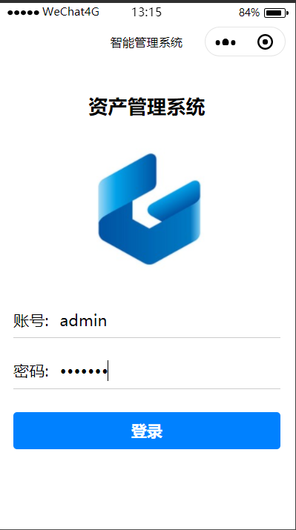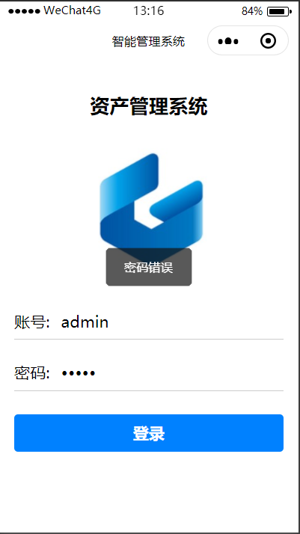

登录后可以看到管理员管理的设备，显示当前状态，保护状况和历史异常，以及实时的温湿度状况发生移动异常，微信小程序界面刷新，显示当前状态和异常信息，同时上方的选项卡位置标红。点击处理按钮视为管理员已经处理的异常报警，报警信息消失。管理员可以点击取消对设备的保护状态，取消保护状态后，设备将进行异常报警的发送。
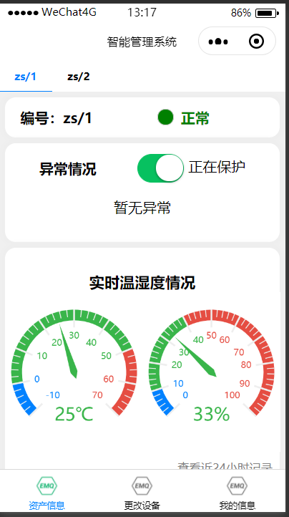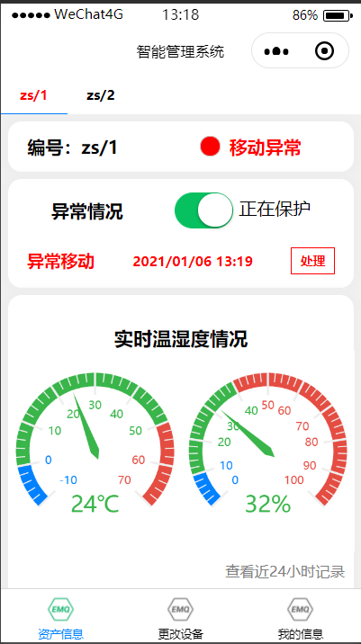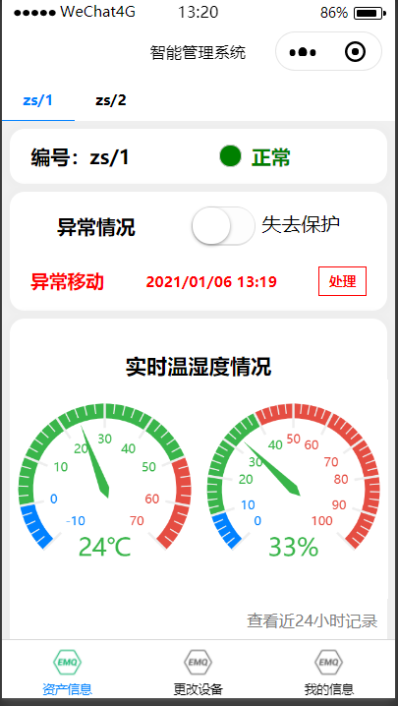
点击查看历史记录可以看到历史的温湿度记录
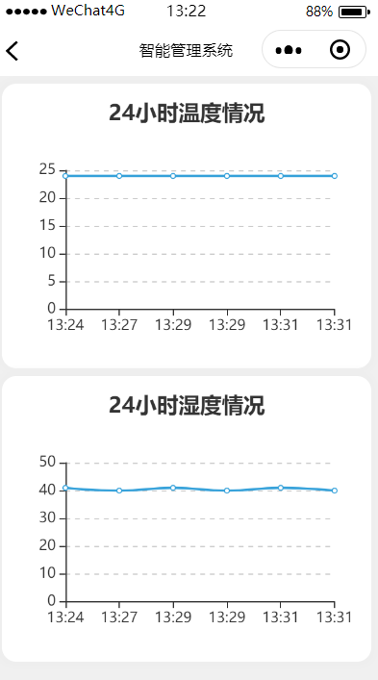
点击上方选项卡可以切换查看的设备。
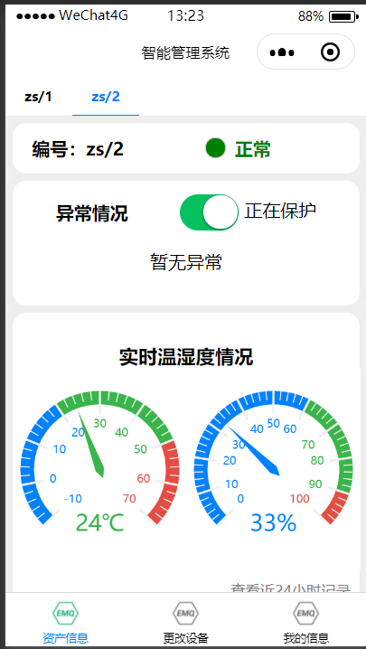
在更改设备的页面，建议移出和添加设备，一台设备只能绑定一个账号否则将报错，绑定时系统会检测是否注册该设备，没有注册的设备也无法绑定
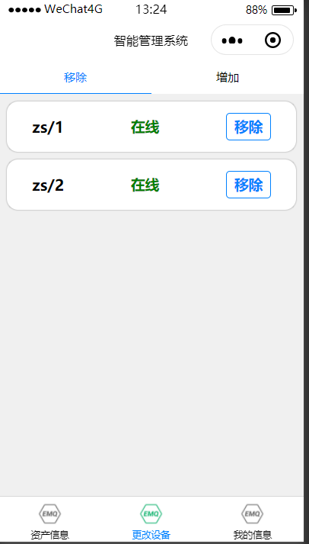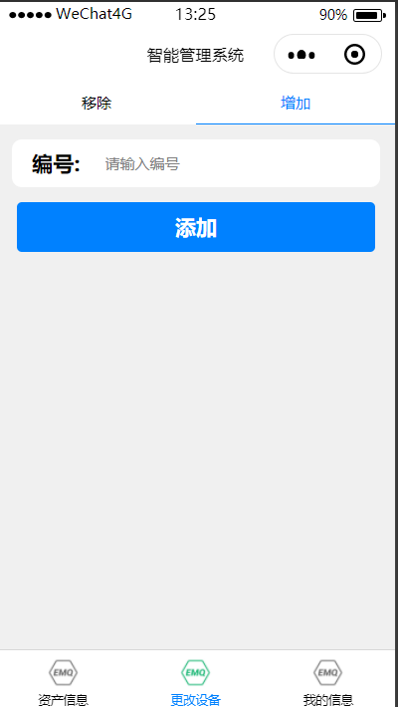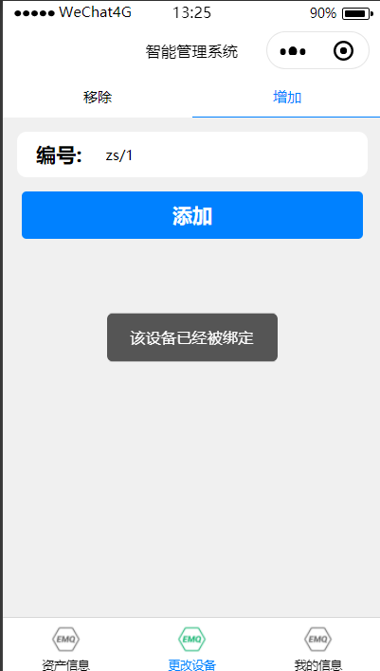
在个人信息界面可以切换登录的管理员账号
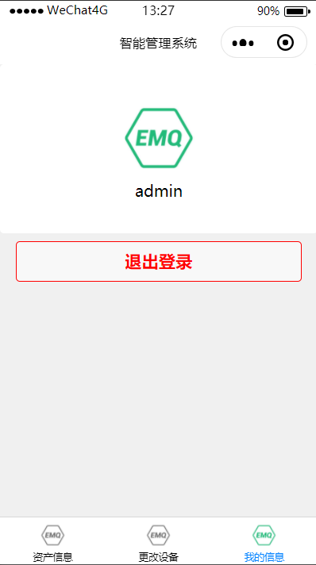

设备监控页面js文件：
//index.js
//获取应用实例
const app = getApp()
var mqtt = require('../../utils/mqtt.js');

import * as echarts from '../../echarts-for-weixin-master/ec-canvas/echarts';
var chart1 = null;
var chart2 = null;

function initChart(canvas, width, height, dpr) {
chart1 = echarts.init(canvas, null, {
width: width,
height: height,
devicePixelRatio: dpr // new
});
canvas.setChart(chart1);

var option = {
backgroundColor: "#ffffff",
color: ["#37A2DA", "#32C5E9", "#67E0E3"],
series: [{
radius: 70,
min:-10,
max:70,
splitNumber: 8,
type: 'gauge',
detail: {
formatter: '{value}℃',
offsetCenter : [0, '70%'],
textStyle: {

fontSize: 20,

}
},
axisLine: {
show: true,
lineStyle: {
width: 12,
shadowBlur: 0,
color: [
[0.1, '#0081ff'],
[0.9, '#39b54a'],
[1, '#e54d42']
]
}
},
pointer: {

show: true,
width: 4,
},
axisTick: {
show: true,
},
//分隔线样式。
splitLine: {
length:20,
},
//刻度标签。
axisLabel: {

show: true,
textStyle: {

fontSize: 10,

}
},

data: [{
value: 0,

}]

}]
};

chart1.setOption(option, true);

return chart1;
}

function initChart2(canvas, width, height, dpr) {
chart2 = echarts.init(canvas, null, {
width: width,
height: height,
devicePixelRatio: dpr // new
});
canvas.setChart(chart2);

var option = {
backgroundColor: "#ffffff",
color: ["#37A2DA", "#32C5E9", "#67E0E3"],
series: [{
radius: 70,

type: 'gauge',
detail: {
formatter: '{value}%',
offsetCenter : [0, '70%'],
textStyle: {

fontSize: 20,

}
},
axisLine: {
show: true,
lineStyle: {
width: 12,
shadowBlur: 0,
color: [
[0.1, '#0081ff'],
[0.9, '#39b54a'],
[1, '#e54d42']
]
}
},
pointer: {

show: true,
width: 4,
},
axisTick: {
show: true,
},
//分隔线样式。
splitLine: {
length:20,
},
//刻度标签。
axisLabel: {
show: true,
textStyle: {

fontSize: 10,

}
},

data: [{
value: 0,

}]

}]
};

chart2.setOption(option, true);

return chart2;
}

连接界面js文件
const app = getApp() //全局变量
var mqtt = require('../../utils/mqtt.js'); //引入mqttjs

Page({
/**
* 页面的初始数据
*/
data: {
address:"wx://47.100.136.15",
port:8083,
path:"/mqtt",
username:"admin",
password:null,

},

AddressInput:function(e){
this.setData({
address:e.detail.value,
})
},

PortInput:function(e){
this.setData({
port:e.detail.value,
})
},

PathInput:function(e){
this.setData({
path:e.detail.value,
})
},

NameInput:function(e){
this.setData({
username:e.detail.value,
})
},

PswInput:function(e){
this.setData({
password:e.detail.value,
})
},

connectmqtt: function() {
let that=this

wx.request({
url: 'http://localhost:8086/admin/login',
data: {
username: this.data.username ,
password: this.data.password
},
header: {
'content-type': 'application/json' // 默认值
},
success: function(res) {
if(res.data.port=="200")
{
const options = {
connectTimeout: 4000, // 超时时间
clientId: 'wx_' + parseInt(Math.random() * 100 + 800, 10),
port: that.data.port,
username: that.data.username,
password: that.data.password,
reconnect : false
}

//ip的拼接
var ipAddress = that.data.address+that.data.path;
//mqtt连接
app.globalData.client = mqtt.connect(ipAddress, options)
//连接失败
app.globalData.client.on('error', (error) => {
wx.showToast({
title: 'MQTT连接错误',
icon: 'none',
duration: 2000
})

})

//连接成功
app.globalData.client.on('connect', (e) => {
wx.showToast({
title: '登录成功',
icon: 'success',
duration: 2000
})
wx.setStorageSync('name', that.data.username)
wx.setStorageSync('id',res.data.data.id)
//跳转
wx.switchTab({
url: '../receive/receive',
})
})
}else{
wx.showToast({
title: res.data.msg,
icon: 'none',
duration: 2000
})
}
}
})

},

})

修改设备绑定信息界面js文件
// pages/change/change.js
Page({

/**
* 页面的初始数据
*/
data: {
menuTapCurrent:0,
ename:"",
equip:[

]
},
enameInput(e){
this.setData({
ename:e.detail.value,
})
},

sumbit(){
let that=this
let id=wx.getStorageSync("id");
wx.request({
url: 'http://localhost:8086/manager/add',
data: {
uid:id,
eid:that.data.ename,
},
header: {
'content-type': 'application/json' // 默认值
},
success: function(res) {
wx.showToast({
title: res.data.msg,
icon: 'none',
duration: 2000
})
wx.request({
url: 'http://localhost:8086/equip/list',
data: {
id:id
},
header: {
'content-type': 'application/json' // 默认值
},
success: function(res) {
that.setData({
equip:res.data.data
})
}
})
}
})
},
unmanager(e){
let that=this
let id=wx.getStorageSync("id");
wx.request({
url: 'http://localhost:8086/manager/unmanager',
data: {
uid:id,
eid:e.currentTarget.dataset.eid,

},
header: {
'content-type': 'application/json' // 默认值
},
success: function(res) {
wx.request({
url: 'http://localhost:8086/equip/list',
data: {
id:id
},
header: {
'content-type': 'application/json' // 默认值
},
success: function(res) {
that.setData({
equip:res.data.data
})
}
})
}
})
},
onLoad(){
let that=this
let id=wx.getStorageSync("id");
wx.request({
url: 'http://localhost:8086/equip/list',
data: {
id:id
},
header: {
'content-type': 'application/json' // 默认值
},
success: function(res) {
that.setData({
equip:res.data.data
})
}
})
},
menuTap:function(e){
var current=e.currentTarget.dataset.current;//获取到绑定的数据
//改变menuTapCurrent的值为当前选中的menu所绑定的数据
this.setData({
menuTapCurrent:current
});

},

})

- 课程学习小结（800字以上）
这学期接触了物联网技术与应用这门方向必修课。在之前的学习中，主要接触软件和编码方面的计算机技术，也主要和代码打交道，而物联网这门课，在编写代码和的基础上，我们还进一步对硬件有了一定的了解，我对计算机技术学习上新的挑战。
在课程的学习中，蔡老师带领我们从最基础的helloword做起，将手上的ESP8266开发板一步步充实为一个物联网的应用，从最开始的串口打印信息，再到呼吸灯，之后是显示屏的可视化输出，还有led彩灯的运用，我们的开发板逐步充实，也有了更多的选择；之后，我们又逐步学会了添加传感器并读取传感器的数据，这次接触了DHT11,三轴传感器等十分通用的传感器模块，我们已经可以设计出比较具有价值的系统，之后我们深入学习相关技术以后，还可以利用物联网的模块做更多的设计和拓展。
在对开发板进行深入的学习以后，我们认识到，设备只是物联网系统中的一个组成部分，一个物联网系统离不开通信和协议，在之前学习的计算机网络等课程中，我们计算机网络的通信只有理论上的认识，也没有具体操作的体验，在这次的物联网课程中，我们使用了http，wifi模块，mqtt等协议，进行了设备和系统之间的通信和信息传输，对之前的计算机网络等内容有了更加深刻和具体可感的认识。
在学习mqtt协议的过程中，老师还请来了来自mqtt协议的头部公司emq的工程师为我们进行现场教学，他们从理论到实战，为我们清晰讲述了mqtt协议的工作原理和操作流程，还手把手为带领我们运用emqx的平台进行mqtt的通信。我们很少有这样的机会和工程师面对面，在工程师事无巨细的指导下，我们很快上手了emqx的产品，打通了整个物联网系统的流程。
在本学期物联网的学习中。蔡老师还带领我们前往行业巨头大华公司进行参观学习，我们有机会走出教室，走进真正的物联网企业，我们看到了头部公司先进的技术和理念，也接触到了高端的物联网设备和产品，深刻体会了物联网在我们生活的方方面面，和未来的重要作用。我们都更加深刻得认识到了物联网对社会的意义，也让我对物联网有了更加浓厚的兴趣。
最后几节课，蔡老师教我们使用websocket，微信小程序等开发工具对物联网完成物联网系统的最后一个环节，将数据展示到界面中，组成一个完整的物联网系统。在简单的上手和操作后，我们实现了从0开始走通物联网的每一个环节，自己完成一个物联网的作品。
最后的大作业，我实现了一个基于mqtt协议和esp8266开发板的资产管理系统，通过将本学期学习的传感器采集数据，控制LED灯闪烁，mqtt协议通信和微信小程序的开发以及数据可视化结合了起来。虽然只是一个小系统，但是我还是感觉小有成就，在之后的学习生活我，我希望可以了解更多物联网的知识，通过自己的学习，深入了解物联网，完成更多更有意义的物联网产品。

