浙大城市学院实验报告
课程名称 物联网技术与应用 实验项目 实验七物联网协议与MQTT基础实验
专业班级 计算机1803 学号 31801150 姓名 张帅
指导老师（签名 ） 蔡建平 日期 实验成绩

一、实验目的：
掌握HTTP协议的相关理论与实践；掌握ESP8266的ESP8266WiFi.h、WiFiClient.h、ESP8266WebServer.h等库的基本方法及使用；熟悉网络应用中WebClient、Web Server的角色。
二、实验内容：
1. MQTT客户端连接服务器部署
2. ESP8266连接MQTT服务器
3. 在OLED屏上显示提交的Topic和订阅的Topic
实验步骤：

1. MQTT客户端连接服务器部署。

MQTT客户端连接MQTT服务器进行消息发布和订阅（需在消息主题中包括本人姓名的首字母）：

客户端截图：
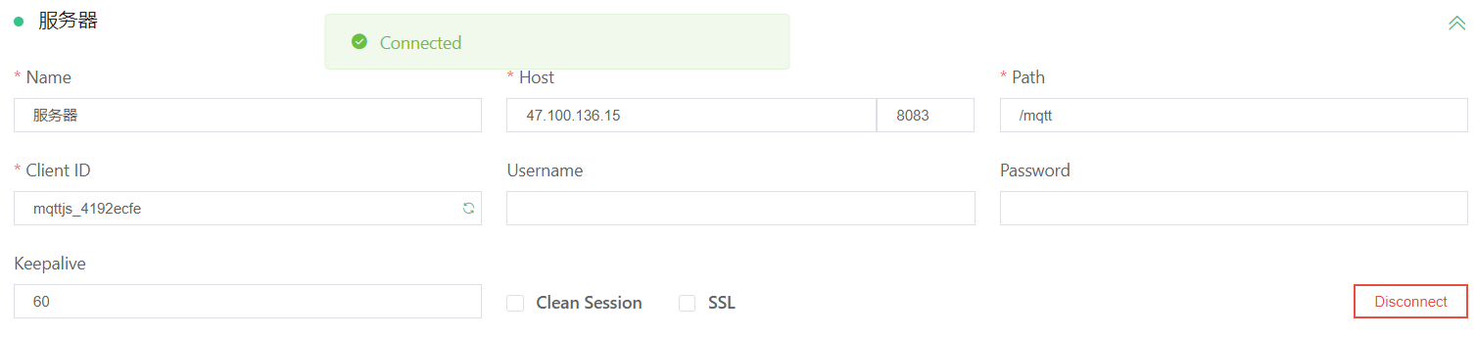

服务端截图：
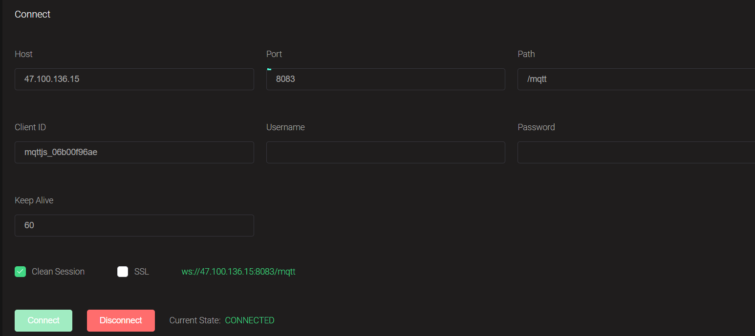

Web客户端连接EMQ服务器进行消息发布和订阅：
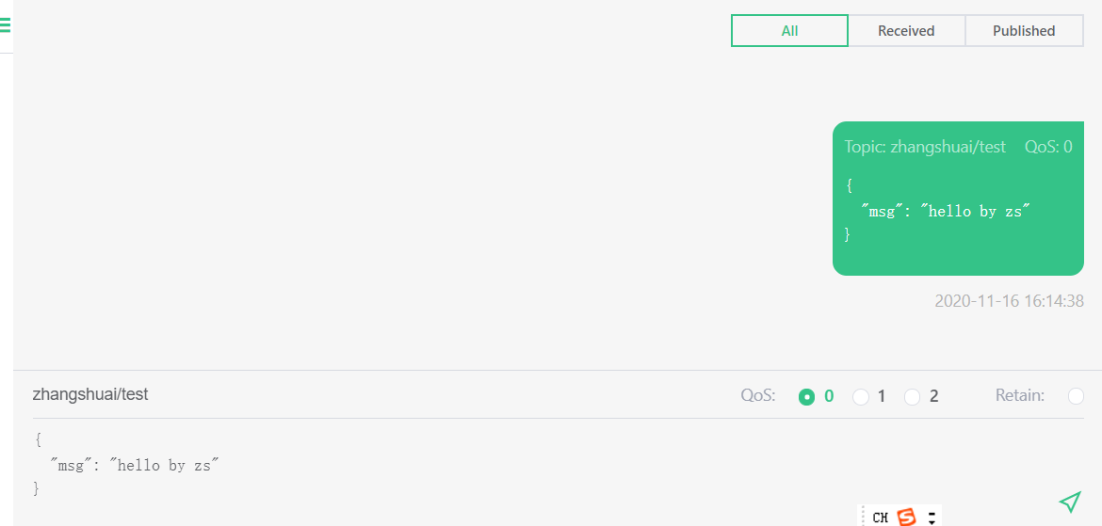

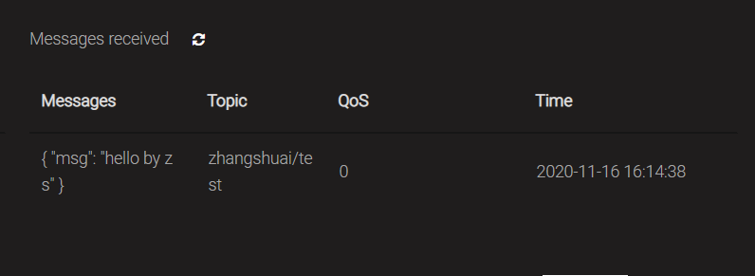

2. ESP8266连接MQTT服务器（需在消息主题中包括本人姓名的首字母）。
代码：
#include <ESP8266WiFi.h>
#include "Adafruit_MQTT.h"
#include "Adafruit_MQTT_Client.h"
#define WLAN_SSID "Mi 10000 Ultra"
#define WLAN_PASS "88888888"
#define AIO_SERVER "47.100.136.15"
#define AIO_SERVERPORT 1883
#define AIO_USERNAME ""
#define AIO_KEY ""

// Create an ESP8266 WiFiClient class to connect to the MQTT server.
WiFiClient client;
// or... use WiFiClientSecure for SSL
//WiFiClientSecure client;

// Setup the MQTT client class by passing in the WiFi client and MQTT server and login details.
Adafruit_MQTT_Client mqtt(&client, AIO_SERVER, AIO_SERVERPORT, AIO_USERNAME, AIO_KEY);
// Setup a feed called 'photocell' for publishing.
// Notice MQTT paths for AIO follow the form: <username>/feeds/<feedname>
Adafruit_MQTT_Publish photocell = Adafruit_MQTT_Publish(&mqtt, AIO_USERNAME "zhangshuai");

// Setup a feed called 'onoff' for subscribing to changes.
Adafruit_MQTT_Subscribe onoffbutton = Adafruit_MQTT_Subscribe(&mqtt, AIO_USERNAME "zhangshuai/1");

// Bug workaround for Arduino 1.6.6, it seems to need a function declaration
// for some reason (only affects ESP8266, likely an arduino-builder bug).
void MQTT_connect();

void setup() {
Serial.begin(115200); delay(10);

Serial.println(F("Adafruit MQTT demo"));

// Connect to WiFi access point.
Serial.println();
Serial.println();
Serial.print("Connecting to ");
Serial.println(WLAN_SSID);

WiFi.begin(WLAN_SSID, WLAN_PASS);
while (WiFi.status() != WL_CONNECTED) { delay(500);
Serial.print(".");
}
Serial.println();

Serial.println("WiFi connected");
Serial.println("IP address: "); Serial.println(WiFi.localIP());

// Setup MQTT subscription for onoff feed. mqtt.subscribe(&onoffbutton);
}
uint32_t x=0; void loop() {
// Ensure the connection to the MQTT server is alive (this will make the first
// connection and automatically reconnect when disconnected). See the MQTT_connect
// function definition further below.
MQTT_connect();

// this is our 'wait for incoming subscription packets' busy subloop
// try to spend your time here

Adafruit_MQTT_Subscribe *subscription;
while ((subscription = mqtt.readSubscription(5000))) { if (subscription == &onoffbutton) {
Serial.print(F("Got: "));
Serial.println((char *)onoffbutton.lastread);
}
}
// Now we can publish stuff!
Serial.print(F("\nSending photocell val ")); Serial.print(x);
Serial.print("...");
if (! photocell.publish(x++)) { Serial.println(F("Failed"));
} else {
Serial.println(F("OK!"));
}

// ping the server to keep the mqtt connection alive
// NOT required if you are publishing once every KEEPALIVE seconds
/*
if(! mqtt.ping()) { mqtt.disconnect();
}
*/
}

// Function to connect and reconnect as necessary to the MQTT server.
// Should be called in the loop function and it will take care if connecting.
void MQTT_connect() {
int8_t ret;

// Stop if already connected.
if (mqtt.connected()) {
return;
}
Serial.print("Connecting to MQTT... "); uint8_t retries = 3;
while ((ret = mqtt.connect()) != 0) { // connect will return 0 for connected
Serial.println(mqtt.connectErrorString(ret));
Serial.println("Retrying MQTT connection in 5 seconds..."); mqtt.disconnect();
delay(5000); // wait 5 seconds retries--;
if (retries == 0) {
// basically die and wait for WDT to reset me
while (1);
}
}
Serial.println("MQTT Connected!");
}
截图：
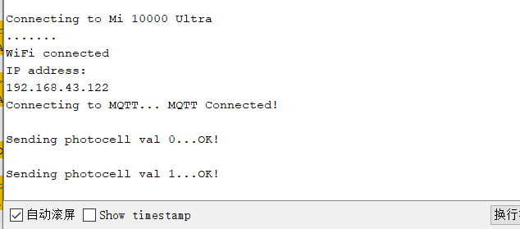
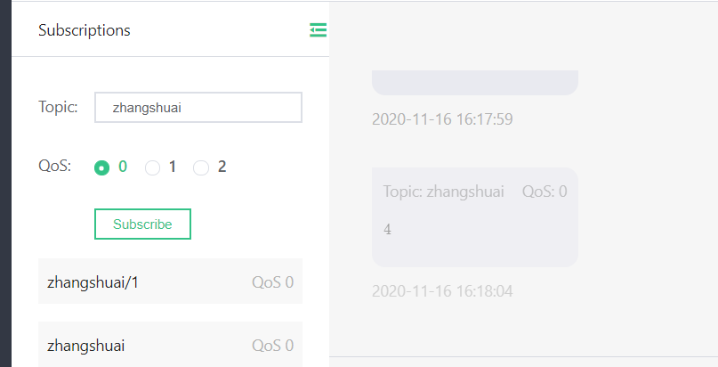
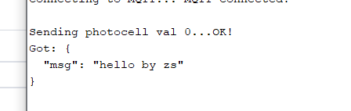

3. 在OLED屏上显示提交的Topic和订阅的Topic（需在消息主题中包括本人姓名的首字母）。

程序：
#include <ESP8266WiFi.h>
#include "Adafruit_MQTT.h"
#include "Adafruit_MQTT_Client.h"
#define WLAN_SSID "Mi 10000 Ultra"
#define WLAN_PASS "88888888"
#define AIO_SERVER "47.100.136.15"
#define AIO_SERVERPORT 1883
#define AIO_USERNAME ""
#define AIO_KEY ""
#include"SSD1306Wire.h"
SSD1306Wire display(0x3c,2,14);

// Create an ESP8266 WiFiClient class to connect to the MQTT server.
WiFiClient client;
// or... use WiFiClientSecure for SSL
//WiFiClientSecure client;

// Setup the MQTT client class by passing in the WiFi client and MQTT server and login details.
Adafruit_MQTT_Client mqtt(&client, AIO_SERVER, AIO_SERVERPORT, AIO_USERNAME, AIO_KEY);
// Setup a feed called 'photocell' for publishing.
// Notice MQTT paths for AIO follow the form: <username>/feeds/<feedname>
Adafruit_MQTT_Publish photocell = Adafruit_MQTT_Publish(&mqtt, AIO_USERNAME "zhangshuai");

// Setup a feed called 'onoff' for subscribing to changes.
Adafruit_MQTT_Subscribe onoffbutton = Adafruit_MQTT_Subscribe(&mqtt, AIO_USERNAME "zhangshuai/1");

// Bug workaround for Arduino 1.6.6, it seems to need a function declaration
// for some reason (only affects ESP8266, likely an arduino-builder bug).
void MQTT_connect();

void setup() {
Serial.begin(115200); delay(10);
display.init();

Serial.println(F("Adafruit MQTT demo"));

// Connect to WiFi access point.
Serial.println();
Serial.println();
Serial.print("Connecting to ");
Serial.println(WLAN_SSID);

WiFi.begin(WLAN_SSID, WLAN_PASS);
while (WiFi.status() != WL_CONNECTED) { delay(500);
Serial.print(".");
}
Serial.println();

Serial.println("WiFi connected");
Serial.println("IP address: "); Serial.println(WiFi.localIP());

// Setup MQTT subscription for onoff feed.
mqtt.subscribe(&onoffbutton);
}
uint32_t x=0; void loop() {
// Ensure the connection to the MQTT server is alive (this will make the first
// connection and automatically reconnect when disconnected). See the MQTT_connect
// function definition further below.
MQTT_connect();

// this is our 'wait for incoming subscription packets' busy subloop
// try to spend your time here

Adafruit_MQTT_Subscribe *subscription;
while ((subscription = mqtt.readSubscription(5000))) { if (subscription == &onoffbutton) {
Serial.print(F("Got: "));
Serial.println((char *)onoffbutton.lastread);

display.flipScreenVertically();
display.clear();
display.drawString(0,10,"topic: zhangshuai/1");
display.drawString(0,20,(char *)onoffbutton.lastread);
display.display();
delay(2000);
}
}
// Now we can publish stuff!
Serial.print(F("\nSending photocell val ")); Serial.print(x);
Serial.print("...");
if (! photocell.publish(x++)) { Serial.println(F("Failed"));
} else {
Serial.println(F("OK!"));

display.flipScreenVertically();
display.clear();
display.drawString(0,10,"topic: zhangshuai");
display.drawString(0,20,String(x));
display.display();
delay(2000);
}

// ping the server to keep the mqtt connection alive
// NOT required if you are publishing once every KEEPALIVE seconds
/*
if(! mqtt.ping()) { mqtt.disconnect();
}
*/
}

// Function to connect and reconnect as necessary to the MQTT server.
// Should be called in the loop function and it will take care if connecting.
void MQTT_connect() {
int8_t ret;

// Stop if already connected.
if (mqtt.connected()) {
return;
}
Serial.print("Connecting to MQTT... "); uint8_t retries = 3;
while ((ret = mqtt.connect()) != 0) { // connect will return 0 for connected
Serial.println(mqtt.connectErrorString(ret));
Serial.println("Retrying MQTT connection in 5 seconds..."); mqtt.disconnect();
delay(5000); // wait 5 seconds retries--;
if (retries == 0) {
// basically die and wait for WDT to reset me
while (1);
}
}
Serial.println("MQTT Connected!");
}

截图：
