浙大城市学院实验报告
课程名称 物联网技术与应用 实验项目 实验八 MQTT云平台及连接数据库
专业班级 计算机1803 学号 31801150 姓名 张帅
指导老师（签名 ） 蔡建平 日期 实验成绩

一、实验目的：
掌握MQTT云平台使用基础知识，规则引擎与数据存储实践。
二、实验内容：
1. 搭建试用 EMQX Cloud；
2. 采用MQTTX或其它MQTT客户端连接EMQ Cloud；
3. 采用 EMQX Cloud mysql 插件连接数据库，并进行数据库操作；
三、实验步骤：
1. 搭建试用 EMQX Cloud；
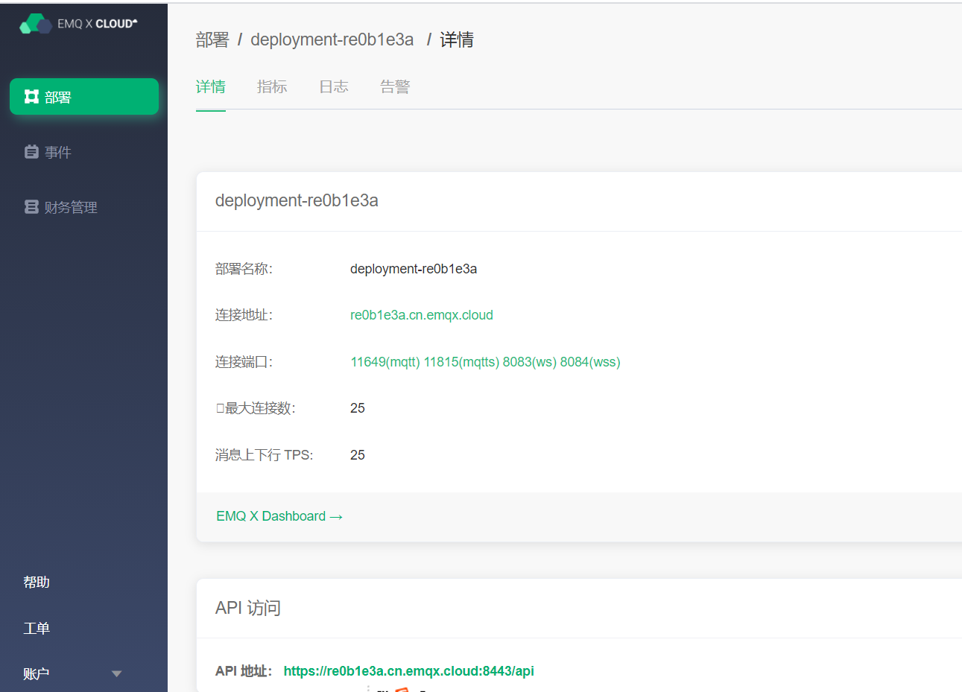

2. 采用MQTTX或其它MQTT客户端连接EMQ Cloud；
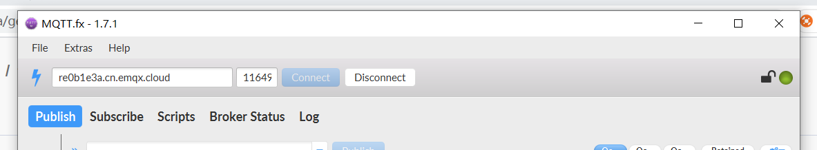
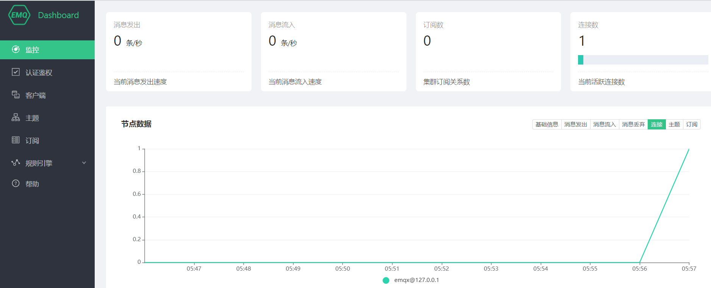

3. 采用 EMQX Cloud MySQL插件连接数据库，并进行数据库操作；

建表并连接，表名为IoT+姓名缩写，比如“IoTCJP”；
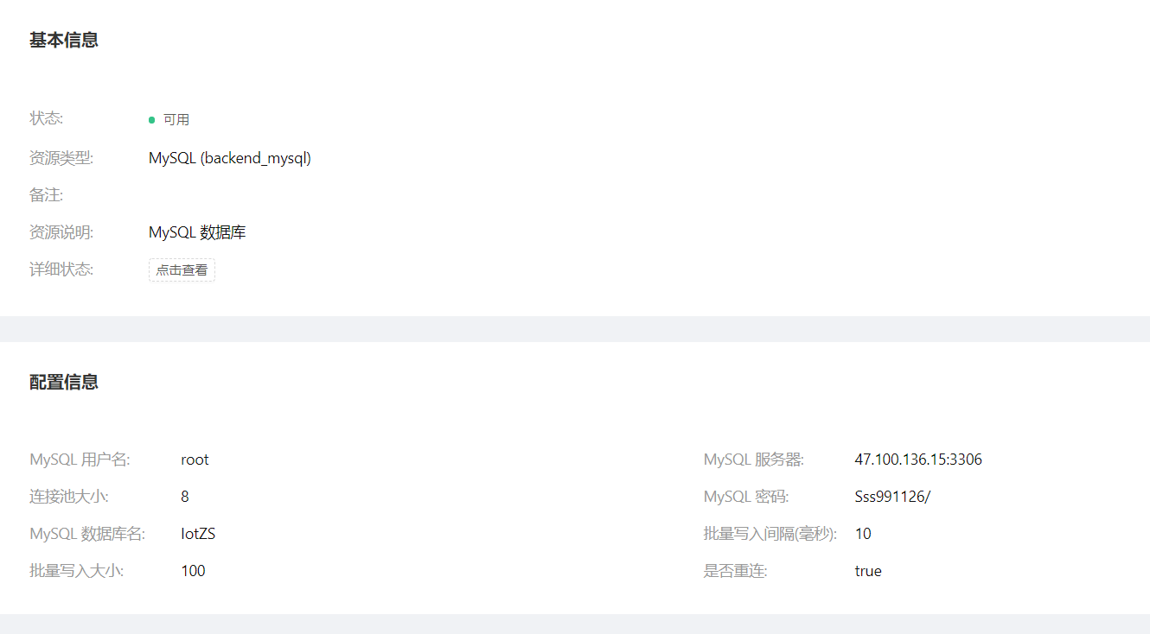
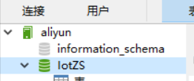

触发 MySQL 规则
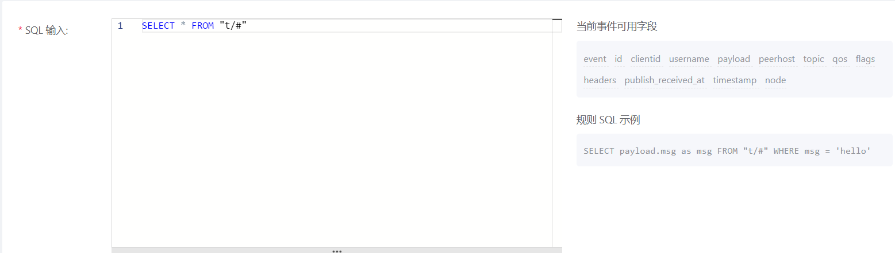


插入数据记录
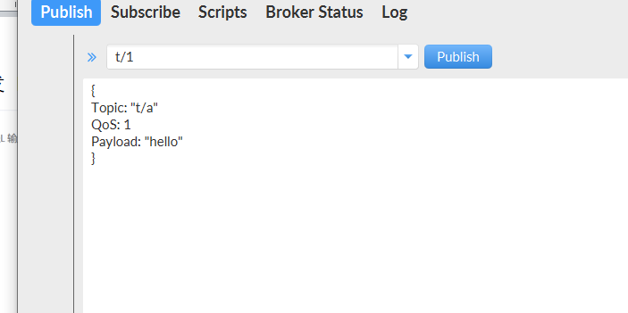

查询 MySQL 数据内容
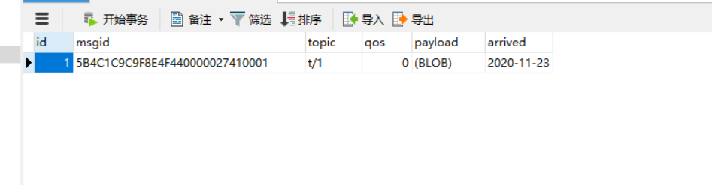

4. （选做）采集ESP8266的温度、湿度、时间等数据，通过MQTT插件写入到MySQL数据库中。
参考字段：
序号 | 学号 | 姓名 | 终端名称 | 湿度 | 湿度 | 时间 | 用户名
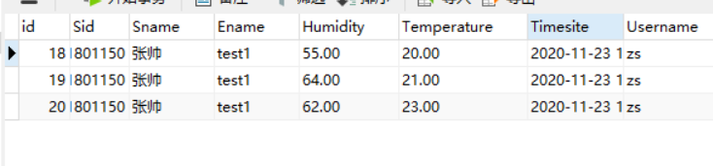
#include <ESP8266WiFi.h>
#include "Adafruit_MQTT.h"
#include "Adafruit_MQTT_Client.h"
#define WLAN_SSID "Mi 10000 Ultra"
#define WLAN_PASS "88888888"
#define AIO_SERVER "re0b1e3a.cn.emqx.cloud"
#define AIO_SERVERPORT 11649
#define AIO_USERNAME "zs"
#define AIO_KEY "sss991126"
#include"SSD1306Wire.h"
SSD1306Wire display(0x3c,2,14);
#include<dht11.h>
#include<ArduinoJson.h>

dht11 DHT11;
// Create an ESP8266 WiFiClient class to connect to the MQTT server.
WiFiClient client;
// or... use WiFiClientSecure for SSL
//WiFiClientSecure client;

StaticJsonDocument<200> doc;
// Setup the MQTT client class by passing in the WiFi client and MQTT server and login details.
Adafruit_MQTT_Client mqtt(&client, AIO_SERVER, AIO_SERVERPORT, AIO_USERNAME, AIO_KEY);
// Setup a feed called 'photocell' for publishing.
// Notice MQTT paths for AIO follow the form: <username>/feeds/<feedname>
Adafruit_MQTT_Publish photocell = Adafruit_MQTT_Publish(&mqtt, AIO_USERNAME "iot/1");

// Setup a feed called 'onoff' for subscribing to changes.
Adafruit_MQTT_Subscribe onoffbutton = Adafruit_MQTT_Subscribe(&mqtt, AIO_USERNAME "iot/1");

// Bug workaround for Arduino 1.6.6, it seems to need a function declaration
// for some reason (only affects ESP8266, likely an arduino-builder bug).
void MQTT_connect();

void setup() {

Serial.begin(115200);
delay(10);
display.init();

Serial.println(F("Adafruit MQTT demo"));

// Connect to WiFi access point.
Serial.println();
Serial.println();
Serial.print("Connecting to ");
Serial.println(WLAN_SSID);

WiFi.begin(WLAN_SSID, WLAN_PASS);
while (WiFi.status() != WL_CONNECTED) { delay(500);
Serial.print(".");
}
Serial.println();

Serial.println("WiFi connected");
Serial.println("IP address: "); Serial.println(WiFi.localIP());

// Setup MQTT subscription for onoff feed.
mqtt.subscribe(&onoffbutton);
}
uint32_t x=0; void loop() {
int chk = DHT11.read(5);
// Ensure the connection to the MQTT server is alive (this will make the first
// connection and automatically reconnect when disconnected). See the MQTT_connect
// function definition further below.
MQTT_connect();

// this is our 'wait for incoming subscription packets' busy subloop
// try to spend your time here

Adafruit_MQTT_Subscribe *subscription;
while ((subscription = mqtt.readSubscription(5000))) { if (subscription == &onoffbutton) {
Serial.print(F("Got: "));
Serial.println((char *)onoffbutton.lastread);

display.flipScreenVertically();
display.clear();
display.drawString(0,10,"topic: iot/1");
display.drawString(0,20,(char *)onoffbutton.lastread);
// display.display();
delay(2000);
}
}
// Now we can publish stuff!
Serial.print(F("\nSending photocell val ")); Serial.print(x);
Serial.print("...");

String output;

doc["sid"] = "31801150";
doc["sname"] = "张帅";
doc["ename"] = "test1";
doc["humidity"] = (float)DHT11.humidity;
doc["temperature"] = (float)DHT11.temperature;
serializeJson(doc ,output);

if (! photocell.publish(output.c_str())) { Serial.println(F("Failed"));
} else {
Serial.println(F("OK!"));

display.flipScreenVertically();
display.clear();
display.drawString(0,10,"topic: iot/1");
display.drawString(0,20,String(x));
// display.display();
delay(2000);
}

// ping the server to keep the mqtt connection alive
// NOT required if you are publishing once every KEEPALIVE seconds
/*
if(! mqtt.ping()) { mqtt.disconnect();
}
*/
}

// Function to connect and reconnect as necessary to the MQTT server.
// Should be called in the loop function and it will take care if connecting.
void MQTT_connect() {
int8_t ret;

// Stop if already connected.
if (mqtt.connected()) {
return;
}
Serial.print("Connecting to MQTT... "); uint8_t retries = 3;
while ((ret = mqtt.connect()) != 0) { // connect will return 0 for connected
Serial.println(mqtt.connectErrorString(ret));
Serial.println("Retrying MQTT connection in 5 seconds..."); mqtt.disconnect();
delay(5000); // wait 5 seconds retries--;
if (retries == 0) {
// basically die and wait for WDT to reset me
while (1);
}
}
Serial.println("MQTT Connected!");
}

