浙大城市学院实验报告
课程名称 物联网技术与应用 实验项目 实验九 MQTT客户端设计
专业班级 学号 姓名
指导老师（签名 ） 蔡建平 日期 实验成绩

一、实验目的：
学习MQTT的Java资源，掌握MQTT客户端设计，连接并完成数据库读写操作。
二、实验内容：
1. 读取订阅的topic消息，显示在控制台;
2. 读取订阅的topic消息，将topic、QoS和payload字段，时间戳分别写入数据表中;
3. 订阅并解析来自WebSocket客户端的JSON格式的消息，并将内容写入数据表中;
三、实验步骤：
1. 读取订阅的topic消息，显示在控制台;
接收消息主题 : toCJP/1248 | 将主题改为姓名缩写/学号后4位
接收消息Qos : 1
接收消息内容 : close
客户端掉线！
接收消息内容 : {"msg": "Hello, CJP20201129!" } | 在Payload载荷部分有姓名缩写和日期信息

客户端代码：
package mqtt;

import org.eclipse.paho.client.mqttv3.MqttClient;
import org.eclipse.paho.client.mqttv3.MqttConnectOptions;
import org.eclipse.paho.client.mqttv3.MqttException;
import org.eclipse.paho.client.mqttv3.MqttTopic;
import org.eclipse.paho.client.mqttv3.persist.MemoryPersistence;

public class Client {
public static final String HOST = "ws://47.100.136.15:8083/mqtt";
public static final String TOPIC = "toZS/1150";
private static final String clientid = "client1150";
private MqttClient client;
private MqttConnectOptions options;
private String userName = "";
private String passWord = "";
public void start() {
try {

client = new MqttClient(HOST, clientid, new MemoryPersistence());

options = new MqttConnectOptions();

options.setCleanSession(true);

options.setUserName(userName);

options.setPassword(passWord.toCharArray());

options.setConnectionTimeout(10);

options.setKeepAliveInterval(20);

client.setCallback(new PushCallback());
MqttTopic topic = client.getTopic(TOPIC);

options.setWill(topic, "close".getBytes(), 2, true);

client.connect(options);

int[] Qos = {1};
String[] topic1 = {TOPIC};
client.subscribe(topic1, Qos);

} catch (Exception e) {
e.printStackTrace();
}
}
public static void main(String[] args) throws MqttException {
Client client = new Client();
client.start();
}

}

回调函数代码：
package mqtt;

import org.eclipse.paho.client.mqttv3.IMqttDeliveryToken;
import org.eclipse.paho.client.mqttv3.MqttCallback;
import org.eclipse.paho.client.mqttv3.MqttMessage;

public class PushCallback implements MqttCallback {

public void connectionLost(Throwable cause) {

System.out.println("客户端掉线！");
}

public void deliveryComplete(IMqttDeliveryToken token) {
System.out.println("deliveryComplete---------" + token.isComplete());
}
public void messageArrived(String topic, MqttMessage message) throws Exception {
System.out.println("接收消息主题 : " + topic);
System.out.println("接收消息Qos : " + message.getQos());
System.out.println("接收消息内容 : " + new String(message.getPayload()));
String str=new String(message.getPayload());

if(str.equals("close"))
System.out.println("客户端掉线！");
else {

SaveMysql save=new SaveMysql();
save.savedate(topic,message.getQos(),str);
//save.savedate2(str);

}
}

}

数据接收截图：
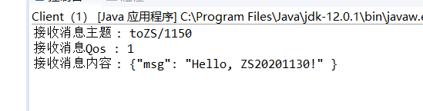

2. 读取订阅的topic消息，将topic、QoS和payload字段，时间戳分别写入数据表中;
写入数据库的程序：
public class SaveMysql {
private static String driver="com.mysql.jdbc.Driver";
private static String url="jdbc:mysql://47.100.136.15:3306/mqtt?serverTimezone=UTC";
private static String user="root";
private static String password="Sss991126/";
Connection conn=null;
Statement stmt=null;
ResultSet rs=null;
public void savedate(String topic,int Qos,String payload) {

java.sql.Timestamp timestamp=new java.sql.Timestamp(System.currentTimeMillis());
String sql = "insert into mqtt(Topic,Qos,payload,Timestamp)"+"values('"+topic+"','"+Qos+"','"+payload+"','"+timestamp+"');";
try {
Class.forName(driver);
conn=DriverManager.getConnection(url,user,password);
stmt=conn.createStatement();
stmt.executeUpdate(sql);
}
catch(Exception e) {
e.printStackTrace();
}
finally {
try {
if(stmt!=null) stmt.close();
if(conn!=null) conn.close();
}
catch(Exception e) {
e.printStackTrace();
}
}
}

截图：
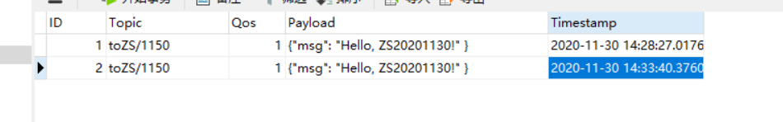

3. （选做）订阅并解析来自WebSocket客户端的JSON格式的消息，并将内容写入数据表中;
代码：
package mqtt;

import java.sql.Connection;
import java.sql.DriverManager;
import java.sql.ResultSet;
import java.sql.Statement;
import com.alibaba.fastjson.JSONObject;

public class SaveMysql {
private static String driver="com.mysql.jdbc.Driver";
private static String url="jdbc:mysql://47.100.136.15:3306/IotZS?serverTimezone=UTC";
private static String user="root";
private static String password="Sss991126/";
Connection conn=null;
Statement stmt=null;
ResultSet rs=null;

public void savedate2(String payload) {
JSONObject equipment = new JSONObject();

java.sql.Timestamp time= new java.sql.Timestamp(System.currentTimeMillis());
try{

equipment = JSONObject.parseObject(payload);
}
catch (Exception e){
e.printStackTrace();
System.out.println("Json格式错误");
return ;
}
String sql = "insert into IoT_test(Sid,Sname,Ename,Humidity,Temperature,Timesite,Username)"+"values('"+equipment.getString("sid")+"','"
+equipment.getString("sname")+"','"+equipment.getString("Ename")+"','"+equipment.getDouble("humidity")+"','"+equipment.getDouble("temperature")
+"','"+time+"','"+equipment.getString("clientid")+"');";
try {
Class.forName(driver);
conn=DriverManager.getConnection(url,user,password);
stmt=conn.createStatement();
stmt.executeUpdate(sql);
}
catch(Exception e) {
e.printStackTrace();
}
finally {
try {
if(stmt!=null) stmt.close();
if(conn!=null) conn.close();
}
catch(Exception e) {
e.printStackTrace();
}
}

}

}

截图：
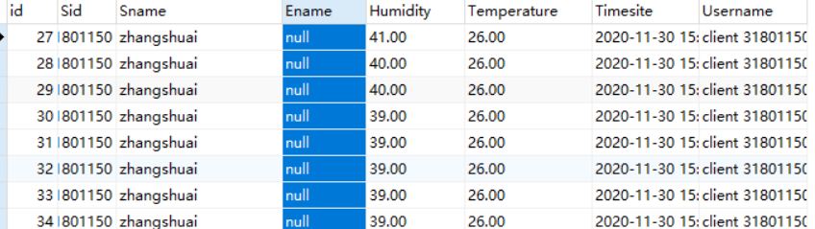
4. （选做）采集ESP8266的温度、湿度、时间等数据，构建JSON格式的消息，并写入到MySQL数据库中。
参考字段：
序号 | 学号 | 姓名 | 终端名称 | 湿度 | 湿度 | 时间 | 用户名

代码：
#include <ESP8266WiFi.h>
#include "Adafruit_MQTT.h"
#include "Adafruit_MQTT_Client.h"
#define WLAN_SSID "Mi 10000 Ultra"
#define WLAN_PASS "88888888"
#define AIO_SERVER "47.100.136.15"
#define AIO_SERVERPORT 1883
#define AIO_USERNAME ""
#define AIO_KEY ""
#include"SSD1306Wire.h"
SSD1306Wire display(0x3c,2,14);
#include<dht11.h>
#include<ArduinoJson.h>

dht11 DHT11;
// Create an ESP8266 WiFiClient class to connect to the MQTT server.
WiFiClient client;
// or... use WiFiClientSecure for SSL
//WiFiClientSecure client;

StaticJsonDocument<200> doc;
// Setup the MQTT client class by passing in the WiFi client and MQTT server and login details.
Adafruit_MQTT_Client mqtt(&client, AIO_SERVER, AIO_SERVERPORT, AIO_USERNAME, AIO_KEY);
// Setup a feed called 'photocell' for publishing.
// Notice MQTT paths for AIO follow the form: <username>/feeds/<feedname>
Adafruit_MQTT_Publish photocell = Adafruit_MQTT_Publish(&mqtt, AIO_USERNAME "toZS/1150");

// Setup a feed called 'onoff' for subscribing to changes.
Adafruit_MQTT_Subscribe onoffbutton = Adafruit_MQTT_Subscribe(&mqtt, AIO_USERNAME "toZS/1150");

// Bug workaround for Arduino 1.6.6, it seems to need a function declaration
// for some reason (only affects ESP8266, likely an arduino-builder bug).
void MQTT_connect();

void setup() {

Serial.begin(115200);
delay(10);
display.init();

Serial.println(F("Adafruit MQTT demo"));

// Connect to WiFi access point.
Serial.println();
Serial.println();
Serial.print("Connecting to ");
Serial.println(WLAN_SSID);

WiFi.begin(WLAN_SSID, WLAN_PASS);
while (WiFi.status() != WL_CONNECTED) { delay(500);
Serial.print(".");
}
Serial.println();

Serial.println("WiFi connected");
Serial.println("IP address: "); Serial.println(WiFi.localIP());

// Setup MQTT subscription for onoff feed.
mqtt.subscribe(&onoffbutton);
}
uint32_t x=0; void loop() {
int chk = DHT11.read(5);
// Ensure the connection to the MQTT server is alive (this will make the first
// connection and automatically reconnect when disconnected). See the MQTT_connect
// function definition further below.
MQTT_connect();

// this is our 'wait for incoming subscription packets' busy subloop
// try to spend your time here

Adafruit_MQTT_Subscribe *subscription;
while ((subscription = mqtt.readSubscription(5000))) { if (subscription == &onoffbutton) {
Serial.print(F("Got: "));
Serial.println((char *)onoffbutton.lastread);

display.flipScreenVertically();
display.clear();
display.drawString(0,10,"topic: toZS/1150");
display.drawString(0,20,(char *)onoffbutton.lastread);
// display.display();
delay(2000);
}
}
// Now we can publish stuff!
Serial.print(F("\nSending photocell val ")); Serial.print(x);
Serial.print("...");

String output;

doc["sid"] = "31801150";
doc["sname"] = "zhangshuai";
doc["ename"] = "test1";
doc["clientid"] = "client 31801150";
doc["humidity"] = (float)DHT11.humidity;
doc["temperature"] = (float)DHT11.temperature;
serializeJson(doc ,output);

if (! photocell.publish(output.c_str())) { Serial.println(F("Failed"));
} else {
Serial.println(F("OK!"));

display.flipScreenVertically();
display.clear();
display.drawString(0,10,"topic: iot/1");
display.drawString(0,20,String(x));
// display.display();
delay(2000);
}

// ping the server to keep the mqtt connection alive
// NOT required if you are publishing once every KEEPALIVE seconds
/*
if(! mqtt.ping()) { mqtt.disconnect();
}
*/
}

// Function to connect and reconnect as necessary to the MQTT server.
// Should be called in the loop function and it will take care if connecting.
void MQTT_connect() {
int8_t ret;

// Stop if already connected.
if (mqtt.connected()) {
return;
}
Serial.print("Connecting to MQTT... "); uint8_t retries = 3;
while ((ret = mqtt.connect()) != 0) { // connect will return 0 for connected
Serial.println(mqtt.connectErrorString(ret));
Serial.println("Retrying MQTT connection in 5 seconds..."); mqtt.disconnect();
delay(5000); // wait 5 seconds retries--;
if (retries == 0) {
// basically die and wait for WDT to reset me
while (1);
}
}
Serial.println("MQTT Connected!");
}

截图：
