浙大城市学院实验报告
课程名称 物联网技术与应用 实验项目 实验十 WebSocket连接MQTT服务
专业班级 学号 姓名
指导老师（签名 ） 蔡建平 日期 实验成绩

一、实验目的：
学习WebSocket相关内容，掌握WebSocket连接MQTT服务的客户端页面设计。
二、实验内容：
1.完成一个HTML页面，实现WebSocket连接MQTT Broket服务，实现消息订阅（Subscribe）和发布（Publish）。
（要求连接自己的MQTT服务器，要求设置用户名和密码，可使用EMQ提供的云服务）
2. 实现订阅消息和发布消息的列表显示。
3. 订阅并解析来自WebSocket客户端的JSON格式的消息，并将内容写入数据表中;
三、实验步骤：
1. 完成一个HTML页面，实现WebSocket连接MQTT Broket服务，实现订阅（Subscribe），发布（Publish）。
（要求连接自己的MQTT服务器，要求设置用户名和密码，可以使用EMQ提供的云服务）
代码：
<!DOCTYPE html>
<html><head><meta http-equiv="Content-Type" content="text/html; charset=UTF-8">

<title>WebSocket</title>
<!-- mqtt.js -->
<script src="./WebSocket_files/mqtt.min.js"></script>
</head>
<style type="text/css">
body{
background-color: #111111;
}
#connection{
background-color: #222222;
color: white;
padding: 20px 20px;

}
#connection input{
background-color:#222222;
color: white;
border: 1px #eeeeee solid;
margin: 20px 30px 10px 10px;

}

#pub input{
background-color:#222222;
color: white;
border: 1px #eeeeee solid;
margin: 20px 30px 10px 10px;

}

#sub input{
background-color:#222222;
color: white;
border: 1px #eeeeee solid;
margin: 20px 30px 10px 10px;

}

#on{
color: #ffffff;
background-color: limegreen;
width: 100px;
height: 40px;
padding: 0px;
}
#off{
background-color: orangered;
color: #ffffff;
width: 100px;
height: 40px;
padding: 0px;
}

input{
width: 300px;
height: 30px;
border-radius: 5px;
padding-left: 10px;
}

button{

margin: 20px 30px 10px 10px;
border-radius: 5px;

}

select{
background-color: #222222;
color: #ffffff;
width: 100px;
height: 30px;
padding-left: 10px;
margin-left: 10px;
border-radius: 5px;

}

#pub_button{
color: #ffffff;
background-color: limegreen;
width: 100px;
height: 40px;
padding: 0px;
}

#sub_on_button{

color: #ffffff;
background-color: limegreen;
width: 100px;
height: 40px;
padding: 0px;
}

#sub_off_button{
color: #ffffff;
background-color: orangered;
width: 100px;
height: 40px;
padding: 0px;
}
#sub_qos{

margin: 20px 30px 10px 10px;
}

th{
height: 40px;
}

td{
height: 40px;
padding-left: 10px;
}

</style>
<body>
<h2 style="color: white;padding-left: 20px;">WebSocket</h2>
<div id="connection">
<form id="connection_form" name="connection_form" method="post">
<h3>连接</h3>
<b>主机地址: </b><input type="text" value="47.100.136.15" id="host">
<b>端口: </b><input type="text" value="8083" id="port">
<b>Path: </b><input type="text" value="/mqtt" id="path">
<br>
<b>用 户 名：</b><input type="text" id="username">
<b>密码: </b><input type="text" id="password">
<br>
<button type="button" onclick="connection() " id="on">连接</button>
<button type="button" disabled="disabled" id="off" onclick="disconnect()">断开连接</button>

<b >当前连接状态：</b>
<b id="info" style="color: blue;">未连接</b>
</form>
</div>
<br>
<div id="pub" style="background-color:#222222;height:100%;width:49%;float:left;color: white;border-radius: 10px;margin: 5px; ">
<h3 style="padding-left:20px">推送</h3>
<form style="padding-left:20px">
<b>Topic:</b>&nbsp;&nbsp;&nbsp;&nbsp;
<input type="text" id="pub_topic">
<br>
<b>Payload:</b>
<input type="text" id="pub_payload">
<br>
<b>Qos:</b>&nbsp;&nbsp;&nbsp;&nbsp;&nbsp;&nbsp;&nbsp;
<select name="qos" id="pub_qos" style="margin-bottom: 31px;">
<option value="0" selected="">0</option>
<option value="1">1</option>
<option value="2">2</option>
</select>&nbsp;&nbsp;
<button type="button" id="pub_button" disabled="disabled" onclick="pub()">确认推送</button>
</form>
<table width="100%" border="1" id="pub_Tbl">
<tbody>
<tr>
<th scope="col" name="topic">Topic</th>
<th scope="col" name="payload">Payload</th>
<th scope="col" name="qos">Qos</th>
</tr>
</tbody>
</table>
</div>
<div id="sub" style="background-color:#222222;height:100%;width:49%;float:left;color: white;border-right: 1px;border-radius: 10px;margin: 5px 0px 5px 20px;">
<h3 style="padding-left:20px">订阅</h3>
<form style="padding-left:20px">
<b>Topic:</b>&nbsp;&nbsp;&nbsp;&nbsp;
<input type="text" id="sub_topic">
<br>
<b>Qos:</b>&nbsp;&nbsp;&nbsp;&nbsp;&nbsp;&nbsp;&nbsp;
<select name="pub_qos" id="sub_qos" >
<option value="0" selected="">0</option>
<option value="1">1</option>
<option value="2">2</option>
</select>&nbsp;&nbsp;
<br>
<button type="button" id="sub_on_button" disabled="disabled" onclick="sub_on()">订阅</button>
<button type="button" id="sub_off_button" disabled="disabled" onclick="sub_off()">取消订阅</button>
</form>
<br>
<table width="100%" border="1" id="sub_Tbl">
<tbody>
<tr>
<th scope="col">Topic</th>
<th scope="col">Payload</th>
<th scope="col">Qos</th>
</tr>
</tbody>
</table>
</div>

<script>
//连接
var options;
var client;
var connectioning=false;
function connection() {
if(host.value ==""||port.value==""||host.value ==" "||port.value==" "){
window.alert("主机地址和端口不能为空");
return;
}
options = {

clientId: 'mqttjs_' + Math.random().toString(16).substr(2, 8),
username: username.value,
password: password.value
}
console.log("ws://"+host.value+":"+port.value+path.value);

try{
client = mqtt.connect("ws://"+host.value+":"+port.value+path.value,options);
document.getElementById ("on").setAttribute("disabled", "disabled");
document.getElementById ("info").innerHTML =("连接中");
document.getElementById ("info").style.color = 'orange';
connectioning=true;
setTimeout(function () {
if(connectioning == true){
window.alert("连接超时");
document.getElementById ("info").innerHTML =("连接超时");
document.getElementById ("info").style.color = 'red';
document.getElementById ("on").removeAttribute("disabled");
connectioning = false;
client.end();
}
},5000);
client.on('connect', function () {
connectioning=false;

document.getElementById ("info").innerHTML =("连接成功");
document.getElementById ("info").style.color = 'green';

document.getElementById ("off").removeAttribute("disabled");
document.getElementById ("pub_button").removeAttribute("disabled");
document.getElementById ("sub_on_button").removeAttribute("disabled");

document.getElementById ("host").setAttribute("disabled", "disabled");
document.getElementById ("port").setAttribute("disabled", "disabled");
document.getElementById ("path").setAttribute("disabled", "disabled");
document.getElementById ("username").setAttribute("disabled", "disabled");
document.getElementById ("password").setAttribute("disabled", "disabled");
})
}
catch (err) {
window.alert("连接失败!!!\n错误信息："+err)

document.getElementById ("info").innerHTML =("连接失败")
document.getElementById ("info").style.color = 'red';
}
}
function disconnect(){
connectioning=false

document.getElementById ("info").innerHTML =("未连接");
document.getElementById ("info").style.color = 'blue';

document.getElementById ("on").removeAttribute("disabled");
document.getElementById ("off").setAttribute("disabled", "disabled");
document.getElementById ("pub_button").setAttribute("disabled", "disabled");
document.getElementById ("sub_on_button").setAttribute("disabled", "disabled");
document.getElementById ("sub_off_button").setAttribute("disabled", "disabled");

document.getElementById ("host").removeAttribute("disabled");
document.getElementById ("port").removeAttribute("disabled");
document.getElementById ("path").removeAttribute("disabled");
document.getElementById ("username").removeAttribute("disabled");
document.getElementById ("password").removeAttribute("disabled");

client.end(true);
}
function pub() {
if(pub_topic.value == "" ||pub_payload.value == ""||pub_topic.value == " " ||pub_payload.value == " "){
window.alert("Topic 和 Payload 不能为空");
return;
}
var pub_options={
qos: parseInt(pub_qos.value)
};
try{
client.publish(pub_topic.value,pub_payload.value,pub_options,function (e){
var oTr = document.getElementById("pub_Tbl").insertRow(1);
var aText = new Array();
aText[0] = document.createTextNode(pub_topic.value);
aText[1] = document.createTextNode(pub_payload.value);
aText[2] = document.createTextNode(pub_qos.value);
for (var index = 0; index < aText.length; index++) {
var oTd = oTr.insertCell(index);
oTd.appendChild(aText[index]);
}
});
}
catch (err) {
window.alert("发送失败\n错误信息:"+err)
}
}
function sub_on() {
console.log(client.messageIdToTopic)
options = {

clientId: 'mqttjs_' + Math.random().toString(16).substr(2, 8),
username: username.value,
password: password.value
}
console.log("ws://"+host.value+":"+port.value+path.value);
if(sub_topic.value == ""||sub_topic.value == " "){
window.alert("Topic 不能为空");
return;
}
var sub_option = {
qos: parseInt(sub_qos.value)
}
client.subscribe(sub_topic.value,sub_option,function (err,granted) {
if (!err) {
console.log(granted);
document.getElementById ("sub_qos").setAttribute("disabled", "disabled");
document.getElementById ("sub_topic").setAttribute("disabled", "disabled");
document.getElementById ("sub_off_button").removeAttribute("disabled");
document.getElementById ("sub_on_button").setAttribute("disabled", "disabled");

} else {
window.alert("订阅失败\n错误信息:" + err)
}
})
client.on('message', function (topic, payload,packet){
console.log(packet);
var oTr = document.getElementById("sub_Tbl").insertRow(1);
var aText = new Array();
aText[0] = document.createTextNode(topic);
aText[1] = document.createTextNode(payload);
aText[2] = document.createTextNode(packet.qos);
for (var index = 0; index < aText.length; index++) {
var oTd = oTr.insertCell(index);
oTd.appendChild(aText[index]);
}
})
}
function sub_off() {
client.unsubscribe(sub_topic.value,function (err){
if(err){
window.alert("取消订阅失败\n错误原因:"+err);
}
document.getElementById ("sub_qos").removeAttribute("disabled");
document.getElementById ("sub_topic").removeAttribute("disabled");
document.getElementById ("sub_on_button").removeAttribute("disabled");
document.getElementById ("sub_off_button").setAttribute("disabled", "disabled");

})
}
</script>
</body></html>
截图：
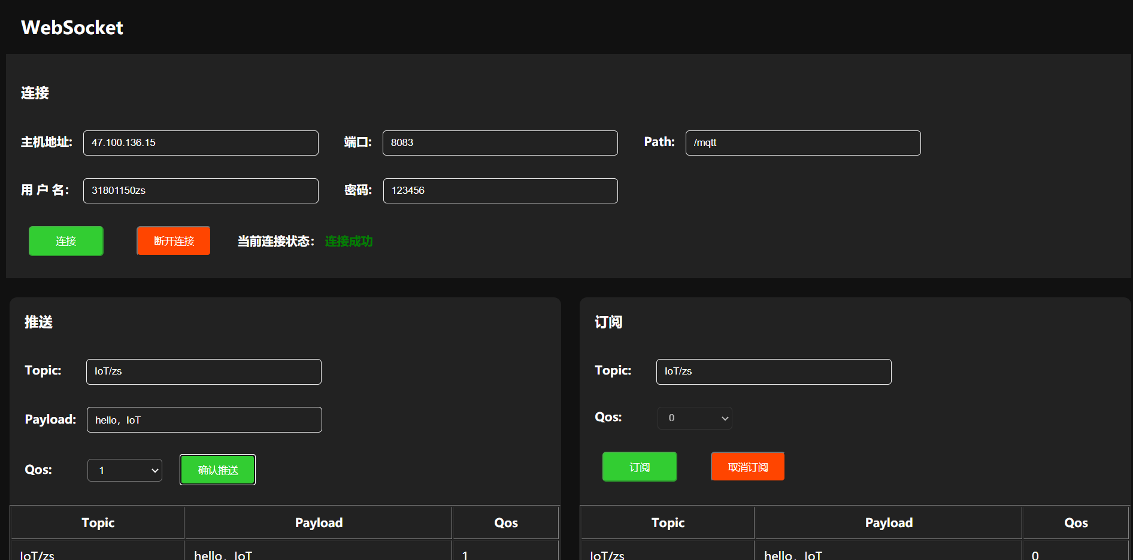

4. 实现订阅消息和发布消息的列表显示。
代码：
<!DOCTYPE html>
<html><head><meta http-equiv="Content-Type" content="text/html; charset=UTF-8">

<title>WebSocket</title>
<!-- mqtt.js -->
<script src="./WebSocket_files/mqtt.min.js"></script>
</head>
<style type="text/css">
body{
background-color: #111111;
}
#connection{
background-color: #222222;
color: white;
padding: 20px 20px;

}
#connection input{
background-color:#222222;
color: white;
border: 1px #eeeeee solid;
margin: 20px 30px 10px 10px;

}

#pub input{
background-color:#222222;
color: white;
border: 1px #eeeeee solid;
margin: 20px 30px 10px 10px;

}

#sub input{
background-color:#222222;
color: white;
border: 1px #eeeeee solid;
margin: 20px 30px 10px 10px;

}

#on{
color: #ffffff;
background-color: limegreen;
width: 100px;
height: 40px;
padding: 0px;
}
#off{
background-color: orangered;
color: #ffffff;
width: 100px;
height: 40px;
padding: 0px;
}

input{
width: 300px;
height: 30px;
border-radius: 5px;
padding-left: 10px;
}

button{

margin: 20px 30px 10px 10px;
border-radius: 5px;

}

select{
background-color: #222222;
color: #ffffff;
width: 100px;
height: 30px;
padding-left: 10px;
margin-left: 10px;
border-radius: 5px;

}

#pub_button{
color: #ffffff;
background-color: limegreen;
width: 100px;
height: 40px;
padding: 0px;
}

#sub_on_button{

color: #ffffff;
background-color: limegreen;
width: 100px;
height: 40px;
padding: 0px;
}

#sub_off_button{
color: #ffffff;
background-color: orangered;
width: 100px;
height: 40px;
padding: 0px;
}
#sub_qos{

margin: 20px 30px 10px 10px;
}

th{
height: 40px;
}

td{
height: 40px;
padding-left: 10px;
}

</style>
<body>
<h2 style="color: white;padding-left: 20px;">WebSocket</h2>
<div id="connection">
<form id="connection_form" name="connection_form" method="post">
<h3>连接</h3>
<b>主机地址: </b><input type="text" value="47.100.136.15" id="host">
<b>端口: </b><input type="text" value="8083" id="port">
<b>Path: </b><input type="text" value="/mqtt" id="path">
<br>
<b>用 户 名：</b><input type="text" id="username">
<b>密码: </b><input type="text" id="password">
<br>
<button type="button" onclick="connection() " id="on">连接</button>
<button type="button" disabled="disabled" id="off" onclick="disconnect()">断开连接</button>

<b >当前连接状态：</b>
<b id="info" style="color: blue;">未连接</b>
</form>
</div>
<br>
<div id="pub" style="background-color:#222222;height:100%;width:49%;float:left;color: white;border-radius: 10px;margin: 5px; ">
<h3 style="padding-left:20px">推送</h3>
<form style="padding-left:20px">
<b>Topic:</b>&nbsp;&nbsp;&nbsp;&nbsp;
<input type="text" id="pub_topic">
<br>
<b>Payload:</b>
<input type="text" id="pub_payload">
<br>
<b>Qos:</b>&nbsp;&nbsp;&nbsp;&nbsp;&nbsp;&nbsp;&nbsp;
<select name="qos" id="pub_qos" style="margin-bottom: 31px;">
<option value="0" selected="">0</option>
<option value="1">1</option>
<option value="2">2</option>
</select>&nbsp;&nbsp;
<button type="button" id="pub_button" disabled="disabled" onclick="pub()">确认推送</button>
</form>
<table width="100%" border="1" id="pub_Tbl">
<tbody>
<tr>
<th scope="col" name="topic">Topic</th>
<th scope="col" name="payload">Payload</th>
<th scope="col" name="qos">Qos</th>
</tr>
</tbody>
</table>
</div>
<div id="sub" style="background-color:#222222;height:100%;width:49%;float:left;color: white;border-right: 1px;border-radius: 10px;margin: 5px 0px 5px 20px;">
<h3 style="padding-left:20px">订阅</h3>
<form style="padding-left:20px">
<b>Topic:</b>&nbsp;&nbsp;&nbsp;&nbsp;
<input type="text" id="sub_topic">
<br>
<b>Qos:</b>&nbsp;&nbsp;&nbsp;&nbsp;&nbsp;&nbsp;&nbsp;
<select name="pub_qos" id="sub_qos" >
<option value="0" selected="">0</option>
<option value="1">1</option>
<option value="2">2</option>
</select>&nbsp;&nbsp;
<br>
<button type="button" id="sub_on_button" disabled="disabled" onclick="sub_on()">订阅</button>
<button type="button" id="sub_off_button" disabled="disabled" onclick="sub_off()">取消订阅</button>
</form>
<br>
<table width="100%" border="1" id="sub_Tbl">
<tbody>
<tr>
<th scope="col">Topic</th>
<th scope="col">Payload</th>
<th scope="col">Qos</th>
</tr>
</tbody>
</table>
</div>

<script>
//连接
var options;
var client;
var connectioning=false;
function connection() {
if(host.value ==""||port.value==""||host.value ==" "||port.value==" "){
window.alert("主机地址和端口不能为空");
return;
}
options = {

clientId: 'mqttjs_' + Math.random().toString(16).substr(2, 8),
username: username.value,
password: password.value
}
console.log("ws://"+host.value+":"+port.value+path.value);

try{
client = mqtt.connect("ws://"+host.value+":"+port.value+path.value,options);
document.getElementById ("on").setAttribute("disabled", "disabled");
document.getElementById ("info").innerHTML =("连接中");
document.getElementById ("info").style.color = 'orange';
connectioning=true;
setTimeout(function () {
if(connectioning == true){
window.alert("连接超时");
document.getElementById ("info").innerHTML =("连接超时");
document.getElementById ("info").style.color = 'red';
document.getElementById ("on").removeAttribute("disabled");
connectioning = false;
client.end();
}
},5000);
client.on('connect', function () {
connectioning=false;

document.getElementById ("info").innerHTML =("连接成功");
document.getElementById ("info").style.color = 'green';

document.getElementById ("off").removeAttribute("disabled");
document.getElementById ("pub_button").removeAttribute("disabled");
document.getElementById ("sub_on_button").removeAttribute("disabled");

document.getElementById ("host").setAttribute("disabled", "disabled");
document.getElementById ("port").setAttribute("disabled", "disabled");
document.getElementById ("path").setAttribute("disabled", "disabled");
document.getElementById ("username").setAttribute("disabled", "disabled");
document.getElementById ("password").setAttribute("disabled", "disabled");
})
}
catch (err) {
window.alert("连接失败!!!\n错误信息："+err)

document.getElementById ("info").innerHTML =("连接失败")
document.getElementById ("info").style.color = 'red';
}
}
function disconnect(){
connectioning=false

document.getElementById ("info").innerHTML =("未连接");
document.getElementById ("info").style.color = 'blue';

document.getElementById ("on").removeAttribute("disabled");
document.getElementById ("off").setAttribute("disabled", "disabled");
document.getElementById ("pub_button").setAttribute("disabled", "disabled");
document.getElementById ("sub_on_button").setAttribute("disabled", "disabled");
document.getElementById ("sub_off_button").setAttribute("disabled", "disabled");

document.getElementById ("host").removeAttribute("disabled");
document.getElementById ("port").removeAttribute("disabled");
document.getElementById ("path").removeAttribute("disabled");
document.getElementById ("username").removeAttribute("disabled");
document.getElementById ("password").removeAttribute("disabled");

client.end(true);
}
function pub() {
if(pub_topic.value == "" ||pub_payload.value == ""||pub_topic.value == " " ||pub_payload.value == " "){
window.alert("Topic 和 Payload 不能为空");
return;
}
var pub_options={
qos: parseInt(pub_qos.value)
};
try{
client.publish(pub_topic.value,pub_payload.value,pub_options,function (e){
var oTr = document.getElementById("pub_Tbl").insertRow(1);
var aText = new Array();
aText[0] = document.createTextNode(pub_topic.value);
aText[1] = document.createTextNode(pub_payload.value);
aText[2] = document.createTextNode(pub_qos.value);
for (var index = 0; index < aText.length; index++) {
var oTd = oTr.insertCell(index);
oTd.appendChild(aText[index]);
}
});
}
catch (err) {
window.alert("发送失败\n错误信息:"+err)
}
}
function sub_on() {
console.log(client.messageIdToTopic)
options = {

clientId: 'mqttjs_' + Math.random().toString(16).substr(2, 8),
username: username.value,
password: password.value
}
console.log("ws://"+host.value+":"+port.value+path.value);
if(sub_topic.value == ""||sub_topic.value == " "){
window.alert("Topic 不能为空");
return;
}
var sub_option = {
qos: parseInt(sub_qos.value)
}
client.subscribe(sub_topic.value,sub_option,function (err,granted) {
if (!err) {
console.log(granted);
document.getElementById ("sub_qos").setAttribute("disabled", "disabled");
document.getElementById ("sub_topic").setAttribute("disabled", "disabled");
document.getElementById ("sub_off_button").removeAttribute("disabled");
document.getElementById ("sub_on_button").setAttribute("disabled", "disabled");

} else {
window.alert("订阅失败\n错误信息:" + err)
}
})
client.on('message', function (topic, payload,packet){
console.log(packet);
var oTr = document.getElementById("sub_Tbl").insertRow(1);
var aText = new Array();
aText[0] = document.createTextNode(topic);
aText[1] = document.createTextNode(payload);
aText[2] = document.createTextNode(packet.qos);
for (var index = 0; index < aText.length; index++) {
var oTd = oTr.insertCell(index);
oTd.appendChild(aText[index]);
}
})
}
function sub_off() {
client.unsubscribe(sub_topic.value,function (err){
if(err){
window.alert("取消订阅失败\n错误原因:"+err);
}
document.getElementById ("sub_qos").removeAttribute("disabled");
document.getElementById ("sub_topic").removeAttribute("disabled");
document.getElementById ("sub_on_button").removeAttribute("disabled");
document.getElementById ("sub_off_button").setAttribute("disabled", "disabled");

})
}
</script>
</body></html>

截图：
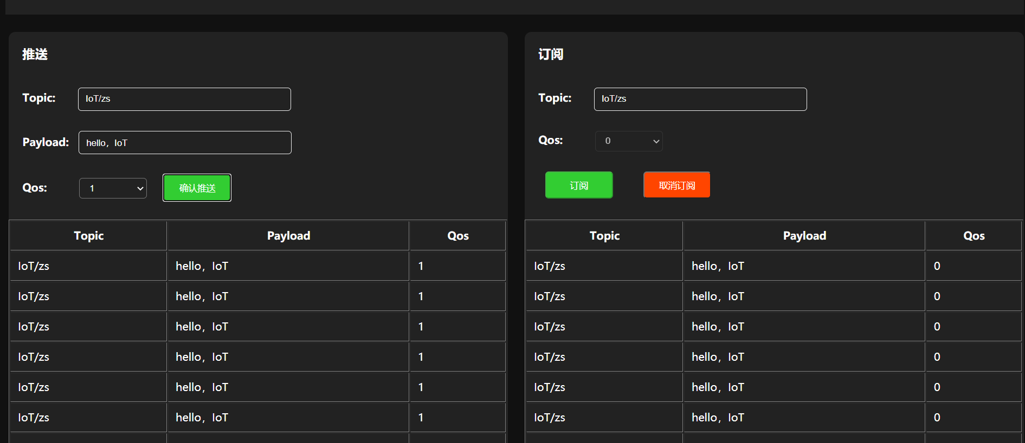
3. 订阅并解析来自自己完成的WebSocket客户端的JSON格式的消息，并将内容写入数据表中;
（WebSocket Topic主题格式：ZUCC/CJP, 将CJP改成自己姓名的缩写）
代码：
package zs;
import java.sql.Connection;
import java.sql.DriverManager;
import java.sql.ResultSet;
import java.sql.Statement;
import com.alibaba.fastjson.JSONObject;

public class SaveMysql {
private static String driver="com.mysql.jdbc.Driver";
private static String url="jdbc:mysql://47.100.136.15:3306/mqtt?serverTimezone=UTC";
private static String user="root";
private static String password="Sss991126/";
Connection conn=null;
Statement stmt=null;
ResultSet rs=null;

public void savedate2(String payload) {
JSONObject equipment = new JSONObject();

java.sql.Timestamp time= new java.sql.Timestamp(System.currentTimeMillis());
try{

equipment = JSONObject.parseObject(payload);
}
catch (Exception e){
e.printStackTrace();
System.out.println("Json格式错误");
return ;
}
String sql = "insert into IoT_test(Sid,Sname,Ename,Humidity,Temperature,Timesite,Username)"+"values('"+equipment.getString("sid")+"','"
+equipment.getString("sname")+"','"+equipment.getString("Ename")+"','"+equipment.getDouble("humidity")+"','"+equipment.getDouble("temperature")
+"','"+time+"','"+equipment.getString("clientid")+"');";
try {
Class.forName(driver);
conn=DriverManager.getConnection(url,user,password);
stmt=conn.createStatement();
stmt.executeUpdate(sql);
}
catch(Exception e) {
e.printStackTrace();
}
finally {
try {
if(stmt!=null) stmt.close();
if(conn!=null) conn.close();
}
catch(Exception e) {
e.printStackTrace();
}
}

}

public void savedate(String topic,int Qos,String payload) {

java.sql.Timestamp timestamp=new java.sql.Timestamp(System.currentTimeMillis());
String sql = "insert into mqtt(Topic,Qos,payload,Timestamp)"+"values('"+topic+"','"+Qos+"','"+payload+"','"+timestamp+"');";
try {
Class.forName(driver);
conn=DriverManager.getConnection(url,user,password);
stmt=conn.createStatement();
stmt.executeUpdate(sql);
}
catch(Exception e) {
e.printStackTrace();
}
finally {
try {
if(stmt!=null) stmt.close();
if(conn!=null) conn.close();
}
catch(Exception e) {
e.printStackTrace();
}
}
}

}

截图：
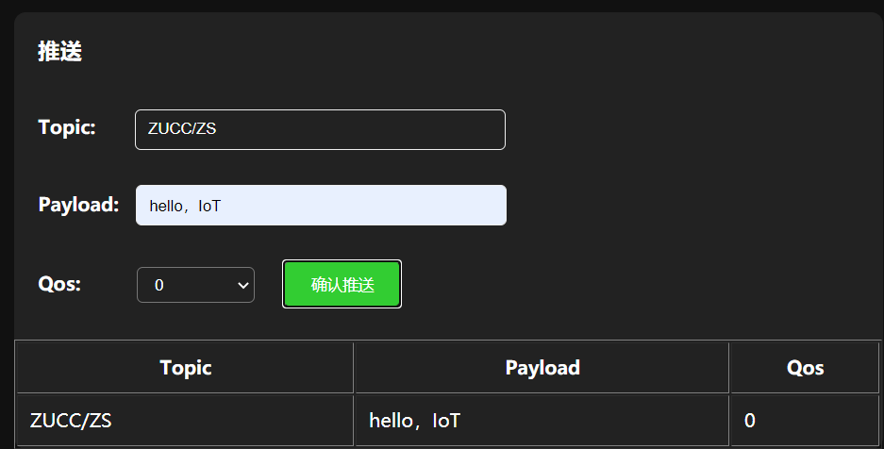
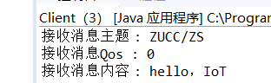
4. 采集ESP8266的温度、湿度、时间等数据，构建JSON格式的消息，并写入到MySQL数据库中。
参考字段：
序号 | 学号 | 姓名 | 终端名称 | 湿度 | 湿度 | 时间 | 用户名

代码：
#include <ESP8266WiFi.h>
#include "Adafruit_MQTT.h"
#include "Adafruit_MQTT_Client.h"
#define WLAN_SSID "Mi 10000 Ultra"
#define WLAN_PASS "88888888"
#define AIO_SERVER "47.100.136.15"
#define AIO_SERVERPORT 1883
#define AIO_USERNAME ""
#define AIO_KEY ""
#include"SSD1306Wire.h"
SSD1306Wire display(0x3c,2,14);
#include<dht11.h>
#include<ArduinoJson.h>

dht11 DHT11;
// Create an ESP8266 WiFiClient class to connect to the MQTT server.
WiFiClient client;
// or... use WiFiClientSecure for SSL
//WiFiClientSecure client;

StaticJsonDocument<200> doc;
// Setup the MQTT client class by passing in the WiFi client and MQTT server and login details.
Adafruit_MQTT_Client mqtt(&client, AIO_SERVER, AIO_SERVERPORT, AIO_USERNAME, AIO_KEY);
// Setup a feed called 'photocell' for publishing.
// Notice MQTT paths for AIO follow the form: <username>/feeds/<feedname>
Adafruit_MQTT_Publish photocell = Adafruit_MQTT_Publish(&mqtt, AIO_USERNAME "toZS/1150");

// Setup a feed called 'onoff' for subscribing to changes.
Adafruit_MQTT_Subscribe onoffbutton = Adafruit_MQTT_Subscribe(&mqtt, AIO_USERNAME "toZS/1150");

// Bug workaround for Arduino 1.6.6, it seems to need a function declaration
// for some reason (only affects ESP8266, likely an arduino-builder bug).
void MQTT_connect();

void setup() {

Serial.begin(115200);
delay(10);
display.init();

Serial.println(F("Adafruit MQTT demo"));

// Connect to WiFi access point.
Serial.println();
Serial.println();
Serial.print("Connecting to ");
Serial.println(WLAN_SSID);

WiFi.begin(WLAN_SSID, WLAN_PASS);
while (WiFi.status() != WL_CONNECTED) { delay(500);
Serial.print(".");
}
Serial.println();

Serial.println("WiFi connected");
Serial.println("IP address: "); Serial.println(WiFi.localIP());

// Setup MQTT subscription for onoff feed.
mqtt.subscribe(&onoffbutton);
}
uint32_t x=0; void loop() {
int chk = DHT11.read(5);
// Ensure the connection to the MQTT server is alive (this will make the first
// connection and automatically reconnect when disconnected). See the MQTT_connect
// function definition further below.
MQTT_connect();

// this is our 'wait for incoming subscription packets' busy subloop
// try to spend your time here

Adafruit_MQTT_Subscribe *subscription;
while ((subscription = mqtt.readSubscription(5000))) { if (subscription == &onoffbutton) {
Serial.print(F("Got: "));
Serial.println((char *)onoffbutton.lastread);

display.flipScreenVertically();
display.clear();
display.drawString(0,10,"topic: toZS/1150");
display.drawString(0,20,(char *)onoffbutton.lastread);
// display.display();
delay(2000);
}
}
// Now we can publish stuff!
Serial.print(F("\nSending photocell val ")); Serial.print(x);
Serial.print("...");

String output;

doc["sid"] = "31801150";
doc["sname"] = "zhangshuai";
doc["ename"] = "test1";
doc["clientid"] = "client 31801150";
doc["humidity"] = (float)DHT11.humidity;
doc["temperature"] = (float)DHT11.temperature;
serializeJson(doc ,output);

if (! photocell.publish(output.c_str())) { Serial.println(F("Failed"));
} else {
Serial.println(F("OK!"));

display.flipScreenVertically();
display.clear();
display.drawString(0,10,"topic: iot/1");
display.drawString(0,20,String(x));
// display.display();
delay(2000);
}

// ping the server to keep the mqtt connection alive
// NOT required if you are publishing once every KEEPALIVE seconds
/*
if(! mqtt.ping()) { mqtt.disconnect();
}
*/
}

// Function to connect and reconnect as necessary to the MQTT server.
// Should be called in the loop function and it will take care if connecting.
void MQTT_connect() {
int8_t ret;

// Stop if already connected.
if (mqtt.connected()) {
return;
}
Serial.print("Connecting to MQTT... "); uint8_t retries = 3;
while ((ret = mqtt.connect()) != 0) { // connect will return 0 for connected
Serial.println(mqtt.connectErrorString(ret));
Serial.println("Retrying MQTT connection in 5 seconds..."); mqtt.disconnect();
delay(5000); // wait 5 seconds retries--;
if (retries == 0) {
// basically die and wait for WDT to reset me
while (1);
}
}
Serial.println("MQTT Connected!");
}

截图：
