|  |
| --- |
| Technische Hochschule Ulm |
| Digital Twin of Kuka KR3 |
| System Requirements |

|  |
| --- |
| Ibrahim Almohamed, Ahmed  21.08.2024 |

Contents

1. Version and Control 2

2. Glossary 3

3. System Overview 5

4. App Sketching 6

a. LoginScreen 6

b. HomeScreen 7

c. DevicesScreen 8

d. ConnectionScreen 10

e. SimulationScreen 11

5. System Use cases 13

6. System Requirements 14

a. Functional Requirements 14

7. Templates 15

# Version and Control

|  |  |  |  |
| --- | --- | --- | --- |
| Version | Name of Editor | Notes | Date |
| 1.0.0 | Ahmed Ibrahim Almohamed | Related to CustomerRequirementV1_0_0.docx | 21.08.2024 |
|  |  |  |  |
|  |  |  |  |

# Glossary

|  |  |
| --- | --- |
| Term | Description |
| DT | Digital Twin |
| KukaDigitalTwin | A Digital twin system of the Kuka KR3 using ROS and Gazebo (simulation tool) . |
| KukaVerse | A Dashboard subsystem that creates a OPCUA server and control the DT . |
| ROS2KR3Core | A software based on ROS2 that runs and manages the simulation of the KR3 Digital twin. |
| ROS2KR3Connection | A connection method to connect the ROS2 (or the host PC) with the KUKA KR3 robot using KUKAVARPROXY . |
| ROS2OPCUABridge | a Software bridge to map a ROS2 node to a OPCUA node. |
| AKL | “Automatisches Kleinteilelager” (DE) or “Automated small parts warehouse” (EN) |
| ROS | Robot Operating System |
| Kuka KR3 |  |
| KVP | KUKAVARPROXY |
| OPC-UA |  |
| SoftRealTime | system where deadlines are important but missing them occasionally does not result in system failure.(average delay of 5ms-30ms) |
| BiDirectionConnection | A connection between the physical and digital robots where commands can be sent from either robot to control the other, and the state information (such as position, velocity, sensor data, etc.) is continuously exchanged. |
| MoveIt2 | A robotic manipulation platform for ROS 2 and incorporates the latest advances in motion planning, manipulation, 3D perception, kinematics, control, and navigation |
| RosInterface | A software interface for the Ros2 to connect the Controllers and the simulation of Gazebo with the KVP protocol. |
| GUI | Graphical User Interface |
| RoboticsLab | A Laboratory at the THU that is used for running experiments of robotics. |
| KukaDigitalTwinDashboard | A Dashboard which is a part of the KukadigitalTwin GUI , used for control and monitor the digital twin and the real twin. |
| RosTasks | A RosTask is a software that aims to create a simple or complicated task for the KukaDigitalTwin , where the user writes a RosNode ,that is runnable on both the physical and digital twins. |
| RQT | RQT is a graphical user interface (GUI) tool for ROS 2. Everything done in RQT can be done on the command line, but RQT provides a more user-friendly way to manipulate ROS 2 elements. |
| RosNode | A node is a participant in the ROS 2 graph, which uses a client library to communicate with other nodes. Nodes can communicate with other nodes within the same process, in a different process, or on a different machine. Nodes are typically the unit of computation in a ROS graph; each node should do one logical thing. |

# System Overview

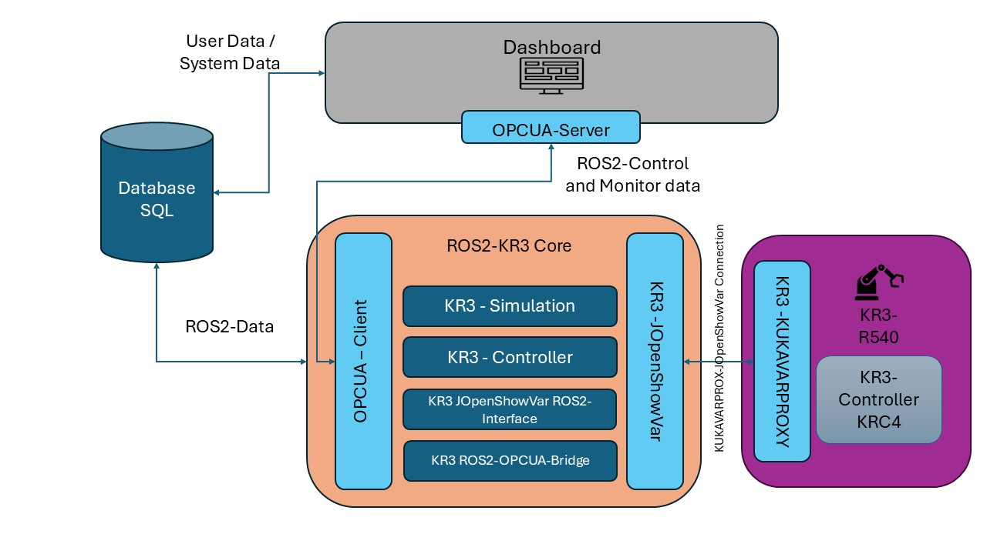

Figure 1: KR3 Digital Twin System Overview

The KukaDigitalTwin is a modular system that builds a Digital Twin of the KUKA KR3 using BiDirectionConnection.

The architecture is designed to scale, allowing additional robots or components to be added without major redesigns. The use of standards like OPC UA and the modular nature of ROS2 support this flexibility.

The KukaDigitalTwin is created from three main subsystems ,the KukaVerse, The ROS2KR3Core and the KR3-R540 physical robot system.

The KukaDigitalTwin creates also connection between the subsystems ,such as the ROS2KR3Connection and the ROS2OPCUABridge .

Also the KukaDigitalTwin contains a backend using SQL to store the user data , the System Data (from the Dashboard) and the ROS2 data .

In this Document it will defined the System use cases and the system requirements ,due to the System-Engineering approach of developing this system .

# App Sketching

## LoginScreen

Figure 2: KukaVerse:Login

This is the start point of the KukaVerse , where the use can login or reset the password.

## HomeScreen

Figure 3: KukaVerse:Home

This is the HomeScreen of the KukaVerse , where the user can see some information about the system.

On the side there is also the is the sections of the app , the state of app connection and the username of the current user.

The Simulate button is disabled here until a connection to the robot is established.

## DevicesScreen

Figure 4: KukaVerse: Devices

The DevicesScreen is the main screen where all the current users robots and their configurations are displayed .

The user can also make new entries here by clicking on the “+” icon in the bottom right corner

.

Which leads to the AddDeviceScreen

Figure 5: KukaVerse : Add Device

On this screen the user can create a new robot with a description , type and name (and more configurations are TBD).

The user saves the new robot so it will be displayed as a card on the DevicesScreen.

## ConnectionScreen

Figure 6: KukaVerse : Connection

On the ConnectionScreen the user can configure the connection to the OPCUA server ,that starts when the connect button is pressed.

The user can set a Device( from stored devices) ,an Endpoint URL and a logging level.

After a connection is established the State “Not connected” changes to “Connected” and the simulate button is unlocked.

## SimulationScreen

Figure 7: KukaVerse : Simulate

On the SimulationScreen , The user views the device and connection configurations.

After that the user Starts the Simulation by pressing the start simulation button that starts the Gazebo on another window and starts the KukaVerse control panel in single mode.

Figure 8: KukaVerse : Control panel :Single

The User here can set a point (x,y,z) and a speed and click on the Go to Point button (the robot here shall start moving to that point and also the simulation).

The user can also check the Set Multi-Points option to save a set of point the robot reach (point1 -> point2 -> point3 ….) after setting each point by clicking the set point Button , and starting a robot job with go to point.

Figure 9: KukaVerse : Control panel Multi

# System Use cases

Figure 10: System Usecases

# System Requirements

## Functional Requirements

# Templates

|  |  |
| --- | --- |
| Requirement ID |  |
|  |  |