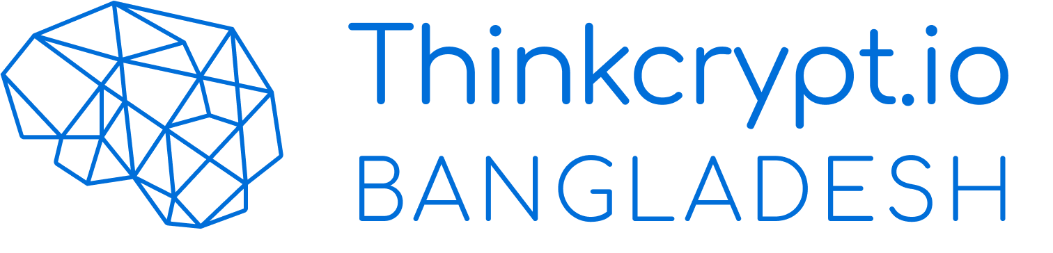

**Proposal:** The client requires a web application where users can create and post their ad campaigns and preview the analytics of individual campaign as well as collective analysis with the help of Facebook Marketing API

**Solution:** Thinkcrypt has done some initial screening on the project and listed down the project into different parts.

|  |  |
| --- | --- |
| 1. Research | 6. Campaign data fetch |
| 1. Login System (FB) | 7. Create post |
| 1. Customer details fetch | 8. Fetch individual campaign data |
| 1. Connect FB API | 9. Project deployment |
| 1. Connect payment gateway |  |

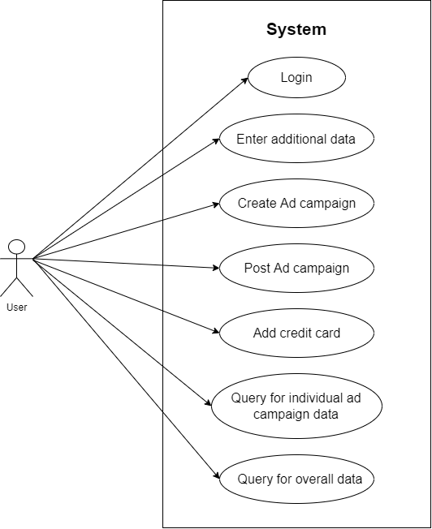

The development of the project will be divided into 4 steps.

**Step 1:** Research, login, customers data fetch

**Step 2:** Campaign data fetch from Facebook using marketing API

**Step 3:** Create Post (a new campaign)

**Step 4:** Fetching individual campaign data + project deployment

Each of the step development will take approximately 9 days. Which will take 9*4 = 36 days in total to develop the project.

All the necessary details need to be discussed before starting of the individual sprint. If any changes need to be done after completing a sprint, then a separate sprint will be created to make the changes. Which might delay the final Project deployment.

**Technology used:**   
**Frontend:**  
1. React.js

**Backend:**1. Node.js

**Payment:** The project is estimated to be completed in 3000 USD.  
Upon approval of the client on proposed quotation, the client needs to pay 10% upfront for the starting of the project.  
After completing each step, the user needs to pay 20%, which is 4*20 = 80%. The rest 10% needs to be paid after the deployment of the project.  
The breakdown of the payment is given below:

|  |  |  |
| --- | --- | --- |
| Down Payment | 10% | 300 USD |
| Step 1 | 20% | 600 USD |
| Step 2 | 20% | 600 USD |
| Step 3 | 20% | 600 USD |
| Step 4 | 20% | 600 USD |
| Deployment | 10% | 300 USD |

**Thank you**