**Website planning**

* Website will have below categories as an individual page
* Home = Home page needs to have a world map zoomed in to bd map and then zoomed into SAMC clinic for better understanding the location of the clinic in the world
* Who we are= The overall summary of the clinic
* History= The history of the clinic needs to have a timeline with the pictures shared with you
* The crisis= The current healthcare situation for women and children in rural areas of BD
* Our projects= The challenge and the response (Basic health-care, Nursing, Covid-19, Women empowerment/education)
* The Team= Explained below
* Donate= Explained below
* Blog= will have write-ups of different ongoing projects once in 2 months
* FAQs= will provide questions and answers later on
* Contact us= our phone number, U.S. location, and social media accounts info
* Privacy policy = how we will protect our donors personal information and transactional history

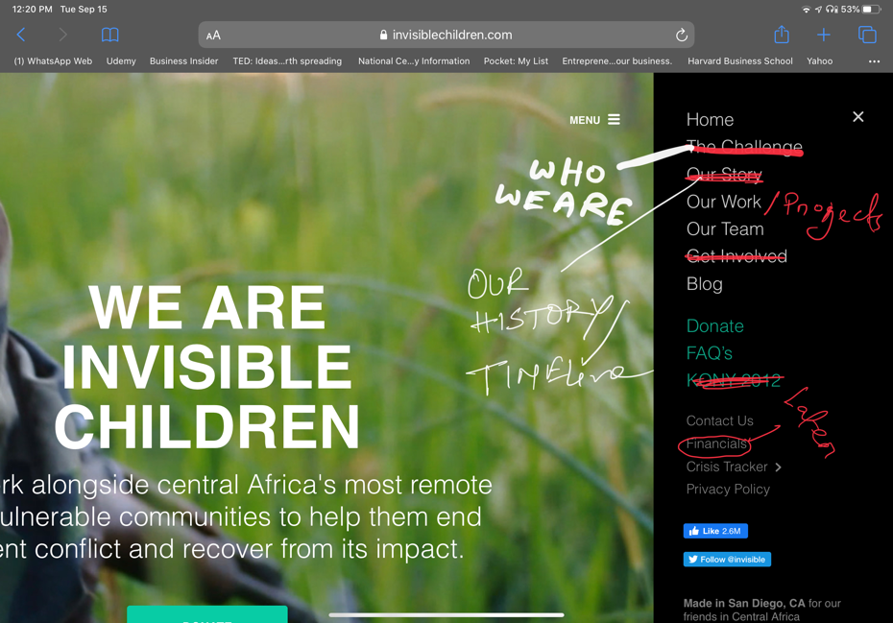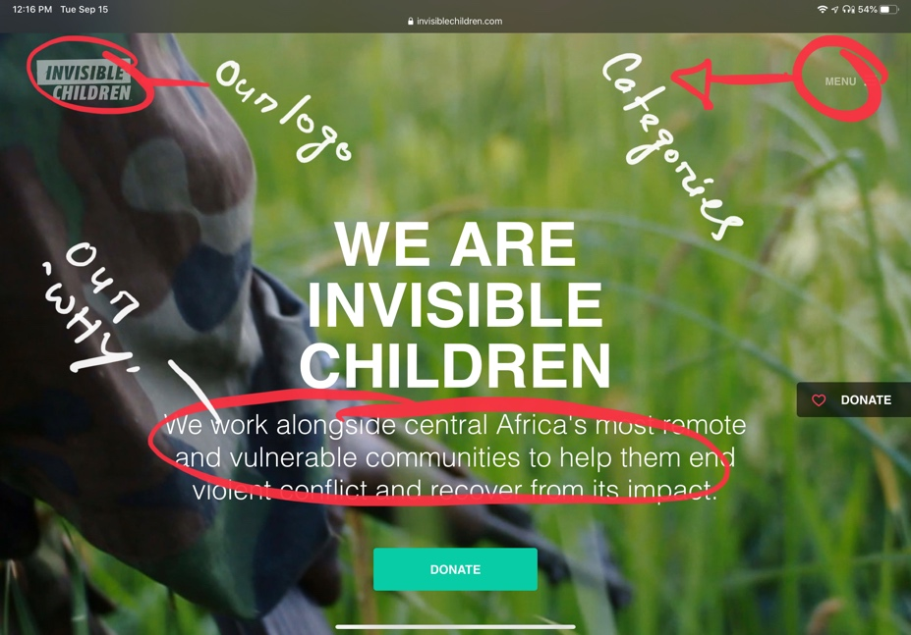

* Donation page:

1. Donation page will have options of any credit card, paypal and direct deposit cheque
2. It will have 3 donation options: Normal Donate, Zakaat Donate, Covid-19 Donate
3. The site needs to be secured for transaction (e.g.- SSL secured)
4. It needs to have the ‘cover processing fees’ option and company match
5. Donor’s personal information should be collected before transaction

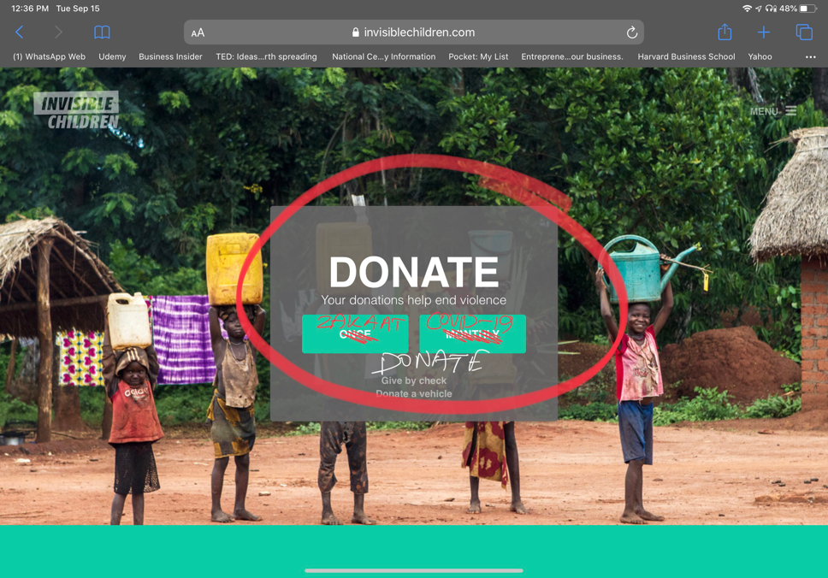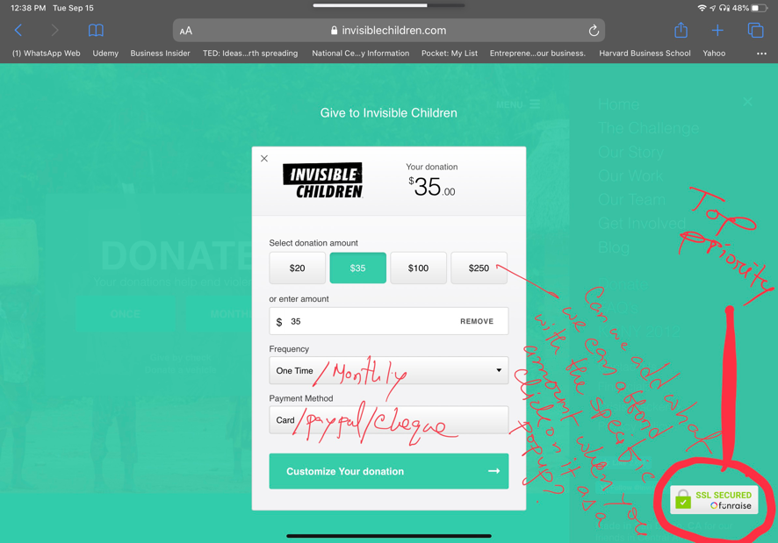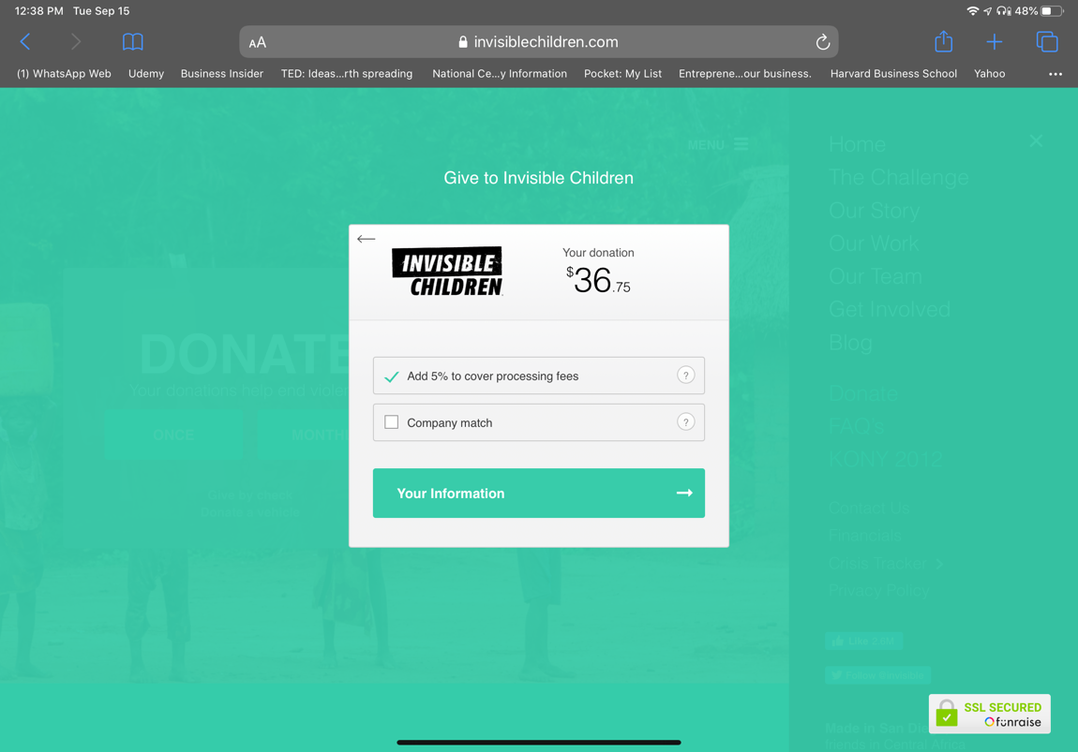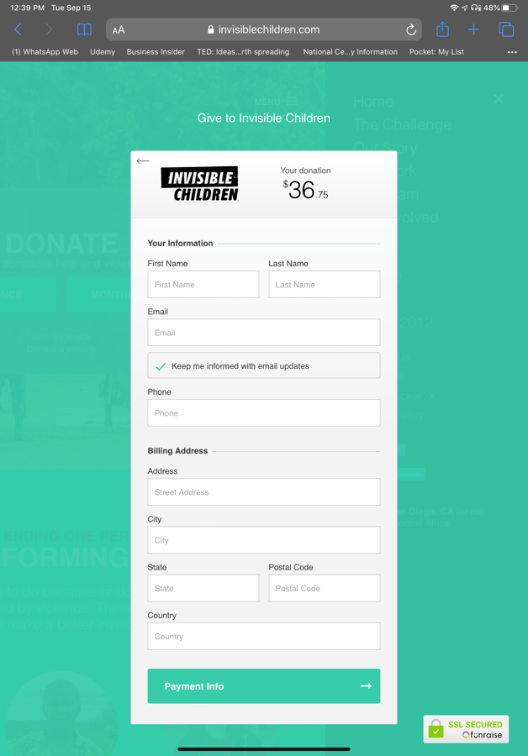

* Team:

1. Team members pictures and name will be there for now. We will add the roles later.
2. Team members names and pictures are in the drive link shared with you.

