FARMILY
An online network platform
for farmers & buyers

Mini Project Report

Submitted by

Aibal Jacob Mani
Reg. No.: AJC22MCA-I006

In Partial fulfillment for the Award of the Degree of
INTEGRATED MASTER OF COMPUTER APPLICATIONS

(INMCA)

APJ ABDUL KALAM TECHNOLOGICAL UNIVERSITY


AMAL JYOTHI COLLEGE OF ENGINEERING AUTONOMOUS
KANJIRAPPALLY

[Affiliated to APJ Abdul Kalam Technological University, Kerala. Approved by AICTE, Accredited by NAAC. Koovappally, Kanjirappally, Kottayam, Kerala – 686518]

2024-2025

DEPARTMENT OF COMPUTER APPLICATIONS

AMAL JYOTHI COLLEGE OF ENGINEERING AUTONOMOUS
KANJIRAPPALLY

CERTIFICATE

This is to certify that the Project report, “FARMILY” is the bona fide work of AIBAL JACOB MANI (Regno: AJC22MCA-I006) carried out in partial fulfillment of the requirements for the award of the Degree of Integrated Master of Computer Applications at Amal Jyothi College of Engineering Autonomous, Kanjirappally, affiliated to APJ Abdul Kalam Technological University. The project was undertaken during the period from January 01, 2025 to April 23, 2025.

Ms. Lisha Varghese Ms. Meera Rose Mathew

Internal Guide Coordinator

Rev. Fr. Dr. Rubin Thottupurathu Jose

Head of the Department

DECLARATION

I hereby declare that the project report “FARMILY” is a bona fide work done at Amal Jyothi College of Engineering Autonomous, Kanjirappally, affiliated to APJ Abdul Kalam Technological University, towards the partial fulfilment of the requirements for the award of the Integrated Master of Computer Applications (INMCA) during the period from January 01, 2025 to April 23, 2025.

Date: 21 April 2025 Aibal Jacob Mani

KANJIRAPPALLY Reg: AJC22MCA-I006

ACKNOWLEDGEMENT

First and foremost, I thank God almighty for his eternal love and protection throughout the project. I take this opportunity to express my gratitude to all who helped me in completing this project successfully. It has been said that gratitude is the memory of the heart. I wish to express my sincere gratitude to our Director (Administration) Rev. Fr. Dr. Roy Abraham Pazhayaparampil and Principal Dr. Lillykutty Jacob for providing good faculty for guidance.

I owe a great depth of gratitude towards our Head of the Department Rev.Fr.Dr. Rubin Thottupurathu Jose for helping us. I extend my whole hearted thanks to the project coordinator Ms. Meera Rose Mathew for her valuable suggestions and for overwhelming concern and guidance from the beginning to the end of the project. I would also express sincere gratitude to my guide Ms. Lisha Varghese for her inspiration and helping hand.

I thank our beloved teachers for their cooperation and suggestions that helped me throughout the project. I express my thanks to all my friends and classmates for their interest, dedication, and encouragement shown towards the project. I convey my hearty thanks to my family for the moral support, suggestions, and encouragement to make this venture a success.

AIBAL JACOB MANI

ABSTRACT

Farmily is an innovative digital platform designed to bridge the gap between farmers and buyers, creating a direct network ecosystem. The application empowers agricultural producers by providing them with a dedicated marketplace to showcase their products, and to connect with their community and buyers who are in need of their products.
The platform supports multiple user roles:
●Farmers (Sellers) can register, list products, manage orders, and track sales through an intuitive dashboard. They can also communicate with buyers, offer custom packaging options, and promote eco-friendly farming practices.
● Buyers (Consumers) can search for products, place orders, and engage with farmers through live chat. They also have the option to pre-order seasonal produce and participate in buyer communities.
●Admins oversee the platform’s operations, moderating content, managing user registrations, resolving disputes and can enable or disable a user to ensure smooth functioning.
Key features include :
1. Registration and Profile Management
2. Listing and Product Management
3. Payment Processing
4. Order Fulfillment
5. Feedback and Rating
6. Platform Maintenance
7. Promotions and Notifications
8. Chat system
Farmily promotes sustainable agricultural practices while supporting local farming communities. The application's robust verification system ensures trust and transparency between all parties, creating a reliable marketplace for agricultural commerce.
CONTENT

SL. NO |  | TOPIC | PAGE NO
1 |  | INTRODUCTION | 1
1.1 |  | PROJECT OVERVIEW | 2
1.2 |  | PROJECT SPECIFICATION | 4
2 |  | SYSTEM STUDY | 6
2.1 |  | INTRODUCTION | 7
2.2 |  | EXISTING SYSTEM | 7
2.3 |  | DRAWBACKS OF EXISTING SYSTEM | 8
2.4 |  | PROPOSED SYSTEM | 9
2.5 |  | ADVANTAGES OF PROPOSED SYSTEM | 10
3 |  | REQUIREMENT ANALYSIS | 11
3.1 |  | FEASIBILITY STUDY | 12
3.1.1 |  | ECONOMICAL FEASIBILITY | 12
3.1.2 |  | TECHNICAL FEASIBILITY | 12
3.1.3 |  | BEHAVIORAL FEASIBILITY | 12
3.1.4 |  | FEASIBILITY STUDY QUESTIONNAIRE | 13
3.2 |  | SYSTEM SPECIFICATION | 16
3.2.1 |  | HARDWARE SPECIFICATION | 16
3.2.2 |  | SOFTWARE SPECIFICATION | 16
3.3 |  | SOFTWARE DESCRIPTION | 17
3.3.1 |  | REACT.JS | 17
3.3.2 |  | DJANGO | 17
4 |  | SYSTEM DESIGN | 18
4.1 |  | INTRODUCTION | 19
4.2 |  | UML DIAGRAM | 19
4.2.1 |  | USE CASE DIAGRAM | 19
4.2.2 |  | SEQUENCE DIAGRAM | 21
4.2.3 |  | STATE CHART DIAGRAM | 23
4.2.4 |  | ACTIVITY DIAGRAM | 25
4.2.5 |  | CLASS DIAGRAM | 27
4.2.6 |  | OBJECT DIAGRAM | 29
4.2.7 |  | COMPONENT DIAGRAM | 31
4.2.8 |  | DEPLOYMENT DIAGRAM | 33
4.3 |  | USER INTERFACE DESIGN USING FIGMA | 35
4.4 |  | DATABASE DESIGN | 37
4.5 |  | TABLE DESIGN | 41
5 |  | SYSTEM TESTING | 48
5.1 |  | INTRODUCTION | 49
5.2 |  | TEST PLAN | 49
5.2.1 | UNIT TESTING |  | 49
5.2.2 | INTEGRATION TESTING |  | 50
5.2.3 | VALIDATION TESTING |  | 50
5.2.4 | USER ACCEPTANCE TESTING |  | 50
5.2.5 | AUTOMATION TESTING |  | 50
5.2.6 | SELENIUM TESTING |  | 51
6 | IMPLEMENTATION |  | 61
6.1 | INTRODUCTION |  | 62
6.2 | IMPLEMENTATION PROCEDURE |  | 62
6.2.1 | USER TRAINING |  | 63
6.2.2 | TRAINING ON APPLICATION SOFTWARE |  | 63
6.2.3 | SYSTEM MAINTENANCE |  | 64
6.2.4 | HOSTING |  | 64
7 | CONCLUSION & FUTURE SCOPE |  | 67
7.1 | CONCLUSION |  | 68
7.2 | FUTURE SCOPE |  | 68
8 | BIBLIOGRAPHY |  | 70
9 | APPENDIX |  | 72
9.1 | SAMPLE CODE |  | 71
9.2 | SCREEN SHOTS |  | 92

List of Abbreviations

- UI – User Interface

- JWT – JSON Web Token

- API – Application Programming Interface

- CSS – Cascading Style Sheets

- RDBMS – Relational Database Management System

- ORM – Object-Relational Mapping

- CSRF – Cross-Site Request Forgery

- XSS – Cross-Site Scripting

- SEO – Search Engine Optimization

- UML – Unified Modeling Language

- UAT – User Acceptance Testing

- DOM – Document Object Model

- REST – Representational State Transfer

- SMTP – Simple Mail Transfer Protocol

- UPI – Unified Payments Interface

CHAPTER 1

INTRODUCTION

PROJECT OVERVIEW

Farmily is a comprehensive digital platform designed to revolutionize agricultural commerce by creating a direct connection between farmers and buyers. The platform addresses key challenges in the agricultural supply chain by eliminating intermediaries and fostering a community-centric marketplace where farmers can showcase their produce and buyers can access fresh, locally-sourced products.

Technical Architecture
Built using modern web technologies including React, the application features a responsive front-end with an intuitive user interface enhanced and smooth animations. The backend infrastructure supports secure user authentication, data management, and transaction processing, ensuring a seamless user experience across devices.

Core Functionalities
- User Authentication & Profile Management
- Secure login and registration with traditional credentials
- Google sign-in integration for streamlined access
- Comprehensive profile management for both farmers and buyers
- Profile completion enforcement to ensure quality user data

Marketplace Features
- Farmer discovery with location-based filtering and search
- Product showcase for farmers to display their offerings
- Demand-response system allowing buyers to post requirements
- Advanced rating and review system for quality assurance

Transaction Management
- Secure payment processing with status tracking
- Real-time deal monitoring for both parties
- Transparent verification system for farmers and products
- Automated notifications for transaction updates

Community Building
- Direct communication channels between farmers and buyers
- Rating and feedback mechanisms to build trust
- Location-based matching to support local farming communities
- User verification to ensure platform integrity
Impact and Innovation
Farmily promotes sustainable agricultural practices by shortening supply chains and reducing food miles. The platform empowers small-scale farmers by providing direct market access and find fair pricing, while offering buyers transparency, quality, and connection to their food sources. It introduces a bargaining system which helps farmers and buyers to find better pricing and offers. By leveraging technology to solve real-world agricultural challenges, Farmily contributes to more resilient local food systems and supports rural livelihoods.

Future Development
The platform continues to evolve with planned enhancements to incorporate advanced analytics for market trends, expanded payment options, and integration with logistics services to further streamline the farm-to-table journey.

PROJECT SPECIFICATION

1. System Architecture
The system architecture is divided into the frontend and backend components. The frontend is developed using React.js with Vite to ensure optimized build performance. Ant Design (antd) is used for consistent UI elements, and styling is managed using both CSS and Tailwind CSS for a responsive design. Component-level state is handled via React Hooks, while navigation is facilitated through React Router DOM. For authentication, JWT token-based security is implemented, along with Google OAuth integration. Data visualization is achieved using Chart.js through the React-ChartJS-2 library. The backend follows a RESTful API architecture. It incorporates JWT token-based authentication with role-based access control. Structured data is stored in a relational database, while profile pictures and product images are managed using cloud storage. Payment processing is integrated with a secure payment gateway to ensure reliable transactions.

2. User Roles and Permissions
There are four main user roles: unauthenticated users, farmers, buyers, and administrators. Unauthenticated users can view the landing page, register as a farmer or buyer, log in, and reset passwords. Farmers can complete and manage their profiles, add/edit/remove products, view and respond to buyer demands, manage deals, track payments, and see ratings and reviews from buyers. Buyers can also complete and manage their profiles, browse farmers and their products, post specific product demands, rate and review farmers, and make payments while tracking deals. Administrators have the ability to verify farmer accounts, monitor platform activity, manage user accounts, and handle dispute resolution.

3. Functional Requirements
The authentication system includes email/password registration, Google sign-in, password recovery via email, session management with JWT tokens, and role selection during Google OAuth. Profile management ensures comprehensive information collection, enforced profile completion, profile picture uploads, contact information verification, and address-based location data. The farmer marketplace includes features such as product listing with details and images, inventory and pricing management, seasonal availability indicators, and farming practice descriptions. The buyer interface provides farmer discovery with filters, location-based search, rating filters, product filtering, and a demand posting system. A rating and review system allows star-based ratings, written reviews, rating aggregation, moderation, and reporting of inappropriate content. Deal management includes creation from demand responses, payment tracking, deal history, auto-refresh functionality, and completion verification. Payment processing supports secure gateway integration, status verification, receipt generation, transaction history, and dispute handling.

4. Non-Functional Requirements
From a performance standpoint, the system aims for page load times under 3 seconds, support for concurrent users, responsive design, and efficient data loading using pagination. Security features include password encryption, JWT token expiration/refresh, input validation/sanitization, and protection from common vulnerabilities. Usability is emphasized with intuitive navigation, consistent UI design, helpful error messages, and responsive user feedback. Reliability is ensured through error handling, logging, API failure fallback mechanisms, and data backups. Scalability is supported with a modular component architecture, indexed databases, optimized APIs, and caching strategies.

5. Technical Constraints
The system supports all modern browsers including Chrome, Firefox, Safari, and Edge, and provides a responsive experience across mobile and desktop. Deployment involves hosting the frontend on a cloud platform, scaling backend APIs, enabling database backups, and using a content delivery network (CDN) for static assets. Development tools include Git for version control, ESLint for code quality, multiple deployment environments (dev, staging, production), and an automated testing framework.

6. Future Enhancements
Planned upgrades include mobile app development, a more advanced analytics dashboard, integration with logistics services, a community forum for knowledge sharing, and seasonal forecasting tools to assist users with planning.

CHAPTER 2

SYSTEM STUDY

INTRODUCTION

The agricultural sector forms the backbone of economies worldwide, particularly in developing countries where a significant portion of the population depends on farming for their livelihood. Despite its importance, the agricultural supply chain faces numerous challenges including finding optimal prices and offers, lack of bargaining systems, exploitation by intermediaries, lack of market access for small farmers, and lack of communication between producers and consumers.

Farmily emerges as a solution to these challenges by leveraging digital technology to create a direct connection between farmers and buyers. This system study examines the existing agricultural marketplace systems, their limitations, and how Farmily's proposed approach addresses these issues to create a more efficient, transparent, and equitable agricultural marketplace.

EXISTING SYSTEM

The traditional agricultural marketplace operates through a multi-tiered distribution system. It is characterized by inefficiencies, lack of transparency, and significant power imbalances that disadvantage small farmers.

2.2.1 NATURAL SYSTEM STUDIED
The traditional agricultural marketplace operates through a multi-tiered distribution system:
- Local Mandis/Markets: Farmers typically sell their produce at local markets where they often face price manipulation and unfair practices.
- Intermediary-Driven Supply Chain: Multiple middlemen including aggregators, wholesalers, and retailers form a chain between farmers and end consumers, each adding their margin and reducing farmer profits.
- Commission Agent System: Farmers rely on commission agents who advance money for inputs but later dictate prices during harvest, often leading to exploitation.
- Seasonal Market Fluctuations: Farmers face extreme price volatility due to seasonal production patterns and limited storage facilities.
- Information Asymmetry: Limited access to market information prevents farmers from making informed decisions about crop selection, pricing, and optimal selling times.

2.2.2 DESIGNED SYSTEM STUDIED

Several digital agricultural marketplaces have emerged in recent years:
- Government E-Marketplaces: Platforms like eNAM (Electronic National Agriculture Market) aim to connect farmers to a unified national market but face implementation challenges and limited adoption.
- B2B Agri-Platforms: Platforms connecting farmers to businesses often focus on large-scale producers, neglecting small and marginal farmers.
- Farm-to-Fork Apps: Consumer-facing applications that deliver farm produce directly to consumers, but typically operate in limited urban areas.
- Commodity Trading Platforms: Digital platforms for agricultural commodity trading that primarily serve large-scale farmers and institutional buyers.
- Agricultural Information Systems: Platforms providing market information and farming advice but lacking transaction capabilities.

DRAWBACKS OF EXISTING SYSTEM

- Limited Digital Literacy: Many farmers lack the technical skills to effectively use digital platforms.
- Fragmented Solutions: Existing platforms address only specific aspects of the agricultural value chain rather than providing comprehensive solutions.
- Inadequate Trust Mechanisms: Lack of robust verification and rating systems creates trust deficits between buyers and sellers.
- Poor User Experience: Many platforms have complex interfaces that are not intuitive for users with limited technical expertise.
- Insufficient Payment Security: Weak payment processing systems lead to transaction failures and payment disputes.
- Limited Community Building: Most platforms focus on transactions rather than fostering community connections and knowledge sharing.
- Inadequate Local Focus: Many platforms fail to account for regional agricultural practices and market conditions.

PROPOSED SYSTEM

Farmily proposes a comprehensive digital platform that addresses the limitations of existing systems through the following components:
- User-Centric Design: The platform features an intuitive interface with modern UI elements, making it accessible to users with varying levels of technical expertise.
- Dual-Role Architecture: Distinct interfaces for farmers and buyers with role-specific functionalities that address their unique needs.
- Robust Authentication System: Secure user authentication with traditional credentials and Google sign-in integration, ensuring platform security while maintaining ease of access.
- Comprehensive Profile Management: Detailed profile creation for both farmers and buyers, with profile completion enforcement to ensure quality user data and build trust.
- Location-Based Matching: Geospatial technology to connect farmers with nearby buyers, reducing transportation costs and promoting local food systems.
- Demand-Response System: Innovative approach allowing buyers to post specific requirements that farmers can fulfill, creating a more dynamic marketplace driven by actual demand.
- Rating and Review Ecosystem: Sophisticated rating system enabling buyers to evaluate farmers based on product quality, reliability, and service, building trust within the community.
- Secure Transaction Processing: Integrated payment system with real-time status tracking, ensuring secure and transparent financial transactions.
- Deal Management: Comprehensive deal tracking from initiation to completion, providing visibility and accountability for both parties.
- Verification System: Multi-level verification for farmers and their products, ensuring authenticity and quality assurance.
- Community Building Features: Tools for direct communication between farmers and buyers, fostering relationships beyond transactions.
- Data Analytics: Insights for farmers on market trends and buyer preferences to inform production decisions.

ADVANTAGES OF PROPOSED SYSTEM

- Disintermediation: Eliminates multiple middlemen, allowing farmers to capture a larger share of the final price.
- Market Access: Provides small and marginal farmers with direct access to a broader market of potential buyers.
- Price Transparency: Creates access to fair market prices, reducing limited information and exploitation.
- Trust Building: Implements verification and rating systems that build confidence between farmers and buyers.
- Community Development: Fosters connections between local farmers and buyers, strengthening community ties.
- Demand Visibility: Gives farmers insight into buyer requirements, enabling better production planning.
- Secure Transactions: Ensures payment security and reduces financial risks for all parties.
- User-Friendly Experience: Provides an intuitive interface accessible to users with varying levels of technical expertise.
- Sustainable Agriculture: Promotes local food systems, reducing food miles and supporting sustainable agricultural practices.

CHAPTER 3

REQUIREMENT ANALYSIS

FEASIBILITY STUDY

This comprehensive feasibility study demonstrates that Farmily is both technically and economically viable, with clear benefits for all stakeholders and a structured approach to implementation and growth.

Economical Feasibility

- Cost-effective development using React.js and modern UI libraries
- Free and open-source tools (Ant Design, Tailwind CSS)
- Cloud-based infrastructure with pay-as-you-go pricing
- Revenue through transaction fees and premium features
- Long-term sustainability through subscription model
- Competitive pricing for farmers and buyers

Technical Feasibility

- Modern tech stack (React.js, Ant Design, Vite)
- Secure Google OAuth integration
- Real-time deal tracking system
- Rating and review system
- Secure payment processing

Behavioral Feasibility

- Intuitive interface with modern design
- Easy profile creation and management
- Simple demand-response system
- Clear rating and review system
- Easy payment tracking
- Basic training modules
- 24/7 customer support

    - Feasibility Study Questionnaire
1 How would the organization cope if this system was not implemented?
Manual record-keeping and phone communication would continue, but with reduced efficiency and increased administrative workload.
2 What are the problems with current processes and how would a new system help alleviate these problems?
Current processes are inefficient, lack transparency, and have no reliable rating system, leading to trust issues and limited market reach. The new system would streamline communication, provide transparent ratings, and automate deal tracking.
3 What direct contribution will the system make to the business objectives and requirements?
It will increase farmer profits, improve buyer satisfaction, and promote sustainable farming practices through direct connections and reduced transaction costs.
- Can information be transferred to and from other organizational systems?
Yes, the system can integrate with payment gateways, notification systems, and analytics platforms for seamless data exchange.
- Does the system require technology that has not previously been used in the organization?
The system requires modern web technologies like React.js and cloud infrastructure, which may be new to the organization.
- What must be supported by the system and what need not be supported?
Core features include user authentication, profile management, product listing, demand-response system, and payment processing. Advanced analytics, weather forecasting, and farm management tools are not essential.
Project Overview
Farmily is a network platform designed to connect farmers and buyers directly. Farmers can list their produce with suggested prices, while buyers can post their demands with suggested prices. Deals are initiated when one party responds to the other's post, but they are finalized only after mutual agreement. Although multiple responses can occur simultaneously, only one active deal is allowed per pair at a time. The platform includes a chat feature for resolving misunderstandings and negotiating terms. The goal of Farmily is to create an efficient, transparent, and user-friendly environment for trading agricultural products.
System Scope
Farmily is a prototype for academic purposes, with scalability options for future real-world deployment in the agriculture sector.
Target Audience
Farmers: Individuals or small groups offering agricultural produce for sale.
Buyers: Consumers or businesses looking to purchase produce.
Administrators: Individuals responsible for managing the platform, ensuring smooth operations, and resolving disputes.
Modules
1. User Authentication:
Secure login and registration for farmers, buyers, and administrators.
2. Farmer Dashboard:
Add, edit, or remove product listings.
View responses to posts and manage deals.
3. Buyer Dashboard:
Post demands with suggested prices.
View responses and manage deals.
4. Search and Filters:
Search by product, location, or price range.
Apply filters to refine results.
5. Deal Management:
Facilitate deal initiation and confirmation between farmers and buyers.
Enforce one active deal per pair at a time.
6. Chat Module:
Enable direct communication for negotiation and clarification.
7. Admin Dashboard:
Monitor activities, moderate posts, and manage user accounts.
8. Notification System:
Notify users about responses, deal confirmations, and new matches.
User Roles
1. Farmer:
List produce with suggested prices.
Respond to buyer demands.
Finalize deals through mutual agreement.
2. Buyer:
Post demands with suggested prices.
Respond to farmer listings.
Finalize deals through mutual agreement.
3. Administrator:
Oversee the platform, manage users, and ensure system integrity.
System Ownership
Farmily is owned and developed by the project developer Aibal Jacob Mani for academic purposes.
Industry/Domain
Agriculture and Business Matchmaking
Data Collection Contacts
Name: Aby Jacob
Role: Farmer
Contact Information: Phone - 9961488171
Questionnaire with Sample Answers
1. Are you a farmer, buyer, or both?
I am both a farmer and a buyer. I sell my produce but occasionally purchase seeds and other products from other farmers.
2. What challenges do you face when trying to buy or sell agricultural products?
Finding trustworthy buyers and sellers is a challenge. Additionally, there is a lack of transparency in pricing and limited access to reliable delivery options.
3. How important is direct communication in your transactions?
It is very important. Direct communication helps clarify terms, negotiate prices, and avoid misunderstandings.
4. What features would you find most useful in a platform like Farmily?
A chat feature for direct communication, notifications for new deals, and tools to track market trends would be highly beneficial.
5. How frequently do you trade agricultural products?
I trade weekly, mostly during harvest season, but demand can vary based on the crop cycle.
6. Would you prefer local trading, regional, or nationwide options?
Local trading is my preference as it minimizes transportation costs and ensures freshness, but regional options are useful for surplus produce.
7. What kinds of produce do you primarily deal with?
I primarily deal with seasonal fruits like jackfruits and mangoes, along with some vegetables like tomatoes and cucumbers.
8. Do you use any existing platforms? If so, what do you like/dislike about them?
I have tried a few platforms, but most are too complex or take high commissions. I like platforms with simple interfaces and direct payments.
9. Would you prefer tools to analyze market trends or pricing for better decision-making?
Yes, having insights on market demand and pricing trends would help me plan my production and pricing better.
10. How critical is it to have transaction summaries or reports for your deals?
Very critical. It helps me keep track of my earnings and expenses, and I can use the data for future planning or tax purposes.

SYSTEM SPECIFICATION

Hardware Specification

Processor - Any modern CPU (Intel Core i3 or AMD Ryzen 3 and above)

RAM - 4GB minimum, 8GB recommended

Hard disk - 256GB SSD minimum

Software Specification

Front End - React.js with Vite, Ant Design, Tailwind CSS

Back End - Django 5.1.4 with Django REST Framework 3.15.2

Database - MySQL with mysqlclient 2.2.7

Client on PC - Windows 10 and above, or any modern operating system

Technologies used -

Frontend: React.js, Ant Design, Tailwind CSS
Backend: Django, Django REST Framework
Database: MySQL
APIs: RESTful APIs, Payment Gateway APIs
Additional: Django CORS Headers, JWT Authentication, Environment Variables

SOFTWARE DESCRIPTION

React.js

- JavaScript library for building user interfaces
- Enables creation of reusable UI components
- Provides efficient rendering and state management
- Supports modern features like hooks and context
- Ideal for building dynamic, single-page applications
- Offers excellent developer experience with JSX
- Supports server-side rendering for SEO
- Large ecosystem of third-party components

Django

High-level Python web framework

Built-in ORM for database operations

Robust authentication system

RESTful API capabilities

Template engine for server-side rendering

Security features (CSRF, XSS protection)

Admin interface for content management

Built-in caching system

URL routing system

Internationalization support

CHAPTER 4

SYSTEM DESIGN

  - INTRODUCTION

The purpose of this system design is to create a comprehensive digital platform that connects farmers directly with buyers, streamlining the agricultural supply chain and promoting sustainable farming practices. The design focuses on creating an intuitive, user-friendly interface while ensuring robust backend functionality and secure data management.

UML DIAGRAM

A UML (Unified Modeling Language) diagram is a visual representation of a software system’s structure or behavior. It helps developers and stakeholders understand how different components interact, how data flows, and how the system is organized.

USE CASE DIAGRAM
The Use Case Diagram for the Farmily System presents a comprehensive overview of the key functionalities provided to different user roles within the platform. The system supports four primary actors: Unauthenticated Users, Farmers, Buyers, and Administrators. Unauthenticated Users can perform basic actions such as registering as a farmer or buyer, logging into the system, resetting their password, and viewing general information on the landing page. Once authenticated, users take on the roles of either Farmers or Buyers.
Farmers are empowered with a range of features designed to help them manage their agricultural products and business interactions. They can complete their profile, add and edit product listings, manage inventory and availability, view and respond to buyer demands, oversee ongoing deals, track payments, and view the ratings they receive from buyers. On the other side, Buyers have access to tools that allow them to browse farmer profiles, search and filter products, post specific demands, view and rate products, make payments, track deals, and view reviews provided by other users.
Administrators function as system overseers, ensuring smooth operations and content moderation. Their responsibilities include verifying user accounts, managing user profiles, monitoring transactions for irregularities, handling disputes between users, viewing analytics to understand platform usage, updating system content, and configuring key settings for optimal performance. Overall, this diagram encapsulates the functional boundaries and relationships of the system, offering a clear and structured understanding of how users interact with the Farmily platform.
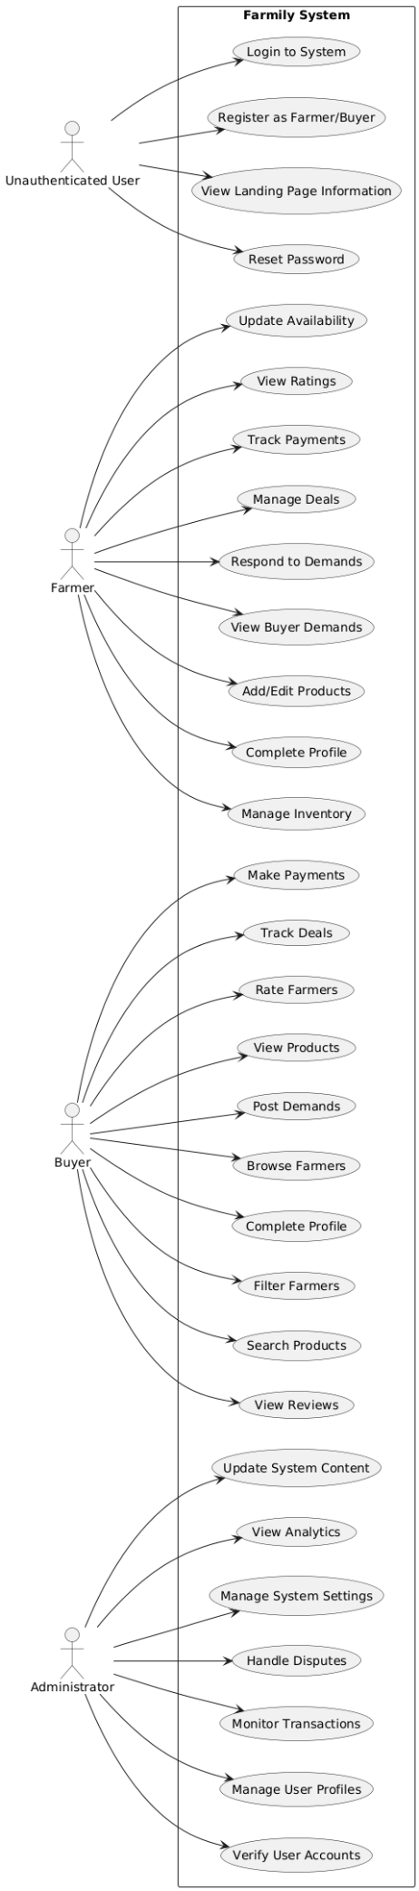
Diagram

4.2.2 SEQUENCE DIAGRAM
The "Demand Posting Flow" Sequence Diagram outlines the key steps involved when a Buyer posts a demand on the Farmily platform. The main components include the Buyer, the React.js Frontend, a JWT-based Authentication Service, the Django-based Demand Service, and a MySQL Database.

The process starts when the Buyer opens the demand form via the frontend. Before submitting, the frontend sends the user's token to the Authentication Service to verify identity. If valid, the frontend proceeds to send the demand details to the Demand Service.

The Demand Service validates the input and stores the information in the database. Upon successful creation, the database returns a demand ID, which is relayed back to the frontend. The user then sees a confirmation along with the demand details.

Basic error handling is in place—for instance, invalid tokens result in authentication errors, and database failures return appropriate messages. This flow ensures secure, validated, and efficient handling of demand creation within the Farmily system.

Diagram
Farmily Sequence Diagram

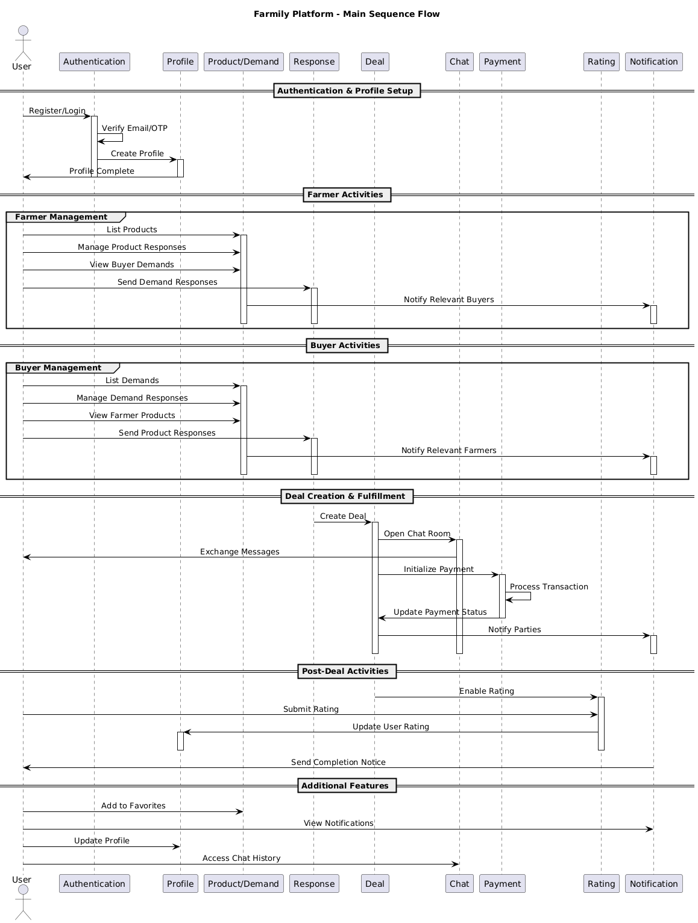

4.2.3 State Chart Diagram
The State Chart Diagram for the Farmily System illustrates the various states a user can experience while interacting with the platform, covering both authentication and core functional processes. The diagram begins with the User Authentication Flow, where a user transitions from an Unauthenticated state to a LoggedIn state after successful login. From there, users are directed to Profile Completion states, as full access to platform features depends on a completed profile.

Once authenticated and verified, users enter different role-based states — either as a Farmer or a Buyer. Each of these user roles has its own set of states and transitions. For farmers, states include Managing Products, Handling Deals, and Updating Profile, with transitions triggered by actions like adding new products, negotiating deals, or editing personal and inventory details. For buyers, states include Managing Demands, Browsing Products, Tracking Deals, and Profile Updates, driven by actions like posting demands, viewing product listings, or initiating deals.

In addition to functional states, the diagram also includes account-level states such as Active, Suspended, and Blocked, which represent administrative or automated actions based on user behavior or system policy violations. At any point, users can trigger a Logout, returning them to the Unauthenticated state.

Transitions between states are triggered by user actions (e.g., login, post demand, update profile), system responses (e.g., successful profile save, demand accepted), or administrative decisions (e.g., account suspension). This state chart provides a comprehensive view of how users move through different states in the system, ensuring clarity around feature access, role-specific workflows, and administrative control.

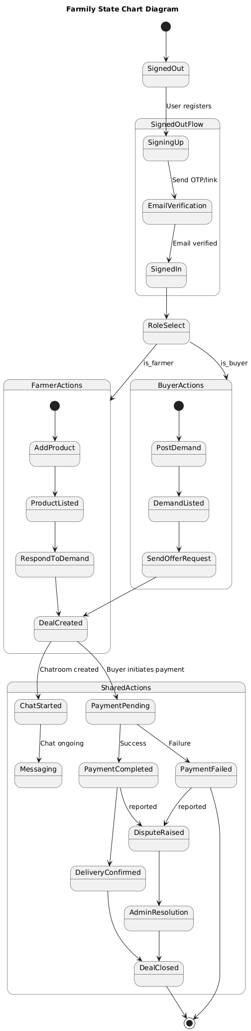
Diagram

4.2.4 Activity Diagram

This activity diagram illustrates the workflow a farmer follows on the Farmily platform, beginning with login and profile completion. Once logged in, the farmer can post products and wait for buyer responses. While waiting, they can continue posting additional products in parallel. When a buyer responds, the farmer reviews the response and decides to either accept or decline it. If accepted, a deal is created, followed by parallel activities for payment processing and inventory updates. Once both are completed, the deal is marked as completed. The diagram includes conditional flows, decision points, and parallel actions, clearly mapping out the end-to-end deal process from the farmer’s perspective.

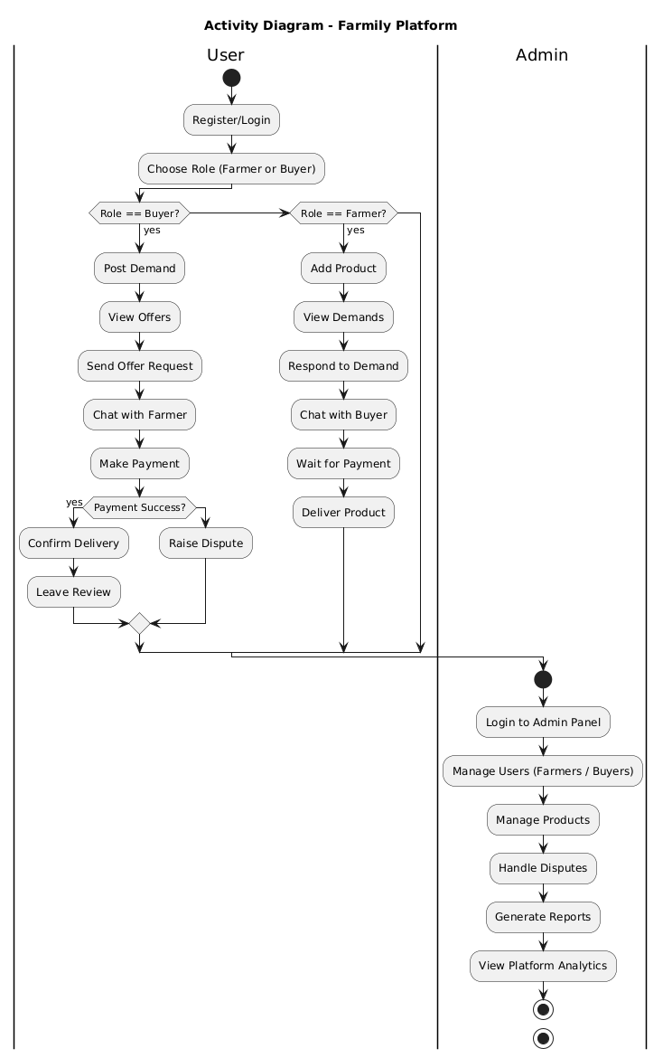
Diagram

Class Diagram
This class diagram represents the core structure of the Farmily system, highlighting key entities and their relationships. At the center is the User class, which serves as a base for both Farmer and Buyer, showcasing inheritance and role-based behavior. Farmers can manage multiple Product entries, while buyers can create Demand posts and interact with available products.

A Response acts as the bridge between products or demands and potential deals. When a response is accepted, a Deal is initiated, managing transaction status and total amount. The system also supports user feedback through the Rating class, which connects buyers and farmers via reviews. Notifications are linked to users, allowing system messages and alerts to be sent.

The diagram includes key attributes and essential methods in each class, outlining the basic functionality of login, posting products or demands, handling deals, and sending notifications. Overall, this structure models the flow of interactions in a digital agriculture marketplace and sets the foundation for both frontend and backend logic.

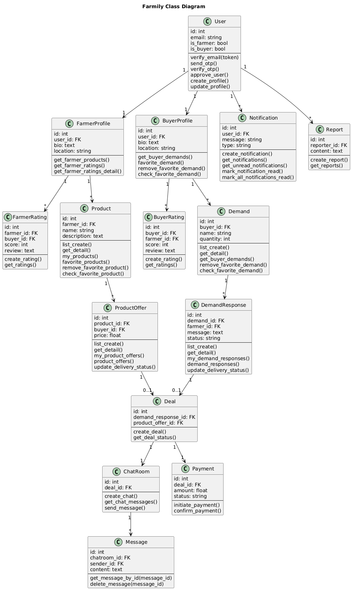
Diagram

Object Diagram
The object diagram represents the overall structure and workflow of the Farmily platform, which is designed to connect farmers with potential buyers in a streamlined and efficient way. In this system, a farmer, represented by the FarmerProfile object, begins by creating a Product, which includes details like crop type, quantity, and price per unit. On the other side, a buyer, represented by the BuyerProfile object, creates a Demand indicating their requirements such as crop type, needed quantity, and maximum price they are willing to pay. Both the farmer and the buyer can initiate and exchange a Response, allowing them to negotiate the deal terms by proposing adjusted quantities and prices.
Once the terms are mutually agreed upon, the Response leads to the creation of a Deal that records the confirmed quantity and total price. The platform also includes a ChatConversation object to facilitate real-time communication between the parties during the negotiation or deal confirmation phase. After the deal is finalized, the Payment object handles the financial transaction, ensuring the amount is transferred successfully using a specified payment method. Lastly, both the farmer and the buyer can provide feedback through a Rating object, contributing to the credibility and trustworthiness of users on the platform. This diagram captures the end-to-end interaction and transaction flow that supports fair and transparent agricultural trading.

Diagram

Farmily Object Diagram

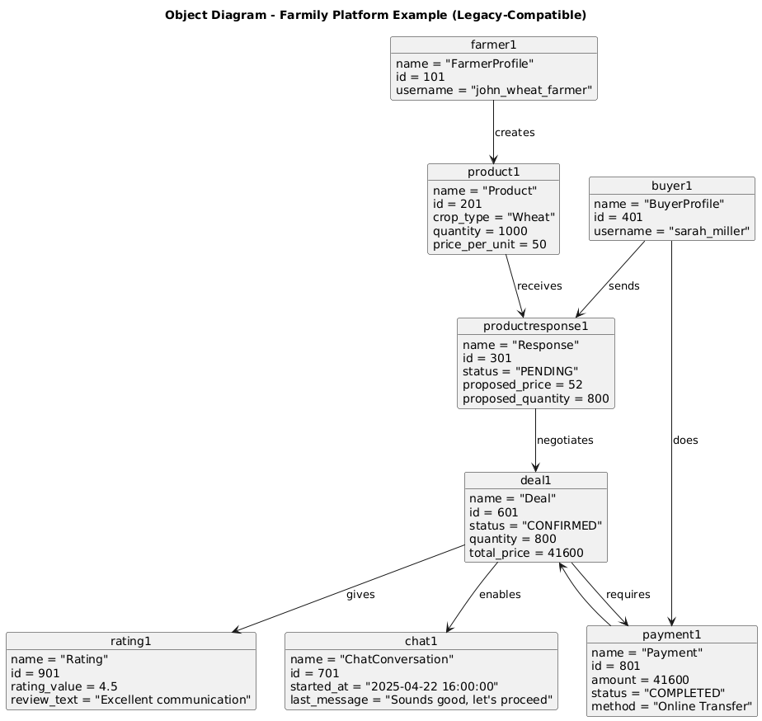

Component Diagram
This component diagram presents a vertically structured view of the Farmily platform’s architecture, clearly separating the frontend, backend, database, and external services.
Frontend (React)
Built using React, the frontend includes:
- User Interface components for interacting with the system.
- State Management for handling app-wide data flow.
- API Integration to communicate with backend services.
- Authentication Token Handler for managing JWT-based sessions.
Backend (Django)
The backend, built with Django, is modularized into services:
- Authentication Service: Manages login, registration, and JWT validation.
- Product & Demand Service: Handles product listings and demand postings.
- Deal Management Service: Manages responses, negotiations, and deal workflows.
- User Profile Service: Handles farmer and buyer profiles.
- Chat System Service: Enables in-app communication tied to deals and demands.
Database Layer
- MySQL: The main data storage for all core entities—users, demands, products, deals, etc.
- Redis: Used for caching frequently accessed data to improve performance.
External Services
- Payment Gateway: Processes financial transactions between buyers and farmers.
- Email Notification Service: Sends system updates, deal alerts, and account actions.
- Google OAuth Integration
Interactions
- Frontend communicates with backend via REST APIs.
- Backend services interact with both the database and external services.
- Services are loosely coupled and modular, enabling scalability and maintainability.
- This vertically organized diagram reflects the clean separation of responsibilities across the system’s components, ensuring scalability, performance, and clear workflow integration.

Diagram
Farmily Component Diagram
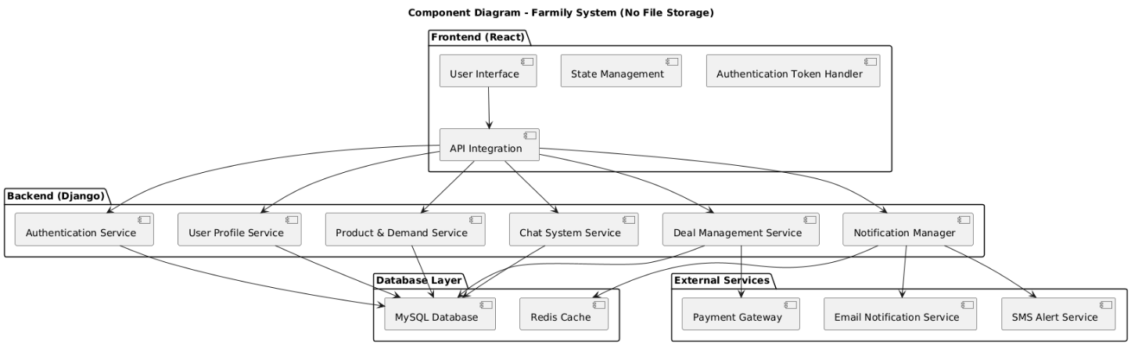

4.2.8 Deployment Diagram
The Farmily deployment architecture features a streamlined yet robust setup. At its core, a single web server hosts Nginx for static file serving and reverse proxy duties, while Gunicorn manages the Django application server. The application layer combines a Django backend with a React frontend, supported by Redis caching for performance optimization. Data management is handled through a local MySQL database for structured data and a dedicated media storage system for product images and user uploads.
External services are integrated to enhance functionality: Stripe handles secure payment processing, SMTP manages email notifications for system updates and alerts, and Google OAuth provides secure user authentication. This architecture supports both web and mobile browser access, ensuring a seamless experience across devices. While currently deployed on a single server, the system is designed with future scalability in mind, allowing for easy expansion through load balancing, database separation, and cloud migration options.
The infrastructure is cost-effective yet scalable, with essential security features including HTTPS encryption and secure payment processing. Basic caching with Redis improves performance, while centralized logging through Django provides monitoring capabilities. This deployment setup balances initial cost constraints with the flexibility needed for future growth and expansion of the platform's capabilities.

Diagram

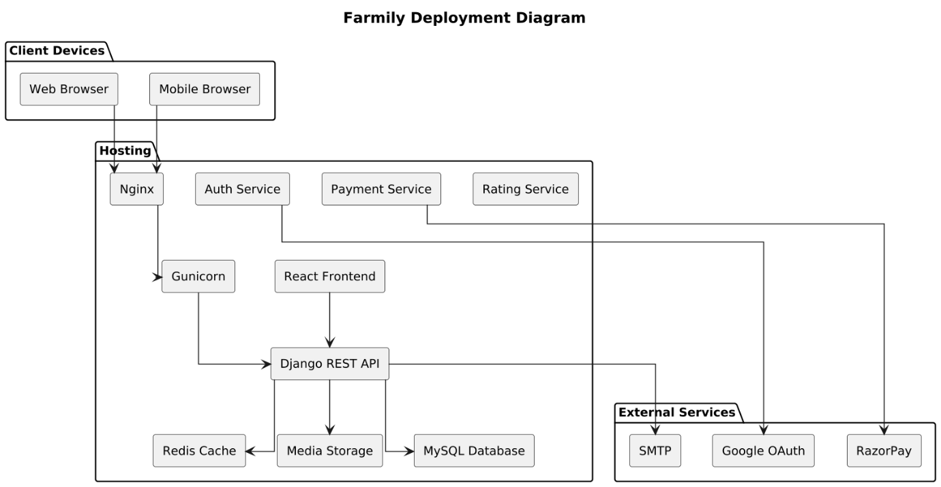

4.3 USER INTERFACE DESIGN USING FIGMA

Form Name: Signup Page

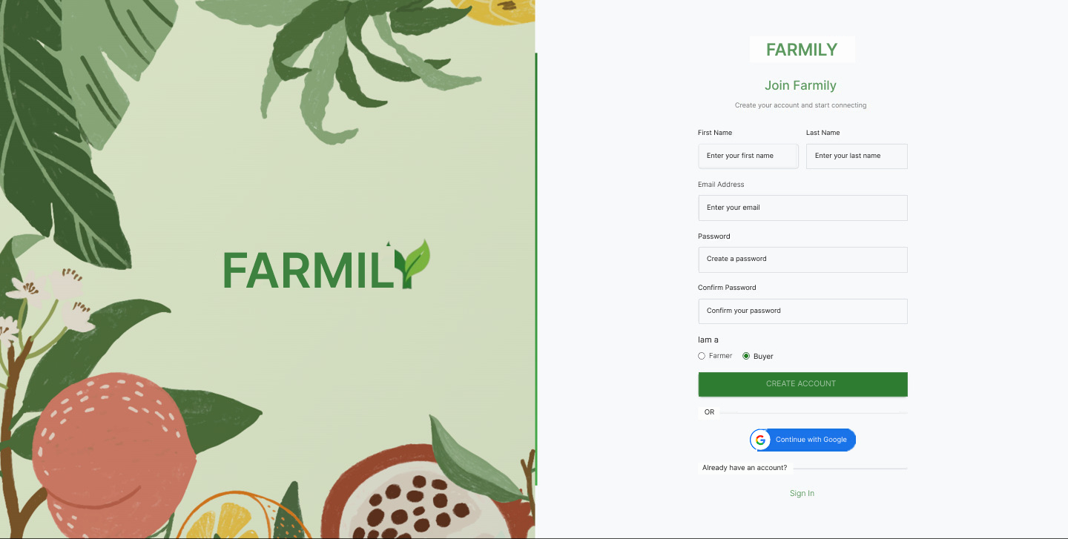

Form Name: Login Page

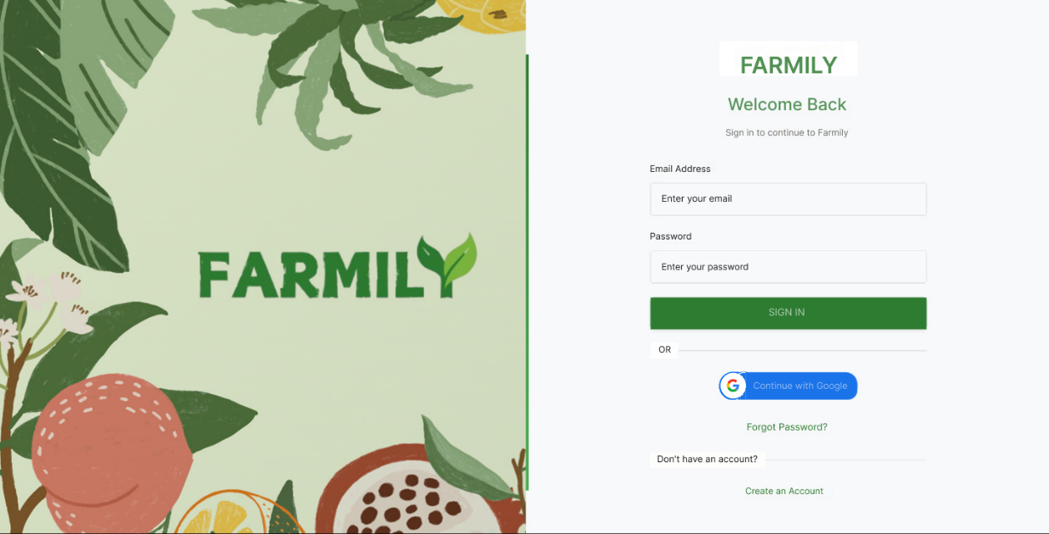

Form Name : Products Page

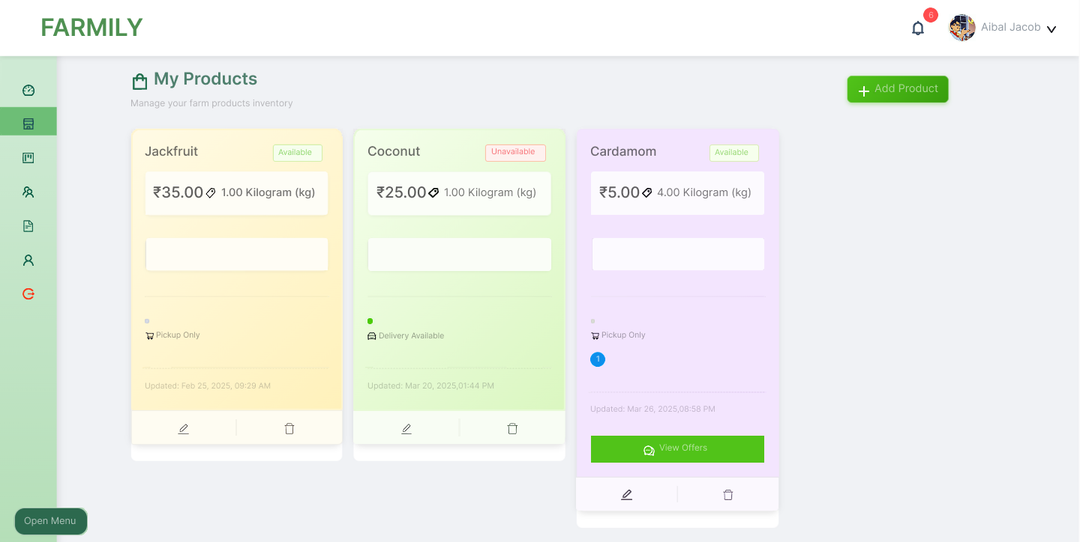

Form Name : Home Page
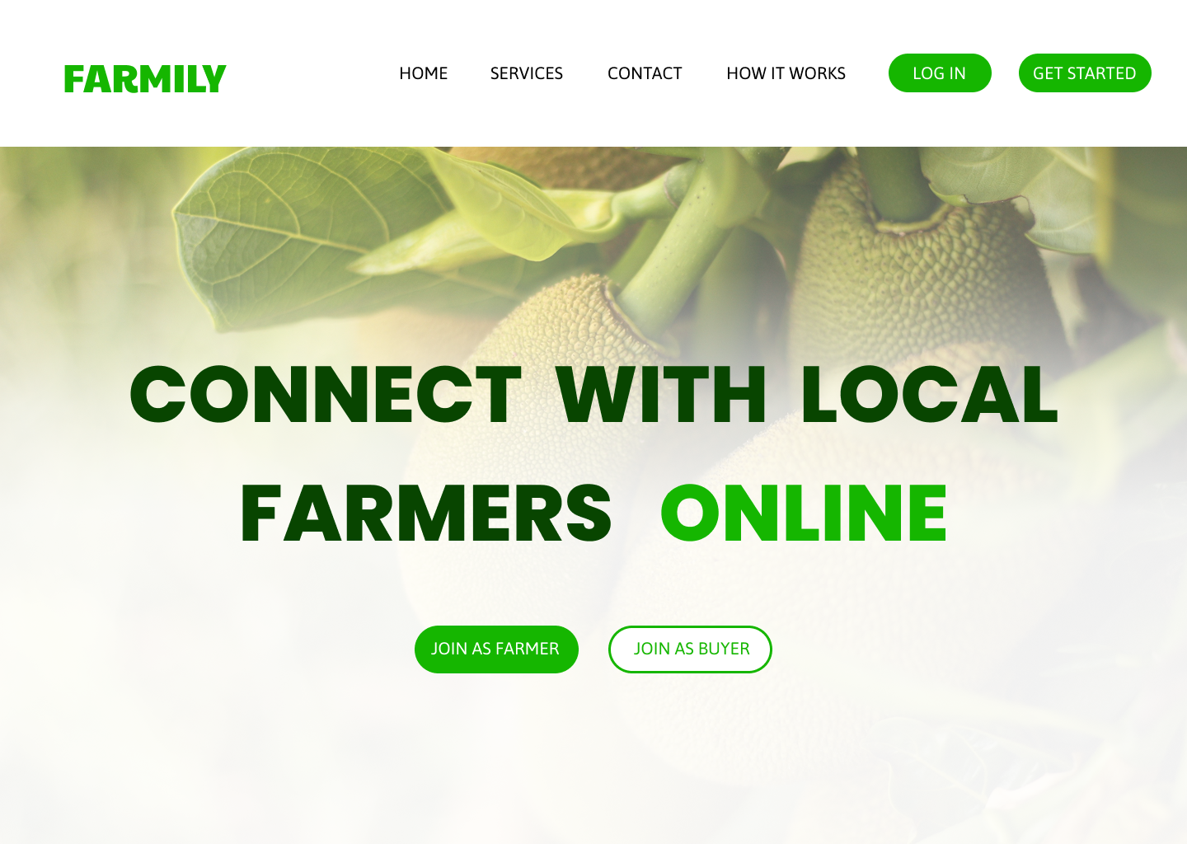

4.4 DATABASE DESIGN

4.4.1 Relational Database Management System (RDBMS)
In the context of Farmily, a Relational Database Management System (RDBMS) serves as the foundational architecture that brings structure and meaning to the agricultural marketplace's complex data ecosystem. Unlike traditional databases, Farmily's RDBMS is meticulously designed to capture the intricate relationships between farmers, buyers, products, and transactions. It acts as a digital backbone, ensuring that every interaction—from a farmer listing a crop to a buyer completing a purchase—is recorded with precision, integrity, and reliability. The system goes beyond mere data storage, creating a robust framework that supports real-time marketplace dynamics, user authentication, and comprehensive transaction tracking.

4.4.2 Normalization

Normalization in the Farmily platform represents a strategic approach to data organization that transforms raw, unstructured information into a coherent and efficient database structure. By systematically breaking down complex data sets into smaller, more focused tables, the normalization process eliminates redundancy and potential inconsistencies that could arise in a agricultural marketplace with diverse user interactions. For Farmily, this means creating a database where a farmer's profile, product listings, and transaction histories are interconnected yet distinct, allowing for flexible querying, easier maintenance, and scalable growth.

First Normal form (1NF)

• Eliminate duplicative columns from the same table.

• Create separate tables for each group of related data and identify each row with a unique column or set of columns (the primary key).

E.g. Below is a students’ record table that has information about student roll number, student name, student course, and age of the student.

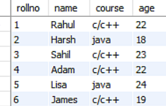

In the students record table, you can see that the course column has two values. Thus, it does not follow the First Normal Form. Now, if you use the First Normal Form to the above table, you get the below table as a result.

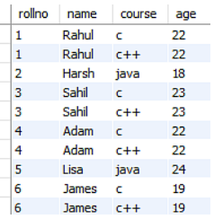

By applying the First Normal Form, you achieve atomicity, and also every column has unique values.

Second Normal form (2NF)

• Meet all the requirements of the first normal form.

• Remove subsets of data that apply to multiple rows of a table and place them in separate tables.

• Create relationships between these new tables and their predecessors through the use of foreign keys. Now understand the Second Normal Form with the help of an example. Consider the table Location:

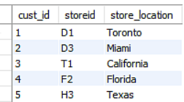

The Location table possesses a composite primary key cust id, storied. The nonkey attribute is store location. In this case, store location only depends on storied, which is a part of the primary key. Hence, this table does not fulfill the second normal form.To bring the table to Second Normal Form, you need to split the table into two parts. This will give you the below tables:

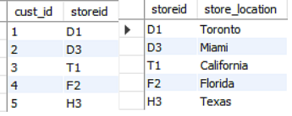

As you have removed the partial functional dependency from the location table, the column store location entirely depends on the primary key of that table, storied.

Third Normal form (3NF)

• Meet all the requirements of the second normal form.

• Remove columns that are not dependent upon the primary key.

• The third Normal Form ensures the reduction of data duplication. It is also used to achieve data integrity. Below is a student table that has student id, student name, subject id, subject name, and address of the student as its columns.

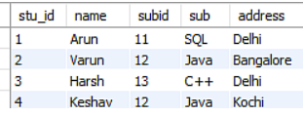
In the above student table, stu_id determines sub_id, and sub_id determines sub. Therefore, stu_id determines sub via sub_id. This implies that the table possesses a transitive functional dependency, and it does not fulfill the third normal form criteria. Now to change the table to the third normal form, you need to divide the table as shown below:
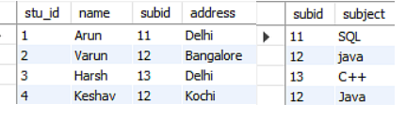
As you can see in both the tables, all the non-key attributes are now fully functional, dependent only on the primary key. In the first table, columns name, sub_id, and addresses only depend on stu_id. In the second table, the sub only depends on sub_id.

4.4.3 Sanitization
Sanitization for Farmily is a comprehensive security shield that protects the platform's data integrity and user trust. In an agricultural marketplace where sensitive information like farm details, personal contacts, and transaction records are exchanged, sanitization becomes a critical defensive mechanism. This process involves meticulously validating, cleaning, and filtering every piece of user-generated content and input before it enters the database. From preventing malicious SQL injections to ensuring that farm sizes are realistic, crop descriptions are appropriate, and user roles are correctly assigned, sanitization acts as a vigilant gatekeeper. It transforms potentially dangerous or inconsistent data into a standardized, safe format, thereby safeguarding the platform against potential security breaches, maintaining data quality, and ensuring a reliable, trustworthy environment for farmers and buyers to conduct their agricultural transactions.
4.4.4 Indexing
Indexing in the Farmily platform is akin to creating an intelligent, high-speed navigation system for the database. As the agricultural marketplace grows with increasing numbers of farmers, products, and transactions, indexing becomes crucial in maintaining swift and efficient data retrieval. Think of it as a sophisticated card catalog in a library, where instead of manually searching through countless books, you can instantly locate exactly what you need. For Farmily, this means rapid searches for specific crops, quick filtering of deals by status, and lightning-fast retrieval of farmer profiles based on various criteria. The indexing strategy is carefully crafted to balance between query speed and write performance, ensuring that whether a buyer is searching for wheat producers or a farmer is checking their transaction history, the response is immediate and seamless. By creating strategic indexes on frequently accessed columns and implementing advanced search techniques, Farmily transforms what could be a sluggish database into a responsive, agile platform that can handle complex queries with remarkable efficiency.

4.5 TABLE DESIGN
1. Users
Primary key: id
Foreign key: none

No. | Field Name | Datatype (Size) | Key Constraints | Description of the Field
1 | id | INT | PRIMARY KEY, AUTO_INCREMENT | Unique identifier for each user
2 | first_name | VARCHAR(50) | NOT NULL | First name of the user
3 | last_name | VARCHAR(50) | NOT NULL | Last name of the user
4 | email | VARCHAR(255) | UNIQUE, NOT NULL | Unique email address of the user
5 | password | VARCHAR(255) | NOT NULL | Encrypted/hashed password
6 | role | ENUM('farmer', 'buyer', 'admin') | NOT NULL | Role assigned to the user
7 | is_verified | BOOLEAN | DEFAULT FALSE | Whether the user’s email/account is verified
8 | created_at | TIMESTAMP | DEFAULT CURRENT_TIMESTAMP | Timestamp when the user account was created
9 | updated_at | TIMESTAMP | DEFAULT CURRENT_TIMESTAMP ON UPDATE CURRENT_TIMESTAMP | Timestamp of the last update

2. Farmer Profile
Primary Key: id
Foreign Key: user_id references table users(id)

No. | Field Name | Datatype (Size) | Key Constraints | Description of the Field
1 | id | INT | PRIMARY KEY, AUTO_INCREMENT | Unique identifier for each farmer profile
2 | user_id | INT | UNIQUE, NOT NULL, FOREIGN KEY (users.id), ON DELETE CASCADE | Links to the associated user account
3 | bio | TEXT | NOT NULL | Short biography or description
4 | phone_number | VARCHAR(20) | UNIQUE | Farmer's contact number
5 | profile_picture | VARCHAR(255) | NOT NULL | URL/path to the farmer's profile picture
6 | date_of_birth | DATE | NOT NULL | Farmer's date of birth
7 | address | TEXT | NOT NULL | Detailed farm or residence address
8 | city | VARCHAR(100) | NOT NULL | City of the farmer's location
9 | state | VARCHAR(100) | NOT NULL | State of the farmer's location
10 | country | VARCHAR(100) | NOT NULL | Country of residence
11 | postal_code | VARCHAR(20) | NOT NULL | Postal or ZIP code
12 | latitude | DECIMAL(10,8) | NOT NULL | Geographic latitude coordinate
13 | longitude | DECIMAL(11,8) | NOT NULL | Geographic longitude coordinate

3. Buyer Profile
Primary Key: id
Foreign Key: user_id references table users(id)

No. | Field Name | Datatype (Size) | Key Constraints | Description of the Field
1 | id | INT | PRIMARY KEY, AUTO_INCREMENT | Unique identifier for each buyer profile
2 | user_id | INT | UNIQUE, NOT NULL, FOREIGN KEY (users.id), ON DELETE CASCADE | Links to the associated user account
3 | bio | TEXT | NOT NULL | Short biography or description
4 | phone_number | VARCHAR(20) | UNIQUE | buyer's contact number
5 | profile_picture | VARCHAR(255) | NOT NULL | URL/path to the buyer's profile picture
6 | date_of_birth | DATE | NOT NULL | buyer's date of birth
7 | address | TEXT | NOT NULL | Detailed farm or residence address
8 | city | VARCHAR(100) | NOT NULL | City of the farmer's location
9 | state | VARCHAR(100) | NOT NULL | State of the farmer's location
10 | country | VARCHAR(100) | NOT NULL | Country of residence
11 | postal_code | VARCHAR(20) | NOT NULL | Postal or ZIP code
12 | latitude | DECIMAL(10,8) | NOT NULL | Geographic latitude coordinate
13 | longitude | DECIMAL(11,8) | NOT NULL | Geographic longitude coordinate

4. Products
Primary Key: id
Foreign Key: farmer_id references table farmer_profiles(id)
No. | Field Name | Datatype (Size) | Key Constraints | Description of the Field
1 | id | INT | PRIMARY KEY, AUTO_INCREMENT | Unique identifier for each product
2 | farmer_id | INT | NOT NULL, FOREIGN KEY (farmer_profiles.id), ON DELETE CASCADE | Links product to a specific farmer profile
3 | category | VARCHAR(255) | NOT NULL | Type of the product
4 | description | TEXT | NOT NULL | Description of the product
5 | price_per_unit | DECIMAL(10,2) | NOT NULL | Price per unit (kg, liter, or piece)
6 | unit_type | ENUM('kg', 'liter', 'piece') | NOT NULL | Unit in which the product is sold
7 | available_quantity | DECIMAL(10,2) | NOT NULL | Amount currently available for sale
8 | Created at | TIMESTAMP | DEFAULT CURRENT_TIMESTAMP | Timestamp when the product wwas listed

5. Demands
Primary Key: id
Foreign Key: farmer_id references table farmer_profiles(id)
No. | Field Name | Datatype (Size) | Key Constraints | Description of the Field
1 | id | INT | PRIMARY KEY, AUTO_INCREMENT | Unique identifier for each product
2 | buyer_id | INT | NOT NULL, FOREIGN KEY (farmer_profiles.id), ON DELETE CASCADE | Links product to a specific buyer profile
3 | category | VARCHAR(255) | NOT NULL | Type of the demand
4 | description | TEXT | NOT NULL | Description of the demand
5 | price_per_unit | DECIMAL(10,2) | NOT NULL | Price per unit (kg, liter, or piece)
6 | unit_type | ENUM('kg', 'liter', 'piece') | NOT NULL | Unit in which the demand is sold
7 | available_quantity | DECIMAL(10,2) | NOT NULL | Amount currently available for sale
8 | Created at | TIMESTAMP | DEFAULT CURRENT_TIMESTAMP | Timestamp when the demand was listed

6. Deals
Primary Key: id
Foreign Keys:
farmer_id references table farmer_profiles(id)
buyer_id references table users(id)
product_id references table products(id)
demand_id references table demands(id)
No. | Field Name | Datatype (Size) | Key Constraints | Description of the Field
1 | id | INT | PRIMARY KEY, AUTO_INCREMENT | Unique identifier for each deal
2 | farmer_id | INT | NOT NULL, FOREIGN KEY (farmer_profiles.id), ON DELETE RESTRICT | References the farmer in the deal
3 | buyer_id | INT | NOT NULL, FOREIGN KEY (users.id), ON DELETE RESTRICT | References the buyer in the deal
4 | product_id | INT | NOT NULL, FOREIGN KEY (products.id), ON DELETE RESTRICT | References the product being sold
5 | quantity | DECIMAL(10,2) | NOT NULL | Quantity of product involved in the deal
6 | total_value | DECIMAL(10,2) | NOT NULL | Total monetary value of the deal
7 | deal_date | DATETIME | NOT NULL | Date and time when the deal was made
8 | status | ENUM(...) | DEFAULT 'pending' | Status of the deal (pending, completed, etc.)
9 | payment_status | ENUM(...) | DEFAULT 'unpaid' | Payment status of the deal
10 | delivery_status | ENUM(...) | DEFAULT 'pending' | Delivery status of the product
11 | created_at | TIMESTAMP | DEFAULT CURRENT_TIMESTAMP | Timestamp when the deal was created

7. Ratings
Primary Key: id
Foreign Keys:
rater_id references table users(id)
rated_user_id references table users(id)
No. | Field Name | Datatype (Size) | Key Constraints | Description of the Field
1 | id | INT | PRIMARY KEY, AUTO_INCREMENT | Unique identifier for each rating
2 | rater_id | INT | NOT NULL, FOREIGN KEY (users.id), ON DELETE CASCADE | User who gave the rating
3 | rated_user_id | INT | NOT NULL, FOREIGN KEY (users.id), ON DELETE CASCADE | User who received the rating
4 | rating_value | DECIMAL(3,2) | NOT NULL, CHECK (rating_value BETWEEN 1 AND 5) | Numeric rating value between 1.00 and 5.00
5 | rating_comment | TEXT | NOT NULL | Optional comment for the rating
6 | rating_type | ENUM('deal', 'overall', 'product') | NOT NULL | Type of rating being provided
7 | rating_date | DATETIME | DEFAULT CURRENT_TIMESTAMP | Timestamp of when the rating was submitted

8. Payments
Primary Key: id
Foreign Keys:
demand_id references table demands(id)
farmer_id references table farmer_profiles(id)
No. | Field Name | Datatype (Size) | Key Constraints | Description of the Field
1 | id | INT | PRIMARY KEY, AUTO_INCREMENT | Unique identifier for each payment
2 | deal_id | INT | NOT NULL, FOREIGN KEY (deals.id), ON DELETE RESTRICT | References the associated deal
3 | buyer_id | INT | NOT NULL, FOREIGN KEY (users.id), ON DELETE CASCADE | References the buyer making the payment
4 | amount | DECIMAL(10,2) | NOT NULL | Amount paid
5 | payment_method | ENUM(...) | NOT NULL | Method used for payment (e.g., UPI, card)
6 | transaction_id | VARCHAR(255) | UNIQUE | Unique transaction ID from payment gateway
7 | status | ENUM(...) | DEFAULT 'pending' | Current status of the payment
8 | payment_date | DATETIME | NOT NULL | Timestamp when payment was made
9 | gateway_response | TEXT | NOT NULL | Response or message from payment gateway
10 | created_at | TIMESTAMP | DEFAULT CURRENT_TIMESTAMP | When the payment record was created
11 | updated_at | TIMESTAMP | DEFAULT CURRENT_TIMESTAMP ON UPDATE CURRENT_TIMESTAMP | Last time the record was updated

9. Chat
Primary Key: id
Foreign Keys:
sender_id references table users(id)
receiver_id references table users(id)
deal_id references table deals(id) (nullable)
demand_id references table demands(id) (nullable)
No. | Field Name | Datatype (Size) | Key Constraints | Description of the Field
1 | id | INT | PRIMARY KEY, AUTO_INCREMENT | Unique identifier for each message
2 | sender_id | INT | NOT NULL, FOREIGN KEY (users.id), ON DELETE CASCADE | ID of the user who sent the message
3 | receiver_id | INT | NOT NULL, FOREIGN KEY (users.id), ON DELETE CASCADE | ID of the user receiving the message
4 | deal_id | INT | FOREIGN KEY (deals.id), ON DELETE SET NULL | Optional reference to the associated deal
5 | demand_id | INT | FOREIGN KEY (demands.id), ON DELETE SET NULL | Optional reference to the associated demand
6 | message_text | TEXT | NOT NULL | Content of the message
7 | is_read | BOOLEAN | DEFAULT FALSE | Indicates whether the message has been read
8 | created_at | TIMESTAMP | DEFAULT CURRENT_TIMESTAMP | Timestamp when the message was created

10. Notifications
Primary Key: id
Foreign Key: user_id references table users(id)
No. | Field Name | Datatype (Size) | Key / Constraints | Description of the Field
1 | id | INT | PRIMARY KEY, AUTO_INCREMENT | Unique identifier for each notification
2 | user_id | INT | NOT NULL, FOREIGN KEY (users.id), ON DELETE CASCADE | User who receives the notification
3 | type | ENUM('deal', 'message', 'demand', 'payment', 'system') | NOT NULL | Type/category of the notification
4 | content | TEXT | NOT NULL | Message/content of the notification
5 | related_id | INT | NOT NULL | ID of related entity (e.g., deal ID, message ID, etc.)
6 | is_read | BOOLEAN | DEFAULT FALSE | Status indicating whether the notification was read
7 | created_at | TIMESTAMP | DEFAULT CURRENT_TIMESTAMP | Time the notification was created

CHAPTER 5

SYSTEM TESTING

  - INTRODUCTION
Farmily Testing Overview: The testing strategy for Farmily is a comprehensive approach designed to ensure the reliability, performance, and user satisfaction of an agricultural marketplace platform. Given the complex interactions between farmers, buyers, deals, and product listings, our testing methodology will cover multiple dimensions of software quality.

Key Testing Objectives:

- Validate core marketplace functionalities
- Ensure seamless user experience
- Verify data integrity and security
- Validate payment and rating systems
- Confirm cross-platform compatibility

Project-Specific Testing Challenges:

- Complex user role management
- Real-time deal and demand interactions
- Payment gateway integration
- Geographically distributed user base
- Diverse agricultural product listings

TEST PLAN
The test plan for the Farmily platform represents a comprehensive and strategic approach to ensuring the highest quality, reliability, and performance of an innovative agricultural digital marketplace. This meticulously crafted methodology goes beyond traditional software testing by addressing the unique complexities of connecting farmers and buyers through a digital ecosystem.
At its core, the test plan is designed to provide a holistic validation framework that encompasses every critical aspect of the platform. It aims to systematically examine and verify the intricate functionalities, user interactions, and technical mechanisms that drive the agricultural marketplace. The primary objective is to create a robust testing strategy that ensures the platform not only meets technical specifications but also delivers an exceptional user experience for both farmers and buyers.

Unit Testing
Unit testing for Farmily focuses on verifying the smallest testable parts of the application, ensuring each individual component functions correctly in isolation. This involves meticulously examining core functionalities like user authentication, deal creation, rating calculations, and data validation. The primary goal is to catch and prevent potential errors at the most granular level, creating a robust foundation for the entire platform by testing individual functions, methods, and small code units that collectively drive the agricultural marketplace's core features.

Integration Testing
Integration testing in Farmily examines how different components and systems work together to create a cohesive platform. It validates the interactions between various modules such as user profiles, product listings, deal mechanisms, and payment systems. This testing approach ensures that the complex workflows of farmers creating products, buyers making demands, and completing transactions occur seamlessly. The focus is on verifying that data flows correctly between different parts of the application, maintaining integrity and functionality across the entire agricultural marketplace ecosystem.

Validation Testing or System Testing
System testing for Farmily represents a comprehensive evaluation of the entire application as a unified system. It validates that the platform meets all specified requirements and business logic across different user scenarios. This testing approach examines the complete functionality from both farmer and buyer perspectives, ensuring that critical workflows like demand creation, deal negotiation, payment processing, and user interactions work flawlessly. The primary objective is to confirm that the system behaves exactly as expected under various conditions, maintaining the integrity of the agricultural marketplace platform.

Output Testing or User Acceptance Testing
User Acceptance Testing (UAT) for Farmily is the final validation stage where actual users verify the platform's functionality, usability, and alignment with business requirements. This testing phase focuses on real-world scenarios, allowing farmers and buyers to interact with the platform and provide feedback on its practical utility. The goal is to ensure that the agricultural marketplace meets user expectations, provides an intuitive interface, and successfully facilitates agricultural transactions across different user roles and interaction scenarios.
    - Automation Testing
Automation testing in Farmily involves creating systematic, repeatable test scripts that validate the platform's functionality without manual intervention. This approach enables consistent and efficient testing of critical user journeys, from product listing to deal completion. By automating repetitive test scenarios, the platform can quickly identify potential issues, ensure regression prevention, and maintain high-quality standards across continuous development and deployment cycles. The focus is on creating a robust testing infrastructure that supports rapid and reliable software evolution.

    - Selenium Testing
Selenium testing for Farmily concentrates on validating the web interface's functionality, responsiveness, and cross-browser compatibility. This testing method simulates real user interactions across different browsers and device sizes, ensuring a consistent and high-quality user experience. The primary objectives include verifying that the platform's user interface remains functional, visually appealing, and easily navigable regardless of the user's chosen browser or device, thereby guaranteeing accessibility and usability for farmers and buyers across various technological environments.

Example:
Test Case 1
Code
import pytest
import time
import json
from selenium import webdriver
from selenium.webdriver.common.by import By
from selenium.webdriver.common.action_chains import ActionChains
from selenium.webdriver.support import expected_conditions as EC
from selenium.webdriver.support.wait import WebDriverWait
from selenium.webdriver.common.keys import Keys
from selenium.webdriver.common.desired_capabilities import DesiredCapabilities
class TestLogin():
def setup_method(self, method):
self.driver = webdriver.Chrome()
self.vars = {}
def teardown_method(self, method):
self.driver.quit()
def test_login(self):
self.driver.get("http://localhost:5173/")
self.driver.set_window_size(1552, 880)
self.driver.find_element(By.CSS_SELECTOR,
"a:nth-child(3) > .farmily-btn-secondary").click()

self.driver.find_element(By.ID, "email").send_keys("aibaljacobmanigenai2024@gmail.com")
self.driver.find_element(By.ID, "password").send_keys("AibalJacob33#")
self.driver.find_element(By.ID, "password").send_keys(Keys.ENTER)
WebDriverWait(self.driver, 10).until(
EC.presence_of_element_located((By.LINK_TEXT, "Logout"))
)
self.driver.find_element(By.LINK_TEXT, "Logout").click()

Output
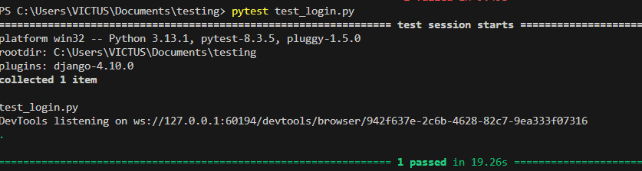
Test Report 1
Test Case 1
Project Name:FARMILY
Login Test Case
Test Case ID: Test_1 |  |  | Test Designed By: Aibal Jacob Mani
Test Priority(Low/Medium/High): High |  |  | Test Designed Date: 8th April 2025
Module Name: Login Page |  |  | Test Executed By : Ms. Lisha Varghese
Test Title : Login test |  |  | Test Execution Date: 9th April 2025
Description: |  |  | To make sure the user can login without any issues
Pre-Condition : User has valid username and password
Step | Test Step | Test Data | Expected Result | Actual Result | Status(Pass/  Fai l)
1 | Open the Farmily homepage | http://localhost:5173/ | Homepage loads successfully | Homepage loaded successfully | Pass
2 | Click the login button | – | Login form appears  Email input field accepts and displays input  Password input field accepts and displays hidden input | Login form appeared  Email entered successfully  Password entered successfully | Pass
3 | Enter valid email | aibaljacobmanigenai2024@gmail.com |  |  | Pass
4 | Enter valid password | AibalJacob33# |  |  | Pass
5 | Submit login form | Press Enter | User should be redirected to dashboard/home | User redirected successfully, Logout button visible | Pass
6 | Wait for Logout to appear |  | Logout button becomes clickable  User is logged out and returned to login page | Logout button appeared  User logged out successfully and returned to login page | Pass
7 | Click Logout |  |  |  | Pass
1 | Open the Farmily homepage | http://localhost:5173/ | Homepage loads successfully | Homepage loaded successfully | Pass
Post-Condition: User successfully logged in and can access the dashboard

Test Case 2:
Code
import pytest
from selenium import webdriver
from selenium.webdriver.common.by import By
from selenium.webdriver.common.keys import Keys
from selenium.webdriver.support.ui import WebDriverWait
from selenium.webdriver.support import expected_conditions as EC
class TestAcceptresponse:
def setup_method(self, method):
self.driver = webdriver.Chrome()
self.driver.maximize_window()
self.wait = WebDriverWait(self.driver, 10)
def teardown_method(self, method):
self.driver.quit()
def test_acceptresponse(self):
driver = self.driver
wait = self.wait
driver.get("http://localhost:5173/")
wait.until(EC.element_to_be_clickable((By.CSS_SELECTOR,"a:nth-child(3) > .farmily-btn-secondary"))).click()
wait.until(EC.presence_of_element_located((By.ID, "email"))).send_keys("aibaljacobmanigenai2024@gmail.com")
driver.find_element(By.ID, "password").send_keys("AibalJacob33#" + Keys.ENTER)

wait.until(EC.element_to_be_clickable((By.LINK_TEXT,"Post Demand"))).click()
wait.until(EC.element_to_be_clickable(
(By.CSS_SELECTOR, "div:nth-child(1) > .ant-col .view-responses-btn span:nth-child(2)")
)).click()
wait.until(EC.element_to_be_clickable(
(By.CSS_SELECTOR, ".ant-space-item > .ant-btn-primary")
)).click()
wait.until(EC.element_to_be_clickable(
(By.CSS_SELECTOR, ".ant-modal-footer > .ant-btn-primary > span")
)).click()
wait.until(EC.element_to_be_clickable(
(By.CSS_SELECTOR, ".ant-modal-wrap:nth-child(2) .ant-modal-footer span")
)).click()

Output
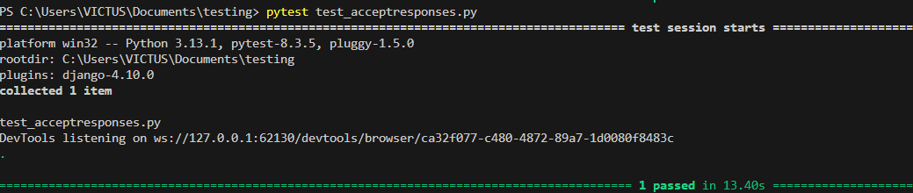
Test Report 2
Test Case 1
Project Name:FARMILY
Accept Response Case
Test Case ID: Test_2 |  |  | Test Designed By: Aibal Jacob Mani
Test Priority(Low/Medium/High): Medium |  |  | Test Designed Date: 8th April 2025
Module Name: Accept Response |  |  | Test Executed By : Ms. Lisha Varghese
Test Title : Accept Response test |  |  | Test Execution Date: 9th April 2025
Description: |  |  | To make sure the user can accept a response without any issues
Pre-Condition :User received a response
Step | Test Step | Test Data | Expected Result | Actual Result | Status(Pass/  Fai l)
1 | Open the Farmily homepage | http://localhost:5173/ | Homepage loads successfully | Homepage loaded successfully | Pass
2 | Click the login button |  | Login form appears  Email input field accepts and displays input  Password input field accepts and displays hidden input | Login form appeared  Email entered successfully  Password entered successfully | Pass
3 | Enter valid email | aibaljacobmanigenai2024@gmail.com |  |  | Pass
4 | Enter valid password | AibalJacob33# |  |  | Pass
5 | Submit login form | Press Enter | User should be redirected to dashboard/home | User redirected successfully, Logout button visible | Pass
6 | Navigate to postdemand page |  | Page opens | Page opened | pass
7 | Click accept button |  | Confirmation modal opens | Modal opened | pass
8 | Accept confirmation |  | Response gets accepted | Response is accepted | Pass
9 | Confirm feedback message |  | Success confirmation notficiation appears | Success confirmation  received | Pass
Post-Condition: User successfully accepted the response and proceeds with the deal

Test Case 3:
Code
import pytest
from selenium import webdriver
from selenium.webdriver.common.by import By
from selenium.webdriver.common.keys import Keys
from selenium.webdriver.support.ui import WebDriverWait
from selenium.webdriver.support import expected_conditions as EC
class TestInvoice:
def setup_method(self, method):
self.driver = webdriver.Chrome()
self.driver.maximize_window()
self.wait = WebDriverWait(self.driver, 10)
def teardown_method(self, method):
self.driver.quit()
def test_invoice(self):
driver = self.driver
wait = self.wait
driver.get("http://localhost:5173/")
wait.until(EC.element_to_be_clickable((By.CSS_SELECTOR,"a:nth-child(3) > .farmily-btn-secondary"))).click()
wait.until(EC.presence_of_element_located((By.ID, "email"))).send_keys("aibaljacobmanigenai2024@gmail.com")
driver.find_element(By.ID,"password").send_keys("AibalJacob33#"+ Keys.ENTER)
wait.until(EC.element_to_be_clickable((By.LINK_TEXT, "Deals"))).click()
wait.until(EC.element_to_be_clickable((
By.CSS_SELECTOR, "li:nth-child(1) .ant-btn > span:nth-child(2)"
))).click()
wait.until(EC.element_to_be_clickable((
By.CSS_SELECTOR, ".ant-space-item > .ant-btn-primary"
))).click()
wait.until(EC.element_to_be_clickable((
By.CSS_SELECTOR, ".deal-invoice-container > .ant-btn"
))).click()
wait.until(EC.visibility_of_element_located((
By.CSS_SELECTOR, ".ant-modal-centered"
)))
Output:
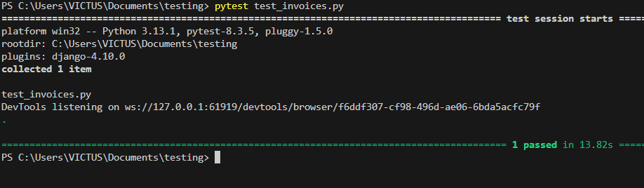

Test Report 3
Test Case 1
Project Name:FARMILY
Invoice Case
Test Case ID: Test_3 |  |  | Test Designed By: Aibal Jacob Mani
Test Priority(Low/Medium/High): Medium |  |  | Test Designed Date: 8th April 2025
Module Name: Invoice |  |  | Test Executed By : Ms. Lisha Varghese
Test Title : Invoice test |  |  | Test Execution Date: 9th April 2025
Description: |  |  | To make sure a user can view the invoice without any issues
Pre-Condition : User is part of a deal
Step | Test Step | Test Data | Expected Result | Actual Result | Status(Pass/  Fai l)
1 | Open the Farmily homepage | http://localhost:5173/ | Homepage loads successfully | Homepage loaded successfully | Pass
2 | Click the login button |  | Login form appears  Email input field accepts and displays input  Password input field accepts and displays hidden input | Login form appeared  Email entered successfully  Password entered successfully | Pass
3 | Enter valid email | aibaljacobmanigenai2024@gmail.com |  |  | Pass
4 | Enter valid password | AibalJacob33# |  |  | Pass
5 | Submit login form | Press Enter | User should be redirected to dashboard/home | User redirected successfully, Logout button visible | Pass
5 | Navigate to “Deals” section |  | Deals page appears | Deals page appeared | Pass
6 | Click to open the first deal |  | Deal detail page loads | Deal detail opened | Pass
7 | Accept deal or respond to it |  | Action accepted, button changes | Deal response accepted | Pass
8 | Click to view invoice |  | Invoice modal appears | Invoice modal appeared | Pass
Post-Condition: User can now successfully view the invoice

Test Case 4
Code:
import pytest
from selenium import webdriver
from selenium.webdriver.common.by import By
from selenium.webdriver.common.keys import Keys
from selenium.webdriver.support.ui import WebDriverWait
from selenium.webdriver.support import expected_conditions as EC
class TestSendchat:
def setup_method(self, method):
self.driver = webdriver.Chrome()
self.driver.maximize_window()
self.wait = WebDriverWait(self.driver, 10)
def teardown_method(self, method):
self.driver.quit()
def test_sendchat(self):
driver = self.driver
wait = self.wait
driver.get("http://localhost:5173/")
wait.until(EC.element_to_be_clickable((By.CSS_SELECTOR,"a:nth-child(3) > .farmily-btn-secondary"))).click()
wait.until(EC.presence_of_element_located((By.ID, "email"))).send_keys("aibaljacobmanigenai2024@gmail.com")
driver.find_element(By.ID,"password").send_keys("AibalJacob33#"+ Keys.ENTER)
wait.until(EC.element_to_be_clickable((By.LINK_TEXT, "Deals"))).click()
wait.until(EC.element_to_be_clickable((
By.CSS_SELECTOR, "li:nth-child(2) .ant-btn > span:nth-child(2)"
))).click()
chat_input = wait.until(EC.presence_of_element_located((
By.CSS_SELECTOR, "div.ant-modal input.ant-input"
)))
chat_input.send_keys("hello")
send_button = wait.until(EC.element_to_be_clickable((
By.CSS_SELECTOR, "div.ant-modal span[role='img']" # Adjust this if your send icon is different
)))
send_button.click()

Output:
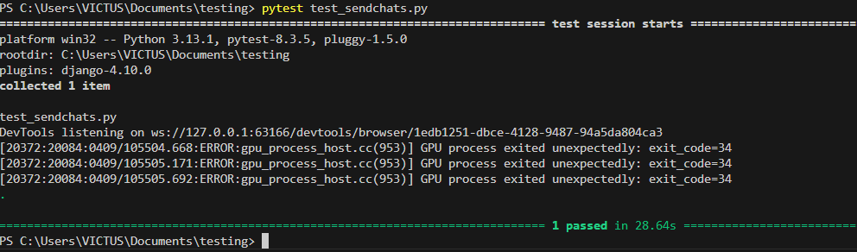

Test report 4
Test Case 1
Project Name:FARMILY
Send Chat Case
Test Case ID: Test_4 |  |  | Test Designed By: Aibal Jacob Mani
Test Priority(Low/Medium/High): Medium |  |  | Test Designed Date: 8th April 2025
Module Name: Send Chat Page |  |  | Test Executed By : Ms. Lisha Varghese
Test Title : Send Chat test |  |  | Test Execution Date: 9th April 2025
Description: |  |  | To make sure a user can chat to another without any issues
Pre-Condition :User is part of a deal
Step | Test Step | Test Data | Expected Result | Actual Result | Status(Pass/  Fai l)
1 | Open the Farmily homepage | http://localhost:5173/ | Homepage loads successfully | Homepage loaded successfully | Pass
2 | Click the login button |  | Login form appears  Email input field accepts and displays input  Password input field accepts and displays hidden input | Login form appeared  Email entered successfully  Password entered successfully | Pass
3 | Enter valid email | aibaljacobmanigenai2024@gmail.com |  |  | Pass
4 | Enter valid password | AibalJacob33# |  |  | Pass
5 | Submit login form | Press Enter | User should be redirected to dashboard/home | User redirected successfully, Logout button visible | Pass
6 | Navigate to “Deals” section |  | Deals section loads | Deals page appeared | Pass
7 | Open second deal to access chat |  | Deal modal with chat appears | Chat modal appeared | Pass
8 | Locate and type message into chat input field | hello | Message appears in input field | Message entered | Pass
9 | Click send button |  | Message is sent and appears in chat area | Message sent successfully | Pass
Post-Condition: The user successfully sent the message

CHAPTER 6

IMPLEMENTATION

INTRODUCTION

The implementation phase for the Farmily agricultural marketplace platform represents a critical transition from conceptual design to a fully functional digital ecosystem. This comprehensive introduction outlines the strategic approach to bringing the platform from development to operational status, focusing on creating a seamless, user-friendly, and technologically robust agricultural marketplace.
The implementation process is designed to address the unique challenges of connecting farmers and buyers through a digital platform, ensuring that every aspect of the system is carefully planned, executed, and optimized. It encompasses a holistic approach that goes beyond mere technical deployment, considering the human, technological, and operational dimensions of the platform.
Key implementation objectives include:
- Ensuring smooth platform deployment
- Providing comprehensive user onboarding
- Establishing robust system maintenance protocols
- Creating a scalable and secure hosting environment
- Supporting user adaptation and platform effectiveness

IMPLEMENTATION PROCEDURES

The implementation procedures for Farmily represent a meticulously crafted roadmap for transforming the digital agricultural marketplace from a conceptual design to a fully operational platform. This comprehensive approach addresses the complex requirements of bringing together farmers and buyers in a digital ecosystem, focusing on creating a seamless, intuitive, and powerful technological solution.
The procedures are designed to ensure:
- Smooth technological integration
- Comprehensive user preparation
- Robust system deployment
- Ongoing platform support and maintenance

User Training
User training for the Farmily platform is a critical component of the implementation strategy, designed to bridge the technological gap and empower users from diverse agricultural backgrounds. The training approach recognizes the varied technological literacy levels of farmers and buyers, creating an inclusive and supportive learning environment.
Key training objectives:
- Demystify platform functionality
- Build user confidence
- Ensure effective platform utilization
- Support digital skill development
Training methodologies:
- Interactive video tutorials
- Step-by-step user guides
- Live webinar sessions
- Personalized support channels
- Multilingual training resources

Training on the Application Software
The application software training for Farmily is a comprehensive educational approach tailored to help users navigate and maximize the platform's capabilities. This training goes beyond basic functionality, focusing on empowering users to leverage the full potential of the agricultural marketplace.
Training focus areas:
- Profile creation and management
- Product listing techniques
- Demand creation and response mechanisms
- Deal negotiation processes
- Payment and transaction workflows
- Rating and review systems
Training delivery methods:
- Contextual in-app guidance
- Detailed video demonstrations
- Interactive user manuals
- Personalized onboarding sessions
- Continuous learning resources

System Maintenance
System maintenance for the Farmily platform is a proactive and comprehensive strategy designed to ensure continuous platform reliability, performance, and security. This approach goes beyond traditional maintenance, creating a dynamic ecosystem of ongoing optimization and support.
Maintenance key components:
- Regular security updates
- Performance monitoring
- Database optimization
- Bug fixing and resolution
- Feature enhancement
- Scalability management
Maintenance strategies:
- Automated monitoring systems
- Periodic security audits
- Continuous integration and deployment
- User feedback incorporation
- Predictive maintenance techniques
    - Hosting
When a web hosting provider allocates space on a web server for an online site, they are enabling the site to be accessible on the internet. Web hosting involves making all the files of a website, such as its code and images, accessible for online browsing. The capacity assigned to a website on a server varies according to the type of web hosting selected, with shared, dedicated, VPS, and reseller hosting being the most prevalent options. These types of hosting are distinguished by the technology used for the server, the level of service provided, and the additional services on offer.
Example: Vercel
Procedure for hosting a website on Vercel:
1. Account Creation
- Visit vercel.com
- Sign up using GitHub, GitLab, or Bitbucket
- Authorize Vercel to access your repositories
2. Project Deployment
- Push your code to a Git repository (e.g., GitHub)
- Import your repository into Vercel
- Vercel auto-detects your project (e.g., React, Next.js)
- Configure build settings (if needed) and deploy
3. Domain Configuration
- Use the default Vercel subdomain (e.g., farmily.vercel.app)
- Or add a custom domain
- Verify and manage DNS settings via Vercel dashboard
- Once deployed, any code pushed to the repo auto-triggers a redeploy

Hosted Website: VERCEL

Hosted Link: https://farmilyfsront.vercel.app

QR Code:


Screenshot

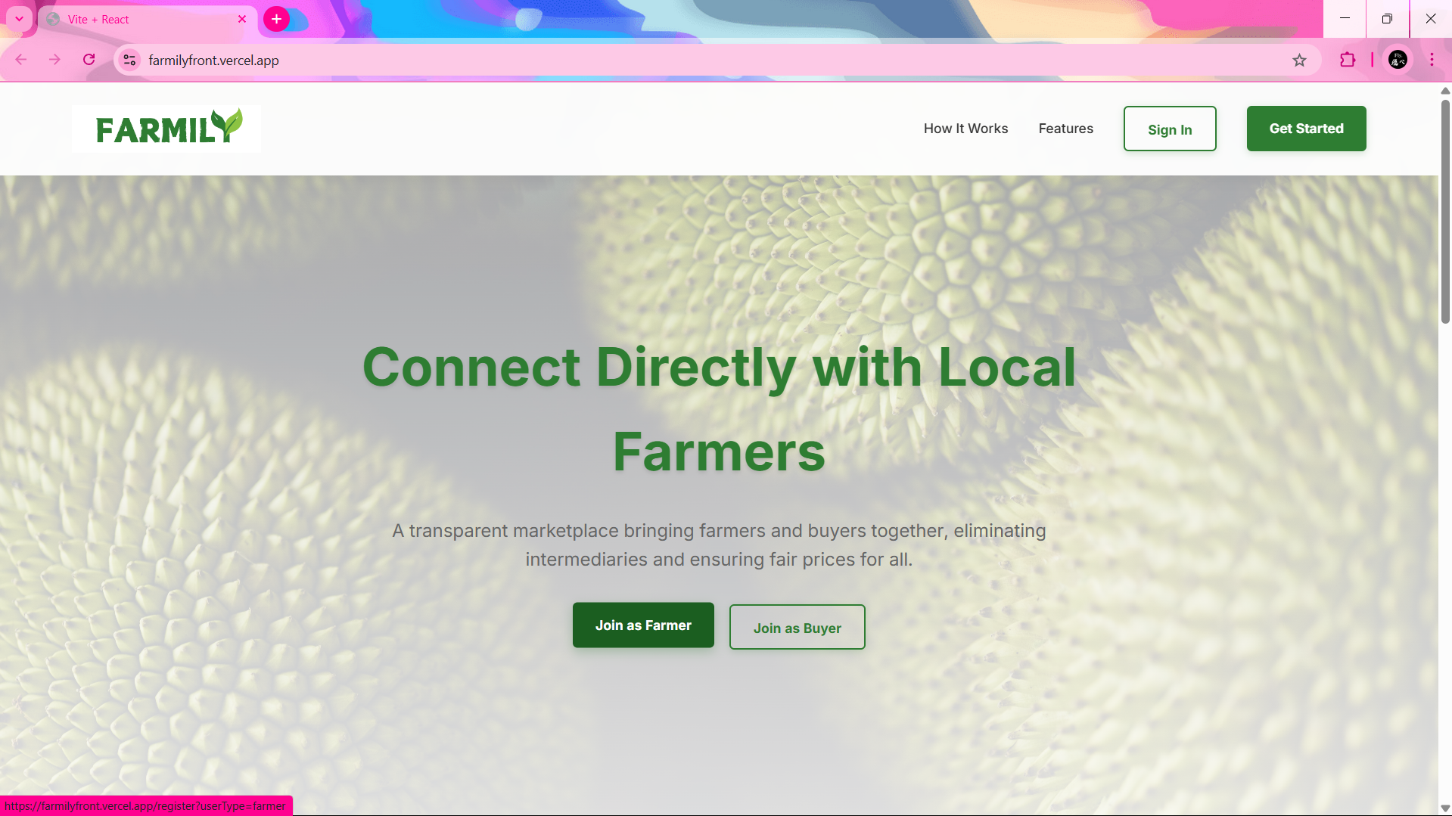

CHAPTER 7

CONCLUSION AND FUTURE SCOPE

CONCLUSION

The Farmily agricultural marketplace platform represents a transformative digital solution designed to revolutionize agricultural commerce by bridging the gap between farmers and buyers through innovative technology. This comprehensive platform emerges as a strategic response to the complex challenges faced by agricultural stakeholders, offering a robust, user-centric ecosystem that simplifies product discovery, negotiation, and transaction processes.

Key Achievements:

Created a seamless digital marketplace for agricultural products

Developed an intuitive, user-friendly platform

Implemented advanced features for farmer and buyer interactions

Established a secure and reliable transaction mechanism

Provided technological empowerment for agricultural communities

The project demonstrates the potential of technology to address critical agricultural market inefficiencies by:

Reducing intermediary dependencies

Enhancing market accessibility

Providing transparent pricing mechanisms

Enabling direct farmer-buyer connections

Supporting agricultural economic growth

Technological Innovation Highlights:

Advanced user authentication

Comprehensive profile management

Real-time demand and deal mechanisms

Secure payment integration

Robust rating and review systems
  - FUTURE SCOPE
The future of the Farmily platform holds immense potential for expansion and technological innovation in agricultural digital marketplaces. The roadmap for future development encompasses several strategic dimensions:
Technological Advancements
- Artificial Intelligence-driven market predictions
- Machine learning for personalized recommendations
- Advanced data analytics for agricultural trends
- Blockchain integration for transparent transactions
Feature Expansion
- Crop health monitoring systems
- Predictive pricing algorithms
- Comprehensive agricultural resource management
- Advanced logistics and transportation integration
Ecosystem Enhancement
- Multi-language support
- Expanded geographical coverage
- Integration with agricultural research institutions
- Comprehensive farmer financial services
Sustainability Initiatives
- Carbon footprint tracking
- Sustainable agricultural practice incentives
- Environmental impact measurement tools
- Climate-resilient farming support
Community Development
- Knowledge sharing platforms
- Farmer skill development programs
- Agricultural education resources
- Community-driven innovation channels
Strategic Vision: Farmily aims to evolve from a digital marketplace to a comprehensive agricultural ecosystem that empowers farmers, supports sustainable practices, and drives agricultural innovation through technological intervention.
Potential Impact:
- Economic empowerment of agricultural communities
- Enhanced market efficiency
- Technological democratization
- Sustainable agricultural development
- Global agricultural connectivity

The future scope of Farmily represents not just a technological project, but a holistic approach to transforming agricultural commerce, bridging technological innovation with the fundamental needs of farming communities worldwide.

CHAPTER 8

BIBLIOGRAPHY

REFERENCES:

- Gary B. Shelly, Harry J. Rosenblatt, “System Analysis and Design”, 2009.
- Roger S Pressman, “Software Engineering”, 1994.
- Pankaj Jalote, “Software engineering: a precise approach”, 2006.
- IEEE Std 1016 Recommended Practice for Software Design Descriptions.

WEBSITES:

- https://www.w3schools.com/
- https://www.draw.io
- https://www.javatpoint.com/
- https://www.tutorialspoint.com/
- https://stackoverflow.com/

CHAPTER 9

APPENDIX

Sample Code
Login and Registration
import React, { useState } from 'react';
import './LoginPage.css';
import axios from 'axios';
import { Link, useNavigate } from 'react-router-dom';
import { useLocation } from 'react-router-dom';
import { ToastContainer, toast } from 'react-toastify';
import 'react-toastify/dist/ReactToastify.css';
import classNames from 'classnames';
import { GoogleLogin } from '@react-oauth/google';
import { jwtDecode } from 'jwt-decode';
export const LoginPage = () => {
const navigate = useNavigate();
const [formData, setFormData] = useState({
email: '',
password: '',
});
const [errors, setErrors] = useState({ email: '', password: '' });
const [serverError, setServerError] = useState('');
const [showResend, setShowResend] = useState(false);
const [googleLoading, setGoogleLoading] = useState(false);
const resendVerificationEmail = async () => {
try {
const response = await axios.post
('http://127.0.0.1:8000/api/resend-verification-email/',
{ email: formData.email });
alert(response.data.message);
} catch (error) {
console.error("Resend email error:", error.response?.data);
alert("Failed to resend verification email. Try again.");
}
};
const handleGoogleSuccess = async (credentialResponse) => {
try {
setGoogleLoading(true);
const decoded = jwtDecode(credentialResponse.credential);
console.log("Google user info:", decoded);
const response = await axios.post('http://127.0.0.1:8000/api/auth/google/', {
token: credentialResponse.credential
});
if (response.data.is_new_user) {
navigate('/google/role-selection', {
state: {
userData: response.data
}
});
} else {
localStorage.setItem('access_token', response.data.access);
localStorage.setItem('refresh_token', response.data.refresh);
localStorage.setItem('user', JSON.stringify(response.data.user));
toast.success("Login successful!");
if (response.data.user.role === 1) {
window.location.href = '/farmer';
} else if (response.data.user.role === 2) {
window.location.href = '/buyer-dashboard';
} else {
window.location.href = '/admin-dashboard';
}
}
} catch (error) {
console.error("Google login error:", error.response?.data || error.message);
toast.error(error.response?.data?.error || "Failed to authenticate with Google.
Please try again.");
} finally {
setGoogleLoading(false);
}
};
const handleGoogleError = () => {
toast.error("Google sign-in was unsuccessful. Please try again.");
setGoogleLoading(false);
};
const handleBlur = (e) => {
const { name, value } = e.target;
if (!value.trim()) {
setErrors((prev) => ({
...prev,
[name]: `${name.charAt(0).toUpperCase() + name.slice(1)} is required.`,
}));
document.getElementById(name).classList.add('invalid');
document.getElementById(name).classList.remove('valid');
} else {
if (name === 'email') {
const emailRegex = /^(?!.*\.\.)[a-zA-Z][a-zA-Z0-9._%+-]\
{0,62}[a-zA-Z0-9]@(?!(?:[.-])|.*[.-]{2})[a-zA-Z][a-zA-Z0-9-]{0,62}
(\.[a-zA-Z0-9-]{1,63})*\.(com|net|org|edu|gov|io|co|info|biz|me|us|uk|ca|au|in)$/;
if (!emailRegex.test(value)) {
setErrors((prev) => ({
...prev,
[name]: 'Please enter a valid email address.',
}));
document.getElementById(name).classList.add('invalid');
document.getElementById(name).classList.remove('valid');
} else {
setErrors((prev) => ({ ...prev, [name]: '' }));
document.getElementById(name).classList.remove('invalid');
document.getElementById(name).classList.add('valid');
}
}
if (name === 'password') {
if (value.length < 6) {
setErrors((prev) => ({
...prev,
[name]: 'Password must be at least 6 characters long.',
}));
document.getElementById(name).classList.add('invalid');
document.getElementById(name).classList.remove('valid');
} else {
setErrors((prev) => ({ ...prev, [name]: '' }));
document.getElementById(name).classList.remove('invalid');
document.getElementById(name).classList.add('valid');
}
}
if (name !== 'email' && name !== 'password') {
setErrors((prev) => ({ ...prev, [name]: '' }));
document.getElementById(name).classList.remove('invalid');
document.getElementById(name).classList.add('valid');
}
}
};
const handleChange = (e) => {
const { name, value } = e.target;
setFormData((prev) => ({ ...prev, [name]: value }));
setErrors((prev) => {
const newErrors = { ...prev };
if (name === 'email') {
const emailRegex = /^(?!.*\.\.)[a-zA-Z][a-zA-Z0-9._%+-]
{0,62}[a-zA-Z0-9]@(?!(?:[.-])|.*[.-]{2})[a-zA-Z][a-zA-Z0-9-]
{0,62}(\.[a-zA-Z0-9-]{1,63})*\.
(com|net|org|edu|gov|io|co|info|biz|me|us|uk|ca|au|in)$/;
if (!emailRegex.test(value)) {
newErrors.email = 'Use a valid email format';
} else {
newErrors.email = '';
}
}
if (name === 'password') {
const password = value;
const errors = [];
if (password.length < 8) {
errors.push('Password must be at least 8 characters long.');
}
if (!/[A-Z]/.test(password)) {
errors.push('Password must contain at least one uppercase letter.');
}
if (!/[a-z]/.test(password)) {
errors.push('Password must contain at least one lowercase letter.');
}
if (!/\d/.test(password)) {
errors.push('Password must contain at least one digit.');
}
if (!/[!@#$%^&*(),.?":{}|<>]/.test(password)) {
errors.push('Password must contain at least one special character.');
}
newErrors.password = errors.length > 0 ? errors.join('') : '';
}
return newErrors;
});
};
const handleSubmit = async (e) => {
e.preventDefault();
setServerError('');
const emailRegex = /^(?!.*\.\.)[a-zA-Z][a-zA-Z0-9._%+-]
{0,62}[a-zA-Z0-9]@(?!(?:[.-])|.*[.-]{2})[a-zA-Z][a-zA-Z0-9-]
{0,62}(\.[a-zA-Z0-9-]{1,63})*\
.(com|net|org|edu|gov|io|co|info|biz|me|us|uk|ca|au|in)$/;
if (!emailRegex.test(formData.email)) {
setErrors((prev) => ({ ...prev, email: 'Please enter a valid email address.' }));
return;
}
if (formData.password.length < 6) {
setErrors((prev) => ({ ...prev, password: 'Password must
be at least 6 characters long.' }));
return;
}
try {
const response = await axios.post('http://127.0.0.1:8000/api/users/login/', {
email: formData.email,
password: formData.password,
});
const { access, refresh, user } = response.data;
localStorage.setItem('access_token', access);
localStorage.setItem('refresh_token', refresh);
toast.success("Login successful!");
console.log("Logged in:", response.data);
localStorage.setItem('user', JSON.stringify(user));
if (user.role === 1) {
window.location.href = '/farmer';
} else if (user.role === 2) {
window.location.href = '/buyer-dashboard';
} else {
window.location.href = '/admin-dashboard';
}
} catch (error) {
console.error(error.response?.data || error.message);
// Show appropriate error message
if (error.response?.data?.detail) {
setServerError(error.response.data.detail);
toast.error(error.response.data.detail);
setShowResend(true); // Enable the resend button
} else if (error.response?.data?.non_field_errors) {
setServerError(error.response.data.non_field_errors.join(", "));
toast.error(error.response.data.non_field_errors.join(", "));
} else {
setServerError('Something went wrong!');
toast.error('Something went wrong!');
}
}
try {
const response = await axios.post('/api/login', { email, password });
console.log("Login successful:", response.data);
} catch (error) {
console.error("Login error:", error.response?.data);
if (error.response?.data?.message === "Email not verified") {
setShowResend(true);
}
}
};
return (
<div className="farmily-auth-container">
<div className="farmily-auth-image"><div className="farmily-auth-image-in"></div></div>
<div className="farmily-auth-content">
<div className="farmily-auth-card">
<div className="farmily-auth-form-container">
<div className="farmily-auth-header">
<Link to="/" className='farmily-auth-logo'><div className="farmily-logo"></div></Link>
<h1>Welcome Back</h1>
<p>Sign in to continue to Farmily</p>
</div>
<form onSubmit={handleSubmit} className=
"farmily-auth-form" method='POST'>
<div className="farmily-form-group">
<label htmlFor="email">Email Address</label>
<input
type="email"
id="email"
name="email"
placeholder="Enter your email"
value={formData.email}
onChange={handleChange}
onBlur={handleBlur}
className={classNames({
invalid: errors.email,
valid: !errors.email && formData.email,
})}
/>
{errors.email && <span className="error-message">{errors.email}</span>}
</div>
<div className="farmily-form-group">
<label htmlFor="password">Password</label>
<input
type="password"
id="password"
name="password"
placeholder="Enter your password"
value={formData.password}
onChange={handleChange}
onBlur={handleBlur}
className={classNames({
invalid: errors.password,
valid: !errors.password && formData.password,
})}
/>
{errors.password && <span className="error-message">{errors.password}</span>}
</div>
{serverError && <div className="server-error">{serverError}</div>}
<button type="submit" className="farmily-auth-button">
Sign In</button>
</form>
<div className="farmily-auth-divider">
<span>OR</span>
</div>
<div className="google-signin-container">
<GoogleLogin
onSuccess={handleGoogleSuccess}
onError={handleGoogleError}
useOneTap
theme="filled_blue"
text="continue_with"
shape="pill"
locale="en"
logo_alignment="center"
width="100%"
/>
</div>
<div className="farmily-auth-footer">
{showResend && (
<button onClick={resendVerificationEmail}
className="farmily-auth-button">
Resend Verification Email
</button>
)}
<Link to="/forgot-password" className="farmily-auth-link">Forgot Password?</Link>
<div className="farmily-auth-divider">
<span>Don't have an account?</span>
</div>
<Link to="/register" className="farmily-auth-link">Create an Account</Link>
</div>
</div>
</div>
</div>
<ToastContainer />
</div>
);
};
export const RegisterPage = () => {
const location = useLocation();
const params = new URLSearchParams(location.search);
const initialUserType = params.get('userType') || 'buyer';
const [formData, setFormData] = useState({
firstName: '',
lastName: '',
email: '',
password: '',
confirmPassword: '',
userType: initialUserType,
});
const [errors, setErrors] = useState({});
const navigate = useNavigate();
const [googleLoading, setGoogleLoading] = useState(false);
const handleGoogleSuccess = async (credentialResponse) => {
try {
setGoogleLoading(true);
const decoded = jwtDecode(credentialResponse.credential);
console.log("Google user info:", decoded);
const response = await axios.post('http://127.0.0.1:8000/api/auth/google/', {
token: credentialResponse.credential
});
if (response.data.is_new_user) {
navigate('/google/role-selection', {
state: {
userData: response.data
}
});
} else {
localStorage.setItem('access_token', response.data.access);
localStorage.setItem('refresh_token', response.data.refresh);
localStorage.setItem('user', JSON.stringify(response.data.user));
toast.success("Login successful!");
if (response.data.user.role === 1) {
window.location.href = '/farmer';
} else if (response.data.user.role === 2) {
window.location.href = '/buyer-dashboard';
} else {
window.location.href = '/admin-dashboard';
}
}
} catch (error) {
console.error("Google login error:", error.response?.data || error.message);
toast.error(error.response?.data?.error || "Failed to authenticate with Google. Please try again.");
} finally {
setGoogleLoading(false);
}
};
const handleGoogleError = () => {
toast.error("Google sign-in was unsuccessful. Please try again.");
setGoogleLoading(false);
};
const handleBlur = (e) => {
const { name, value } = e.target;
if (!value.trim()) {
setErrors((prev) => ({
...prev,
[name]: `${name.charAt(0).toUpperCase() + name.slice(1)} is required.`,
}));
}
else {
setErrors((prev) => ({ ...prev, [name]: '' })); // }
};
const handleChange = (e) => {
const { name, value } = e.target;
setFormData((prev) => {
const updatedData = { ...prev, [name]: value };
setErrors((errors) => {
const newErrors = { ...errors };
if (name === 'email') {
const emailRegex = /^(?!.*\.\.)[a-zA-Z][a-zA-Z0-9._%+-]
{0,62}[a-zA-Z0-9]@(?!(?:[.-])|.*[.-]{2})[a-zA-Z][a-zA-Z0-9-]{0,62}(\.[a-zA-Z0-9-]{1,63})*\.(com|net|org|edu|gov|io|co|info|biz|me|us|uk|ca|au|in)$/;
if (!emailRegex.test(value)) {
setErrors((prev) => ({ ...prev, email: 'Please enter a valid email address.' }));
} else {
setErrors((prev) => ({ ...prev, email: '' }));
}
}
if (name === 'firstName' || name === 'lastName') {
const nameRegex = /^[a-zA-Z]+(?:[' -]?[a-zA-Z]+)*$/;
setErrors((prev) => ({
...prev,
[name]: nameRegex.test(value)
? ''
: `${name.charAt(0).toUpperCase() + name.slice(1)}
must only contain letters, spaces, hyphens, or apostrophes.`,
}));
}
if (name === 'password') {
const password = value;
const errors = [];
if (password.length < 8) {
errors.push('Password must be at least 8 characters long.');
}
if (!/[A-Z]/.test(password)) {
errors.push('Password must contain at least one uppercase letter.');
}
if (!/[a-z]/.test(password)) {
errors.push('Password must contain at least one lowercase letter.');
}
if (!/\d/.test(password)) {
errors.push('Password must contain at least one digit.');
}
if (!/[!@#$%^&*(),.?":{}|<>]/.test(password)) {
errors.push('Password must contain at least one special character.');
}
newErrors.password = errors.length > 0 ? errors.join('') : '';
}
if (name === 'confirmPassword' || name === 'password') {
newErrors.confirmPassword = updatedData.confirmPassword === updatedData.password ? '' : 'Passwords do not match.';
}
return newErrors;
});
return updatedData;
});
};
const handleSubmit = async (e) => {
e.preventDefault();
if (formData.firstName.trim() === '') {
setErrors((prev) => ({ ...prev, firstName: 'First name is required.' }));
return;
}
if (formData.lastName.trim() === '') {
setErrors((prev) => ({ ...prev, lastName: 'Last name is required.' }));
return;
}
const emailRegex = /^(?!.*\.\.)[a-zA-Z][a-zA-Z0-9._%+-]
{0,62}[a-zA-Z0-9]@(?!(?:[.-])|.*[.-]{2})[a-zA-Z][a-zA-Z0-9-]
{0,62}(\.[a-zA-Z0-9-]{1,63})*\
.(com|net|org|edu|gov|io|co|info|biz|me|us|uk|ca|au|in)$/;
if (!emailRegex.test(formData.email)) {
setErrors((prev) => ({ ...prev, email: 'Please enter a valid email address.' }));
return;
}
if (formData.password.length < 6) {
setErrors((prev) => ({ ...prev, password:
'Password must be at least 6 characters long.' }));
return;
}
if (formData.password !== formData.confirmPassword) {
setErrors((prev) => ({ ...prev, confirmPassword: 'Passwords do not match.' }));
return;
}
try {
const response = await axios.post('http://127.0.0.1:8000/api/users/register/', {
email: formData.email,
password: formData.password,
password2: formData.confirmPassword,
first_name: formData.firstName,
last_name: formData.lastName,
role: formData.userType === 'farmer' ? 1 : 2,
is_active: true,
is_superuser: false,
});
toast.success("Verification email has been sent! Redirecting to login...");
setTimeout(() => navigate('/login'), 2000);
} catch (error) {
console.error("Error:", error.response?.data || error.message);
if (error.response?.data?.email?.[0] === 'user with this email already exists.') {
toast.error('This email is already in use. Please try another one.');
} else if (error.response?.data?.detail) {
toast.error(error.response.data.detail); } else if (error.response?.data?.non_field_errors) {
toast.error(error.response.data.non_field_errors.join(', '));
} else {
toast.error('Something went wrong!'); }
}
};
return (
<div className="farmily-auth-container">
<div className="farmily-auth-image"><div className="farmily-auth-image-in"></div></div>
<div className="farmily-auth-content">
<div className="farmily-auth-card">
<div className="farmily-auth-form-container">
<div className="farmily-auth-header">
<Link to="/" className='farmily-auth-logo'><div className="farmily-logo"></div></Link>
<h1>Join Farmily</h1>
<p>Create your account and start connecting</p>
</div>
<form onSubmit={handleSubmit} className="farmily-auth-form">
<div className="farmily-form-row">
<div className="farmily-form-group">
<label htmlFor="firstName">First Name</label>
<input
type="text"
id="firstName"
name="firstName"
placeholder="Enter your first name"
value={formData.firstName}
onChange={handleChange}
onBlur={handleBlur}
className={classNames({
invalid: errors.firstName,
valid: !errors.firstName && formData.firstName,
})}
/>
{errors.firstName && <span className="error-message">{errors.firstName}</span>}
</div>
<div className="farmily-form-group">
<label htmlFor="lastName">Last Name</label>
<input
type="text"
id="lastName"
name="lastName"
placeholder="Enter your last name"
value={formData.lastName}
onChange={handleChange}
onBlur={handleBlur}
className={classNames({
invalid: errors.lastName,
valid: !errors.lastName && formData.lastName,
})}
/>
{errors.lastName && <span className="error-message">{errors.lastName}</span>}
</div>
</div>
<div className="farmily-form-group">
<label htmlFor="email">Email Address</label>
<input
type="email"
id="email"
name="email"
placeholder="Enter your email"
value={formData.email}
onChange={handleChange}
onBlur={handleBlur}
className={classNames({
invalid: errors.email,
valid: !errors.email && formData.email,
})}
/>
{errors.email && <span className="error-message">
{errors.email}</span>}
</div>
<div className="farmily-form-group">
<label htmlFor="password">Password</label>
<input
type="password"
id="password"
name="password"
placeholder="Create a password"
value={formData.password}
onChange={handleChange}
onBlur={handleBlur}
className={classNames({
invalid: errors.password,
valid: !errors.password && formData.password,
})}
/>
{errors.password && <span className="error-message">{errors.password}</span>}
</div>
<div className="farmily-form-group">
<label htmlFor="confirmPassword">Confirm Password</label>
<input
type="password"
id="confirmPassword"
name="confirmPassword"
placeholder="Confirm your password"
value={formData.confirmPassword}
onChange={handleChange}
onBlur={handleBlur}
className={classNames({
invalid: errors.confirmPassword,
valid: !errors.confirmPassword && formData.confirmPassword,
})}
/>
{errors.confirmPassword && <span className="error-message">{errors.confirmPassword}</span>}
</div>
<div className="farmily-form-group">
<label>I am a:</label>
<div className="farmily-radio-group">
<label>
<input
type="radio"
name="userType"
value="farmer"
checked={formData.userType === 'farmer'}
onChange={(e) => setFormData
({ ...formData, userType: e.target.value })}
/>
Farmer
</label>
<label>
<input
type="radio"
name="userType"
value="buyer"
checked={formData.userType === 'buyer'}
onChange={(e) => setFormData
({ ...formData, userType: e.target.value })}
/>
Buyer
</label>
</div>
</div>
<button type="submit" className="farmily-auth-button">
Create Account</button>
</form>
<div className="farmily-auth-divider">
<span>OR</span>
</div>
<div className="google-signin-container">
<GoogleLogin
onSuccess={handleGoogleSuccess}
onError={handleGoogleError}
useOneTap
theme="filled_blue"
text="continue_with"
shape="pill"
locale="en"
logo_alignment="center"
width="100%"
/>
</div>
<div className="farmily-auth-footer">
<div className="farmily-auth-divider">
<span>Already have an account?</span>
</div>
<Link to="/login" className="farmily-auth-link">Sign In</Link>
</div>
</div>
</div>
</div>
<ToastContainer />
</div>
);
};

Screen Shots

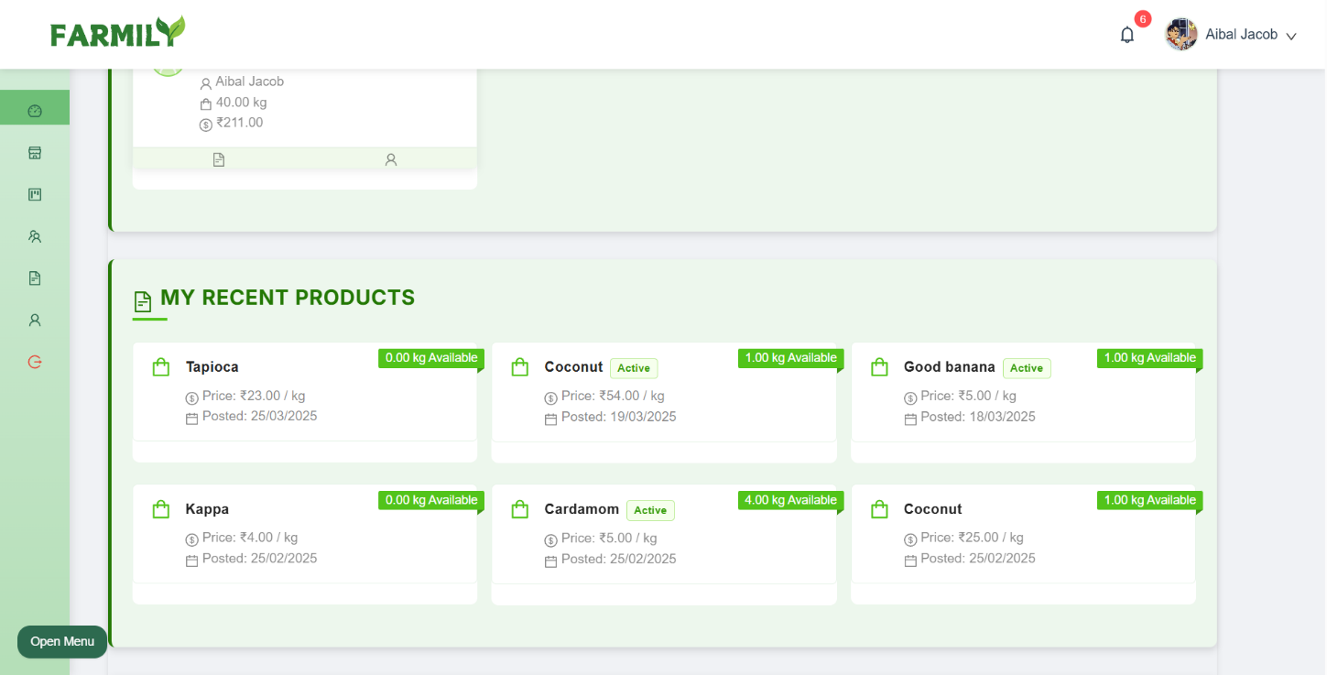
Fig 1. Farmer Dashboard Overview

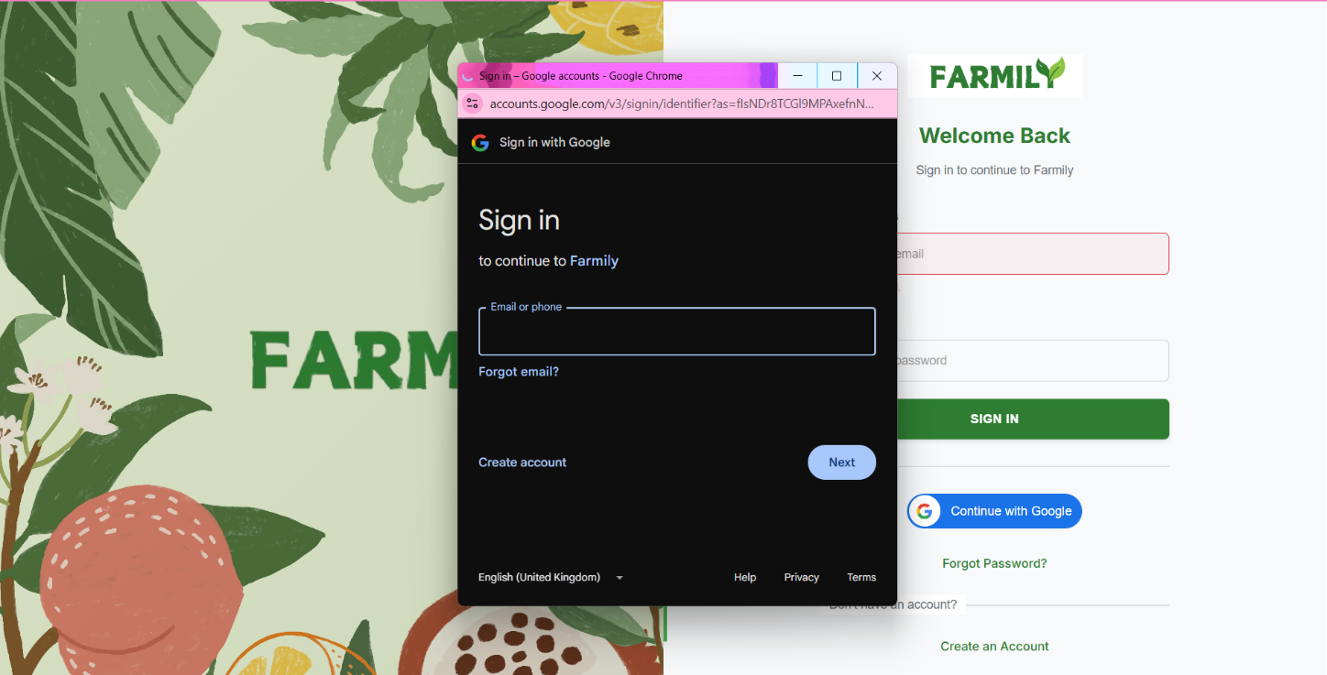
Fig 2. Login Page

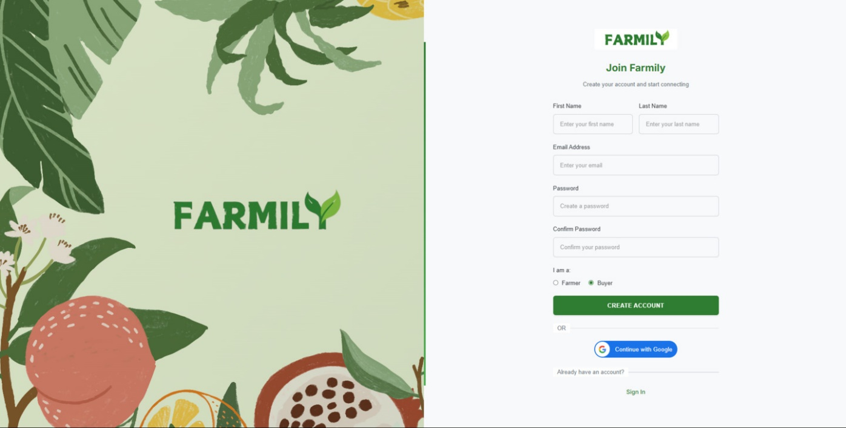
Fig 3. Sign up page

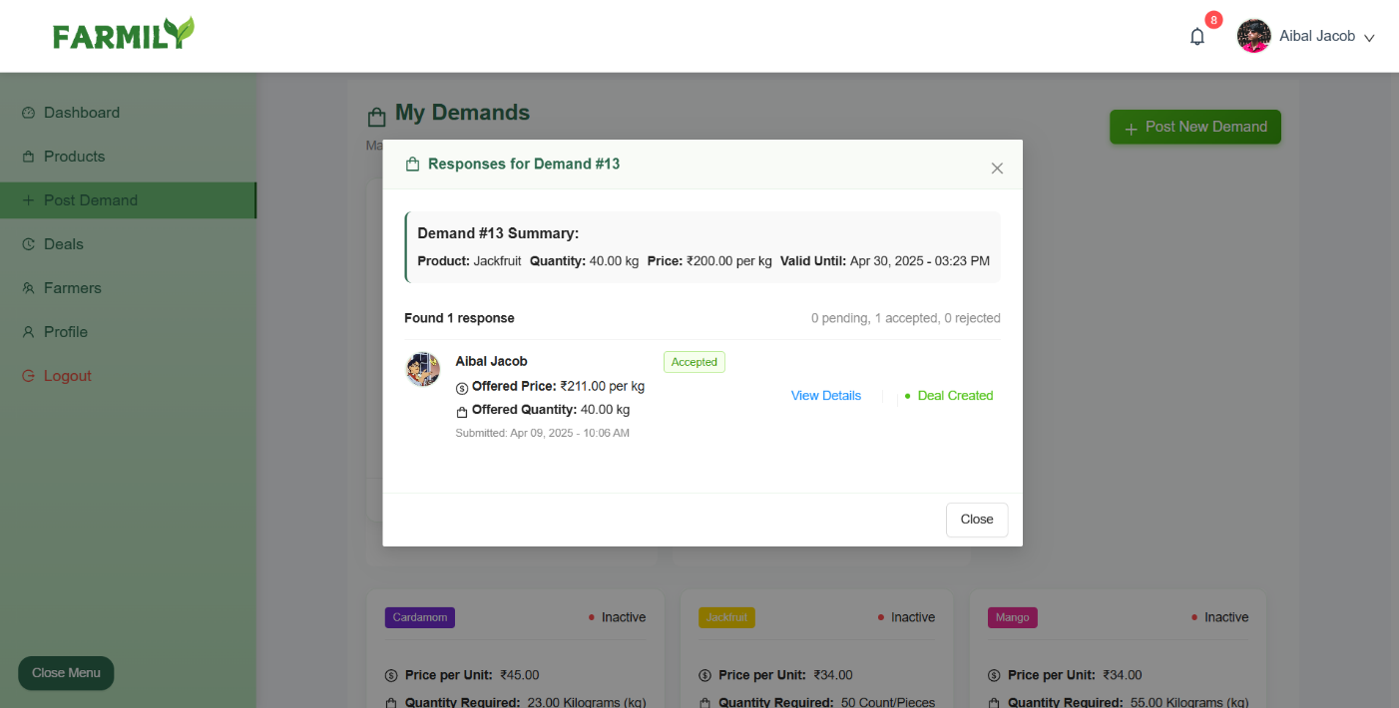
Fig 4. Manage responses

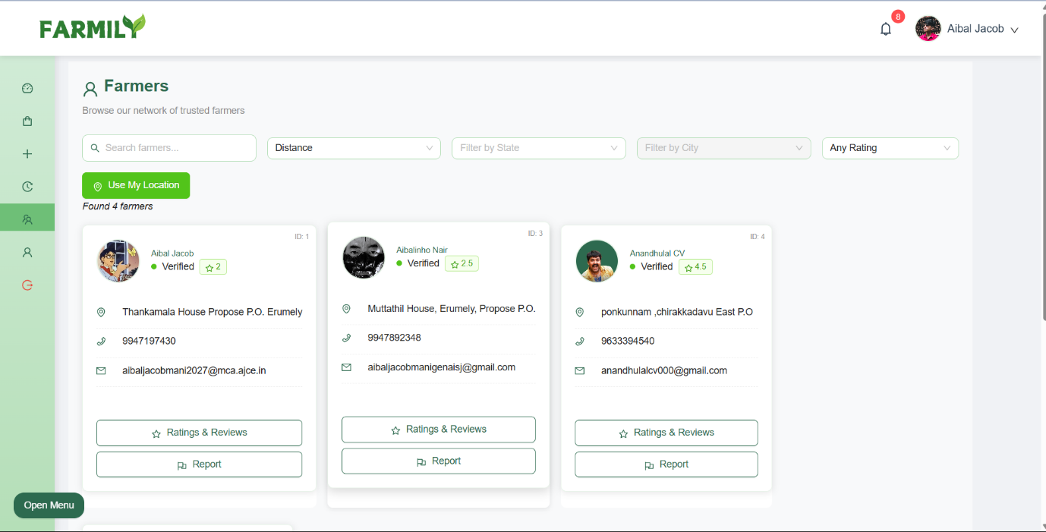
Fig 5.View Farmers

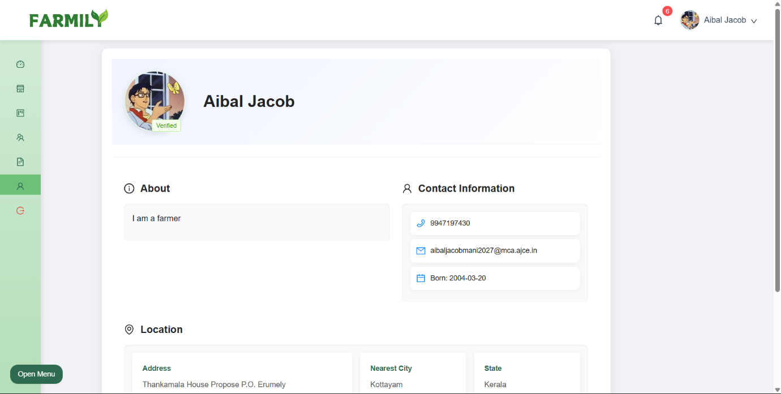
Fig 6. Manage Profile

