| Create a table called EMP with the following structure. EMPNO NUMBER(6) ENAME VARCHAR2(20) JOB VARCHAR2(10) DEPTNO NUMBER(3) SAL NUMBER(7,2) Allow NULL for all columns except ename and job |
| --- |
| Add a column experience to the emptable. |
| Modify the column width of the job field of emptable |
| Create dept table with the following structure. DEPTNO NUMBER(2) DNAME VARCHAR2(10) LOC VARCHAR2(10) Deptno as the primary key |
| Create the emp1 table with ename and empno, add constraints to check the empno value while entering (i.e) empno >100. |
| Drop a column experience to the emptable. |

.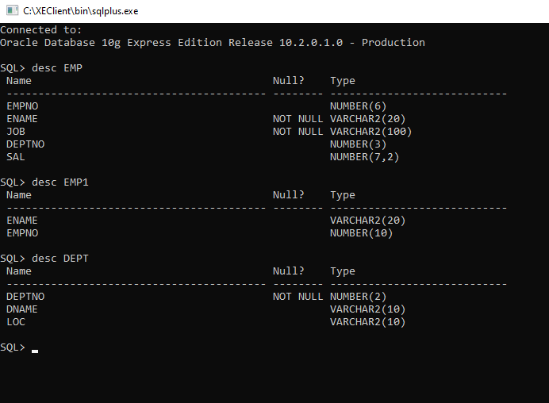

Familiarize the DDL Commands ALTER,DROP,TRUNCATE,RENAME. Create a table 'emply' with attributes empno int(4) as primary key,ename char(10), joiningdate,salary,commission and insert the following 5 rows of data

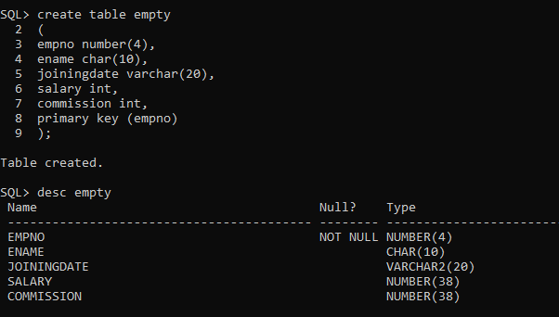

.

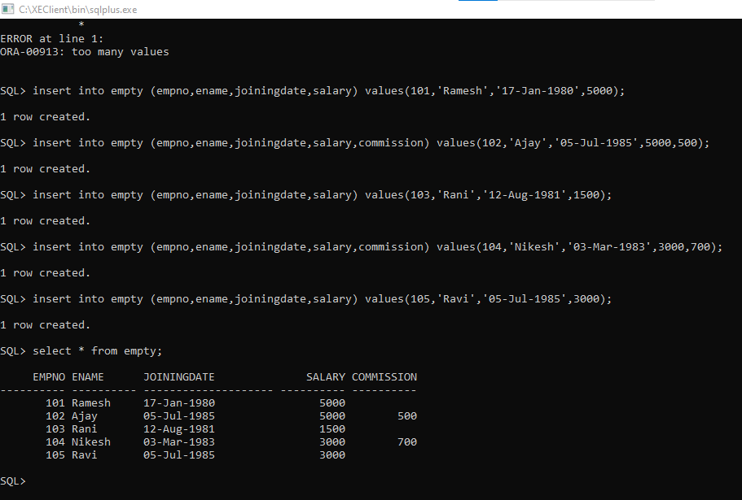

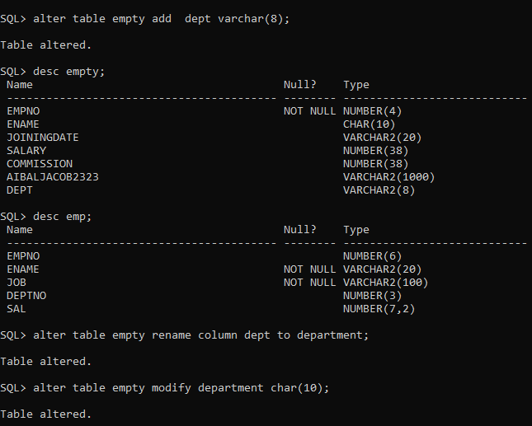

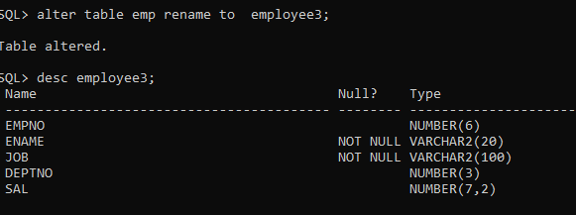

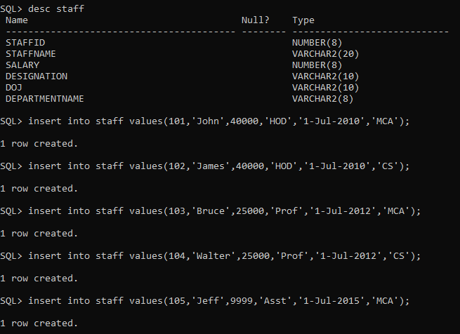

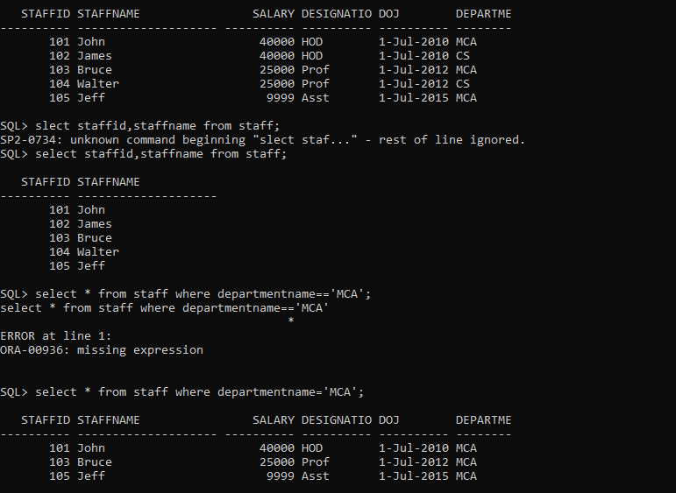

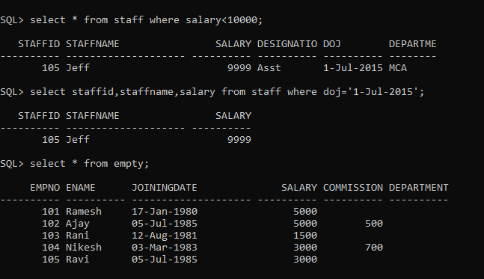

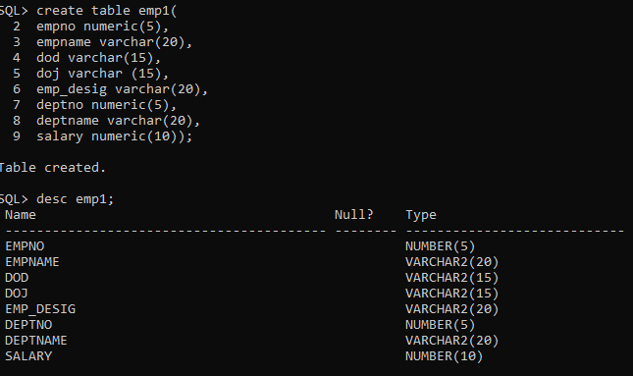

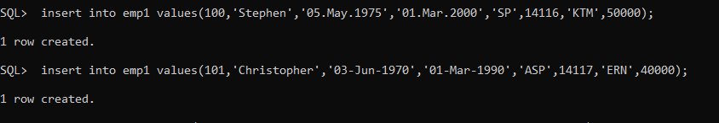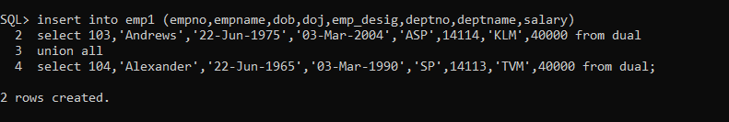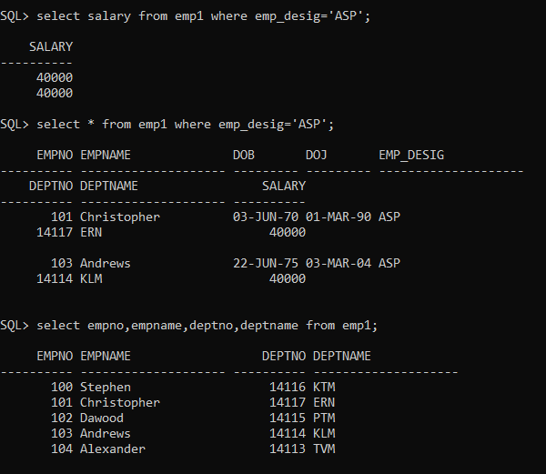

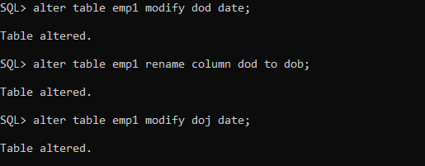

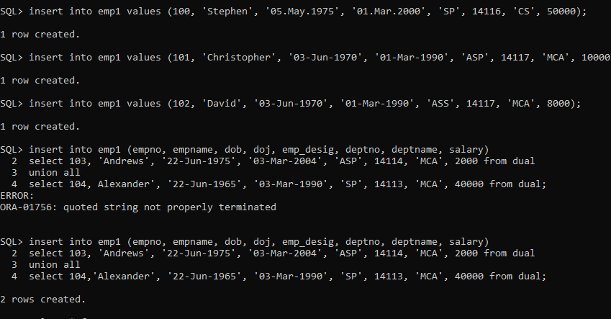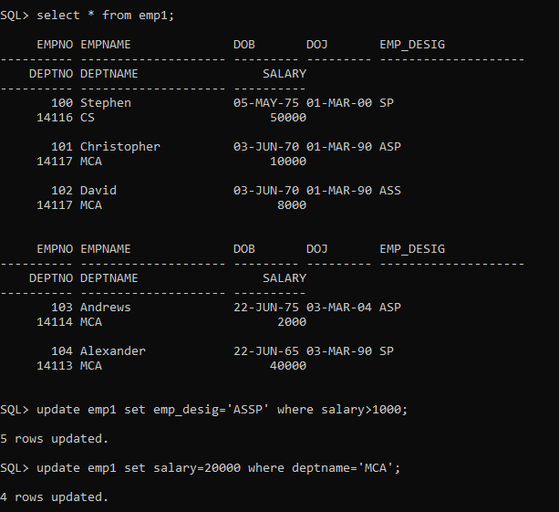

**Exp 4**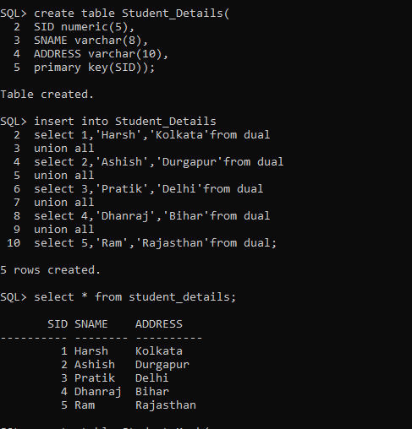

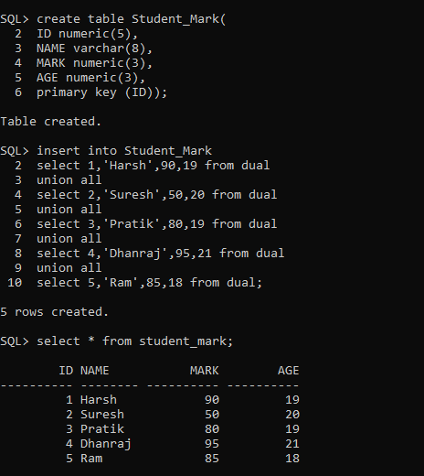

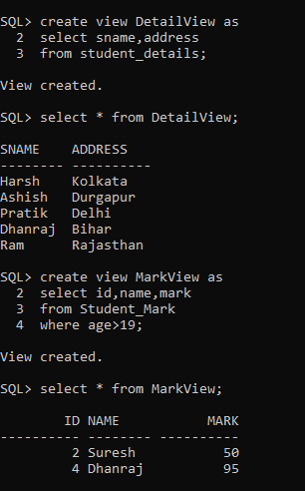

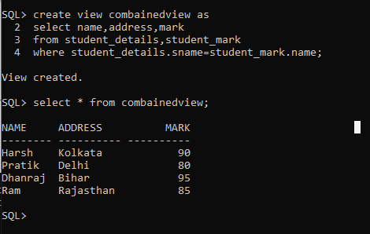

**Exp-5**

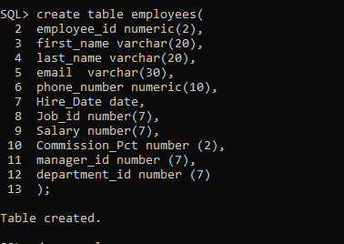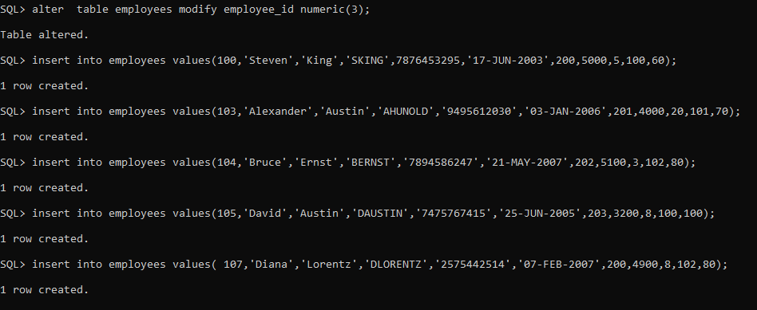

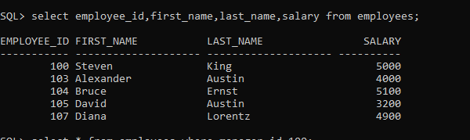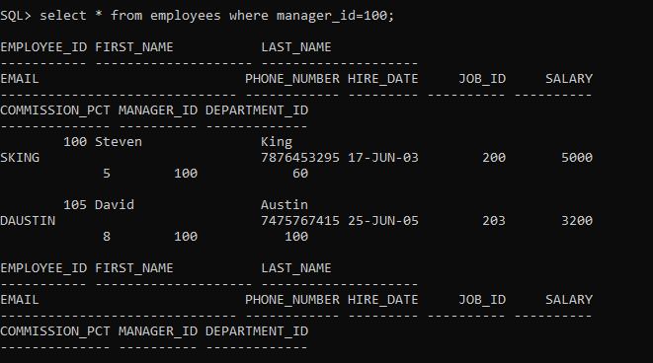

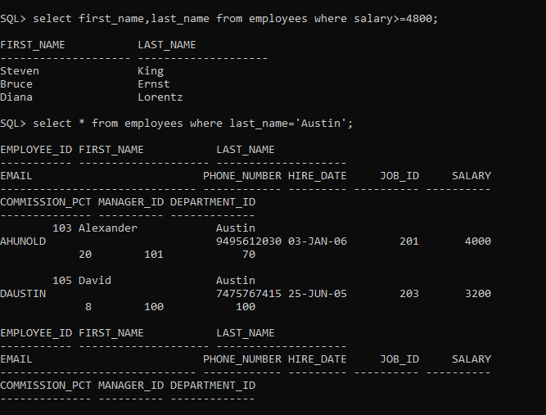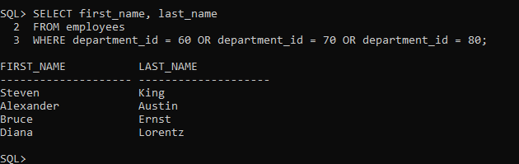

**Exp-6**

**create table Client_Master(Client_no varchar(6),Client_Name char(25),Client_Address varchar(25),Client_City varchar(20),Client_State varchar(20),Balance_Due number(20));**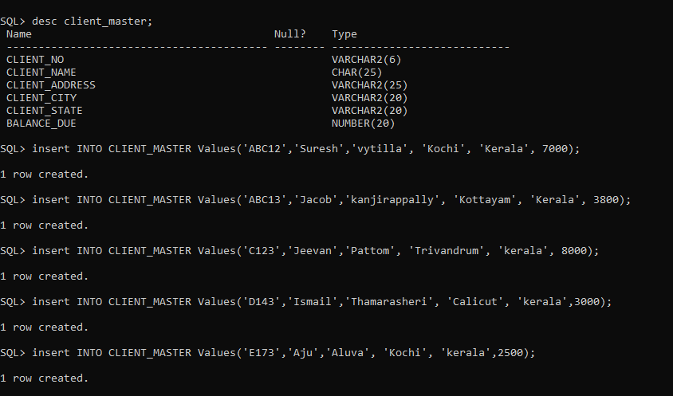

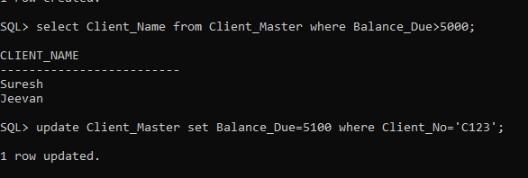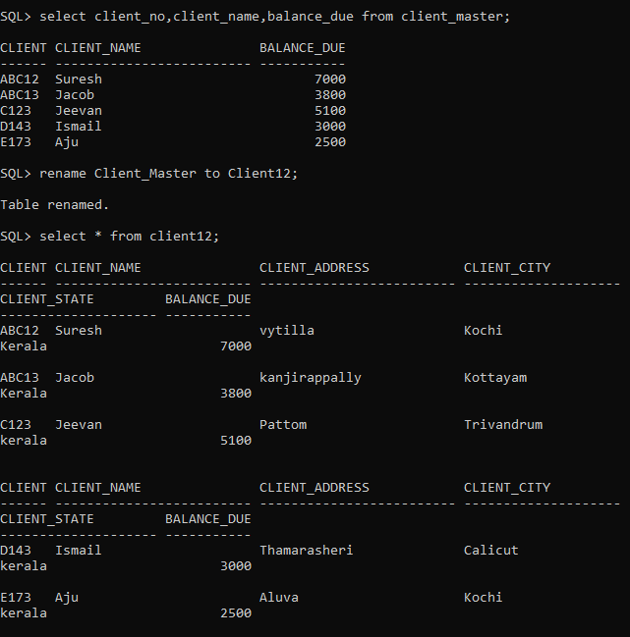

**Exp-7**

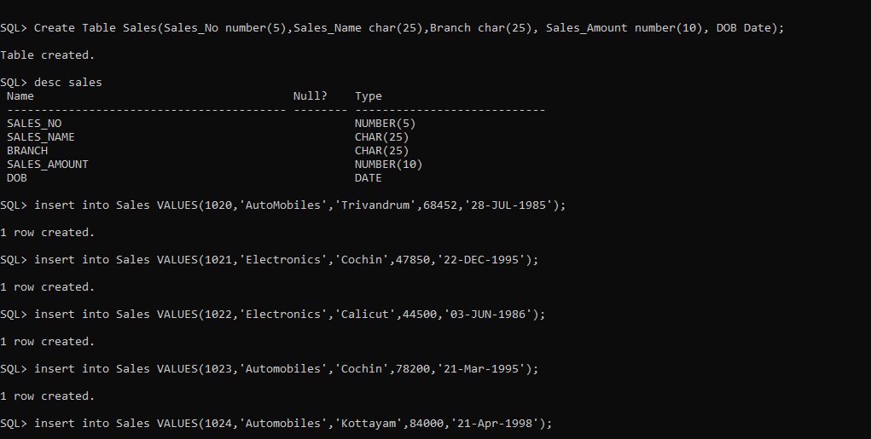

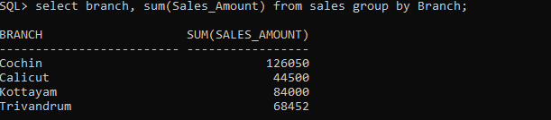

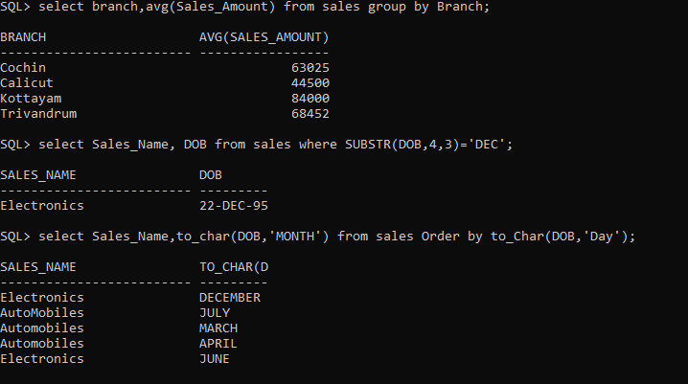

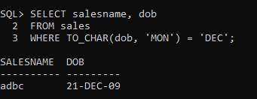

**Experiment -5**

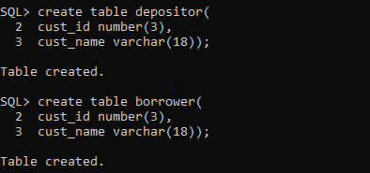

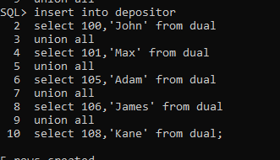

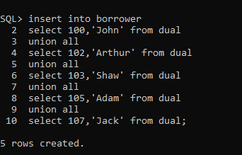

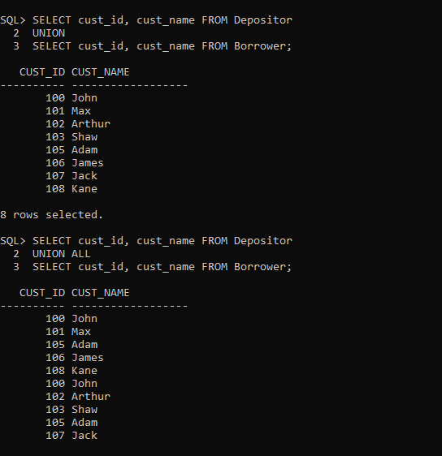

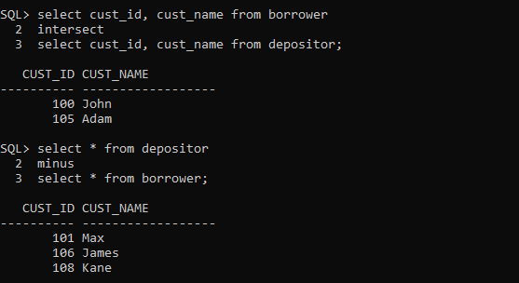

**Experiment -6**

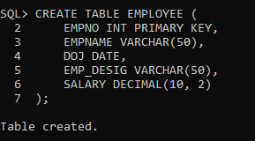

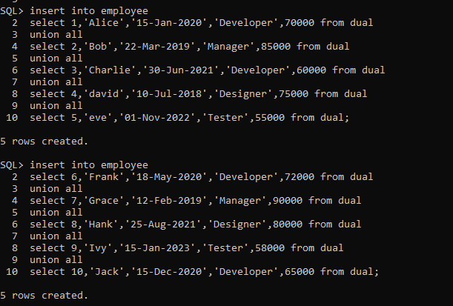

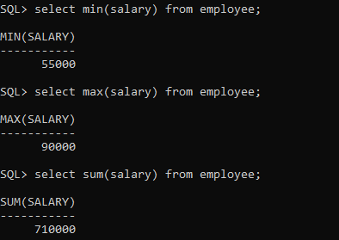

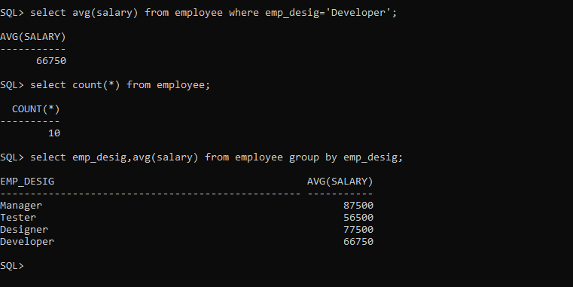

**experiment-7**

**SQL> create table salesman(**

**2 sale_id number(5),**

**3 Name varchar(10),**

**4 city varchar(10),**

**5 commission number(6));**

**Table created.**

**SQL> create table customer(**

**2 c_id number(5),**

**3 c_name varchar(10),**

**4 city varchar(10),**

**5 grade varchar(5),**

**6 sale_id number(5));**

**Table created.**

**SQL> create table orders (**

**2 order_no number(5),**

**3 purch_amt number(5),**

**4 ord_date date,**

**5 c_id number(5),**

**6 sale_id number(5));**

**Table created.**

**SQL> INSERT INTO salesman (sale_id, Name, city, commission)**

**2 SELECT 1, 'John D', 'NY', 10 FROM DUAL UNION ALL**

**3 SELECT 2, 'Jane S', 'LA', 15 FROM DUAL UNION ALL**

**4 SELECT 3, 'Emily J', 'CH', 12 FROM DUAL UNION ALL**

**5 SELECT 4, 'Mike B', 'HU', 13 FROM DUAL UNION ALL**

**6 SELECT 5, 'Jess D', 'PH', 14 FROM DUAL UNION ALL**

**7 SELECT 6, 'James W', 'PHI', 8 FROM DUAL UNION ALL**

**8 SELECT 7, 'Pat G', 'SA', 20 FROM DUAL UNION ALL**

**9 SELECT 8, 'David M', 'SD', 17 FROM DUAL UNION ALL**

**10 SELECT 9, 'Linda R', 'DA', 11 FROM DUAL UNION ALL**

**11 SELECT 10, 'Charles', 'SJ', 9 FROM DUAL;**

**10 rows created.**

**SQL> INSERT INTO customer (c_id, c_Name, city, grade, sale_id)**

**2 SELECT 1, 'Alice', 'NY', 'A', 1 FROM DUAL UNION ALL**

**3 SELECT 2, 'Bob', 'LA', 'B', 2 FROM DUAL UNION ALL**

**4 SELECT 3, 'Cate', 'CH', 'C', 3 FROM DUAL UNION ALL**

**5 SELECT 4, 'Dan', 'HU', 'A', 4 FROM DUAL UNION ALL**

**6 SELECT 5, 'Eva', 'PH', 'B', 5 FROM DUAL UNION ALL**

**7 SELECT 6, 'Frank', 'PHI', 'D', 6 FROM DUAL UNION ALL**

**8 SELECT 7, 'Grace', 'SA', 'C', 7 FROM DUAL UNION ALL**

**9 SELECT 8, 'Henry', 'SD', 'B', 8 FROM DUAL UNION ALL**

**10 SELECT 9, 'Ivy', 'DA', 'A', 9 FROM DUAL UNION ALL**

**11 SELECT 10, 'Jack', 'SJ', 'C', 10 FROM DUAL;**

**10 rows created.**

**SQL> INSERT INTO orders (order_No, purch_amt, ord_date, c_id, sale_id)**

**2 SELECT 1, 150, '15-Jan-2023', 1, 1 FROM DUAL UNION ALL**

**3 SELECT 2, 200, '20-Feb-2023', 2, 2 FROM DUAL UNION ALL**

**4 SELECT 3, 50, '25-Mar-2023', 3, 3 FROM DUAL UNION ALL**

**5 SELECT 4, 800, '30-Apr-2023', 4, 4 FROM DUAL UNION ALL**

**6 SELECT 5, 1200, '05-May-2023', 5, 5 FROM DUAL UNION ALL**

**7 SELECT 6, 1800, '10-Jun-2023', 6, 6 FROM DUAL UNION ALL**

**8 SELECT 7, 2500, '15-Jul-2023', 7, 7 FROM DUAL UNION ALL**

**9 SELECT 8, 75, '20-Aug-2023', 8, 8 FROM DUAL UNION ALL**

**10 SELECT 9, 90, '25-Sep-2023', 9, 9 FROM DUAL UNION ALL**

**11 SELECT 10, 5000, '30-Oct-2023', 10, 10 FROM DUAL;**

**10 rows created.**

**SQL> select salesman.name,customer.c_name,customer.city from salesman inner join customer on salesman.city=customer.city;**

**NAME C_NAME CITY**

**---------- ---------- ----------**

**John D Alice NY**

**Jane S Bob LA**

**Emily J Cate CH**

**Mike B Dan HU**

**Jess D Eva PH**

**James W Frank PHI**

**Pat G Grace SA**

**David M Henry SD**

**Linda R Ivy DA**

**Charles Jack SJ**

**10 rows selected.**

**SQL> create table student(**

**2 roll_no number(10) primary key,**

**3 stud_name varchar(20) constraint b2 check(substr(stud_name,1,1)in('B','S','E','P')),**

**4 mark number(4),**

**5 dept_no varchar(6) references department(dept_no),**

**6 city varchar(20) constraint b3 check (city in('Cochin','Bombay','Madras','Delhi')),**

**7 Date_of_joining date);**

SQL> SET SERVEROUTPUT ON;

SQL> DECLARE

2 n INT;

3 r INT := 1; -- Initialize r to 1

4 PROCEDURE fact(x IN INT, y OUT INT) IS

5 BEGIN

6 y := 1; -- Initialize y to 1 (factorial starts at 1)

7 FOR i IN 1..x LOOP

8 y := y * i;

9 END LOOP;

10 END;

11 BEGIN

12 n := 5;

13 fact(n, r); -- Call the procedure

14 DBMS_OUTPUT.PUT_LINE('fact=' || r); -- Output the result

15 END;

16 /

**set serveroutput on;**

**SQL> declare**

**2 a int;**

**3 b int;**

**4 c int;**

**5 procedure sum(x in int, y in int, z out int) is**

**6 begin**

**7 z := x + y;**

**8 end;**

**9 begin**

**10 a := 5;**

**11 b := 5;**

**12 sum(a, b, c); -- Added semicolon here**

**13 dbms_output.put_line('sum=' || c);**

**14 end;**

**15 /**

**EXP 7**

**Create 3 Tables Salesman(sale_id,Name,city,commission),Customer(c_id,c_Name,city, grade, sale_id), orders(order_No,purch_amt,ord_date,c_id,sale_id) and insert 10 values in each table**

**-- Creating Salesman table**

**CREATE TABLE Salesman (**

**sale_id INT PRIMARY KEY,**

**Name VARCHAR(50),**

**city VARCHAR(50),**

**commission DECIMAL(5, 2)**

**);**

**-- Creating Customer table**

**CREATE TABLE Customer (c_id INT PRIMARY KEY,c_Name VARCHAR(50),city VARCHAR(50), grade INT,sale_id INT,FOREIGN KEY (sale_id) REFERENCES Salesman(sale_id));**

**-- Creating Orders table**

**CREATE TABLE Orders (order_No INT PRIMARY KEY, purch_amt DECIMAL(10, 2),ord_date DATE, c_id INT, sale_id INT, FOREIGN KEY (c_id) REFERENCES Customer(c_id), FOREIGN KEY (sale_id)REFERENCES Salesman(sale_id));**

**-- Inserting values into Salesman**

**INSERT INTO Salesman VALUES (101, 'John Doe', 'New York', 15.00);**

**INSERT INTO Salesman VALUES(102, 'Jane Smith', 'Los Angeles', 10.00);**

**INSERT INTO Salesman VALUES(103, 'Sam Brown', 'New York', 12.50);**

**INSERT INTO Salesman VALUES(104, 'Nancy Green', 'Chicago', 14.00);**

**INSERT INTO Salesman VALUES(105, 'Bob White', 'Miami', 13.00);**

**INSERT INTO Salesman VALUES(106, 'Anna Blue', 'Seattle', 9.00);**

**INSERT INTO Salesman VALUES(107, 'Tom Black', 'New York', 18.00);**

**INSERT INTO Salesman VALUES(108, 'Lucy Pink', 'Chicago', 11.00);**

**INSERT INTO Salesman VALUES(109, 'Mark Red', 'Los Angeles', 8.00);**

**INSERT INTO Salesman VALUES(110, 'Tina Purple', 'Seattle', 15.50);**

**-- Inserting values into Customer**

**INSERT INTO Customer VALUES (1, 'Alice', 'New York', 200, 101);**

**INSERT INTO Customer VALUES(2, 'Bob', 'Los Angeles', 100, 102);**

**INSERT INTO Customer VALUES(3, 'Charlie', 'New York', 300, 103);**

**INSERT INTO Customer VALUES(4, 'David', 'Chicago', 150, 104);**

**INSERT INTO Customer VALUES(5, 'Eva', 'Miami', 250, 105);**

**INSERT INTO Customer VALUES(6, 'Frank', 'Seattle', 180, 106);**

**INSERT INTO Customer VALUES(7, 'Grace', 'New York', 270, 107);**

**INSERT INTO Customer VALUES(8, 'Hank', 'Chicago', 120, 108);**

**INSERT INTO Customer VALUES(9, 'Ivy', 'Los Angeles', 210, 109);**

**INSERT INTO Customer VALUES(10, 'Jack', 'Seattle', 310, 110);**

**-- Inserting values into Orders**

**INSERT INTO Orders VALUES (1001, 1500.00, '2024-01-15', 1, 101);**

**INSERT INTO Orders VALUES(1002, 200.00, '2024-01-20', 2, 102);**

**INSERT INTO Orders VALUES(1003, 2500.00, '2024-02-05', 3, 103);**

**INSERT INTO Orders VALUES(1004, 1700.00, '2024-03-10', 4, 104);**

**INSERT INTO Orders VALUES(1005, 600.00, '2024-03-15', 5, 105);**

**INSERT INTO Orders VALUES(1006, 800.00, '2024-04-01', 6, 106);**

**INSERT INTO Orders VALUES(1007, 3000.00, '2024-04-15', 7, 107);**

**INSERT INTO Orders VALUES(1008, 900.00, '2024-05-01', 8, 108);**

**INSERT INTO Orders VALUES(1009, 1300.00, '2024-05-20', 9, 109);**

**INSERT INTO Orders VALUES(1010, 500.00, '2024-06-01', 10, 110);**

**2.SELECT s.Name AS Salesman, c.c_Name AS Customer, s.city**

**FROM Salesman s**

**JOIN Customer c ON s.city = c.city AND s.sale_id = c.sale_id;**

**3.SELECT o.order_No, o.purch_amt, c.c_Name, c.city**

**FROM Orders o**

**JOIN Customer c ON o.c_id = c.c_id**

**WHERE o.purch_amt BETWEEN 500 AND 2000;**

**4.SELECT c.c_Name AS Customer, c.city AS City, s.Name AS Salesman, s.commission**

**FROM Customer c**

**JOIN Salesman s ON c.sale_id = s.sale_id;**

**5.SELECT c.c_Name AS Customer, c.city AS CustomerCity, s.Name AS Salesman, s.commission**

**FROM Customer c**

**JOIN Salesman s ON c.sale_id = s.sale_id**

**WHERE s.commission > 12;**

**6.SELECT c.c_Name AS Customer, c.city AS CustomerCity, s.Name AS Salesman, s.city AS SalesmanCity, s.commission**

**FROM Customer c**

**JOIN Salesman s ON c.sale_id = s.sale_id**

**WHERE s.city <> c.city AND s.commission > 12;**

**7.SELECT o.order_No, o.ord_date, o.purch_amt, c.c_Name, c.grade, s.Name AS Salesman, s.commission**

**FROM Orders o**

**JOIN Customer c ON o.c_id = c.c_id**

**JOIN Salesman s ON o.sale_id = s.sale_id;**

**8.SELECT c.c_Name AS Customer, c.city AS CustomerCity, c.grade, s.Name AS Salesman, s.city AS SalesmanCity**

**FROM Customer c**

**JOIN Salesman s ON c.sale_id = s.sale_id**

**ORDER BY c.c_id ASC;**

**9.SELECT c.c_Name AS Customer, c.city AS CustomerCity, c.grade, s.Name AS Salesman, s.city AS SalesmanCity**

**FROM Customer c**

**JOIN Salesman s ON c.sale_id = s.sale_id**

**WHERE c.grade < 300**

**ORDER BY c.c_id ASC;**

**10.SELECT c.c_Name, c.city, o.order_No, o.ord_date, o.purch_amt**

**FROM Orders o**

**JOIN Customer c ON o.c_id = c.c_id**

**ORDER BY o.ord_date ASC;**