ECE 454 Mechatronics Embedded Design

Crash Proof

Final Report

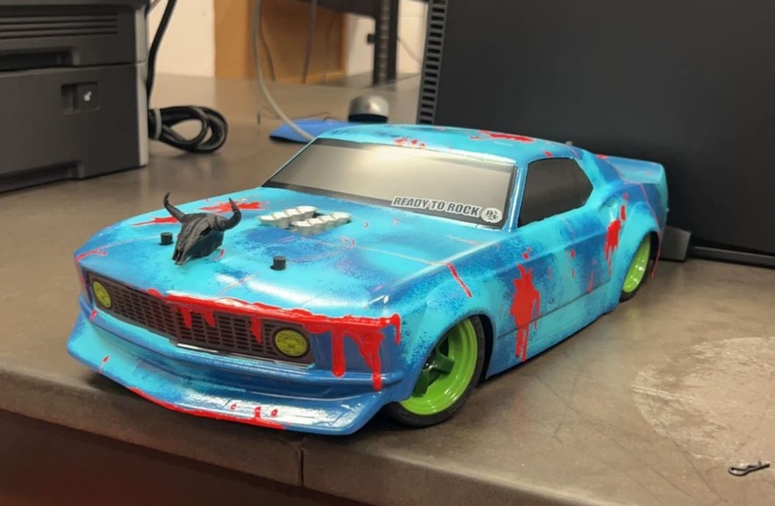

Team members:
Anthony Ibarra (Leader)
Joe Hackl
Sai Rahul Annamali
Leonardo Garcia

Overview:
The project has been filled with experience unlike other projects in regards to designing, developing, and troubleshooting. Designing and Developing areas in both hardware and software parts of the self driving car.

Milestones: During the project there were many milestones achieved by our team.

We accomplished
- Building DC-DC Converter, and Motor Controller(full bridge)
- Programming using PWM for the Motor Controller, Servo, & Line Camera
- Programming the Velocity Sensing and Control algorithms
- Developing the entire circuit in Altium Designer for manufacturing

PCB Design -
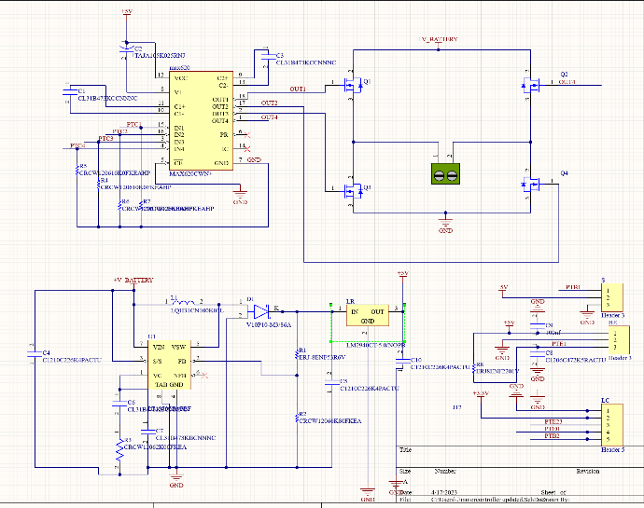
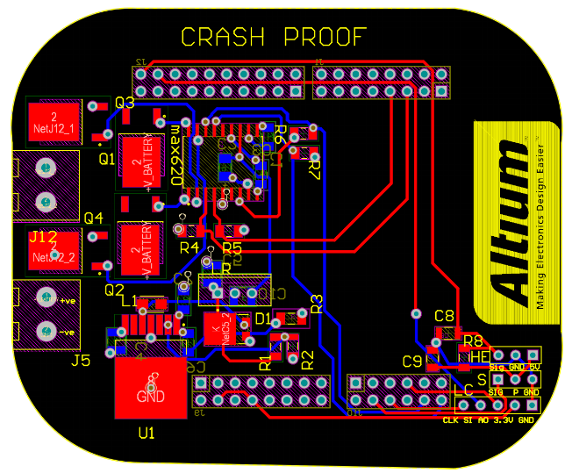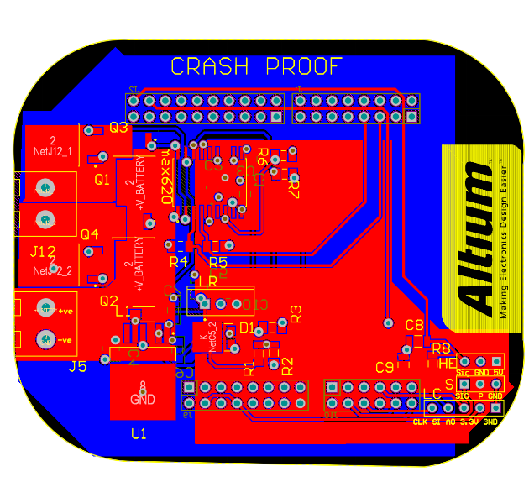
- We understood the basic fundamentals and rules for designing a PCB layout in Altium software.
- Since we used a full H- bridge we had to come up with a layout that makes sure there is proper power dissipation near the motor controller unit.
- Polygons were created for the respective power planes to reduce routing.

Risks: There where a couple of risks taken throughout the project namely

Full H-Bridge:
- Choosing to implement the full H-bridge for the motor controller, seeing as it is a bit of an overkill and the increase of parts will increase the cost of the project and room for an error or malfunction to occur during development and testing.

Boost Converter (DC-DC) Bypass:
- Due to lack of time it was decided not to implement the Bypass for the boost converter which has a high chance of burning up during practical testing.

Backup Board (Perfboard):
- Starting the Backup Board later than early in the semester
- In doing so the backup was rushed and became messy and unrefined, but functional

Issues:
Being more noticeable in the latter half of the project. Some members in the team had a large workload compared to other members causing the lack of work done outside of work hours(lab). There was also the case that some members did not fully understand the entire project as a whole; this most likely was caused by dividing the work done which in turn some members are more knowledgeable in different areas of the project in comparison to other members. The problems from delivery serviced etc. caused time issues in the long run especially with all the other unfortunate events.

Actions and decisions:
Many risks were taken for this project because overall it was a learning experience, and the best way for one to learn and have success is by taking risks, making mistakes and overcoming challenges that we face. When the project started to get hectic in regards to the work that needed to be done with respect to the time at hand. The team was split with one side more focused on the circuit construction for the pcb using Altium designer, and the other side was more focused on the embedded design and implementation of the hardware and software with the car.

Conclusion:
The project was a phenomenal experience regarding an embedded system and a mechatronics system working in conjunction with each other. The ending may not have been ideal, but in some cases nothing ever really ends up as ideal due to constraints or compromises. In the end the car did follow the line in practice. Although there were motor speed control problems causing the motor to rev up too much. This was most likely due to some soldering misconnection or pinouts difference from software to the board. The final goal of the project was a success, giving us the experience of working with a mechatronic embedded system.

